QUESTION 40

Title
Advantages and Disadvantages of Dynamic Programming vs Greedy Algorithms (Comparative Analysis)

Aim
To analyze and compare Dynamic Programming and Greedy Algorithms by evaluating their advantages, disadvantages, computational complexity, scalability, and suitability for solving optimization problems.

Problem Statement
Many optimization problems can be solved using either Dynamic Programming (DP) or Greedy techniques. The objective is to compare both approaches, analyze their strengths and limitations, evaluate their computational performance, and identify situations where each paradigm is most appropriate.

Introduction
Algorithm design techniques play a crucial role in solving computational problems efficiently. Two of the most widely used paradigms are Dynamic Programming and Greedy Algorithms.
Dynamic Programming solves problems by breaking them into smaller overlapping sub-problems and storing intermediate results.
Greedy Algorithms solve problems by making the best local decision at every step with the expectation of reaching a globally optimal solution.
Although both techniques are used for optimization problems, their approaches, performance, and outcomes differ significantly.

Objectives
- Understand Dynamic Programming and Greedy techniques.
- Compare their advantages and disadvantages.
- Analyze computational complexity.
- Evaluate scalability for large problems.
- Identify suitable applications for each approach.
- Generate insights for selecting the appropriate paradigm.

Theory

Dynamic Programming (DP)
Dynamic Programming is an optimization method that solves complex problems by dividing them into smaller overlapping sub-problems.
The solutions of sub-problems are stored and reused whenever needed.

Characteristics
- Overlapping sub-problems
- Optimal substructure
- Memorization or Tabulation
- Guaranteed optimal solution

Greedy Algorithm
A Greedy Algorithm makes the best possible choice at each step without reconsidering previous decisions.
It aims to obtain a globally optimal solution through locally optimal choices.

Characteristics
- Local optimization
- Simple implementation
- Fast execution
- Low memory usage

Problem Used for Comparison

Coin Change Problem
Given:
Coins = {1, 3, 4}
Amount = 6

Greedy Solution
Choose largest coin first:
4 + 1 + 1
Coins Used = 3

Dynamic Programming Solution
Choose optimal combination:
3 + 3
Coins Used = 2
The DP solution is better because it produces the minimum number of coins.

Algorithmic Approaches

Dynamic Programming Approach
- Create a table for all amounts.
- Store minimum coins needed for each amount.
- Reuse previously computed values.
- Return optimal result.

Greedy Approach
- Select the largest available coin.
- Subtract its value from the amount.
- Repeat until the amount becomes zero.
- Return the solution obtained.

Advantages of Dynamic Programming
- Produces optimal solutions.
- Handles complex optimization problems.
- Avoids repeated calculations.
- Improves efficiency through stored results.
- Suitable for problems with overlapping sub-problems.

Disadvantages of Dynamic Programming
- High memory consumption.
- Complex implementation.
- Larger execution overhead.
- Requires additional storage structures.

Advantages of Greedy Algorithms
- Easy to implement.
- Faster execution.
- Low memory requirements.
- Suitable for large datasets.
- Efficient for real-time applications.

Disadvantages of Greedy Algorithms
- May not produce optimal solutions.
- Depends heavily on local decisions.
- Not applicable to all optimization problems.
- Can lead to incorrect results for some cases.

Comparison Table
Feature | Dynamic Programming | Greedy Algorithm
Optimal Solution | Always Optimal | Not Always Optimal
Execution Speed | Moderate | Fast
Memory Usage | High | Low
Complexity | Higher | Lower
Scalability | Moderate | High
Accuracy | High | Medium
Implementation | Complex | Simple

Computational Complexity

Dynamic Programming
Time Complexity:
O(n × amount)
Space Complexity:
O(amount)

Greedy Algorithm
Time Complexity:
O(n log n)
Space Complexity:
O(1)

Scalability Analysis

Dynamic Programming
Dynamic Programming performs efficiently for medium-sized optimization problems. However, memory usage increases as problem size grows.

Suitable For
- Knapsack Problem
- Longest Common Subsequence
- Matrix Chain Multiplication
- Coin Change Problem

Greedy Algorithm
Greedy Algorithms scale efficiently for large datasets because they require less memory and fewer computations.

Suitable For
- Kruskal's Algorithm
- Prim's Algorithm
- Huffman Coding
- Activity Selection Problem

Source Code
# DP vs Greedy Comparison

amount = 6
coins = [1, 3, 4]

# Greedy Solution
count = 0
amt = amount

for coin in sorted(coins, reverse=True):
while amt >= coin:
amt -= coin
count += 1

print("Greedy Coins Used =", count)

# Dynamic Programming Solution
dp = [float('inf')] * (amount + 1)
dp[0] = 0

for i in range(1, amount + 1):
for coin in coins:
if coin <= i:
dp[i] = min(dp[i], dp[i - coin] + 1)

print("DP Coins Used =", dp[amount])

Sample Output
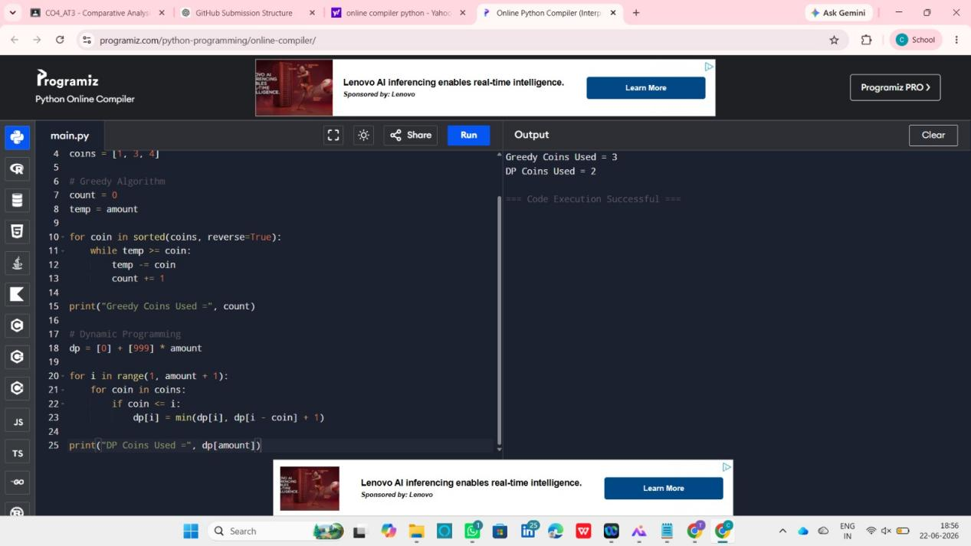

Analysis
The Greedy Algorithm selects the largest coin first and uses three coins to make the amount.
Dynamic Programming evaluates all possible combinations and finds the optimal solution using only two coins.
This demonstrates that Dynamic Programming guarantees optimal, whereas Greedy algorithms may produce sub-optimal results.

Applications

Dynamic Programming
- Resource Allocation
- Route Optimization
- Bioinformatics
- Machine Learning
- Financial Planning

Greedy Algorithms
- Network Design
- Data Compression
- Scheduling Problems
- Minimum Spanning Trees
- Routing Systems

Insights for Selecting Appropriate Paradigms

Choose Dynamic Programming When:
- Optimal solution is mandatory.
- Overlapping sub-problems exist.
- Accuracy is more important than speed.

Choose Greedy Algorithm When:
- Fast execution is required.
- Memory resources are limited.
- The problem satisfies the greedy-choice property.

Result
The comparative analysis shows that Dynamic Programming provides optimal and accurate solutions but requires higher memory and computational resources. Greedy Algorithms offer faster execution and lower memory consumption but may not always produce optimal results. Therefore, the choice between DP and Greedy depends on problem characteristics, resource availability, and optimization requirements.

