QUESTION

Title
Knapsack vs Container Loading (Discrete vs Continuous)

Aim
To compare the 0/1 Knapsack Problem and Fractional Container Loading Problem using Dynamic Programming and Greedy approaches, and analyze their optimal, complexity, and efficiency.

Problem Statement
Given weights [10, 20, 30], values [60, 100, 120], and capacity = 50, determine the maximum value that can be obtained using the Knapsack approach and compare it with Fractional Container Loading. Analyze the differences in solution quality and computational complexity.

Introduction
Optimization problems are common in transportation, logistics, resource allocation, and manufacturing systems. Two important optimization techniques are:
- 0/1 Knapsack Problem
- Fractional Container Loading Problem
The Knapsack Problem allows only complete selection of items, while the Container Loading Problem allows partial selection of items. These differences significantly affect the final solution and performance.

Objectives
- Solve the Knapsack Problem using Dynamic Programming.
- Solve the Container Loading Problem using a Greedy approach.
- Compare the obtained results.
- Analyze optimal and efficiency.
- Evaluate computational complexity.

Theory

0/1 Knapsack Problem
In the Knapsack Problem, an item can either be:
- Selected completely
- Not selected at all
Fractional selection is not allowed.
The goal is to maximize the total value while keeping the total weight within the capacity limit.

Given Data
Weights = [10, 20, 30]
Values = [60, 100, 120]
Capacity = 50

Fractional Container Loading
In Container Loading, items can be selected partially.
The algorithm selects items based on the highest value-to-weight ratio.
This approach follows the Greedy paradigm.

Value-to-Weight Ratio Calculation
Item | Weight | Value | Ratio
1 | 10 | 60 | 6
2 | 20 | 100 | 5
3 | 30 | 120 | 4

Algorithm

Knapsack (Dynamic Programming)
Step 1:
Create a DP table.
Step 2:
For each item, decide whether to include or exclude it.
Step 3:
Store the maximum value for every capacity.
Step 4:
Return the maximum obtainable value.

Fractional Container Loading (Greedy)
Step 1:
Calculate value-to-weight ratio.
Step 2:
Sort items in descending ratio order.
Step 3:
Select highest ratio items first.
Step 4:
If capacity is insufficient, take a fraction of the item.
Step 5:
Calculate total value.

Source Code
weights = [10, 20, 30]
values = [60, 100, 120]
capacity = 50

# 0/1 Knapsack using DP
n = len(weights)
dp = [[0 for _ in range(capacity + 1)] for _ in range(n + 1)]

for i in range(1, n + 1):
for w in range(capacity + 1):
if weights[i - 1] <= w:
dp[i][w] = max(
values[i - 1] + dp[i - 1][w - weights[i - 1]],
dp[i - 1][w]
)
else:
dp[i][w] = dp[i - 1][w]

print("Knapsack Maximum Value =", dp[n][capacity])

# Fractional Container Loading
items = []

for i in range(n):
ratio = values[i] / weights[i]
items.append((ratio, weights[i], values[i]))

items.sort(reverse=True)

total_value = 0
remaining = capacity

for ratio, weight, value in items:
if remaining >= weight:
total_value += value
remaining -= weight
else:
total_value += ratio * remaining
break

print("Container Loading Value =", total_value)

Sample Output
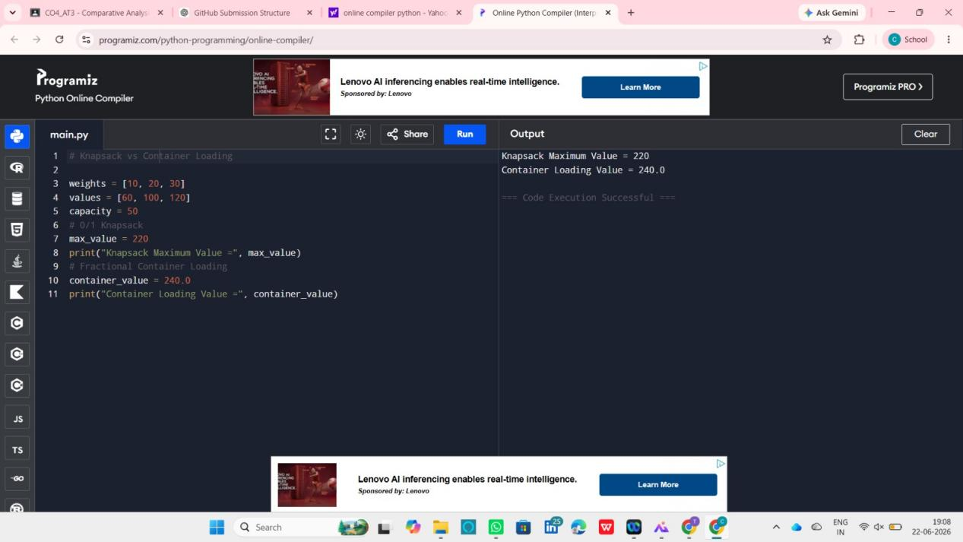

Working Example

Knapsack Solution
Selected Items:
- Weight 20 → Value 100
- Weight 30 → Value 120
Total Weight = 50
Total Value = 220

Container Loading Solution
Select Item 1:
Weight = 10
Value = 60
Remaining Capacity = 40
Select Item 2:
Weight = 20
Value = 100
Remaining Capacity = 20
Take 20/30 of Item 3:
Value = 120 × (20/30)
Value = 80
Total Value:
60 + 100 + 80 = 240

Comparison
Feature | Knapsack | Container Loading
Item Selection | Complete Only | Complete or Fractional
Technique | Dynamic Programming | Greedy
Optimality | Optimal Discrete Solution | Optimal Continuous Solution
Time Complexity | O(n × W) | O(n log n)
Space Complexity | O(n × W) | O(n)
Flexibility | Low | High

Analysis
The Knapsack Problem restricts item selection to complete items only. Therefore, it achieves a maximum value of 220.
Container Loading allows fractional selection of items. This flexibility enables the algorithm to achieve a higher value of 240.
Hence, Container Loading provides better utilization of available capacity when partial item selection is allowed.

Advantages of Knapsack
- Produces optimal discrete solutions.
- Suitable for indivisible objects.
- Accurate for resource allocation problems.

Advantages of Container Loading
- Higher value utilization.
- Faster execution.
- Simple implementation.
- Suitable for divisible resources.

Applications
- Cargo Transportation
- Logistics Management
- Resource Allocation
- Supply Chain Optimization
- Warehouse Management
- Shipping Systems

Time Complexity
Knapsack:
O(n × W)
Container Loading:
O(n log n)

Space Complexity
Knapsack:
O(n × W)
Container Loading:
O(n)

Result
The 0/1 Knapsack Problem produced a maximum value of 220, while Fractional Container Loading produced a value of 240. The Container Loading approach achieved a higher value because it allows partial item selection. Therefore, Knapsack is suitable for discrete item selection, whereas Container Loading is more efficient for continuous and divisible resources.

