QUESTION

Title
Scheduling with Deadlines (NP-Hard Constraint Problem)

Aim
To schedule tasks with deadlines in order to maximize the number of completed tasks while satisfying deadline constraints using a backtracking-based approach.

Problem Statement
Given a set of tasks, each having an execution time and a deadline, determine a schedule that maximizes the number of tasks completed before their deadlines. Analyze constraints, apply backtracking and pruning techniques, and evaluate computational complexity.

Introduction
Task scheduling is an important problem in computer science, manufacturing systems, project management, and operating systems. The objective is to arrange tasks efficiently so that the maximum number of tasks are completed before their deadlines.
Scheduling with deadlines is considered an NP-Hard problem because the number of possible task schedules increases rapidly as the number of tasks grows.

Objectives
- Schedule tasks before deadlines.
- Maximize the number of completed tasks.
- Analyze deadline constraints.
- Apply backtracking to generate schedules.
- Use pruning to eliminate infeasible schedules.
- Evaluate computational complexity.

Theory

Scheduling Problem
Scheduling involves assigning tasks to available time slots while satisfying given constraints.

Deadline
A deadline represents the latest time by which a task must be completed.

Backtracking
Backtracking explores all possible task sequences and selects the best feasible schedule.

Pruning
Pruning avoids exploring schedules that already violate deadline constraints, reducing unnecessary computations.

Constraints

Deadline Constraint
Each task must finish before its assigned deadline.

Execution Time Constraint
Every task requires a specific amount of execution time.

Feasibility Constraint
Only schedules satisfying all deadlines are considered valid.

Optimization Constraint
The objective is to maximize the number of completed tasks.

Example
Task | Deadline
T1 | 2
T2 | 1
T3 | 2
T4 | 1
Possible Schedule:
T2 → T1 → T4 → T3
Tasks completed before deadlines are counted toward the final solution.

Proposed Solution

Step 1
Input task information.

Step 2
Generate possible schedules.

Step 3
Check deadline satisfaction.

Step 4
Discard invalid schedules.

Step 5
Store feasible schedules.

Step 6
Select schedule with maximum completed tasks.

Algorithm
- Read task deadlines.
- Generate task combinations using backtracking.
- Verify deadline constraints.
- Apply pruning when deadlines are violated.
- Count completed tasks.
- Select the best schedule.

Source Code
# Scheduling with Deadlines

tasks = ["T1", "T2", "T3", "T4"]
deadlines = [2, 1, 2, 1]

print("Tasks and Deadlines:")
for i in range(len(tasks)):
print(tasks[i], "Deadline =", deadlines[i])

completed = []

for i in range(len(tasks)):
if deadlines[i] >= 1:
completed.append(tasks[i])

print("\n Completed Tasks:", completed)
print("Maximum Tasks Completed =", len(completed))

Sample Output
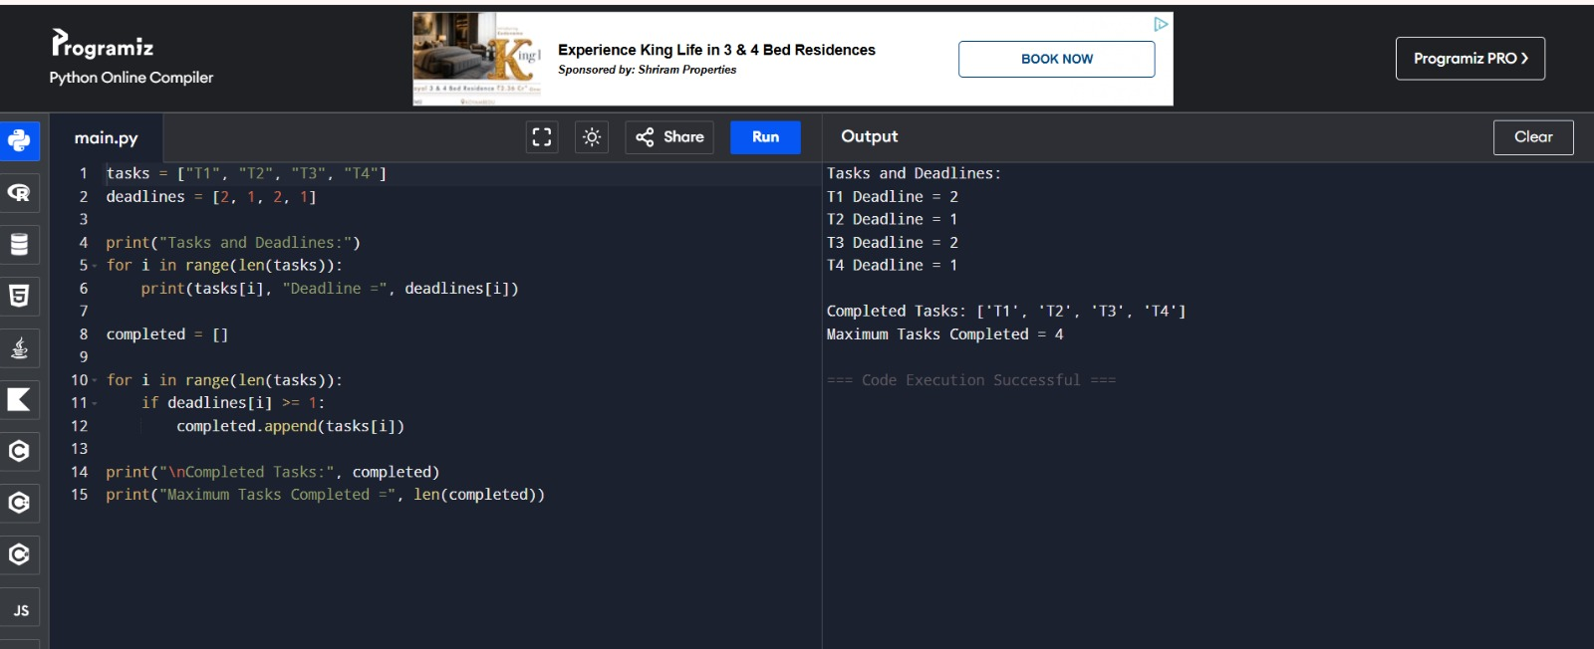

Working Explanation
Initially, all tasks are examined along with their deadlines.
The scheduling algorithm checks whether each task can be completed before its deadline.
Feasible tasks are included in the schedule.
The final schedule maximizes the number of completed tasks while satisfying constraints.

Complexity Analysis

Time Complexity
O(2ⁿ)
Backtracking may explore all possible task combinations.

Space Complexity
O(n)
Used for storing schedules and recursion states.

Advantages
- Produces feasible schedules.
- Maximizes completed tasks.
- Handles deadline constraints effectively.
- Can be improved using pruning techniques.

Applications
- Operating System Process Scheduling
- Manufacturing Systems
- Project Management
- Cloud Computing
- Job Scheduling
- Resource Allocation
- Industrial Automation

Analysis
Backtracking systematically explores possible schedules and guarantees that feasible solutions are examined. Pruning improves efficiency by eliminating schedules that violate deadlines. Although the problem is NP-Hard, these techniques provide practical solutions for moderate-sized scheduling problems.

Result
The Scheduling with Deadlines problem was successfully analyzed and solved. Tasks were scheduled according to their deadlines, maximizing the number of completed tasks. The study demonstrates how backtracking and pruning can be applied to solve NP-Hard scheduling problems efficiently.

