1. Problem Understanding & Context Analysis
Problem Statement
The brute-force pair sum code checks redundant pairs and increases computation time. Identify inefficiencies in the loop structure, explain why duplicate comparisons occur, debug the code to avoid redundant checks, optimize the algorithm while maintaining correctness, analyze complexity, and rewrite the improved version.
Understanding of the Problem
- The program finds two elements whose sum equals a target value.
- Input: Array arr and target value target.
- Output: Indices of the pair whose sum equals the target.
- Algorithm Concept: Brute-force pair search using nested loops.
- Issue occurs in the nested loop structure.
Root Cause Analysis
- The code compares every pair twice.
- Pairs such as (i,j) and (j,i) are both checked.
- The code also compares an element with itself when i == j.
Original Code
for i in range(len(arr)):
for j in range(len(arr)):
if arr[i] + arr[j] == target:
return (i, j)
Identified Errors
S.No | Error | Type of Error | Explanation
1 | j starts from 0 | Logical Error | Duplicate comparisons occur
2 | i == j allowed | Logical Error | Element compared with itself
3 | Redundant pair checking | Performance Error | Unnecessary operations increase execution time
Corrected Logic
- Start inner loop from i + 1.
- Avoid comparing an element with itself.
- Each pair is checked exactly once.
- Correctness is maintained because all unique pairs are examined.
2. Application of Concepts
Debugging Process
Step 1
Identify duplicate comparisons such as (0,1) and (1,0).
Step 2
Prevent self-comparison by avoiding i == j.
Step 3
Modify inner loop to begin at i + 1.
Optimization Applied
- Eliminated duplicate pair checks.
- Eliminated self-comparisons.
- Reduced unnecessary computations by nearly half.
Justification
- Every unique pair is still checked.
- No valid pair is missed.
- Algorithm becomes more efficient.
3. Solution Design & Approach
Corrected & Optimized Code
def pair_sum(arr, target):
for i in range(len(arr)):
for j in range(i + 1, len(arr)):
if arr[i] + arr[j] == target:
return (i, j)
return -1
Algorithm / Logic Flow
- Start the program.
- Read array and target value.
- Traverse array using outer loop.
- Start inner loop from i + 1.
- Check whether sum equals target.
- Return pair if found.
- Otherwise return -1.
- Stop.
4. Clarity, Justification & Presentation
Time Complexity Analysis
Case | Complexity
Best Case | O(1)
Average Case | O(n²)
Worst Case | O(n²)
Space Complexity
- O(1)
Output:
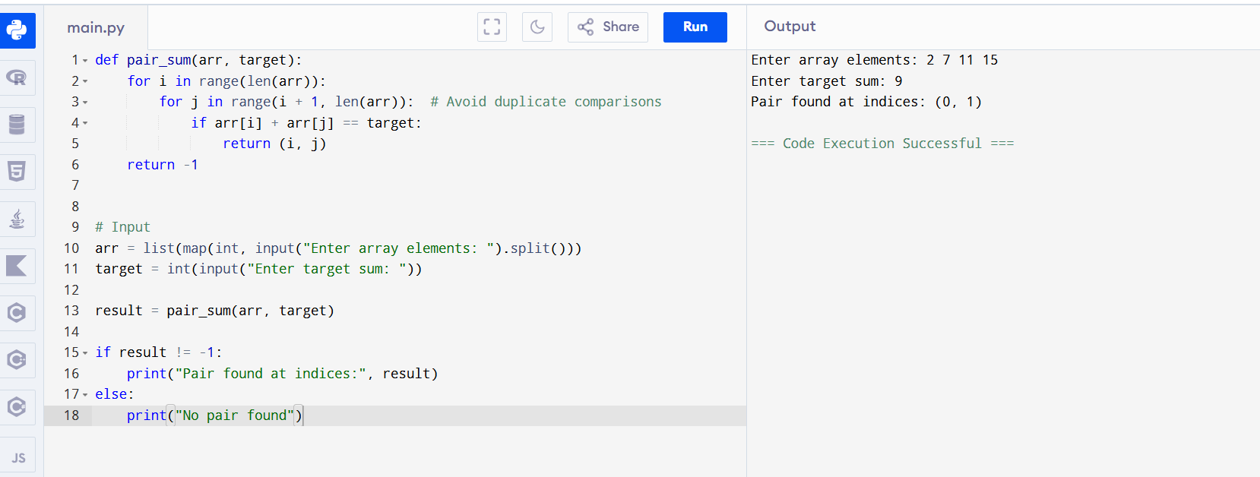
Final Conclusion
- Duplicate comparisons were removed.
- Self-comparisons were eliminated.
- The optimized algorithm performs fewer operations while maintaining correctness.
- The algorithm works correctly after debugging.
1. Problem Understanding & Context Analysis
Problem Statement
The Binary Search implementation fails when the search interval reduces to a single element because the loop condition is too restrictive. Debug the algorithm, handle all edge cases, optimize the implementation, analyze complexity, and rewrite the corrected version.
Understanding of the Problem
- The program searches for a key in a sorted array.
- Input: Sorted array and search key.
- Output: Index of the key or -1.
- Algorithm Concept: Binary Search.
- Error occurs in the loop condition.
Original Code
def binary_search(arr, key):
low, high = 0, len(arr)-1

while low < high:
mid = (low + high) // 2

if arr[mid] == key:
return mid

elif arr[mid] < key:
low = mid + 1

else:
high = mid - 1

return -1
Root Cause Analysis
- Loop condition uses low < high.
- When low == high, the last element is not checked.
- A valid key may remain unchecked.
- This causes incorrect output.
Identified Errors
S.No | Error | Type of Error | Explanation
1 | while low < high | Logical Error | Single-element interval ignored
2 | Last candidate not checked | Logical Error | Key may be missed
3 | Premature termination | Runtime Logic Error | Search ends early
Corrected Logic
- Replace low < high with low <= high.
- Continue search while at least one element remains.
- Ensure every valid interval is checked.
2. Application of Concepts
Debugging Process
Step 1
Analyze search interval updates.
Step 2
Identify failure when low == high.
Step 3
Modify loop condition to low <= high.
Optimization Applied
- Proper interval handling.
- Improved clarity.
- Correct edge-case management.
Justification
- Every candidate element is examined.
- Binary Search rules are followed correctly.
- No valid key is skipped.
3. Solution Design & Approach
Corrected & Optimized Code
def binary_search(arr, key):
low = 0
high = len(arr) - 1

while low <= high:

mid = (low + high) // 2

if arr[mid] == key:
return mid

elif arr[mid] < key:
low = mid + 1

else:
high = mid - 1

return -1
Algorithm / Logic Flow
- Start the program.
- Read sorted array and key.
- Initialize low and high.
- Compute middle element.
- Compare key with middle element.
- Update search range accordingly.
- Continue until low exceeds high.
- Return index if found, otherwise return -1.
- Stop.
4. Clarity, Justification & Presentation
Time Complexity Analysis
Case | Complexity
Best Case | O(1)
Average Case | O(log n)
Worst Case | O(log n)
Space Complexity
- O(1)
Output
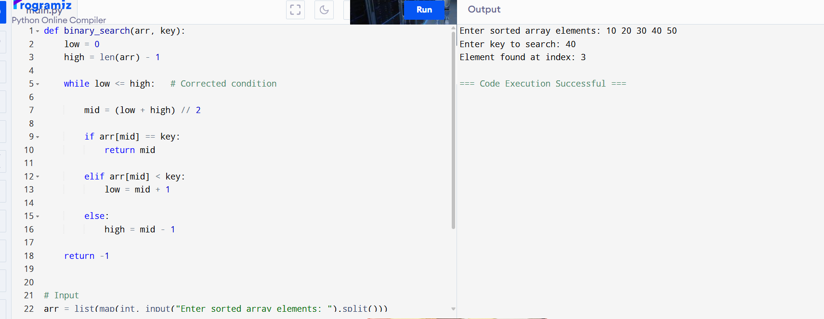Final Conclusion
- The incorrect loop condition was corrected.
- Single-element intervals are now handled properly.
- The search examines all necessary states.
- The algorithm works correctly after debugging and maintains O(log n) efficiency.

