Task 2: AI Chatbot
Smart Restock Alerts — Build Plan and Architecture
ADM Beallathon 2026

Purpose of this document
This document lays out the architecture and the phase-by-phase build plan for Task 2 — the customer-facing AI chatbot. It is written so that this component can be built independently and then handed off cleanly for integration into a React.js frontend and a Spring Boot backend, which are being built in parallel by a teammate.

Where this fits in the overall project
- Task 1 — MySQL database: Products, Suppliers & Lead Times, and Sales & Interest Log tables, seeded with sample data.
- Task 2 — this document: the AI chatbot service (prediction, recommendations, subscriptions, admin demand alert).
- Task 3 — Admin dashboard reading from the same MySQL tables (sales charts, low-stock warnings, demand forecasts).
- Task 4 — Live restock notification loop: admin updates stock, customer is notified automatically.

Architecture
The chatbot is built as an independent Python service exposing REST endpoints, so it can be called by Spring Boot (recommended) or directly by React. It is not a Streamlit app — Streamlit cannot be embedded into or called from a React and Spring Boot stack, since it renders its own standalone web pages rather than exposing callable endpoints. FastAPI is used instead so the service speaks plain JSON over HTTP, which any frontend or backend can consume.
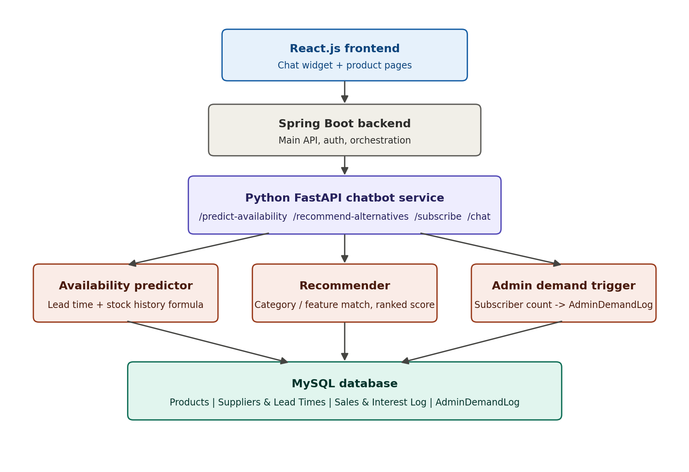

Note on Streamlit
Streamlit is useful only as a private, local tool for you to quickly test the prediction and recommendation logic yourself while developing. It should not be positioned as the chatbot your friend integrates — it cannot be embedded in React and Spring Boot has no way to call it. The integration point is always the FastAPI service described above.

Task 2 endpoints (the integration contract)
Endpoint | Purpose | Method
/predict-availability/{id} | Returns estimated restock window and confidence score | GET
/recommend-alternatives/{id} | Returns 2–3 in-stock alternative products with match scores | GET
/subscribe | Saves a customer's restock subscription and checks the admin demand threshold | POST
/chat | Main conversational entry point tying the above together | POST
/admin/demand-alerts | Read-only feed for the Task 3 dashboard | GET

Phase-by-phase build plan
Follow these phases in order. Each phase produces something testable on its own before moving to the next, so you always have a working checkpoint.
Phase 1: Lock the integration contract first
Before writing any code, agree with your friend on how the pieces will talk to each other: React calls Spring Boot, and Spring Boot calls your Python FastAPI chatbot service. Decide together on endpoint names and exact JSON request and response shapes now, because changing this later means both of you redo work.
Phase 2: Set up the Python project structure
Create a clean project with a virtual environment and a requirements.txt containing fastapi, uvicorn, mysql-connector-python, and scikit-learn. Organize folders as api/, db/, and models/, keeping the AI logic separate from the web layer from day one so it stays testable and easy to hand off.
Phase 3: Build the database layer
Write a single db.py module containing the MySQL connection and reusable query functions such as get_stock, get_supplier_leadtime, get_alternatives, and log_subscription. Seed the Products, Suppliers and Lead Times, and Sales and Interest Log tables with 10 to 15 realistic rows. Every other module in the project will import from this file.
Phase 4: Write the core logic as plain Python functions
Build predict_availability(product_id) and recommend_alternatives(product_id) as pure functions with no web framework involved yet. Test them directly with sample product IDs until the outputs look correct. This is the actual intelligence of the system, so get it right in isolation before exposing it through an API.
Phase 5: Wrap the logic in a REST API
Use FastAPI to expose endpoints: GET /predict-availability/{product_id}, GET /recommend-alternatives/{product_id}, POST /subscribe, and POST /chat. Each endpoint should return clean, predictable JSON. This API is the actual deliverable that your friend will integrate with.
Phase 6: Add the admin demand trigger
Inside the /subscribe endpoint, after saving a new subscription, count how many customers have subscribed to that product and update an AdminDemandLog row if the count crosses your chosen threshold. Expose a separate GET /admin/demand-alerts endpoint so the Task 3 dashboard can read this independently.
Phase 7: Document and test every endpoint yourself
FastAPI automatically generates interactive Swagger documentation at the /docs route. Use it to test each endpoint with sample data before your friend touches anything. Also test with Postman or curl to confirm the JSON matches exactly what a frontend developer would expect, with correct field names, correct types, and no unexpected null values.
Phase 8: Package the handoff
Enable CORS in FastAPI so React and Spring Boot can call the service from a different port. Give your friend the run command (uvicorn main:app --reload), a .env.example file for database credentials, a short README listing every endpoint with a sample request and response, and ideally an exported Postman collection. This turns your code into something he can plug in directly, without needing to ask you questions.

Tech stack summary
Layer | Choice
API framework | FastAPI + uvicorn
Database access | mysql-connector-python
Similarity / matching | scikit-learn (cosine similarity) or plain MySQL queries
Personal testing UI (optional) | Streamlit — not for integration, local use only
Integration target | Spring Boot (calls this API) and React.js (chat UI)

