**Human-Computer Interaction through Hand Gesture Recognition and Voice Commands**

***Abstract*—** This exploration delves into the fusion of voice commands and hand gestures for system control in human-computer interaction (HCI). Leveraging advancements in speech recognition, voice command technology provides an intuitive communication channel with computing devices. Simultaneously, hand gestures offer a natural, non-intrusive alternative, precious in contexts where traditional input methods are cumbersome. The design, implementation, and evaluation of an integrated HCI system harmonizing voice and gesture-based interactions are investigated. Users can seamlessly execute tasks like volume adjustment, window manipulation, navigation, selection, and system operations through both natural language commands and predefined hand gestures. Rigorous user testing, feedback analysis, and usability assessments evaluate the combined system's effectiveness, accuracy, and user satisfaction. Additionally, this explores the potential applications of this integrated HCI approach in diverse domains such as gaming, healthcare, education, and smart home automation. This exploration contributes valuable insights to HCI, facilitating intuitive and accessible interaction modalities, thereby bridging the gap between users and technology and opening avenues for innovative human-centric computing solutions.

***Keywords*:-** Voice command, Hand gestures, System control, Human-computer interaction (HCI), Speech recognition, Natural language commads, Gesture-based interactions.

1. ***Introduction***

Human-computer interaction (HCI) has evolved significantly, offering various modalities for users to interact with digital systems. Among these modalities, voice command and hand gesture recognition stand out as intuitive and efficient methods of communication between humans and computers.

Voice-commanded HCI leverages natural language processing (NLP) technologies to interpret spoken language, allowing users to control devices, navigate interfaces, and execute commands through verbal instructions. This modality enhances accessibility and hands-free operation, making it particularly useful in contexts where manual input is impractical or challenging.

On the other hand, HCI by hand gesture recognition utilizes computer vision and machine learning techniques to interpret hand and finger movements as input. This approach offers a natural and tactile interaction, allowing users to manipulate virtual objects, navigate interfaces, and perform actions without physical touch or traditional input devices.

Both voice command and hand gesture recognition technologies contribute to a more intuitive and user-friendly computing experience. They find applications in diverse fields such as gaming, virtual reality, healthcare interfaces, smart home devices, and accessibility tools for individuals with disabilities.

While voice-commanded HCI excels in hands-free operation and natural language understanding, hand gesture recognition HCI provides a tactile and gesture-based interaction that complements traditional input methods. Challenges such as accuracy, privacy concerns, and integration with existing systems continue to drive research and development in these areas, aiming to enhance user experience and expand the capabilities of human-computer interaction.

**Applications of Voice Command HCI:**

* Smart Homes: Voice-controlled devices like smart speakers, thermostats, and lighting systems allow users to manage their home environments effortlessly.
* Healthcare: Voice interfaces are used in healthcare for dictation of medical records, patient monitoring, and voice-controlled medical devices, improving efficiency and accessibility for healthcare professionals and patients.
* Automotive Industry: Voice commands in cars enable hands-free control of entertainment systems, navigation, and communication, enhancing driver safety and convenience.
* Education: Voice-controlled educational tools and language learning apps provide interactive and engaging learning experiences for students of all ages.

**Applications of Hand Gesture Recognition HCI:**

* Gaming and Entertainment: Gesture-based gaming consoles and VR/AR systems offer immersive gaming experiences where users can control gameplay and interact with virtual environments using natural hand movements.
* Industrial Automation: Gesture-controlled interfaces in industrial settings improve worker safety and efficiency by enabling hands-free control of machinery, equipment, and robotic systems.
* Art and Design: Artists and designers use gesture recognition technology for digital sketching, sculpting, and 3D modeling, leveraging intuitive gestures for creative expression.

**Voice Command HCI Advantages:**

Voice-commanded HCI offers several advantages that contribute to its widespread adoption and usability across various domains:

* **Accessibility:** Voice commands enhance accessibility for individuals with physical disabilities or impairments that affect traditional input methods. It provides a hands-free interaction option, allowing users to control devices and access digital content more independently.
* **Efficiency:** Users can perform tasks more efficiently using voice commands, especially in scenarios where manual input or navigation through interfaces is time-consuming or impractical. For example, voice-controlled virtual assistants streamline information retrieval and task execution.
* **Multitasking:** Voice command enables multitasking by allowing users to interact with digital systems while performing other activities. This feature is particularly beneficial in contexts such as cooking, driving, or exercising, where hands-free operation is crucial.
* **Natural Language Understanding:** Advances in natural language processing (NLP) technologies improve the accuracy and comprehension of voice commands, leading to more intuitive interactions and reducing the need for complex command syntax.

**Hand Gesture Recognition HCI Advantages:**

Hand gesture recognition HCI offers unique advantages that enhance user experience and interaction with digital interfaces:

* **Immersive Interaction:** Gesture-based interaction provides a more immersive experience, especially in gaming, virtual reality (VR), and augmented reality (AR) applications. Users can manipulate virtual objects and navigate environments using intuitive hand movements.
* **Spatial Awareness:** Hand gesture recognition systems promote spatial awareness and intuitive control over digital content. This is beneficial in design applications, where precise gestures translate into specific actions like zooming, rotating, or manipulating objects.
* **Non-verbal Communication**: Gestures convey non-verbal cues and expressions, adding a layer of communication beyond verbal commands. This aspect is valuable in social interactions, collaborative environments, and expressive interfaces.
* **Gesture Customization:** Users can customize gesture-based interactions to suit their preferences and workflows, enhancing personalization and user engagement with digital systems.

**Future Directions and Challenges:**

As voice command and hand gesture recognition HCI continue to evolve, several challenges and opportunities shape their future development:

* **Hybrid Modalities**: Integrating voice commands and hand gestures into hybrid modalities offers a more comprehensive and adaptable HCI approach. This fusion combines the strengths of both modalities while addressing their respective limitations.
* **Privacy and Security:** Ensuring user privacy and data security remains a critical concern, especially in voice command HCI where sensitive information may be involved. Robust authentication mechanisms and data encryption are essential for maintaining user trust.
* **Robustness and Accuracy:** Improving the robustness and accuracy of gesture recognition systems, particularly in diverse environmental conditions and user contexts, is an ongoing research focus. Machine learning algorithms and sensor technologies play a crucial role in enhancing gesture recognition performance.
* **User Feedback and Adaptation:** Implementing feedback mechanisms and adaptive interfaces based on user gestures and voice commands enhances user experience and system responsiveness. Continuous user feedback loops contribute to HCI systems' adaptability and user satisfaction.

1. ***Literature survey***

Zahra, R., Shehzadi, A., Sharif, M. I., Karim, A., Azam, S., De Boer, F., Jonkman, M., & Mehmood, M. (Year). “Camera-based interactive wall display using hand gesture recognition”. [1] The paper focuses on improving hand gesture recognition for a more natural human-computer interaction experience. Previous methods involving external devices like gloves and LEDs have been used, but they make interaction less natural. The proposed system aims to use bare hand gestures. The system consists of three modules: one for gesture recognition using Genetic Algorithm and Otsu thresholding, another for controlling functions outside of PowerPoint files or Word documents, and the third for finger counting using the convexity hull method. The system aims to provide efficient processing speed for gesture recognition, making it more effective and reliable.

Sánchez-Nielsen, E.,., Antón-Canalís, L., & Hernández-Tejera, M. (2004). “Hand gesture recognition for human-machine interaction”.[2] The authors aim to propose a real-time vision system for hand gesture recognition, using general-purpose hardware and low-cost sensors, for visual interaction environments. They present an overview of the proposed system, which consists of two major modules: hand posture location and hand posture recognition. The process includes initialization, acquisition, segmentation, pattern recognition, and action execution. For Hand Posture Detection, The authors discuss techniques for detecting hand postures, including skin color features, color smoothing, grouping skin-tone pixels, edge map extraction, and blob analysis. The advantages are Adaptability and Low-Cost Implementation. Disadvantages are User-specific Visual Memory and processing Speed. The system achieves a high accuracy of 90% in recognizing hand postures. However, this accuracy may vary depending on factors such as lighting conditions, background complexity, and user-specific variations.

Alnuaim, A., & Zakariah, M. (2022). Human-Computer Interaction with Hand Gesture Recognition Using ResNet and MobileNet. Computational Intelligence and Neuroscience, 2022.[3] Sign language is the native language of deaf people, used for communication. There is no standardization across different sign languages, such as American, British, Chinese, and Arab sign languages. The study proposes a framework consisting of two CNN models trained on the ArSL2018 dataset to classify Arabic sign language. The models are individually trained and their final predictions are ensembled for better results

The proposed framework achieves high F1 scores for all 32 classes, indicating good classification performance on the test set.

Badi, H. (2016). Recent methods in vision-based hand gesture recognition. International Journal of Data Science and Analysis [4]. Two feature extraction methods, hand contour and complex moments, were explored for hand gesture recognition, with complex moments showing better performance in terms of accuracy and recognition rate. Hand contour-based neural networks have faster training speeds compared to complex moments-based neural networks. Complex moments-based neural networks are more accurate than hand contour-based neural networks, with a higher recognition rate.

The complex moments algorithm is, however, used to describe the hand gesture and treat the rotation problem in addition to the scaling and translation. The back-propagation learning algorithm is employed in the multi-layer neural network classifier.

Xu, J., & Wang, H. (2022). Robust Hand Gesture Recognition Based on RGB-D Data for Natural Human-Computer Interaction. Journal Name (italicized), Volume(italicized).[5]

The paper presents a robust RGB-D data-based recognition method for static and dynamic hand gestures.

For static hand gesture recognition, the paper proposes a method that involves hand gesture contour extraction, identification of palm center using the Distance Transform (DT) algorithm, and localization of fingertips using the K-Curvature-Convex Defects Detection algorithm (K-CCD).

The distances of the pixels on the hand gesture contour to the palm center and the angle between the fingertips are considered as auxiliary features for recognition.

For dynamic hand gesture recognition, the paper combines the Euclidean distance between hand joints and the shoulder center joint with the modulus ratios of skeleton features to generate a unifying feature descriptor.

Shi, Y., Li, Y., Fu, X., Miao, K., & Miao, Q. (2021). Review of dynamic gesture recognition. Virtual Reality & Intelligent Hardware.[6]. The paper provides a detailed survey of the latest developments in gesture recognition technology for videos based on deep learning.

It categorizes the reviewed methods into three groups based on the type of neural networks used for recognition

Two stream convolutional neural networks, 3D convolutional neural networks, and Long-short Term Memory (LSTM) networks .

The advantages and limitations of existing technologies are discussed, with a focus on the feature extraction method of the spatiotemporal structure information in a video sequence.

Fahad, M., Akbar, A., Fathima, S., & Bari, M. A. (2023). Windows-Based AI-Voice Assistant System using GTTS. Mathematical Statistician and Engineering Applications.[7] Virtual assistants have diverse applications in healthcare, finance, education, and more.

Concerns about privacy, security, bias, and discrimination in virtual assistants.

Virtual assistants use advanced technologies like NLP, ML, and data analytics.

Studies show virtual assistants can assist in studies, healthcare, and personal finance.

Python is highlighted for automating desktop tasks efficiently

Text-to-Speech (TTS): Utilize GTTS to convert the assistant's responses from text to speech. You can generate audio files or stream the audio directly

NLU (Optional): If you want your assistant to understand natural language commands, you can integrate a natural language understanding (NLU) tool like Dialogflow, Wit.ai, or Rasa.

Assistant Logic: Implement the core logic of your assistant, including understanding user commands, executing tasks, and generating appropriate responses.

Biradar, S., Bramhapurkar, P., Choudhari, R., Patil, S., & Kulkarni, d. personal virtual voice desktop assistant and intelligent decision maker.[8] The paper is Natural Language Processing: VDAs rely on Natural Language Processing (NLP) technology to understand and respond to user requests. Research in this area has focused on improving the accuracy and effectiveness of NLP algorithms, as well as exploring the use of NLP in combination with other technologies, such as machine learning and deep learning.

Machine Learning: Machine learning algorithms play a critical role in the functionality of VDAs. Research in this area has explored the use of machine learning to improve the accuracy and relevance of VDA responses, as well as the use of machine learning to personalize the VDA experience for individual users.

Integration with Other Technologies: VDAs can be integrated with other technologies, such as voice assistants and wearable devices, to provide a more comprehensive and integrated user experience. Research in this area has explored the potential benefits and challenges of integrating VDAs with other technologies.

Mahesh, T. R. (2023). Personal AI Desktop Assistant. International Journal of Information Technology, Research and Applications.[9] The paper "On the Track of Artificial Intelligence: Learning with Intelligent Personal Assistants" by Nil Goksel and Mehmet Emin Mutlu explores how intelligent personal assistants (IPAs) can revolutionize the way we learn and interact with information. Moustafa Elshafei believes that Virtual Personal Assistants (VPAs) represent the next step in mobile and smart user network services. VPAs are designed to provide a wide range of information in response to user requests, making it easier for users to manage their tasks and appointments, as well as control phone calls using voice commands. Conducted research on speech analysis, which involves a pattern recognition technique for determining whether the voice input is voiced speech, unvoiced, or silent based on signal dimensions. However, the system has limitations, such as the need for the algorithm to be trained on the specific set of dimensions selected and for the recording conditions to be consistent.

Kumar, S., Mohanty, A., Varshney, M., & Kumar, A. Smart IoT Based Healthcare Sector.[10] Focuses on voice assistants like Alexa, Cortana, Google Assistant, and Siri.

Discusses challenges and limitations of voice assistants

Outlines the development of a voice-based assistant without cloud services.

choose a Platform/Language: Decide on the platform you want your voice assistant to run on (e.g., Windows, macOS, Linux) and the programming language you'll use (e.g., Python, JavaScript).

Speech Recognition: Integrate a speech recognition system to convert spoken words into text. There are APIs available for this purpose, such as Google's Speech Recognition API or libraries like SpeechRecognition for Python.

Natural Language Understanding (NLU): After converting speech to text, the next step is to understand the user's intent. NLU tools like Dialogflow, Wit.ai, or Rasa can help extract meaning from user inputs.

1. ***Methodology***

**Hand Gestures Recognition**

1. **Data Collection**: The data is created which consists of different types of hand gestures that are created by customized ones.
2. **Hand Image:** Hand input images play a crucial role in enabling natural and intuitive interactions between users and digital devices, enhancing the usability and accessibility of various HCI applications. It is a series of images capturing the movements, poses, or gestures of a human hand. In the context of Human-Computer Interaction (HCI), hand-input images are used as a means of input for controlling and interacting with digital devices or interfaces. We created Static Hand input images. Static hand input images capture the hand in a particular pose or position.

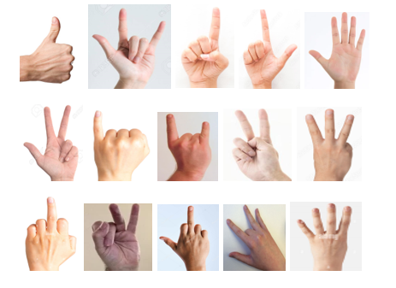

**Fig 1: Hand Gesture Dataset**

1. **Hand Detection:** Hand detection involves identifying and locating the presence of human hands within an image or video frame. This detection serves as the precursor to further analysis, such as recognizing specific gestures or actions performed by the hands. The goal of hand detection is to accurately identify the regions of an image or video that contain human hands, typically represented by bounding boxes or keypoints, enabling subsequent analysis such as gesture recognition or hand tracking.

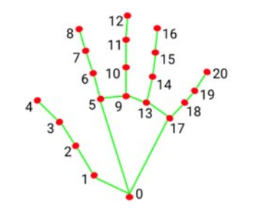

**Fig 2: Hand Detection**

1. **Pre-Processing:** Preprocessing in hand gesture recognition involves several steps to enhance the quality of input data before feeding it into a machine learning model.

* **Image Acquisition:** Hand gestures are typically captured using cameras or depth sensors. Ensuring good lighting conditions and camera settings can improve the quality of the input images.
* **Image Cropping:** The captured image may contain irrelevant background information. Cropping the image to focus only on the region of interest (ROI) containing the hand can reduce unnecessary information and speed up processing.
* **Noise Reduction:** Image noise can degrade the performance of hand gesture recognition algorithms. Techniques like Gaussian blurring or median filtering can help reduce noise while preserving important features.

1. **Feature Extraction:** Here, we used a “Hand Tracking Module” that serves as a modular and reusable component that encapsulates the functionality required for detecting, tracking, and analyzing hand movements and gestures in various applications such as human-computer interaction, virtual reality, and augmented reality. This module likely captures video frames from the webcam using OpenCV (cv2 library).

* **Hand Detection:** The module likely contains algorithms for detecting hands in images or video frames. This may involve techniques like color segmentation, contour detection, or machine learning-based object detection to identify regions of interest corresponding to hands.
* **Hand Landmark Detection:** Once hands are detected, the module may include algorithms for detecting and localizing landmarks or keypoints on the detected hands. These landmarks typically correspond to specific points on the hand, such as fingertips, knuckles, and palm points.
* **Finger Tracking:** The module may track the movement and configuration of fingers based on the detected landmarks. This involves analyzing the spatial relationships between landmarks to determine finger positions and orientations.

1. **Recognition:** The system recognizes specific gestures or actions based on finger counting results and possibly other hand gestures by using the convex hull method. Gestures such as thumbs up, pointing, or making a closed fist may trigger different actions or commands.

* **Rule-based Classification:** Simple rule-based algorithms are used to classify gestures based on the configuration of detected landmarks (finger keypoints). For example, detecting the number of extended fingers and their relative positions to recognize gestures like thumbs up or index finger pointing.
* **Template Matching:** Template matching algorithms may be used to compare the current hand configuration with predefined templates of gestures to recognize specific gestures accurately.

1. **Gesture Dictionary:** A gesture dictionary, also referred to as a gesture library, is a collection of reference gestures that the system can recognize. Each gesture in the dictionary is associated with a specific meaning or command.

The dictionary stores representations of various hand gestures. Depending on the chosen feature extraction techniques, these representations can be in different forms.

* **Geometric data:** This might include the locations of fingertips, palm center, and angles between fingers.
* **Image templates:** The dictionary might store pre-defined hand image templates representing specific gestures.
* **Feature descriptors:** In more advanced systems, the dictionary might store feature descriptors extracted from hand images using techniques like keypoint detection and description.
* **Association with Commands:** Each gesture in the dictionary is linked to a specific command or action. This allows the system to translate a recognized gesture into a meaningful output. For instance, a raised index finger gesture might be mapped to a "click" command in a virtual environment.

1. **Command:** The system executes the command associated with the recognized gesture. This may involve sending a signal to a device, performing an action on a computer, or controlling a robot.

**System Commands:**

* Volume Control
* Power Management
* Window Management
* Application Commands
* Other Commands

These commands are executed based on the specific hand gestures detected by the program. The code defines a mapping between finger combinations and corresponding commands. By using hand gestures as an interface, the code allows for a hands-free way to control the system and applications.

1. **Execution:** Once a gesture is recognized, the system translates the recognized gesture into a corresponding command.

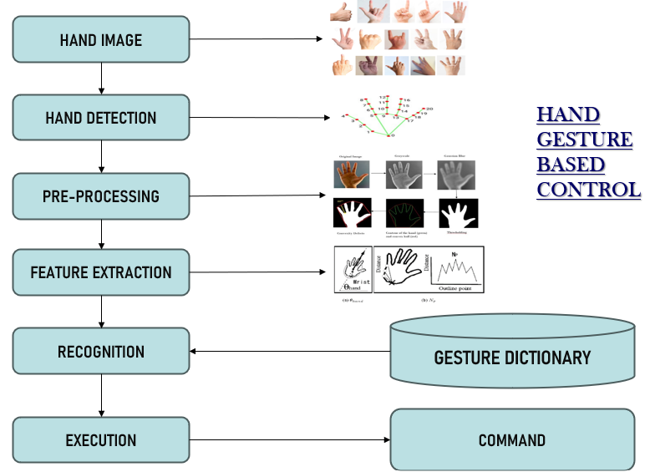

**Fig 3: Hand Gesture Flow Chart**

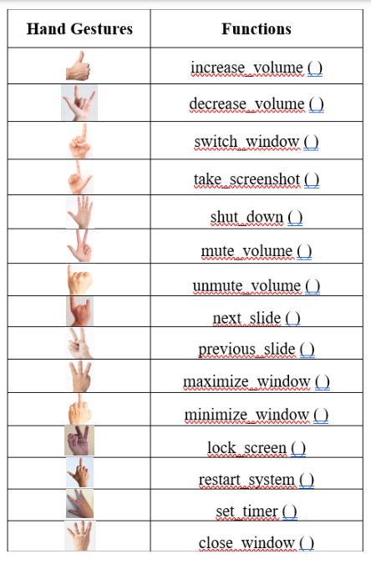

**Fig 4: Hand Gestures and its Functions**

**Voice Commands Recognition**

1. **Input Voice Command:** An input voice command is a spoken instruction you give to a voice control system. It's essentially how you tell the system what you want it to do, but instead of typing on a keyboard, you use your voice. This is the actual phrase or sentence you speak into the microphone. It should be clear and concise for the voice recognition system to understand accurately. The core part of the voice command that specifies the action you want the system to perform. Examples include "open YouTube," "increase volume," or "send a message."An input voice command is a natural language way to interact with a system, providing a hands-free and potentially more convenient alternative to traditional keyboard or mouse input.

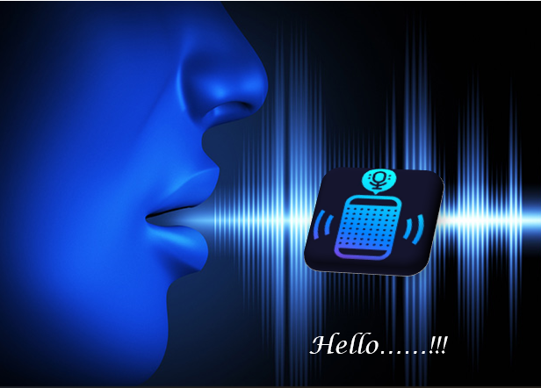

1. **Conversion of Voice into Text using Speech Recognition Module:** After the user speaks the s, the voice control system uses a speech recognition module to convert the spoken audio into text. This module analyzes the sound waves from the microphone and tries to match them to patterns corresponding to words and phrases in its database.

* **Capturing Audio:** The process begins with capturing audio input from a microphone connected to the computer.
* **Preprocessing:** Before processing the audio, some preprocessing steps might be applied, such as adjusting for ambient noise. This ensures that the speech recognition system can better distinguish the user's voice from background noise.
* **Recognition:** Once the audio is captured and preprocessed, it is fed into the speech recognition system provided by the speech_recognition module. The module utilizes various algorithms and techniques, including Hidden Markov Models (HMMs), Deep Neural Networks (DNNs), or Connectionist Temporal Classification (CTC), depending on the specific implementation and configuration. These algorithms analyze the audio waveform and attempt to identify patterns corresponding to spoken words or phrases.
* **Decoding:** The recognized audio is decoded into a sequence of phonemes or words based on the analysis performed by the recognition algorithms. This decoding process involves comparing the audio features extracted from the input waveform with the features of known speech patterns stored in the system's language model.
* **Output:** Finally, the recognized speech is output as text, typically in the form of a string. This text representation can then be further processed or used for various purposes, such as executing commands in a voice-controlled system, generating captions for audio content, transcribing spoken dialogues, etc.

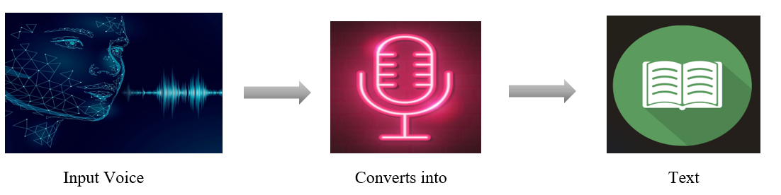

1. **Understanding the command given by the User:**

Once the speech recognition module converts the voice to text, the system tries to understand the meaning of the command. This may involve tasks like identifying the keywords in the sentence and understanding the overall intent of the user.

* **Natural Language Processing (NLP):** The system leverages NLP techniques to analyze the spoken command and extract its meaning.

This involves tasks like :

* **Part-of-Speech Tagging:** Identifying the grammatical role of each word (e.g., noun, verb, adjective) to understand the sentence structure.
* **Intent Recognition:** Determining the overall goal or action the user wants the system to perform (e.g., "open YouTube" implies the intent to access a video platform).
* **Understanding Context:**The system might consider the context of the conversation or user's previous interactions to better understand the command.

For example, if the user previously said "play music," a subsequent command like "play next" would likely refer to playing the next song in the music playlist.

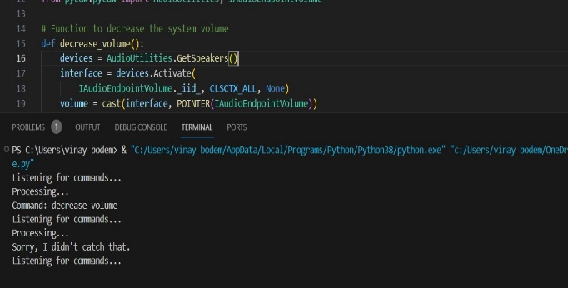

1. **Processing the command:** After understanding the command, the system needs to process it and determine the appropriate action to take. This might involve breaking down the command into smaller steps or fetching information from external sources.

* **Command Matching and Breakdown:**
* The system maintains a database of supported commands and their corresponding actions. When it receives a user command (like "open YouTube"), it searches this database for a match.
* If the command is simple and well-defined (e.g., "increase volume"), the system can directly proceed to the execution stage.
* **Argument Extraction:**
* Some commands require additional information to perform the desired action accurately. These are called arguments. For instance, opening a specific website requires the URL as an argument.
* The system might employ NLP techniques to extract these arguments from the user's spoken command. It could involve identifying named entities (e.g., URLs in the case of web searches) or using context to understand the intended argument.
* **Function Execution:**
* Once the system understands the command and any necessary arguments, it translates that knowledge into concrete actions. This is where pre-written functions come into play.
* The system's codebase likely contains a collection of functions, each designed to perform a specific task. These functions could be responsible for controlling system settings (like volume), opening applications, interacting with websites, or controlling media playback.
* Based on the parsed command and arguments, the system triggers the appropriate function(s) to carry out the user's request.
* **System Interaction:**
* The functions executed in the previous step interact with various components to fulfill the user's command. This interaction might involve:
* Accessing the operating system (OS) to adjust settings (e.g., volume control) or launch applications.
* Interacting with external APIs or services (e.g., opening a website requires communication with a web browser).
* Controlling software programs (e.g., media players for music playback).

1. **Checking in the Commands and Functions:**

The system checks its database of commands and functions to see if it can find a match for the user's command. This database likely contains a list of all supported commands and the corresponding functions that the system should execute to perform those commands. By maintaining a well-defined command database and efficiently matching user commands with their corresponding functionalities, the system ensures it can accurately interpret user intent and execute the desired actions.

1. **Executing the command:** If the system finds a match for the user's command in its database, it executes the corresponding function. These functions are essentially a set of pre-written instructions that tell the system how to perform specific actions.

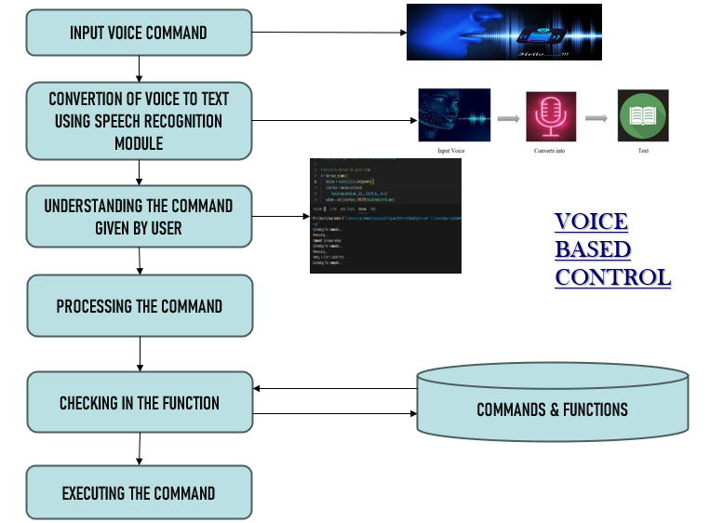

**Fig 5: Voice Commands Recognition Flow Chart**

1. ***Results***

The results of the exploration into the fusion of voice commands and hand gestures for system control in human-computer interaction (HCI) reveal promising advancements in intuitive communication channels with computing devices.

**Hand Gesture Outcomes:**

Users were able to interact with digital systems using natural hand movements, enabling tasks such as navigation, selection, and control of applications and devices. The system's effectiveness was evident in its ability to accurately detect and classify a variety of hand gestures, including complex movements and poses.

**Voice Commands Outcomes:**

Users were able to interact with computing devices and applications effortlessly, issuing commands for tasks such as volume adjustment, application control, and system navigation. The system's effectiveness was evident in its ability to accurately interpret a wide range of spoken instructions, even amidst variations in accent, tone, and speech speed.

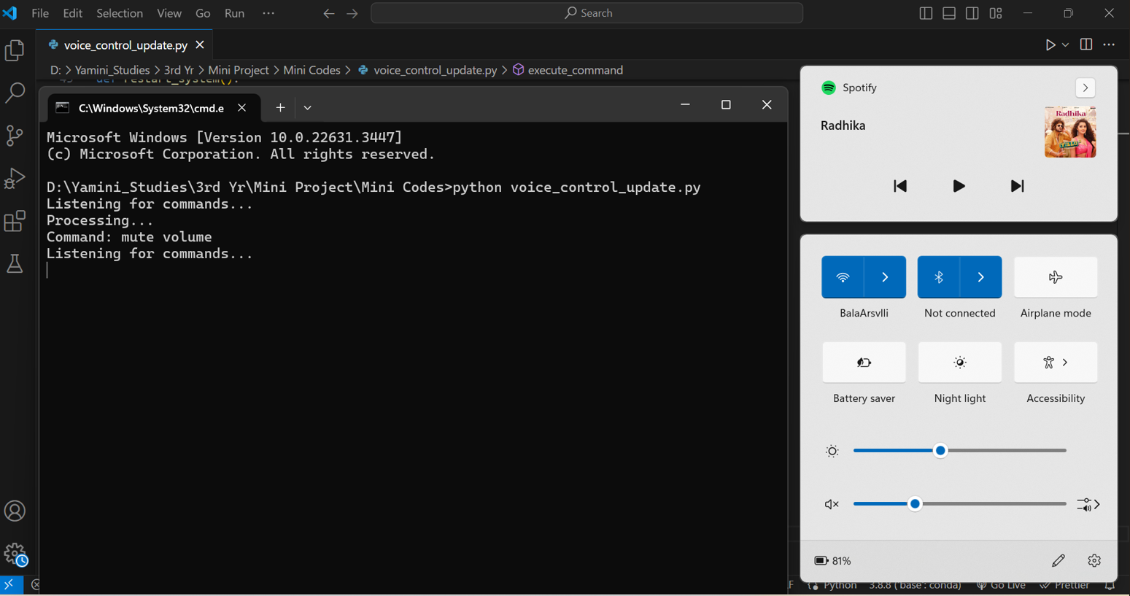

**Fig 7: Voice Command for Mute Volume**

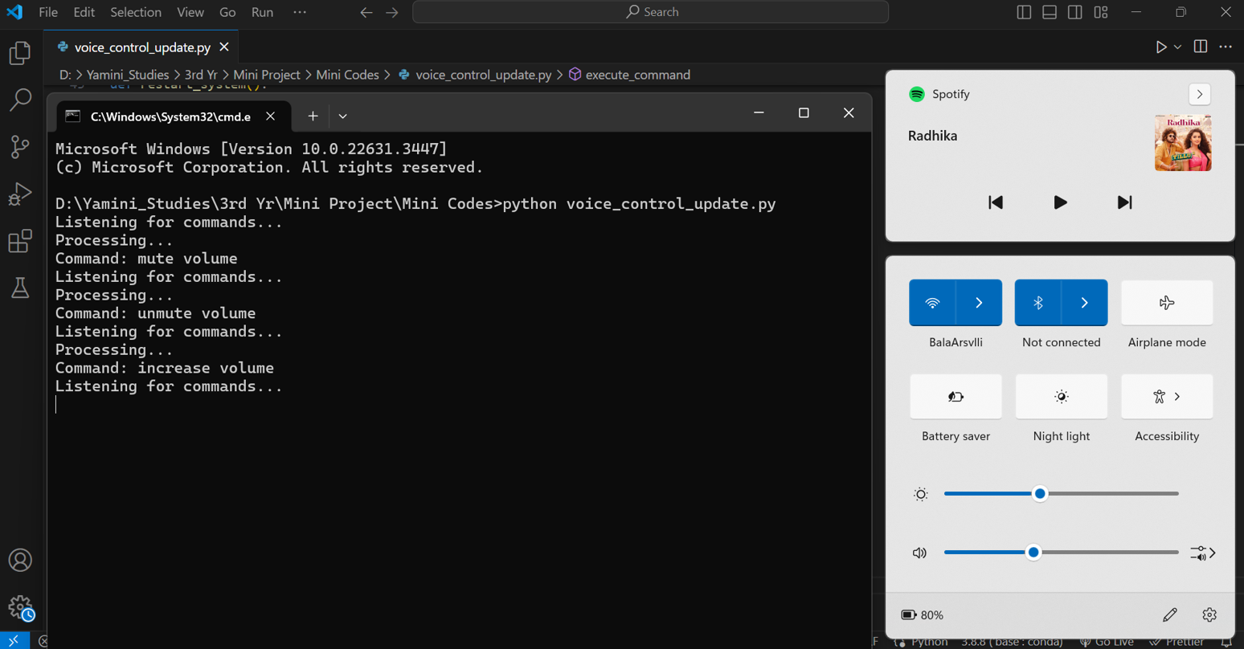

**Fig 8: Voice Command For Increase Volume**

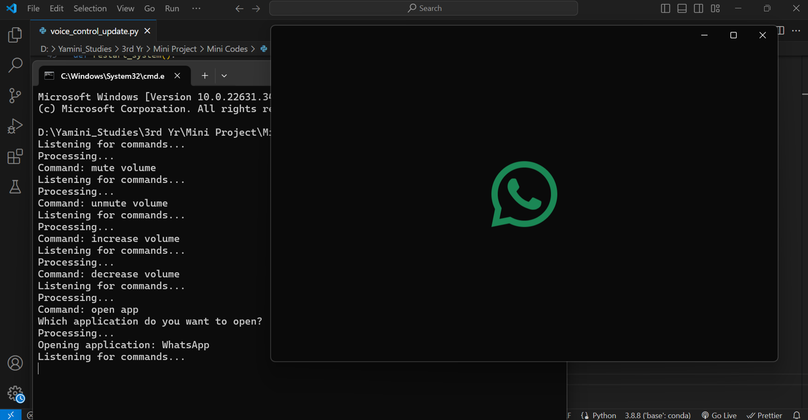

**Fig 9: Voice Command For Open APP**

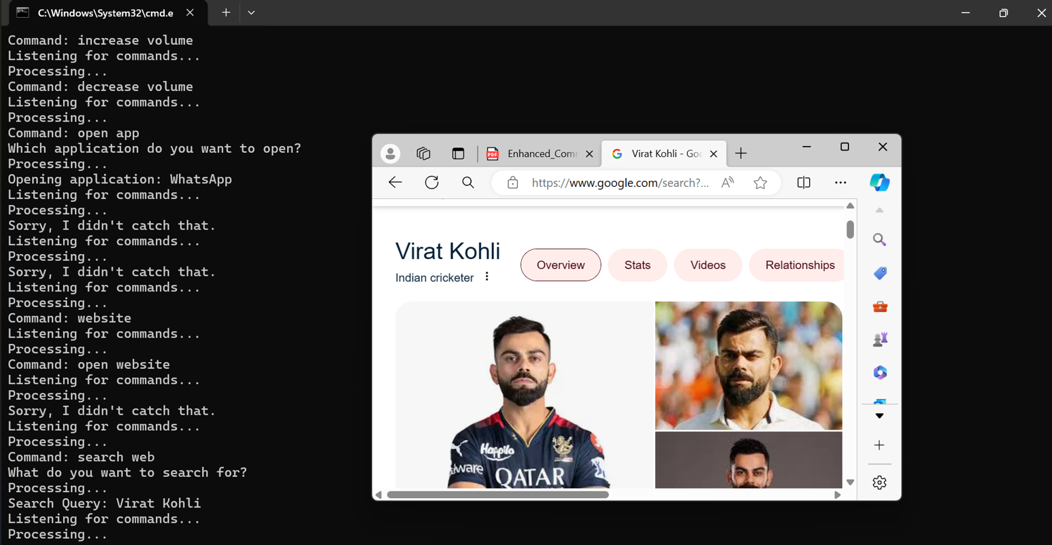

**Fig 10: Voice Command For Search Web**

1. ***Conclusion and Future Scope***

In conclusion, the integration of voice commands and hand gestures for system control in human-computer interaction (HCI) represents a significant advancement in intuitive communication channels with computing devices. This exploration has demonstrated the potential of leveraging speech recognition and gesture recognition technologies to create a seamless and natural interaction experience for users across various domains.

By harmonizing voice and gesture-based interactions, users can execute tasks such as volume adjustment, window manipulation, navigation, selection, and system operations with ease and efficiency. The rigorous evaluation of an integrated HCI system has highlighted its effectiveness, and user satisfaction, paving the way for innovative human-centric computing solutions.

Moreover, the potential applications of this integrated HCI approach are diverse, ranging from gaming and healthcare to education and smart home automation. Voice-commanded HCI offers hands-free operation and natural language understanding, while hand gesture recognition HCI provides tactile and gesture-based interaction, complementing traditional input methods.

Despite challenges such as accuracy, privacy concerns, and integration complexities, ongoing research and development efforts continue to enhance user experience and expand the capabilities of human-computer interaction. By bridging the gap between users and technology, this exploration contributes valuable insights to HCI, fostering intuitive and accessible interaction modalities and opening avenues for future innovation.

In the future, the integration of voice commands and hand gestures for human-computer interaction (HCI) holds immense potential for revolutionizing how users interact with technology. This approach offers a seamless and intuitive way to control devices and execute commands, enhancing user experience across various domains. This advancement enables seamless and intuitive communication with computing devices across various domains, including gaming, healthcare, education, and smart home automation.

By offering hands-free operation, natural language understanding, and tactile interaction, this approach enhances user experience and accessibility. Despite existing challenges, ongoing research and development efforts aim to further improve accuracy, privacy, and integration, paving the way for innovative HCI solutions that bridge the gap between users and technology.

As a result, the future scope for this integrated HCI approach is promising, with potential for continued advancements and widespread adoption in diverse fields.

1. ***References***
2. Zahra, R., Shehzadi, A., Sharif, M. I., Karim, A., Azam, S., De Boer, F., Jonkman, M., & Mehmood, M. (Year). “Camera-based interactive wall display using hand gesture recognition”.
3. Sánchez-Nielsen, E., Antón-Canalís, L., & Hernández-Tejera, M. (2004). “Hand gesture recognition for human-machine interaction”.
4. Siby, J. E. R. A. L. D., Kader, H. I. L. W. A., & Jose, J. I. N. S. H. A. (2015). “Hand gesture recognition. IJITR) International Journal of Innovative Technology and Research”, Volume, (3), 7-11.
5. Panwar, M., & Mehra, P. S. (2011, November). “Hand gesture recognition for human computer interaction”. In 2011 International Conference on Image Information Processing (pp. 1-7). IEEE.
6. Patel, Sunny, Ujjayan Dhar, Suraj Gangwani, Rohit Lad, and Pallavi Ahire. "Hand-gesture recognition for automated speech generation." In 2016 IEEE International Conference on Recent Trends in Electronics, Information & Communication Technology (RTEICT).
7. Badi, H. (2016). Recent methods in vision-based hand gesture recognition. International Journal of Data Science and Analysis.
8. Fahad, M., Akbar, A., Fathima, S., & Bari, M. A. (2023). “Windows Based AI-Voice Assistant System using GTTS”. Mathematical Statistician and Engineering Applications.
9. Bhargav, K. M., Bhat, A., Sen, S., Reddy, A. V. K., & Ashrith, S. D. (2022, September). Voice-Based Intelligent Virtual Assistant for Windows. In International Conference on Innovations in Computer Science and Engineering.
10. voice-based intelligent virtual assistant for Windows usin python *Rose Thomas, *Surya V S, *Tincy A Mathew, **Tinu Thomas International Journal of Engineering Research & Technology (IJERT)
11. Chinchane, A., Bhushan, A., Helonde, A., & Bidua, K. SARA: A Voice Assistant Using Python. International Journal for Research in Applied Science and Engineering Technology, 10(6), 3567-3582.
12. Geetha, V., Gomathy, C. K., Vardhan, K. M. S., & Kumar, N. P. (2021). The voice-enabled personal assistant for PC using Python. International Journal of Engineering and Advanced Technology.
13. Asodariya, H., Vachhani, K., Ghori, E., Babariya, B., & Patel, T. Desktop Voice Assistant.