Birla Institute of Technology and Science, Pilani
Instruction Division

First Semester 2025-2026

Course Handout Part II
Date: 30/07/2025
In addition to the Part-I (General Handout) for all courses appended to the timetable, this portion gives further specific details regarding the course.

Course No. : CS G526

Course Title : Advanced Algorithms & Complexity

Instructor-in-Charge: Dr. Apurba Das

1. Scope and Objective:
The objective of this course is to enable each individual student to pursue some of these activities:
- explore advanced topics in algorithmic and complexity theory;
- engage in analysis and design of complex algorithms for real-world problems in current application domains;
- learn and evaluate advanced / novel algorithm design strategies and techniques
- understand sturdy / open problems in algorithmic or complexity theory by analyzing known approaches and their limitations.
The scope of this course includes
- algorithm design strategies such as Randomization and Approximation as well as specific techniques therein.
- NP-hard problems and approaches to handle them using approximation algorithhms
- Problem/application domains such as online social networks, Internet and the Web, number theory and cryptography, and distributed computing.
2. Text Book:
T1. “Randomized Algorithms”, by “Motwani, Rajiv & P. Raghavan”, CUP, 1995.
T2. “Combinatorial Optim.: Algo. & Complexity”, by “Papadimitnou, C.H. & Kenneth Steiglitz”, PHI, 1982

- Reference Books:
R1. The Design of Approximation of Algorithms. Williamson and Shmoys, Cambridge Press.
R2. Design and Analysis of Randomized Algorithms. Hromkovic, Springer.
R3. Approximation Algorithms. Vijay Vazirani. Springer.
R4. Complexity and Approximation, G. Auseiello, et.al. Springer.
R5. Algorithm Design. Kleinberg and Tardos. Pearson Education.
AR. Additional reading assigned by the Instructor

- Course Plan

No. of Lectures | Learning Objectives | Topic | Reference
1 Lec | Importance of randomized algorithms and complexity classes | Introduction & Motivation – Advanced Algorithms & Complexity | -
2 Lecs | Review of probability theory | Review of Design Techniques, Complexity Classes and necessary basics in Probability
3 Lecs | Understanding the classification of randomized algorithms | Randomized Algorithms : Las Vegas & Monte Carlo Techniques, | T1 – Ch 1
3 Lecs | Understanding the success rate of the randomized algorithm | Chebyshev Inequality, Tail Inequalities | T1-Ch3, Ch4
3 Lecs | Understanding how randomization helps in creating some advanced data structures | Data Structures for randomized algorithms -  Skip Lists and Hash Tables | T1-Ch8
2 Lecs | Understanding how randomization has helped to obtain algorithms better than deterministic counter parts. | Randomized graph algorithms | T1 – Ch 10
2 Lecs | Understanding the Minimax theorem and its implication in game theory. | Game Theoretic Techniques | T1 – Ch 4
2 Lecs | Understanding role of randomization in parallel algorithms. | Parallel and Distributed Algorithms; PRAM model, Maximal independent sets, Byzantine Agreement | T1-Ch12
2 Lecs | Basic Number theoretic algorithms. | Basic Number-Theoretic Algorithms – Euclid’s Algorithm, Computing Euler’s phi function and Quadratic Residues. | T1 - Ch 14
2 Lecs | Understanding of basics of online algorithms | Online Algorithms | T1 - Ch 13
4 Lecs | Understanding of complexity classes and their definitions. How to prove a problem is NP-Complete? | Polynomial time reductions, vertex cover, independent set, set cover, 3-satisfiability, Hamiltonian cycle, 3-dimensional cycle, graphs 3-colorability, subset-sum, P vs. NP, NP-completeness, Co-NP, PSPACE, PSPACE-complete, Reducibility, NP-complete problems . | R5
7 Lecs | Design techniques for approximation algorithms | The greedy method, sequential algorithms, local search, linear programming, dynamic programming, | R1 and R4
3 Lecs | Hardness of approximation | Absolute & relative approximation (additive & mutiplicative), approximation classes, APX, PTAS, FPTAS, limits to approximability: the gap technique | R4
4 Lecs | Techniques in proving the hardness of approximation | NP, PCP, Non approximability results, reduction from NP-complete problems, reductions that preserve approximation, reductions from probabilistically checkable proofs, reduction from unique games | R1 & R4
5. Evaluation Scheme:

Sr. No. | Component | Duration | Weightage (%) | Date & Time | Remarks
1. | Midterm | 90 min | 25% | Will be announced | Closed Book
2. | Lab exams | 1 hour | 10% | Will be announced in Class | Open Book
3. | Term Project  - Literature survey & Problem statement  - Problem Scoping and Analysis, Mid-Term Progress & Report  - Seminar  - Conclusion, Viva and Report | Throughout the Semester | 10 % |  | Open Book
4. | Class Interaction | During the class | 10% | In the class | Open book
5. | Lab Interaction | During the lab | 10% | In the lab | Open book
6. | Compre Exam | 3 hrs. | 35 % | Will be announced | Closed book

- Chamber Consultation hours: Friday 1pm-2pm @ H-123

6. Make-up Policy:
Prior Permission of the Instructor-in-Charge is usually required to take a make-up for a test. The regulations set by AGSRD office for make-ups must be followed. A make-up test shall be granted only in genuine cases on justifiable grounds.

- NC criteria: X = Min{30% of the average of top 10 performers, 40% of the median marks}. Those who get less than X, will get an NC in the course.

- Notices: Notice regarding the course will be posted in the google classroom (I will create and will share with the students).
- Academic Honesty and Integrity Policy: Academic honesty and integrity are to be maintained by all the students throughout the semester and no type of academic dishonesty is acceptable.

- Disclaimer: Any kind of unfair means in exams and assignments will be strictly dealt.
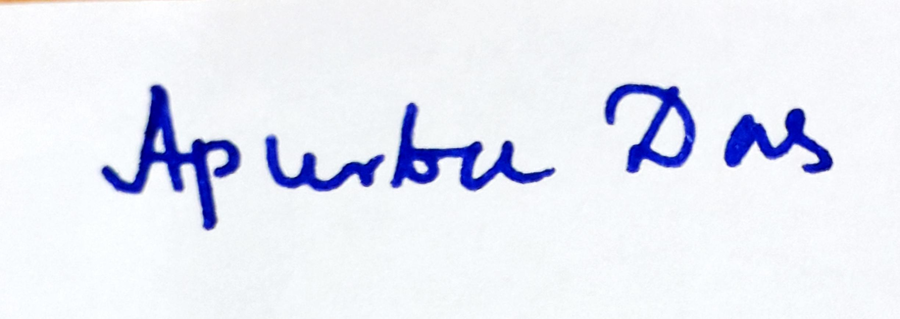
Instructor-in-charge
CS G526.

