SIMATS ENGINEERING

CO3-ASSESSMENT TOOL 1

COURSE NAME: Computer Networks
COURSE CODE: CSA07

COURSE OUTCOME COVERED
CO3: Analyze the performance of core network protocols such as TCP, UDP, HTTP,
and DNS under varying conditions
Assessment Tool Weightage: 40%
Dr.V.Parthipan

Code of Conduct:
I Y. Guru Charan (192565020) (Name / Reg No) certify that this submission is my
original work and that I have adhered to the guidelines specified for this assessment.
I understand that any violation of academic integrity rules will result in disciplinary
action.
Y. Guru Charan
Signature of the student

Experiments

QUESTIONS:4 Total Marks:40
1. Capture packets during a TCP connection setup. Identify the three packets involved in the
handshake (SYN, SYN-ACK, and ACK). Demonstrate the role of each flag and how they
establish a reliable connection. (BL4) (10)
2. Capture a DNS query using UDP in Wireshark. Compare the UDP header size
with TCP and note the absence of sequence numbers or acknowledgments.
Discuss how this lightweight design impacts speed and reliability. (BL4)
3. Simulate packet loss (e.g., disconnect briefly) and capture traffic in Wireshark.
Observe how TCP retransmits lost packets while UDP does not. Explain why this
difference makes TCP reliable but slower compared to UDP. (BL4) (10)
4. Use Wireshark to capture DNS traffic while resolving a domain name. Identify the
query type (A, AAAA, MX) and the response received. Measure the time taken for
resolution and explain why DNS typically uses UDP.(BL4) (10)

ANSWERS:
1)
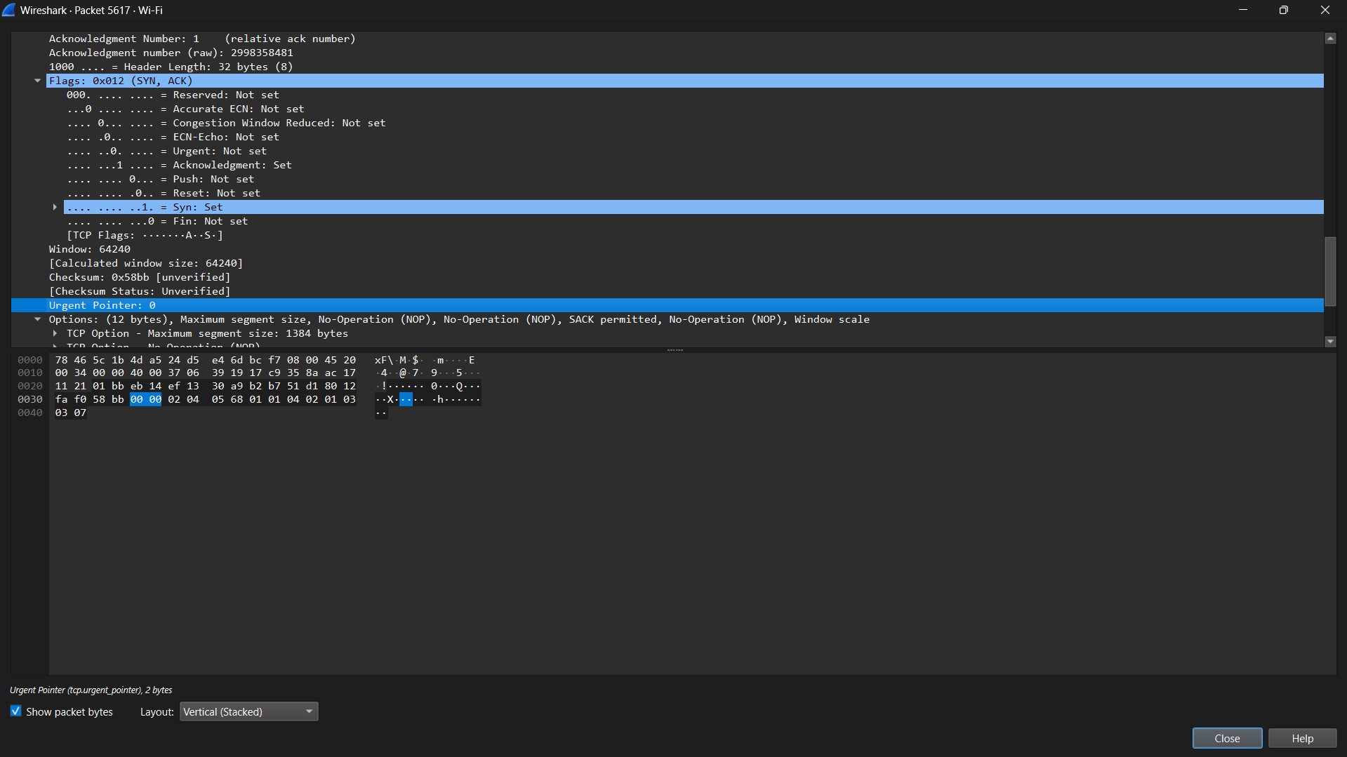

2)
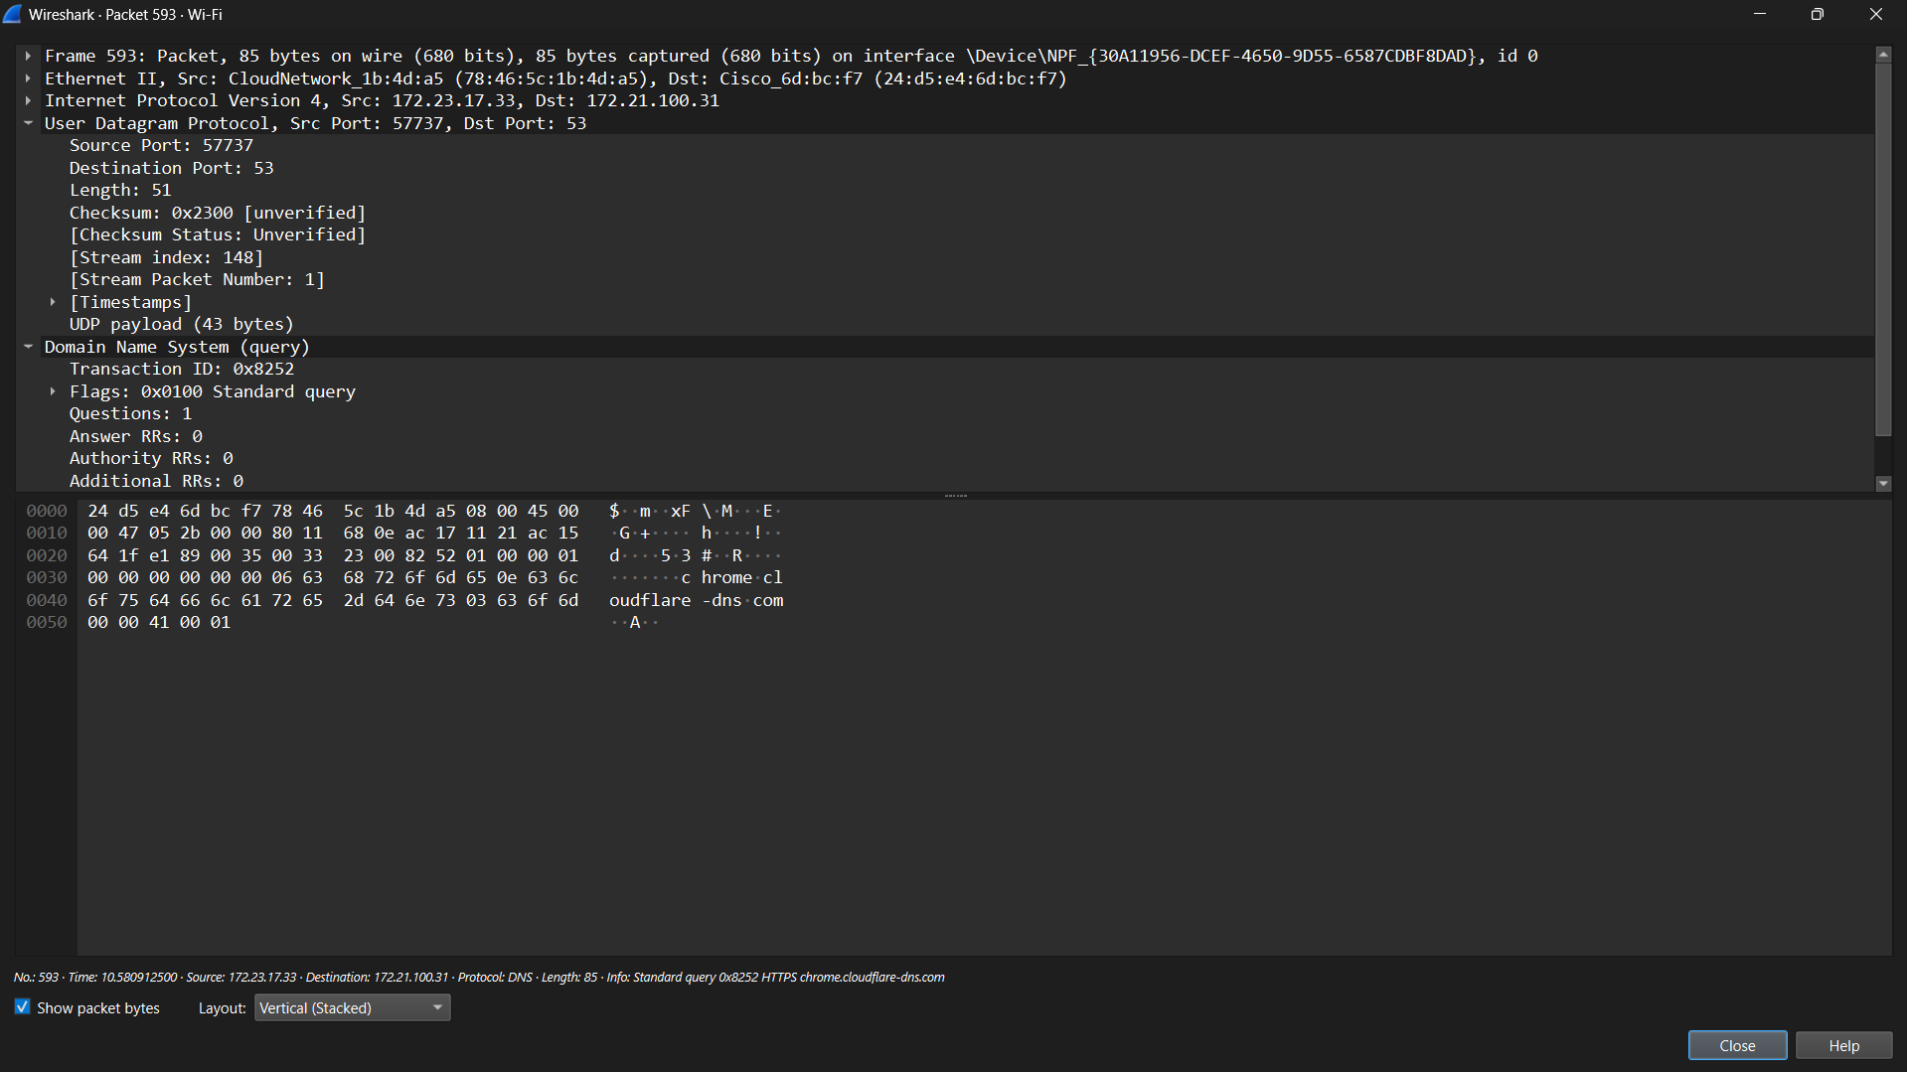

3)
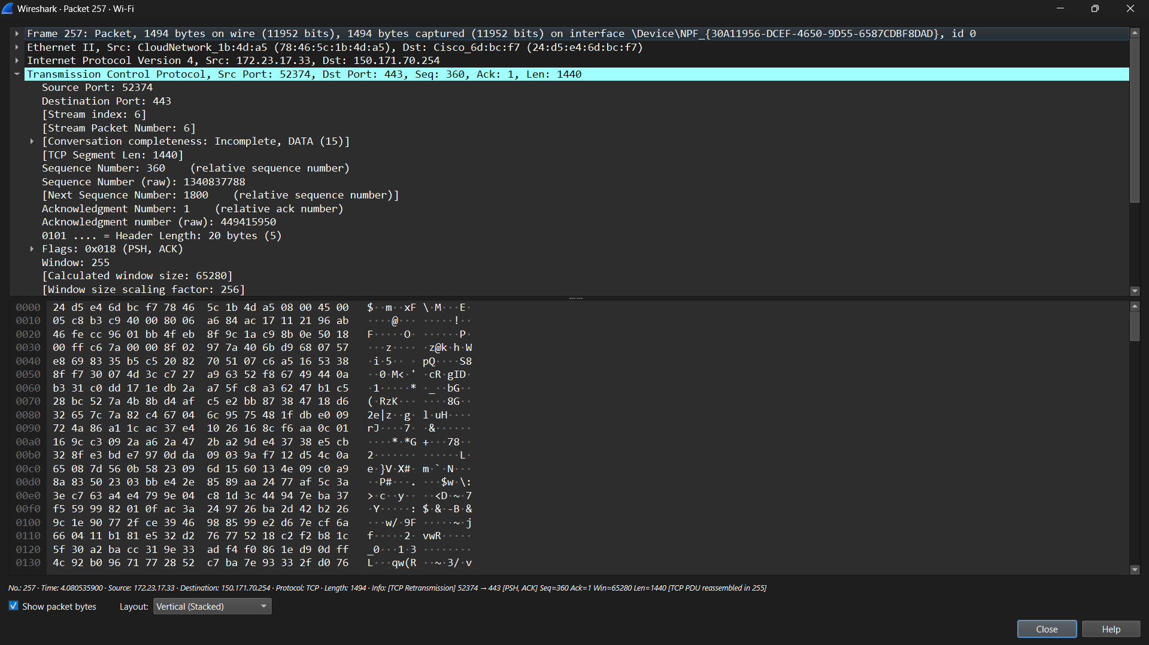

4)
