UNIT-1
EXPERIEMENT-1
AIM: To find the roots of a quadratic equation using C++.
DESCRIPTION: Write a C++ program to find the roots of a quadratic equation of the form
ax2+bx+c=0ax^2 + bx + c = 0ax2+bx+c=0
The program should:
- Accept values for coefficients a, b, and c.
- Calculate the discriminant D=b2−4acD = b^2 - 4acD=b2−4ac.
- Determine the nature of the roots based on the discriminant:
  - D > 0 → Two distinct real roots.
  - D = 0 → Two equal real roots.
  - D < 0 → Two complex roots.
- Display the roots accordingly.
PROGRAM:
#include <iostream>
#include <cmath> // for sqrt() function
using namespace std;
int main()
{
float a, b, c;
cout << "Enter coefficients a, b and c: ";
cin >> a >> b >> c;
float discriminant = b*b - 4*a*c;
float root1, root2;
if (a == 0) {
cout << "This is not a quadratic equation (a cannot be 0)." << endl;}
else if (discriminant > 0) {
// Real and distinct roots
root1 = (-b + sqrt(discriminant)) / (2*a);
root2 = (-b - sqrt(discriminant)) / (2*a);
cout << "Roots are real and distinct." << endl;
cout << "Root 1 = " << root1 << endl;
cout << "Root 2 = " << root2 << endl;
}else if (discriminant == 0) {
// Real and equal roots
root1 = root2 = -b / (2*a);
cout << "Roots are real and equal." << endl;
cout << "Root = " << root1 << endl;
}else {
// Complex roots
float realPart = -b / (2*a);
float imagPart = sqrt(-discriminant) / (2*a);
cout << "Roots are complex and imaginary." << endl;
cout << "Root 1 = " << realPart << " + " << imagPart << "i" << endl;
cout << "Root 2 = " << realPart << " - " << imagPart << "i" << endl;
} return 0;
}
OUTPUT:
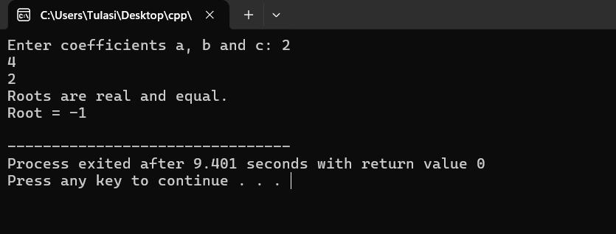
RESULT:The C++ program successfully computes and displays the roots of a quadratic equation based on the discriminant — whether they are real and distinct, real and equal, or complex.

EXPERIEMENT-2
Aim: Find factorial of a given number using recursion.
Description: Write a C++ program to calculate the factorial of a given positive integer using recursion.
The program should:
- Accept an integer n from the user.
- Use a recursive function factorial(int n) to compute:
n!=n×(n−1)×(n−2)×⋯×1n! = n \times (n-1) \times (n-2) \times \dots \times 1n!=n×(n−1)×(n−2)×⋯×1
with the base case:
factorial(0)=1factorial(0) = 1factorial(0)=1
- Display the factorial result for the given number.
Program:
#include <iostream>
using namespace std;
long factorial(int n)
{
if (n == 0 || n==1)
return 1;
else
return n * factorial(n - 1);
}
int main()
{
int number;
cout << "Enter a positive integer: ";
cin >> number;

if (number < 0) {
cout << "Factorial is not defined for negative numbers." << endl;
} else
{
long result = factorial(number);
cout << "Factorial of " << number << " = " << result << endl;
}
return 0;
}
Output:
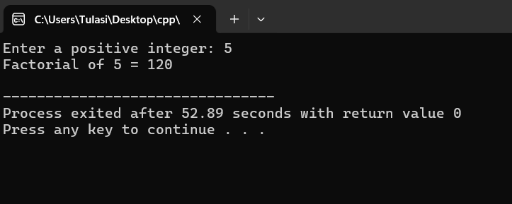
RESULT: The C++ program successfully calculates the factorial of a given number using recursion.
It repeatedly calls the function until the base condition is met, demonstrating the concept of recursive function calls in C++.

EXPERIEMENT-3
Aim: Implement scope resolution and namespaces.
Description: Write a C++ program to demonstrate the use of scope resolution operator (::) and namespaces.
The program should:
- Show how the scope resolution operator can be used to:
  - Access a global variable when a local variable has the same name.
  - Define a function outside its class.
- Create one or more namespaces containing variables or functions.
- Demonstrate accessing namespace members using:
  - The namespace name with the scope resolution operator (namespace_name::member).
  - The using directive to simplify access.
- Display outputs to clearly indicate how scope resolution and namespaces work.
Program:
#include <iostream>
using namespace std; // using standard namespace
int x = 100; // Global variable
namespace MyNamespace
{
int value = 50;
void show()
{
cout << "Inside MyNamespace, value = " << value << endl;
}
}
int main()
{ int x = 10; // Local variable
cout << "Local x = " << x << endl;
cout << "Global x = " << ::x << endl; // Using scope resolution to access global x
cout << "Namespace value = " << MyNamespace::value << endl;
MyNamespace::show();
return 0;
}
Output: 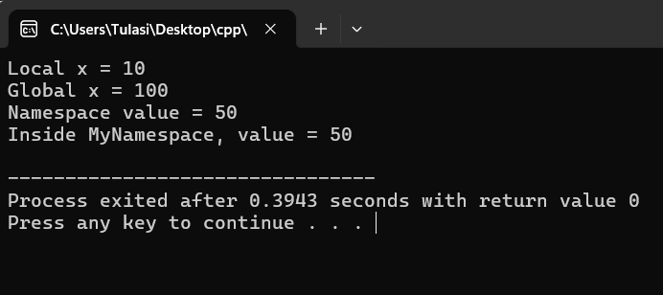
RESULT: The C++ program successfully demonstrates the use of scope resolution operator (::) to access global variables and the use of namespaces to avoid naming conflicts and organize code logically.

EXPERIEMENT-4
Aim: Illustrate the use of default arguments and access specifiers
Description: Write a C++ program to demonstrate the use of default arguments in functions and access specifiers in classes.
The program should:
- Create a function with one or more default arguments, allowing it to be called with fewer parameters.
- Create a class containing data members and member functions, using different access specifiers:
  - public
  - private
  - protected
- Show how access specifiers control the visibility and accessibility of class members.
- Display outputs that clearly illustrate the effect of default arguments and different access levels.
Program:
#include <iostream>
using namespace std;
class Student
{
private: // it is the default access specifier
int sno; // Private: accessible only inside the class
protected:
string sgrade; // Protected: accessible in derived classes
public:
string sname; // Public: accessible from outside
// Constructor
Student(int sn, string sna, string sg)
{
sno = sn;
sname = sna;
sgrade = sg;
}
// Function with default arguments
void disp(string sgrade = "Pass")
{
cout << " Name: " << sname << endl;
cout << "Roll Number: " << sno << endl;
cout << "Grade: " << sgrade << endl;
}
};
int main()
{
Student s1(100, "Tulasi", "A+"); // Creating object
cout << "Name of the Student ="<< s1.sname << endl; // accessing public variable
s1.disp();
s1.disp("Distinction");
s1.disp();
return 0;
}
Output:
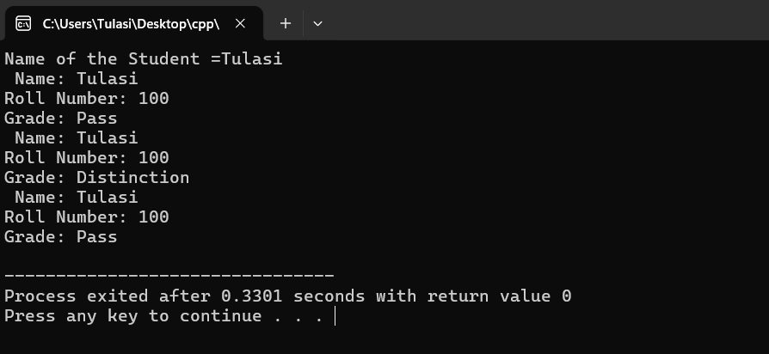
RESULT:The program successfully demonstrates default arguments and access specifiers in C++.
It produces the correct output using both default and user-defined values.

