HYR

Hire Your Resume



Thomas

Yeong

Angela

James

0. Contents

1. Introduction

2. Functional Requirements

3. External interface requirements

4. Conclusion

1. Introduction

1. What is HYR?

Make Your Resume Great Again. HYR, Hire Your Resume build a new resume by using your resume and job description for the company you are applying for. We extract the keyword of job descriptions to compare with your resume. And we extract experience information by analyzing your past resume for your new start. Then, we match suited information to the job description of the company among your experience information. Finally, our AI build a new resume optimized for each company using the extracted information

1. Who is our intended audience?

Advanced candidates who can apply for various job. And Job searcher who need to write a new resume to change their job

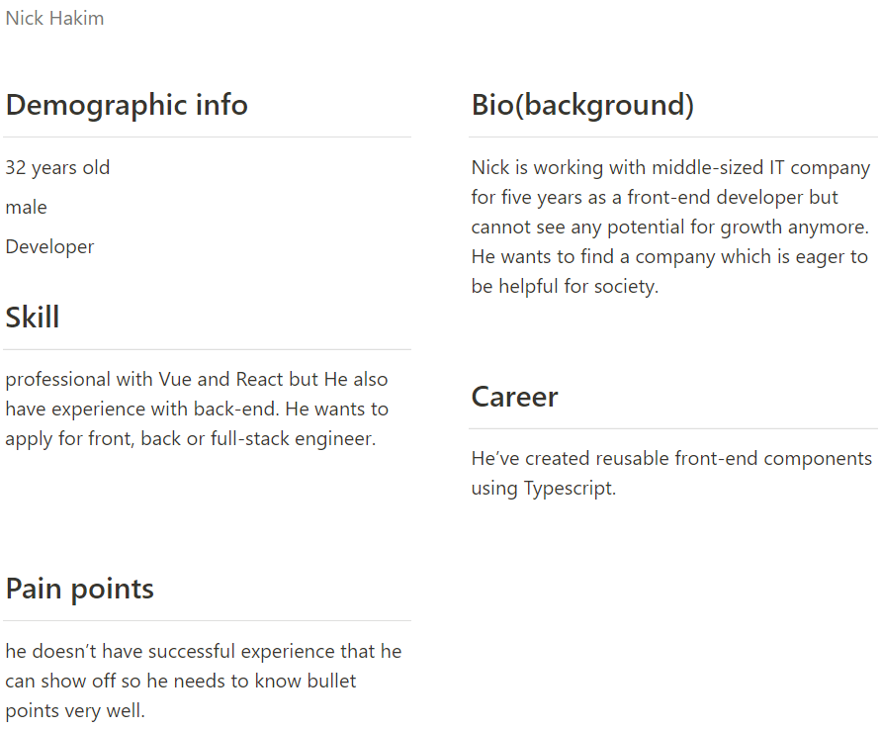

Persona 1. Nick Hakim

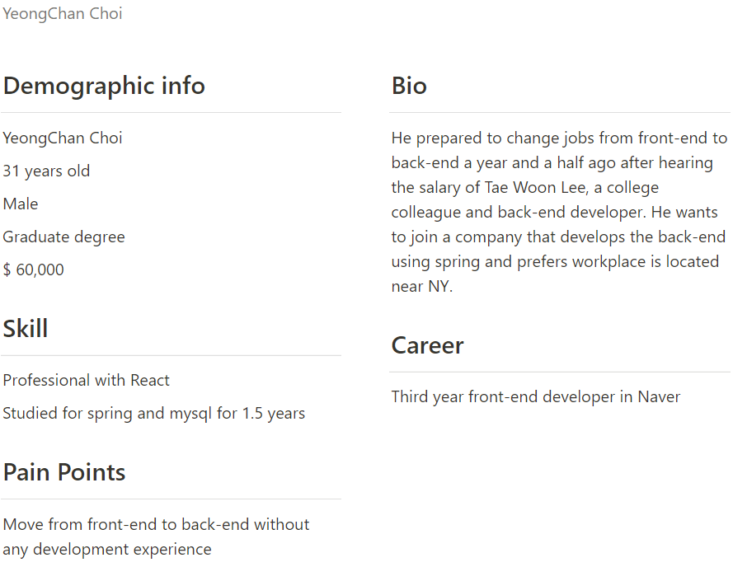

Persona 2. YeongChan Choi

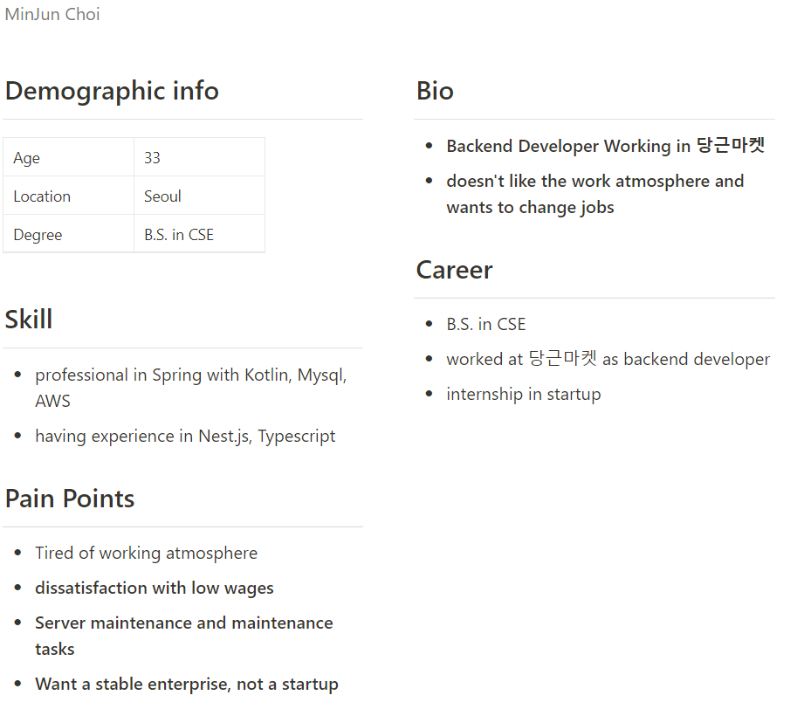

Persona 3. MinJun Choi

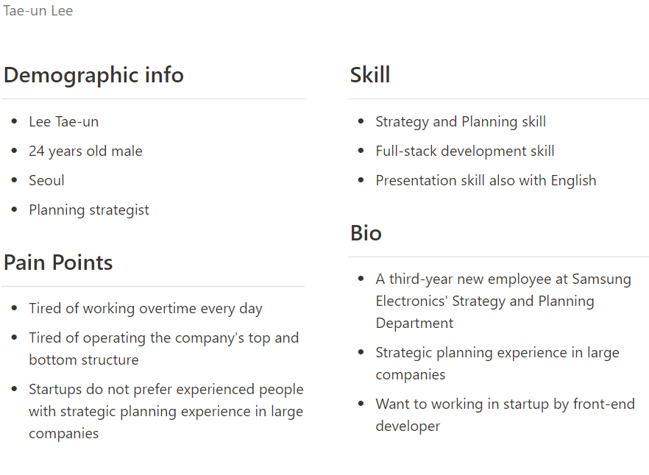

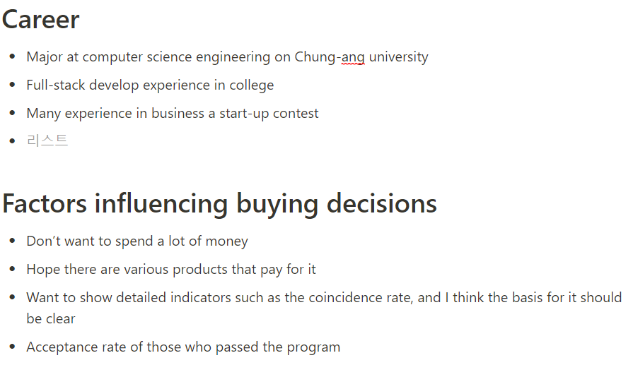

Persona 4. Tae-un Lee

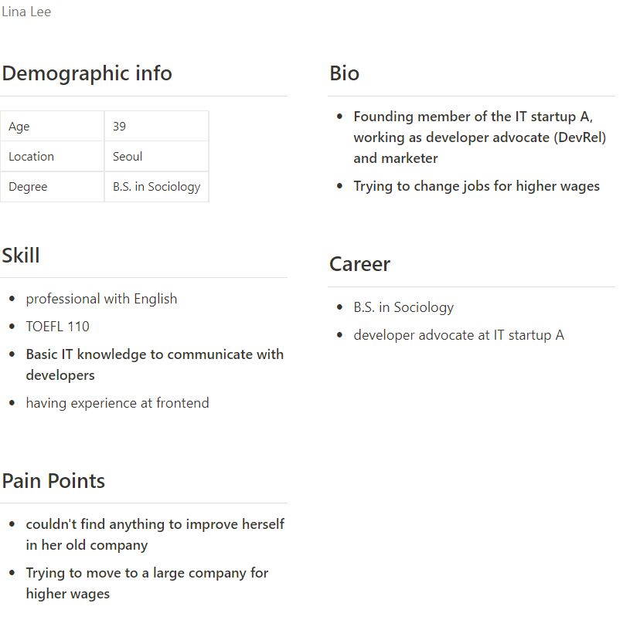

Persona 5. Lina Lee

1. Why HYR?

Unlike other resume maker, build a customized resumes referring to the job descriptions. Also, we give you free consultations, brilliant client services, innovative solutions, 24/7 support.

1. How to use HYR?

Step 1. Input your resume

Step 2. Select, or input job description of the company to support

Step 3. Run it!

Step 4. AI build new resume!

2. Functional Requirements

1. What we annotated

We annotated college, skill, work experience, major, ability, award, education, age, degree for the resume and company, job, required skills, preferred skills, project, department, benefit, required year for the job description. College means the college you graduated, skill means the skill (objective ability) you have (ex. JAVA, C++, …), work experience means where you worked before and what you did, major means what you major in, ability means your subjective ability (ex. work hard under pressure, diligent, …), award means your award you got, education means what you learned or your grade, age means your age and degree means your degree. For job description, company means the company who made a job description, job means the job you will do, required skills means what you have to need, preferred skills means which gives you plus when you have it, project means the project you will do when you got hired, department means where you are going to work, benefit means the benefits you will get when you got hired (ex. salary, health care, …), required year means the minimum years you have to do some experience before.

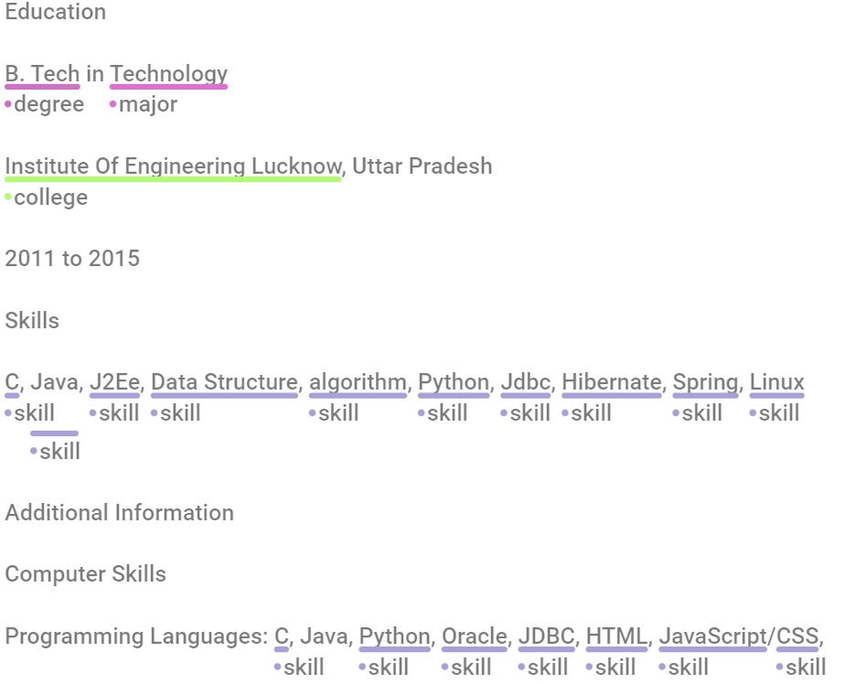

Example of annotated resume

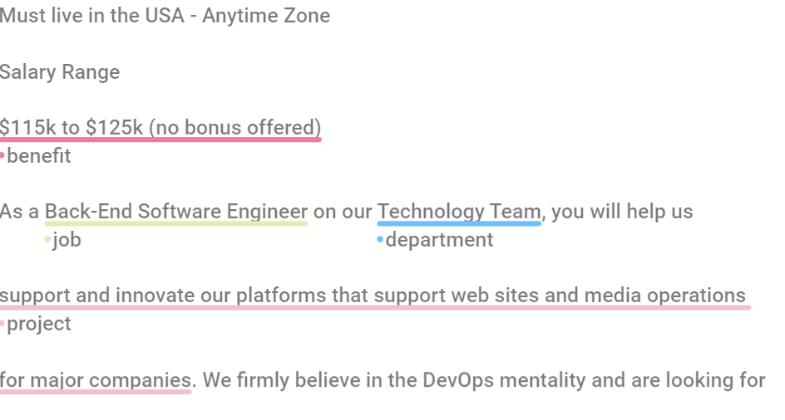

Example of annotated job description

1. About our spaCy model

spaCy에서 이미 만들어진 모델을 doccano에서 annotate한 resume 110개와 job description 160개를 사용해서 따로 train 시킴.

사용자가 본인의 resume과 job description을 input data로 넣으면, 이미 만들어진 두 모델을 이용하여job description 중에 어느 요소가 충족되어 있는지, 어느 부분이 부족한지 user의 resume에서 찾아서 알려줌 (오늘 저녁에 영어로 바꿔놓을 예정)

3. External interface requirements

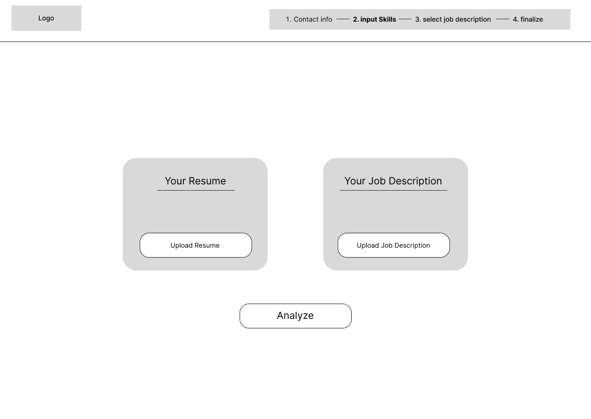

<Input page>

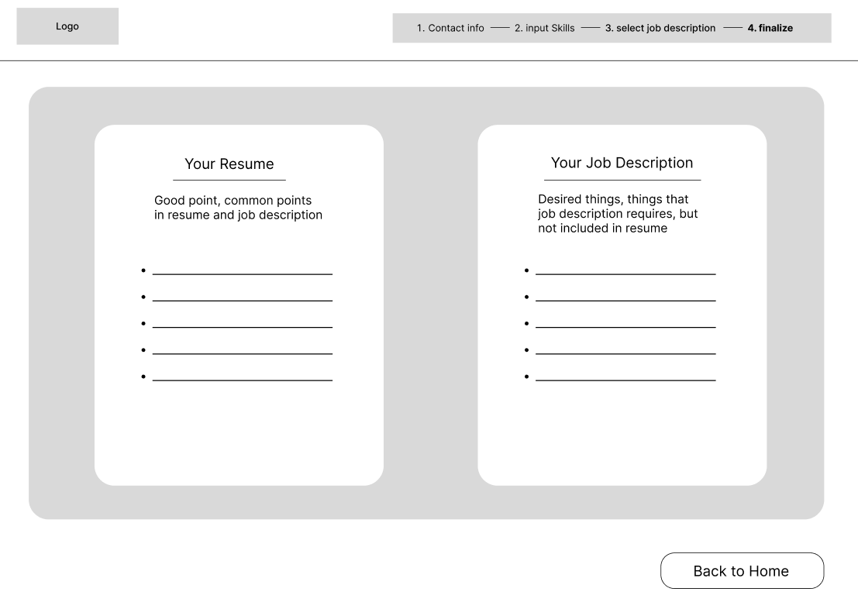

<output page>

4. Conclusion

1. How much?

* **Trial Plan (For Free)**

Once in a lifetime opportunity.

1 Times to build resume

Only one company at a time

For beginners

* **Standard Plan ($89.9 / 5 Times)**

5 Times to build resume

Good Plan for the first payment

Can select multiple companies at once to build

For Intermediate Users

Can help you to get a new job

* **Premium Plan ($159.9 / 10 Times)**

10 Times to build resume

Lower price than standard plan

For professionals