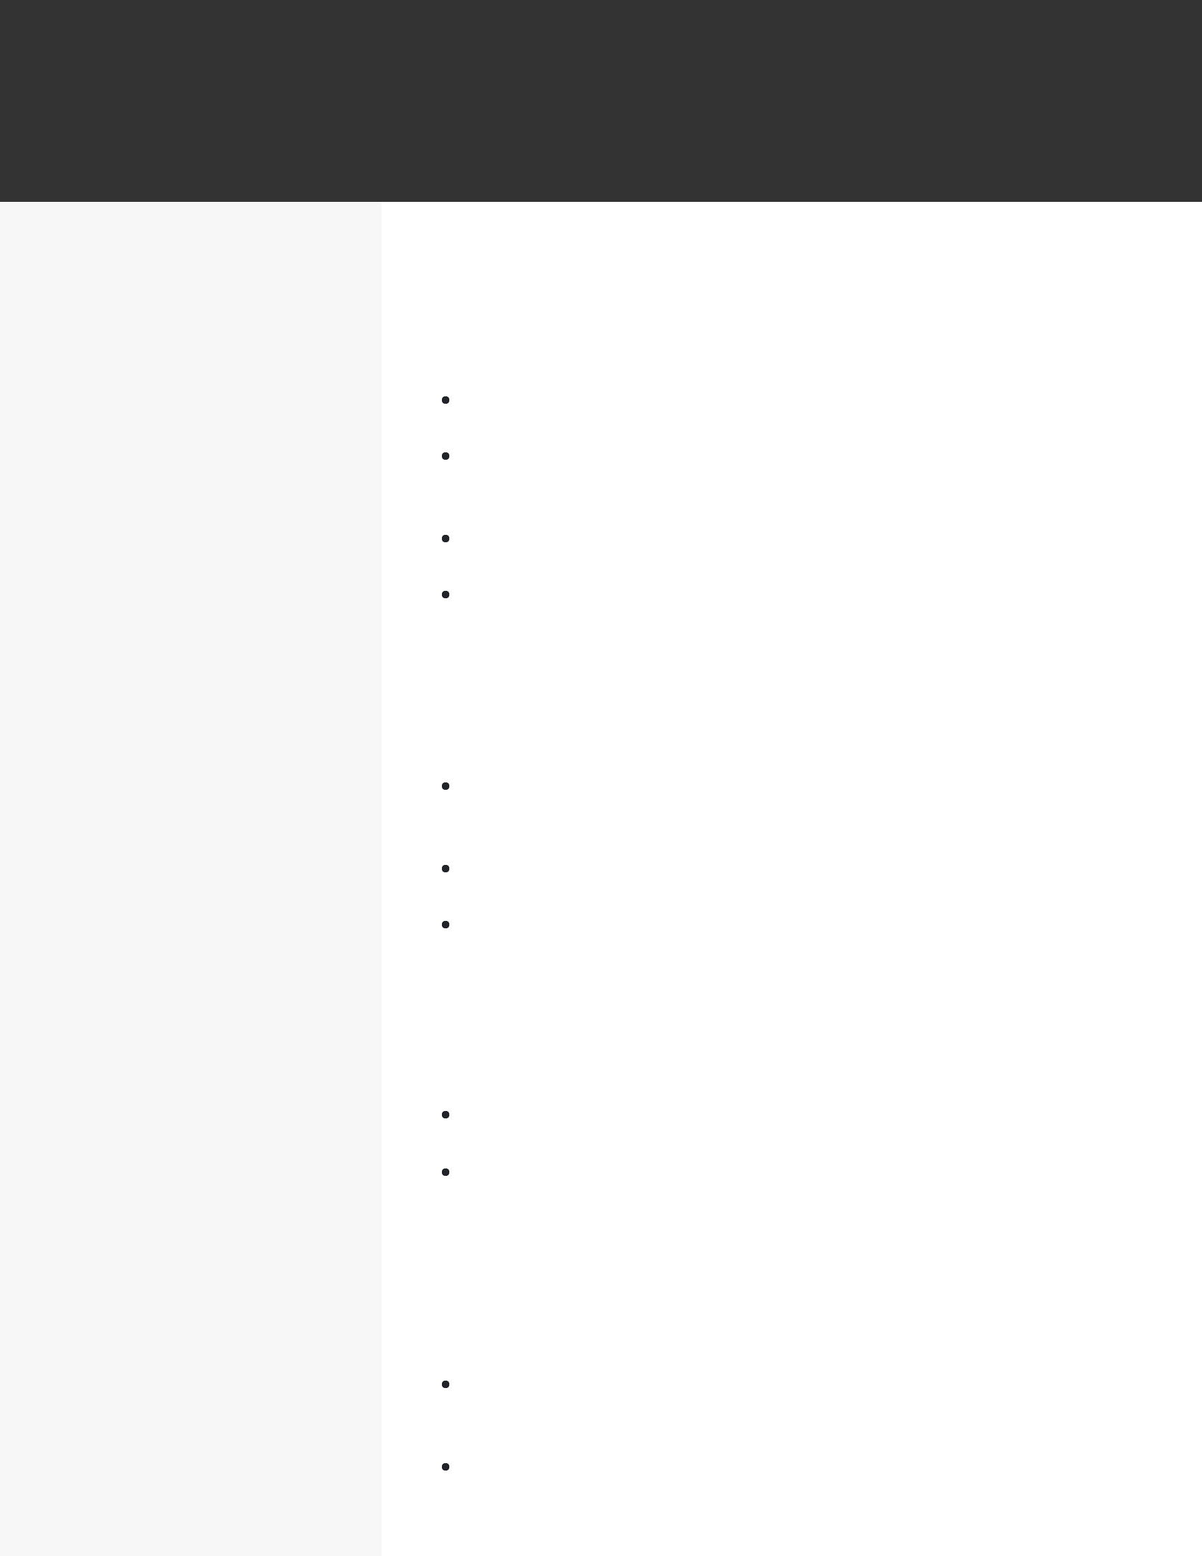CHARLES MCTURLAND

*SOFTWARE ENGINEER*

**CONTACT**

cmcturland@email.com 

1. 456-7890  New York, NY  LinkedIn 

**EDUCATION**

B.S.

Computer Science

University of Pittsburgh

September 2008 - April 2012 Pittsburgh, PA

**SKILLS**

Python (Django)

Javascript (NodeJS ReactJS,

jQuery)

SQL (MySQL, PostgreSQL,

NoSQL)

HTML5/CSS

AWS

Unix, Git

**WORK EXPERIENCE**

Software Engineer

Embark

January 2015 - current / New York, NY

Worked with product managers to re-architect a multi-page web app into a single page web-app, boosting yearly revenue by $1.4M

Constructed the logic for a streamlined ad-serving platform that scaled to our 35M users, which improved the page speed by 15% after implementation

Tested software for bugs and operating speed, fxing bugs and documenting processes to increase effciency by 18%

Iterated platform for college admissions, collaborating with a group of 4 engineers to create features across the software

Software Engineer

MarketSmart

April 2012 - January 2015 / Washington, DC

Built RESTful APIs that served data to the JavaScript front -end based on dynamically chosen user inputs that handled over 500,000 concurrent users

Built internal tool using NodeJS and Pupeteer.js to automate QA and monitoring of donor-facing web app, which improved CTR by 3%

Reviewed code and conducted testing for 3 additional features on donor-facing web app that increased contributions by 12%

Software Engineer Intern

Marketing Science Company

April 2011 - March 2012 / Pittsburgh, PA

Partnered with a developer to implement RESTful APIs in Django, enabling analytics team to increase reporting speed by 24%

Using Selenium I built out a unit testing infrastructure for a client application that reduced the number of bugs reported by the client by 11% month over month

**PROJECTS**

Poker Simulation

Built a full-stack web app to allow users to simulate and visualize outcomes of poker hands against opponents of different play styles using open source cards.js on the front-end

Utilized sci-kit learn in Python to simulate possible outcomes under different scenarios that the user chose