Devanshu Chatter~~j~~ee

@ devanshu4190@gmail.com ❿ +91 7355164558  [Github](https://github.com/01-dc) ❶ [LinkedIn](https://www.linkedin.com/in/devanshu-chatterjee-517645200/)

# Education

## B.Tech (Information Technology)

9.37 CGPA | Upto 5th Semester

⬧ Dec 2020 - Aug 2024  IIEST, Shibpur

## Intermediate (ISC board)

98.75% | PCM & CS

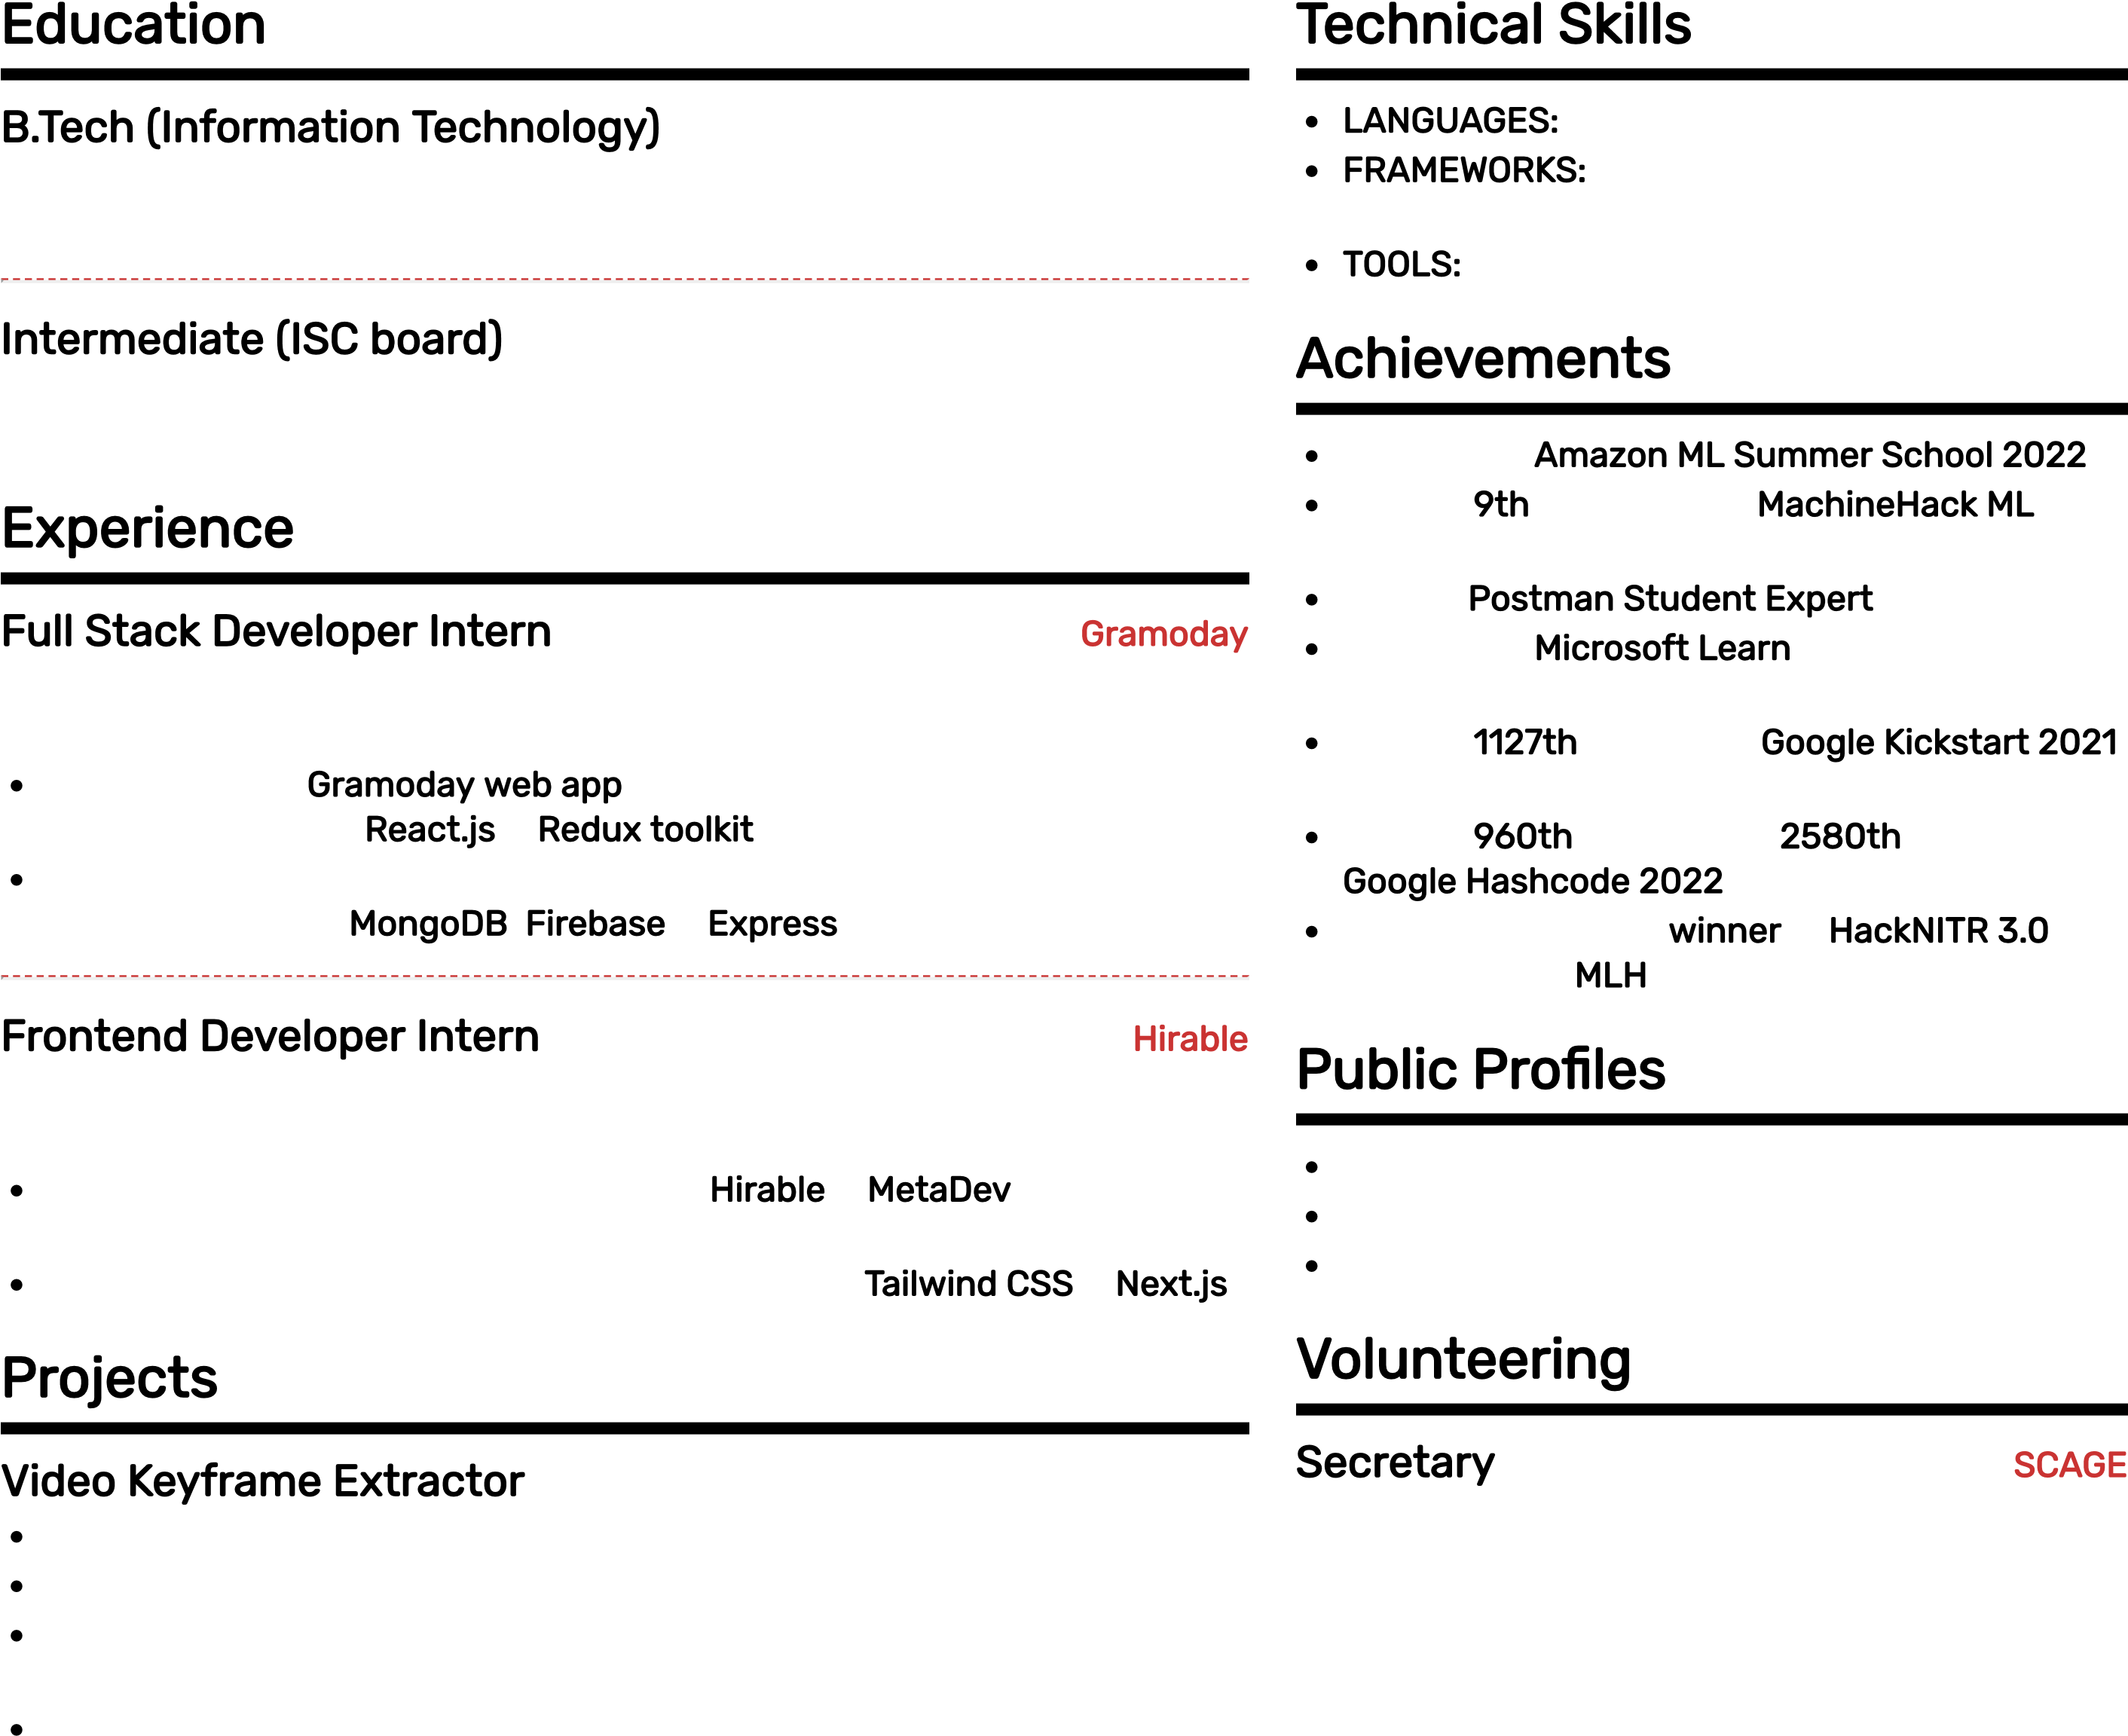 2019  City Montessori School, Lucknow Experience

## Full Stack Developer Intern [Gramoday](https://gramoday.net/)

⬧ Jul 2022 - Sep 2022  Remote

Contributing to Gramoday web app by designing pages, xing UI bugs & functional bugs on React.js & Redux toolkit.

Contributing to Gramoday API by managing ingestion, endpoints, authentication on MongoDB, Firebase & Express.

## Frontend Developer Intern [Hirable](https://www.linkedin.com/company/hirable-me/about/)

⬧ Mar 2022 - Jul 2022  Remote

Contributing to Edtech websites named Hirable & MetaDev by designing frontend components and integrating with backend.

Creating custom and reusable components using Tailw~~i~~nd CSS & Next.js.

# Projects

## Video Keyframe Extractor

Python, OpenCV, Imagehash

Extract Keyframes/Presentation Slides from recorded videos.

Learned about python-opencv library and imagehashing algorithms along with matplotlib to analyse data.

Learned about modular python code and independent modules. Source-code: [Github](https://github.com/01-DC/video-keyframe-extractor)

## noob docs

React.js, Socket.io, Express, MongoDB

Collaborate over text documents or code without the hassle of logging in.

Learned about WebSocket protocol and React hooks.

Server deployed on Heroku and database on MongoDB Atlas.

Source-code: [Github](https://github.com/01-DC/noob-docs)

Deployed URL: [Link](http://noob-docs.vercel.app/)

## Video Class~~i~~ cation us~~i~~ng CNN+RNN

Tensor ow, OpenCV, NumPy, matplotlib, scikit-learn

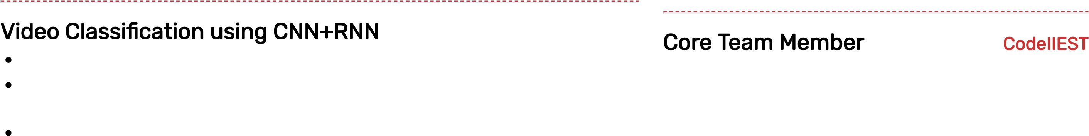Trained a neural network to classify videos by single labels based on actions begin performed in it.

Used UCF-50 public video dataset. OpenCV for extracting frames from videos. CNN for feature extraction from each frame. RNN for analysing frames of video in sequence.

Model performs with an accuracy score of 0.9016. Source-code: [Github](https://github.com/01-DC/Applications-Of-RNN/blob/main/HAR_on_UCF50.ipynb)

# Techn~~i~~cal Sk~~i~~lls

LANGUAGES~~:~~ C++, Python, Javascript

FRAMEWORKS~~:~~ React.js, Next.js, Node.js,

Express.js, TailwindCSS TOOLS~~:~~ Linux, Git, Postman

# Achievements

Selected in Amazon ML Summer School 2022.

Ranked 9th out of 360 in Mach~~i~~neHack ML work hours prediction challenge. Earned Postman Student Expert badge.

Selected in M~~i~~crosoft Learn Student Ambassadors program.

Ranked 1127th globally in Google K~~i~~ckstart 2021 Round H.

Ranked 960th in India and 2580th globally in Google Hashcode 2022.

Mental health track w~~i~~nner in HackNITR 3.0 hackathon by MLH.

# Publ~~i~~c Pro les

Leetcode: [1_DC](https://leetcode.com/1_DC/)

Google Cloud: [Qwiklabs Pro le](https://www.qwiklabs.com/public_profiles/8572fcf2-ca53-4de5-95d9-fc328b53a707) Behance: [My Artworks](https://www.behance.net/dc4190)

# Volunteer~~i~~ng

## Secretary SCAGE

⬧ Oct 2022 - Current  IIEST, Shibpur

Society of Creative Arts and Green

Environment

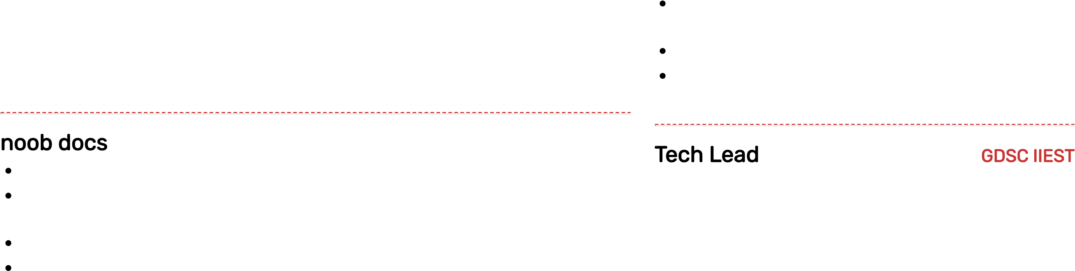Managing entire working of club and all events. Conducting activities and organising events to promote creativity among students.

Tech Lead GDSC IIEST

⬧ Sep 2022 - Current  IIEST, Shibpur

Managing technical requirements and logistics of events.

Taking sessions on topics like development, open source and machine learning. Website: [URL](https://gdsc.community.dev/indian-institute-of-engineering-science-and-technology-shibpur-howrah/)

## Core Team Member CodeIIEST

⬧ Mar 2021 - Current  IIEST, Shibpur

Took sessions on C++ programming concepts.

Conducting sessions under Open Source and Development chapter.

Editing session recordings for Youtube channel.

Youtube Channel: [URL](https://www.youtube.com/c/CodeIIEST)

My Sessions: [01](https://youtu.be/CAIRhaUaUBQ) | [02](https://youtu.be/pnflD2WF7oA)