

PROJECT REPORT

Python(Django) based website

Submitted by:
Name : tulika vijay
Roll no. : UE153106
Branch : CSE
Sem : 5th

Index

- Introduction
- techical background
- Problem Background
- Expected Result
- Innovation and usefulness
- Market Potenial
- Software
- Code
- Screenshots
- Data dictionary
- Biblography

Introduction

Abstract. The use of the Web (World Wide Web) has had many positive effects on education. It overcomes time and space limitations in traditional schools. Teachers and students
are now using the Web to access vast amounts of information and resources in the cyberspace. Also, learning via the Web enables both synchronous and asynchronous communication. Despite of many benefits of the Web, it may weaken students’ motivation due to lack of face-to-face communication. In this paper, I provide a learning model(website) called Hacking Online Education, which
is based on the principles of MOOCs , contructivism, to provide motivation and collaborative learning for students in the Web environment.
Aim of this Project is to develop a website that assists students and teachers alike to discover online courses, to enroll in courses from different sources, to compare these sources and to track their progress. Students can decide on their own pace and with which session they would like to begin their studies.
The aim is to centralise online education, with courses and practice material all in one place. The user can use login, logout, signin and explore. The user can then build his/her profile by adding different courses he/she is following. He/she can then rate courses and compare courses from the whole database. The rating of the courses are based on the users’ review only.
The first massive open online course (MOOCs) emerged from the open educational resources(OER) movement. MOOCs are recent and widely researched development.

Techical Background

The project is based on Django as backend and Html ,Css ,Javascript holding the frontend. It uses data from different MOOCs like edx , couresra, hackerrank etc, and relevant and active links.
The Project uses Ajax to perform various functions like rating a course and adding courses to a user’s profile.

The Technical aspect used in solving this problem involved:
- Django(python based framework)
- Sqllite(database)
- Html/CSS
- JavaScript
- Ajax

Python



Python is a widely used high-level programming language for general-purpose programming, created by Guido van Rossum and first released in 1991. An interpreted language, Python has a design philosophy that emphasizes code readability (notably using whitespace indentation to delimit code blocks rather than curly brackets or keywords), and a syntax that allows programmers to express concepts in fewer lines of code than might be used in languages such as C++ or Java.The language provides constructs intended to enable writing clear programs on both a small and large scale.

Django


Django is a high-level Python Web framework that encourages rapid development and clean, pragmatic design. Built by experienced developers, it takes care of much of the hassle of Web development, so you can focus on writing your app without needing to reinvent the wheel. It’s free and open source.

Object-relational mapper
Deﬁne your data models entirely in Python. You get a rich, dynamic database-access API for free — but you can still write SQL if needed.
class Band(models.Model):
"""A model of a rock band."""
name = models.CharField(max_length=200)
can_rock = models.BooleanField(default=True)

class Member(models.Model):
"""A model of a rock band member."""
name = models.CharField("Member's name", max_length=200)
instrument = models.CharField(choices=(
('g', "Guitar"),
('b', "Bass"),
('d', "Drums"),
),
max_length=1
)
band = models.ForeignKey("Band")

URLs and views
A clean, elegant URL scheme is an important detail in a high-quality Web application. Django encourages beautiful URL design and doesn’t put any cruft in URLs, like .php or .asp.
To design URLs for an application, you create a Python module called a URLconf. Like a table of contents for your app, it contains a simple mapping between URL patterns and your views.
from django.conf.urls import url

from . import views

urlpatterns = [
url(r'^bands/$', views.band_listing, name='band-list'),
url(r'^bands/(\d+)/$', views.band_detail, name='band-detail'),
url(r'^bands/search/$', views.band_search, name='band-search'),
]

from django.shortcuts import render

def band_listing(request):
"""A view of all bands."""
bands = models.Band.objects.all()
return render(request, 'bands/band_listing.html', {'bands': bands})

Templates
Django’s template language is designed to strike a balance between power and ease. It’s designed to feel comfortable and easy-to-learn to those used to working with HTML, like designers and front-end developers. But it is also flexible and highly extensible, allowing developers to augment the template language as needed.

<html>
<head>
<title>Band Listing</title>
</head>
<body>
<h1>All Bands</h1>
<ul>
{% for band in bands %}
<li>
<h2><a href="{{ band.get_absolute_url }}">{{ band.name }}</a></h2>
{% if band.can_rock %}<p>This band can rock!</p>{% endif %}
</li>
{% endfor %}
</ul>
</body>
</html>

Forms
Django provides a powerful form library that handles rendering forms as HTML, validating user-submitted data, and converting that data to native Python types. Django also provides a way to generate forms from your existing models and use those forms to create and update data.

from django import forms

class BandContactForm(forms.Form):
subject = forms.CharField(max_length=100)
message = forms.CharField()
sender = forms.EmailField()
cc_myself = forms.BooleanField(required=False)

SQLite
SQLite is a relational database management system contained in a C programming library. In contrast to many other database management systems, SQLite is not a client–server database engine. Rather, it is embedded into the end program.
SQLite is ACID-compliant and implements most of the SQL standard, using a dynamically and weakly typed SQL syntax that does not guarantee the domain integrity.

HTML/CSS
HTML is the language in which most websites are written. HTML is used to create pages and make them functional. The code used to make them visually appealing is known as CSS.

AJAX
AJAX stands for Asynchronous JavaScript And XML. In a nutshell, it is the use of the XMLHttpRequest object to communicate with servers. It can send and receive information in various formats, including JSON, XML, HTML, and text files. AJAX’s most appealing characteristic is its "asynchronous" nature, which means it can communicate with the server, exchange data, and update the page without having to refresh the page.

Problem Background
The MOOC Guide suggests six possible challenges for cMOOCs:
- Relying on user-generated content can create a chaotic learning environment
- Digital literacy is necessary to make use of the online materials
- The time and effort required from participants may exceed what students are willing to commit to a free online course
- Once the course is released, content will be reshaped and reinterpreted by the massive student body, making the course trajectory difficult for instructors to control
- Participants must self-regulate and set their own goals
- Language and translation barriers
Another alternative to MOOCs is the Self-Paced Online Course (SPOC) which provides a high degree of flexibility. Students can decide on their own pace and with which session they would like to begin their studies. According to a report by Class Central founder Dhawal Shah, more than 800 self-paced courses have been available in 2015.

Expected Result


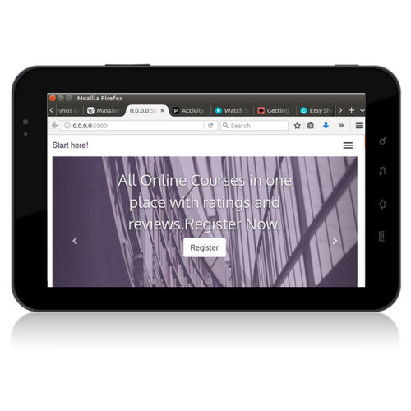

CODE
Django is a MTV framework which stands for model, templates and view. The project consists of database models in the form of sqlite, templates for frontend, view for url requests, url mappings and a bunch of static files.
Project directory
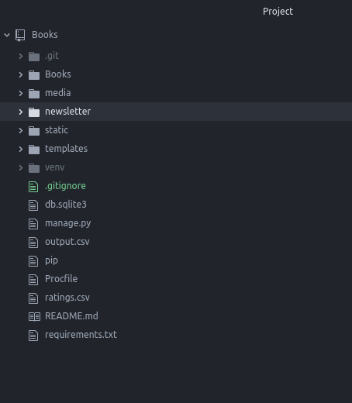

Newsletter app
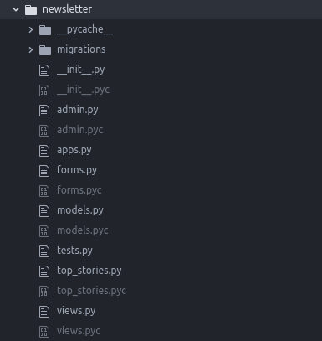

MODELS
# -*- coding: utf-8 -*-
from __future__ import unicode_literals
from django.contrib.auth.models import User
from django.db import models
from django.utils import timezone
from django.contrib.contenttypes.fields import GenericRelation
from star_ratings.models import Rating
# Create your models here.
#sign up form for newsletter not login or contact
class SignUp(models.Model):
full_name=models.CharField(max_length=60,blank=True)
email=models.EmailField()

def __unicode__(self):
return self.email

class UserProfile(models.Model):
user = models.OneToOneField(User)
phone=models.CharField(max_length=10)
designation=models.CharField(max_length=20)
image=models.ImageField(upload_to='profile_images', blank=False)

def __unicode__(self):
return self.user.username

class Categories(models.Model):
category_name=models.CharField(max_length=30,null=False)
url=models.URLField()
description=models.TextField()
rating=models.IntegerField()
image=models.ImageField(upload_to='categories', blank=True)
sort=models.CharField(max_length=30,default='courses')
ratings = GenericRelation(Rating, related_query_name='categories')

def __unicode__(self):
return self.category_name

class Pages(models.Model):
category=models.ForeignKey(Categories,on_delete=models.CASCADE,null=True,related_name='category')
name=models.CharField(max_length=30,null=False)
rating=models.IntegerField()
url=models.URLField()
ratings = GenericRelation(Rating, related_query_name='pages')

def __unicode__(self):
return self.name

class Course(models.Model):
user=models.ForeignKey(User,on_delete=models.CASCADE)
course=models.CharField(max_length=50)
timestamp=models.TimeField()
date=models.DateField(default=timezone.now)
ratings = GenericRelation(Rating, related_query_name='course')

class Meta :
ordering=['course']

def __unicode__(self):
return self.course

def create_course(self,user,course,timestamp):
user_course=self.create(user,course,timestamp)
return user_course

class StandAlone(models.Model):
user=models.ForeignKey(User,on_delete=models.CASCADE)
name=models.CharField(max_length=50)
url=models.URLField()
description=models.TextField()
image=models.ImageField(upload_to='course')
ratings = GenericRelation(Rating, related_query_name='standalone')

def __unicode__(self):
return self.name

class Challenge(models.Model):
user=models.ForeignKey(User,on_delete=models.CASCADE)
name=models.CharField(max_length=50)
url=models.URLField()
description=models.TextField()
rating=models.IntegerField()
image=models.ImageField(upload_to='course')
ratings = GenericRelation(Rating, related_query_name='challenge')

def __unicode__(self):
return self.name

class Code100(models.Model):
user=models.ForeignKey(User,on_delete=models.CASCADE)
timestamp=models.TimeField()
started=models.BooleanField()
done=models.BooleanField(blank=True)
ratings = GenericRelation(Rating, related_query_name='code100')

def __unicode__(self):
return self.started

