Hello!

To start application You need:

1. Open MySql workbench and run this script

CREATE TABLE `php`.`pineapple` (

`id` INT NOT NULL AUTO_INCREMENT,

`email` VARCHAR(45) NOT NULL,

`createDate` VARCHAR(45) NOT NULL,

PRIMARY KEY (`id`));

1. Download code from <https://github.com/tulitas/pineapple>
2. In package database open file config.php and change host and port, pass and login, in DB name write your shema name 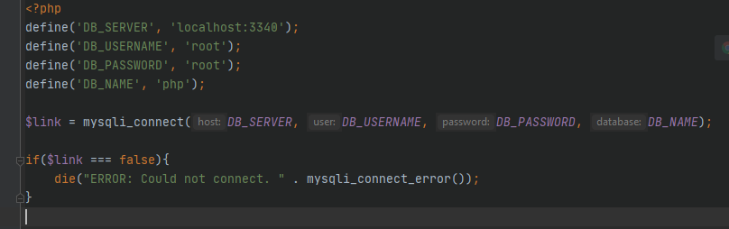
3. Run application from index.php file



