

CAPSTONE PROJECT REPORT
Report 2 - Project Management Plan

Ho Chi Minh, September 2026
Table of Contents
I. Record of Changes 3
II. Project Management Plan 4
1. Overview 4
1.1 Cost & Time Estimations 4
1.2. Project Objectives 7
1.3 Project Risks 8
2. Management Approach 10
2.1 Project Process 10
2.2 Quality Management 13
2.3 Project Training Plan 15
3. Responsibility Assignments 17
3.1. Project Organisation 17
3.2 Responsibility 17
4. Project Communications 20
5. Configuration Management 23
5.1 Document Management 23
5.2 Source Code Management 23
5.3 Tools & Infrastructures 24

I. Record of Changes
Date | A*  M, D | In charge | Change Description
02/06/2026 | A | NamNM | Initiate document
01/07/2026 | M | NamNM | Update Cost & Time Estimations section
05/07/2026 | M | TuPT | Update Project Training Plan schedule
10/07/2026 | A | HienNT | Add Project Risks table
15/07/2026 | M | KhoaHD | Update Responsibility Assignment matrix
18/07/2026 | M | NamNM | Revise Management Approach section
22/07/2026 | A | TuPT | Add Project Communications table
28/07/2026 | M | HienNT | Update Quality Management content
02/08/2026 | M | KhoaHD | Update Configuration Management section
08/08/2026 | M | NamNM | Review and consolidate Project Management Plan
12/08/2026 | M | TuPT | Final formatting and review before submission
22/09/2026 | M | Project team | Align plan with current FE, BE and RAG scope and revise estimates and quality controls
*A - Added M - Modified D - Deleted

II. Project Management Plan

1. Overview

1.1 Cost & Time Estimations
This plan defines the work, quality controls, responsibilities and configuration practices for IQGS across the Next.js frontend, ASP.NET Core backend and Python RAG service
The revised WBS estimates 100 person-days across initiation, planning, four development iterations and release preparation, including Interview Studio, candidate practice, hiring, AI Coach and payments; these are planning estimates rather than recorded effort, and the team must confirm capacity and calendar dates before committing to delivery

# | WBS Item | Complexity | Efforts (person-days)
1 | Initiation |  | 1
1.1 | Project scope confirmation with supervisor | Simple | 1
2 | Planning |  | 3
2.1 | Scope, risk and requirement traceability review | Medium | 1
2.2 | Architecture, interfaces and release planning | Medium | 2
3 | Sprint 1 - Foundation and Authentication |  | 13
3.1 | Cross-service architecture and API contracts | Medium | 2
3.2 | Environment, deployment configuration and CI review | Medium | 3
3.3 | PostgreSQL, pgvector and EF Core migrations | Medium | 2
3.4 | Registration, OTP, local login and OAuth | Medium | 3
3.5 | JWT refresh, password recovery and role checks | Medium | 2
3.6 | Foundation unit and integration verification | Medium | 1
4 | Sprint 2 - Interview Studio and Question Sets |  | 23
4.1 | JD input, parsing, analysis and Studio settings | Medium | 3
4.2 | System and HR knowledge ingestion, scoped retrieval and citations | Complex | 6
4.3 | Plan refinement, approval and asynchronous question generation | Complex | 7
4.4 | Draft or published sets, manual builder and Excel export | Medium | 4
4.5 | Editing, regeneration, revisions and publication checks | Medium | 3
5 | Sprint 3 - Practice and Hiring |  | 23
5.1 | Marketplace, hiring search and bookmarks | Medium | 3
5.2 | Timed practice, evaluation and conditional anti-cheat | Complex | 5
5.3 | Feedback, history, skill statistics and gamification | Medium | 4
5.4 | HR analytics and first-attempt hiring results | Complex | 4
5.5 | Consent, recommendations, shortlist and recruiter invitations | Complex | 5
5.6 | Practice and hiring integration verification | Medium | 2
6 | Sprint 4 - AI Coach and Platform Management |  | 29
6.1 | CV parsing and private candidate question generation | Complex | 5
6.2 | Coach diagnostics, competency scoring and roadmaps | Complex | 7
6.3 | Role-specific plans, quotas and administration | Medium | 5
6.4 | SePay payments, callbacks and transaction history | Complex | 4
6.5 | Administration, moderation and cross-service regression | Complex | 5
6.6 | Defect resolution and technical documentation | Medium | 3
7 | Release Preparation |  | 8
7.1 | FE, BE and RAG deployment and rollback readiness | Complex | 3
7.2 | Security, performance and full system verification | Complex | 3
7.3 | User acceptance review and handover evidence | Medium | 2
 | TOTAL ESTIMATED EFFORT (person-days) |  | 100
Table 1: Scope and Estimation

1.2. Project Objectives
# | Testing Stage | Test Coverage | No. of Defects | % of Defect | Notes
1 | Review | 100% scope reviewed | 0 blockers | Measure after review | Planning target, with scope and design review records
2 | Unit Test | Target 75% service coverage | 0 open critical defects | Measure after execution | xUnit and pytest exist, coverage and pass rate require measured evidence
3 | Integration Test | 100% critical integration scenarios | 0 open critical defects | Measure after execution | Cover ownership, callbacks, plans, sessions, invitations and payments
4 | System Test | 100% agreed critical user journeys | 0 release blockers | Measure after execution | Run FE, BE and RAG together before acceptance; these are targets, not achieved results
Table 2: Quality Targets

1.3 Project Risks
The risk register covers technical dependencies, data protection and delivery constraints in the current implementation; owners review mitigation progress during weekly meetings and escalate risks that affect an iteration goal

# | Risk Description | Impact | Possibility | Response Plans
1 | Insufficient RAG, pgvector or model-provider experience | High | Medium | Nam and Hiền schedule guided work and peer review before Studio integration
2 | Model service outage, cost or long response times | High | Medium | Nam monitors usage, sets a team-approved budget and tests timeout and recovery with the configured provider
3 | Scope growth from Coach and hiring workflows | High | High | Nam re-estimates the backlog and confirms priorities and calendar dates with the supervisor
4 | FE, BE and RAG schema or callback mismatch | High | Medium | Hiền coordinates schema changes and tests callbacks, invalid payloads and service restarts
5 | Migration or source merge conflicts | Medium | High | All members use reviewed pull requests and coordinate schema ownership and migration order
6 | Private document or candidate-data exposure | High | Medium | Hiền reviews owner filters, consent and role boundaries with adversarial integration cases
7 | Duplicate or forged payment notifications | High | Medium | Nam tests notification authentication, transaction matching and duplicate processing
8 | Weak AI answers, citations or Coach scoring | High | Medium | Khoa and Hiền curate evaluation cases and compare model dimensions with backend scoring rules
9 | Incomplete deployment stack or lost RAG background work | High | Medium | Nam verifies pgvector and all services, documents recovery and tests backup and rollback before release
Table 3: Project Risk

2. Management Approach

2.1 Project Process
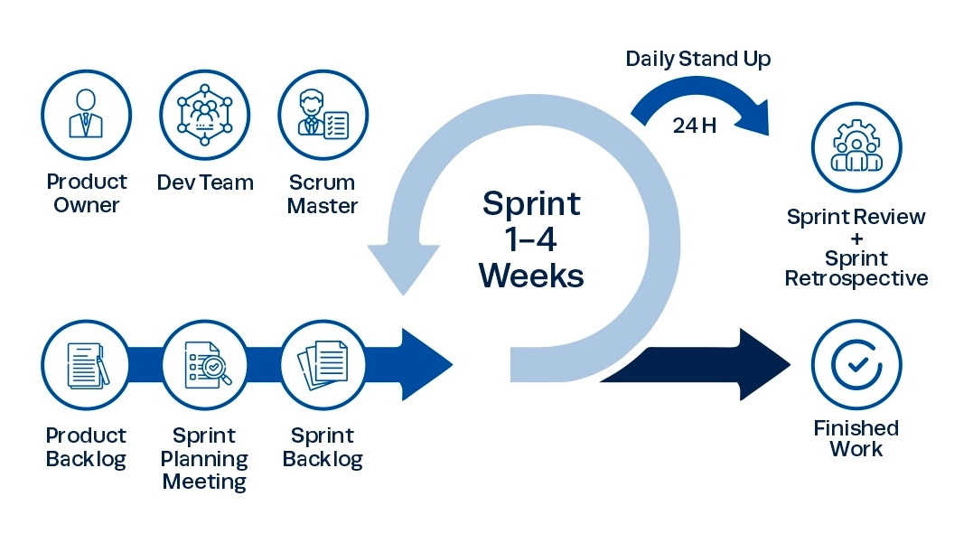
Figure 1: Scrum Model Process (Link)
The team will use the Scrum process illustrated above to deliver and review IQGS in increments spanning the frontend, backend and RAG service, with acceptance criteria covering both the user workflow and cross-service behaviour
The project manager maintains the prioritised backlog and assigns an owner and reviewer to each item, using the planned Jira workflow To Do, In Progress, In Review and Done; repository evidence does not establish the current Jira board or remote branch protection settings
The four iterations below are a revised sequencing plan for the current scope, replacing the original June to August calendar baseline; iteration durations and release dates require team approval because 100 person-days already represent 5 full-capacity working weeks for four members before availability and contingency allowances
- Sprint 1: Foundation, infrastructure and authentication
- Sprint Planning: Define acceptance criteria for WBS items 3.1 to 3.6 and confirm FE, BE and RAG interfaces, configuration owners and database migration responsibilities
- Implementation: Establish Next.js, the four backend layers and FastAPI integration, PostgreSQL with pgvector, account registration and email OTP, local and OAuth login, JWT refresh, password recovery, roles and account status checks
- Daily Scrum: Review progress and blockers across all three codebases and coordinate interface or migration changes before implementation
- Sprint Review: Demonstrate authentication and role-specific access with documented test evidence and collect supervisor feedback
- Sprint Retrospective: Revisit estimates, integration delays and ownership gaps, then update the backlog and risk register
- Testing: Run the relevant xUnit tests and API checks for registration, OTP, token refresh, password reset, OAuth failures and inactive accounts, recording the actual results rather than assuming complete coverage
- Sprint 2: Interview Studio, knowledge ingestion and question sets
- Sprint Planning: Define acceptance criteria for WBS items 4.1 to 4.5, including document ownership, generation recovery and publication rules
- Implementation: Support text and PDF, DOCX or TXT job descriptions, system and HR knowledge sources, chunking and pgvector retrieval, plan generation and refinement, approval and asynchronous generation through Hangfire and RAG callbacks, with citations, question editing, draft or published sets and Excel export
- Daily Scrum: Track model access, embedding compatibility, parsing failures and FE progress updates for asynchronous jobs
- Sprint Review: Demonstrate the complete Studio workflow and confirm that question sources remain within the permitted knowledge scope
- Sprint Retrospective: Review retrieval relevance, citation quality, generation latency and recovery from interrupted background tasks
- Testing: Exercise plan revisions, owner-scoped retrieval, JSONL ingestion, callbacks, generation failures, rubric requirements and publication limits using relevant xUnit, pytest and API scenarios
- Sprint 3: Practice marketplace, hiring and analytics
- Sprint Planning: Define acceptance criteria for WBS items 5.1 to 5.6, covering practice completion, official hiring attempts and candidate consent
- Implementation: Deliver browsing and bookmarks, timed text-answer sessions, AI feedback and practice history, HR analytics, hiring assessments, candidate recommendations, shortlist and comparison, recruiter invitations and candidate responses, with configurable camera and tab monitoring where enabled
- Daily Scrum: Resolve session state, evaluation delays and permission mismatches between candidate and recruiter views
- Sprint Review: Demonstrate practice and hiring flows, including first completed official attempts, consent checks and invitation acceptance or rejection
- Sprint Retrospective: Review feedback quality, query performance and session recovery, prioritising measured issues rather than assuming a caching layer
- Testing: Verify timeout submission, repeated attempts, recommendation eligibility, candidate privacy, invitation transitions, analytics and anti-cheat events when enabled

- Sprint 4: AI Coach, subscriptions, administration and release readiness
- Sprint Planning: Define acceptance criteria for WBS items 6.1 to 6.6 and 7.1 to 7.3, with explicit owners for cross-service release checks
- Implementation: Complete CV parsing and personal question generation, Coach diagnostics, competency scoring and roadmaps, role-specific Free and Premium plans, SePay payments, administration and feedback moderation, then integrate all modules and prepare deployment configuration
- Daily Scrum: Track payment reconciliation, quota enforcement, Coach scoring and outstanding deployment dependencies
- Sprint Review: Demonstrate the agreed release scope and review unresolved defects, test evidence and deployment prerequisites before recommending acceptance
- Sprint Retrospective: Record lessons learned, actual effort and model or infrastructure constraints for the final report
- Testing: Run regression and controlled payment tests, assess external dependency failures and benchmark representative workloads, then record release decisions and unresolved limitations without treating source implementation as proof of production readiness

2.2 Quality Management
2.2.1 Defect Prevention
The following preventive controls are planned for each iteration
- Nam coordinates sprint priorities, acceptance criteria and risk review with the team and supervisor
- Training covers Next.js and TypeScript, ASP.NET Core, FastAPI, pgvector and the configured LLM and embedding providers, with extra review for unfamiliar components
- Maintain a checklist for ownership filters, secrets, async callbacks, payment idempotency, EF Core migrations and embedding dimensions
2.2.2 Reviewing
- Before coding, confirm user outcomes, error states and acceptance criteria across FE, BE and RAG
- Review the implemented product scope against the approved requirements and the existing-system analysis in Report 1
- Assign at least two reviewers to major reports and record feedback and approval before supervisor submission
- Review interfaces against DomainLayer, ApplicationLayer, InfrastructureLayer and WebAPI, together with the separate Python RAG boundary
- Require peer review before merging shared release work and verify repository protection settings with the maintainer; this document states the intended policy rather than a verified GitHub configuration
2.2.3 Unit Testing
- Prioritise business rules and edge cases in authentication, plans, sessions, invitations, payments and scoring, with a proposed 75% service coverage target measured by an agreed coverage tool
- The backend contains xUnit unit and integration test projects and RAG contains pytest suites; the inspected workflow supports backend deployment, so test automation on every pull request remains a configuration task until demonstrated
- Each defect record should include severity, affected module, reproduction steps, expected and actual results, and an assigned owner
- Resolve release-blocking defects before acceptance and explicitly defer lower-priority issues with an owner and reason
2.2.4 Integration Testing
  - Run the relevant unit suites before validating affected integration paths and record environment, revision and results
  - Verify backend integration with RAG, PostgreSQL and pgvector, Azure Blob Storage, identity and email providers and SePay, including timeout, retry and invalid-response behaviour
  - Maintain test cases and execution evidence in the agreed shared tracker, linking defects to the relevant source revision
  - Define preconditions, isolated test accounts, representative documents, controlled database state, execution steps and expected results for each scenario
  - Use Swagger or Postman for API checks alongside the existing integration suites; add automated collection execution only when a maintained collection and runner are available
2.2.5 System Testing
  - Require an integration review and a known defect list before end-to-end acceptance testing
  - Trace the agreed user stories to test scenarios across administrator, recruiter and candidate workflows, recording measured coverage instead of asserting an unverified story count
  - Benchmark page loading and AI job latency separately, with a proposed 50-user workload only after environment sizing; validate access control, knowledge isolation, callback authentication, payment replay handling and camera permissions, and record thresholds before execution

2.3 Project Training Plan
The training plan supports the revised scope and assigns sessions before the relevant iteration rather than implying that historical training was completed; participants may waive a session only after demonstrating the required capability to the designated reviewer

Training Area | Participants | When, Duration | Waiver Criteria
Git, pull requests and interface review | Nam, Hiền, Tú, Khoa | Before Sprint 1, 1 day | Reviewed sample pull request
.NET 8, EF Core, JWT and Hangfire | Nam, Hiền | Before Sprint 1, 3 days | Demonstrate tested API and migration
Next.js, TypeScript and role-based UI | Tú, Khoa | Before Sprint 1, 3 days | Demonstrate page, API and error states
FastAPI, pgvector and source isolation | Nam, Hiền | Before Sprint 2, 3 days | Pass retrieval and ownership exercises
Studio plans, callbacks and model quality | All members | Before Sprint 2, 2 days | Trace and review complete generation job
Practice, hiring consent and Coach scoring | All members | Before Sprints 3 and 4, 2 days | Explain session and scoring acceptance cases
SePay, deployment and test evidence | All members | Before release, 2 days | Demonstrate callback and recovery tests
Table 4: Training plan

3. Responsibility Assignments

3.1. Project Organisation
The organisation model below retains the supervisor and four-member team from the project baseline, with shared analysis, development and testing responsibilities; the matrix assigns proposed delivery ownership and does not infer authorship from source files

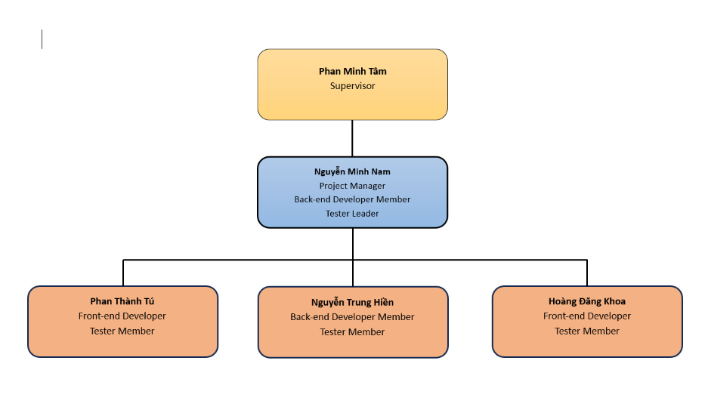
Figure 2: Project Organisation

3.2 Responsibility
The responsibility matrix uses the D-R-S-I model to identify implementation, review, support and information responsibilities for the revised scope
- D (Do) - performs the task
- R (Review) - reviews and evaluates the task
- S (Support) - assists with the task
- I (Informed) - receives progress and decisions
Every work item has a delivery owner, and cross-service changes require a reviewer from the affected module
Responsibility | NamNM | TuPT | HienNT | KhoaHD
Document and Report
Project Introduction Document | D | S, R | S, R | S, R
Project Management Plan Document | D | D | S, R | S, R
Software Requirements Specification (SRS) Document | D | D | S, R | S, R
Software Design Document | D, R | D, R | D, R | D, R
Testing Document | D, R | D, R | D, R | D, R
User Manual / System Usage Guide | S, R | S, R | D | S, R
Final Project Report | S, R | S, R | S, R | D
Presentation Slides | S, R | S, R | S, R | D
Analysis & Design
Context Diagram | D | I | I | I
Use case diagram | D | D | S, R | S, R
Main workflow | D | S, R | D | S, R
Screen flow diagram | S, R | S, R | D | S, R
Entity relationship diagram | D | S, R | S, R | S, R
System architecture diagram | D | S, R | S, R | S, R
Sequence diagram | D, R | D, R | D, R | D, R
Class diagram | D, R | D, R | D, R | D, R
Database design | D | S, R | S, R | S, R
UI design | R | D | R | S
Package diagram | R | R | D | R
Implementation
Source code management | D | D | D | I
Code Front-end | I | D | I | D
Code Back-end | D | I | D | I
Python RAG, retrieval and model services | S | I | D | R
Interview Studio and question-set workflow | R | D | D | S
Practice, hiring and candidate privacy | D | S | R | D
AI Coach and competency scoring | R | S | D | D
SePay, subscriptions and release configuration | D | I | R | S
Deploy web | S | D | D | S
Testing
Develop the Test Plan | R | D | I | I
Create Unit Test Cases and Execute Testing | D | I | I | D
Create Integration Test Cases and Execute Testing | D, R | D, R | D, R | D, R
Create System Test Cases and Execute Testing | D, R | D, R | D, R | D, R
Prepare Test Reports | S, R | D | S | S
Table 5: Responsibility

4. Project Communications
Communication Item | Who / Target | Purpose | When / Frequency | Type, Tool, Method(s)
Daily Meeting | All team members | To quickly update yesterday's progress, today's tasks, and flag technical blockers so the team can support immediately | Daily (Mon - Fri)8:00 - 8:30 | Online  Voice calls via Google Meet; updating tasks on the Jira Board
Weekly Meeting | All team members | To review weekly results, lock current Sprint progress, discuss FE-BE integration issues, and distribute the workload evenly for the next week | Every Saturday or Sunday evening | Hybrid (Online/Offline)  Google Meet or face-to-face meetings at the campus library
Meeting with Supervisor | All team members and Mr. Phan Minh Tâm | To report milestone progress, get feedback on the RAG pipeline | Weekly (Thursdays or scheduled in advance with the supervisor) | Offline or Online  On-campus meetings or online via Google Meet
Iteration Review | All team members | To accept completed features, run system demos | At the end of each agreed iteration | Online  Google Meet discussion paired with Jira evaluation
Emergency Meeting | Relevant members or the whole team | To handle critical unexpected issues immediately (e.g., Azure deployment server crash, heavy Git merge conflicts, or sudden requirement changes) | Whenever a critical emergency occurs | Urgent Online Meeting  Quick notification via pinned Zalo messages, moving instantly to Google Meet
Code Review | Developer and designated Reviewer | To verify code conventions and optimize logic | Whenever a feature or bugfix is completed on GitHub | Asynchronous  Pull Request (PR) creation on GitHub; discussion via line comments or Zalo
Document Review | All team members (evenly distributed sections) | To cross-review chapters in Report 2 and the SRS to catch typos, formatting errors, or inconsistencies between FE and BE descriptions | Before submission deadlines or document freezing dates | Asynchronous  Comments and "Suggesting" mode directly on Google Docs
UI/UX Discussion | All team members | To align on User Flows for all actors | Early project phases or before starting a sprint with new user interfaces | Online Visual  Reviewing designs on Figma while discussing via Google Meet

5. Configuration Management

5.1 Document Management
The project retains Google Drive and the shared document workflow from the management baseline, with Word report copies stored in the agreed submission folder; access rights and remote history must be maintained by the team
- Google Drive: Organise requirements, design, reports, meeting records and test evidence by document type and revision (Link)
- Google Docs: Collaborate on report drafts and meeting records before producing the submission copy (Link)
- Google Sheets: Maintain estimates, requirement traceability and test execution records
- Canva: Prepare presentation material from the approved report content
- Our document management process includes:
- Version History: Keep reviewable document revisions and record the source baseline used for code-aligned updates
- Access and Sharing: Assign viewer, commenter and editor permissions according to team responsibilities
- Document Approval: Resolve reviewer comments, record the approving member and preserve a separate final submission copy

5.2 Source Code Management
Use Git and GitHub to trace source changes across all three components, with compatible releases recorded together rather than treating each repository independently
- Component Repositories: Maintain frontend, backend and RAG source boundaries, recording the exact commit or working-tree state used for each test and release
- Frontend:FE/AI_Interview_Question_Generation_RAG_LLM_FE contains Next.js routes, interface components and API clients GitHub Frontend
- Backend and RAG: IQGS-SEP490-Backend contains .NET application layers and migrations, while RAG contains FastAPI routes, retrieval and model services GitHub Backend
- Branching Strategy: Agree a shared integration branch and use short-lived feature or fix branches with pull requests
- Release Branch: Promote a reviewed revision only after the required checks pass and record the release identifier
- Integration Branch: Coordinate FE contracts, BE DTOs and RAG schemas before merging interdependent changes
- Feature Branches: Link each branch and pull request to a backlog item and include affected modules and verification evidence
- Configuration: Keep secrets outside source control, document required environment keys and coordinate migrations, embedding dimensions and provider settings
- Release Control: Verify branch protection, preserve rollback revisions and database backups, and deploy FE, BE and RAG with compatible configuration and health checks

5.3 Tools & Infrastructures
The table distinguishes technologies present in source from collaboration tools retained as the team plan and infrastructure that still requires release verification
Category | Tools / Infrastructure
Communication | Planned team channels: Zalo, Messenger and Google Meet
Technology | Next.js 16, React 19 and TypeScript; ASP.NET Core .NET 8; Python FastAPI
Database | PostgreSQL, EF Core and pgvector
IDEs/Editors | Visual Studio Code and Visual Studio
Diagramming | Drawio
Design tool | Figma
Documentation | Word , Google Docs, Sheets and Canva collaboration
Version Control | GitHub for FE, BE and RAG
Testing | xUnit with Moq, pytest, frontend typecheck and build, Swagger
Deployment server | Azure Blob Storage integration and backend deployment workflow exist; current Compose covers BE and plain PostgreSQL only, so FE, RAG and pgvector provisioning require separate release configuration
Project management | Jira
Table 7: Tools & Infrastructures

