


CAPSTONE PROJECT REPORT
Report 6 – Software User Guides

– Ho Chi Minh City, September 2026 –

Table of Contents
I. Record of Changes 3
II. Release Package and User Guides 4
1. Deliverable Package 4
2. Installation Guides 4
2.1 System Requirements 4
2.2 Installation Instructions 5
3. User Manual 7
3.1 Overview 7
3.2 Workflow 1 Knowledge ingestion 7
3.3 Workflow 2 Studio generation 8
3.4 Workflow 3 Studio chat and refinement 9
3.5 Workflow 4 Manual question builder 10
3.6 Workflow 5 Candidate overview and recruitment 11
3.7 Workflow 6 CV upload and profile 12
3.8 Workflow 7 Marketplace practice 13
3.9 Workflow 8 AI feedback 14
3.10 Workflow 9 Dashboard and history 15
3.11 Workflow 10 Admin knowledge and RAG operations 16
3.12 Workflow 11 Subscription upgrade 17
3.13 Workflow 12 JD fit review and hiring publication 18
3.14 Workflow 13 AI Coach diagnostic 19
3.15 Workflow 14 Roadmap drills and reassessment 20
4. Troubleshooting 21
Source references 22

I. Record of Changes
Date | A* M, D | In charge | Change Description
01/07/2026 | A | All | First version: Software User Guides for IQGS (System Requirements, Installation, User Manual)
08/07/2026 | A | KhoaHD | Added System Requirements and Installation Instructions (Backend, RAG Service, Frontend setup)
10/07/2026 | A | NamNM | Added User Manual Overview and Workflow 1–3 (Knowledge Base Ingestion, AI-Powered Question Generation, Ask AI)
15/07/2026 | A | TuPT | Added Workflow 4–7 (Manual Question Builder, Invite Candidate, Candidate Overview & AI Recommendation, CV Parsing)
18/07/2026 | A | HienNT | Added Workflow 8–12 (Marketplace, AI Evaluation & Feedback, Dashboard, Admin Oversight, Subscription Payment) and Deliverable Package
30/07/2026 | M | NamNM | Revised Workflow 1–2 diagrams and description after RAG ingestion pipeline refactor
08/08/2026 | M | HienNT | Updated Workflow 9 and 13 (AI Evaluation Freemium/Premium, SePay Payment) after webhook signature and subscription tier adjustments
16/08/2026 | M | All | Final review and consistency pass across all workflow sections before submission
17/08/2026 | M | All | Format pass; added Workflow 12–13 (JD-Fit review, AI Coach) aligned with Report 3/4
22/09/2026 | M | IQGS Project Team | Revised against current FE, BE and RAG source; updated diagrams and verification evidence.
*A - Added M - Modified D - Deleted

II. Release Package and User Guides

1. Deliverable Package
Artifact | Purpose
FE/AI_Interview_Question_Generation_RAG_LLM_FE | Next.js frontend source and lockfile.
IQGS-SEP490-Backend | ASP.NET solution, projects, EF configuration/migrations and tests.
RAG | FastAPI service, requirements, settings and tests.
Report 1–7 DOCX | Introduction, plan, requirements, design, tests, installation/user guides and consolidated report.
ReportN/Diagrams | Editable draw.io diagrams corresponding to each report.
Report4/Schema and Report5/Evidence | Full schema column inventory and verification logs.

2. Installation Guides

2.1 System Requirements
Dependency | Requirement
Node/npm | Use a Node release compatible with the checked-in Next.js version; install dependencies from package-lock.json.
.NET | SDK/runtime compatible with net8.0; PostgreSQL EF provider and project NuGet dependencies.
Python | A Python environment able to install RAG/requirements.txt; the recorded tests used Python 3.13.
Database | PostgreSQL with pgvector installed and vector dimension consistent with embedding configuration.
AI | Configured OpenAI-compatible chat endpoint and Ollama embedding endpoint/model. Vision-capable Ollama is needed for image CV parsing.
Storage/network | Azure Blob configuration; BE-to-RAG and RAG-to-BE callback reachability; required CORS/TLS.
Optional integrations | OAuth providers, email delivery and SePay are required for their respective workflows.

The checked-in docker-compose.yml starts postgres:16 and the WebAPI only. It does not provision the frontend, RAG, Ollama or pgvector extension installation. It is therefore not a complete one-command production deployment. Provision a pgvector-capable database and all external dependencies deliberately.

2.2 Installation Instructions

2.2.1 Database
Create a dedicated database and least-privilege application credentials. Install/enable vector. Review AppDbContext, migrations and synchronization code; back up an existing database before applying changes. Confirm the resulting schema matches AppDbContext after applying migrations rather than assuming the command alone establishes parity.

2.2.2 Backend restore and build
From IQGS-SEP490-Backend run dotnet restore IQGS-BE.sln, then dotnet build IQGS-BE.sln. Supply server configuration through environment variables or a controlled local development configuration. Run unit tests before connecting external services.

2.2.3 Backend schema and startup
Review dotnet ef migrations list --project InfrastructureLayer --startup-project WebAPI, then apply approved migrations to the dedicated database. Start with dotnet run --project WebAPI. Program.cs calls DatabaseSeeder, configures Hangfire and registers recurring jobs; do not point an exploratory startup at an uncontrolled database.

2.2.4 RAG installation
From RAG create/activate a Python virtual environment and run python -m pip install -r requirements.txt. Configure OLLAMA_BASE_URL, CHAT_MODEL, EMBEDDING_MODEL and INTERNAL_API_KEY. The service persists its vector index in a local ChromaDB store (CHROMA_PERSIST_DIR and related collection settings), not PostgreSQL; configure chat and embedding models independently. Start python -m uvicorn api.app:app --host 127.0.0.1 --port 8000 for local development.

2.2.5 RAG readiness
Check /health and confirm configuration and database status. Test an authenticated internal operation and callback reachability with dedicated data. A model name in configuration must correspond to a provider-available model; do not assume the default model string can always be pulled locally.

2.2.6 Frontend installation
From FE/AI_Interview_Question_Generation_RAG_LLM_FE run npm ci. Configure NEXT_PUBLIC_API_BASE_URL for the backend and any supported public OAuth client IDs. Run npm run typecheck and npm run build, then npm run start; npm run dev is the development workflow.

2.2.7 End-to-end verification
Register test identities and exercise verification/login, HR Studio generation/publication, Candidate practice/feedback, Coach and authorized Admin operations. Validate Blob and callbacks. Test SePay only with controlled payment-provider configuration and explicit test orders.

2.2.8 Release and rollback
Record source state, dependency versions, schema changes, configuration names and known failures. Back up data before deployment. Roll back application and schema changes through a reviewed recovery procedure; never assume a destructive down migration is safe.
Configuration group | Required names or purpose
BE database | ConnectionStrings__DefaultConnection
BE authentication/integrations | JWT/OAuth/email/Blob settings required by the configured services; inject actual secrets outside reports.
BE RAG/internal | RagService and InternalApi settings; a mutually matching internal key and reachable callback URL.
RAG required | OLLAMA_BASE_URL; INTERNAL_API_KEY
RAG chat | CHAT_MODEL (served through the OLLAMA_BASE_URL endpoint)
RAG embeddings | EMBEDDING_MODEL; CHROMA_PERSIST_DIR; CHROMA_SYSTEM_COLLECTION; CHROMA_HR_COLLECTION; DATA_FOLDER
RAG retrieval | CHUNK_SIZE; CHUNK_OVERLAP; TOP_K_SYSTEM; TOP_K_HR; MIN_SCORE
FE | NEXT_PUBLIC_API_BASE_URL; public OAuth configuration where used. Never place service secrets in NEXT_PUBLIC variables.
Payment | SePay configuration and webhook verification settings; callback/notification connectivity.

3. User Manual

3.1 Overview
Sign in with the correct role and complete your profile before entering the role portal. The procedures below follow current routes. Permission, subscription and input errors should be resolved before retrying. A mock or disconnected screen is explicitly identified so it is not confused with a completed feature.

3.2 Workflow 1 Knowledge ingestion
Actor: HR or Admin.
Choose the knowledge scope/folder and upload PDF/DOCX/TXT (HR) or JSONL Q/A (Admin); upload the document and note its document ID; track its status from QUEUED to PROCESSING to COMPLETED (with chunk count); then review failed stages before reingesting, delete it if no longer needed, and attach the documents in Studio.
Expected outcome and limits: A completed document can participate in retrieval. HR document ownership and selection remain enforced.
Knowledge page
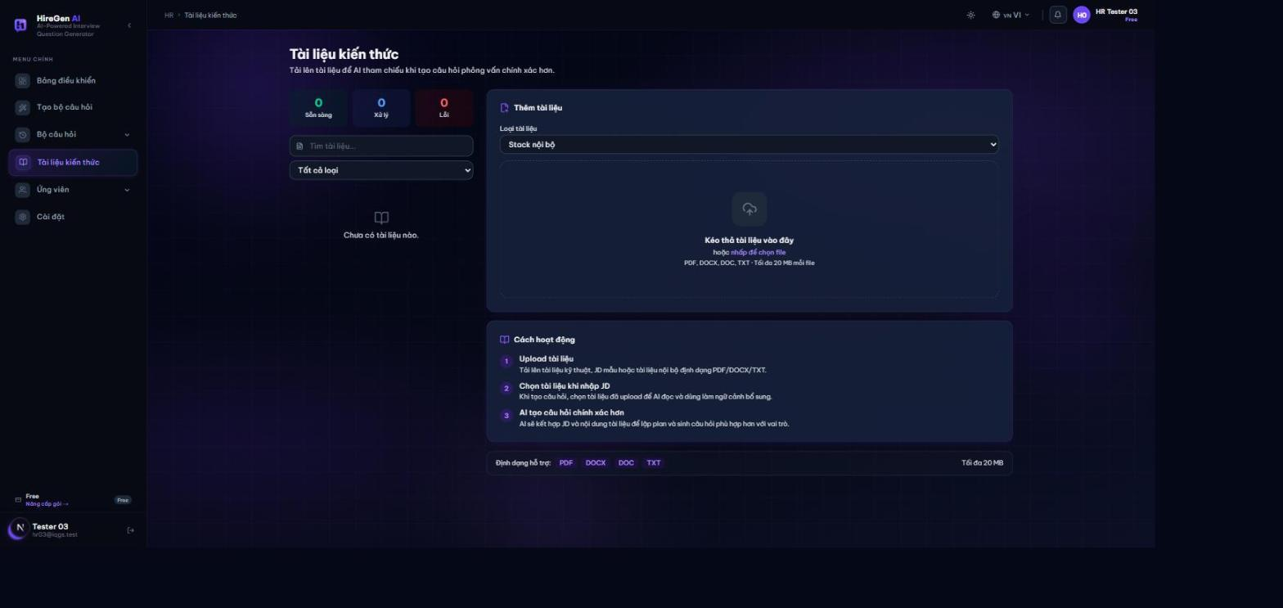
Select jd rolepack
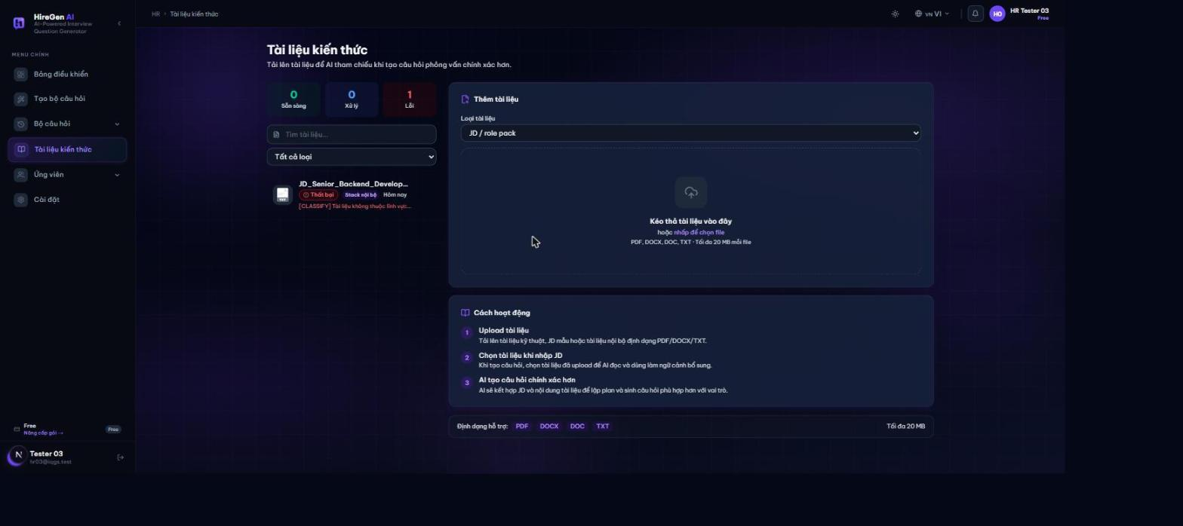
Document list status
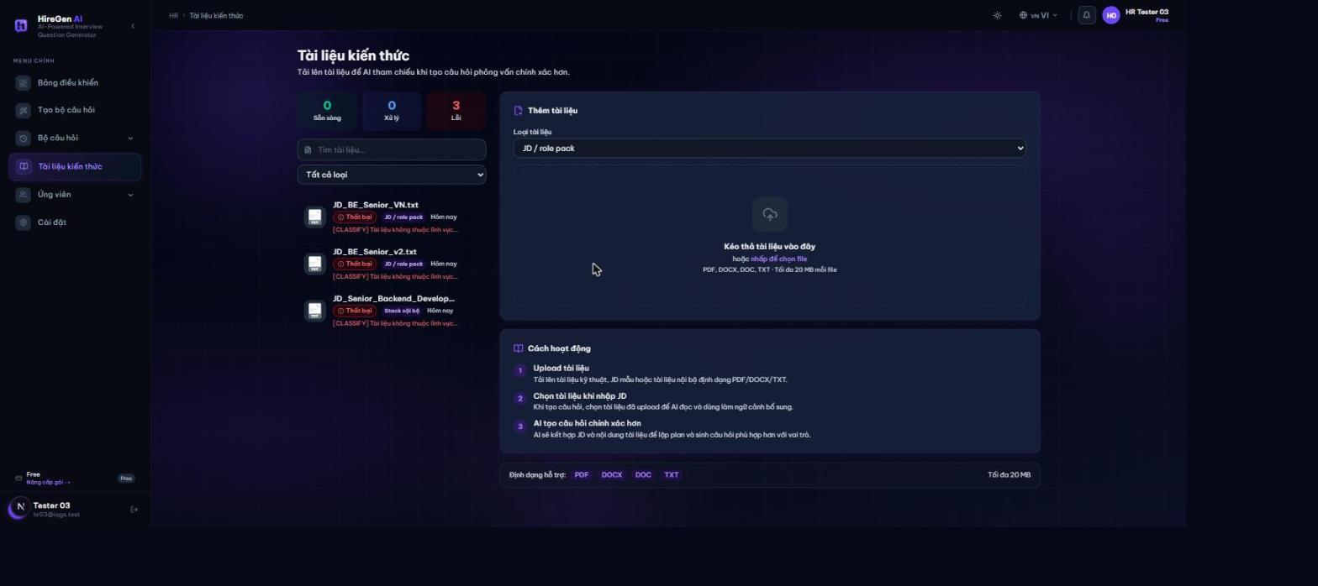
Figure 1. Knowledge ingestion

3.3 Workflow 2 Studio generation
Actor: HR.
Create or open a project and paste or upload the JD; analyze the JD and confirm its role, skills and metadata, attaching relevant HR documents; generate the interview plan and review and approve it; generate the questions and wait for the run to reach Completed; then review the wording, rubric and citations, regenerate as needed, and save the result as a question set.
Expected outcome and limits: A reviewed saved set is ready for publication. The old /hr/generate route redirects to this screen.
Studio start
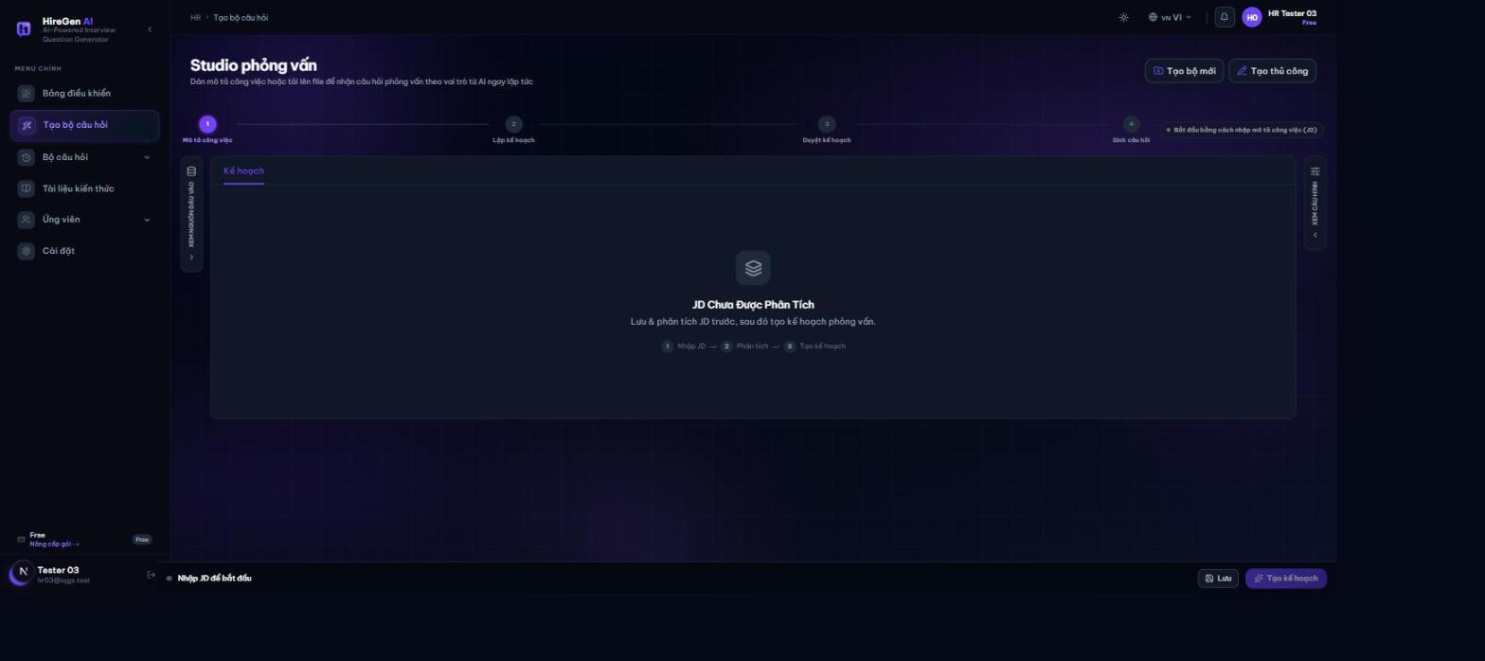
Jd input panel
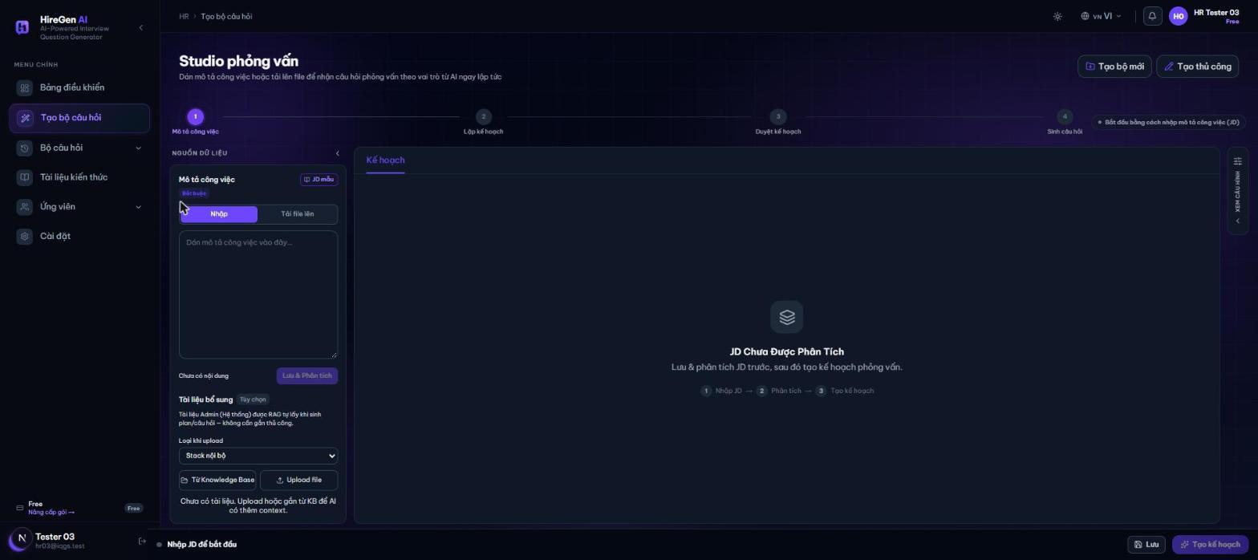
Jd analyzed
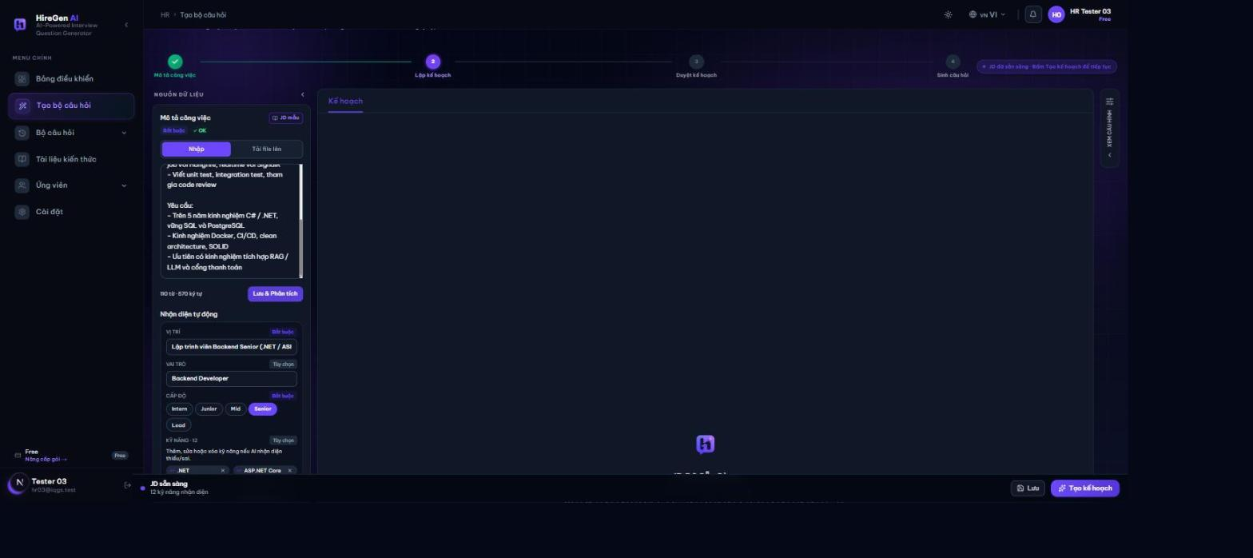
Plan generating
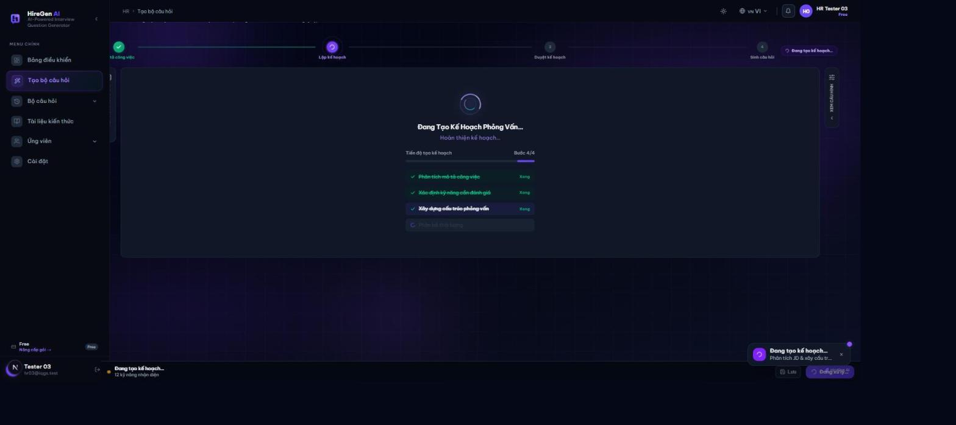
Plan review
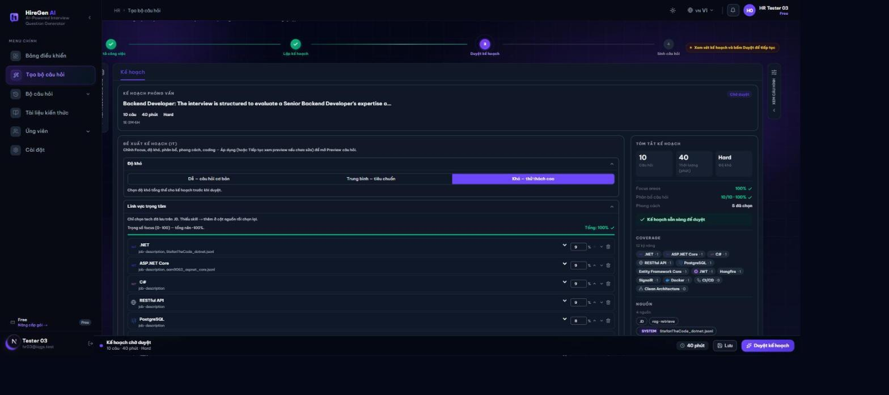
Plan approved
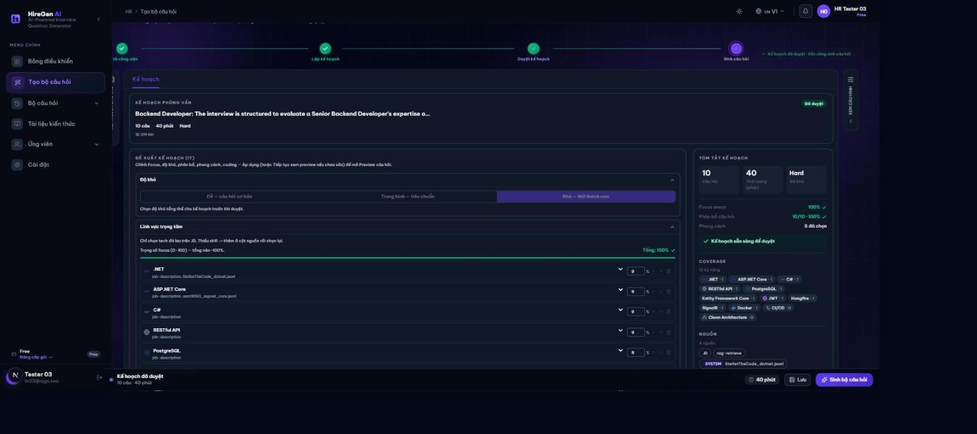
Questions generating
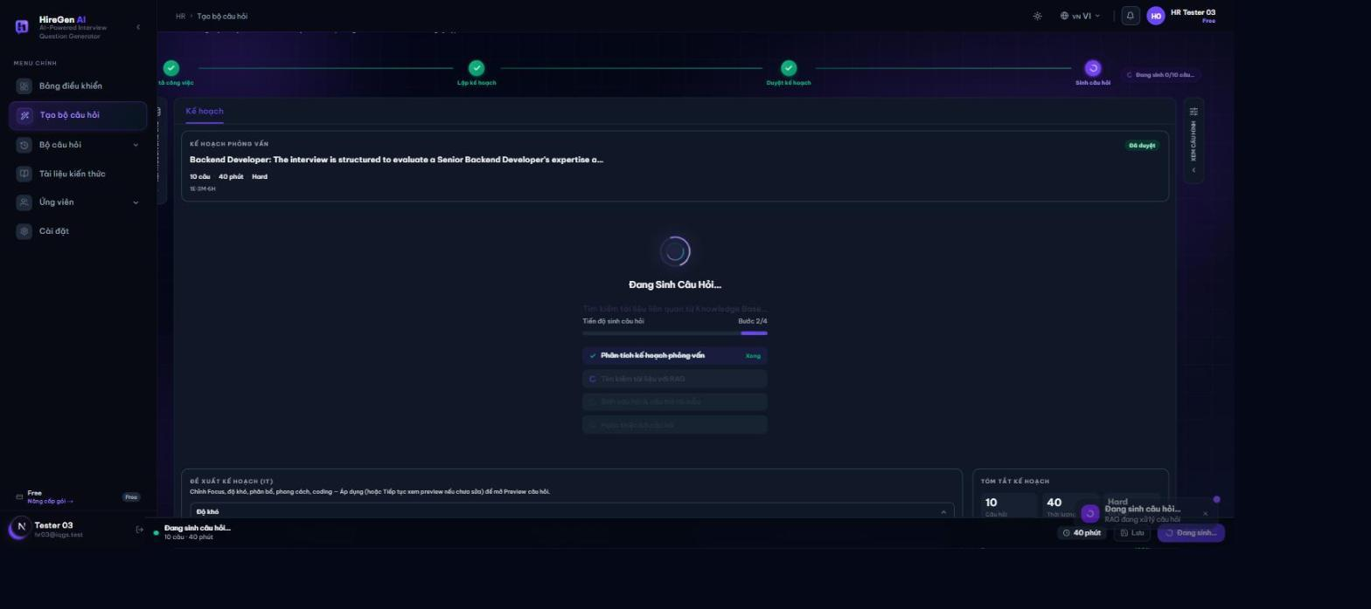
Questions generated
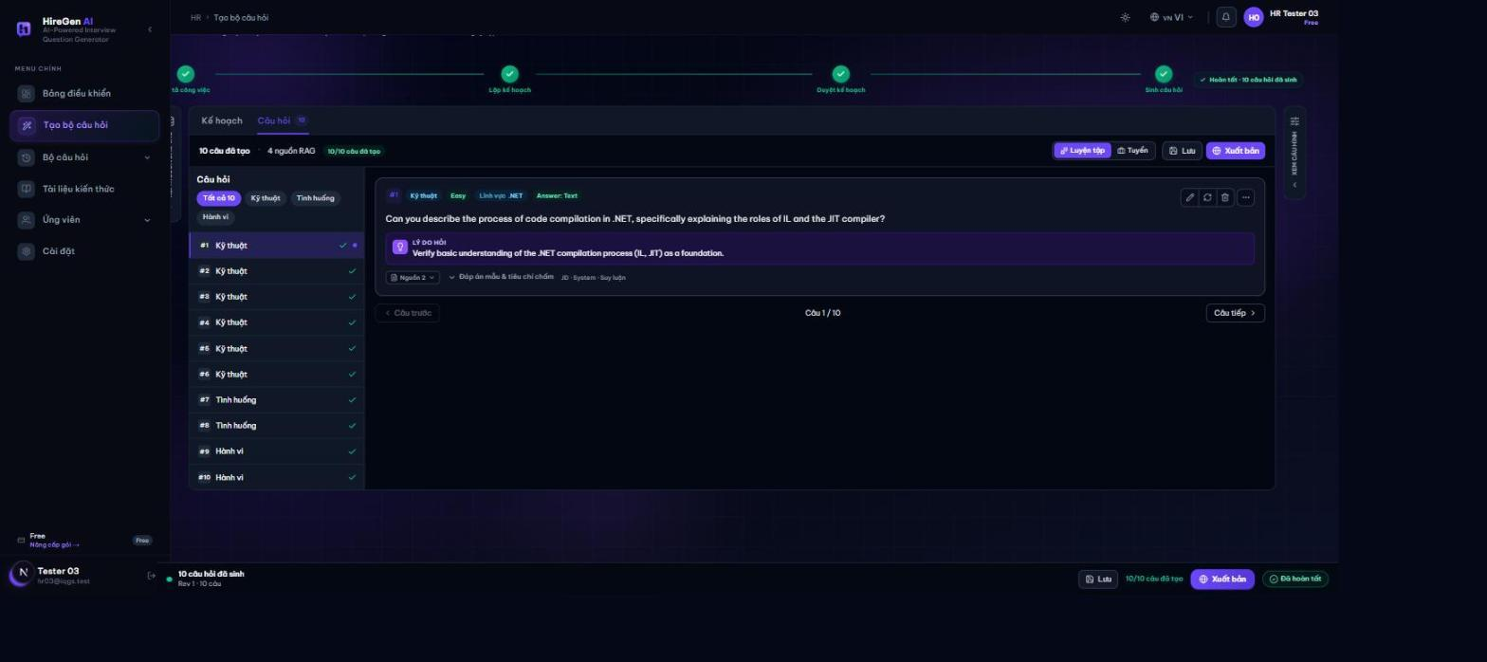
Answer rubric expanded
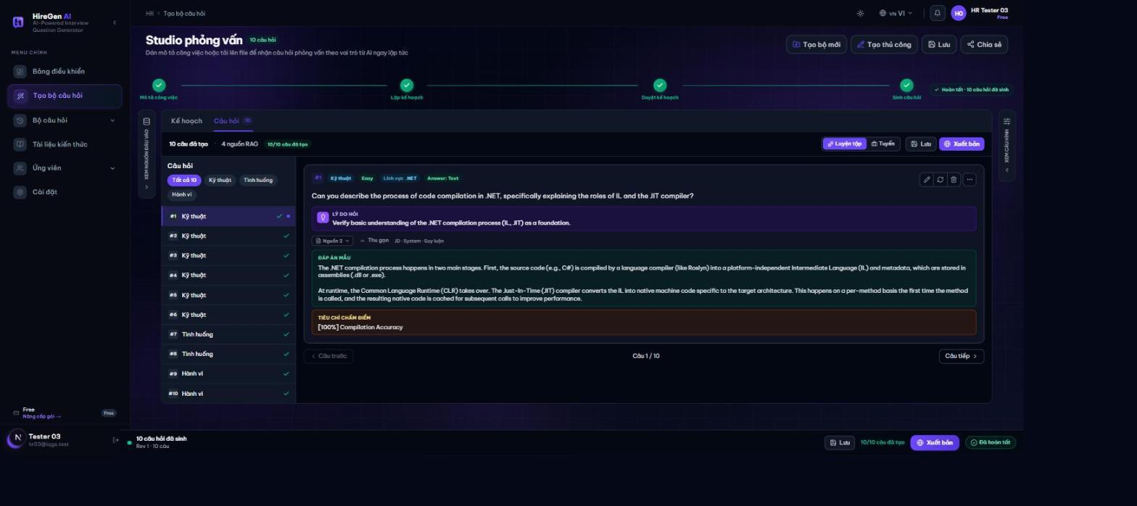
Set saved
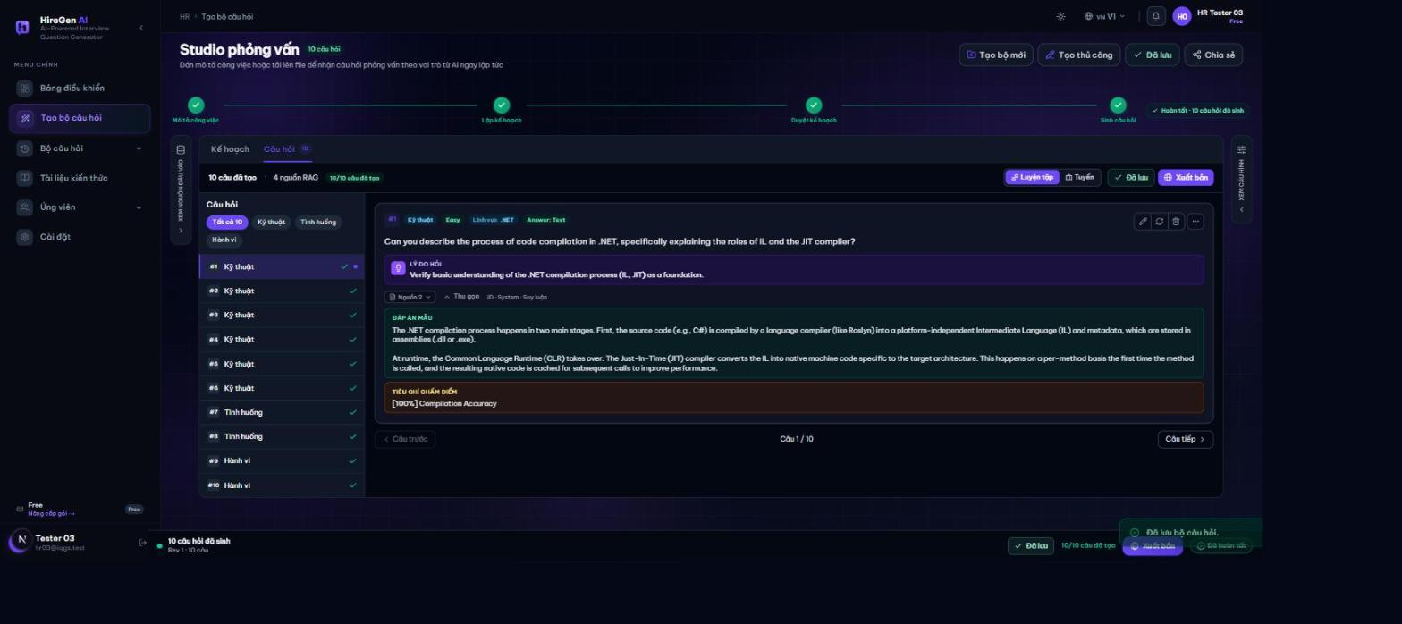
Figure 2. Studio generation

3.4 Workflow 3 Studio chat and refinement
Actor: HR.
Open a project with its JD/plan context, enter a plan-change request and inspect the returned changes and explanation, then review the new plan before approving it or regenerating again.
Expected outcome and limits: Transcript history persists. The generic SSE chat endpoint is a mock implementation and is not the validated AI-refinement path.
Quota limit dialog
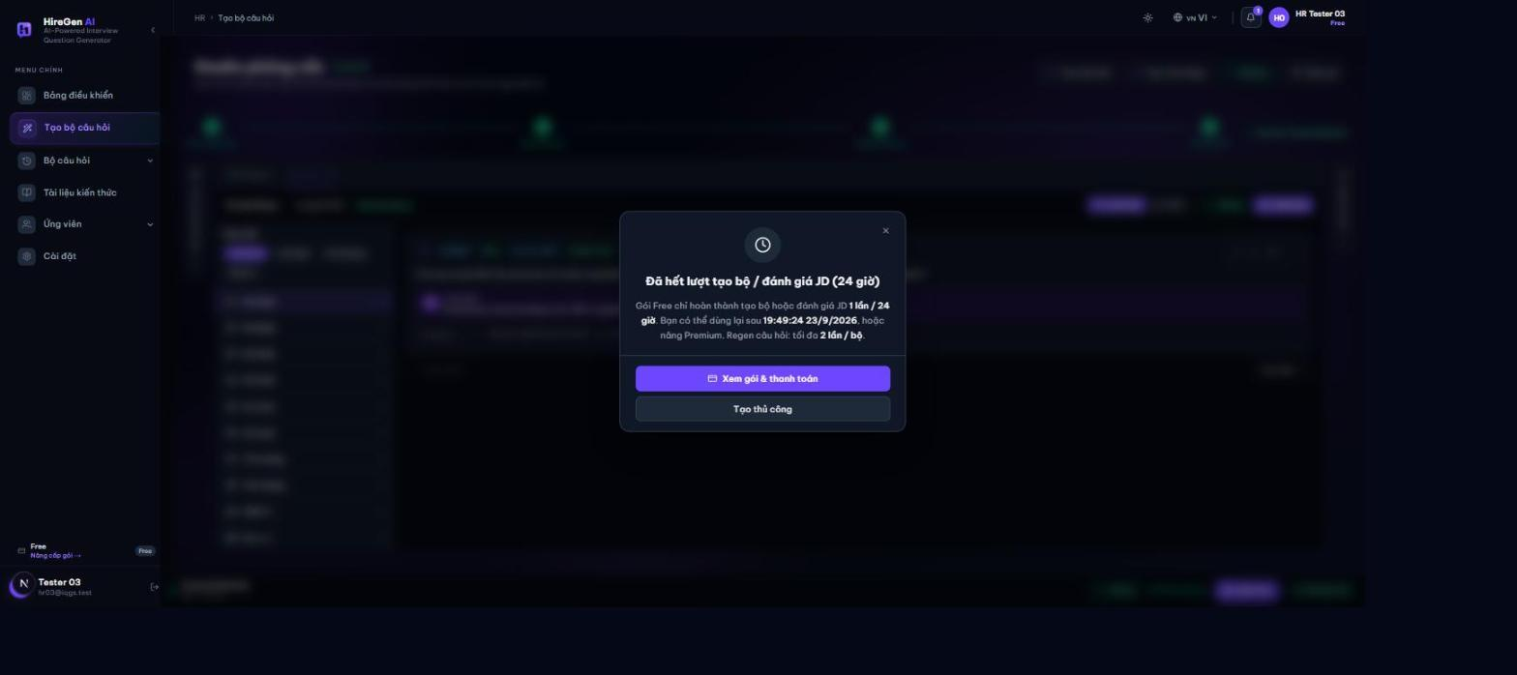
Figure 3. Studio chat and refinement

3.5 Workflow 4 Manual question builder
Actor: HR.
Create a set with a title and role/JD context; add the question content, type, difficulty, skill, answer and rubric; attach an image if needed, order the questions and set a time limit; then save it as a draft or publish it after review.
Expected outcome and limits: The manual set uses the same question-set lifecycle as Studio output.
Manual builder start
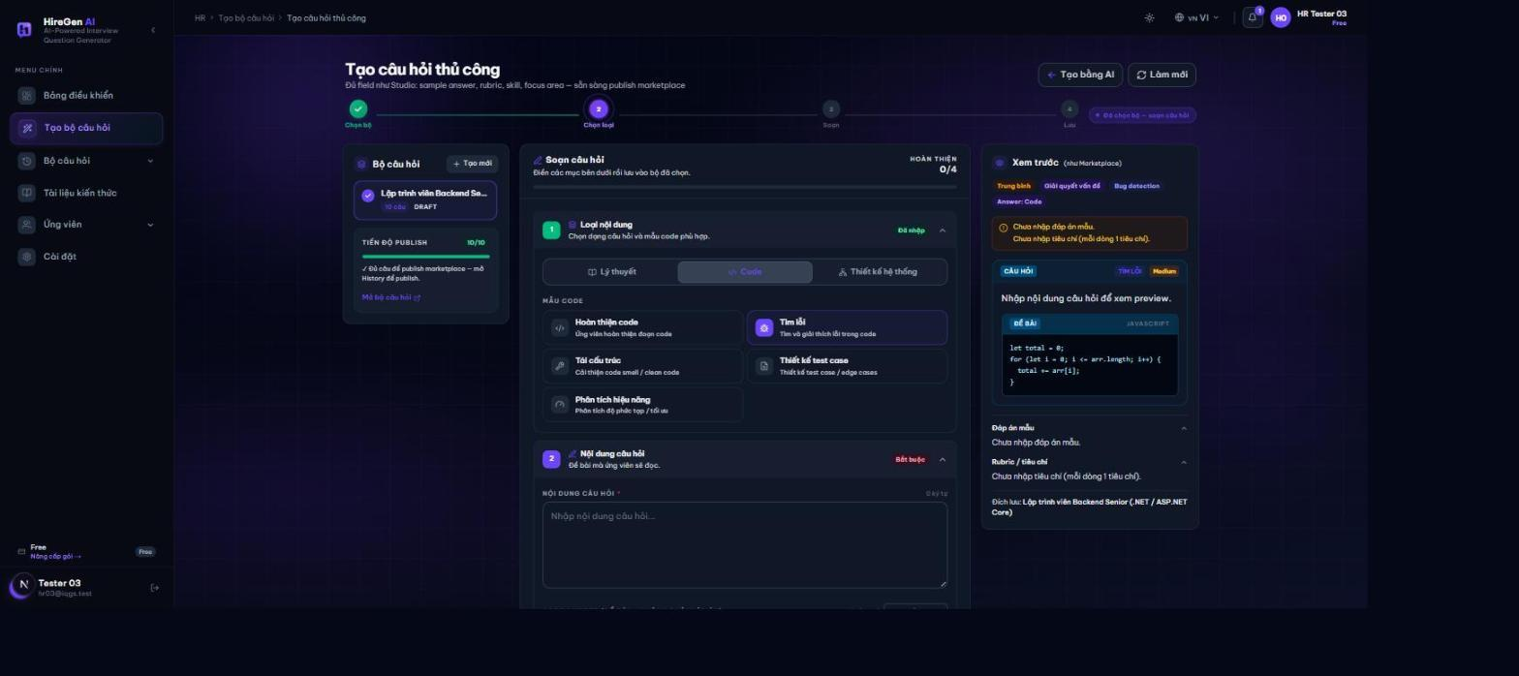
Question content filled
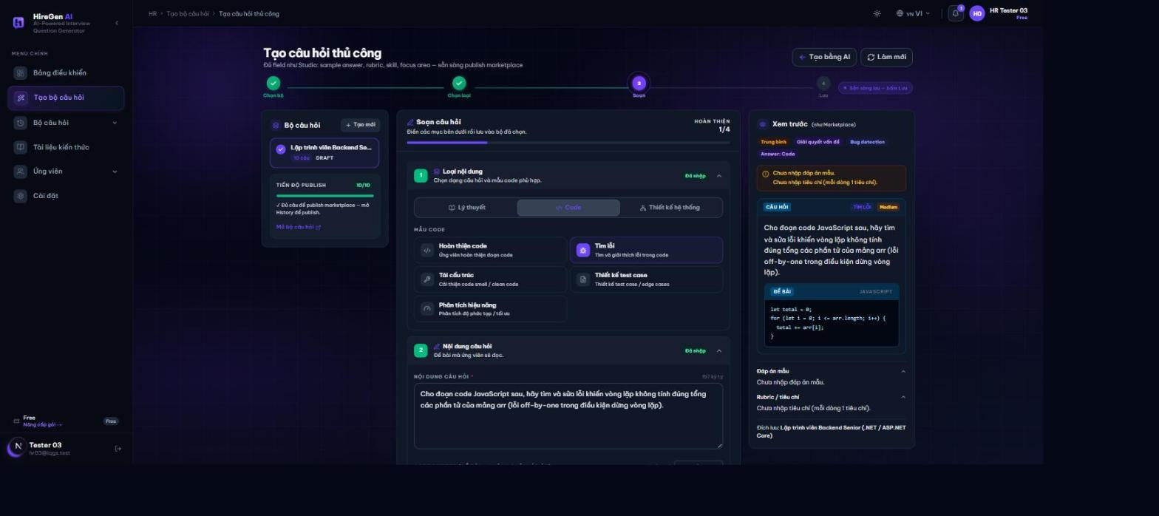
Classification section
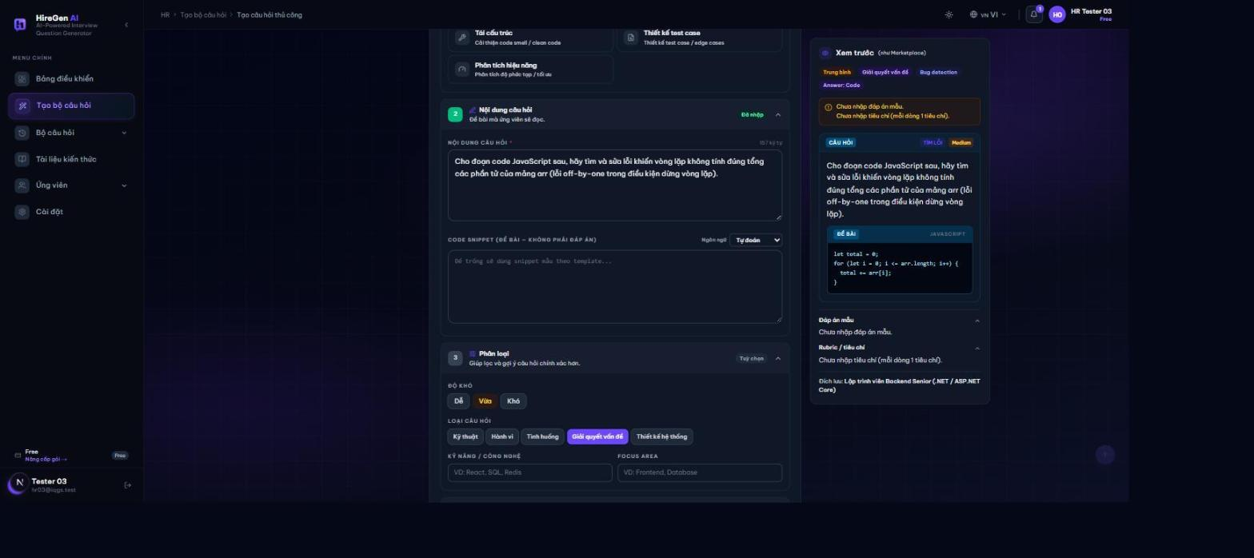
Skill focus filled
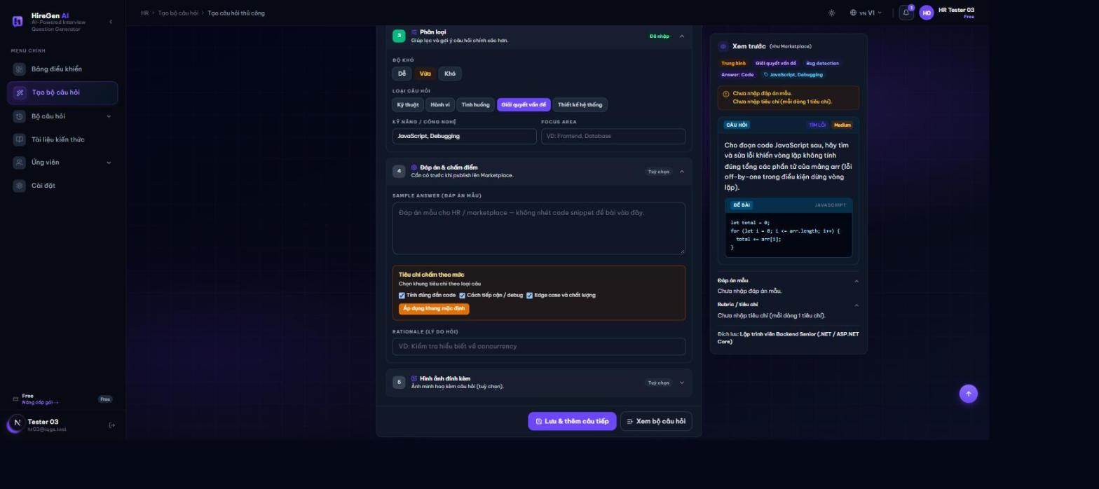
Answer rubric filled
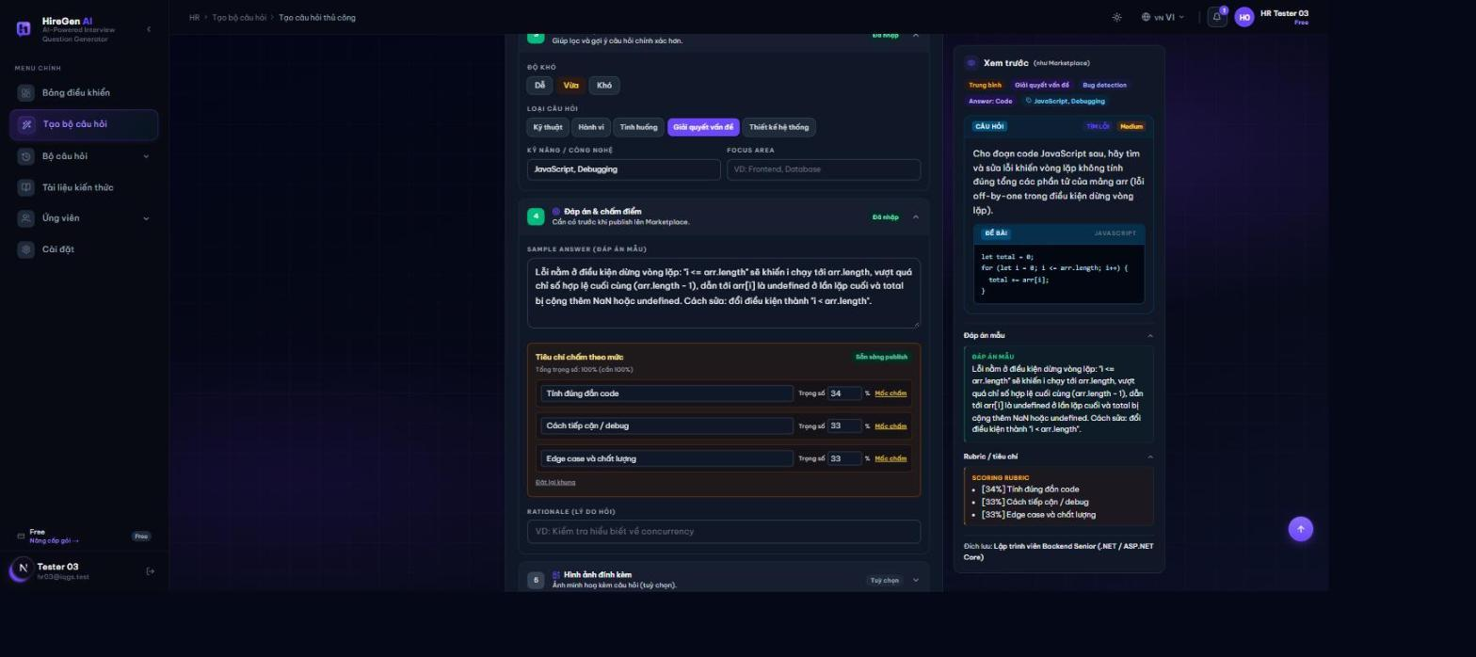
Image section rationale
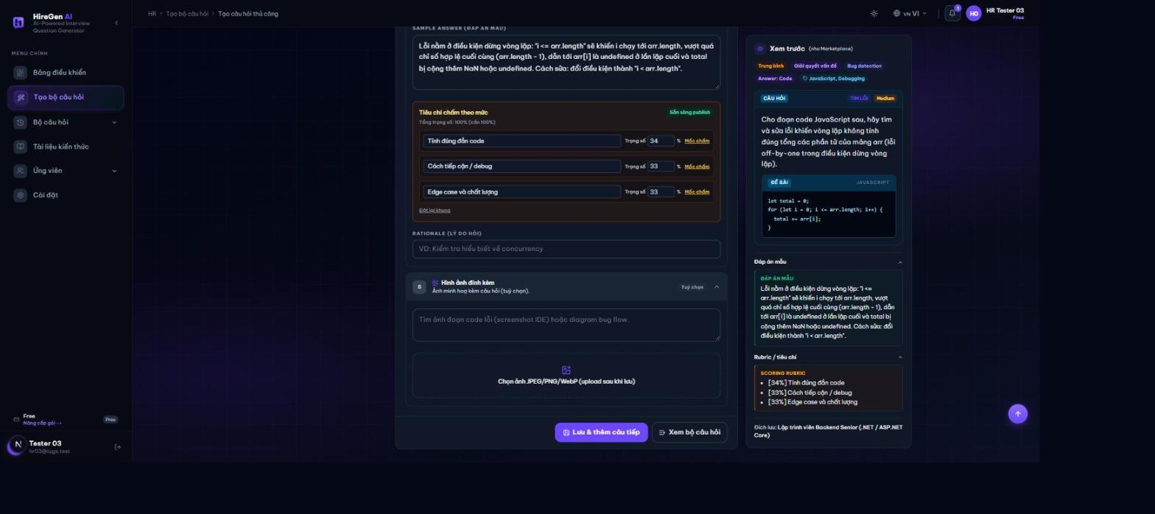
Question saved
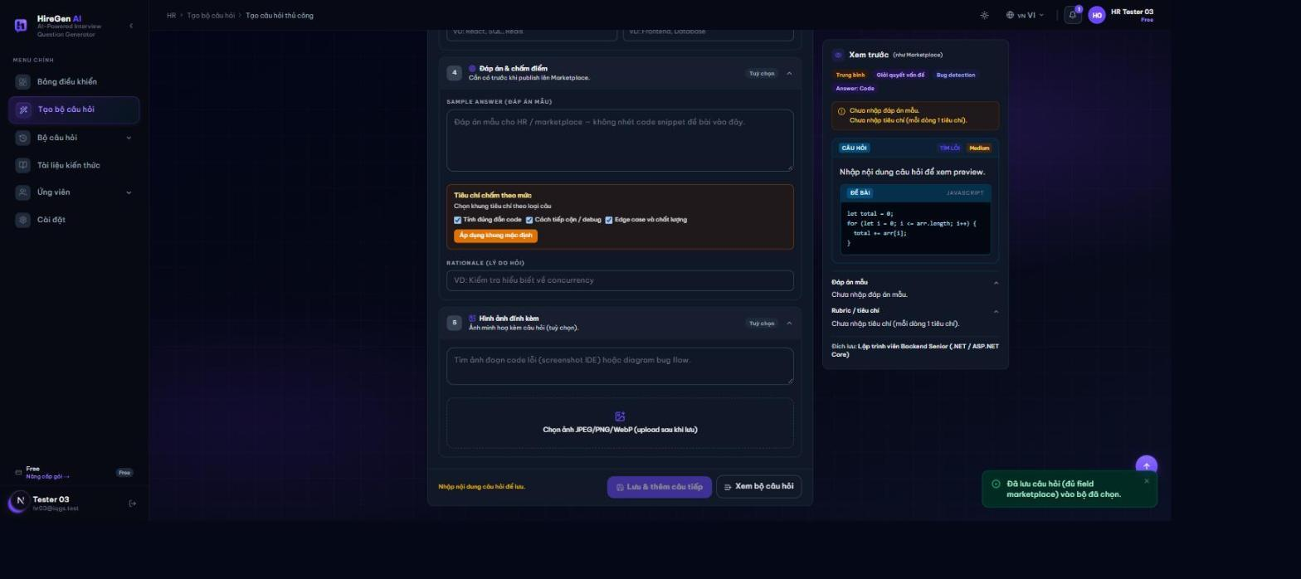
Set now 11 questions
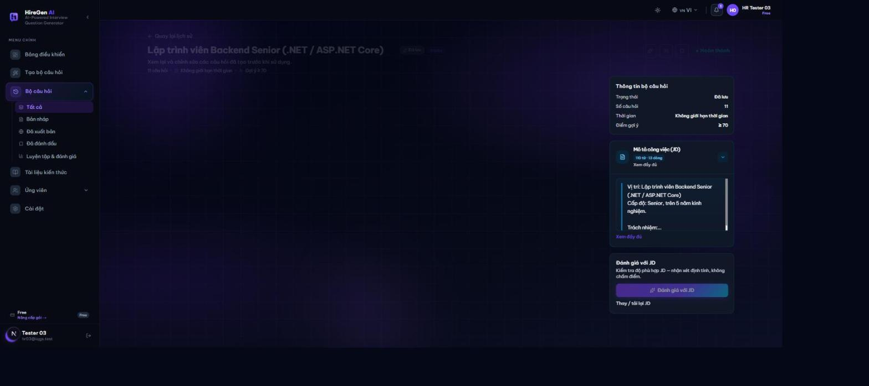
Figure 4. Manual question builder

3.6 Workflow 5 Candidate overview and recruitment
Actor: HR.
Open recommendations or talent discovery and filter the list; inspect a candidate's skills, practice evidence and consent-dependent CV data; compare candidates and shortlist, dismiss or restore as appropriate; then send an invitation or offer and monitor the response.
Expected outcome and limits: Only eligible information is exposed. Candidate invitations appear in the Candidate portal.
Candidate recommendations empty
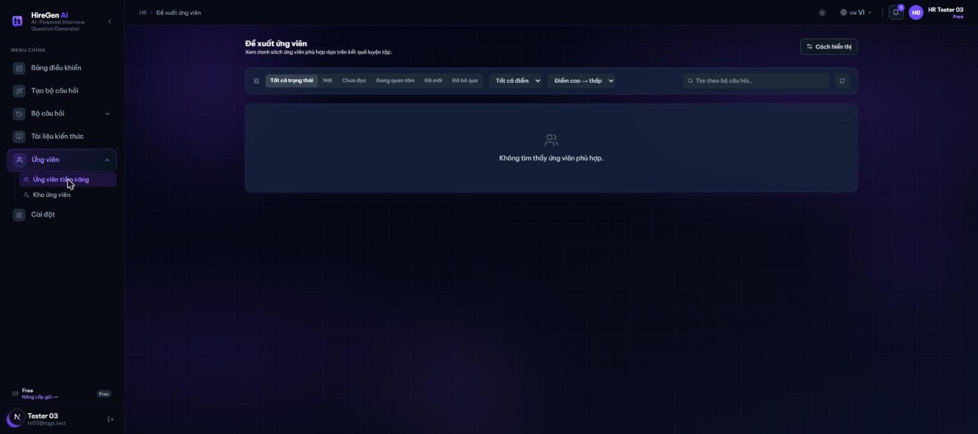
Talent pool
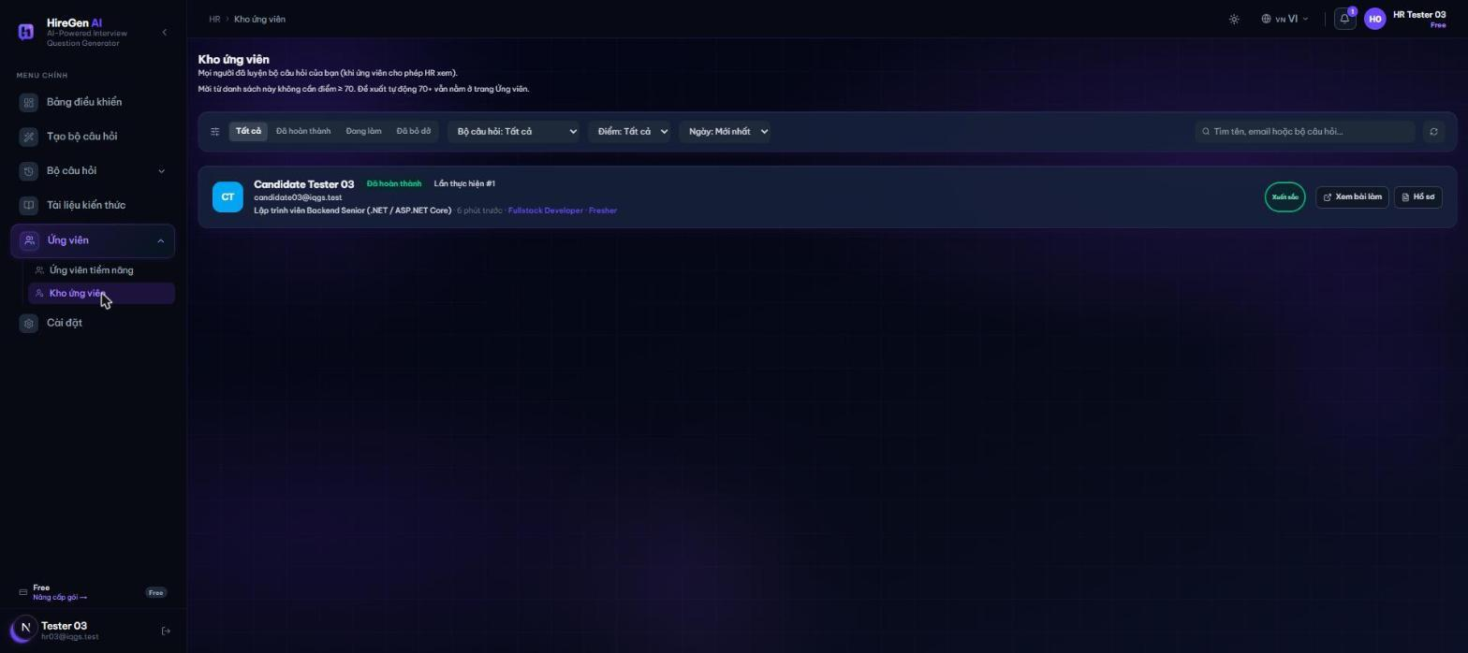
Candidate profile detail
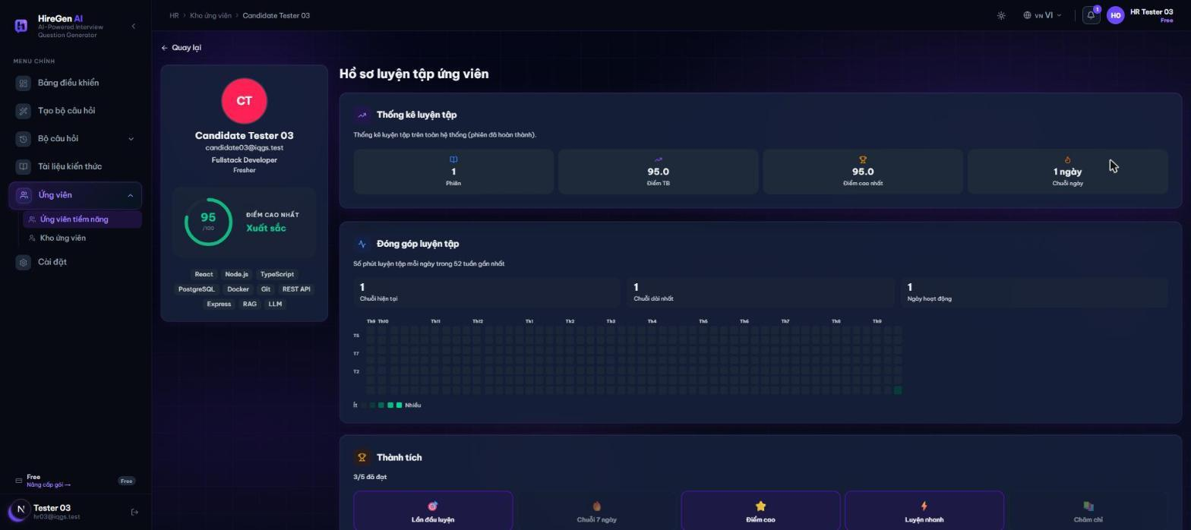
Figure 5. Candidate overview and recruitment

3.7 Workflow 6 CV upload and profile
Actor: Candidate.
Choose a CV in PDF, DOCX, JPG, JPEG or PNG within the size limit (default 5 MB) and upload it; wait for classification and parsing, noting that invalid input may be rejected; review the extracted skills, summary and role and confirm or correct them; then manage profile synchronization and locked fields, deleting the CV if needed.
Expected outcome and limits: Profile context supports practice and coaching. Parsing does not establish a demonstrated competency level.
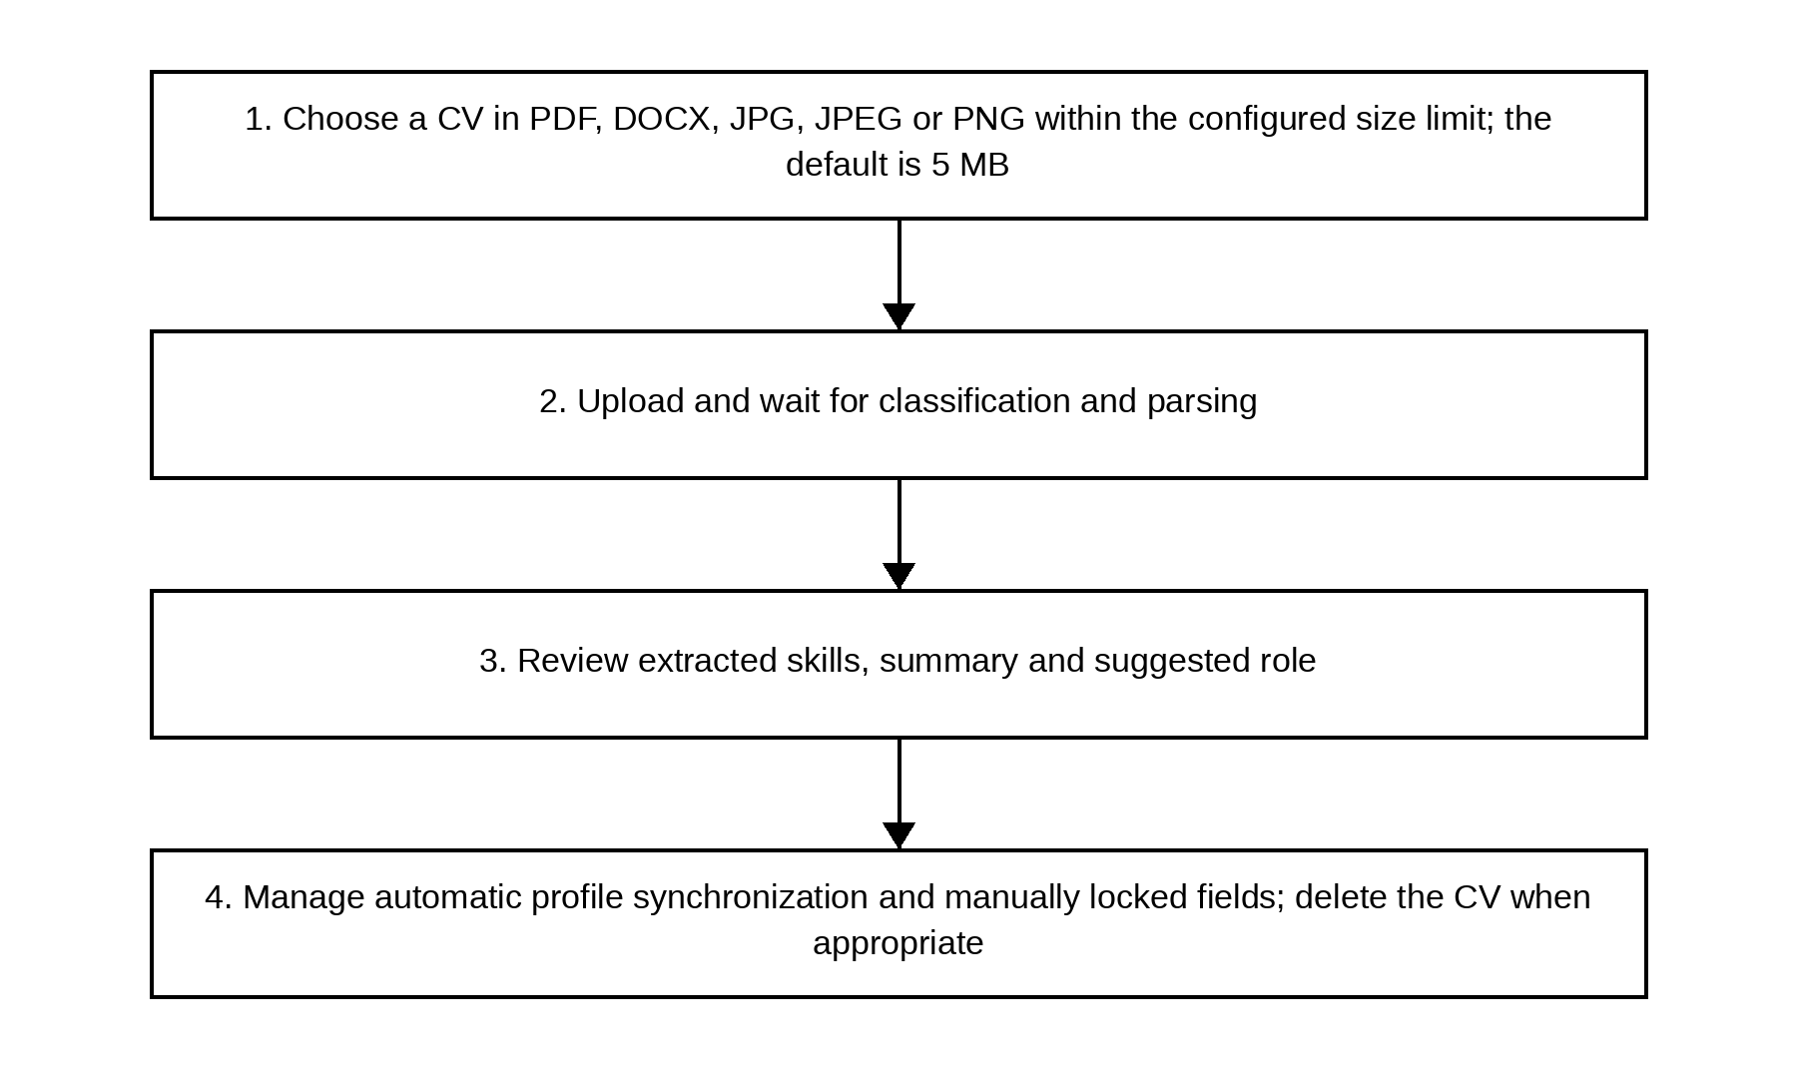
Figure 6. CV upload and profile

3.8 Workflow 7 Marketplace practice
Actor: Candidate.
Browse or filter published sets or open a bookmark (hiring postings are at /candidate/jobs); read the set's description, publisher, time limit and conditions; start or resume the session, answer the questions and save as required; then complete the session, or let it expire, and review the result once available.
Expected outcome and limits: Session state and access are enforced by the backend. Personal sets remain private to their intended owner.
Marketplace browse
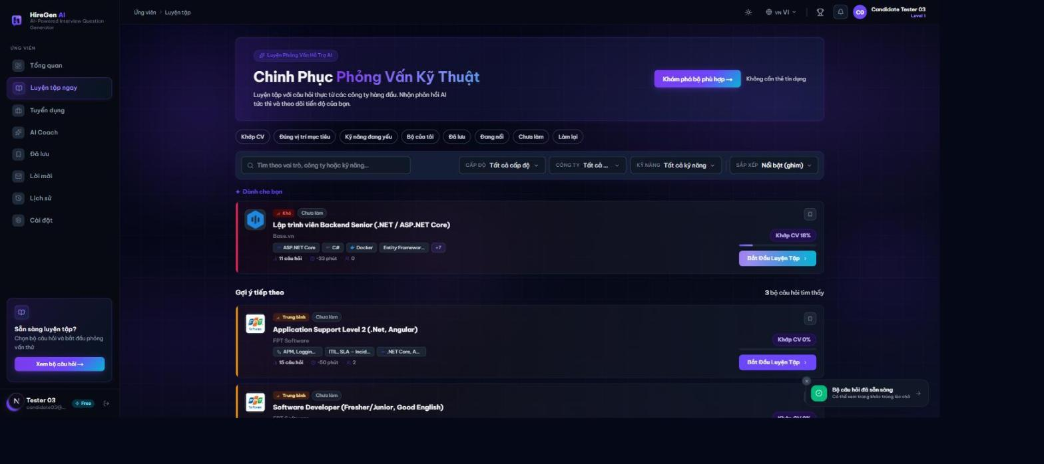
Set detail page
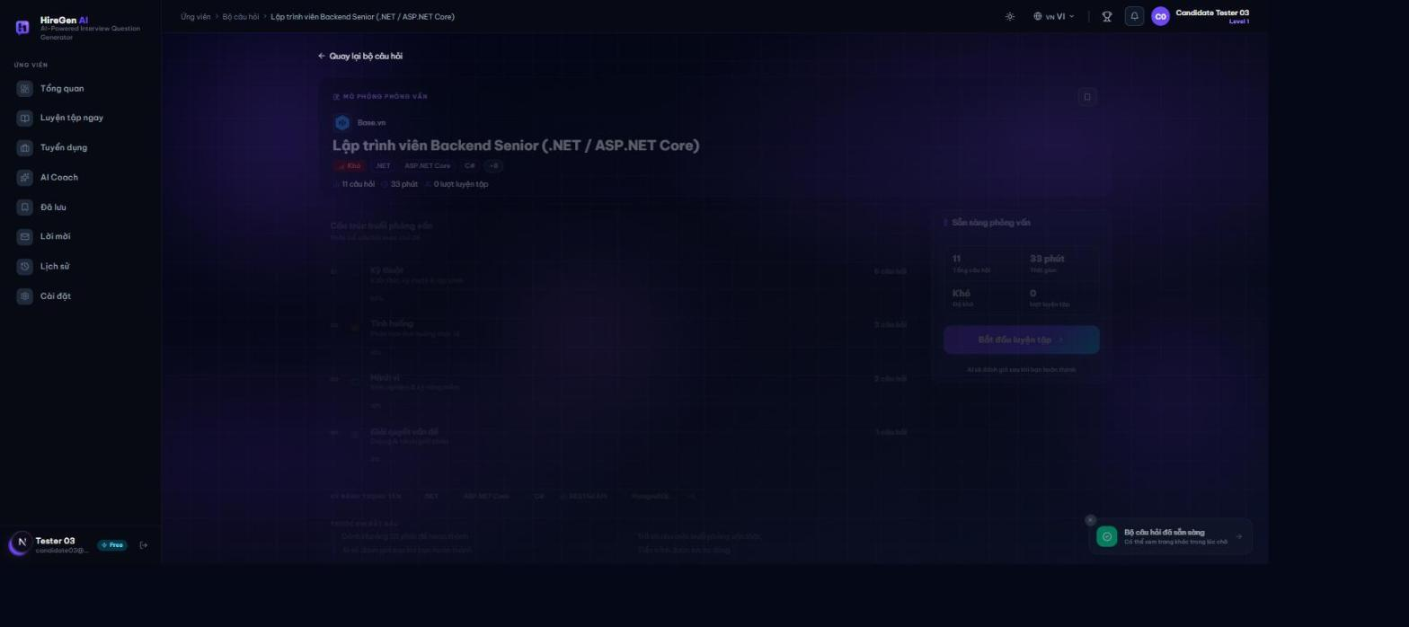
Set detail structure
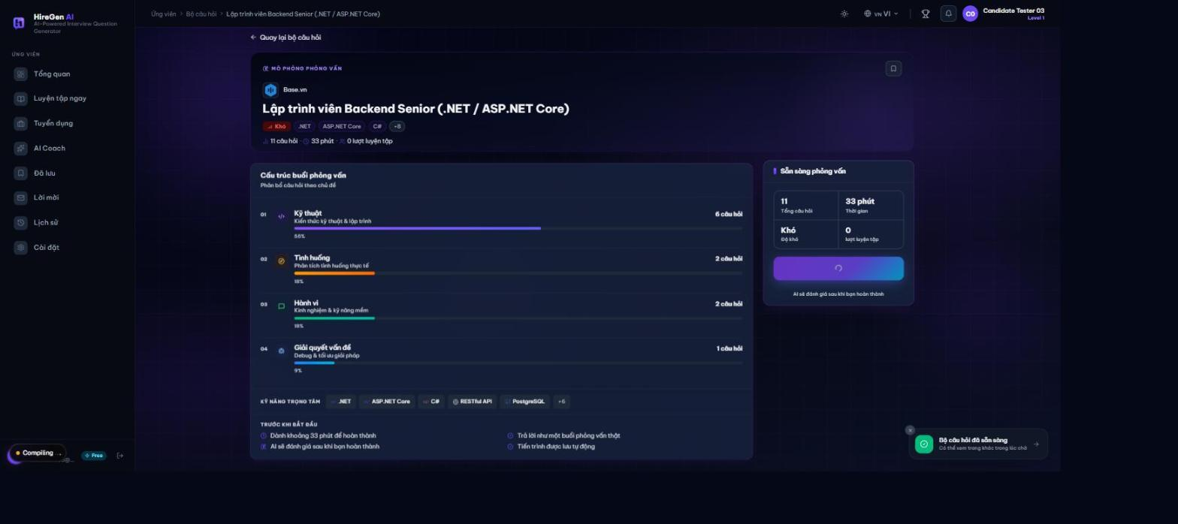
Practice question 1
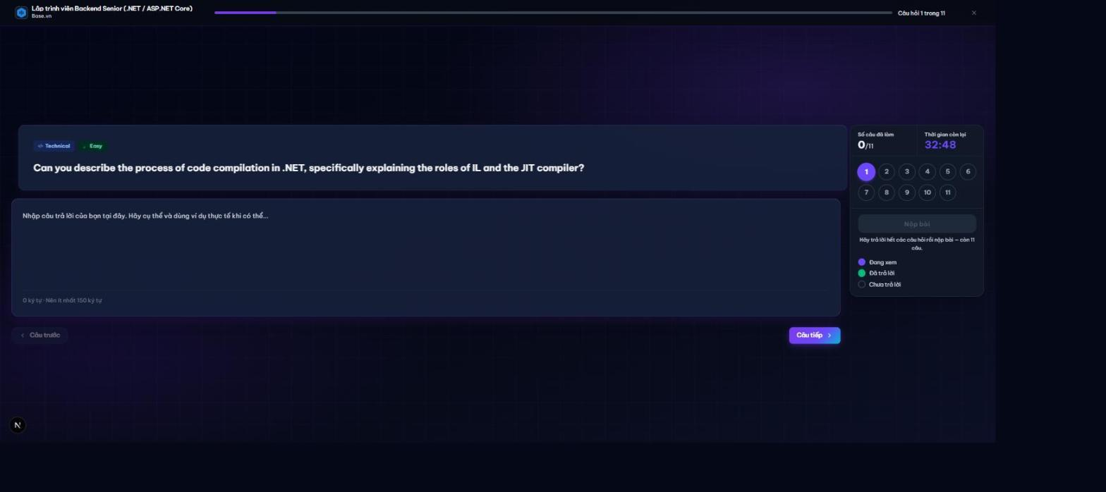
Question1 answered
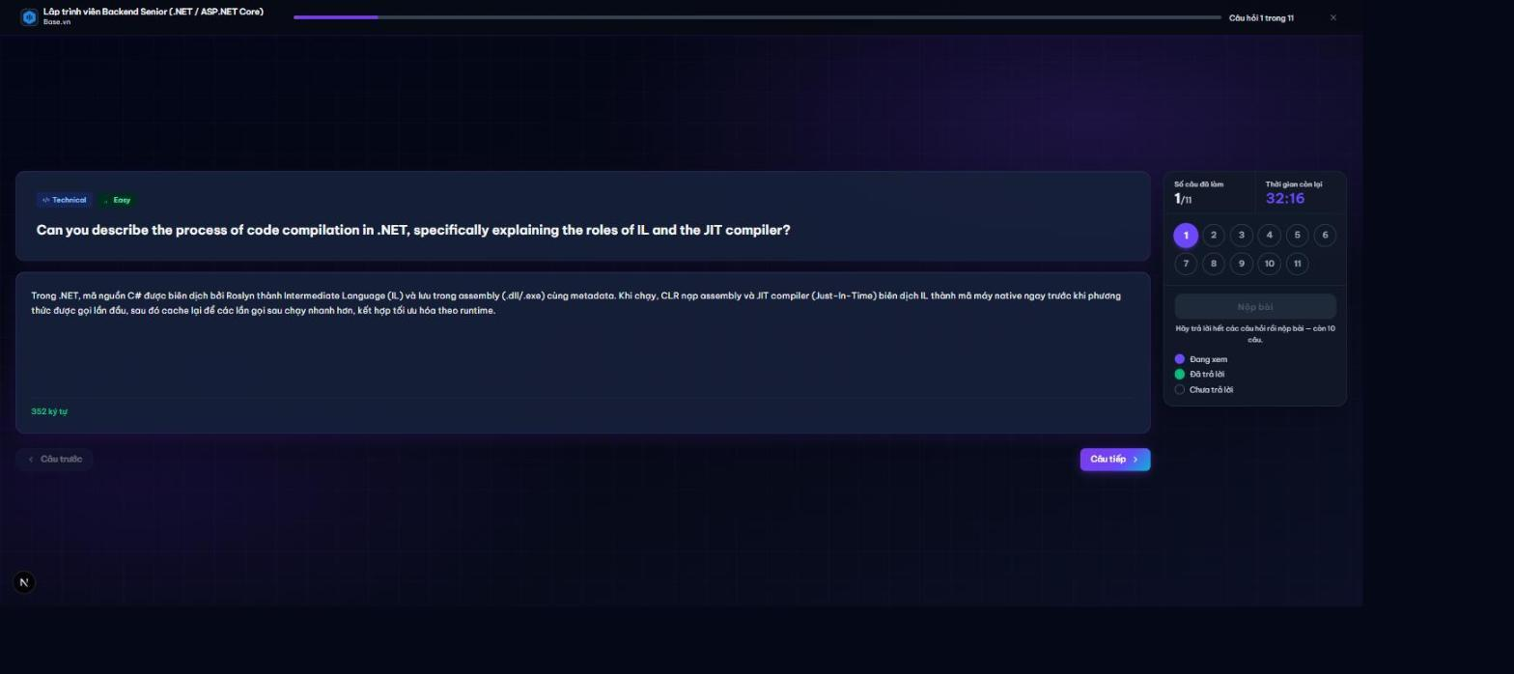
Code question
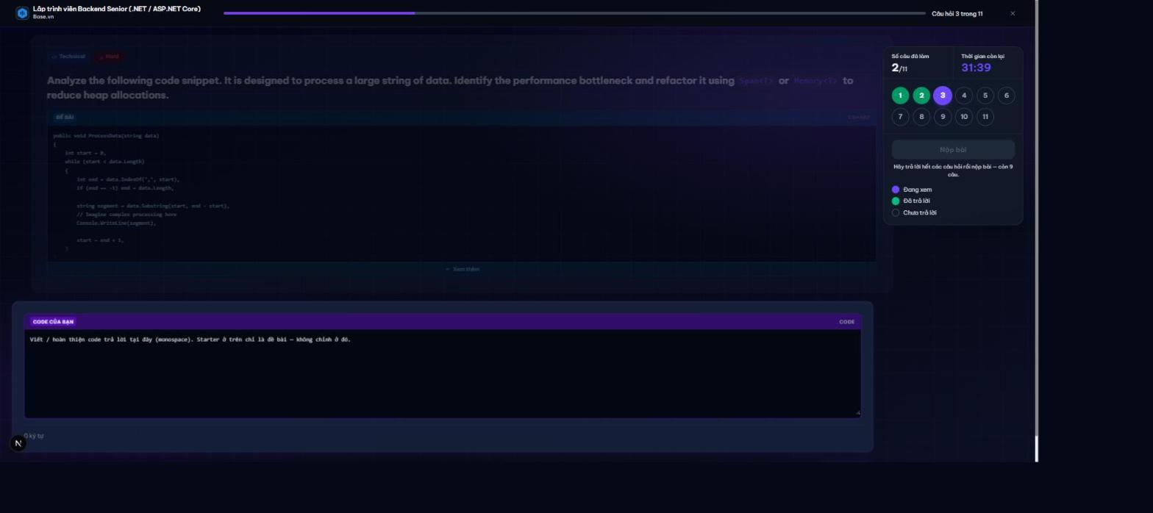
Progress midway
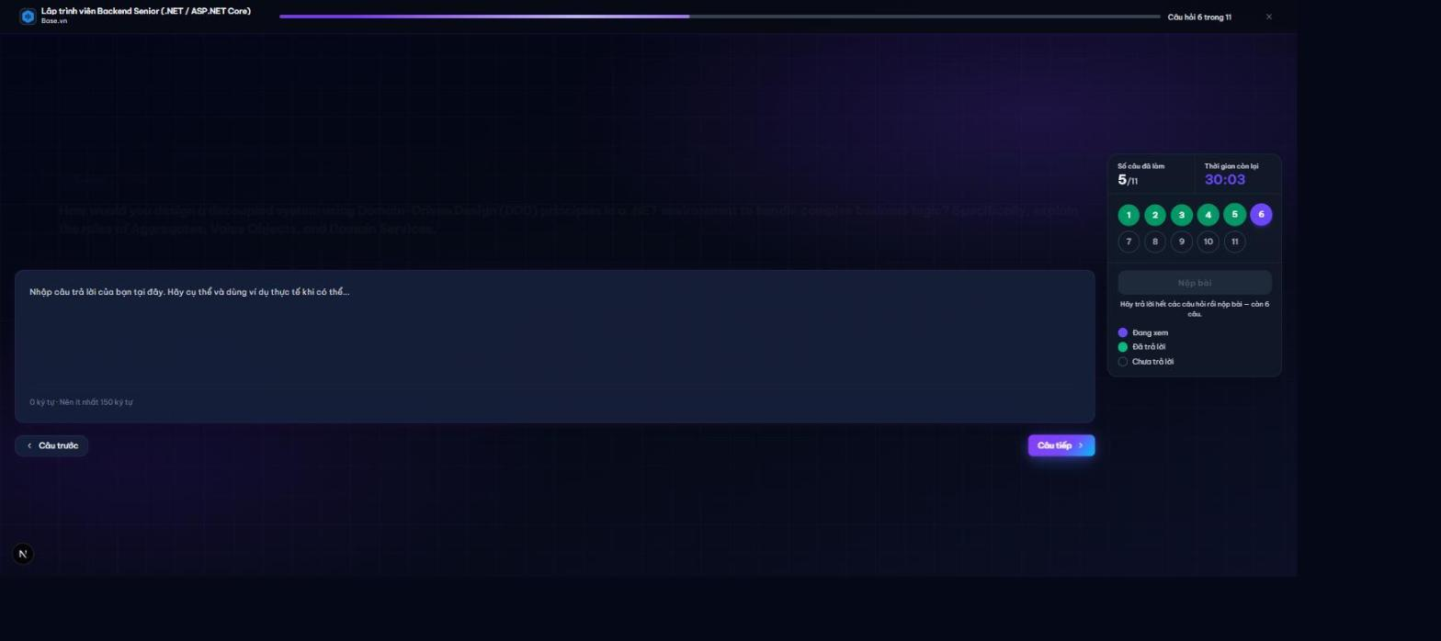
Question11 nearcomplete
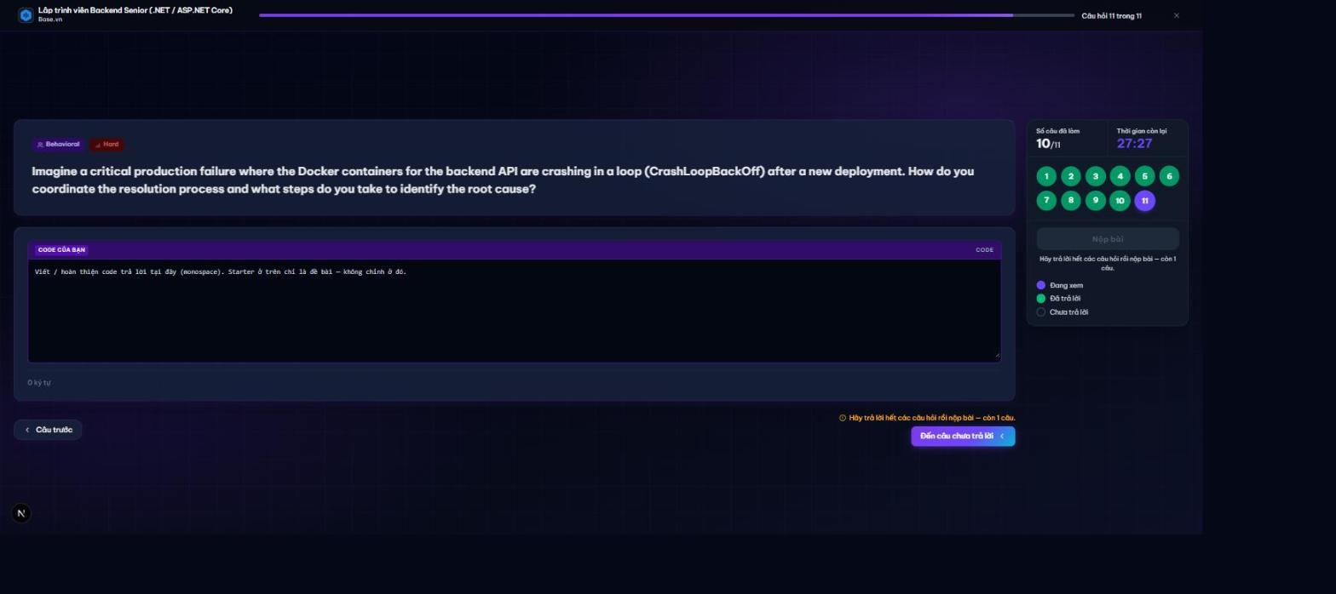
All answered ready submit
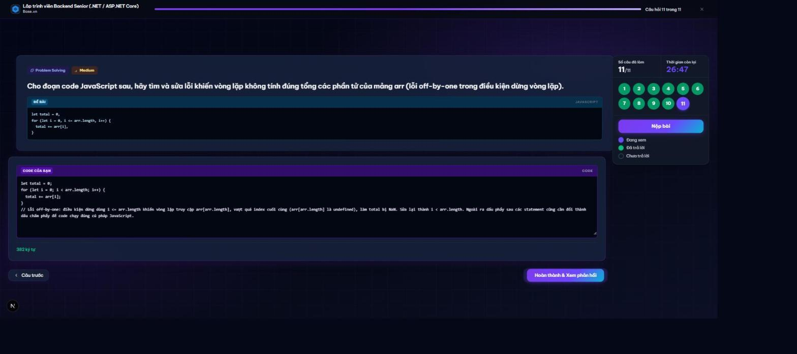
Submit confirmation
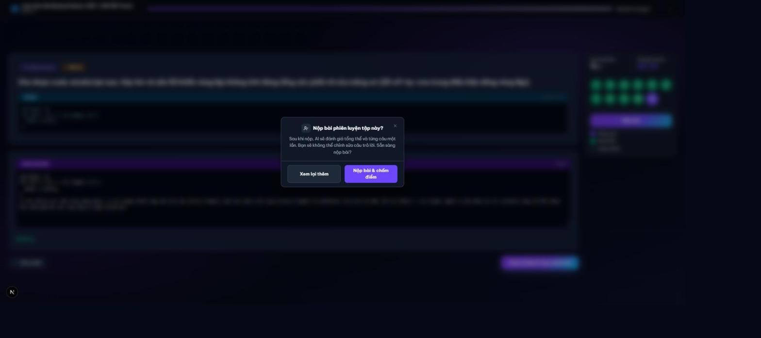
Ai evaluating
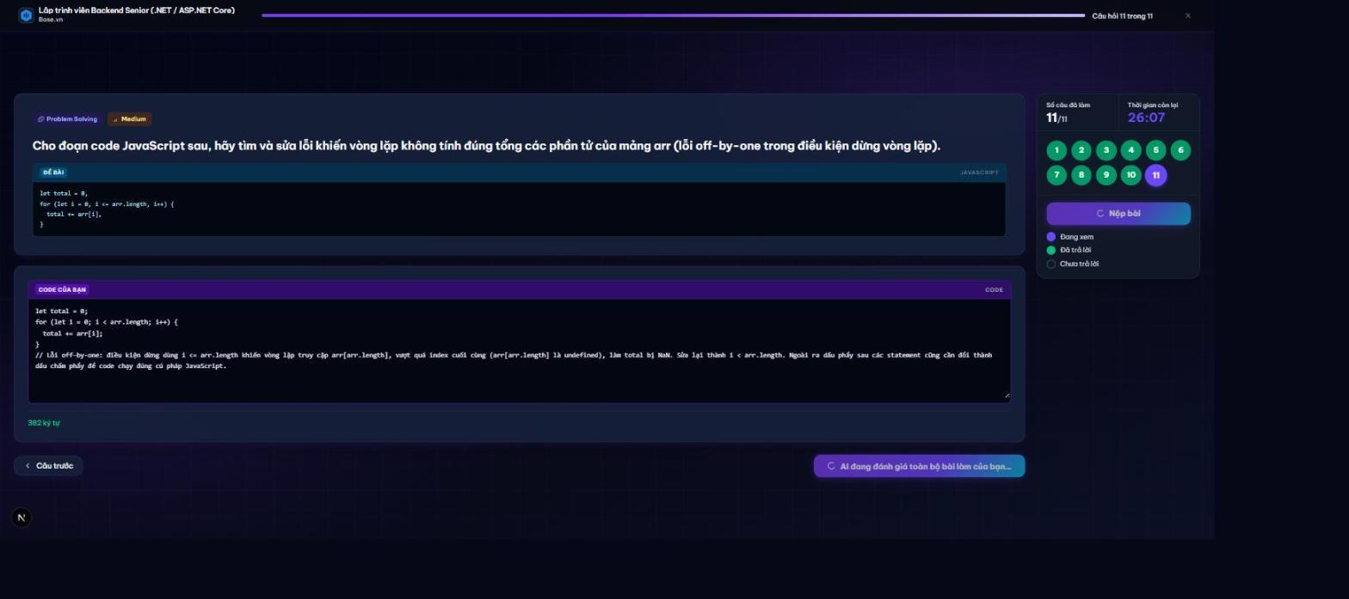
Result score 95
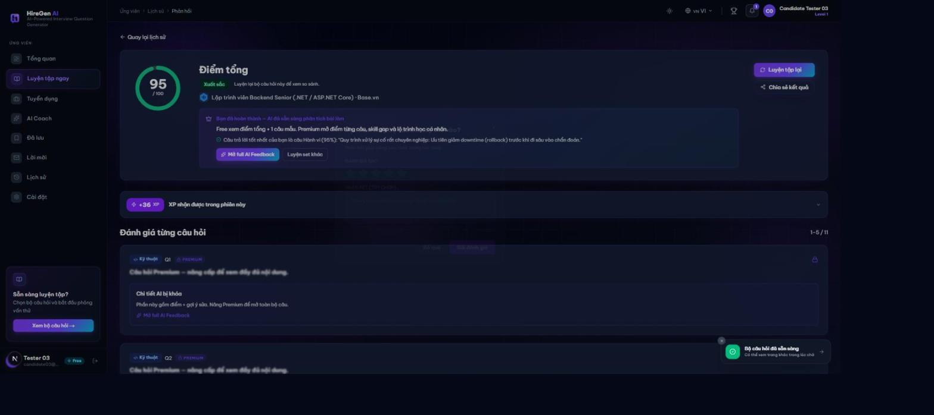
Figure 7. Marketplace practice

3.9 Workflow 8 AI feedback
Actor: Candidate.
Open a completed session result and read the overall score and subscription-level feedback; review strengths, gaps and suggested skills against the rubric; then use further practice or a coaching diagnostic to address weaknesses.
Expected outcome and limits: Feedback is advisory and model-dependent. Premium visibility and quotas are controlled by current plan limits.
Result overview
Premium locked feedback
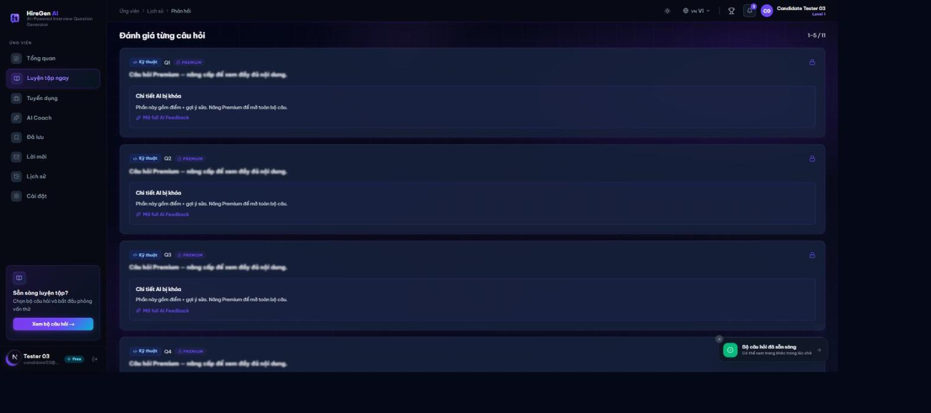
Per question review
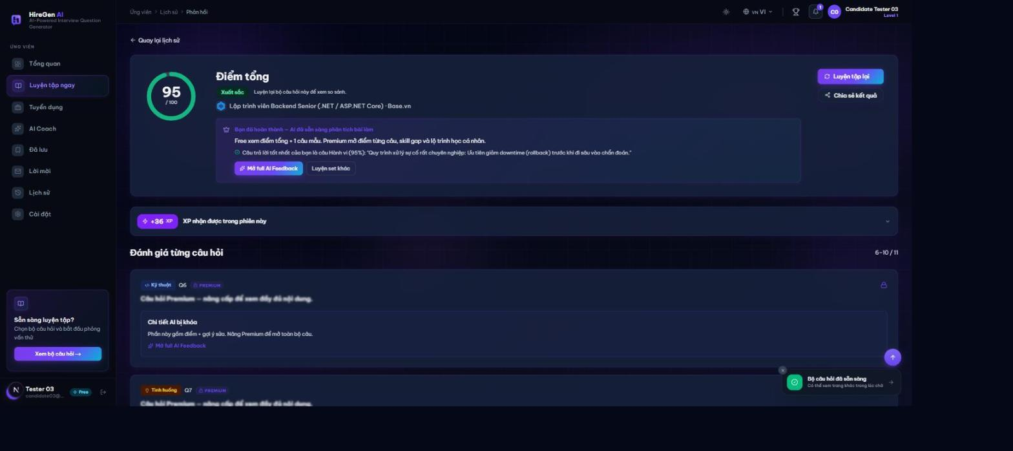
Figure 8. AI feedback

3.10 Workflow 9 Dashboard and history
Actor: Candidate.
Open the dashboard to review current activity, streak and achievements; review the practice history and reopen a completed result
Expected outcome and limits: Activity and learning evidence are distinct from a formal hiring decision.
Dashboard initial
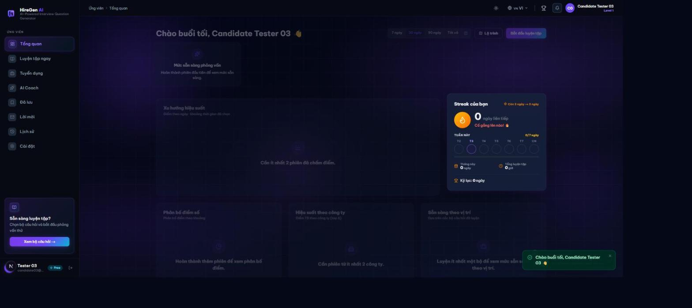
Practice history
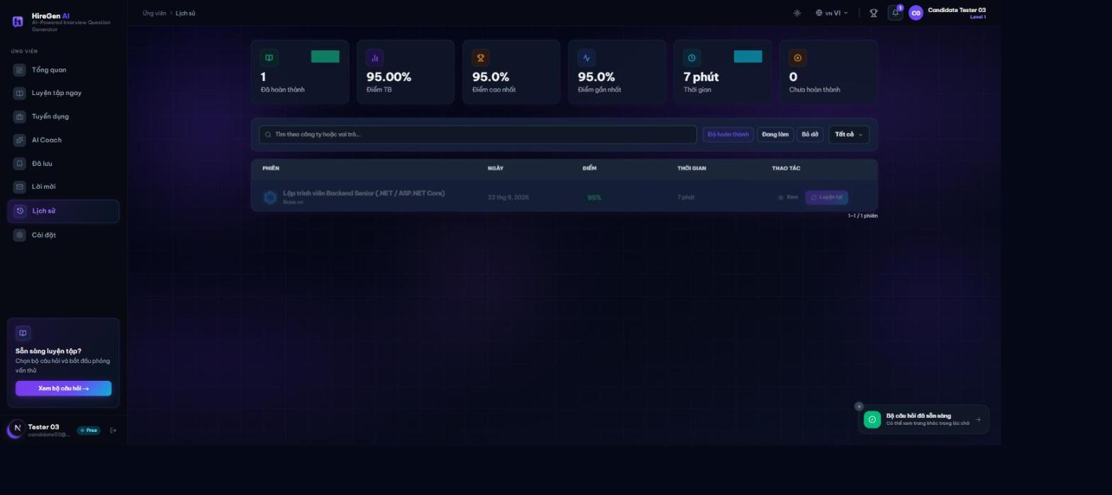
Dashboard after practice
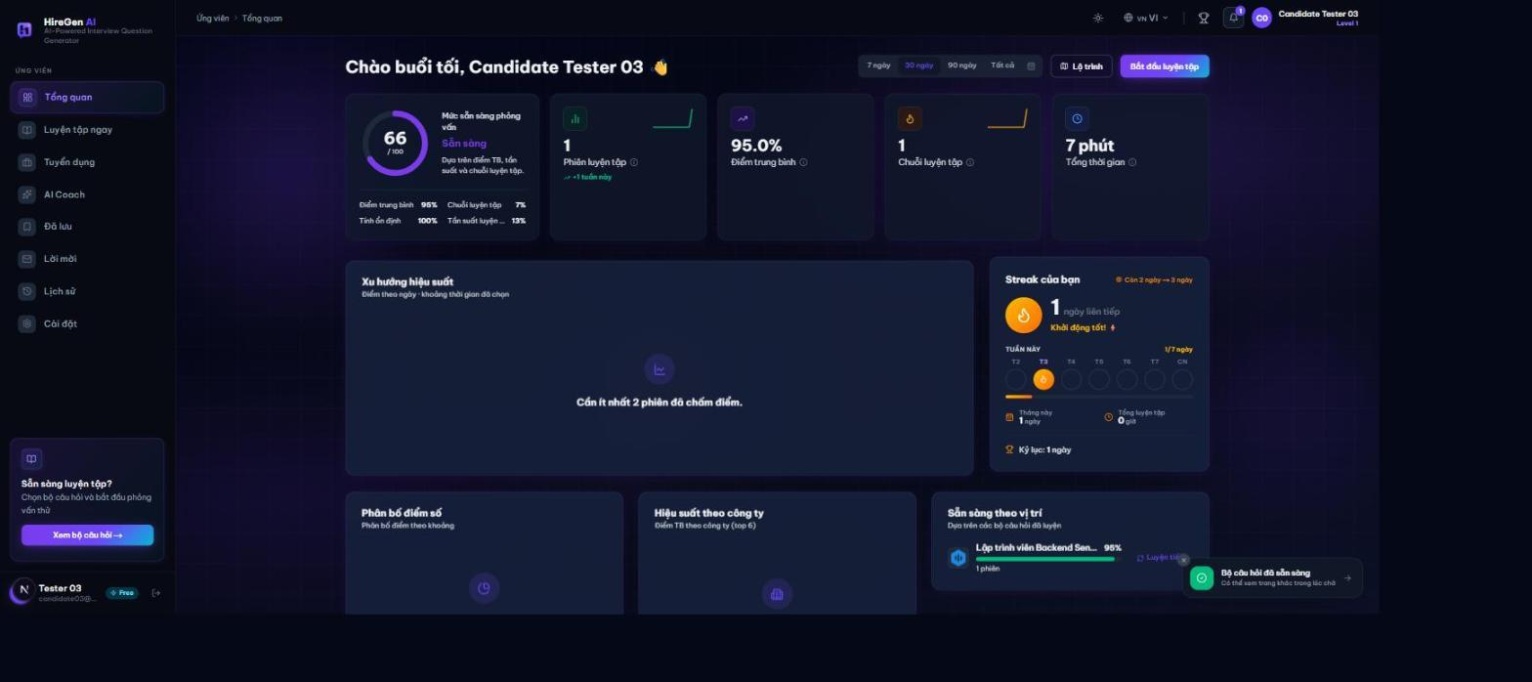
Figure 9. Dashboard and history

3.11 Workflow 10 Admin knowledge and RAG operations
Actor: Admin.
Inspect SYSTEM documents, ingestion status and folder classification; add, move, rename, reingest or remove documents as needed; check RAG health/status and database/configuration health before diagnosing failures. Editable runtime settings have no matching BE routes, and the current frontend no longer calls them, so no runtime-settings editing capability is exposed here; use server-side configuration instead.
Expected outcome and limits: Runtime overrides exist in RAG; a complete Admin editing flow is not established. A healthy /health response is not an LLM quality benchmark.
Admin knowledge overview
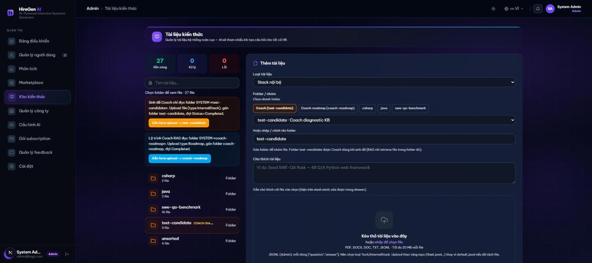
Folder file list
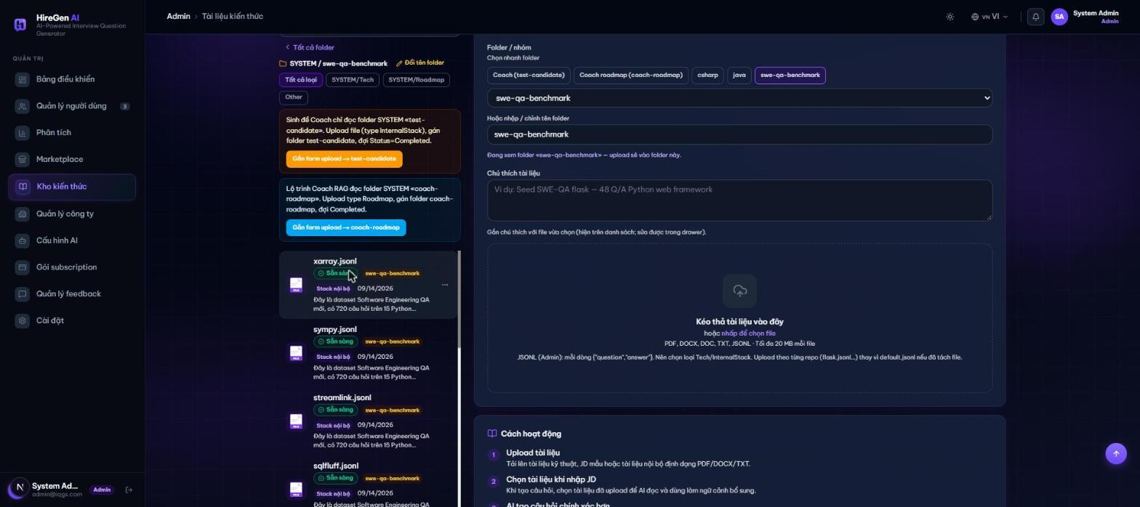
Rag system status
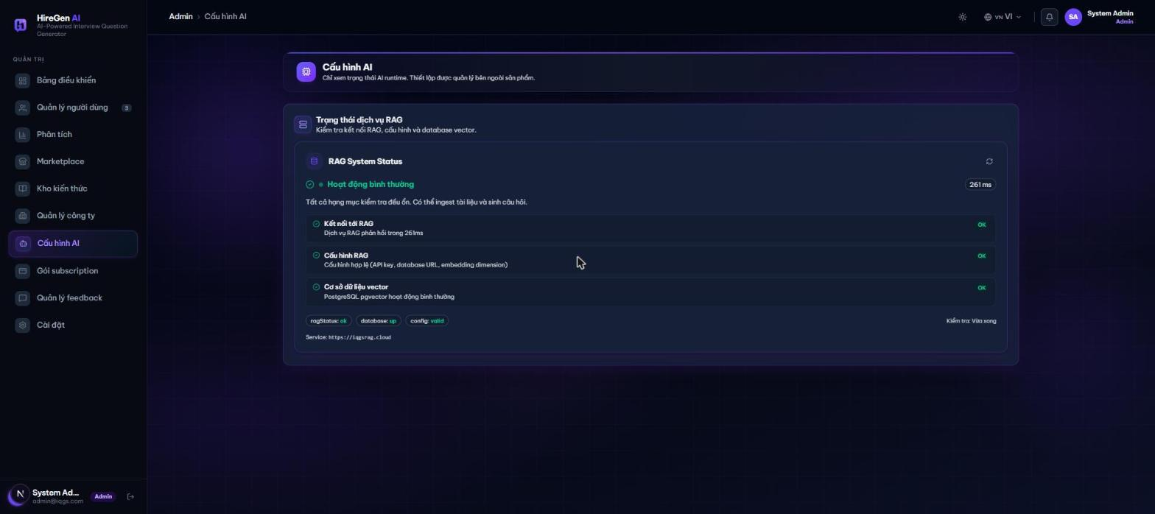
Figure 10. Admin knowledge and RAG operations

3.12 Workflow 11 Subscription upgrade
Actor: HR or Candidate.
Review the current plan and usage limits; request an upgrade and use the returned order/QR/payment information; complete payment with the exact order reference and wait for a server-confirmed Paid status; then refresh the entitlement/usage display, creating a new order if the previous one expires.
Expected outcome and limits: A QR display or local button press does not activate Premium. Payment is reconciled by the backend webhook path.
Billing current plan
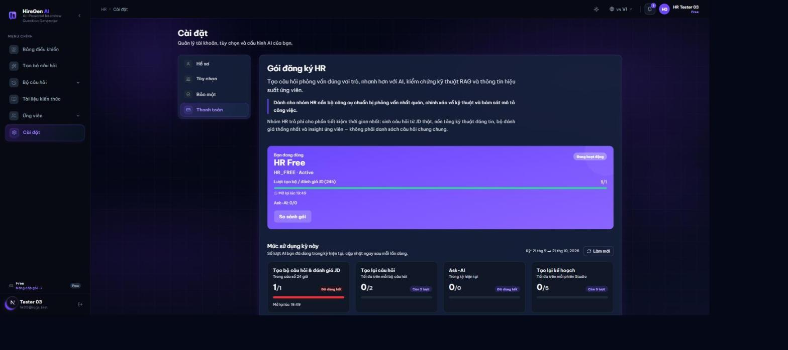
Usage quota detail
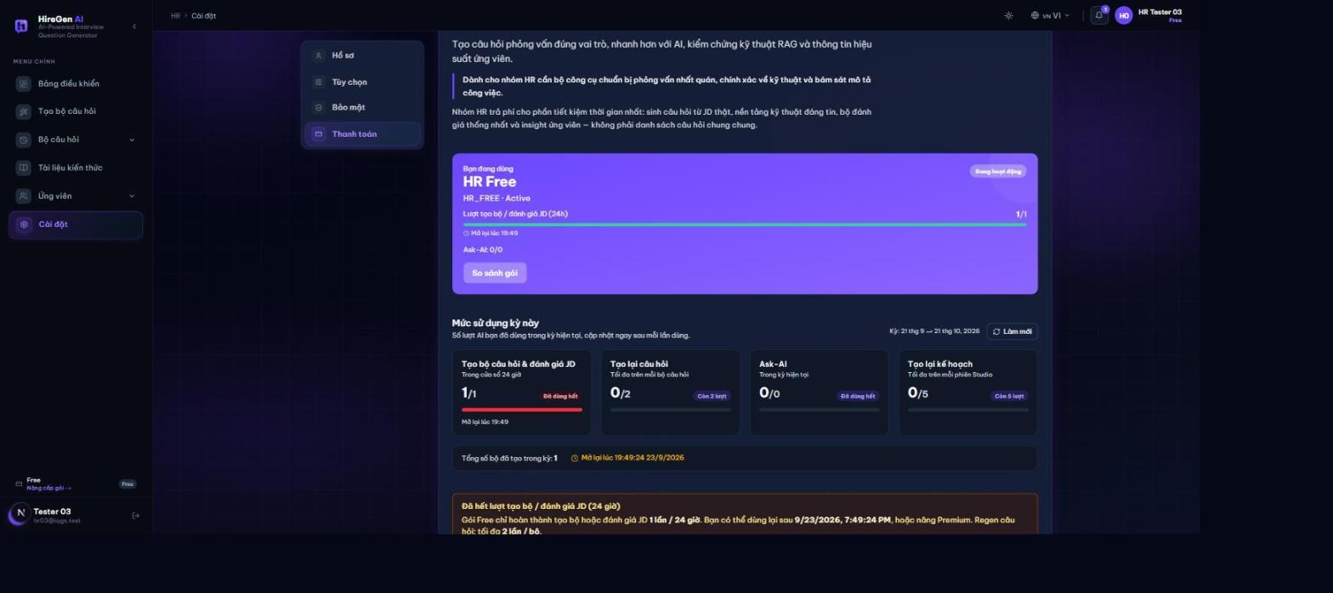
Plan comparison
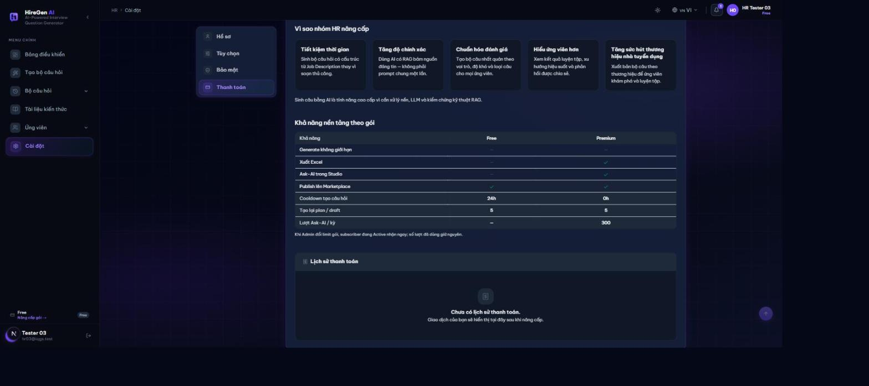
Premium plan detail
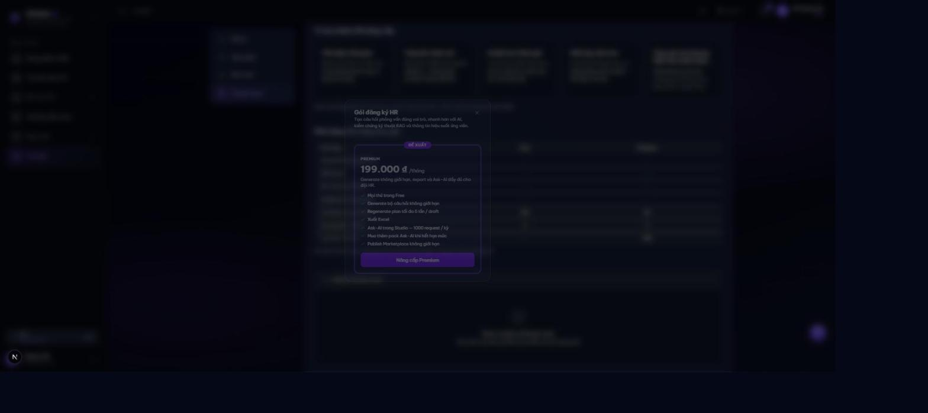
Plan comparison sidebyside
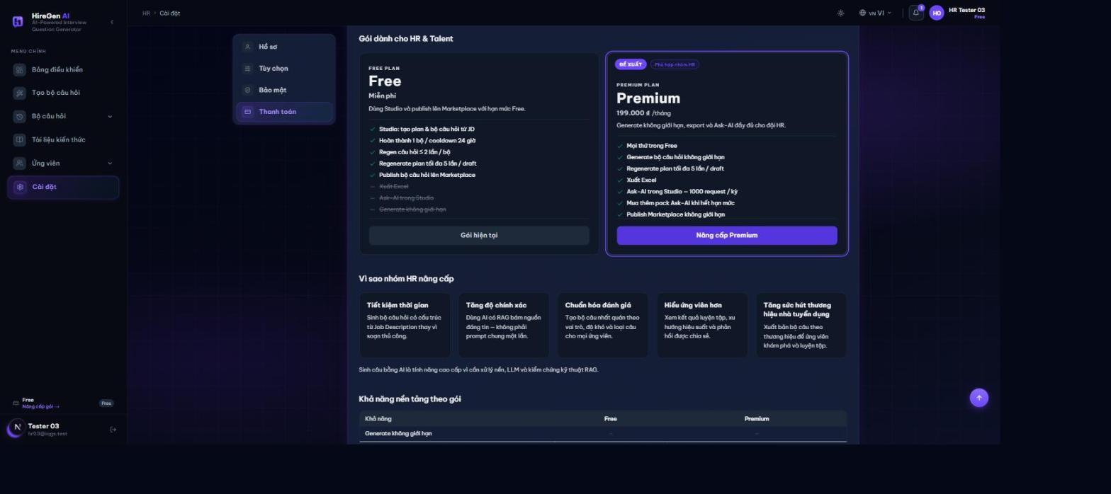
Sepay qr order
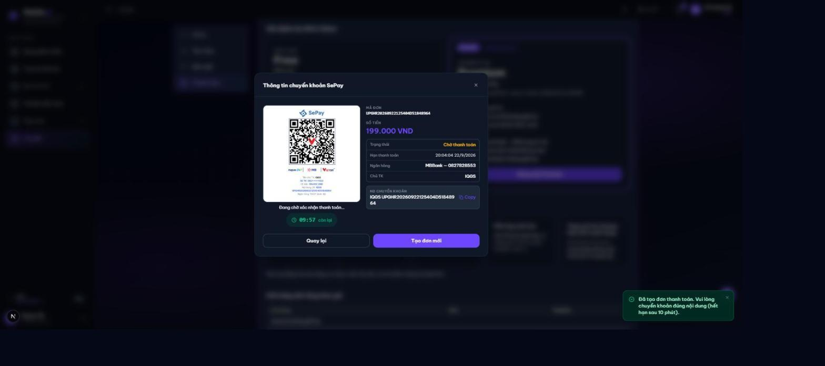
Figure 11. Subscription upgrade

3.13 Workflow 12 JD fit review and hiring publication
Actor: HR.
Open the saved set and attach or correct its generation JD; request a JD-fit review and check the coverage/skill feedback; select the questions and choose practice or hiring mode, configuring a public JD and posting details for hiring; then review the candidate-facing posting, keeping internal content separate.
Expected outcome and limits: The published subset is the candidate-facing assessment. Fit review is advisory.
Set detail questions list
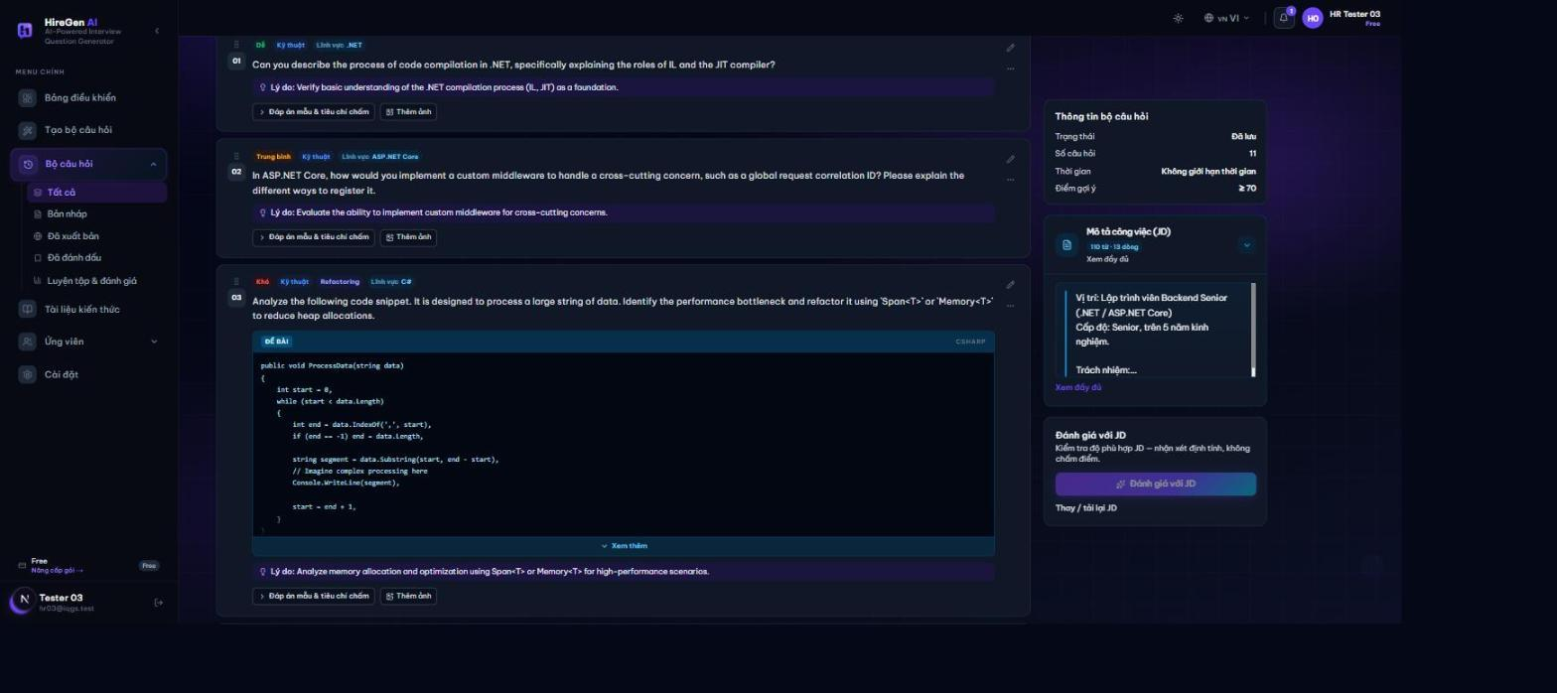
Publish dialog practice mode
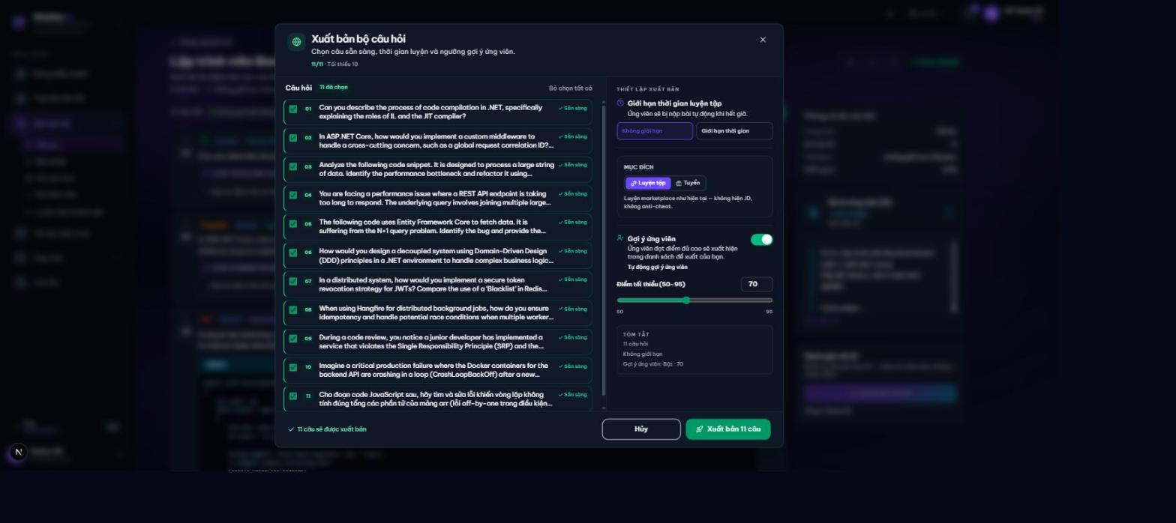
Publish hiring mode
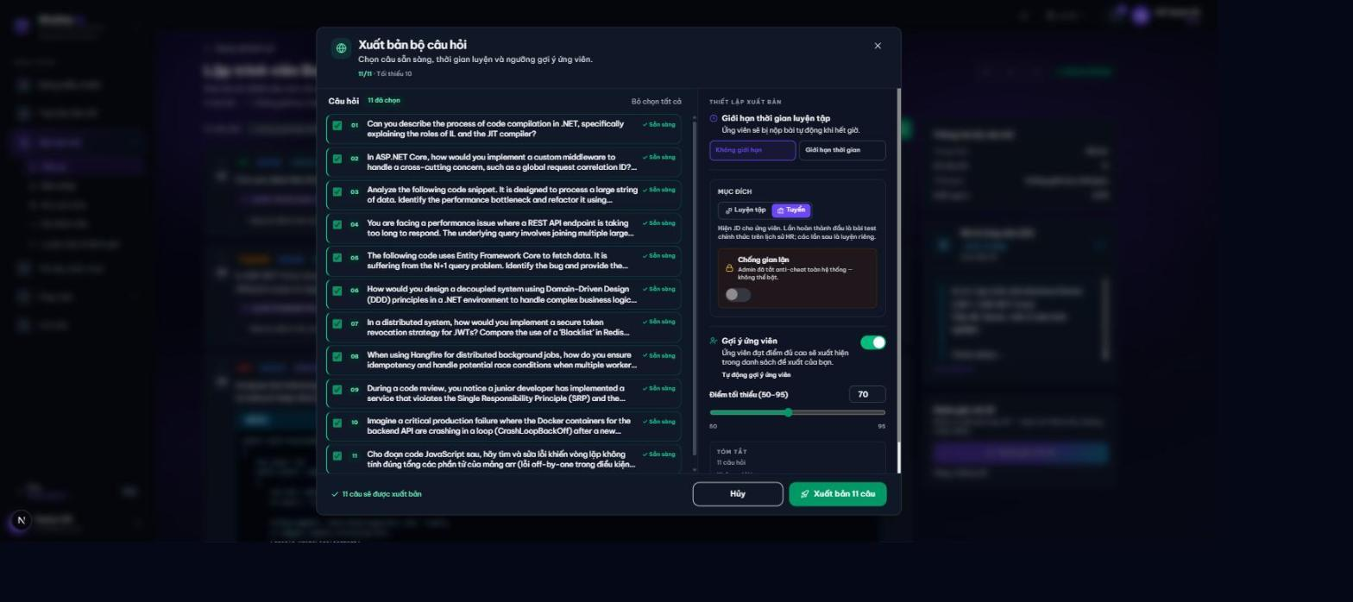
Publish validation error
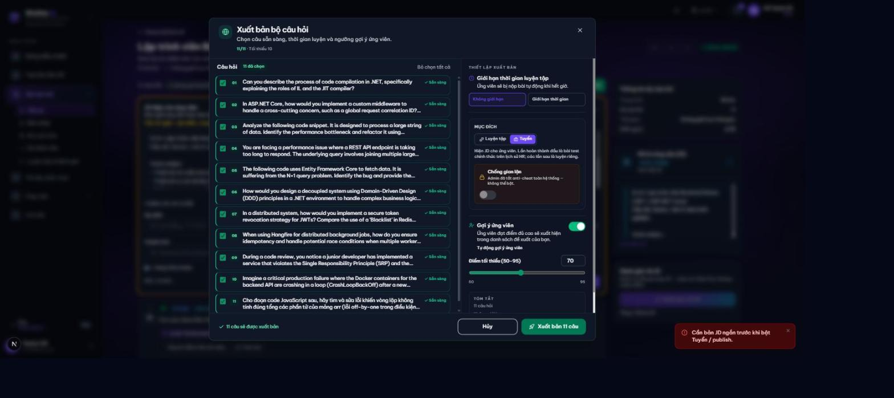
Published marketplace
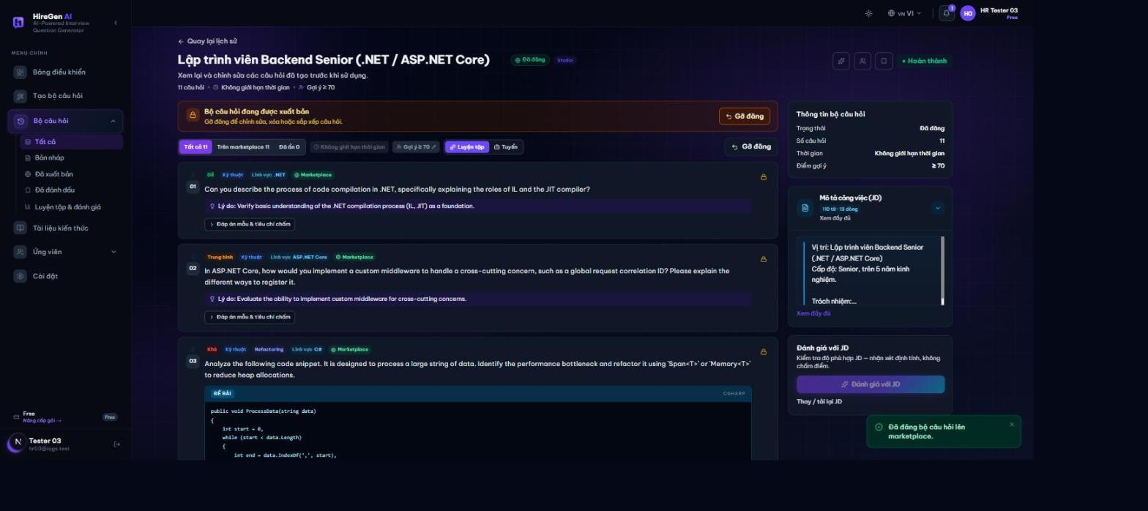
Figure 12. JD fit review and hiring publication

3.14 Workflow 13 AI Coach diagnostic
Actor: Candidate.
Confirm the target role, level, experience and skills, reviewing the suggested CV-derived context; select the competency framework and start the diagnostic job; complete the generated assessment and wait for the competency report; then review the demonstrated skill scores and evidence, revisiting history or resetting the run as needed.
Expected outcome and limits: Self-assessed level and CV experience are not automatically promoted to demonstrated level.
Coach goal confirmation
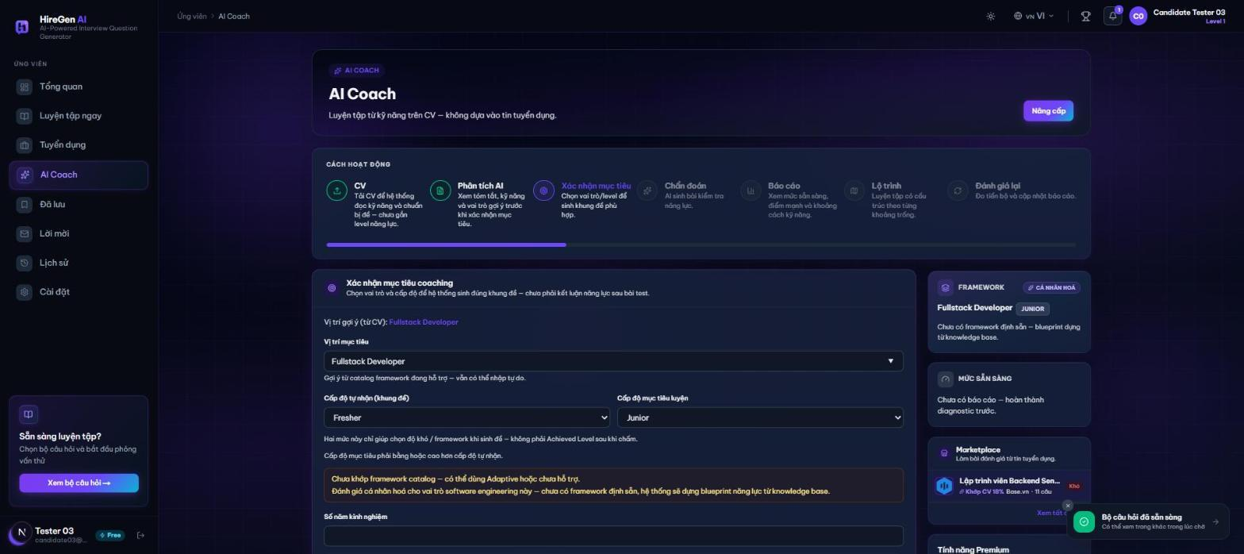
Diagnostic ready
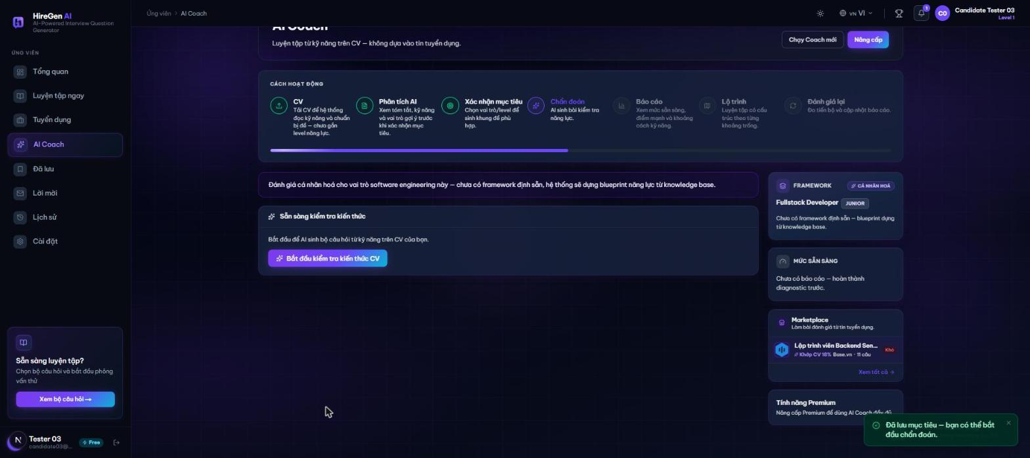
Premium paywall
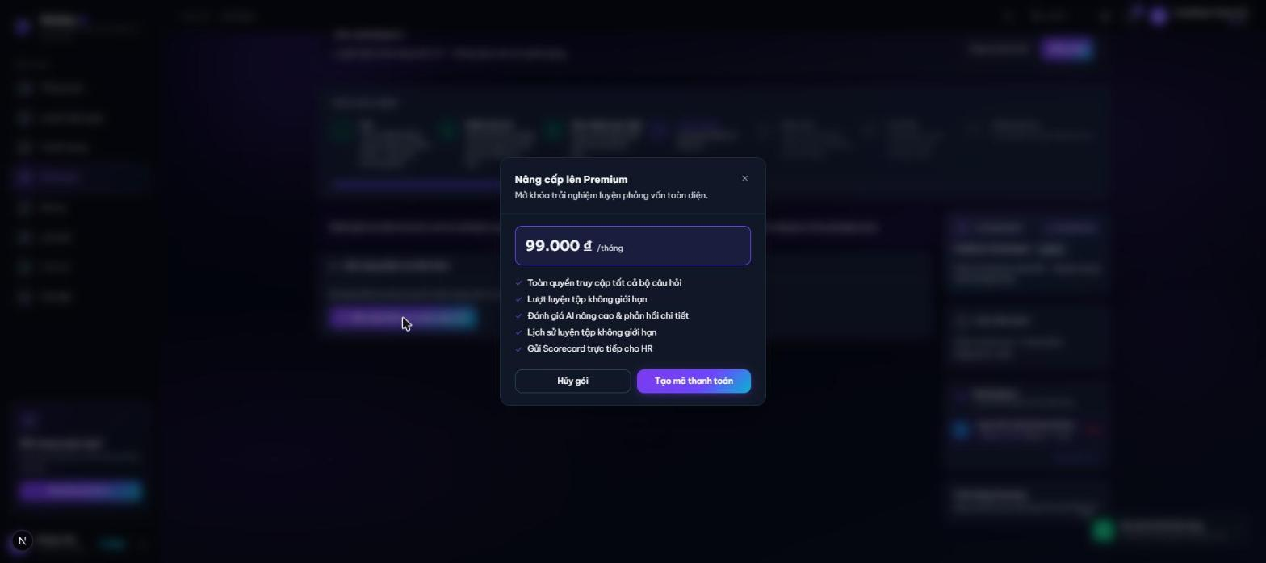
Figure 13. AI Coach diagnostic

3.15 Workflow 14 Roadmap drills and reassessment
Actor: Candidate.
Read the suggested roadmap, adjust the draft and accept the plan; start the roadmap and work through the assigned items; generate a drill for an item, practice and review feedback; then request reassessment and compare the new evidence with prior results.
Expected outcome and limits: Progress is tied to stored roadmap and assessment records; generation still depends on available SYSTEM knowledge.
Roadmap redirects to coach
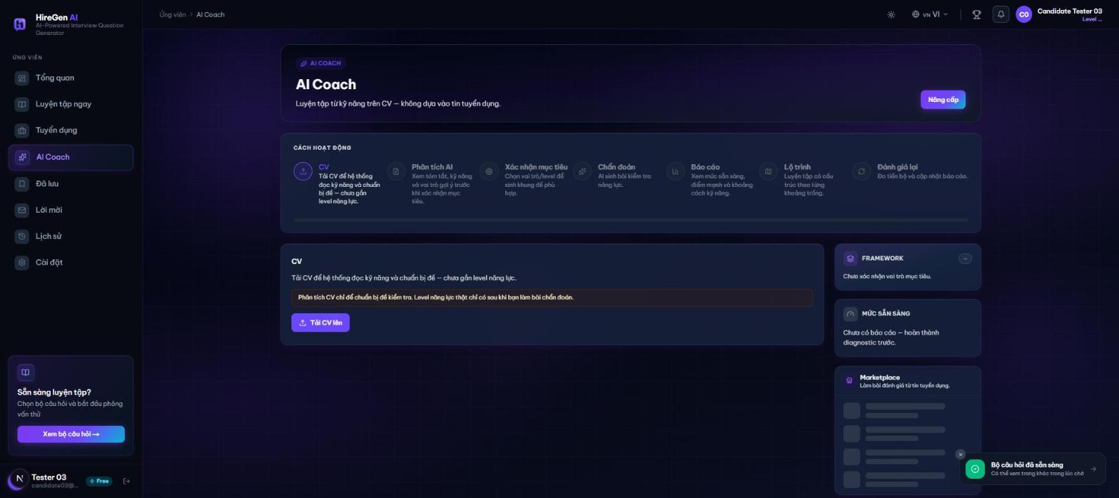
Figure 14. Roadmap drills and reassessment

