3: Cookbooks

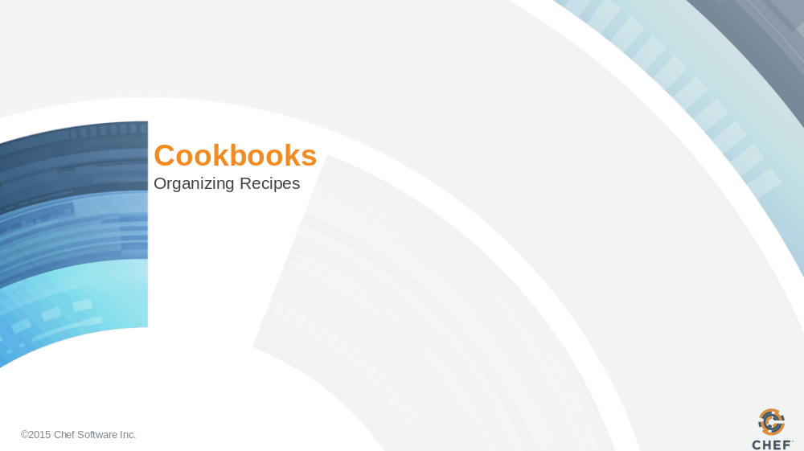

Slide 2

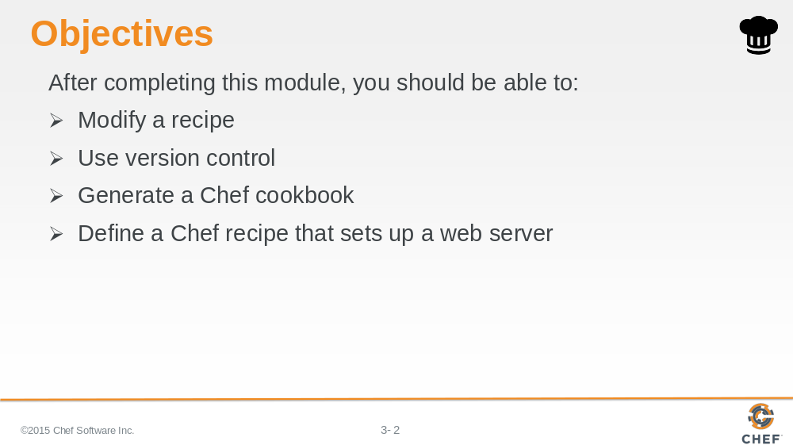

In this module you will learn how to modify a recipe, use version control, generate a Chef cookbook and define a Chef recipe that sets up a web server.

Slide 3

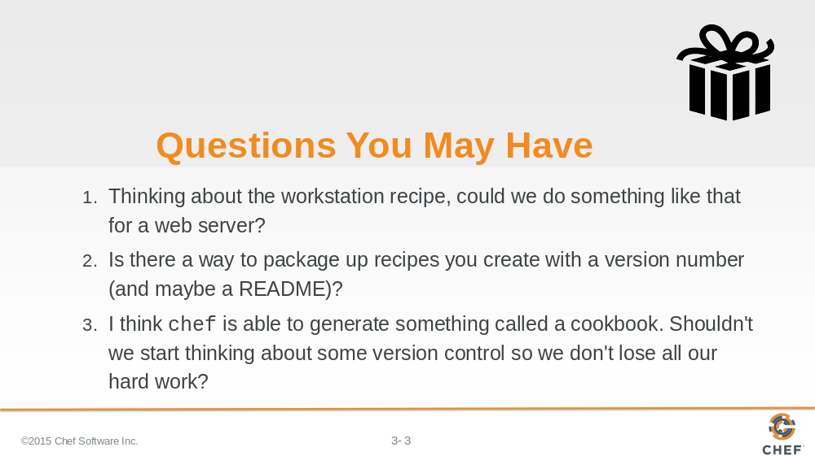

Answers:

1. The recipe that you put together to setup the workstation proved useful--useful enough to see if the same could be done with a webserver. It's a package, a file, and a service. Everything you've already completed. Well, almost everything.

2. Now the request to add version control and a README would definitely make it easier to share the recipes that we create. Without version control we'd have no way to build this software collaboratively or recover our work. Without a README no one would know what the recipe even was supposed to do or what it did.

3. And yes, before we start creating more recipes and cookbooks, we should choose a versioning solution.

Slide 4

Before we answer that question, let’s talk about collaboration. Usually, none of us work in a vacuum, and it’s important that systems are in place to make collaboration easier. One such system is versioning. Versioning will make it easier to share the recipes that we create.

A versioning system should include:

A Central Repository into which all the developers publish their work.
Each revision should be stored as a new version.
For each change, a commit message should be added so that everyone knows what has or has not been changed

Slide 5

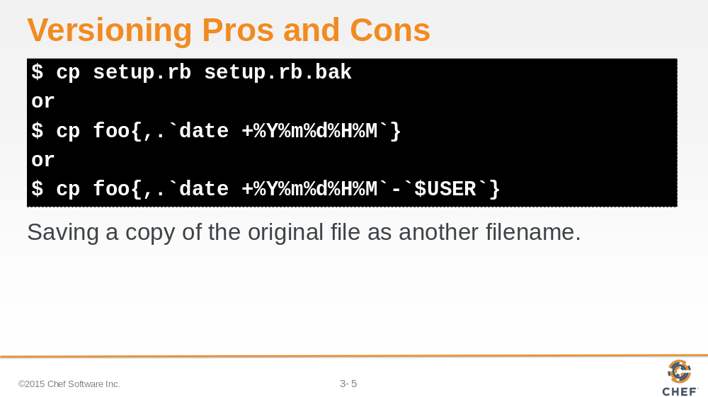

Let’s explore this first option of renaming the file by adding a quick extension, like in the first example shown here. In this way we can keep working on the original file as we add more features. As a group let’s talk about the pros and cons of using this strategy.

So obviously a single backup won't do. We need backups more often as we are going to be iterating quickly.

We could use the current date and time down to the minute like in the second example. As a group let’s talk about the pros and cons of using this strategy.
Would adding the user's name to the end of the file, like in the third example, solve the problems we are facing with other choices? Again what are the pros and cons of this new approach?

Slide 6

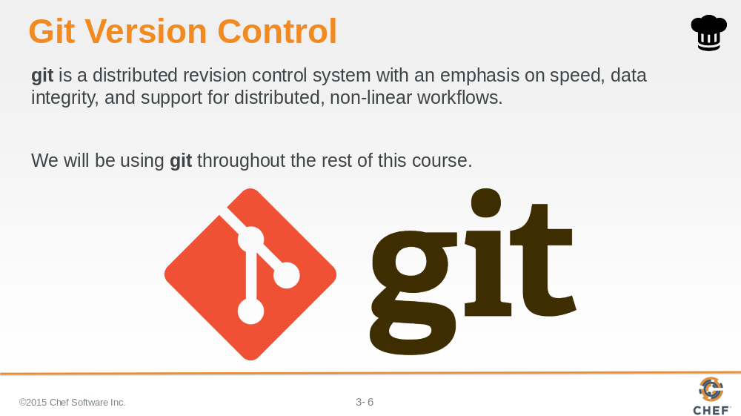
How about we use git?
What are the pros and cons of this approach?
For the rest of this course we will be using git. This may not be the version control software you use on your teams or within your organization and that is alright. Our use of git within this course is used solely to demonstrate the use of version control when developing Chef code. When you develop with Chef you are welcome to use the version control system of your choice.

Instructor Note: It is not important that the learners understand and learn all of git during this course. It is more important that the learners understand when and where to use version control to save their work. This is about training them on making changes, testing, and then committing their work. Version control is an instrumental piece of the workflow when you adopt Infrastructure as code. There are some benefits of learning and using git because Chef uses git and GitHub to do almost all development of Chef. The majority of the Chef community uses git and GitHub.

Slide 7

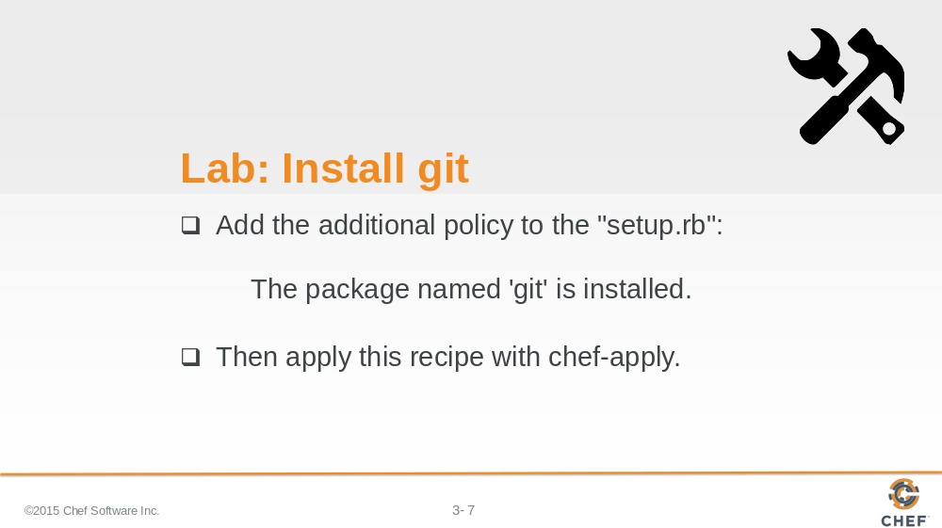

Is git installed? Do we know if it will be installed with every new instance that is setup?

It sounds like we need the tool now to store our cookbook but we also want to define a policy that git is installed on all of our workstations. Update the setup recipe to define the new policy and apply the setup recipe again.

Instructor Note: Allow 5 minutes to complete this exercise.

Slide 8

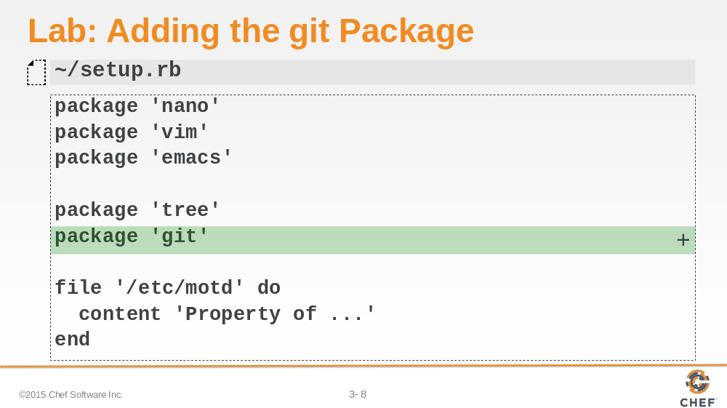

We add a package resource named 'git' to the setup recipe within our setup recipe.

Slide 9

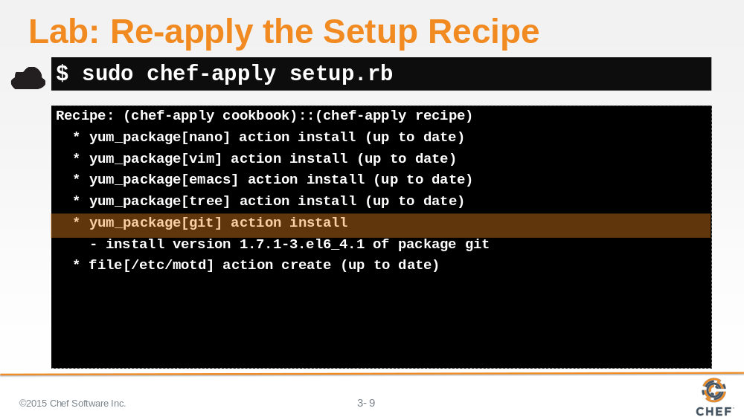

Then we use chef-apply to apply our recipe.

Slide 10

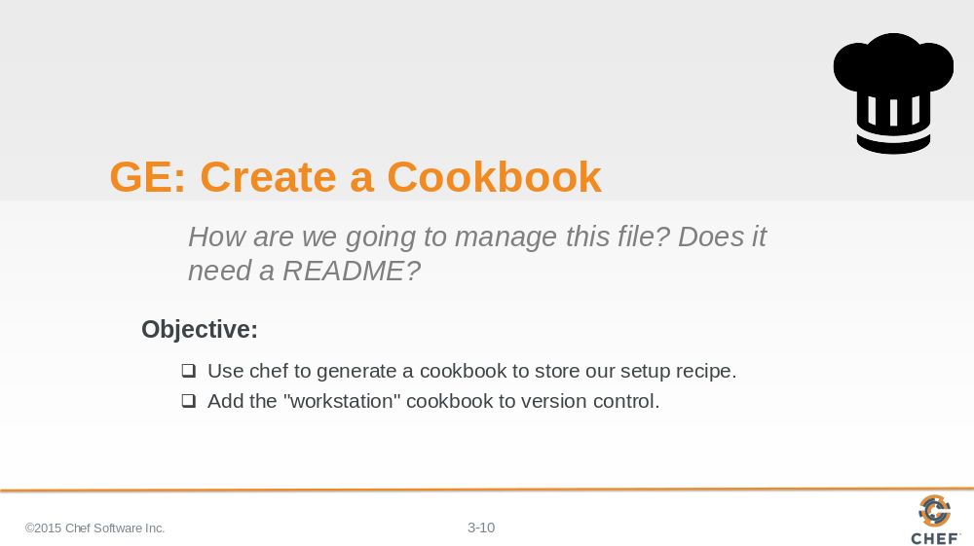

The setup recipe now installs everything we currently need on our workstation.

But before throw this recipe file into a directory with our other scripts we should look at a concept in Chef called a cookbook.

What is a cookbook? How do we create one? Let's ask 'chef'.

Slide 11

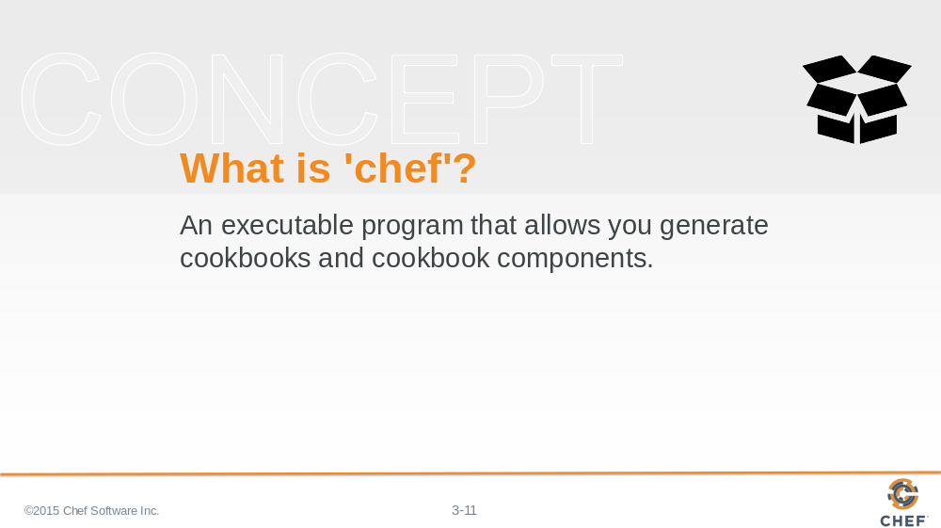

In this context, 'chef' is a command, not the company.

What's the best way to learn Chef? Use Chef. We want you to literally run 'chef'.

Slide 12

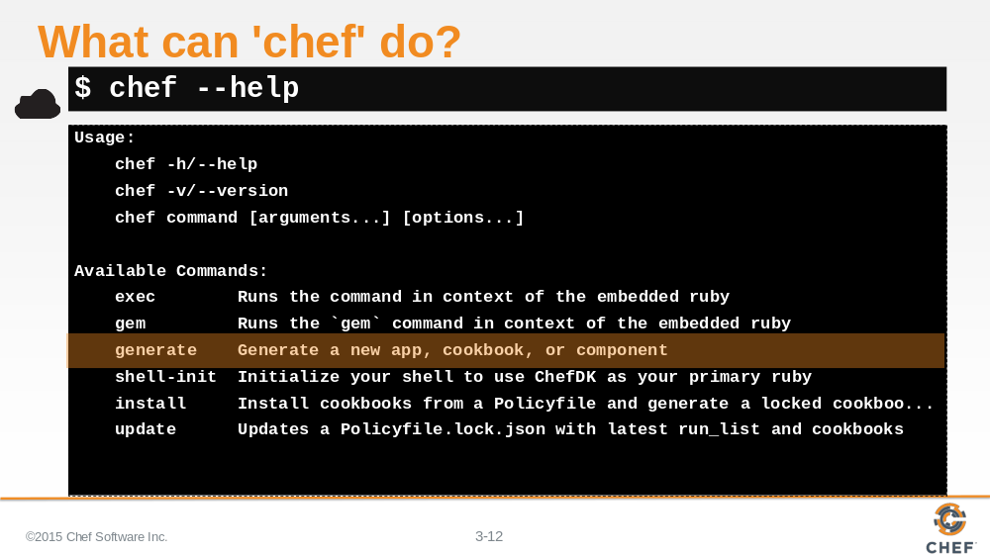

'chef' is a command-line application that does quite a few things. The most important thing to us right now is its ability to generate cookbooks and components.

Alright. So 'chef' can generate a cookbook. But what is the purpose of a cookbook? That sounds like we should read the documentation.

Slide 13

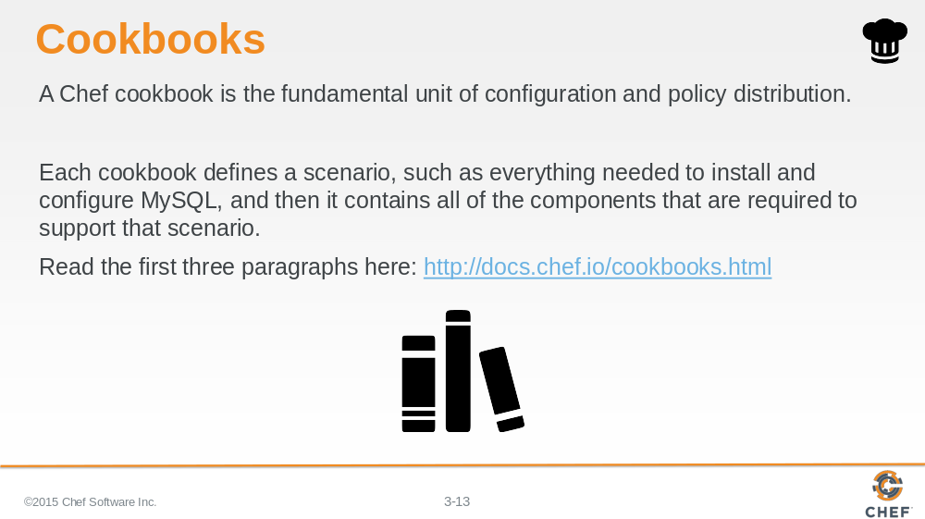

It's important that you learn to read the Chef documentation. Let’s look up cookbooks in Chef's documentation. Visit the docs page on cookbooks and read the first three paragraphs.

A cookbook is a structure that contains recipes. It also contains a number of other things--but right now we are most interested in a finding a home for our recipes, giving them a version, and providing a README to help describe them.

Slide 14

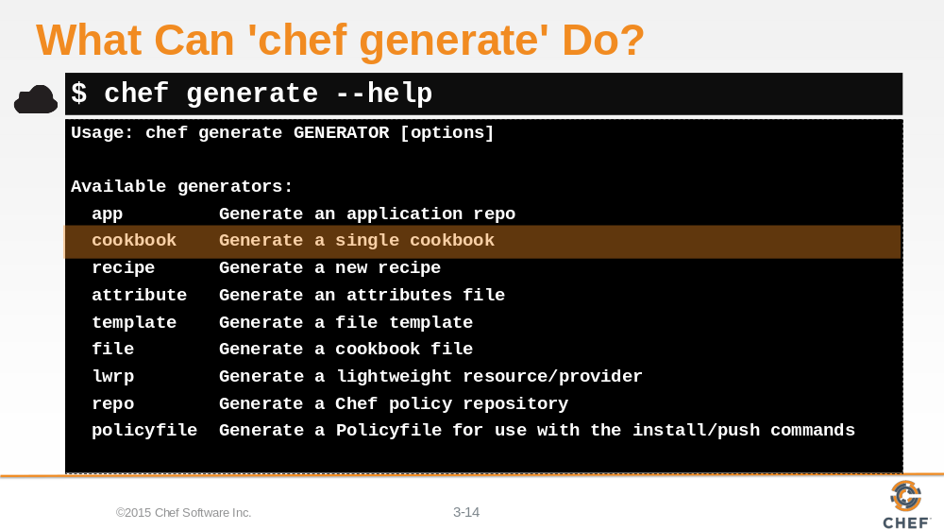

Let’s examine the 'chef generate' command. We can see that the command is capable of generating a large number of different things for us. It looks like if we want to generate a cookbook we're going to need to use 'chef generate cookbook'.

Slide 15

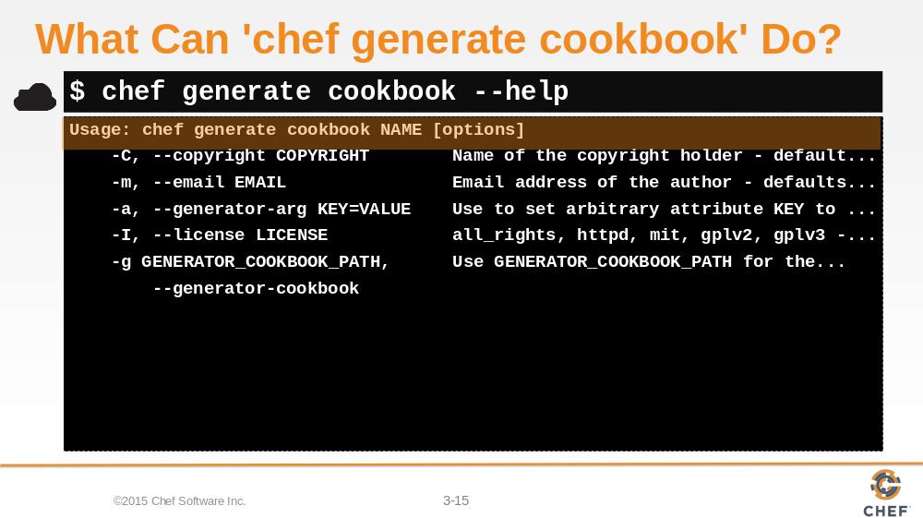

Let’s ask the 'chef generate cookbook' command for help to see how it is used.

To generate a cookbook, all we have to do is provide it with a name.

There are two hard things in Computer Science and one of those is giving something a name.

Slide 16

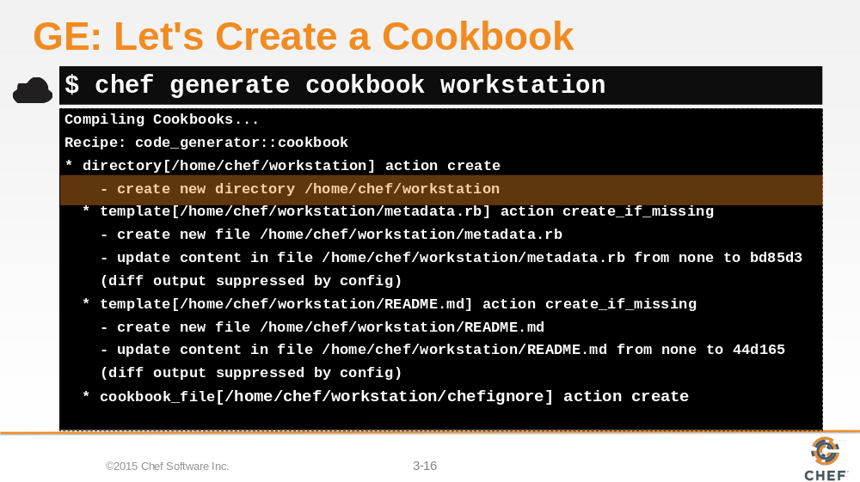

We have you covered. Call the cookbook workstation. That's a generic enough name.

We want you to use 'chef generate' to generate a cookbook named workstation.

Slide 17

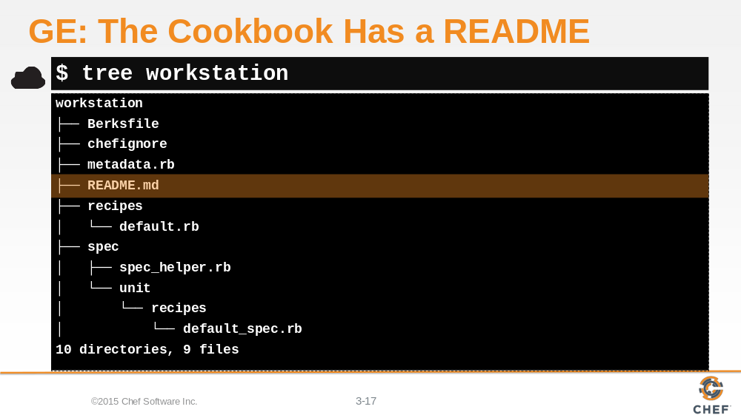

Aren't you curious what's inside it? Let’s take a look with the help of the 'tree' command. If we provide 'tree' with a path we will see all the visible files in the specified directory.

So the chef cookbook generator created an outline of a cookbook with a number of default files and folders. The first one we'll focus on is the README.

Slide 18

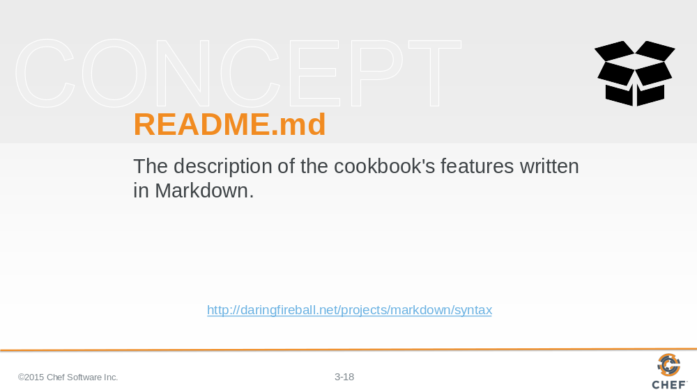

All cookbooks that 'chef' will generate for you will include a default README file. The extension .md means that the file is a markdown file.

Markdown files are text documents that use various punctuation characters to provide formatting. They are meant to be easily readable by humans and can be easily be rendered as HTML or other formats by computers.

Slide 19

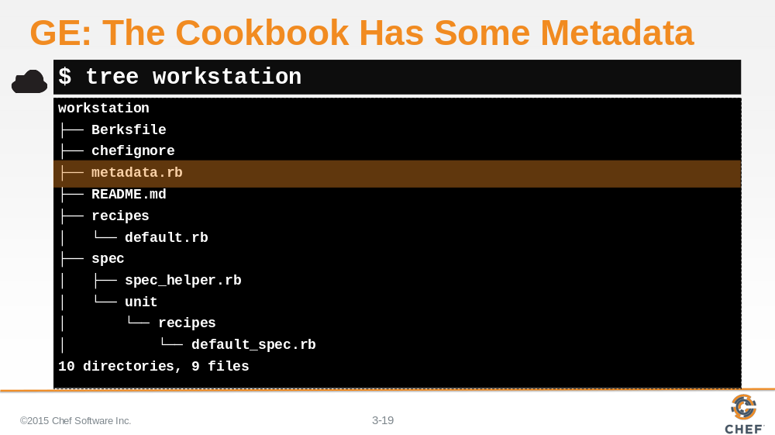

The cookbook also has a metadata file.

Slide 20

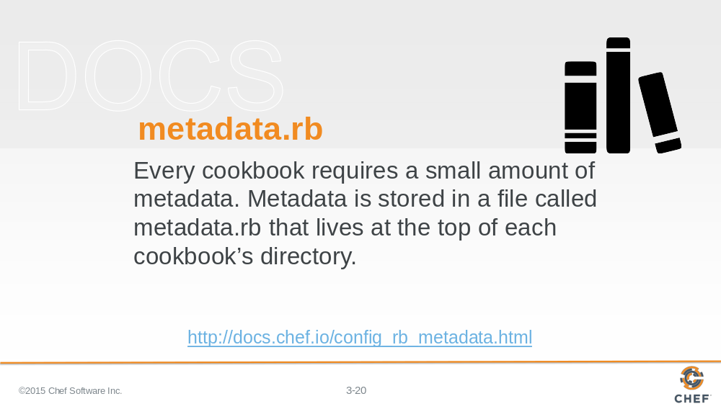

This is a ruby file that contains its own domain specific language (DSL) for describing the details about the cookbook.

Slide 21

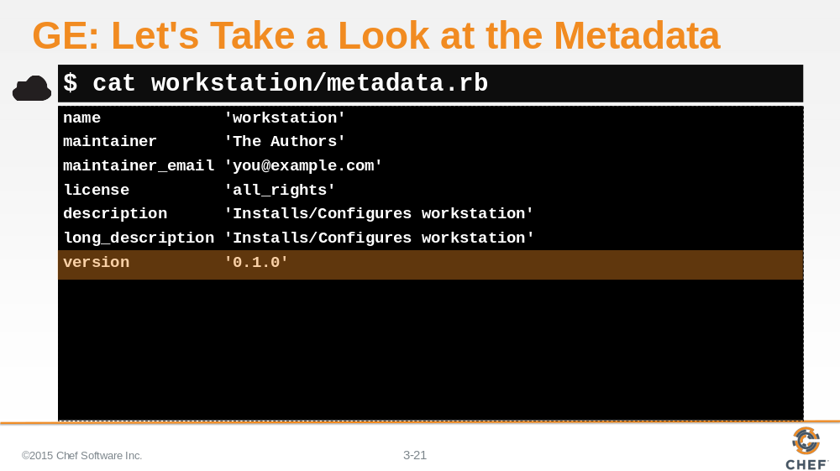

If you view the contents of your new cookbook's metadata, you'll see a number of details that help describe the cookbook:

The name of the cookbook, its maintainer, a way to reach them, how the cookbook is licensed, descriptions, and the cookbook's version number.

Slide 22

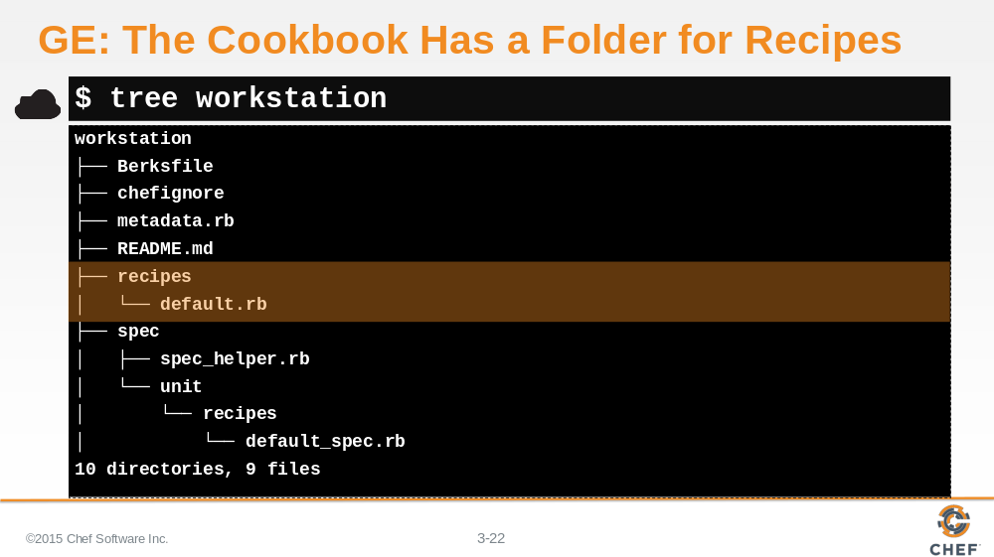

The cookbook also has a folder named recipes. This is where we store the recipes in our cookbook. You'll see that the generator created a default recipe in our cookbook. What does it do?

Slide 23

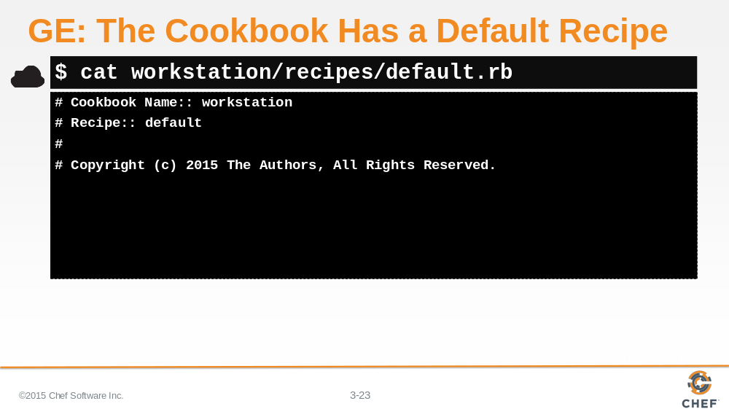

Looking at the contents of the default recipe you'll find it's empty except for some ruby comments.

A cookbook doesn't have to have a default recipe but most every cookbook has one. It's called default because when you think of a cookbook, it is probably the recipe that defines the most common configuration policy.

Slide 24

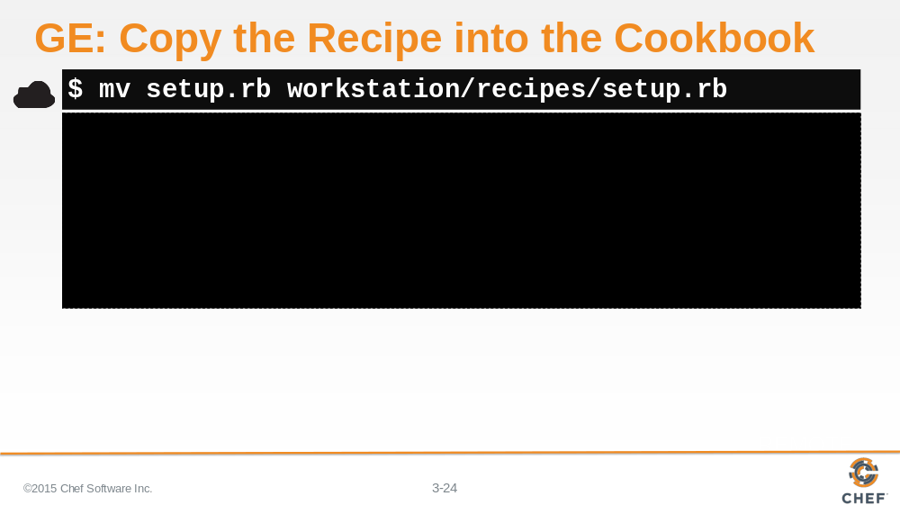

From the Home directory, move your setup.rb recipe to the workstation cookbook and place it alongside our default recipe.

Slide 25

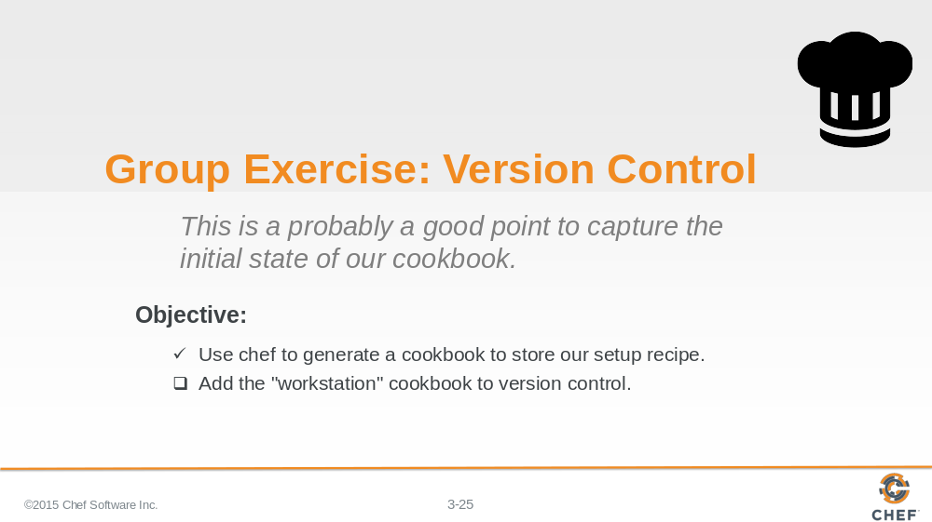

Now that we have our cookbook with its README and version number, it's time to start tracking our changes with git.

Slide 26

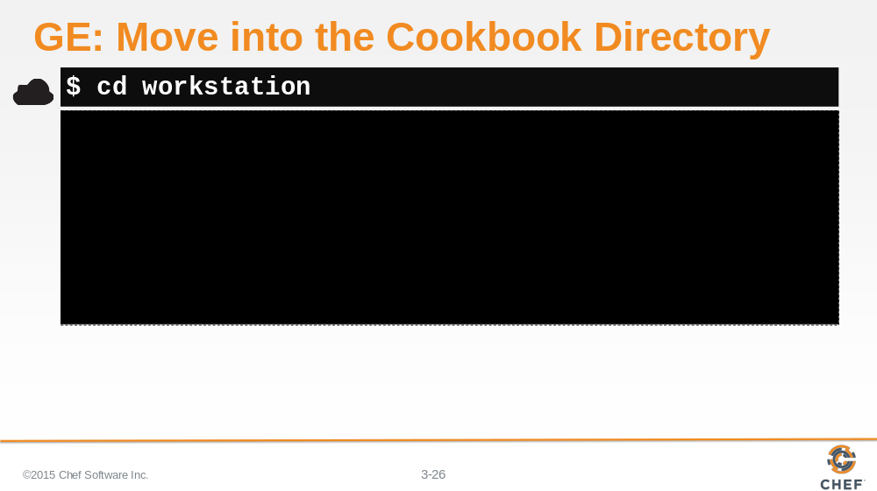

Change into the workstation cookbook directory.

Slide 27

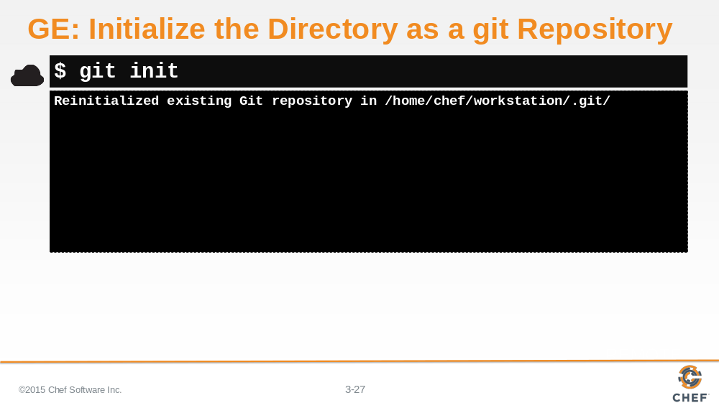

We want git to start tracking the entire contents of this folder and any content in the subfolders. To do that with git, you need to execute the command 'git init' in the parent directory of the cookbook that you want to start tracking.

You will notice that git will say that the repository has been 'Reinitialized'. This is because the chef cookbook generator detected that we have git installed and automatically initialized the cookbook as a git repository.

Slide 28

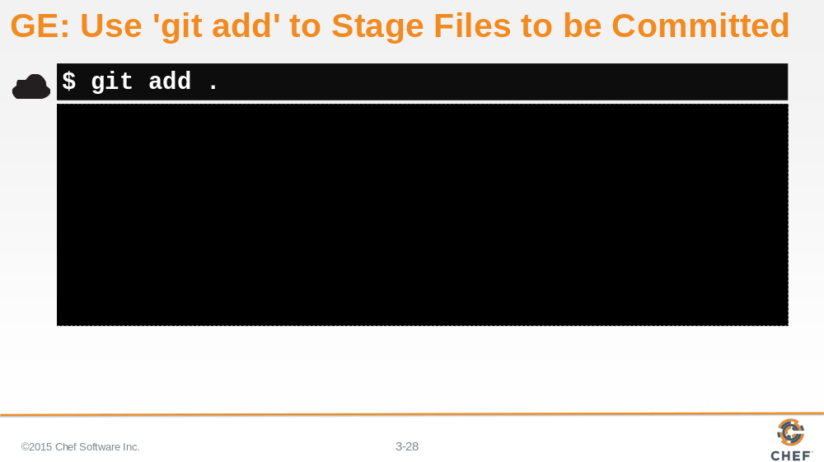

Now we need to tell git which files it should start tracking in source control. In our case, we want to add all the files to the repository and we can do that by executing 'git add .' (dot).

This will place all the files into a staging area.

Slide 29

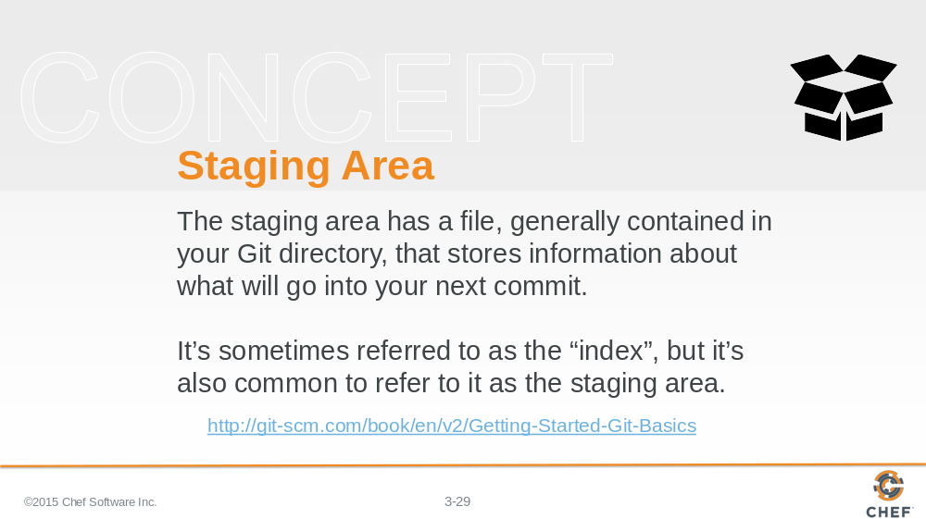

You can think of the staging area as a box in which to put a bunch of items -- like a care package you would send to someone.

Staging files means to put them in the box, but don't close it up because you may add a few things, and don't close it up because you may replace or remove a few things. But put the items in the box because eventually we are going to close that box when it is ready to send it off.

Slide 30

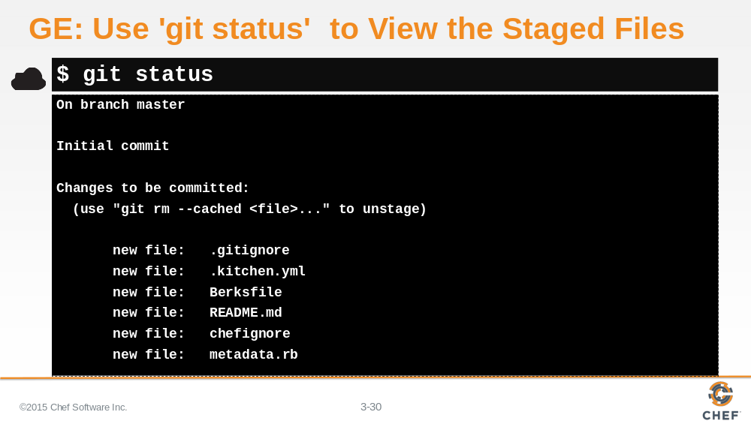

Let’s see what changes we have placed in the staging area.

Thinking about our care package example, this is like looking inside the box and taking an inventory, allowing us to figure out if we need to move more things in or remove things we accidently threw in there.

Running `git status` allows us to see in the box. Git reports back to us the changes that will be committed.

Instructor Note: Git helpfully tries to show you the command you can use to remove an item from that box. This is useful if you want to include all items except for one or simply manage everything before you commit.

Slide 31

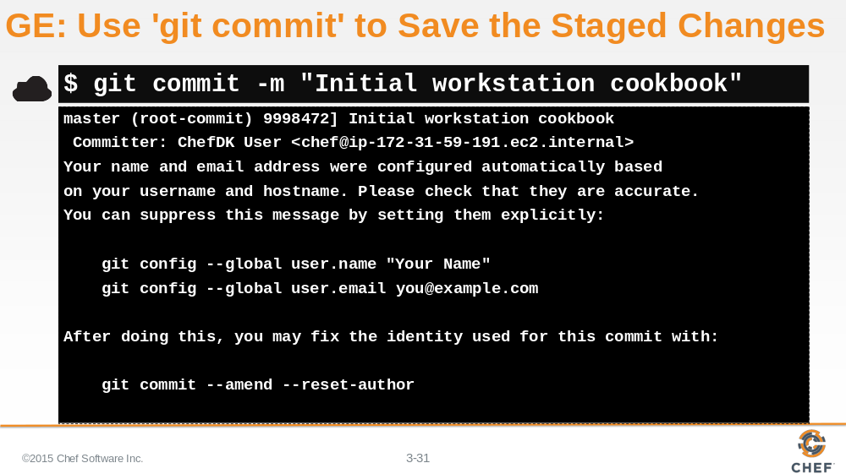

If everything that is staged looks correct, then we are ready to commit the changes.

This is like saying we're ready to close the box up.

This is done in git with git commit. We can optionally provide a message on the command-line and that is done with the -m flag and then a string of text that describes that change.

Slide 32

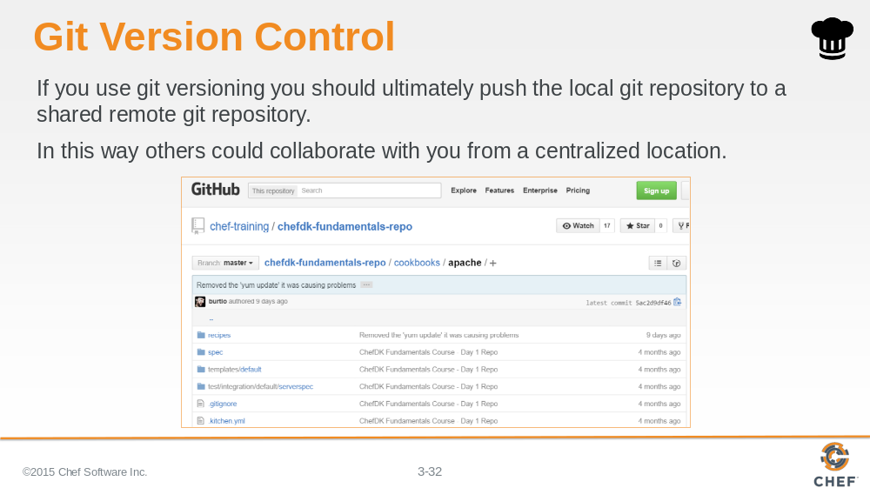

git tracks all our commits, all those closed up boxes, locally on the current system. If we wanted to share those commits with other individuals we would need to push those changes to a central repository where we could collaborate with other members of the team.

Slide 33

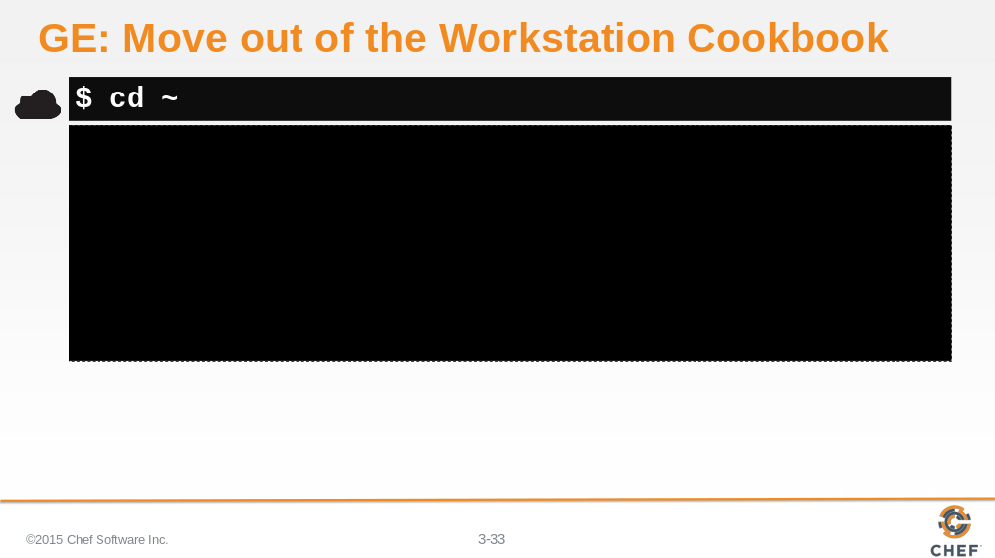

Now that we are done adding our workstation cookbook to version control lets return to our home directory.

Slide 34

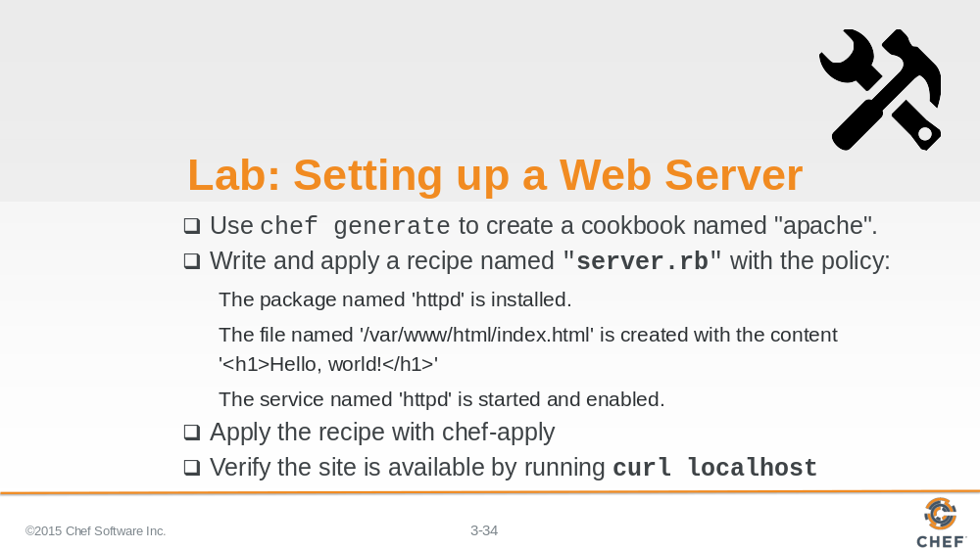

Now. Here is your latest challenge. Deploying a Web Server with Chef.

Thinking about all that we have accomplished so far that hopefully seems possible.
We need a cookbook named apache that has a server recipe. Within that server recipe we need to install the appropriate package. Write out an example HTML file, and then start and enable the service.
Then we should apply that recipe and make sure the site is up and running by running a command to visit that site.
So show me it can be done!

Instructor Note: Allow 15 minutes to complete this exercise.

Slide 35

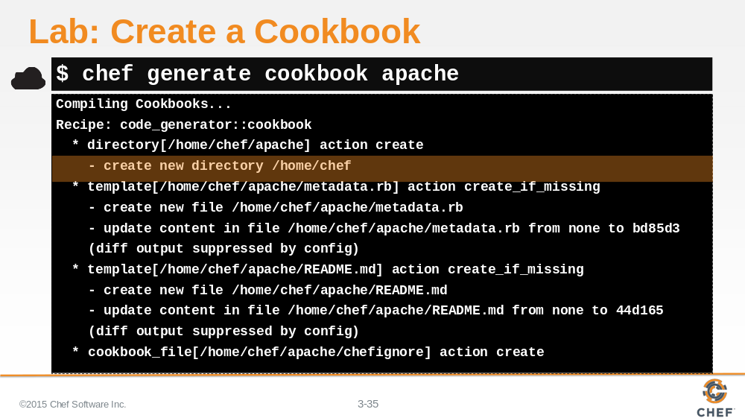

From the Chef home directory, run the command 'chef generate cookbook apache'. This will place the apache cookbook alongside the workstation cookbook.

Slide 36

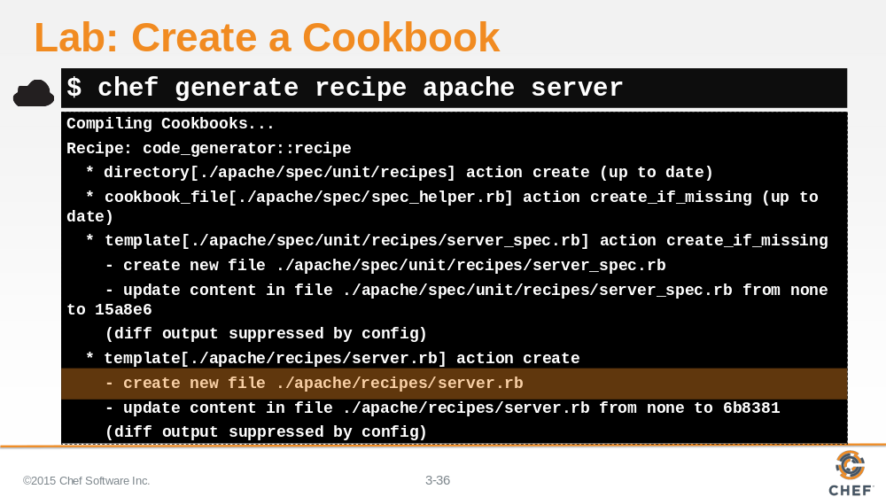

Chef generate can also generate our recipe file as well. Running the command `chef generate recipe apache server` it will generate the server recipe within the apache cookbook we created.

Slide 37

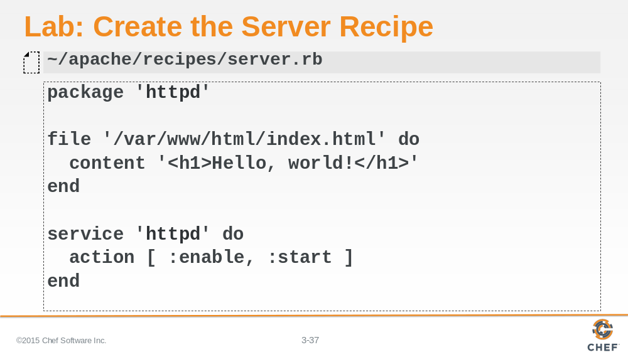

The server recipe, found at ~/apache/recipes/server.rb, defines the policy:

* The package named httpd is installed.

* The file named '/var/www/html/index.html' is created with the content 'Hello, world!'

The service named httpd is started and enabled.

Instructor Note: The service action defines two actions within a Ruby array. Ruby arrays are ordered, integer-indexed collections of any object. Each element in an array is associated with and referred to by an index.

Slide 38

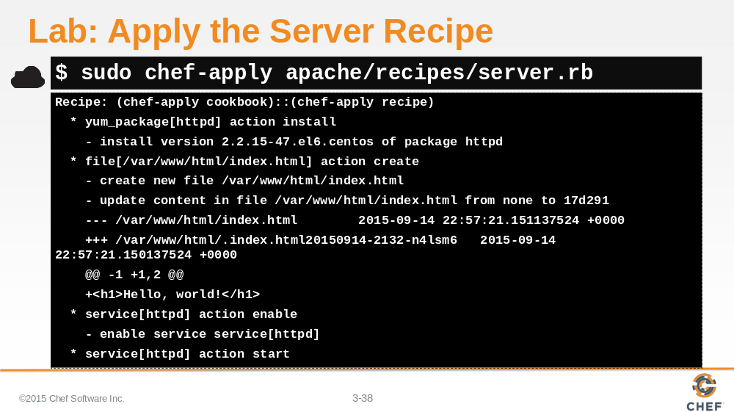

When applying the recipe with 'chef-apply', you need to specify the partial path to the recipe file within the apache cookbook's recipe folder.

Slide 39

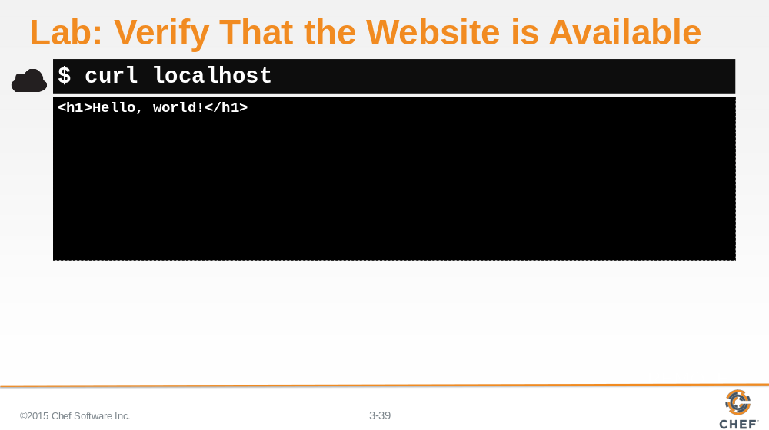

You already setup apache, which is a web server. So verify that the website is available and returns the content we expect to see.

Slide 40

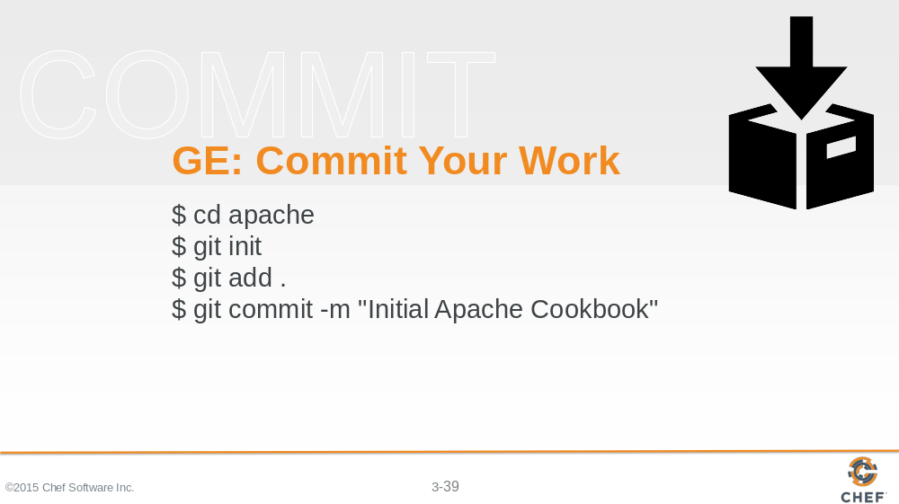

Now, with everything working it is time to add the apache cookbook to version control.

Move into the apache directory.
Initialize the cookbook as a git repository.
Add all the files within the cookbook.
And commit all the files in the staging area.

Slide 41

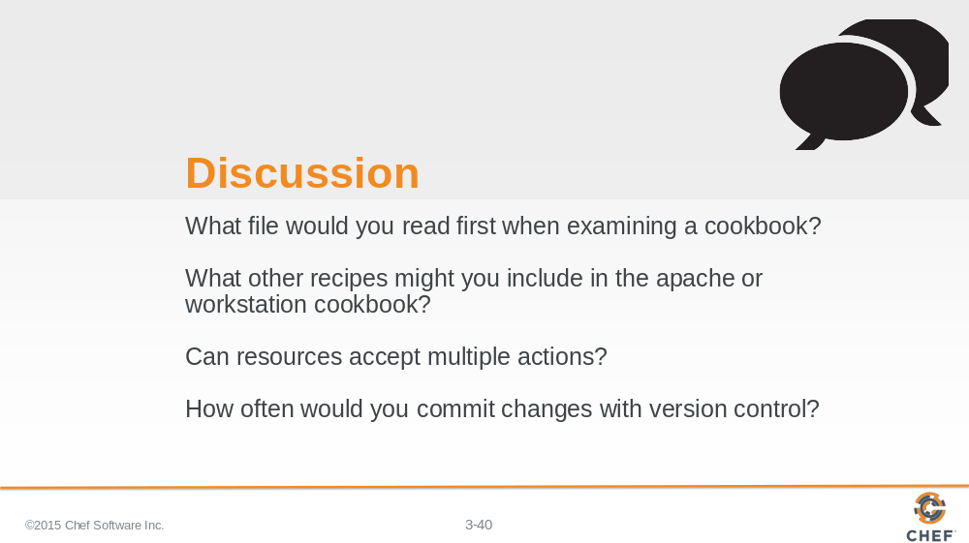

Answer these questions.

With your answers, turn to another person and alternate asking each other asking these questions and sharing your answers.

Slide 42

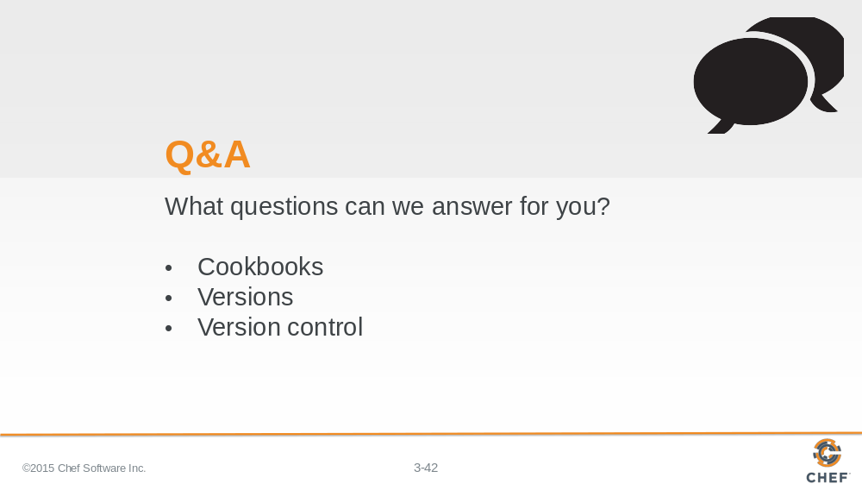

What questions can we help you answer?

General questions or more specifically about cookbooks, versioning and version control.

Slide 43



