6: Details About the System



Slide 2

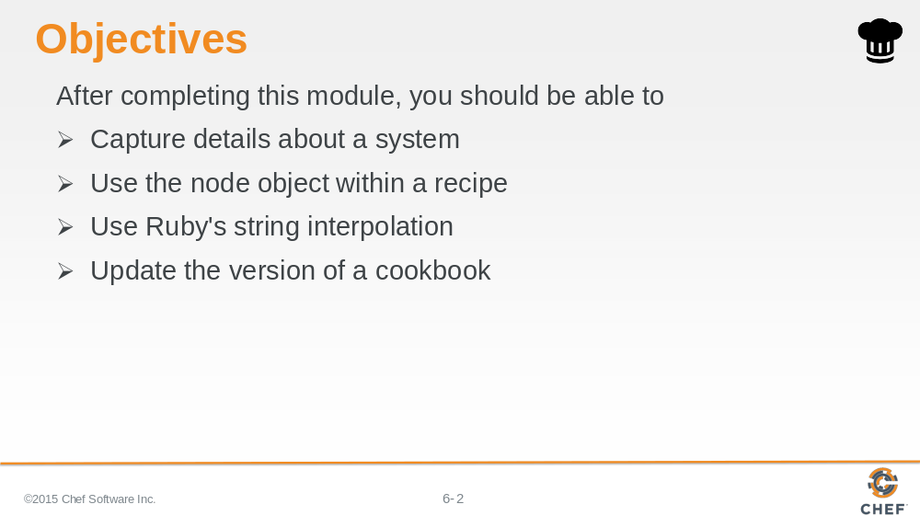

In this module you will learn how to capture details about a system, use the node object within a recipe, use Ruby's string interpolation, and update the version of a cookbook.

Slide 3

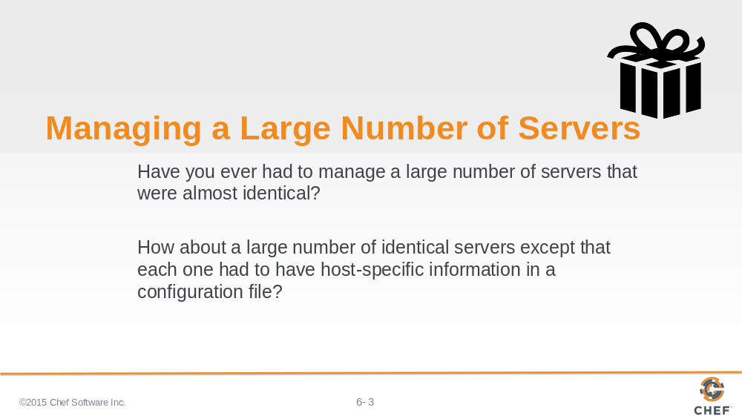

Have you ever had to manage a large number of servers that were almost identical?

How about a large number of identical servers except that each one had to have host-specific information in a configuration file?

The file needed to have the hostname or the IP address of the system. Maybe you needed to allocate two-thirds of available system memory into HugePages for a database. Perhaps you needed to set your thread max to number of CPUs minus one. The uniqueness of each system required you to define custom configuration files. Custom configurations that you need to manage by hand.

Slide 4

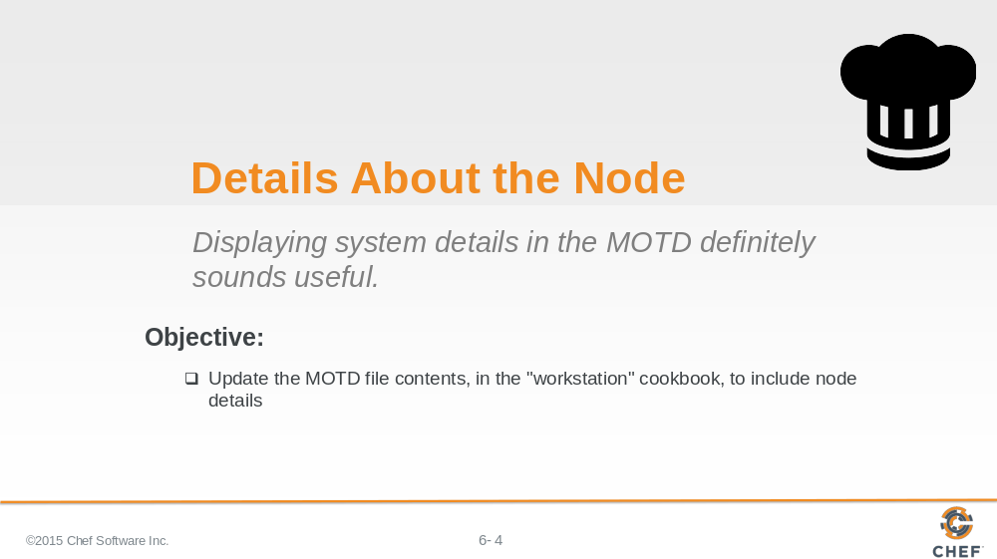

Here we've been given the simple request of providing some additional details about our node in both our Message of the Day and our default index page that we deploy with our web server.

We'll start first with our message of the day.

Slide 5

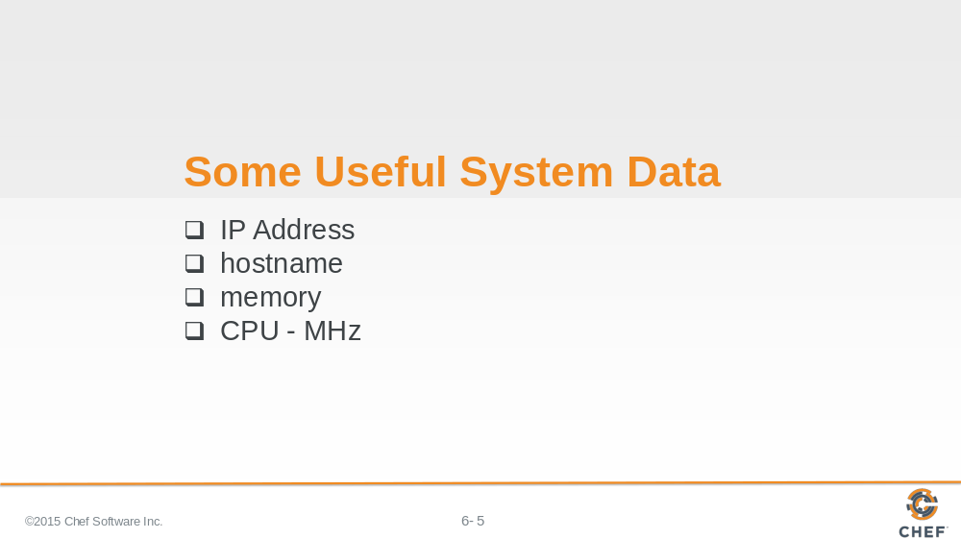

Thinking about some of the scenarios that we mentioned at the start of the session makes us think that it would be useful to capture:

The IP address, hostname, memory, and CPU megahertz of our current system.

We'll walk through capturing that information using various system commands starting with the IP address.

Instructor Note: The next series of steps often seem like an obvious mistake to the learners. It may be helpful to have the learners watch as you perform these steps and comment on the process.

Slide 6

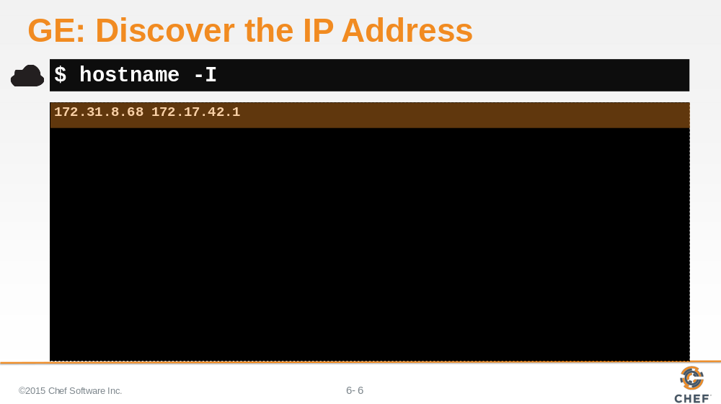

To discover the IP address of the node, we can issue the command

`hostname -I`

Slide 7

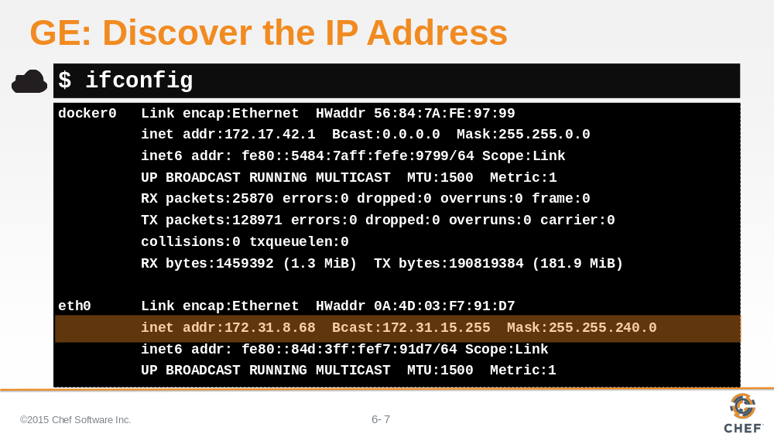

Or you can dig it out of the results of running `ifconfig`.

Slide 8

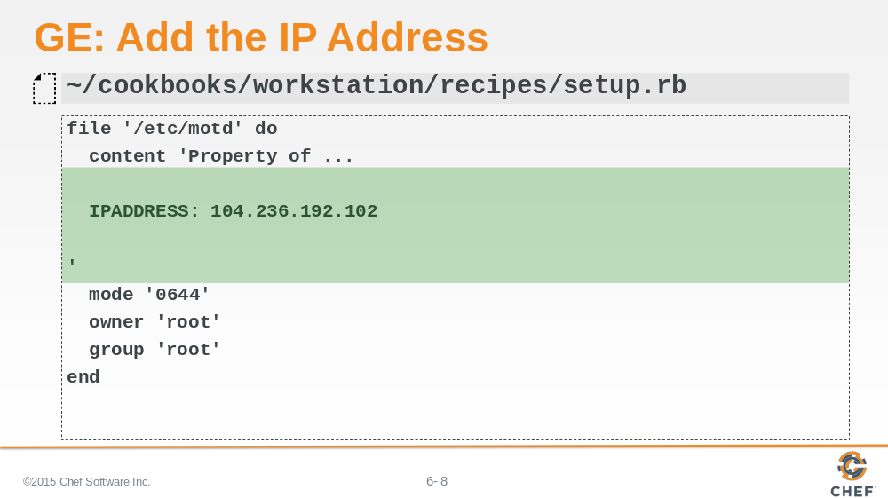

You can include this information in our '/etc/motd by updating the contents of the file resource's content attribute.

Within the existing string value we've inserted a number of new lines for formatting and placed our IP address along with its value.

Slide 9

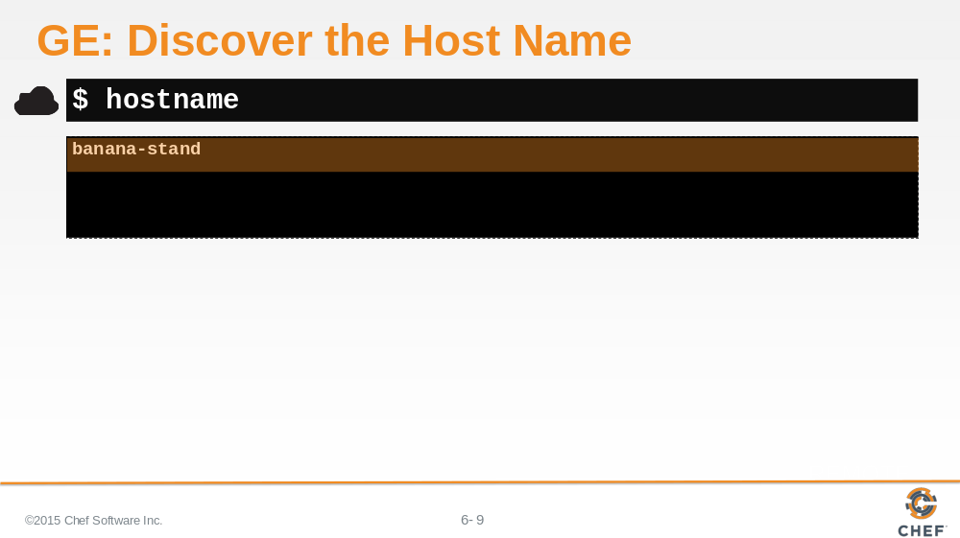

Next is the machine's hostname. This is easily retrievable with the `hostname` command.

Note: The host name of your virtual workstation may simply be an IP address. For example, 'ip-172-31-2-14x'.

Slide 10

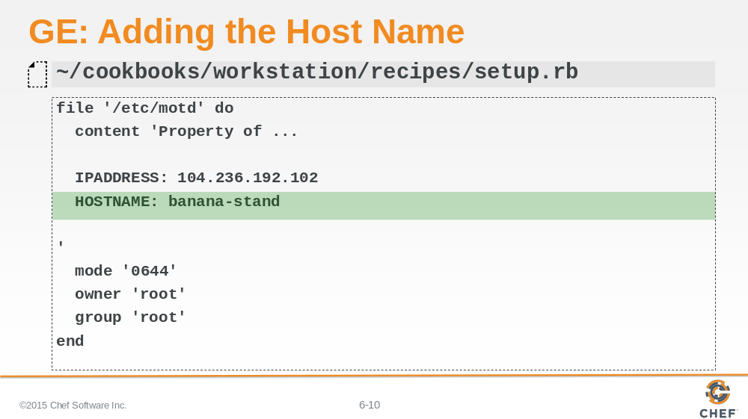

We can also include this information in the file resource's attribute on a new line below our IP address.

Slide 11

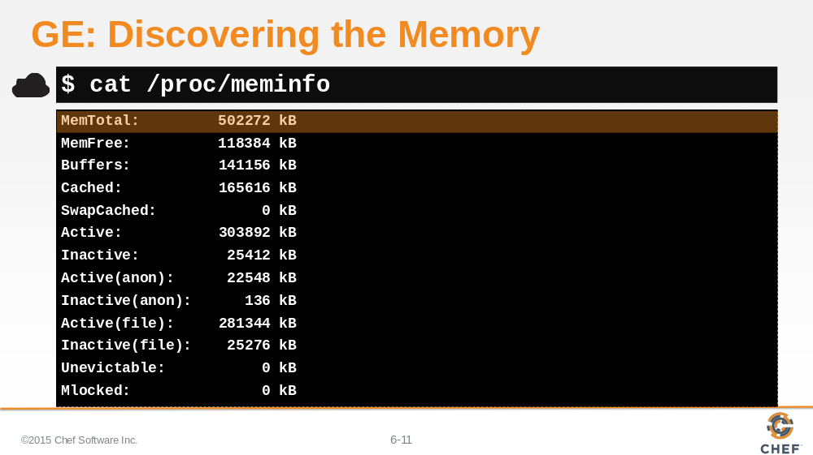

One way to gather the memory of our system is to `cat` the contents of the /proc/meminfo. There we can select the total memory available on the system.

Slide 12

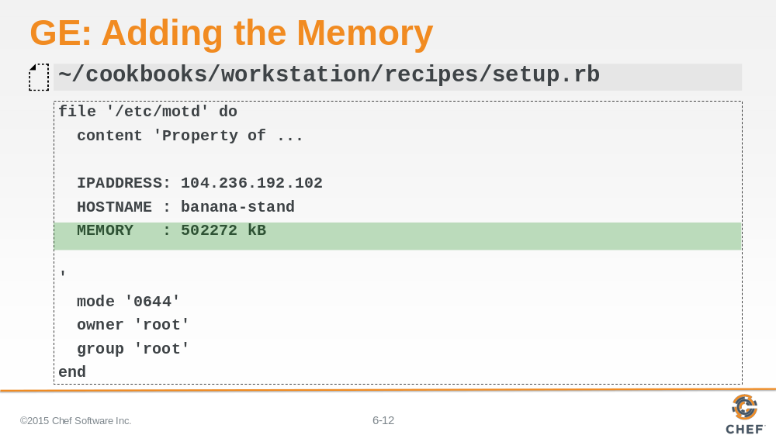

And again, add it in the file resource's attribute below your hostname.

Slide 13

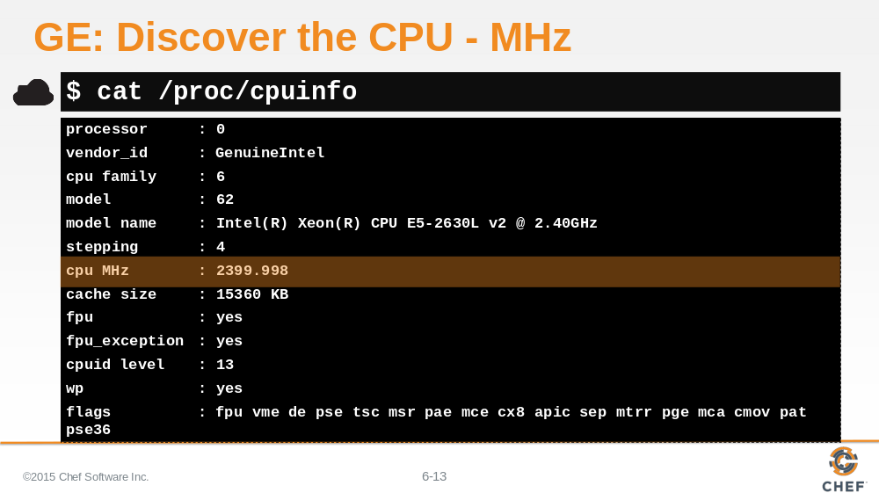

Discovering information about the system's CPU is very similar. We can `cat` the contents of /proc/cpuinfo and select the CPU megahertz from the results.

Slide 14

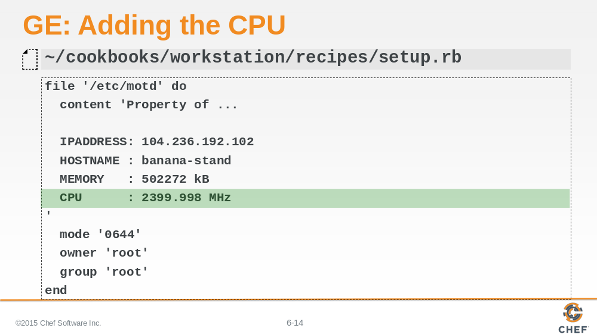

Add the CPU information to the file resource's content attribute.

Slide 15

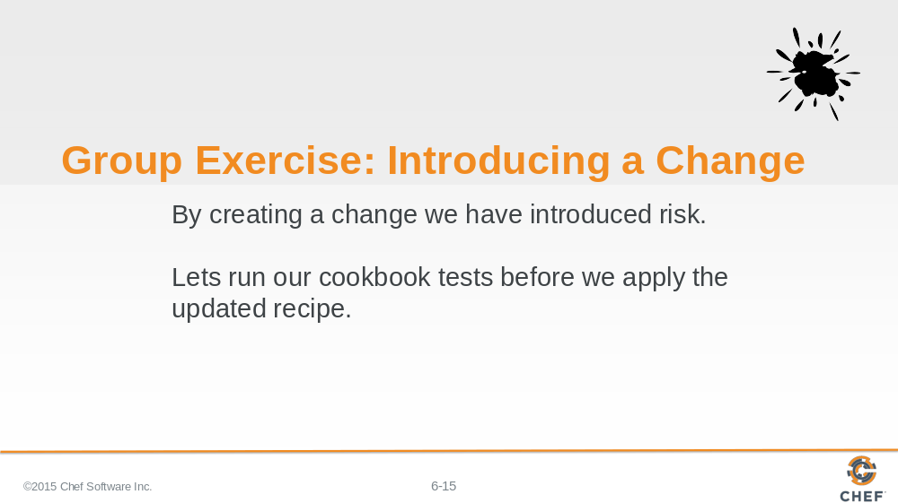

By updating the file resource we have introduced a change to the cookbook and introduced a risk. This change may not work. It could be a typo when transcribed from the slide, or the code that we have provided you may be out-of-date, or very possibly, incorrect.

Before we apply the updated recipe we can use testing to ensure the recipe is correctly defined.

Instructor Note: This is important to reinforce the workflow of working with recipes. Even though this seems like a small change it important to verify every change.

Slide 16

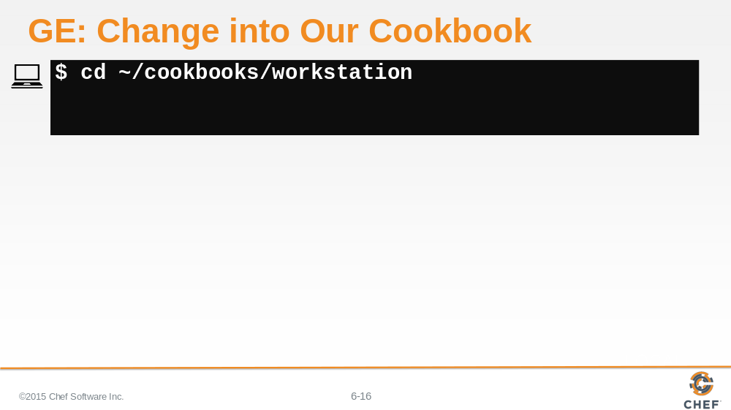

Remember, we are testing a specific cookbook with kitchen so we need to be within the directory of the cookbook. So change directory into the workstation cookbook's directory.

Slide 17

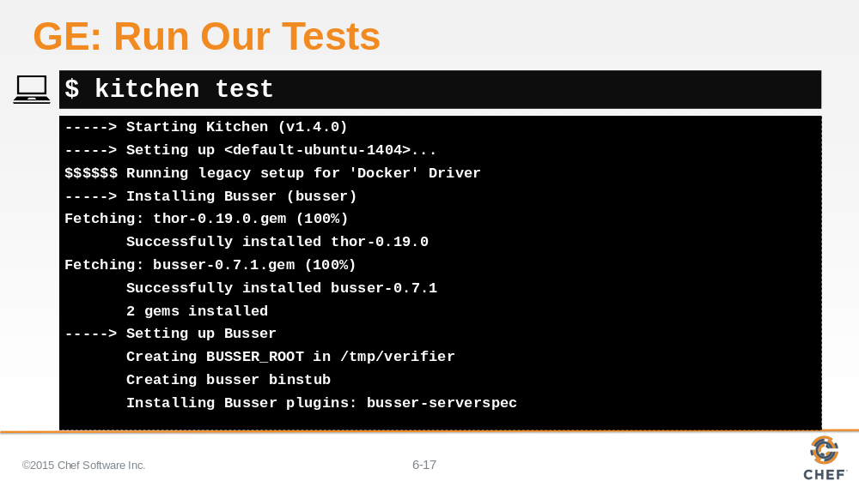

We have not defined any new tests related to the content changes of the /etc/motd. So running the tests will tell us if we have accidentally broken any of the existing functionality but there is nothing testing the new functionality that we added.

Slide 18

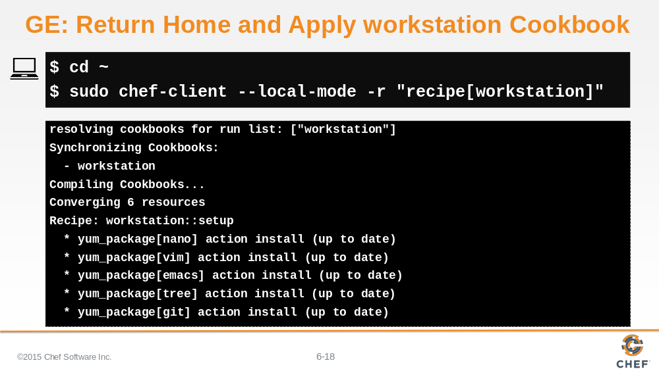

If everything looks good, then we want to use `chef-client`. `chef-client` is not run on a specific cookbook--it is a tool that allows us to apply recipes for multiple cookbooks that are stored within a cookbooks directory.

1. So we need to return home to the parent directory of all our cookbooks.

2. Then use `chef-client` to locally apply the run list defined as: the workstation cookbook's default recipe.

Slide 19

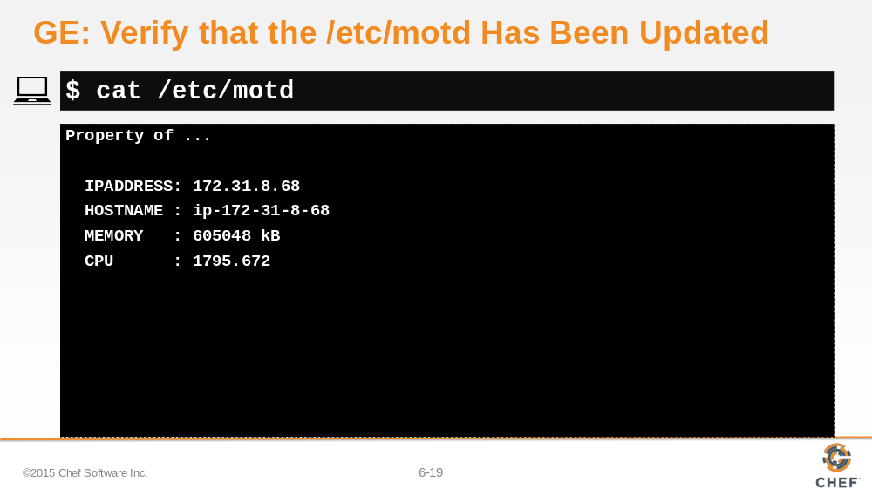

Verify that your /etc/motd had been updated with our values.

Slide 20

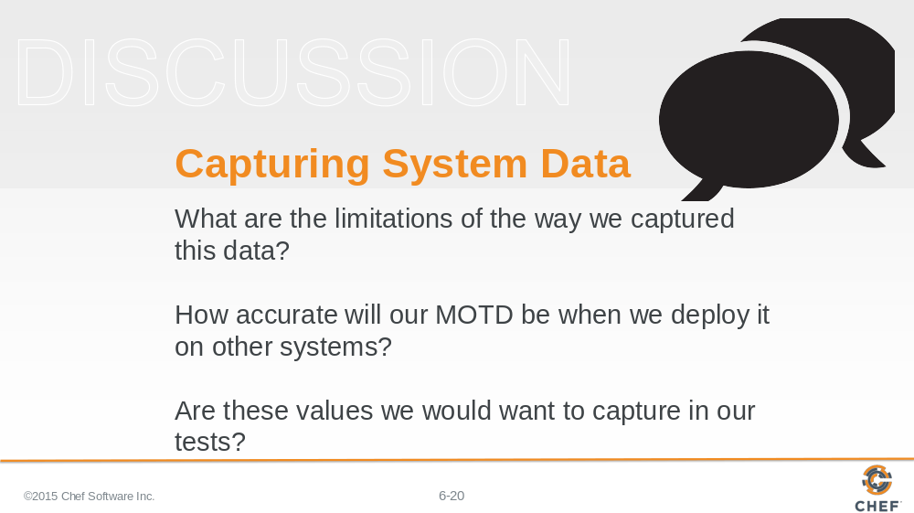

Now that we've defined these values, let’s reflect:

What are the limitations of the way we captured this data?

How accurate will our MOTD be when we deploy it on other systems?

Are these values we would want to capture in our tests?

Slide 21

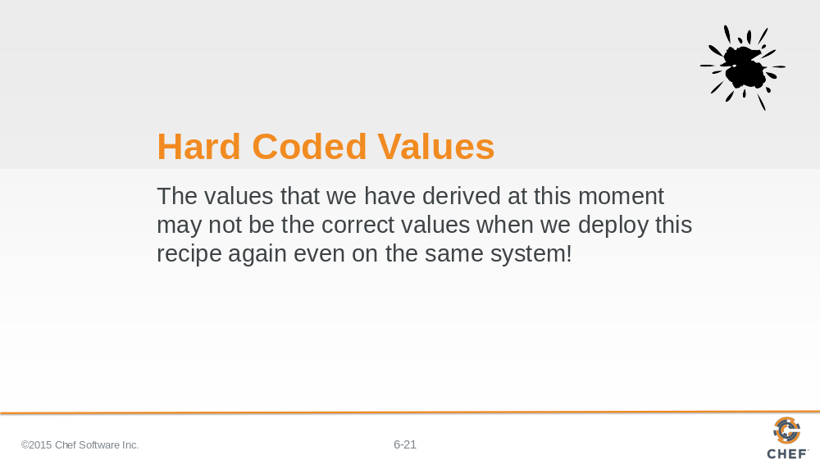

If you have worked with systems for a while, the general feeling is that hard-coding the values in our file resource's attribute probably is not sustainable because the results are tied specifically to this system at this moment in time.

Slide 22

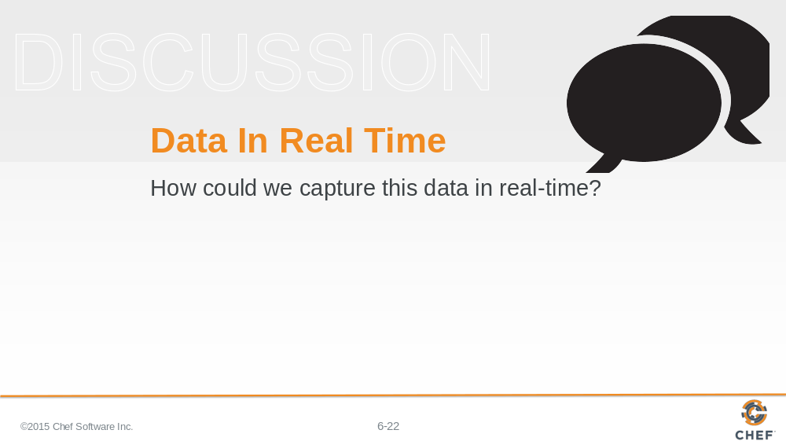

So how can we capture this data in real-time?

Capturing the data in real-time on each system is definitely possible. One way would be to execute each of these commands, parse the results, and then insert the dynamic values within the file resource's content attribute.We could also figure out a way to run system commands within our recipes. Before we start down this path, we'd like to introduce you to Ohai.

Instructor Note: There are many ways within Ruby to escape out and run a system command. Someone new to Chef and Ruby may reach for those and this section is important in showing that most of the work has already been done.

Slide 23

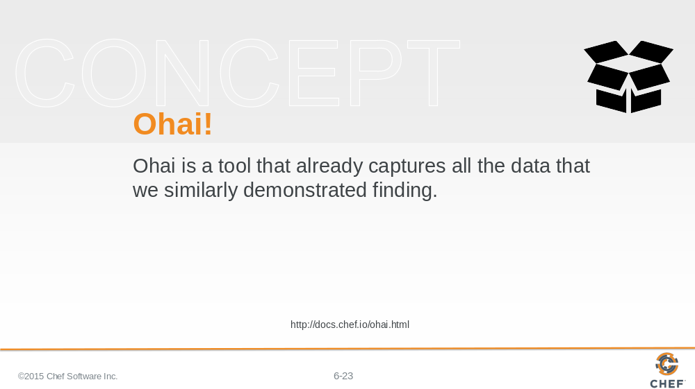

Ohai is a tool that detects and captures attributes about our system. Attributes like the ones we spent our time capturing already.

Slide 24

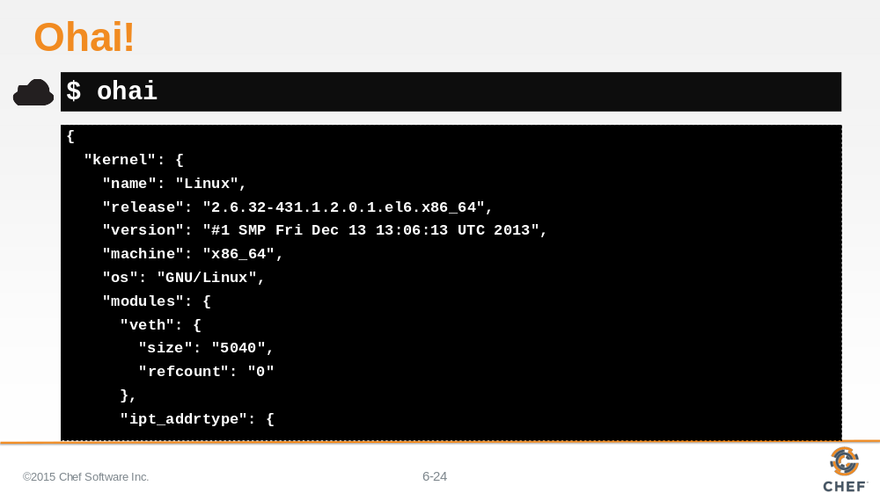

Ohai is also a command-line application that is part of the ChefDK.

Slide 25

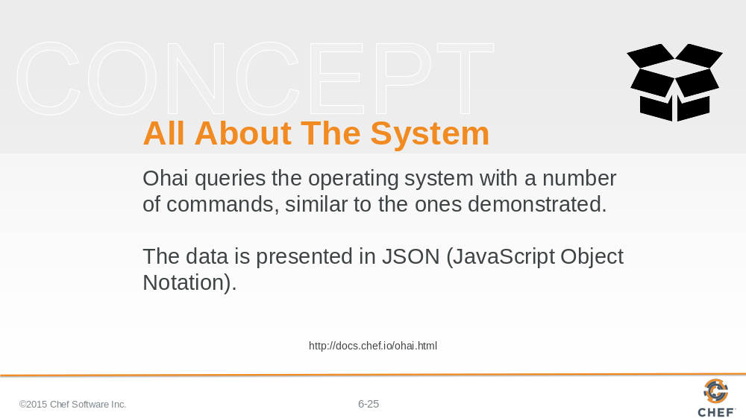

Ohai, the command-line application, will output all the system details represented in JavaScript Object Notation (JSON).

Slide 26

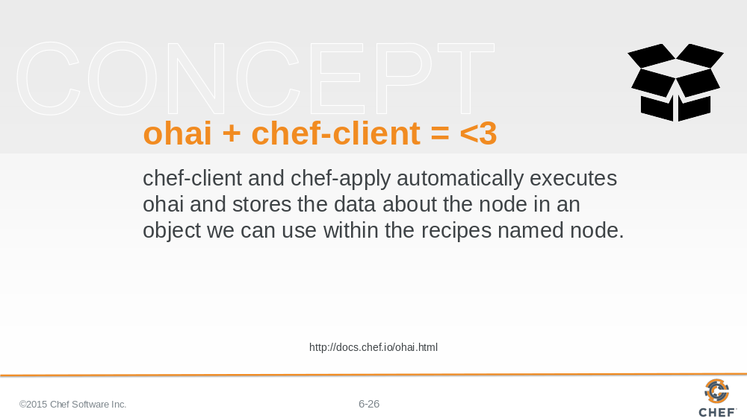

These values are available in our recipes because `chef-client` and `chef-apply` automatically execute Ohai. This information is stored within a variable we call 'the node object'

Slide 27

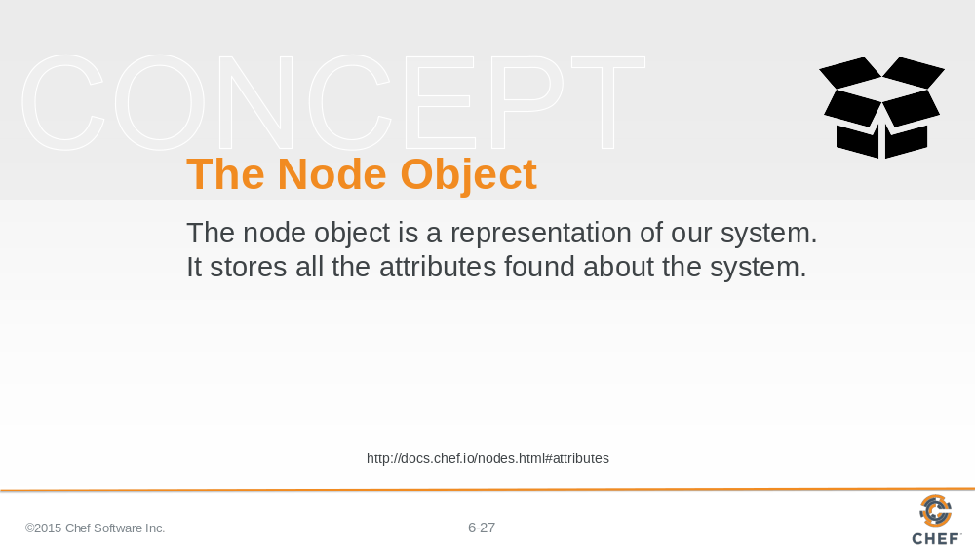

The node object is a representation of our system. It stores all these attributes found about the system. It is available within all the recipes that we write to assist us with solving the similar problems we outlined at the start.

An attribute is a specific detail about a node, such as an IP address, a host name, a list of loaded kernel modules, the version(s) of available programming languages that are available, and so on.

Lets look at using the node object to retrieve the ipaddress, hostname, total memory, and cpu megahertz.

Slide 28

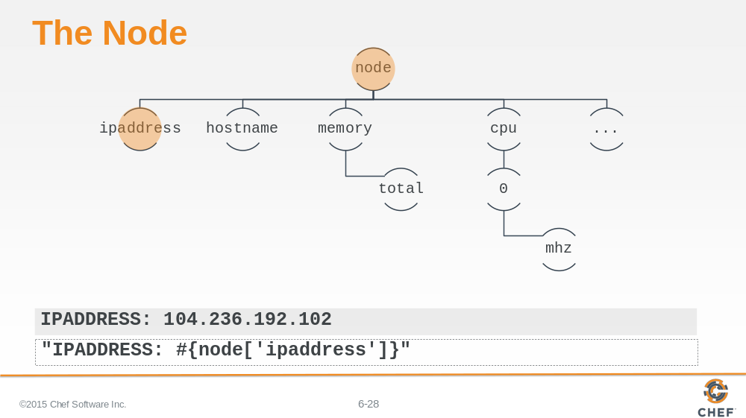

This is the visualization of the node attributes as a tree. That is done here to illustrate that the node maintains a tree of attributes that we can request from it.

The shaded text near the bottom of this slide is the hard-coded value we currently have in the file resource's content attribute.

At the very bottom is an example of how we could use the node's dynamic value within a string instead of the hard-coded one.

Slide 29

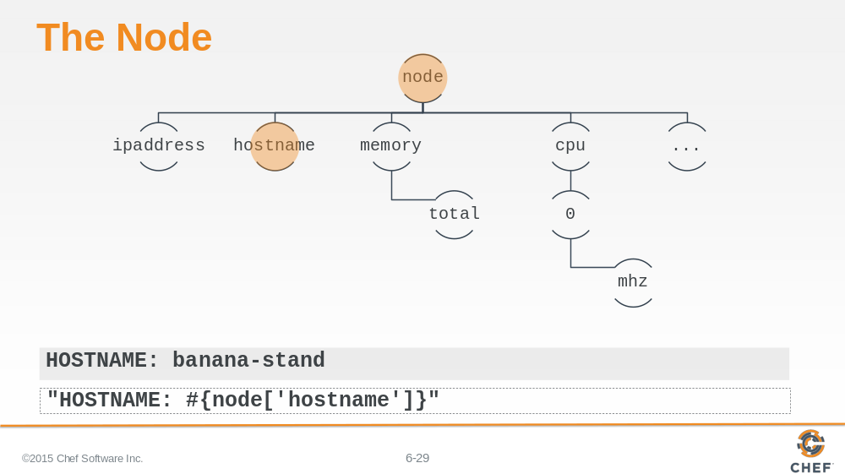

The node maintains a hostname attribute. This is how we retrieve and display it.

Slide 30

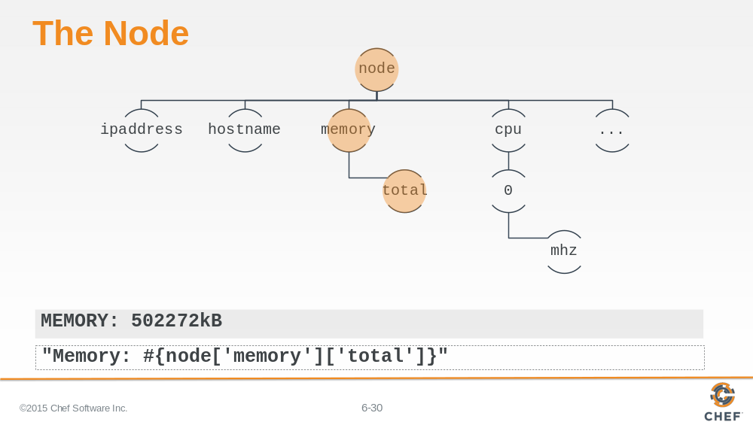

The node contains a top-level value memory which has a number of child elements. One of those child elements is the total amount of system memory.

Accessing the node information is different. We retrieve the first value 'memory', returning a subset of keys and values at that level, and then immediately select to return the total value.

Slide 31

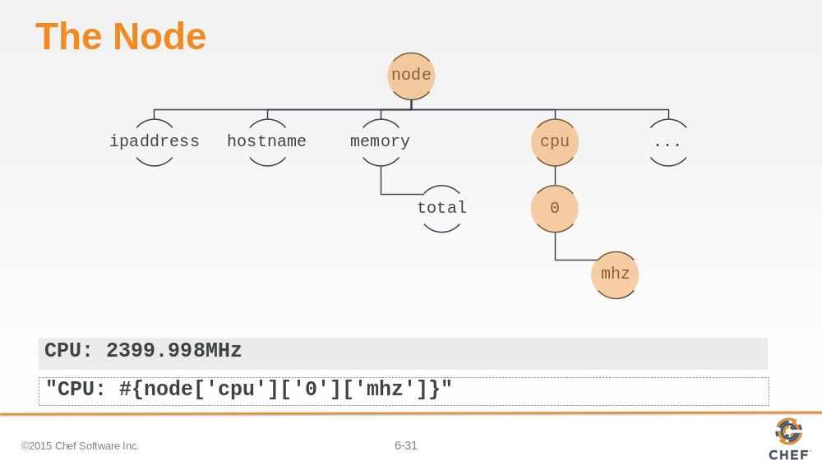

And finally, here we return the megahertz of the first CPU.

Slide 32

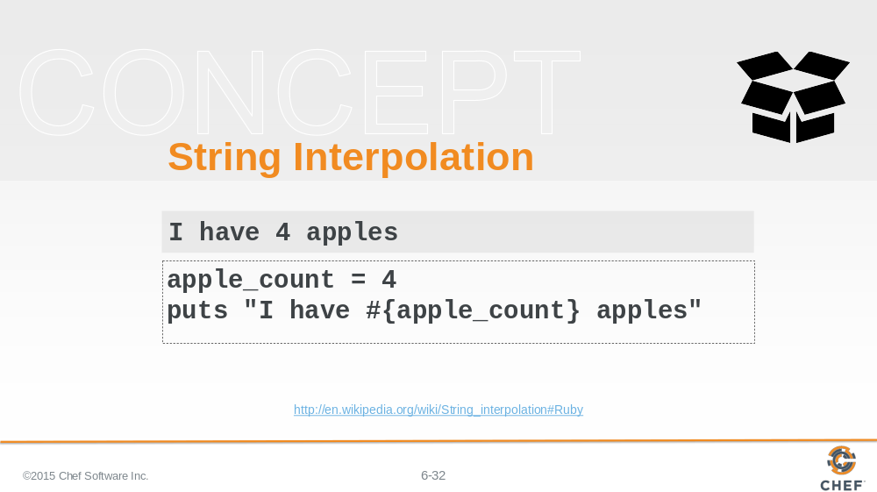

In all of the previous examples we demonstrated retrieving the values and displaying them within a string using a ruby language convention called string interpolation.

Slide 33

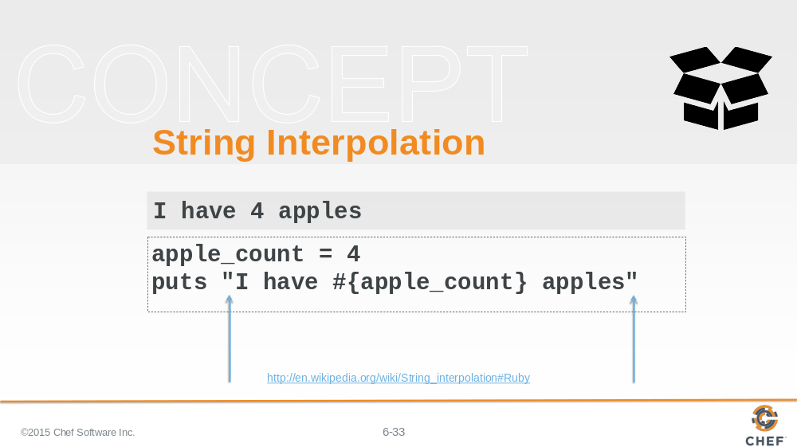

String interpolation is only possible with strings that start and end with double-quotes.

Slide 34

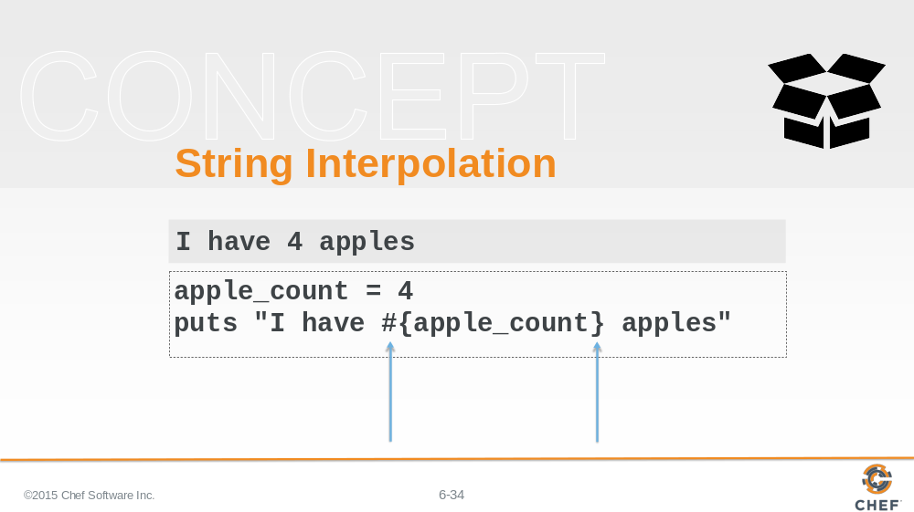

To escape out to display a ruby variable or ruby code you use the following sequence: number sign, left curly brace, the ruby variables or ruby code, and then a right curly brace.

Slide 35

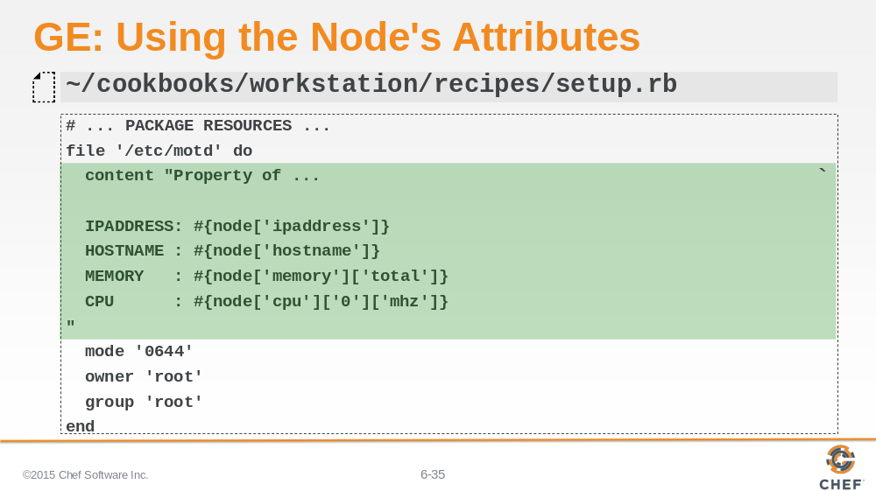

In this group exercise, instead of using hard-coded values, use string interpolation within the file resource's content attribute to allow the system to access the node object's attribute for:
IP address
Hostname
Total memory
Megahertz of the first CPU.

Slide 36

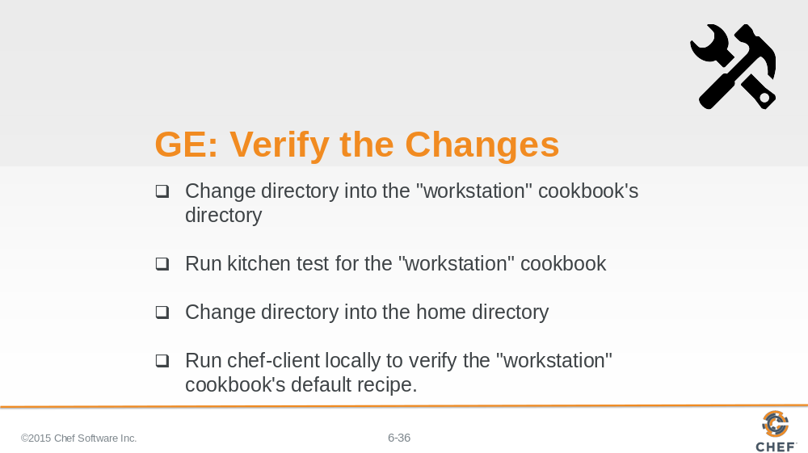

Again we have created a change.

Move into the workstation cookbook's directory. Verify the changes we made to the workstation cookbook's default recipe with kitchen. Return to the home directory. Use 'chef-client' to locally apply the workstation cookbook's default recipe.

Instructor Note: Allow 8 minutes to complete this exercise.

Slide 37

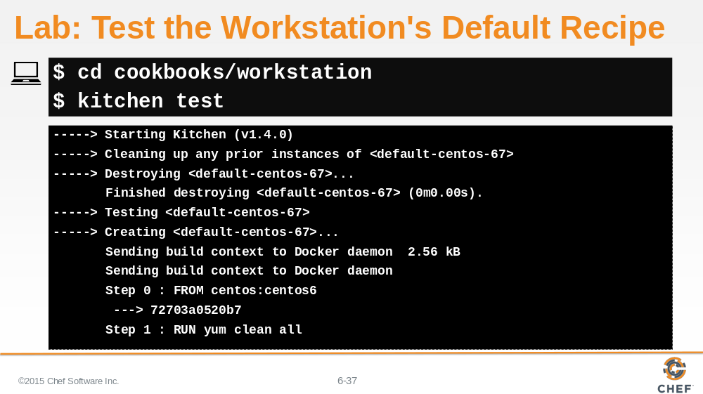

Change into the workstation cookbook's directory and then run `kitchen test` to verify that the changes we introduced did not cause a regression.

Slide 38

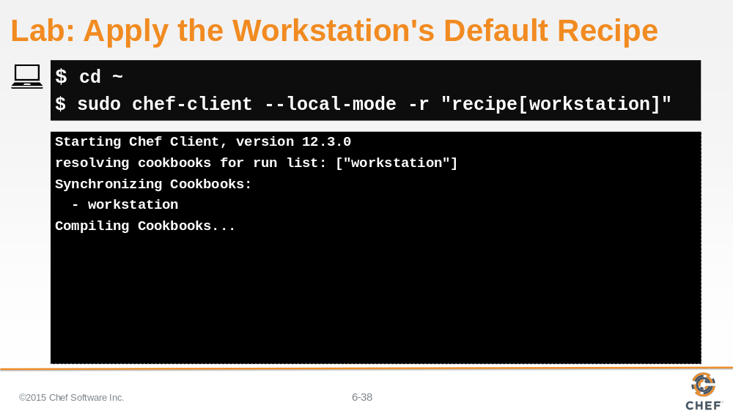

If everything passes and you feel confident that it will also work on the current workstation, change to the home directory and then run `chef-client` to apply the apache cookbook locally to the system.

Slide 39

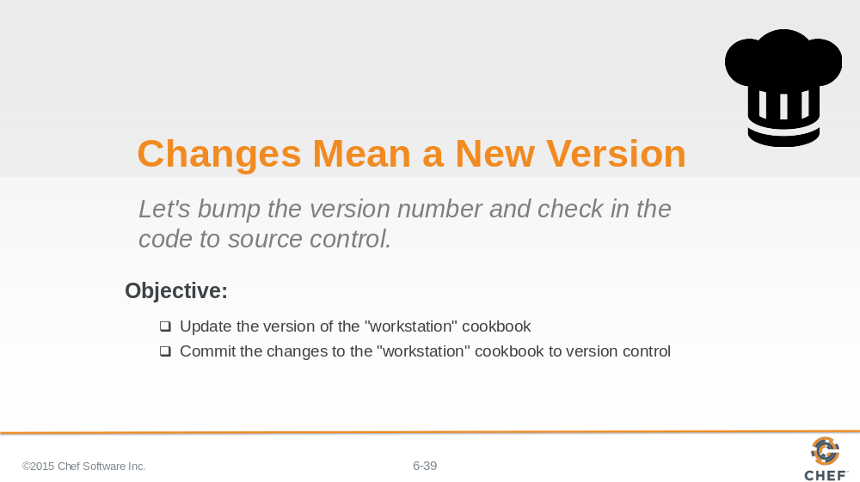

Now that we've made these significant changes and verified that they work, its time we bumped the version of the cookbook and commit the changes.

Slide 40

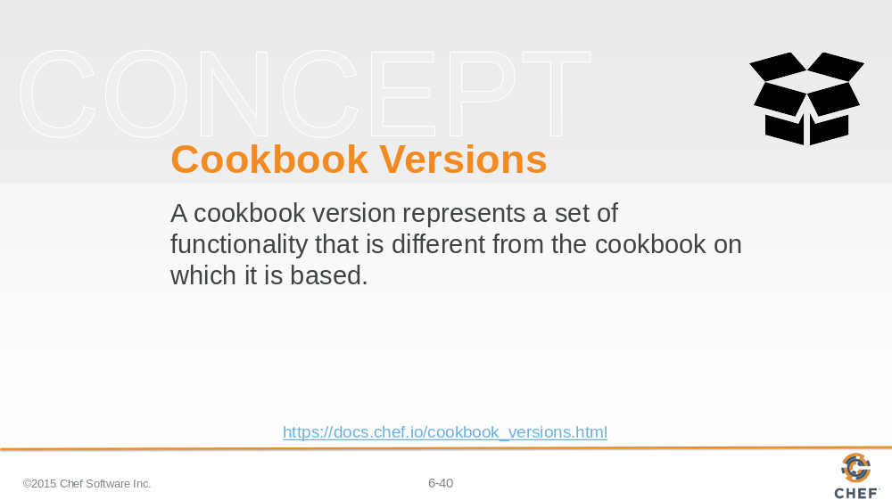

A version may exist for many reasons, such as ensuring the correct use of a third-party component, updating a bug fix, or adding an improvement.

The first version of the cookbook displayed a simple property message in the /etc/motd. The changes that we finished are new features of the cookbook.

Slide 41

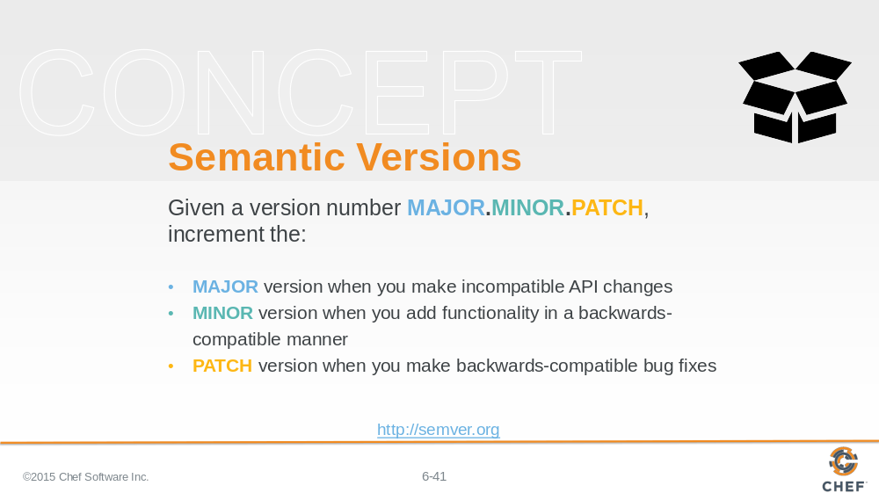

Cookbooks use semantic version. The version number helps represent the state or feature set of the cookbook. Semantic versioning allows us three fields to describe our changes: major; minor; and patch.

Major versions are often large rewrites or large changes that have the potential to not be backwards compatible with previous versions. This might mean adding support for a new platform or a fundamental change to what the cookbook accomplishes. Minor versions represent smaller changes that are still compatible with previous versions. This could be new features that extend the existing functionality without breaking any of the existing features. And finally Patch versions describe changes like bug fixes or minor adjustments to the existing documentation.

Slide 42

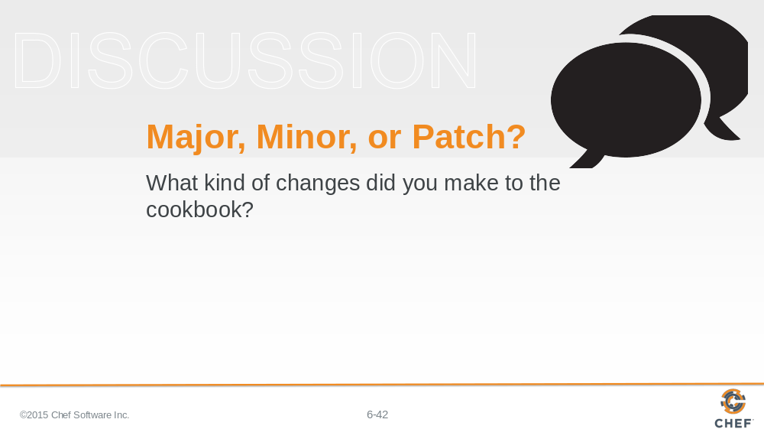

So what kind of changes did you make to the cookbook? How could we best represent that in an updated version?

Slide 43

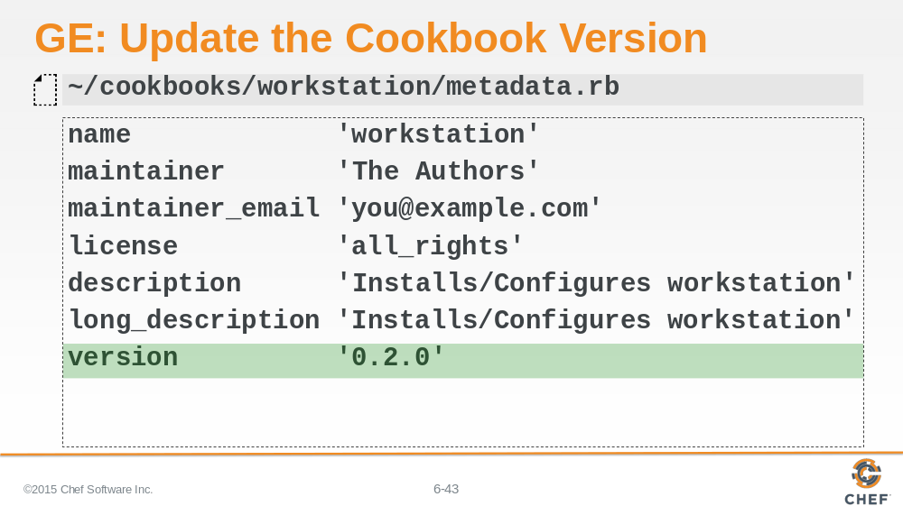

Changing the contents of an existing resource--by adding the attributes of the node doesn't seem like a bug fix and it doesn't seem like a major rewrite. It is like a new set of features while remaining backwards compatible.

Edit ~/cookbooks/workstation/metadata.rb and update the version's minor number to 0.2.0.

Slide 44

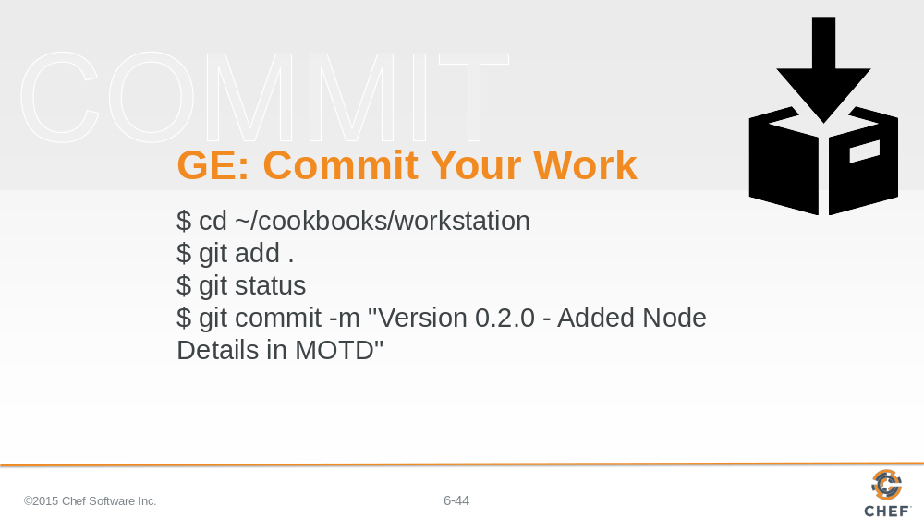

The last thing to do is commit our changes to source control. Change into the directory, add all the changed files, and then commit them.

Slide 45

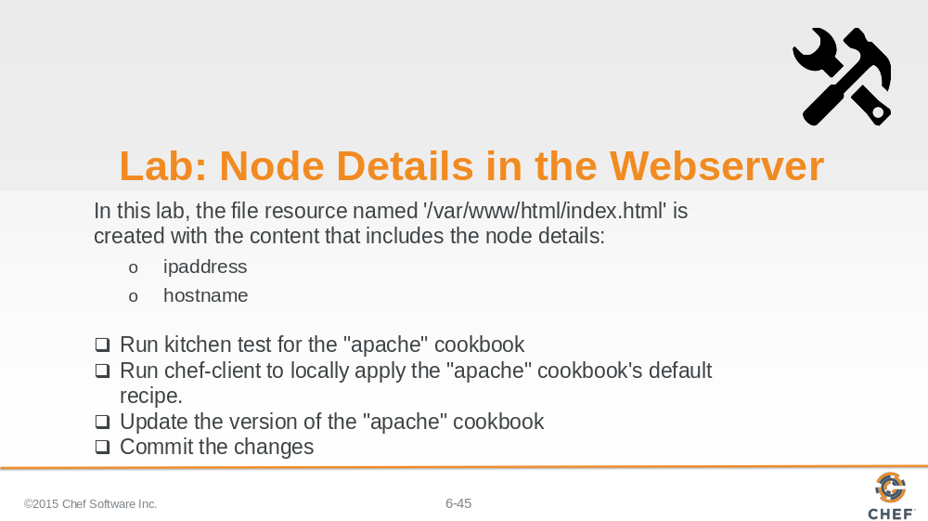

Now it's time to add similar functionality to the apache cookbook. You should try to follow the high-level steps in this slide to complete this lab.

Instructor Note: Allow 15 minutes to complete this exercise.

Slide 46

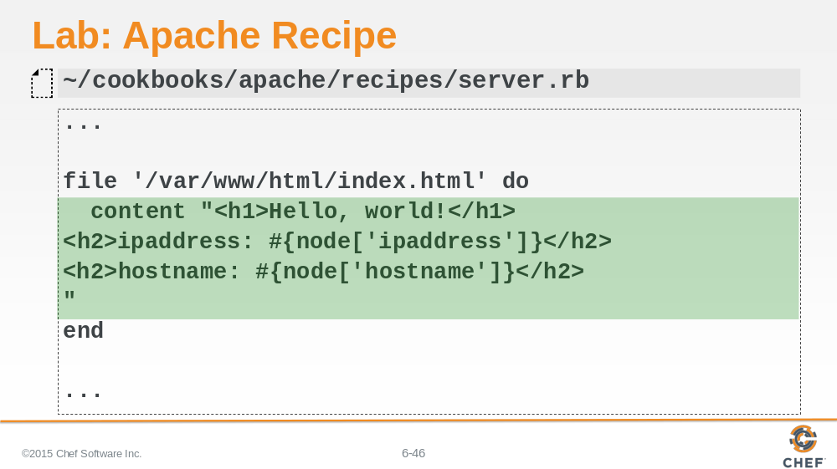

Update the file resource, named '/var/www/html/index.html, to be created with the content that includes the node's IP address and its host name.

Slide 47

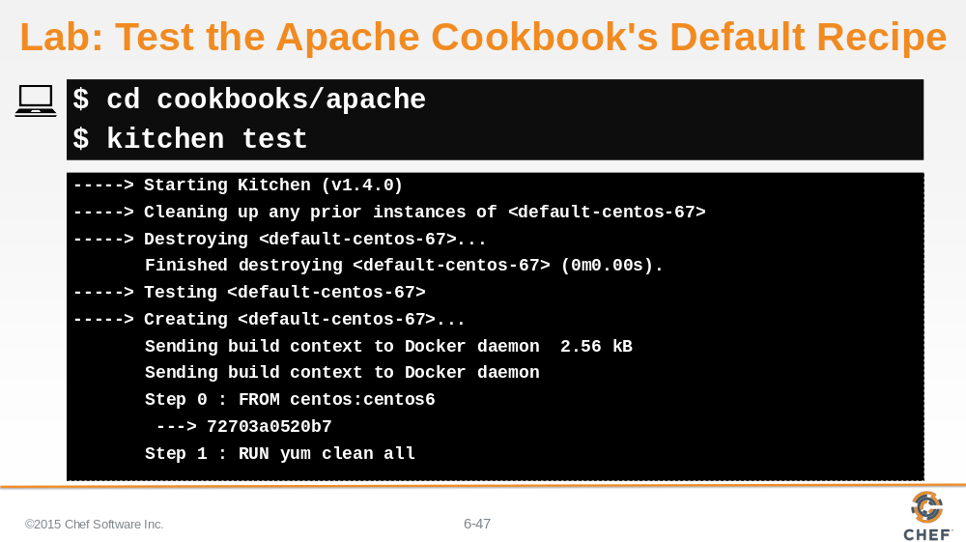

Change into the apache cookbook's directory and then run `kitchen test` to verify that the changes we introduced did not cause a regression.

Slide 48

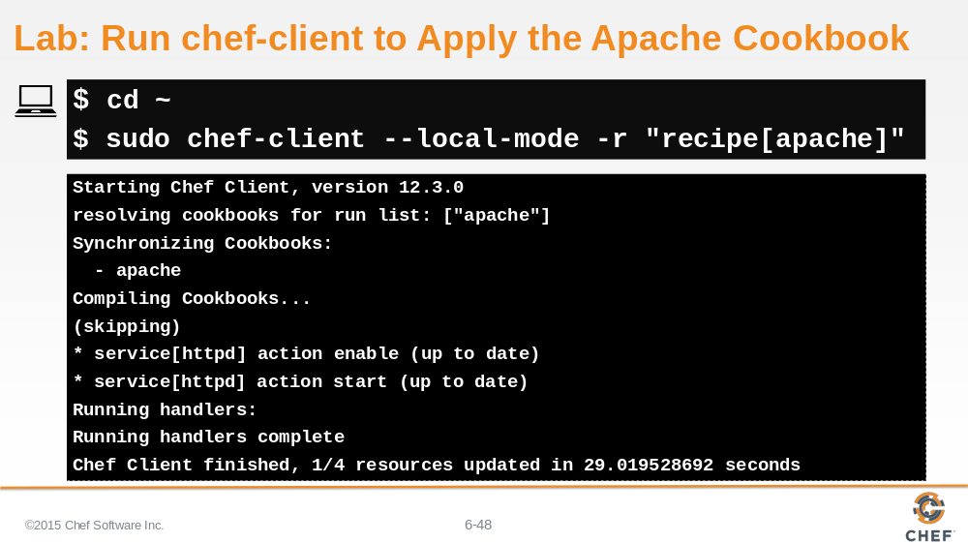

If everything passes and you feel confident that it will also work on the current workstation, change to the home directory and then run `chef-client` to apply the apache cookbook locally to the system.

Slide 49

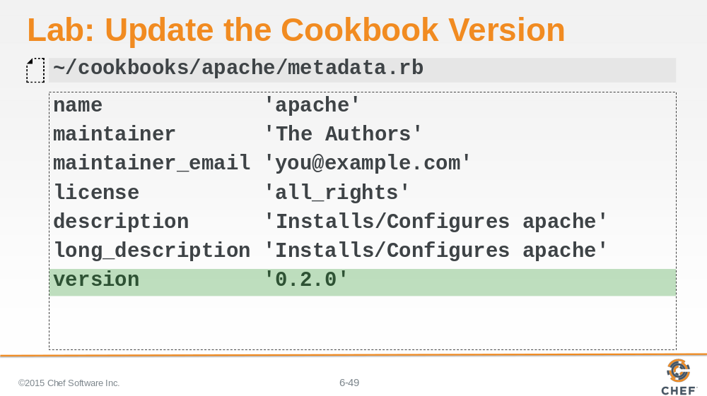

Showing these two attributes in the index html page seems very similar to the feature we added for the workstation cookbook. So update the version of the apache cookbook to 0.2.0 as well.

Slide 50

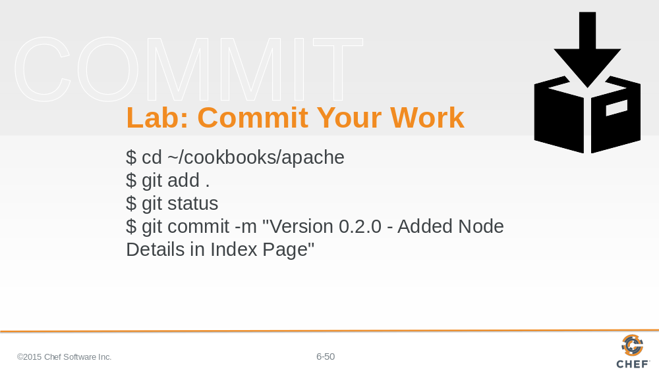

And finally, commit your changes to git.

Slide 51

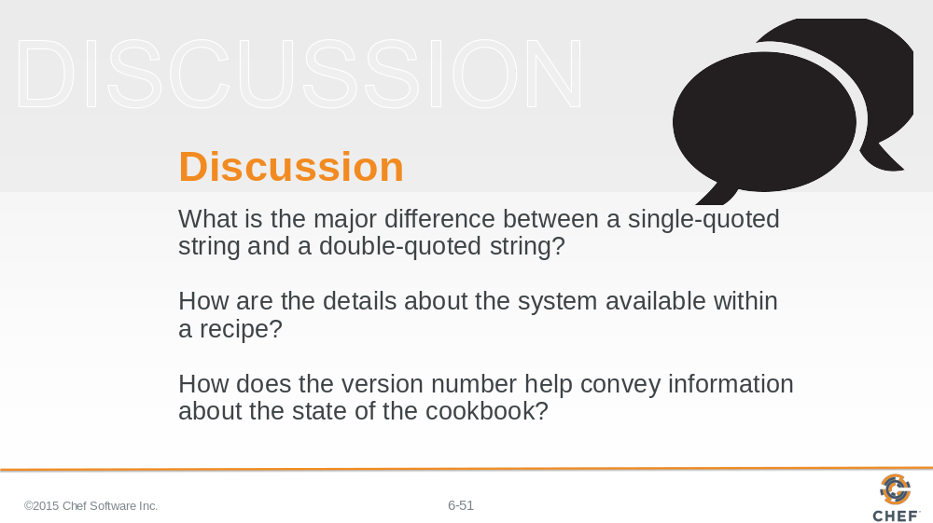

Answer these questions.

With your answers, turn to another person and alternate asking each other asking these questions and sharing your answers.

Slide 52

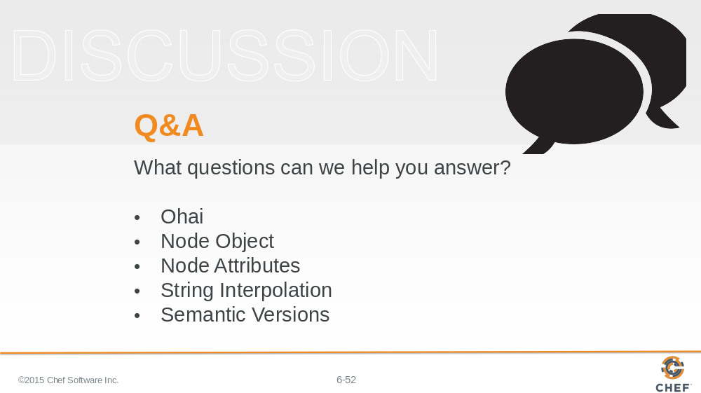

With that we have added all of the requested features.

What questions can we help you answer?

In general or about specifically about ohai, the node object, node attributes, string interpolation, or semantic versioning.

Slide 53



