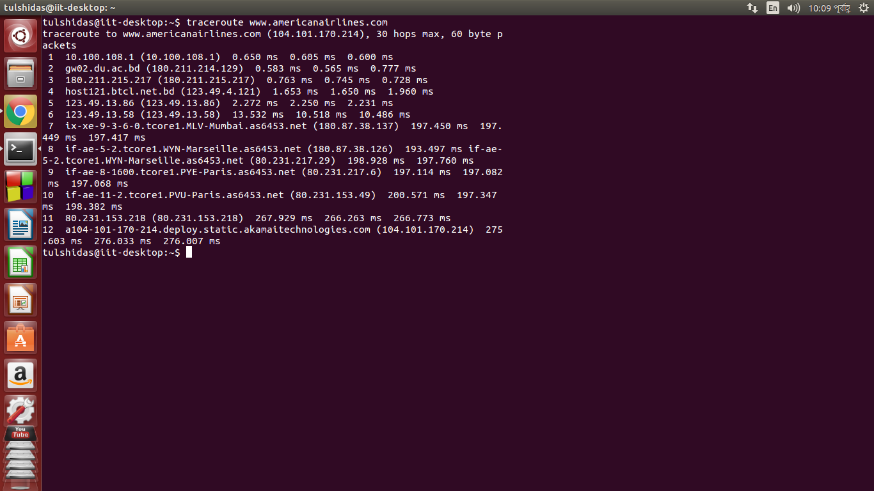
IP address | Internet Service Provider | State/Region
10.100.108.1 | RFC 1918 | No reference
180.211.214.129 | Bangladesh Telecommunications Company Ltd. | Dhaka,Bangladesh
180.211.215.217 | Bangladesh Telecommunications Company Ltd. | Dhaka,Bangladesh
123.49.4.121 | Bangladesh Telecommunications Company Ltd. | Dhaka,Bangladesh
123.49.13.86 | Bangladesh Telecommunications Company Ltd. | Dhaka,Bangladesh
123.49.13.58 | Bangladesh Telecommunications Company Ltd. | Dhaka,Bangladesh
180.87.38.137 | Tata-communications-ltd | India,Maharashtra
180.87.38.126 | Tata-communications-ltd | India,Maharashtra
80.231.217.29 | TATA Communications | France,Marseille
80.231.217.6 | TATA Communications | France,Marseille
80.231.253.49 | TATA Communications (Canada) Ltd. | United Kingdom,London
104.101.170.214 | Akamai Technologies | United States,Massachusettss

Total Time:267.929+266.263+266.773=800.965

