traceroute mail.silkroad-europe.com
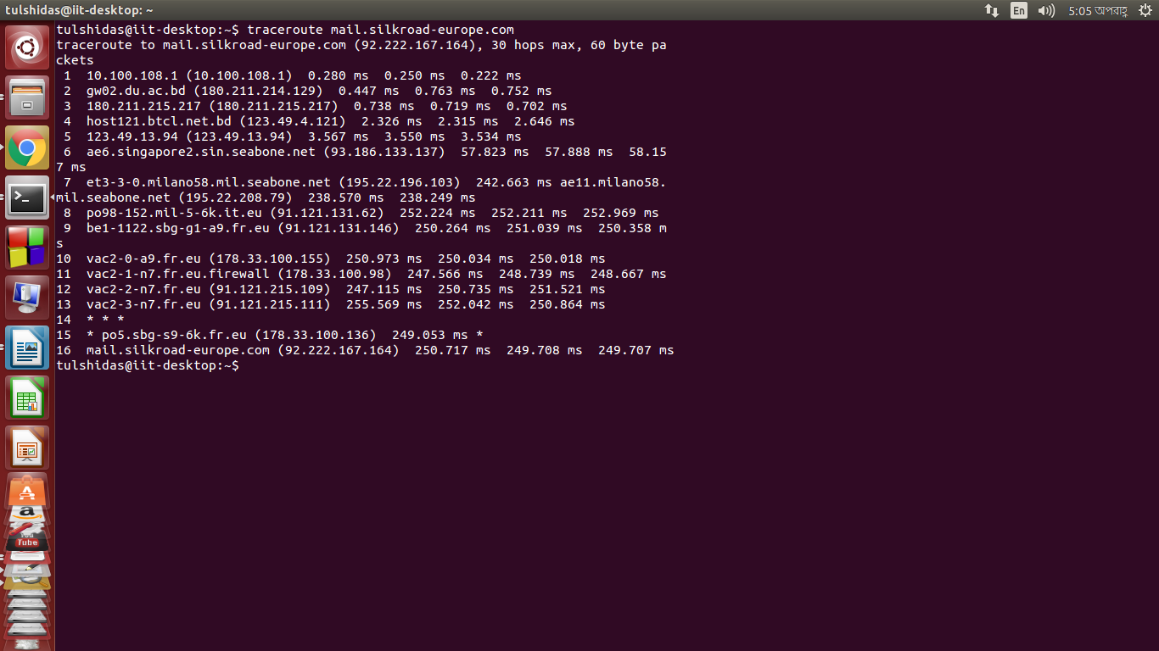
IP address | Internet Service Provider | State/Region
10.100.108.1 | Private network | Dhaka ,Bangladesh
180.211.214.129 | Bangladesh Telecommunications Company Ltd. | Dhaka ,Bangladesh
180.211.215.217 | Bangladesh Telecommunications Company Ltd. | Dhaka ,Bangladesh
123.49.4.121 | Bangladesh Telecommunications Company Ltd. | Dhaka ,Bangladesh
123.49.13.94 | Bangladesh Telecommunications Company Ltd. | Dhaka ,Bangladesh
93.186.133.137 | Sea-bone | Italy,Latiam
195.22.196.103 | Sea-bone | Italy,Latiam
91.121.131.62 | Ovh Isp | France,Roubaix
91.121.131.146 | Ovh Isp | France,Roubaix
178.33.100.155 | Ovh Isp | France,Roubaix
178.33.100.98 | Ovh Isp | France,Roubaix
91.121.215.109 | Ovh Isp | France,Roubaix
91.121.215.111 | Ovh Isp | France,Roubaix
178.33.100.136 | Ovh Isp | France,Roubaix
92.222.167.164 | Ovh Isp | France,Roubaix

Total Time: 250.717+249.708+249.707=750.132

