Traceroute www.google.com.au

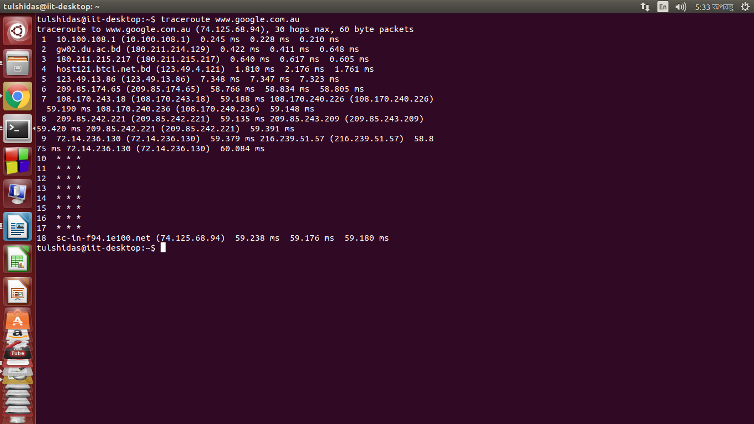

IP address | Internet Service Provider | State/Region
10.100.108.1 |  | Bangladesh
  Private network
180.211.214.129 |  | Dhaka ,Bangladesh
  Bangladesh Telecommunications Company Ltd.
180.211.215.217 |  | Dhaka ,Bangladesh
  Bangladesh Telecommunications Company Ltd.
123.49.4.121 | Bangladesh Telecommunications Company Ltd. | Dhaka ,Bangladesh
123.49.13.86 | Bangladesh Telecommunications Company Ltd. | Dhaka ,Bangladesh
209.85.174.65
  Google Inc.
  United States ,Chicago
108.170.243.18 | Google Inc. | United States ,Chicago
108.170.240.236 | Google Inc. | United States ,Chicago
209.85.242.221 | Google Inc.
  United States,Ashburn
72.14.236.130 | Google Inc.
  United States,California
74.125.68.94 | Google Inc. | United States ,Chicago

Total Time:59.238+59,176+59.180=177.594

