Traceroute www.asiawebdirect.com

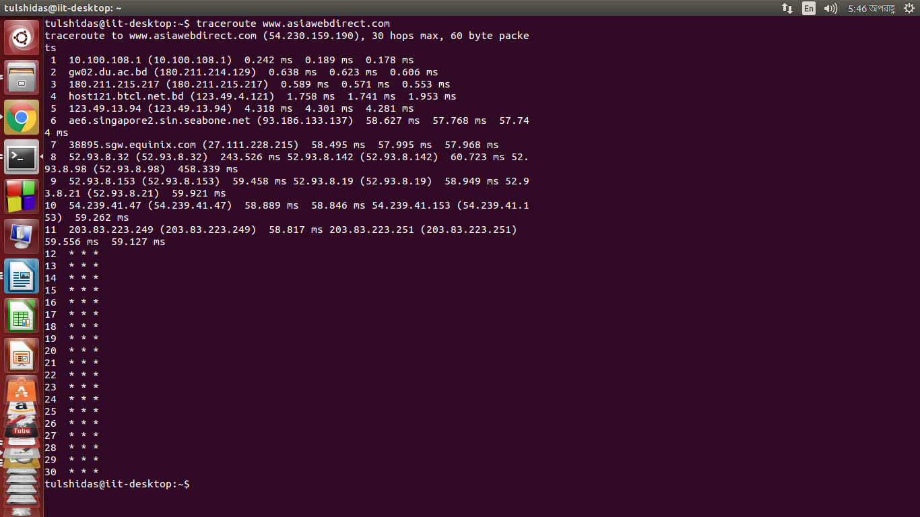
IP address | Internet Service Provider | State/Region
10.100.108.1 |  | Dhaka,Bangladesh
  Private network
180.211.214.129 |  | Dhaka,Bangladesh
  Bangladesh Telecommunicati
  -ons Company Ltd.
180.211.215.217 |  | Dhaka,Bangladesh
  Bangladesh Telecommunicati
  -ons Company Ltd.
123.49.4.121 | Bangladesh Telecommunicati  -ons Company Ltd. | Dhaka,Bangladesh
123.49.13.94 | Bangladesh Telecommunicati  -ons Company Ltd. | Dhaka,Bangladesh
93.186.133.137 | Bangladesh Telecommunicati  -ons Company Ltd. | Dhaka,Bangladesh
27.111.228.215 | Equinix
  Singapore (Queenstown Esta
  te)
52.93.8.76
  Amazon Technologies Inc.
  United States , Washington
52.93.8.129 |  | United States , Washington
  Amazon Technologies Inc.
54.239.41.153 | Amazon Technologies Inc. | United States , Washington
203.83.223.251 | Amazon
  Central Singapore

Total Time: Not found

