Accounting Module

* Charts of Accounts
* Reconcile

Chart of Accounts Page

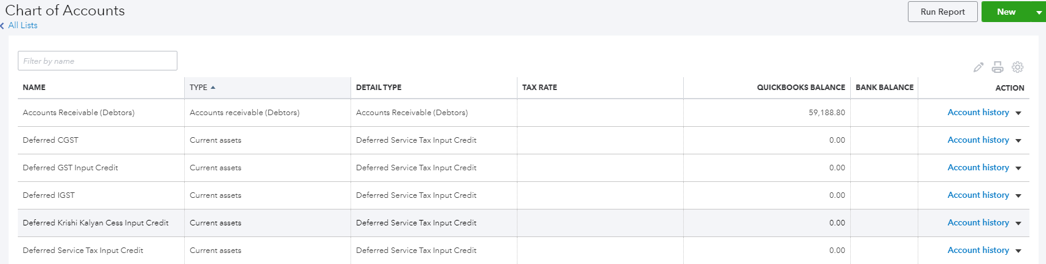

Chart of Accounts Page->Action(Account History)

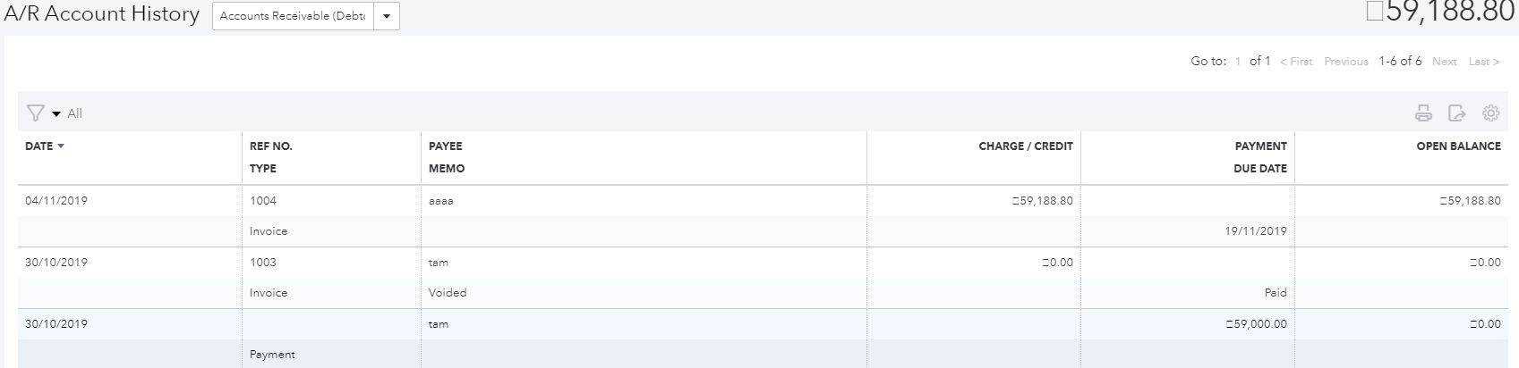

Chart of Accounts Page->(onclick)New Button

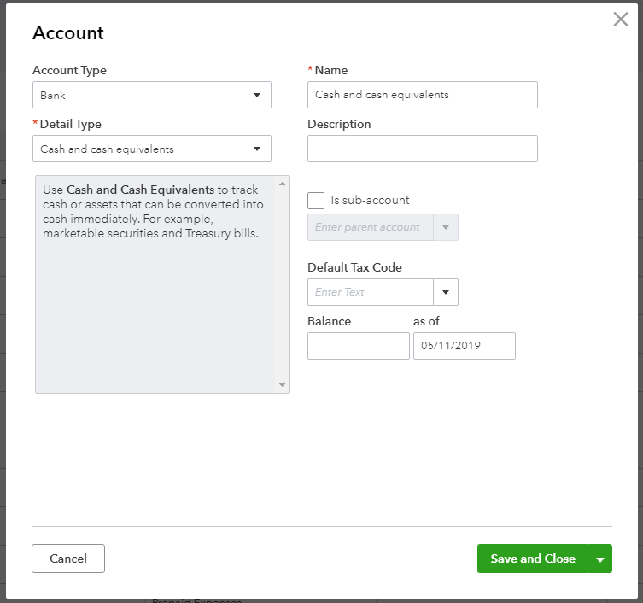

Reconcile

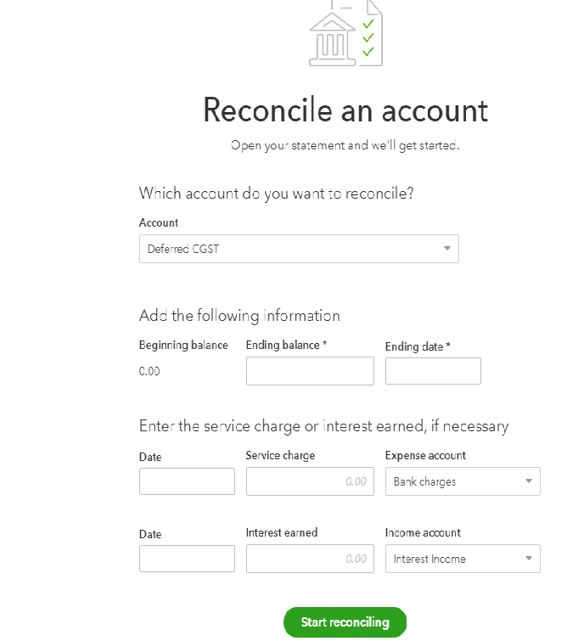

Purchase Module

* Vendor
* Expenses
* Recurring Expenses
* Purchase Orders
* Bills
* Payments Made
* Recurring Bills
* Vendor Credits

Vendor Page



Vendor->(onclick)Add New Button

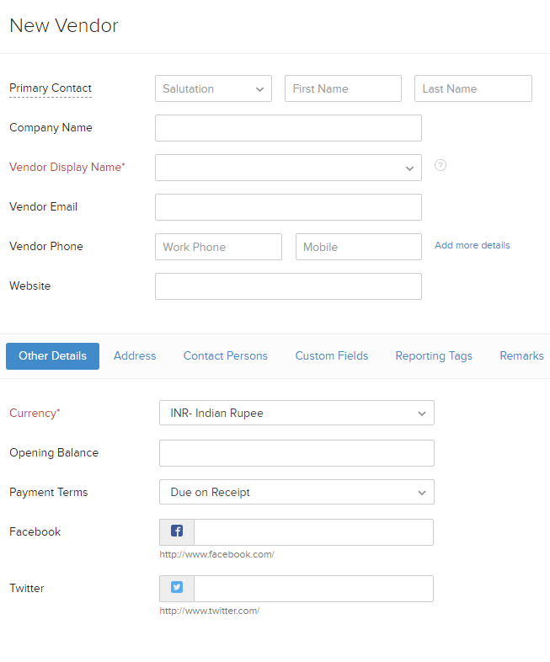

Expenses Page

* Record Expenses
* Record Mileage
* Bulk and Expenses

Record Expenses

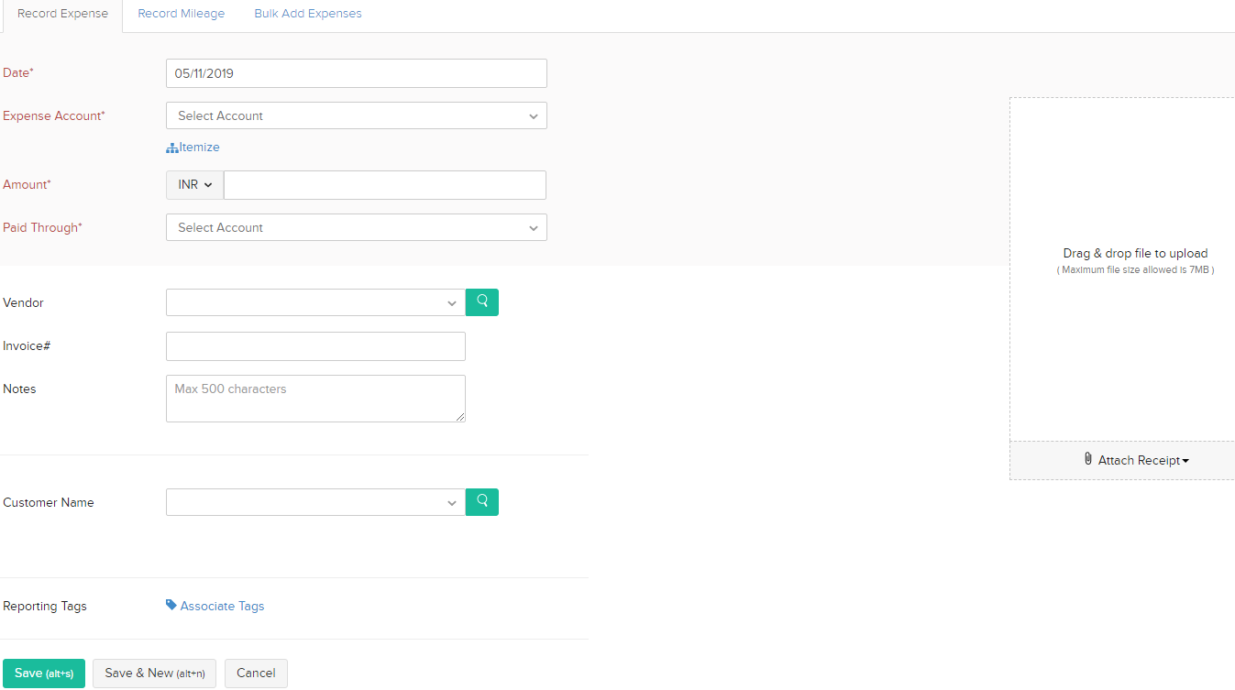

Record Mileage

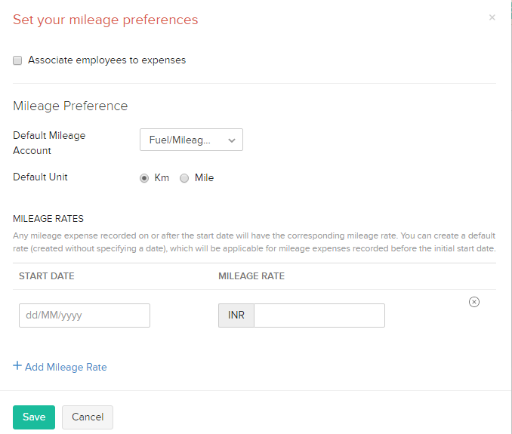

Bulk and Expenses

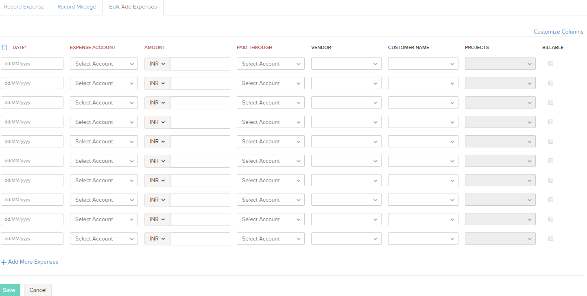

Recurring Expenses Page

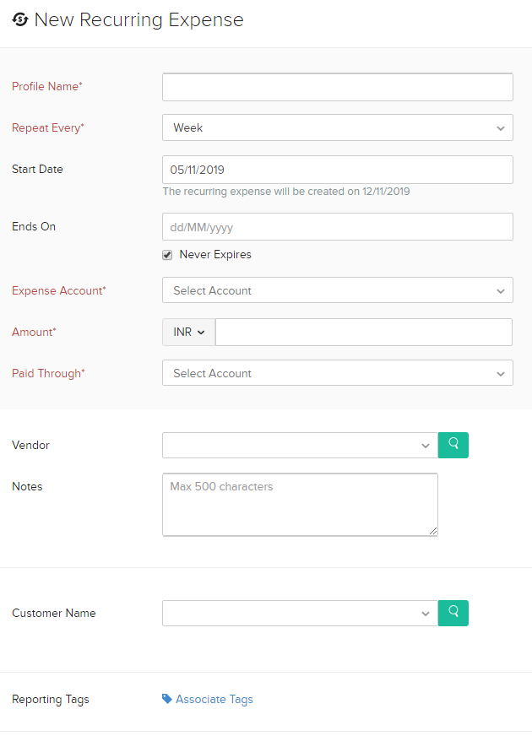

Purchase Orders Page(Organization form)

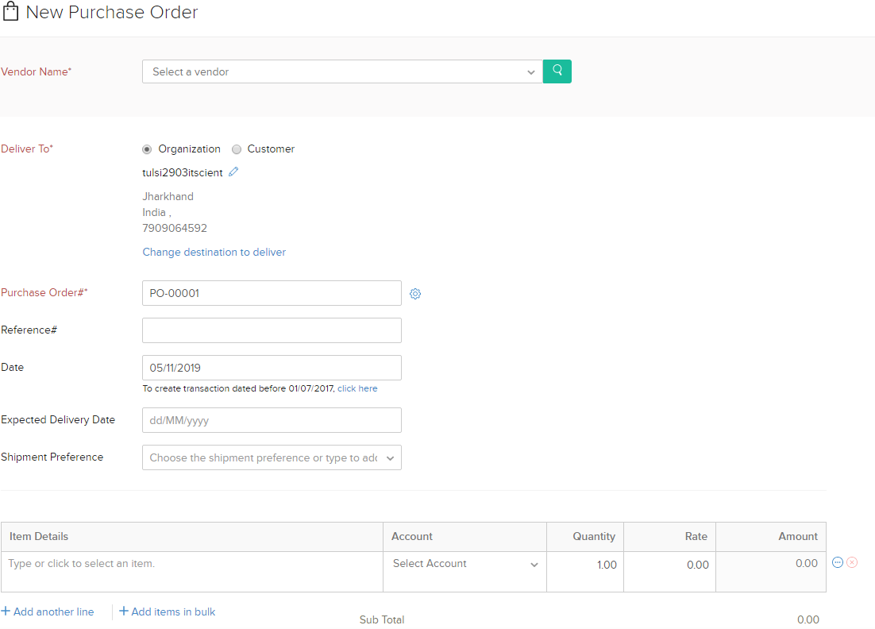

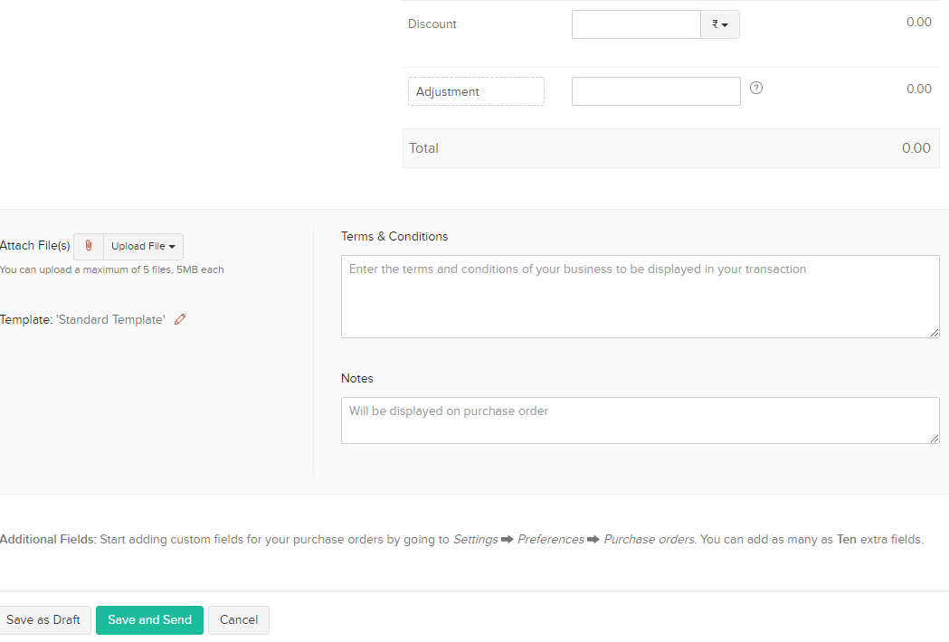

Purchase Orders Page(Customer form)

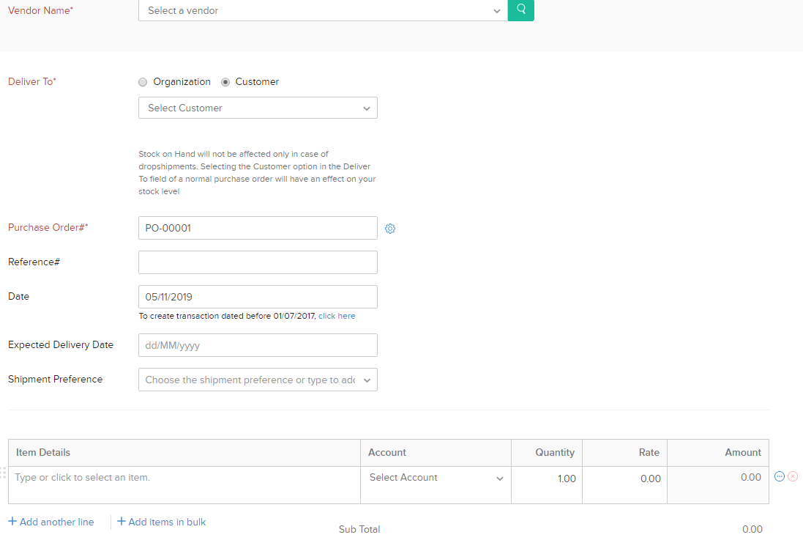

Bills Page



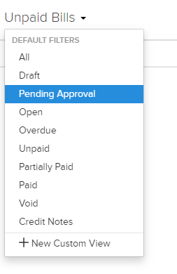

Bills Page->Add new Bills button(onclick)

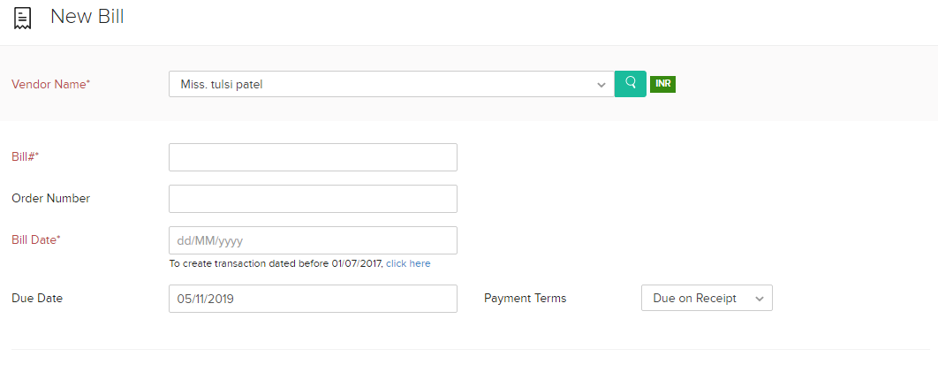

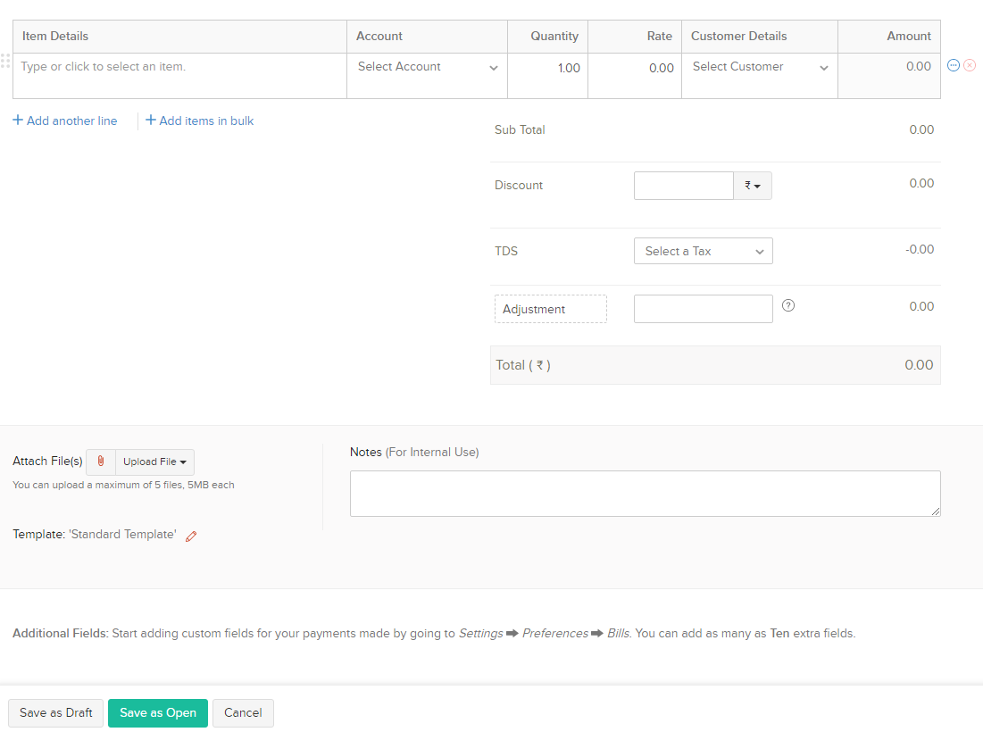

Payments Made Page



Payments Made->Go to unpaid bills Button(onclick)

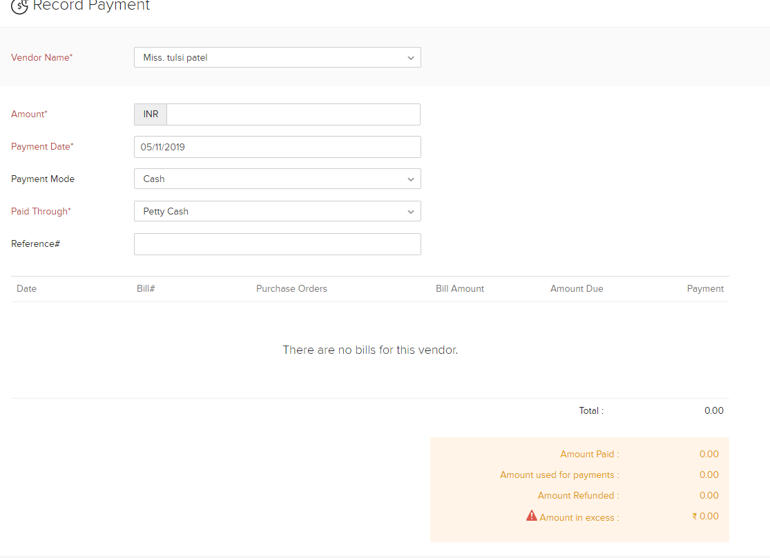

Recurring Bills Page

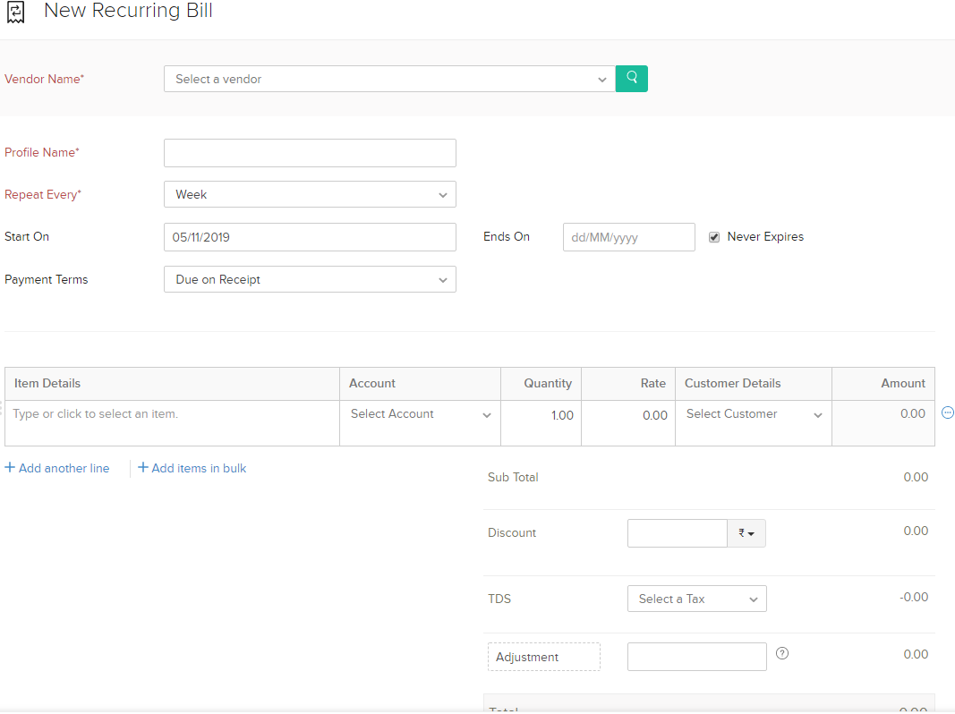

Vendors Credit Page

