CUSTOM THEMING

* The theme for a website defines the appearance of its user interface (UI): the logo, the color scheme, and the links in the page headers and footers are examples of different aspects of an Open edX site that are defined by its theme.
* Open edX provides a default theme that is defined by page templates, CSS styling, and assets such as images that are provided in the Open edX code. You can change the appearance of the following parts of an Open edX site.
* The Studio UI, which is used by course teams.
* The learning management system (LMS) UI, which is used by learners and course teams.
* The UI of the E-commerce service, which is used by course offering and order managers.
* Themes are located outside of the Open edX source directories, in any location you like although in our project we decided to modify the pre-existing stanford-style theme directory present in /opt/bitnami/apps/edx/edx-platform/themes directory which also has some more default themes.
* Themes should have the following folder structure:

edx/edx-platform/themes

|cms

|static

|templates

|lms

|static

|templates

* You must give the files that you create for a theme the same relative file paths and file names as the default files that they override.
* Like in case for modifying lms files we should follow the structure provided at the default lms directory:/opt/bitnami/apps/edx/edx-platform/
* As shown in the images below in order to overwrite a file names course.html we have to create another file named course.html

In the corresponding file in our custom themes directory.

* Then we can change the contents of the newly created file according to our needs.

The following picture shows the location of file in default directory

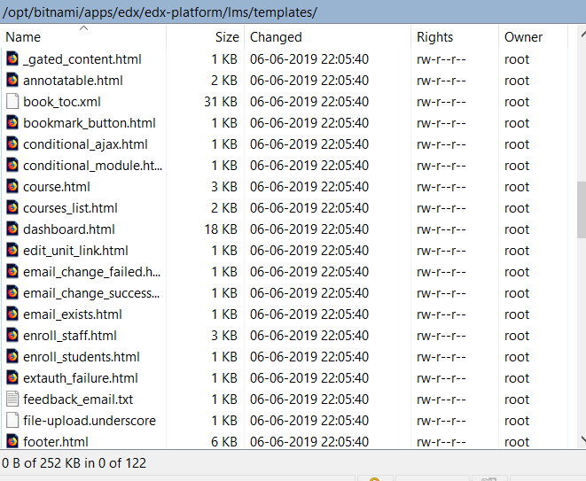

The following picture shows the location of file in our custom directory

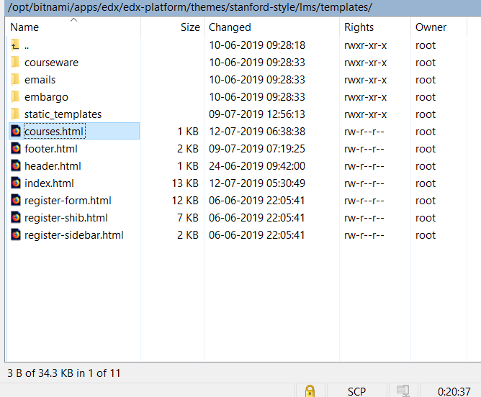

**Enabling Themes:**

* For each Open edX component that you want to theme, set the ENABLE_COMPREHENSIVE_THEMING configuration property to true. The specific method that you use to configure Open edX components depends on the type of environment you are using. For example, you can set the configuration property in the following files.
* For the LMS, you edit opt/bitnami/apps/edx/conf/lms.env.json to set "ENABLE_COMPREHENSIVE_THEMING": true.
* For Studio, you edit opt/bitnami/apps/edx/conf/cms.env.json to set "ENABLE_COMPREHENSIVE_THEMING": true.
* For each Open edX component that you want to apply a theme to, add the absolute path of the themes directory to the COMPREHENSIVE_THEME_DIRS configuration property.The specific method that you use to configure Open edX components depends on the type of environment you are using. For example, you can set the configuration property in the following files.
* For Studio, add the path to COMPREHENSIVE_THEME_DIRS in opt/bitnami/apps/edx/conf/cms.env.json.

"COMPREHENSIVE_THEME_DIRS":["/my-open-edx-themes/edx-platform]

* For the LMS, add the path to COMPREHENSIVE_THEME_DIRS in /edx/app/edxapp/lms.env.json.

"COMPREHENSIVE_THEME_DIRS":["/my-open-edx-themes/edx-platform]

* Then set your custom theme as the default theme for your site using the following steps

1. Sign in to the Django administration console for your base URL. For example, http://localhost:80/admin.
2. Select **Site themes**.
3. Select **Add site theme**.
4. From the **Site** menu, select the site you want to apply a theme to.
5. In the **Theme dir name** field, enter the identifier of the theme.
6. Select **Save**.

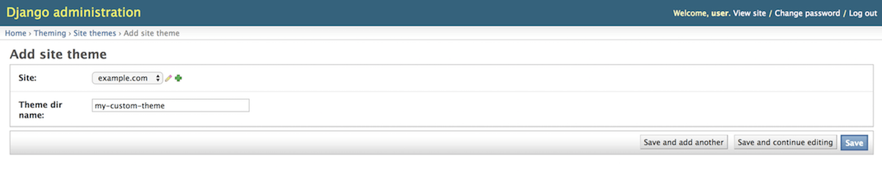

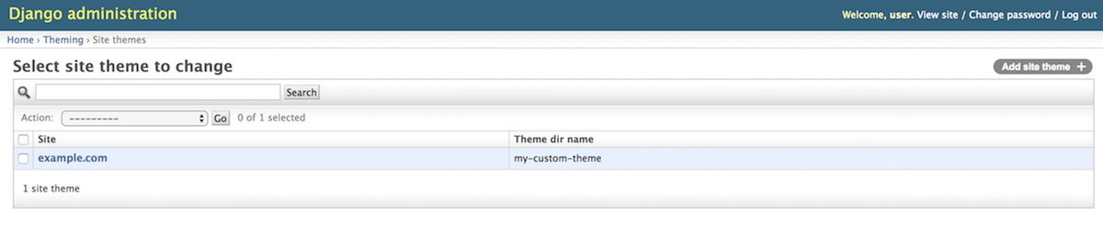

**Note:** In order to access the Django admin site at localhost:80/admin you need to connect to the server using the Putty client by using the correct credentials.

**Build assets for your custom theme:**

* If you used custom theme for lms then use the command:

sudo /opt/bitnami/apps/edx/bin/edxapp-update-assets-lms

* If you used custom theme for cms then use the command:

sudo /opt/bitnami/apps/edx/bin/edxapp-update-assets-cms

Finally restart the server by first turning off then turning on the the Bitnami machine running on your Virtual Box.

The changes made would now be visible on your site.

CUSTOMIZING THE WEB PORTAL

**Customizing the front page:**

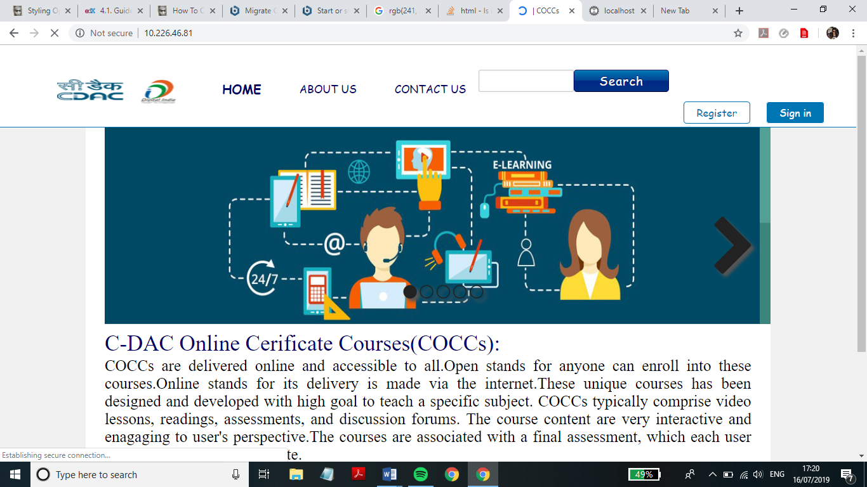

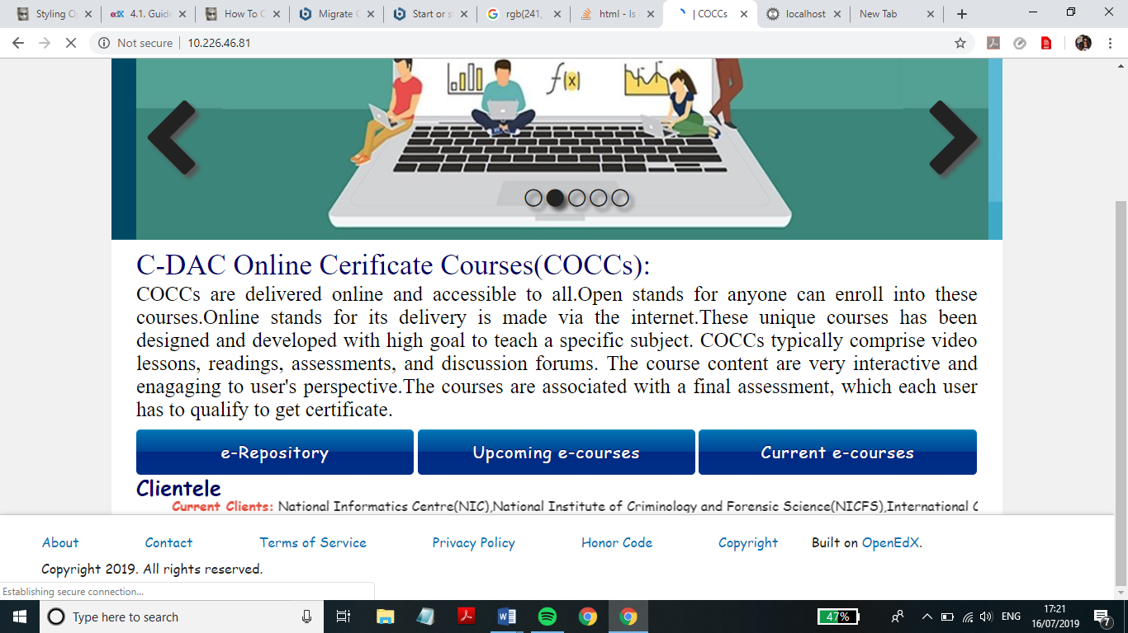

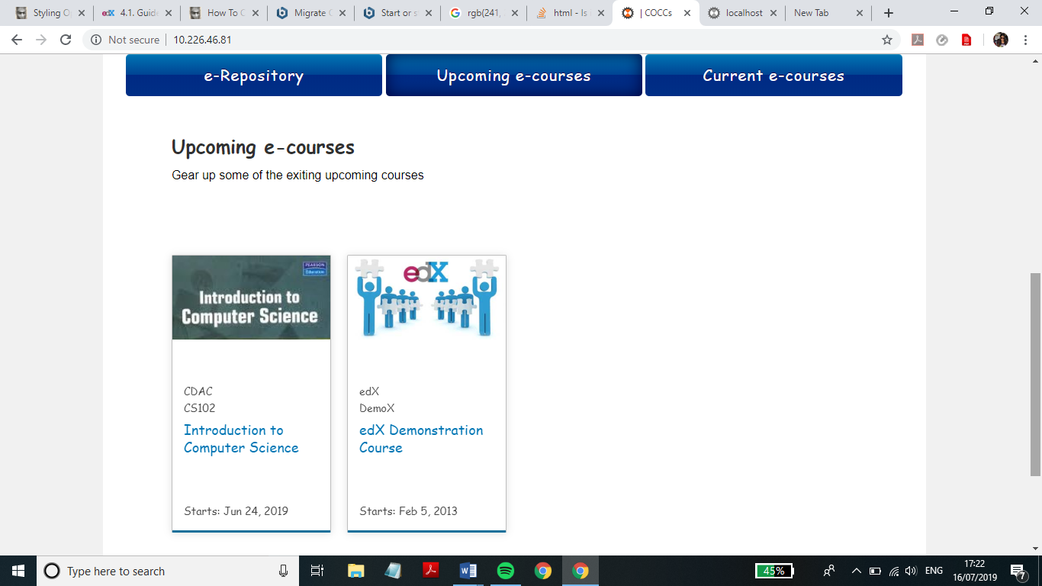

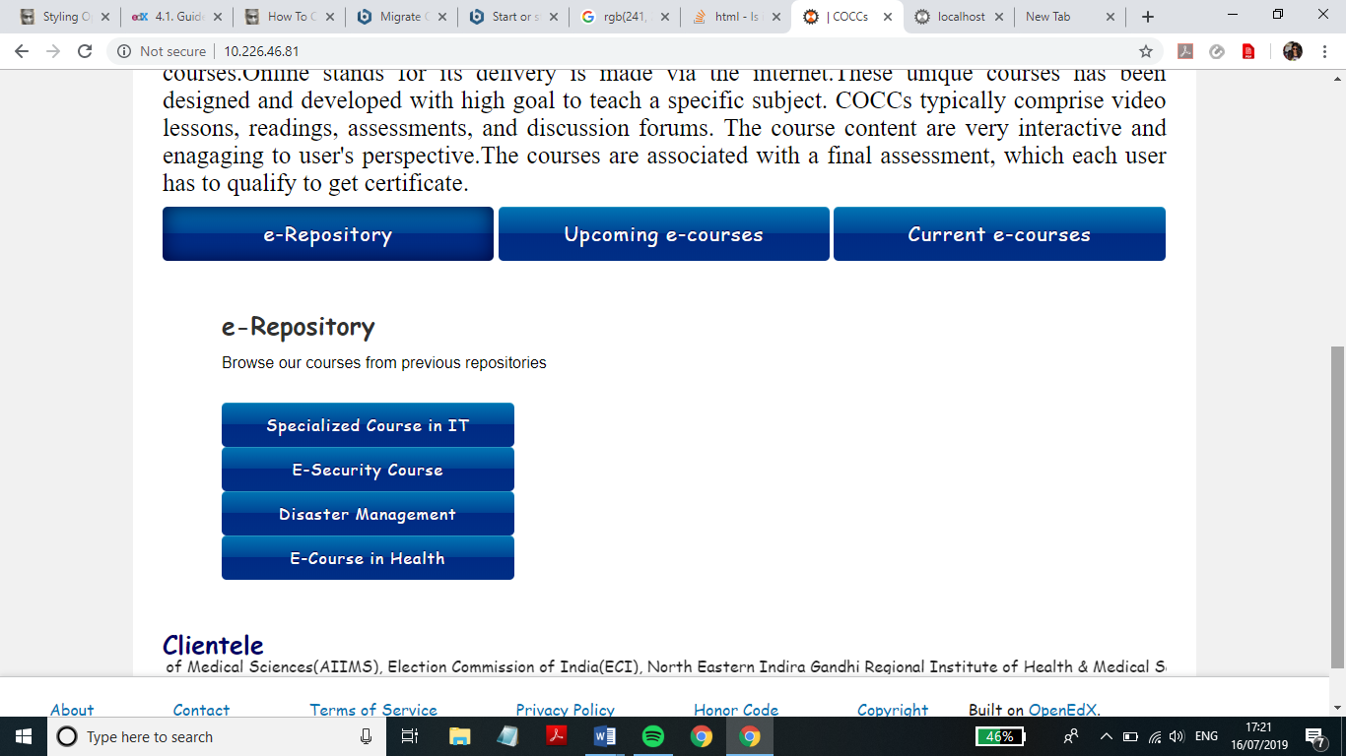

The front page customization is done by editing the index.html, header.html and the footer.html files.

Changes in the index.html file:

* The index.html class has a head and a body.
* The head contains the style tag which contains all the all the styling applied to the html elements on the front page.
* The body contains the division for the image slider, the three buttons and subsequent options and for the marquee showing the list of the clients.
* The body also contains a script tag which contains the javascript code for showing different divisions at the click of different buttons.
* The script for the slider is present in an external file named function.js which is referred to by using the highlighted statement shown below.



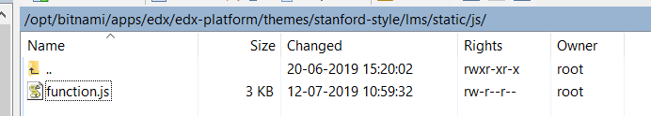

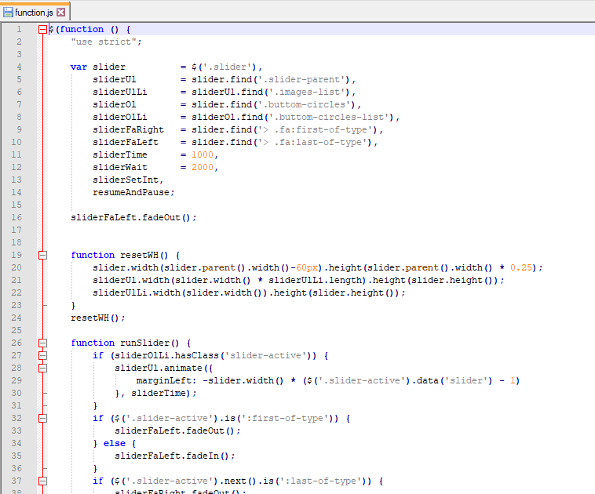

* All these changes are done in the section tag shown below.

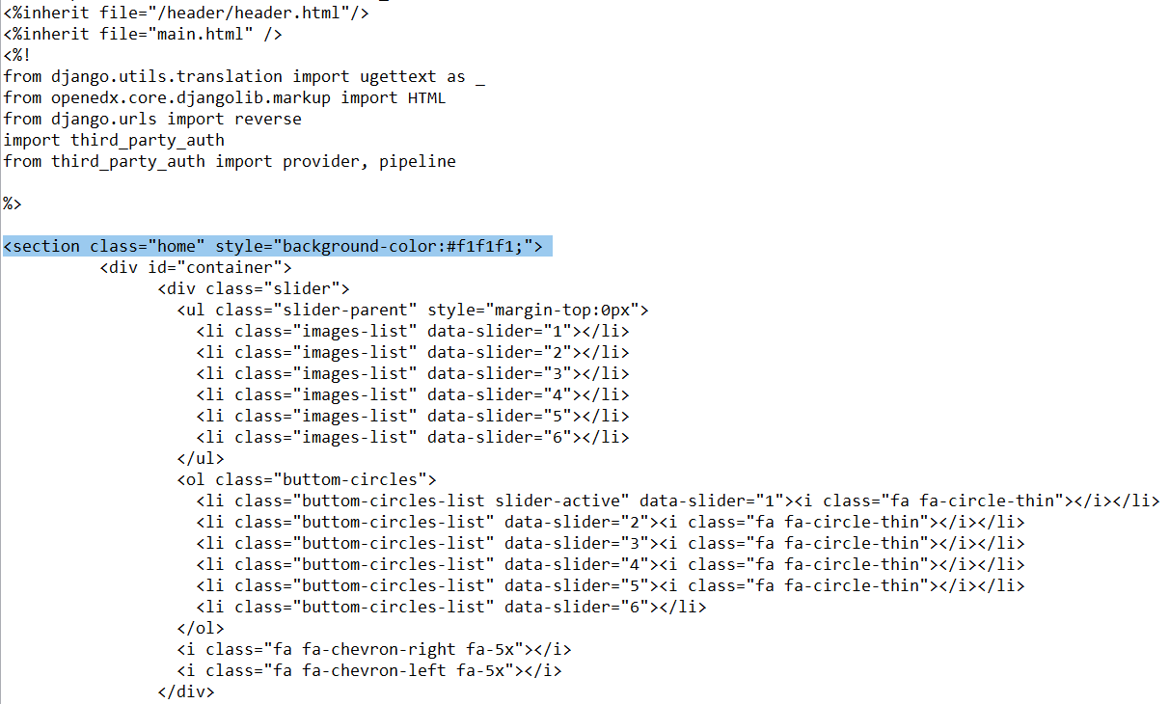

* All the static files used the markup should be present inside the static directory and should be referred by the ${static.url(‘<placeholder>’)} statement where the directory path of your file inside the static folder should be written instead of <placeholder>
* All the images to be used must be saved in the static/images directory and should be referred to by using ${static.url(‘images/img.jpg’)} where img.jpg is the name your image
* **For the tabs:** A division called newtab was made and the tabs were added.

The styling was done using internal css and the openpage was used for functioning of tabs.

The html code for the structure, the css for styling and the javascript for clicking events is attached below:

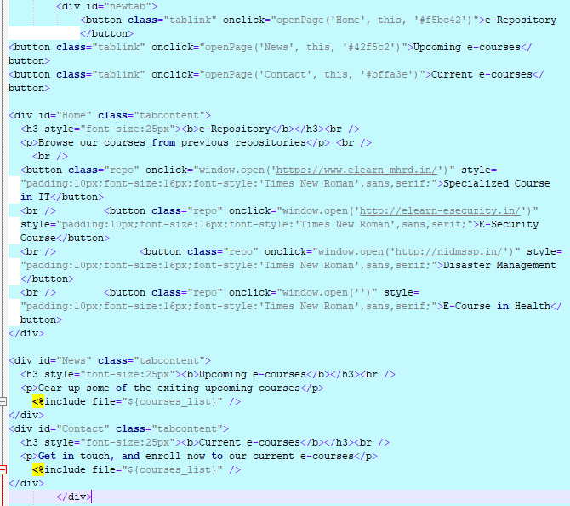 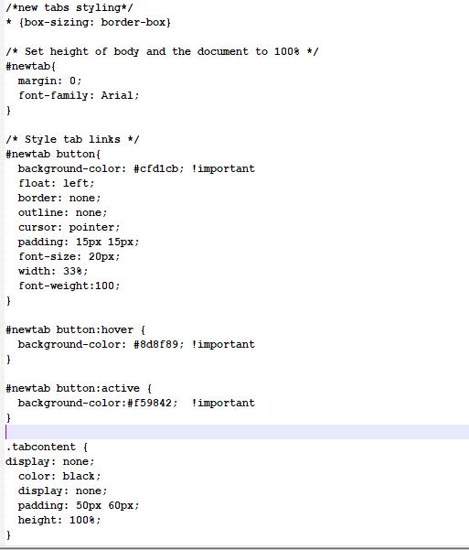

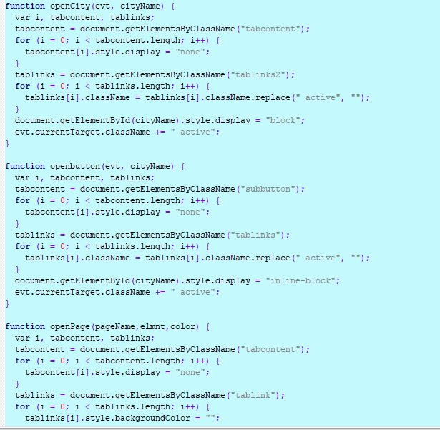

* **For the clients:** Marquee tag was used to display the clients’ name.

<h3 style="color: #000066;float:left;font-size:25px"><b>Clientele</b></h3>

<marquee><span id="hclient"><b>Current Clients:</b></span> National Informatics Centre(NIC),National Institute of Criminology and Forensic Science(NICFS),International Centre for Information Systems and Audit (iCISA) <span id="hclient"><b>Previous Clients:</b></span> National Institute of Disaster Management(NIDM), All India Institute of Medical Sciences(AIIMS), Election Commission of India(ECI), North Eastern Indira Gandhi Regional Institute of Health & Medical Sciences (NEIGRIHMS), Regional Institute of Medical Sciences(RIMS), NIT Manipur, NIT Silchar, Uttarakhand Police</marquee>

Changes in the footer.html file:

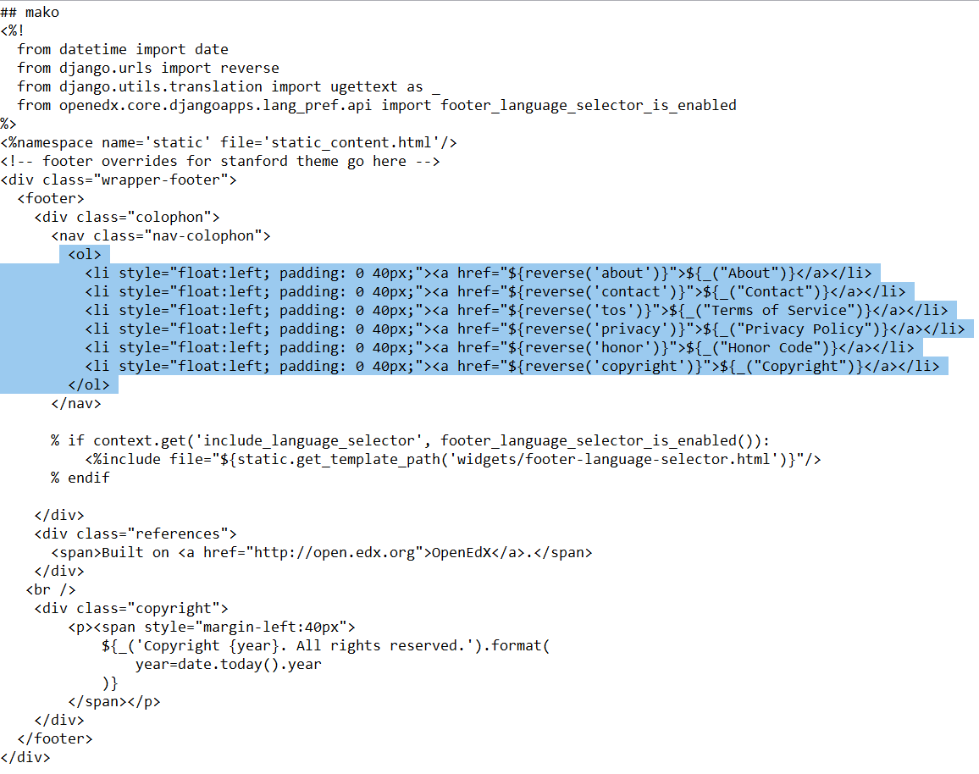

* This file contains the links to the static pages which can be seen at the footer of the front page.
* They are all present in a list which is then horizontally aligned.
* The static pages are referred to by using the <a href="${reverse('about')}">${_("About")}</a> line where ‘about’ is the name of the html being referred.
* All these static files are placed in the themes/stanford-style/lms/static_templates folder.

Changes in the header.html file:

* The header file present in our theme directory i.e. themes/stanford-style/lms/templates folder inherits the header file present in edx-platform/lms/templates/header folder using the highlighted statement shown below.

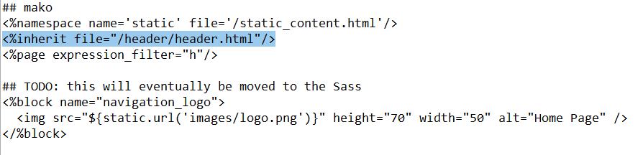

* The header file in the edx-platform/lms/templates/header folder includes navbar-logo-header.html using the following statement.

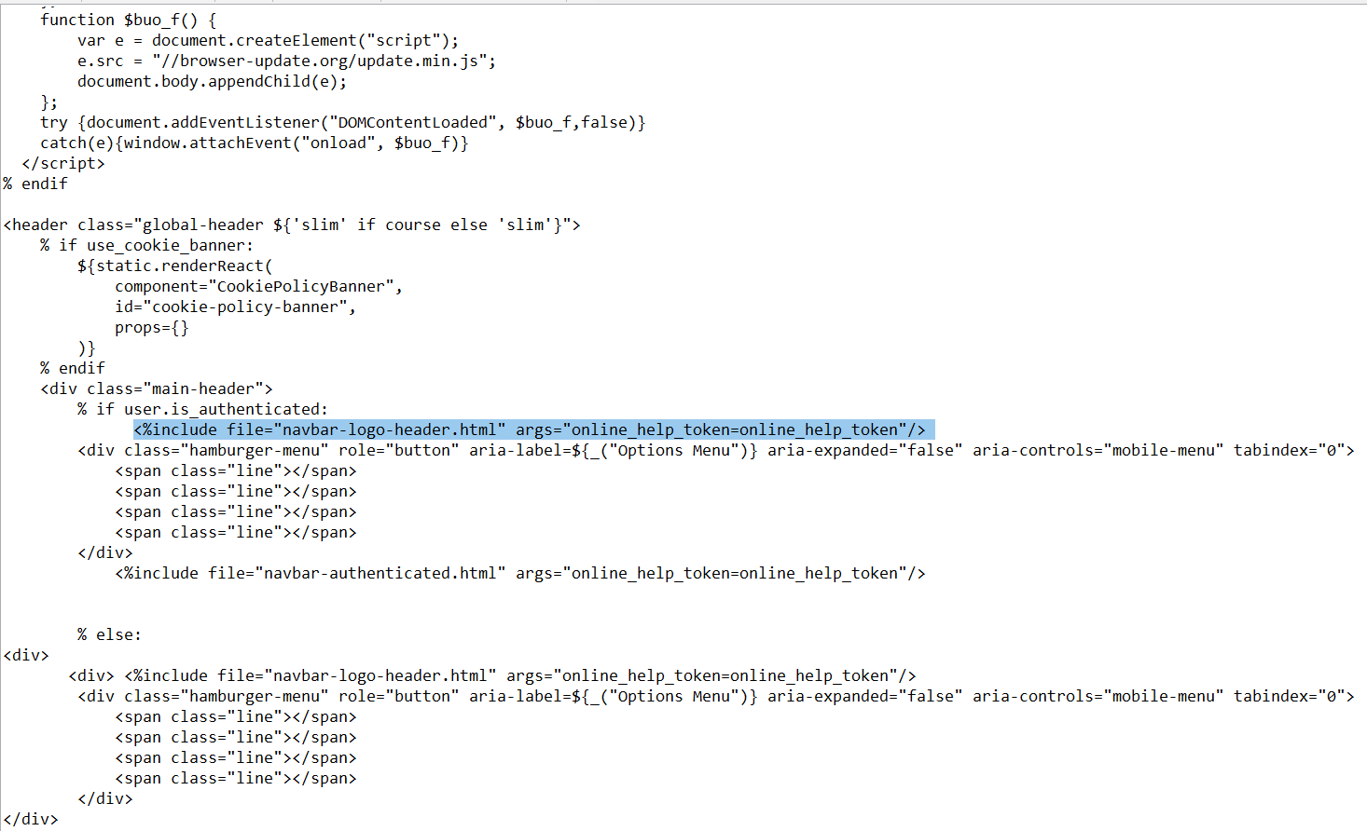

* The navbar-logo-header.html contains menu and the logo in the <h1 class="header-logo"> tag as shown below.

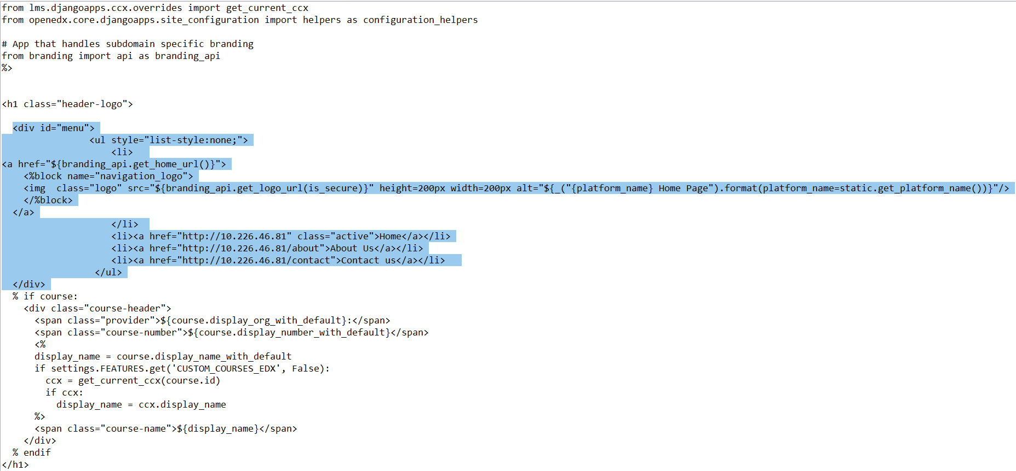

**Customizing the static pages:**

The About page:

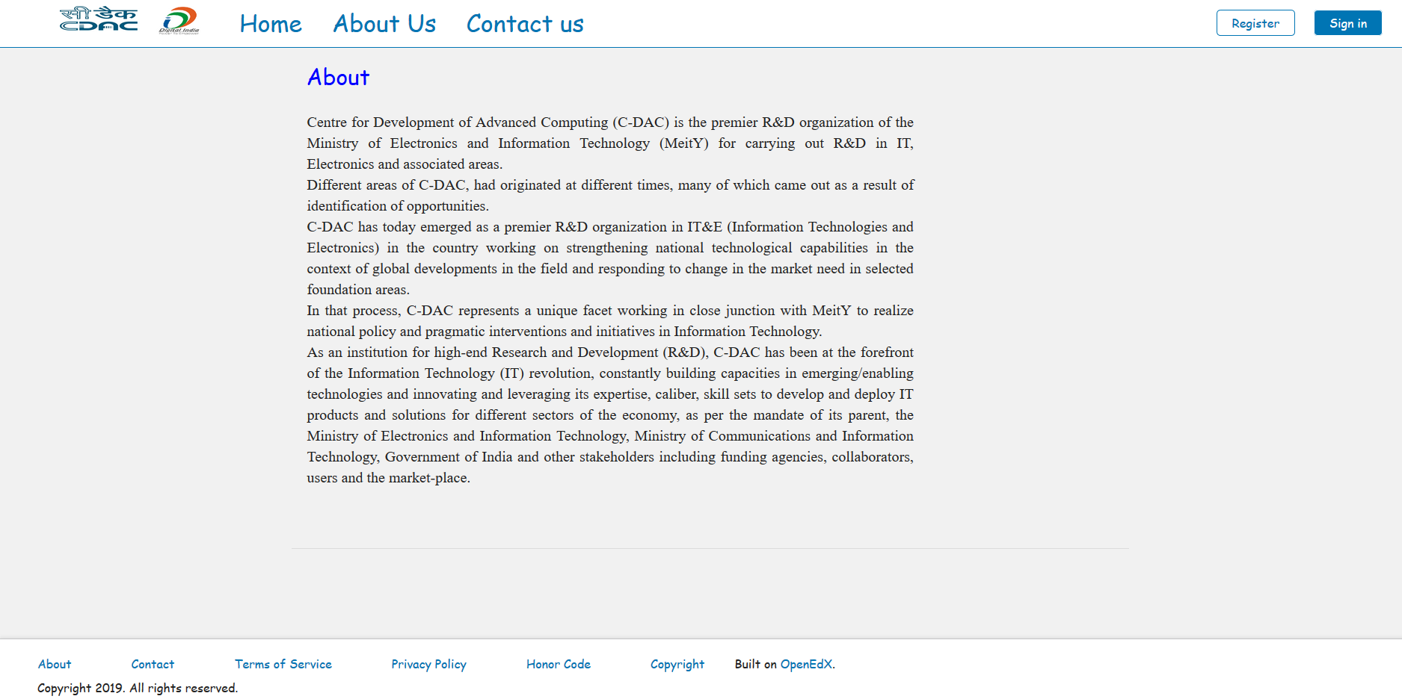

All the text is written in the <article> tag which provides the default styling for the text.

The changes in the about.html are shown below.

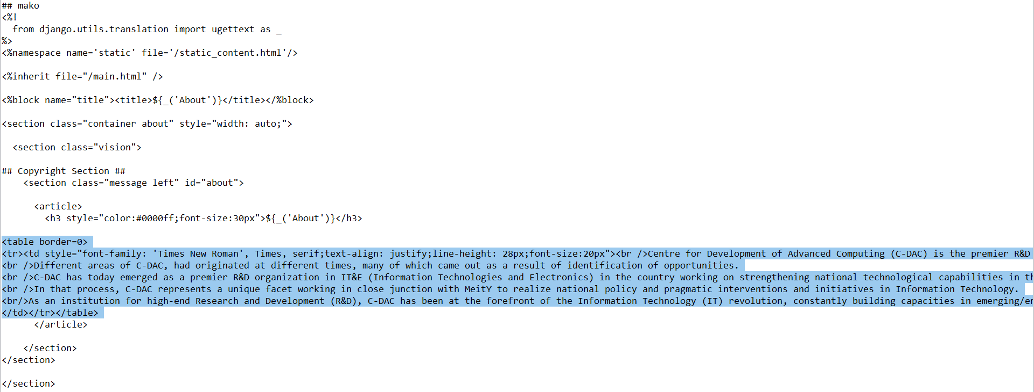

The Contact Us page:

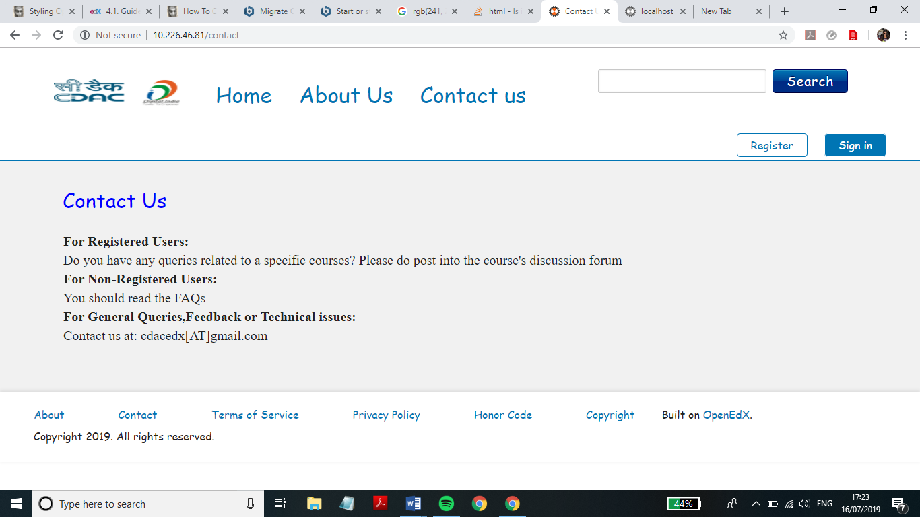

The changes in the contact.html are shown below:

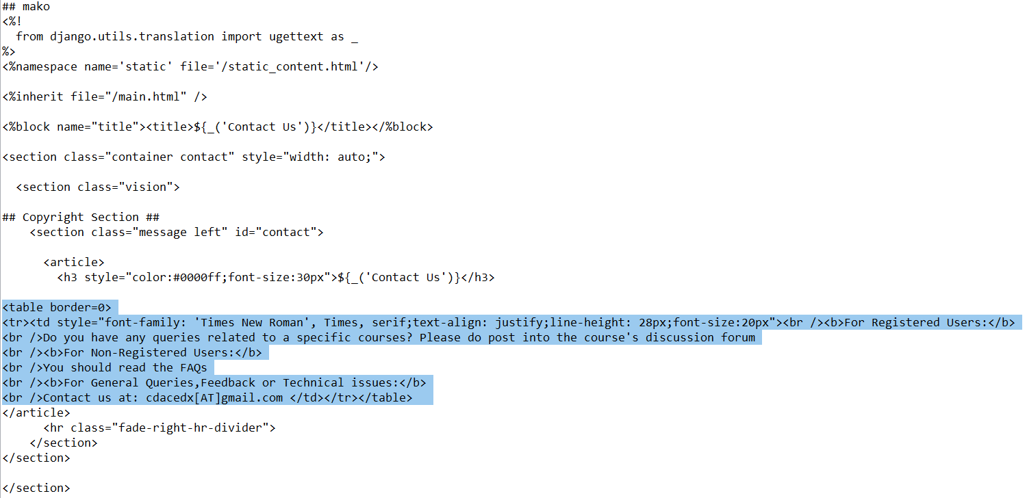

The Term of Service page:

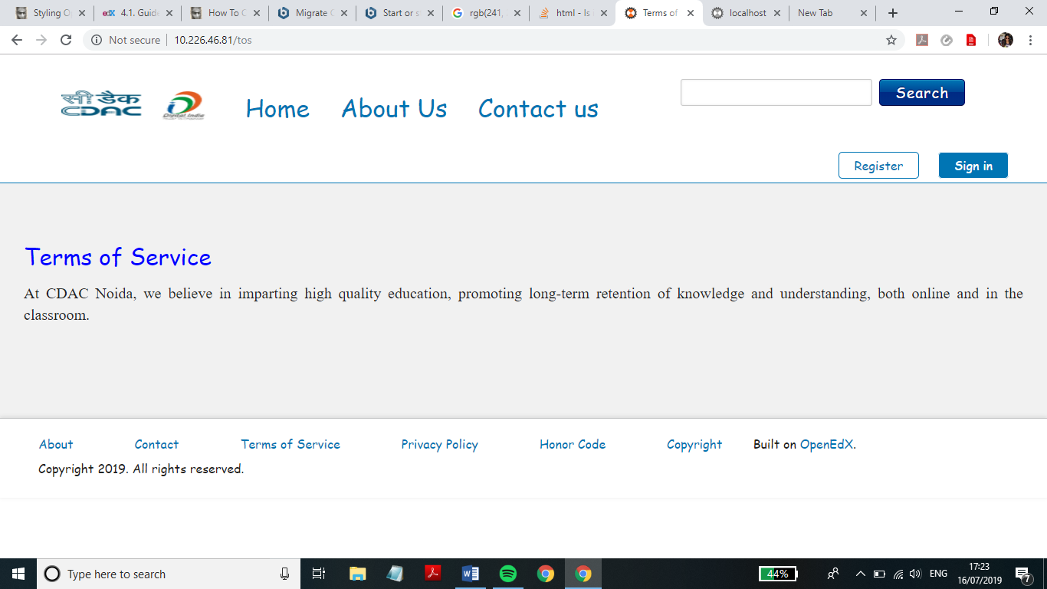

The changes in tos.html are shown below:

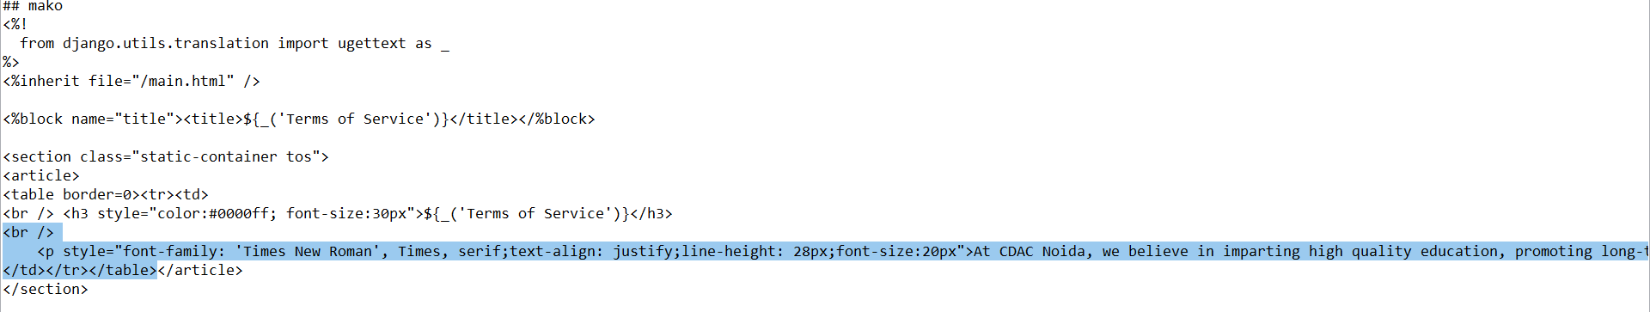

The Privacy Policy page:

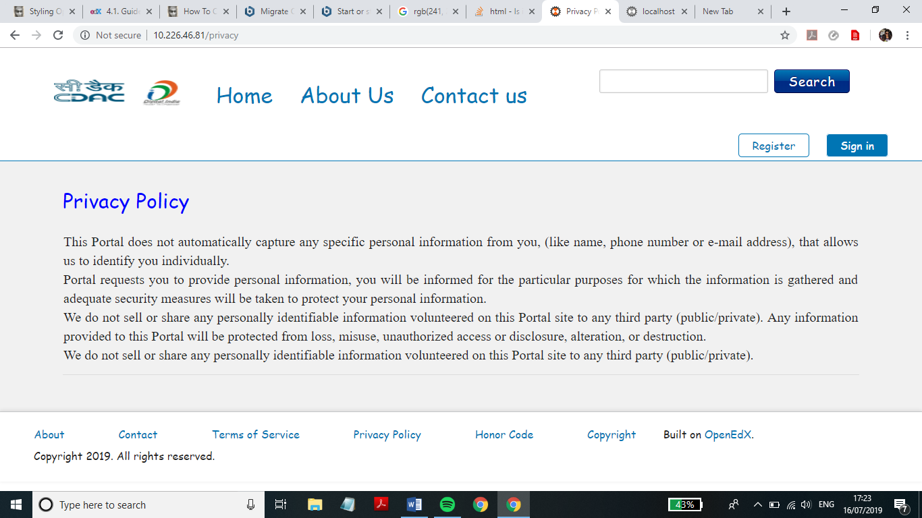

The changes in privacy.html are shown below:

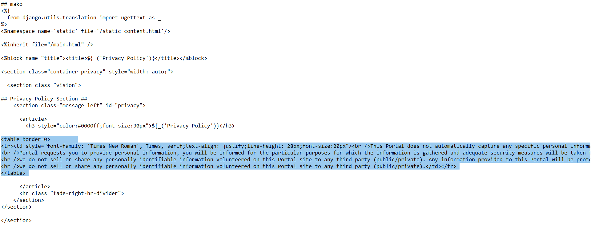

The Honor Code page:

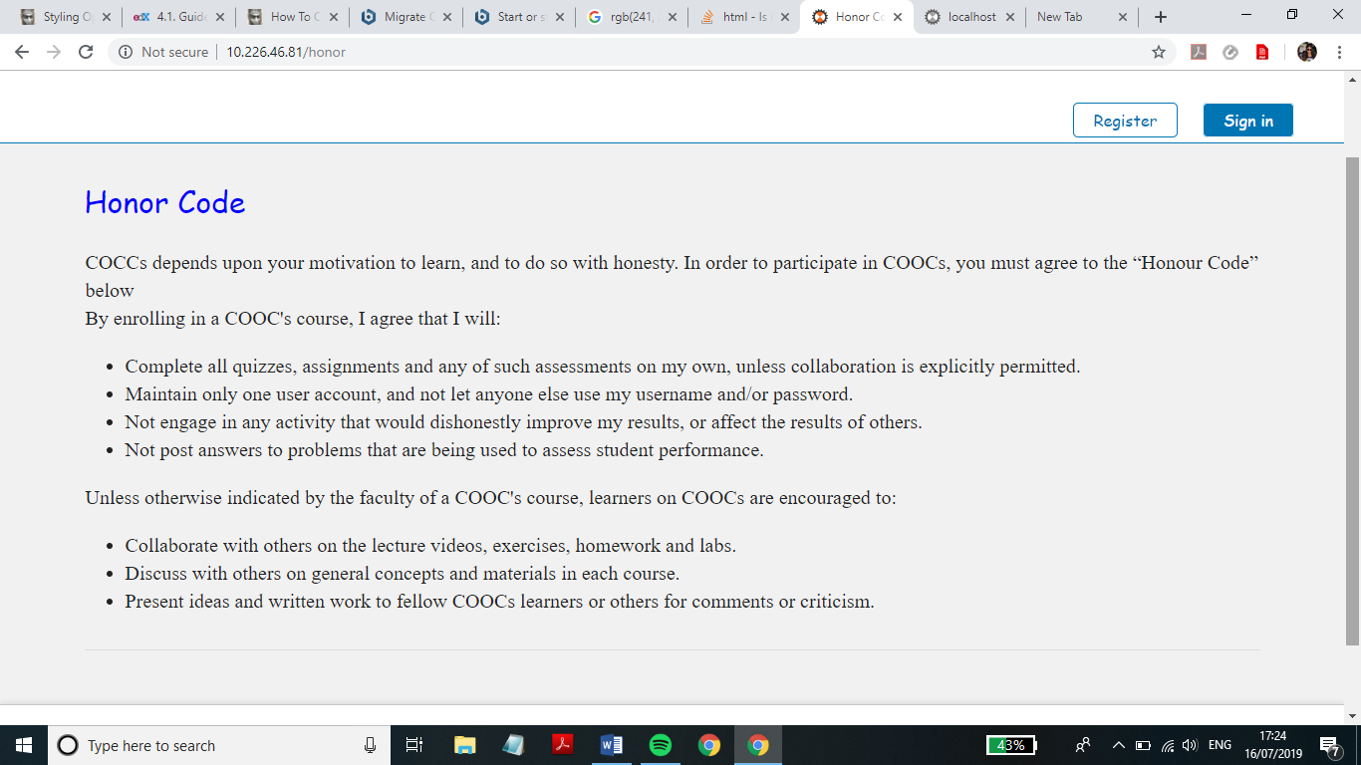

The changes in honor.html are shown below:

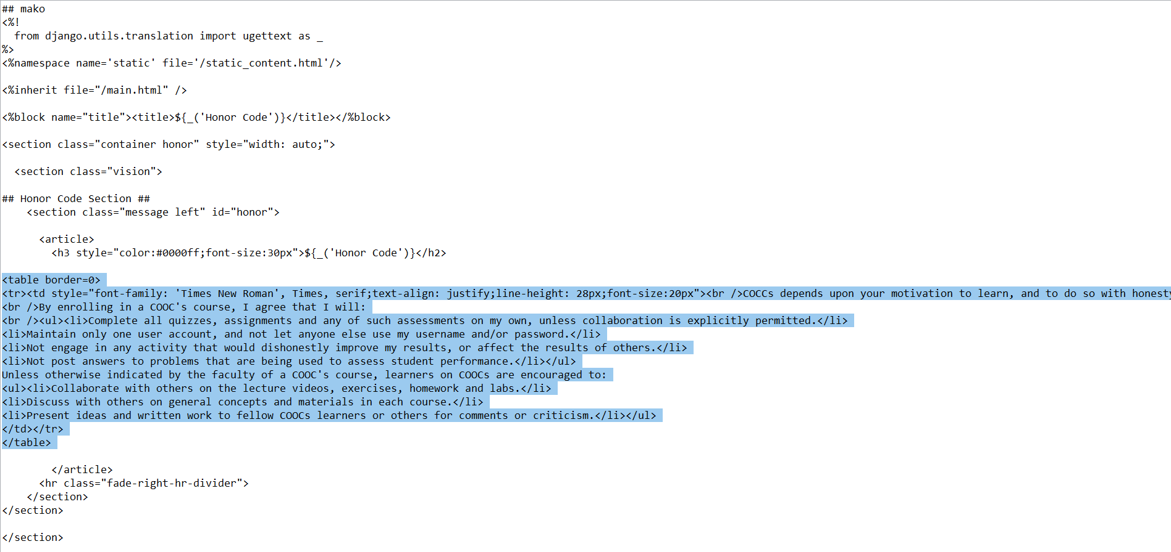

The Copyright page:

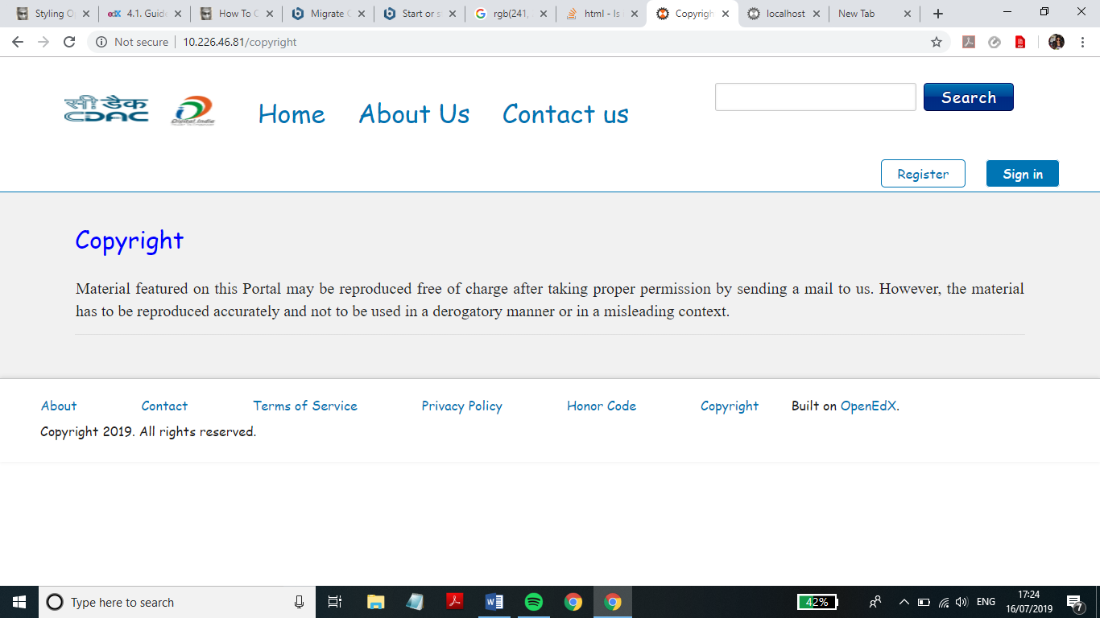

The changes in copyright.html are shown below:

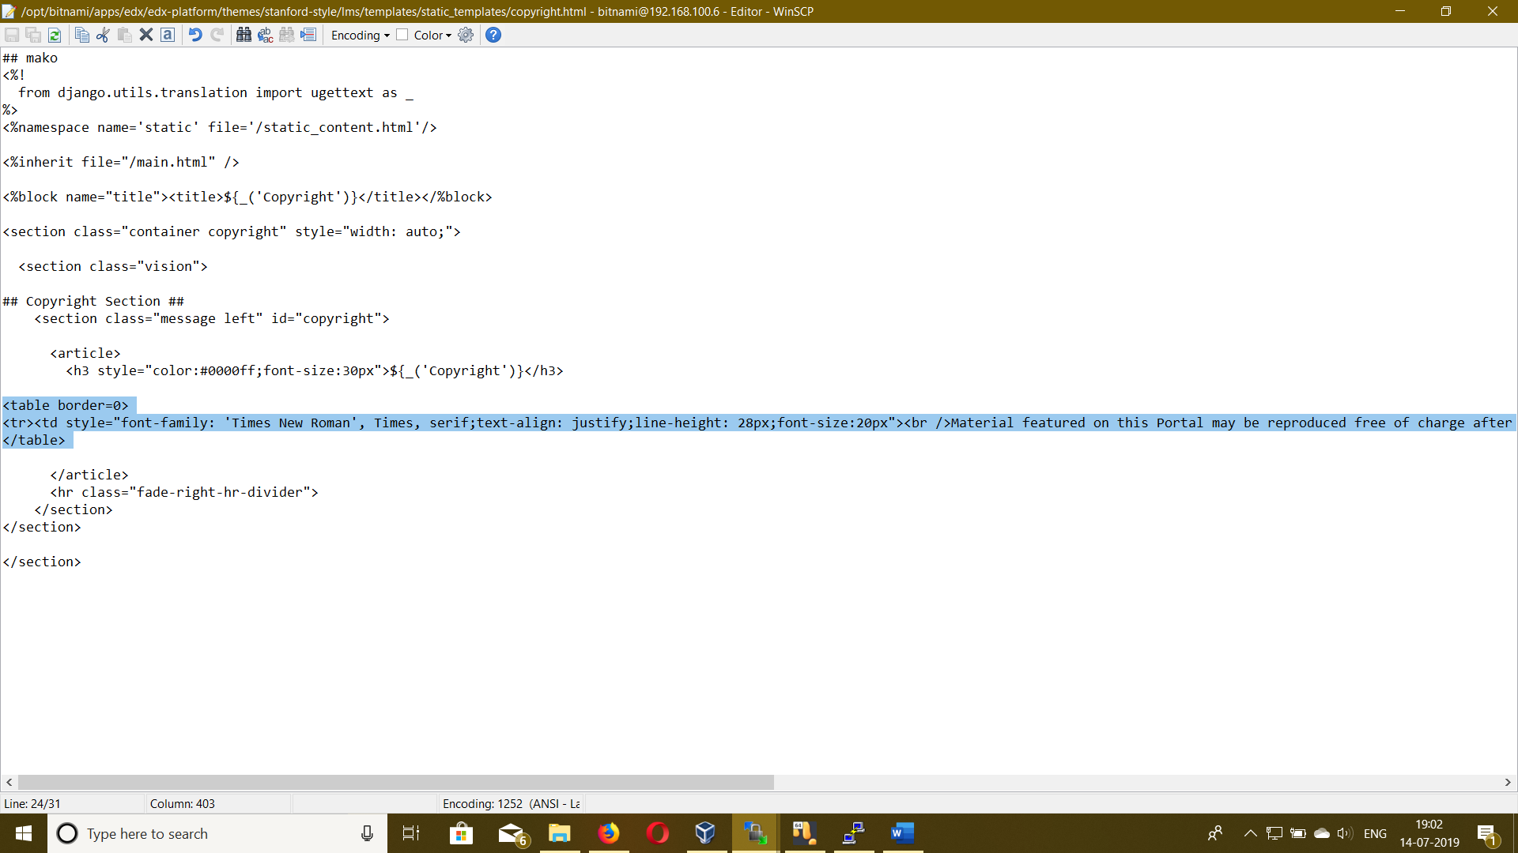

**The main.html file:**

The main.html file present in the edx-platform/lms/templates folder is inherited in all the html files created and changes done in this file and the files included in it using the <%include file="filename.html"/> statement would reflected in all the inheriting files.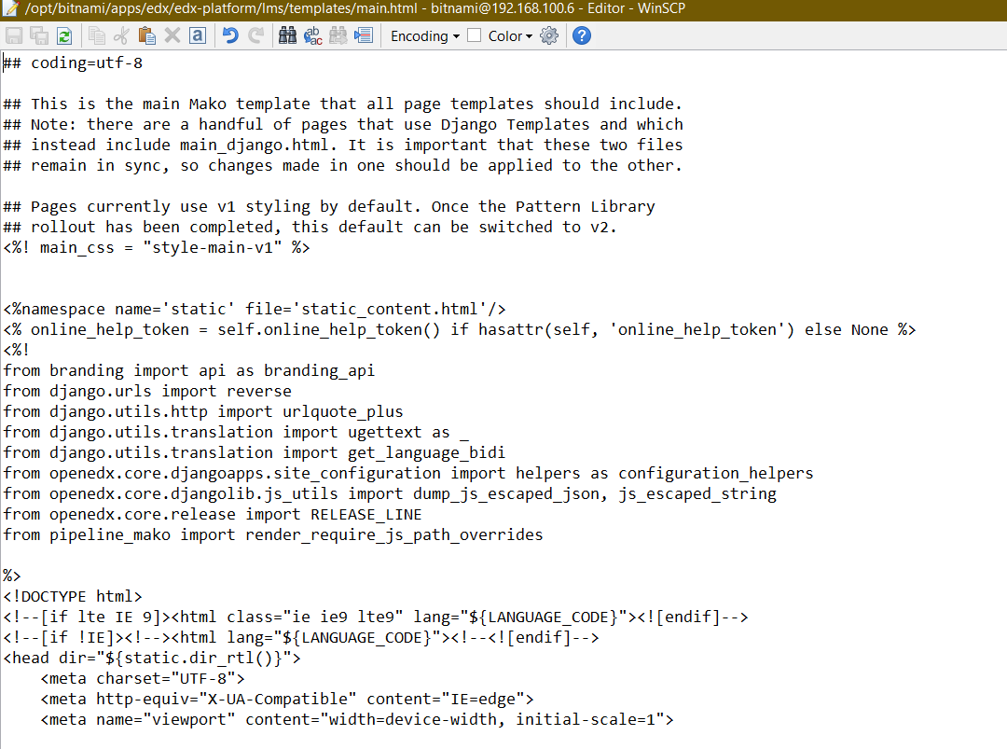

ENABLING AND CUSTOMIZING CERTIFICATES

Organizations and course teams can choose to generate certificates for learners who pass a course. Learners can view, print, or share their certificates. To enable course certificates on your instance of Open edX, you must enable a feature flag in both :

1.Learning Management System

2.Studio

But before that we need to modify the lms.env.json and cms.env.json files, which are located one level above the edx-platform directory. In the lms.env.json and cms.env.json files, set the value of CERTIFICATES_HTML_VIEW within the FEATURES object to true.

"FEATURES": {

...

'CERTIFICATES_HTML_VIEW': true,

...

}

Save the lms.env.json and cms.env.json files.If it does not exist already, create the folder /tmp/certificates owned by the user and group www-data. Depending on your configuration, this folder might not survive reboots, and so might need to be created by a script. Then, run database migrations.

1. In **Learning Management System** :

1. Access the LMS Django Administration website for your instance of Open edX. To do this, go to <https://10.226.46.81/admin>.
2. Under **Site Administration** > **Certificates**, add an HTML View Configuration, and select **Enabled**.
3. Set the following certificates-related parameters for your Open edX instance.

platform_name, company_about_url, company_privacy_url, company_tos_url, company_verified_certificate_url, logo_src, logo_url

For each course mode for which you want to offer certificates (such as “honor” or “verified”), define these parameters.

certificate_type, certificate_title, document_body_class_append.

Make sure the mode name matches your course mode name exactly. An example follows.

{

"default": {

"accomplishment_class_append": "accomplishment-certificate",

"platform_name": "COCCs",

"company_about_url":" http://10.226.46.81/about",

"company_privacy_url": "http://10.226.46.81/our-privacy-policy",

"company_tos_url": " http://10.226.46.81/tos",

"company_verified_certificate_url": " http://10.226.46.81/verified-certificates",

"logo_src": "/static/certificates/images/logo.png",

"logo_url": " <https://www.cdac.in/> "

},

"honor": {

"certificate_type": "honor",

"certificate_title": "Honor Certificate",

"document_body_class_append": "is-honorcode"

},

"verified": {

"certificate_type": "verified",

"certificate_title": "Verified Certificate",

"document_body_class_append": "is-idverified"

},

"base": {

"certificate_type": "base",

"certificate_title": "Certificate of Achievement",

"document_body_class_append": "is-base"

},

"distinguished": {

"certificate_type": "distinguished",

"certificate_title": "Distinguished Certificate of Achievement",

"document_body_class_append": "is-distinguished"

}

}

1. Save the configuration parameters.
2. Restart the Studio and LMS processes to load the updated environment configurations.

2. In **Studio**, Before you can create certificates, you must enable certificates for your course.

1. From the **Settings** menu, select **Advanced Settings**.
2. In the **Certificate Web/HTML View Enabled** field, enter true.
3. At the bottom of the page, select **Save Changes**.

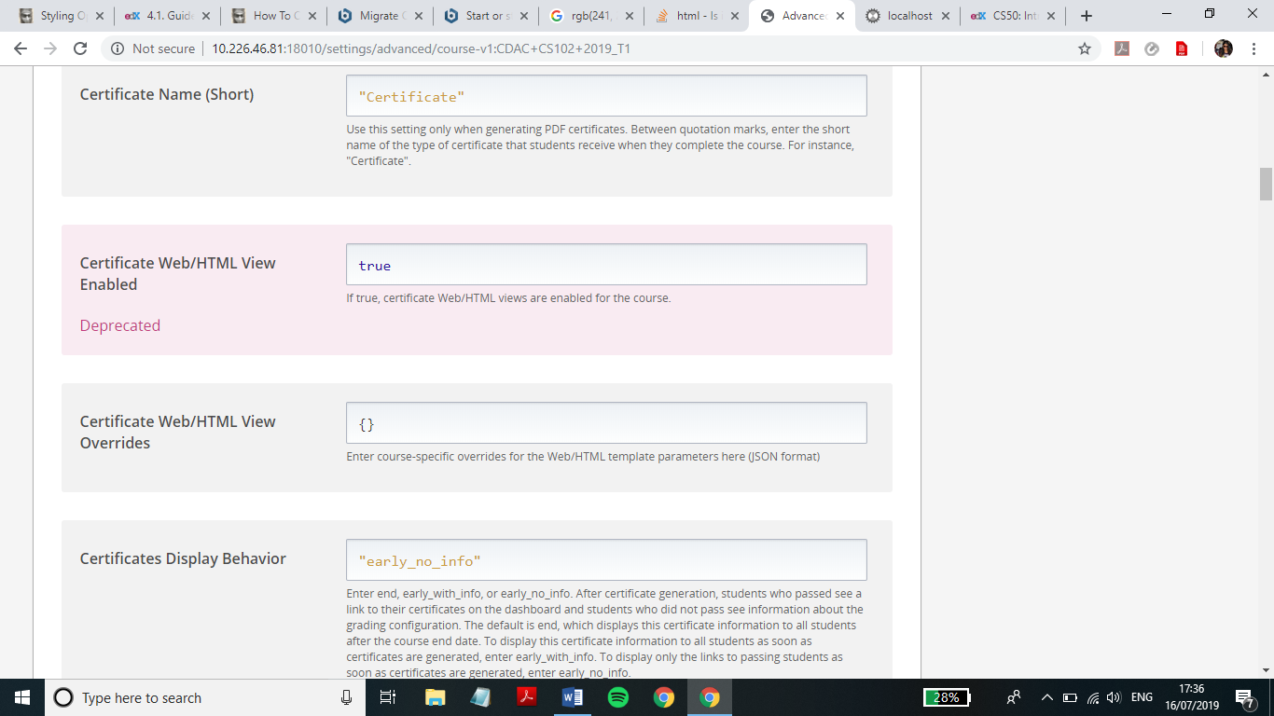

4.Then, under settings tab click on **certificates**. Here choose a course mode from the options and click on Preview Certificate button to have a look. Also, we can add signatory names, designations and signature images using the certificates page.

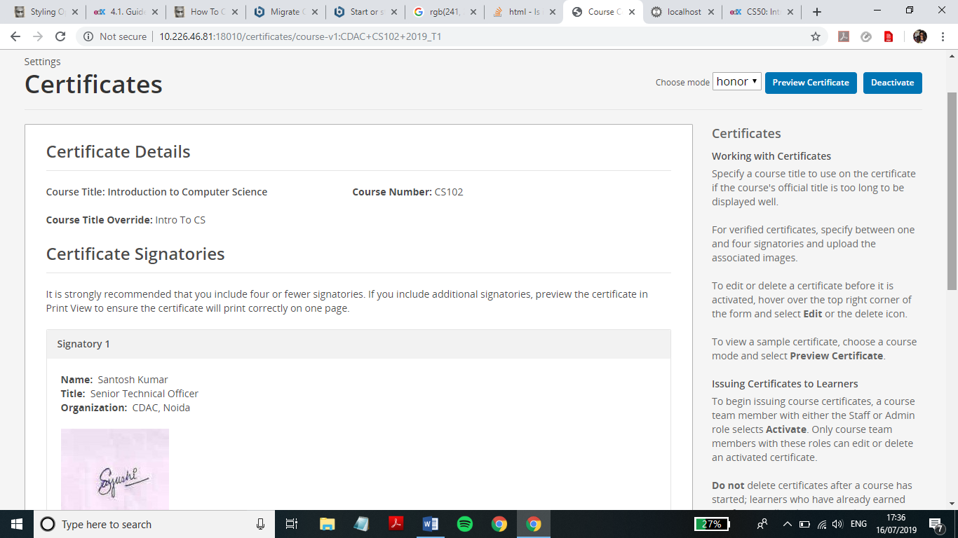

The preview of the certificate generated is as follows:

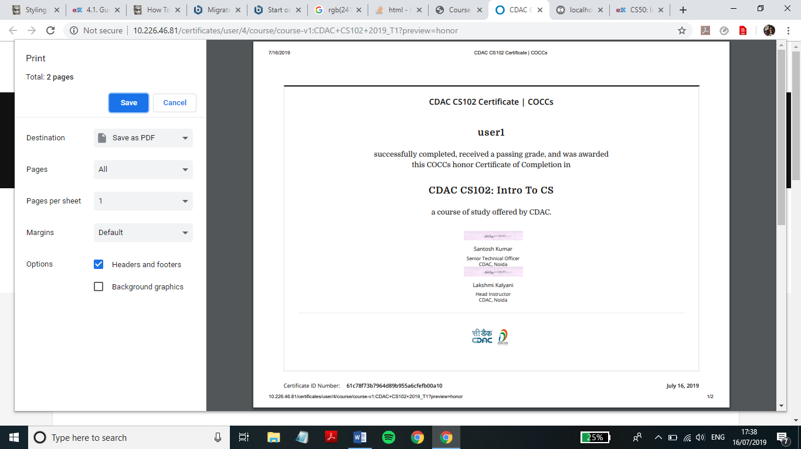

By default, Studio automatically generates certificates as each learner passes the course for both self-paced and instructor-paced courses.

* For self-paced courses, certificates are available immediately after Studio generates them.
* For instructor-paced courses, certificates become available 48 hours after your course end date by default. You can also specify a different date to make certificates available. For more information, see [Specify a Different Certificates Available Date](https://edx.readthedocs.io/projects/open-edx-building-and-running-a-course/en/latest/set_up_course/studio_add_course_information/studio_creating_certificates.html#specify-an-alternative-certificates-available-date).

When certificates become available to learners, a link to the certificate is visible on the learner dashboard and the **Progress** page.

You can edit certificates before and after they are activated.

Only course team members with the Staff or Admin role can edit activated certificates.

Optionally, you can specify an alternative course title to use on the certificate. You might want to use a different title on your course certificates if, for example, the official course name is too long to fit on the certificate.

1. In Studio, from the **Settings** menu, select **Certificates**.
2. On the **Certificates** page, at the top of the certificate form, select the **Edit** icon.
3. In the **Course Title Override** field, enter the alternative title for your course.
4. Select **Save**.

By default, certificates become available to learners 48 hours after your course ends. You can also specify a different date to make certificates available.

1. In Studio, open your course.
2. On the **Settings** menu, select **Schedule & Details**.
3. In the **Course Schedule** section, enter the date and time when you want to issue certificates in the **Certificates Available Date** and **Certificates Available Time** fields.

After you have finished editing your certificate, you can preview a certificate for verification purposes. When you have verified your certificate, a course team member with the Admin or Staff role can activate the certificate.

To activate a certificate, follow these steps.

1. Make sure that you have the Admin or Staff role for the course. For more information, see [Planning Course Staff](https://edx.readthedocs.io/projects/open-edx-building-and-running-a-course/en/latest/set_up_course/planning_course_run_information/staffing.html#course-staffing).
2. In Studio, on the **Settings** menu, select **Certificates**.
3. On the **Certificates** page, select **Activate**.

After certificates are activated, learners in your course who attain a passing grade or otherwise qualify receive certificates.

When you add signatory image files to a certificate, the uploaded files are listed in Studio on the **Files & Uploads** page.

To add signatory names and images to the certificates:

1. In Studio, from the **Settings** menu, select **Certificates**.

2. On the **Certificates** page, add the names under signatory names and enter the designation.

3. Optionally, add the signatory image for the particular signatory.

4. Click on **Save,** and the changes will be reflected which one can preview by clicking the **Preview Certificates** button.