User's Manual

Inhalt

1 Introduction 2

2 Start 2

2.1 Status Bar 2

2.2 Tree View 3

2.3 Button Frame 4

2.4 Object Canvas 5

2.4.1 Object Buttons on Canvas 5

3 Create/Change Object 5

3.1 General Structure 6

3.2 Buttons 6

# 1 Introduction

The SEKaseG Tool stores data from different departments working together on a common project. An example for such a project is the development of a mechatronic product. Within the development process, the departments for construction, electronics and project management work together. To exchange and store data, a project is created in the SEKaseG Tool. The different parts of the mechatronic product are represented in the form of objects, each containing a specific set of data classes. The data can be imported from and exported to text, CSV and PDF files. The user can subscribe to single objects to receive information concerning changes on the object via e-mail.

# 2 Start

When the Tool is started, the start screen appears. It consists of the status bar [1], the tree view [2], the button frame [3] and the object canvas [4]. In this section, these four elements are described.

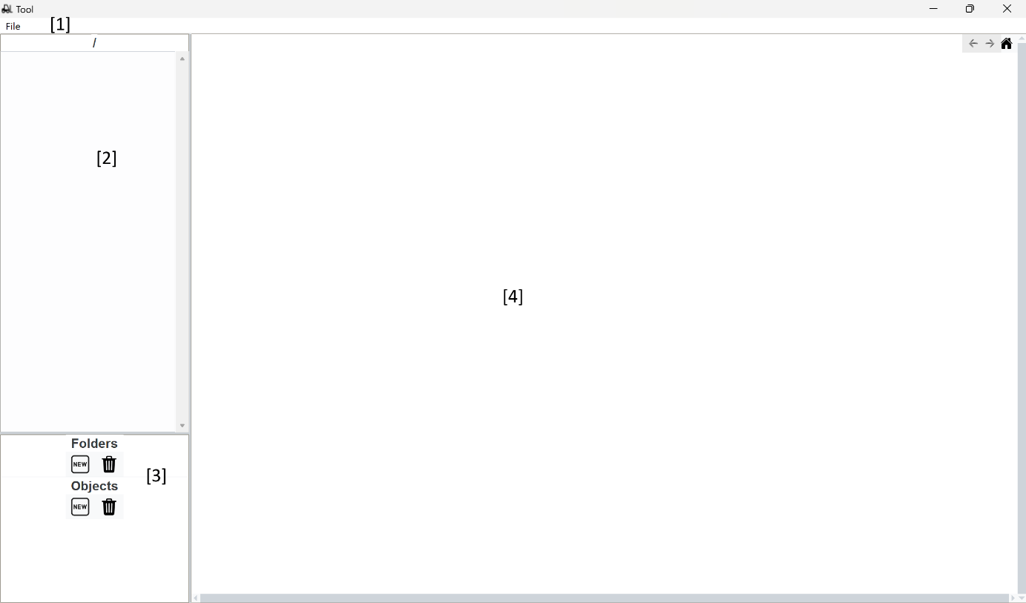

## 2.1 Status Bar

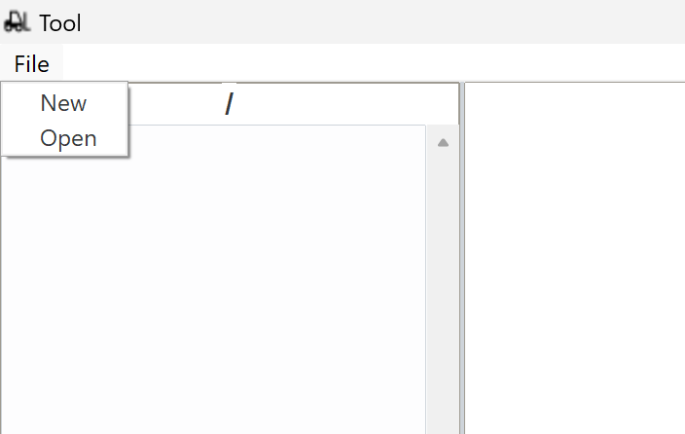The status bar contains the *File* button, which defines the directory for storing the project data in the computer's file system. The directory has to be chosen before working on a project. When pressing the *File* button, a drop-down menu appears where the user can choose to open an existing project or create a new one.

When the option for a new file is selected, a folder named “Objects” is created in the location where the program is installed only if the folder doesn’t exist already. The user is asked for the name of the project and the project folder is stored in the *Objects* folder.

If the option for opening an existing file is selected, the file system is opened and the user is asked to choose the folder of the project they want to work on.

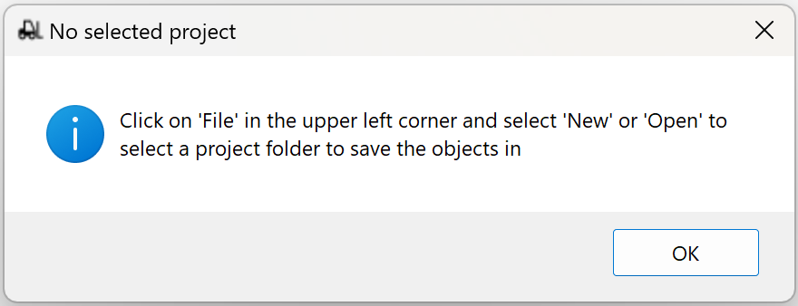Once the project folder is defined, its name appears in the upper part of the list box. If no project folder is selected, the text “No selected project” is displayed in the same location. An error message appears if the button for creating a new object is pressed without having chosen a directory first.

An open project looks like this:

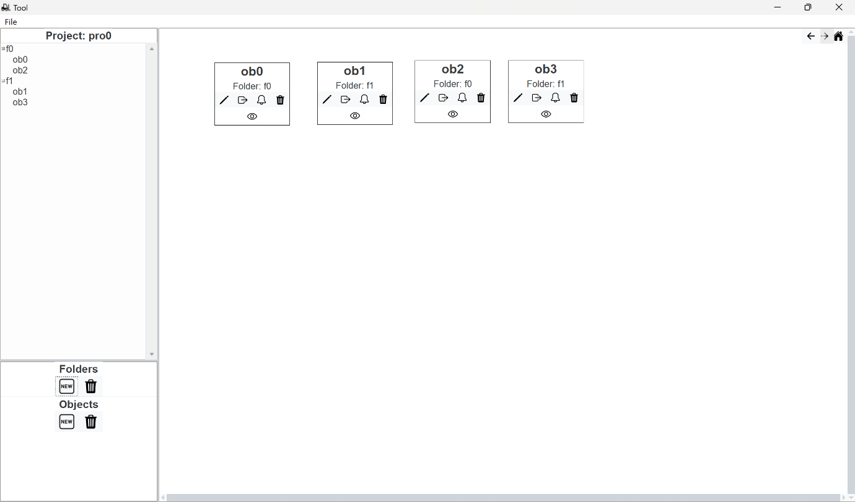

## 2.2 Tree View

The tree view lists the folders and objects of the open project. The tree view's scrollbar becomes active if the list of folders and objects is longer than the provided space.

Folders are listed on the first level of the tree view. When a folder is selected in the tree view, the objects it contains are highlighted on the canvas.

Objects are placed on the second level, below the folder they belong to. When an object is selected in the tree view, it is highlighted on the canvas.

## 2.3 Button Frame

The button frame contains *New* and *Delete* buttons for folders and objects, respectively*.* A project folder must be chosen before the buttons can be used (see Section Status Bar).

When the *New Folder* button is pressed, the user is first asked for a folder name. The name can’t exist already within the same project. If the chosen name already exists, an error message appears, then the use­­­r is asked for a folder name again. The same holds for the *New Object* button.

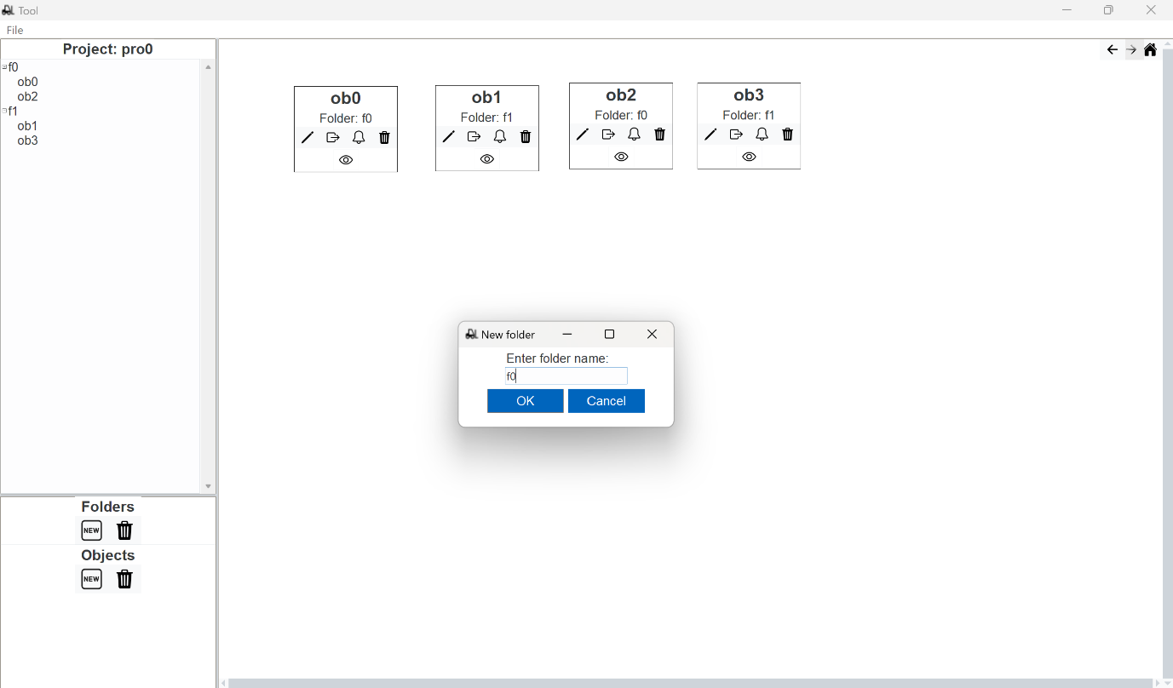

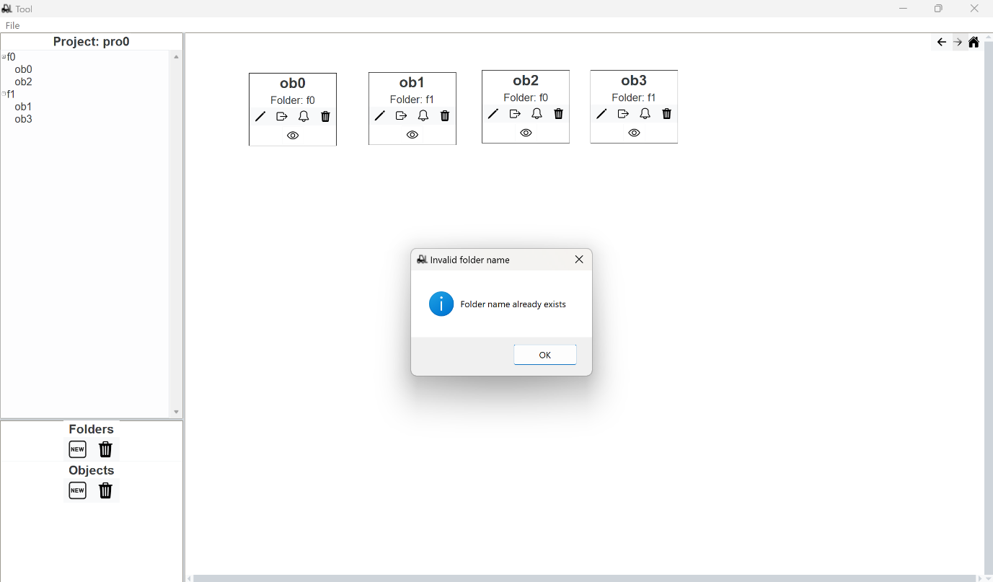

Folders and objects can be deleted via the delete buttons when selected in the tree view. If a folder is deleted, the objects it contains are deleted as well.

## 2.4 Object Canvas

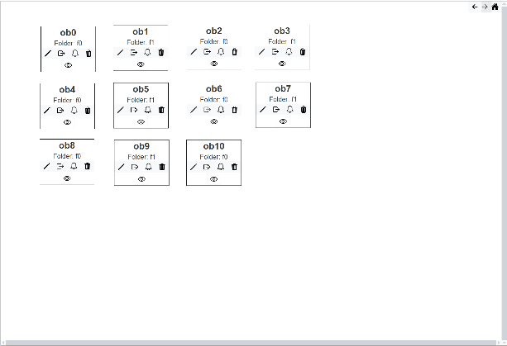Created objects are displayed on the canvas. When an existing project is opened, every object it contains appears on the canvas automatically. Each object's position is saved so that they appear in the same place as the last time they were displayed. Objects are draggable. The canvas expands, and its scrollbars are activated when an object is dragged to its borders.

When pressing the *Home* button in the upper right corner of the canvas, the view is reset. The reset means that the vertical scrollbar is moved to the top and the horizontal scrollbar is moved to the left. Left to the Home button, the *Back* and *Forth* buttons are located. They can be used to go one step back (i.e., reverse the creation of an object or folder) or one step forth. They become active when there is a project version to go back or forth to.

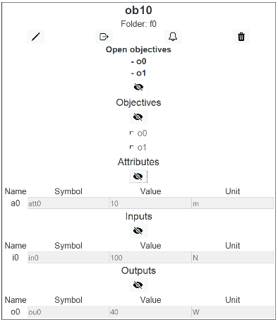An object on the canvas is represented by a box. On top of the box, the object’s name and its folder the folder are displayed, followed by buttons to interact with the object. If there are open objectives for the object, they are displayed below the buttons. The object’s box can be expanded to view its properties with the *Show object properties* button and collapsed with the *Hide object properties* button. Each of the properties section can be expanded or closed with the respective button in the section.

### 2.4.1 Object Buttons on Canvas

* **Change Object**

This button opens the window for editing the object (see Section 3).

* **Export Object to …**

This button opens a dialogue with a dropdown menu. The user can choose the file type for the export of the object data.

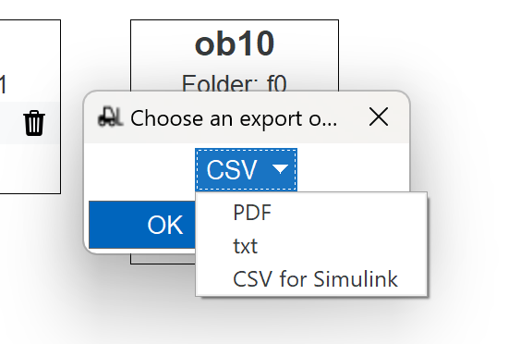

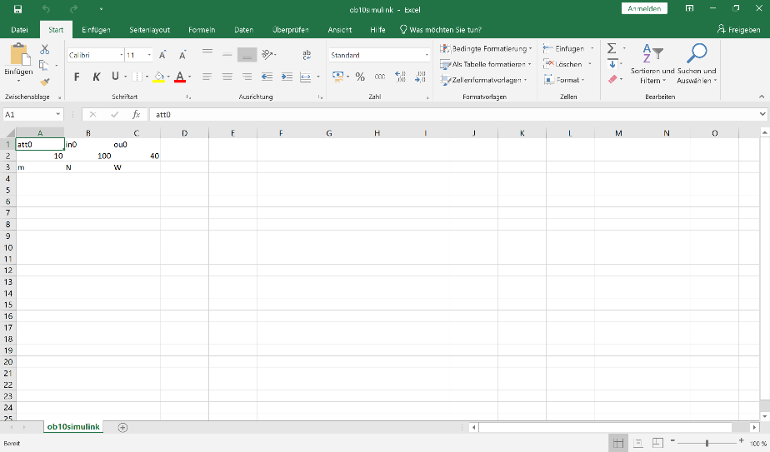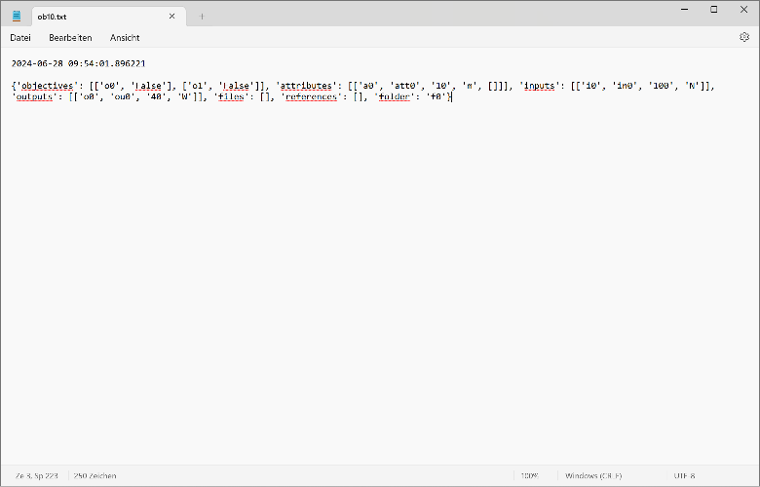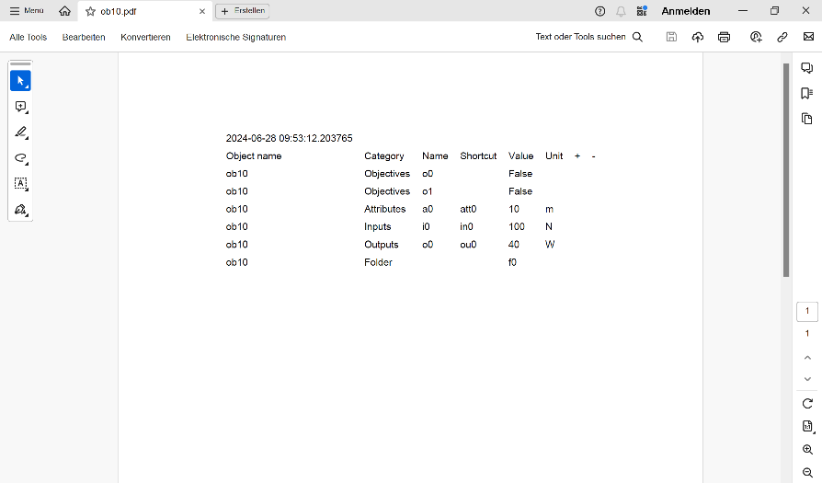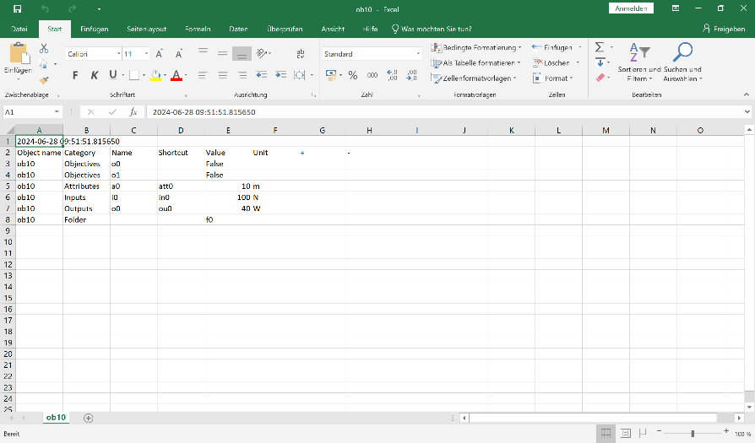The following images show the format of the different options for exporting.

From top to bottom: CSV, PDF, CSV for a Simulink export, text.

* **Subscribe**

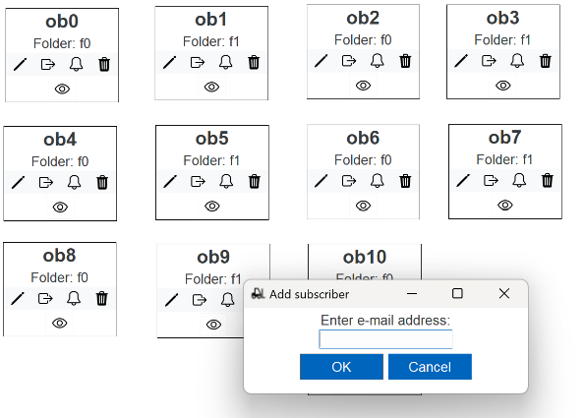This button opens a dialog for adding a subscriber to the object. Subscribers are informed via e-mail about changes made to the object or references of the object.

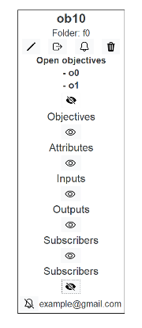The subscribers’ e-mail addresses are added at the bottom of the object box. Left of each e-mail address is a button to cancel the subscription.

* **Delete object**

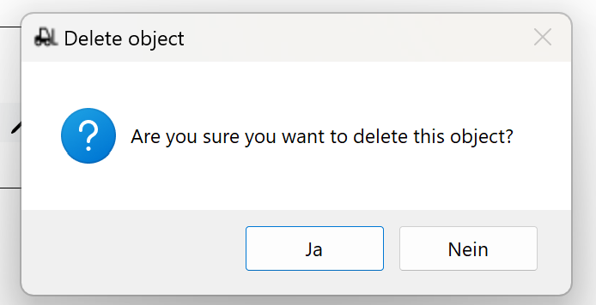Before deleting the object, the user has to confirm the process in a popup.

# 3 Create/Change Object

This section describes the dialog window that opens when creating a new object or changing an existing one. When editing an existing object, the input boxes of the different properties are already filled in, whereas they are blank when creating a new object.

## 3.1 General Structure

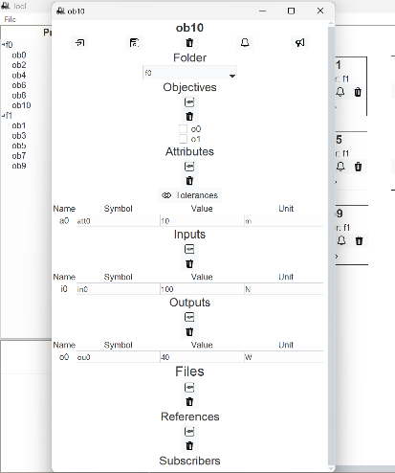In the upper part of the window, the five buttons *Import data from …*, *Save Object*, *Delete object*, *Subscribe* and *Save & Publish* are located. Below is the set of object properties consisting of *Folder*, *Objectives*, *Attributes*, *Inputs*, *Outputs*, *Files* and *References*. At the bottom of the window, the subscribers' e-mail addresses are listed.

Elements can be added to each property by pressing the *New* button. The user is then asked for the name of the element. Depending on the property, different input boxes appear. These input boxes can be boxes to be filled with text or numbers (i.e., for *Outputs*: *Symbol*, *Value*, *Unit*) or dropdown menus (i.e., for *Folder* and *References*). To the property *Attributes*, two additional columns can optionally be added for the tolerances.

Each time the *Delete …* button of a property is pressed, the last element of the corresponding property is removed. When the property only contains one element and the *Delete …* button is pressed, the columns are also removed.

## 3.2 Buttons

* 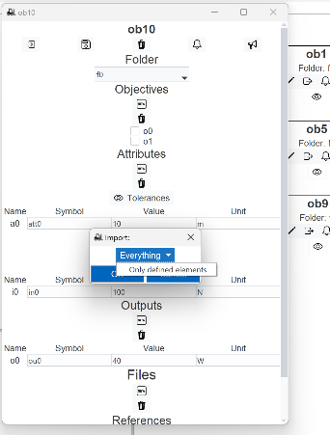**Import data from …**

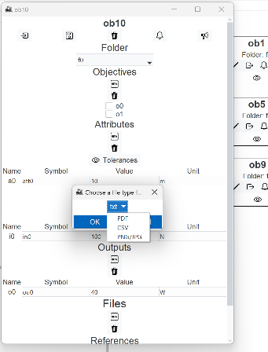The data for the properties can be imported by pressing the *Import data from …* button. The file type for data imports is chosen in the first drop-down menu that pops up. After choosing the file type, a second drop-down menu is used to define the import mode.

The option *Everything* is meant for imports previously exported from the SEKaseG Tool (see Section 2.4.1, Export object to …). This option is equivalent to copying every element in the import file into the object. This option is possible for text, PDF and CSV files.

If the option *Only defined elements* is chosen, the import file is scanned for already defined element names and only the entry boxes of these elements are filled out. This option is possible for text, PDF, CSV and PNG/JPG files.

* **Save object**

This button closes the editing window and displays the object box on the canvas. If the *Close* button in the upper right-hand corner is pressed, the object box appears on the canvas, but the changes made are discarded.

* **Subscribe** (see Section 2.4.1, Subscribe)
* **Save & Publish**

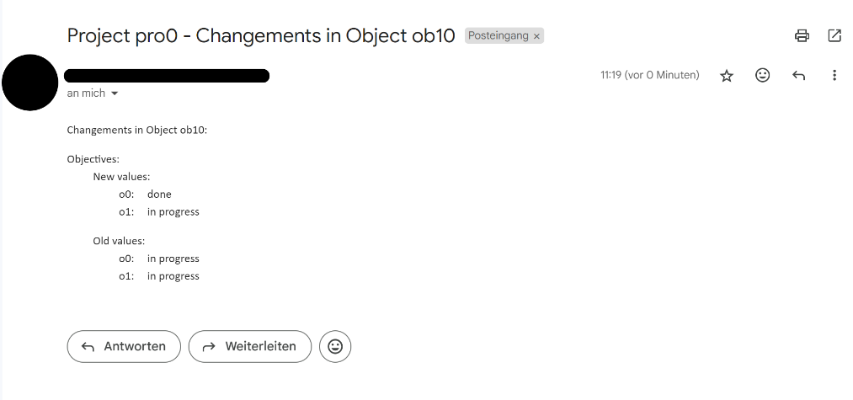When pressing this button, the same happens as when pressing the Save object button. Additionally, the subscribers of the object receive an e-mail containing the changes made to the object. Since the e-mail is sent via Outlook, the Outlook application must be opened in the background for the process to work. If one element of a property is changed, the e-mail lists all property elements, once with old values and once with new values.