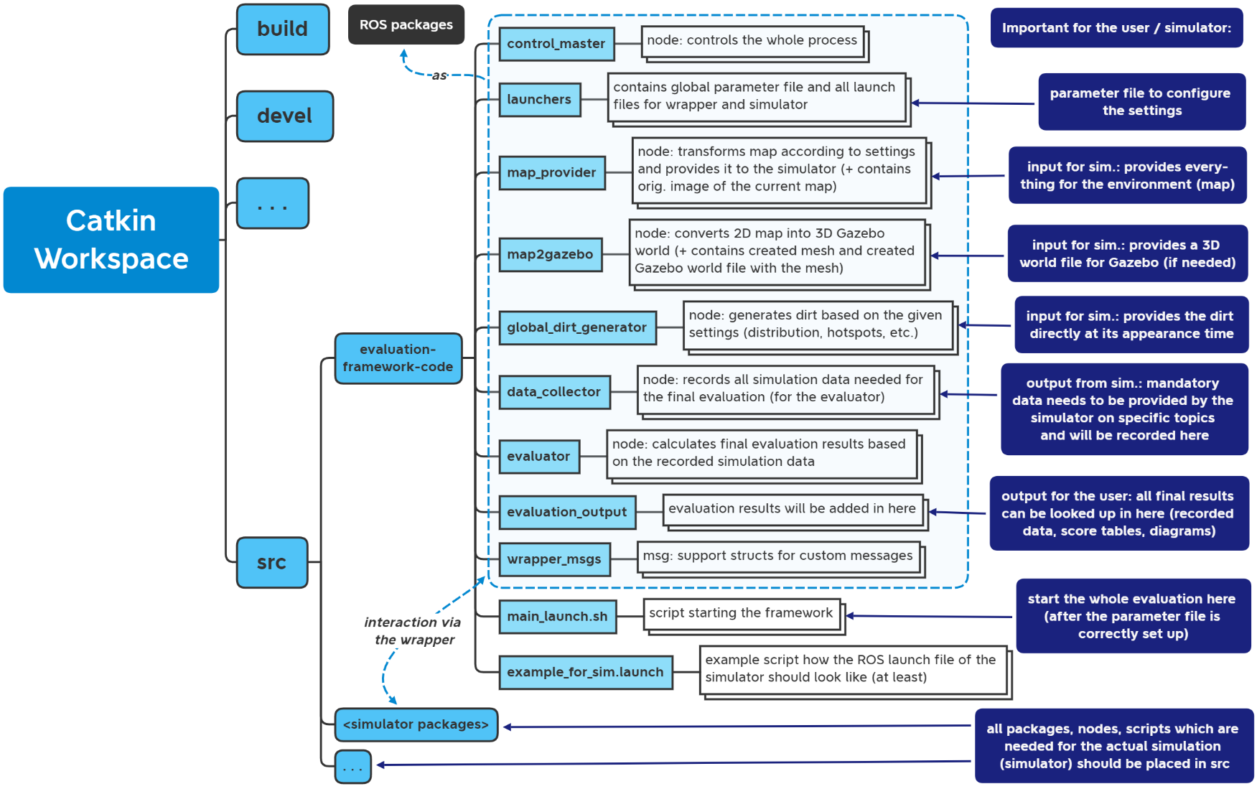

**Input side**

**Output side + evaluation**