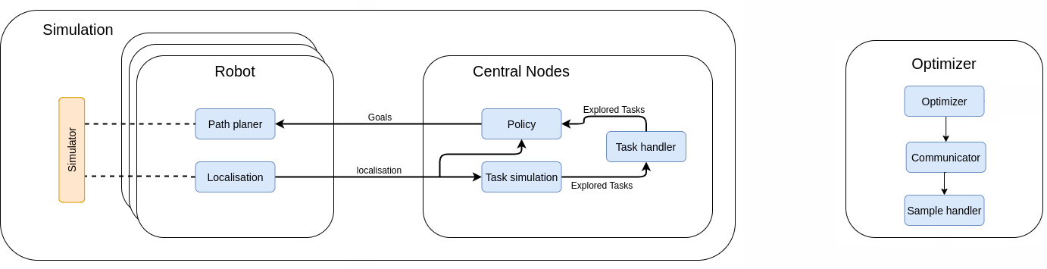

Raw Data

Each sample calls

one simulation