Installation

CSC100 Introduction to programming in C/C++

Marcus Birkenkrahe

Table of Contents
1. What are you going to learn?
2. Why we don't just get coding
3. Emacs for C programming
4. Infrastructure Setup
5. Install a C compiler (Windows + MacOS)
6. Install Emacs
7. Customize Emacs
8. Summary
9. Jargon
10. What's next
11. References

What are you going to learn?
- Why we don't just get coding
- Setting up infrastructure
- Install a C compiler
- Install the Emacs editor and IDE
- Customize the IDE
- Summary of concepts/code
- What's next

Why we don't just get coding
There are two reasons - one is philosophical, the other is technical.
"Understanding underlying technologies helps you develop a sense of what can go wrong. Knowing just high-level tools makes it easy to ask the wrong questions. It's worth learning to use a hammer before graduating to a nail gun. Learning underlying systems and tools gives you the power to build new tools, which is important because there will always be a need for tool builders, even if tool users are more common. Learning about computers so that the behavior of programs isn't a mystery enables you to craft better code." (Steinhart, 2019)
The other reason has to do with C itself:
TASK | SOFTWARE
C source code needs to be written and edited | editor
C source code needs to be compiled, linked and debugged | compiler
C object code needs to be run | shell
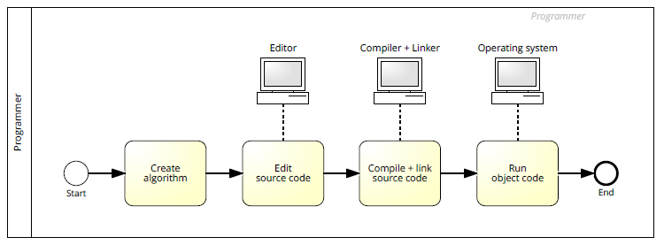
Image: C programming workflow / BPMN model
There are different routes to getting C running on your computer, depending on your operating system (Linux, MacOS or Windows).
The problem with most IDEs is that they're clunky. They take some time getting used to, have many functions that you'll never need, and any time spent on learning the IDE is wasted unless you keep working with it. IDEs do not teach you transferable skills.

Emacs for C programming

What is Emacs ?
 Image: GNU Emacs logo. Source: GNU Project
Emacs is an extensible editor written in C, with Emacs Lisp, a Lisp dialect, as an extenstion language. It was first released in 1985. Its extensibility and a large, active, passionate community of developers and users made sure that it still evolves.

How do you use Emacs?
I've written an article about this for the introductory data science course (FAQ). I use Emacs for most of my computing needs, not just as an editor, but also for writing, organizing, and planning. See also "Getting started with Emacs" (Kenlon, 2020).

How will we use Emacs?
We'll use it as:
- EDITOR to write source code,
- NOTEBOOK to write literate programs, and
- SHELL to build and run code.

Infrastructure Setup
The sections below cover most of the infrastructure used in my courses. They are also available as FAQs on GitHub.
If you look at this at GitHub, look at .org files for syntax highlighting.

Install a C compiler (Windows + MacOS)

Windows
- Download the installer from sourceforge.
- Run the installer - accept all presets.
- Add the location of the executable file gcc to the Windows PATH (C:\Program Files (x86)\mingw-w64\i686-8.1.0-posix-dwarf-rt_v6-rev0\mingw32\bin):
  - Search for PATH and open the menu System Properties
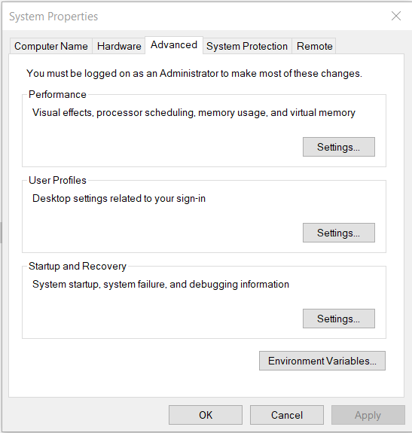
  - Open the menu Environment Variables, click on the PATH variable and choose Edit
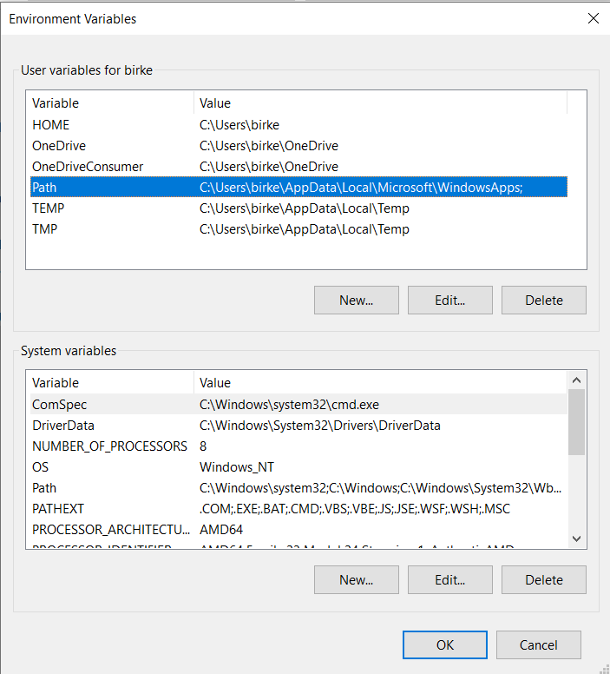
  - Click on New and paste the path ~C:\Program Files
(x86)\mingw-w64\i686-8.1.0-posix-dwarf-rtv6-rev0\mingw32\bin~ into the empty line. Confirm three times with OK to close all menus.
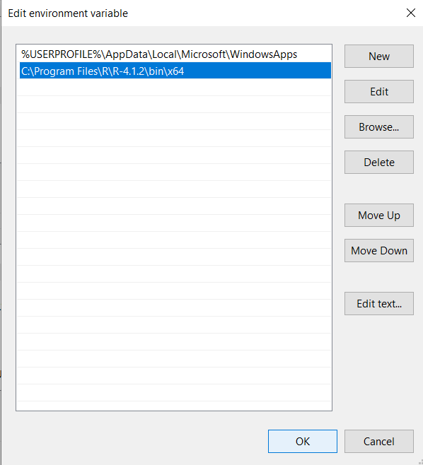
  - To test, search for CMD, open a terminal and enter gcc --version - you should get the output shown below. Close the window.
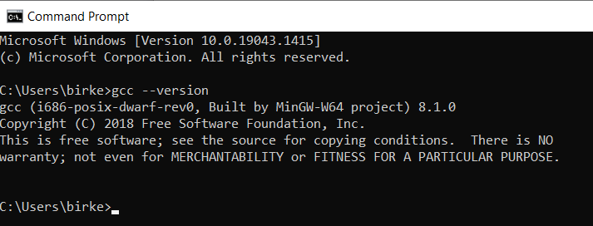

MacOS
Apple no longer allows GNU tools - instead, you can install the Clang compiler.
- Check if you already have a C compiler: open a terminal (search for terminal app) and enter cc -v.
- If no compiler is found, download it by entering xcode-select --install
- Test it by typing cc -v.
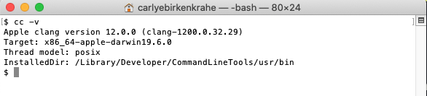

Install Emacs

Download and Installation for Windows
- Download GNU Emacs + ESS as a modified version for Windows.
- Run the installer - accept all presets.
- Check out the guided tour.
- Open Emacs, type CTRL-h t (C-h t) and complete the tutorial.

Download and Installation for MacOS
- Download GNU Emacs + ESS as a modified version for MacOS.
- Run the installer - accept all presets.
- Check out the guided tour.
- Open Emacs, type CTRL-h t (C-h t) and complete the tutorial.

Customize Emacs
GNU Emacs is much more than a text editor and an IDE. It's more like an operating system inside your operating system. Among the many things that Emacs is capable of, we only need one for this class: the ability to create and run interactive notebooks.
This will give you the power of Jupyter notebooks or Colaboratory on your computer, and you can share notebooks with anyone, who has Emacs.
The central package for many day to day tasks is Org-mode. Here is a set of Org-mode tutorials (with videos) covering many interesting applications. Org-mode is especially popular among scientists, and among these, physicists (my original tribe), who developed it.
And here is an excellent video tutorial by someone who is also getting started with Emacs for the first time like you:
- The Absolute Beginner's Guide to Emacs (System Crafters, 2021) - 1hr30min.
And here is a (much shorter) video by a former user of the Vim editor who switches to GNU Emacs:
- Switching to GNU Emacs (DistroTube, 2019) - 22 min.

Create configuration file
To create interactive computing notebooks in Emacs, we use the Org-mode and Babel packages. Both are already installed in your version of Emacs, but you have to tell Babel, which languages you want to work with.
Customization like this is done with a configuration file .emacs, which is placed in your home directory (~/~). Where this folder is actually located on your computer depends on your operating system.
Download the configuration file from GitHub. Here is the code, in case you want to copy and paste it from here.

(put 'dired-find-alternate-file 'disabled nil)

;; require ob-sqlite and ob-sql (for compilation in org src blocks) & tangle
(require 'ob-sqlite)
(require 'ob-sql)
(require 'ob-emacs-lisp)

;; active Babel languages
(org-babel-do-load-languages
'org-babel-load-languages
'((R . t)
(sql . t)
(python . t)
(emacs-lisp . t)
(C . t)))

;; Syntax highlight code in your SRC blocks The last variable removes
;; the annoying “Do you want to execute” your code when you type:
;; C-c C-c
(setq org-confirm-babel-evaluate nil
org-src-fontify-natively t
org-src-tab-acts-natively t)

;; enable snippet expansion via org-structure-template-alist
(require 'org-tempo)

;; get packages from MELPA package manager
(require 'package)
(add-to-list 'package-archives
'("melpa-stable" . "https://stable.melpa.org/packages/"))

;; enable global line numbers display
;; display-line-numbers-mode toggles on/off
(global-display-line-numbers-mode)

t

Create sample notebook
To create a notebook, create an .org file. Then type C-c C-, and select your chunk from the list. You can also abbreviate this by entering <s on any line.
Check out ./babel_c.org for examples with C code blocks.

Layout changes
You can completely change anything about the way Emacs looks, feels and behaves. Here are a few suggestions with code snippets based on my own customizations.
If you change your ~/.emacs file, you need to evaluate the file (M-x h evaluate-region) or restart Emacs to see the changes.
Emacs Lisp is a fun language to learn, because through Emacs you can play around with it and see what it does much more easily than with other languages. Here is a complete tutorial for non-programmers. Lisp (and Emacs Lisp) is a functional programming language (like R).

Customize theme and font
To change the theme, enter M-x custom-themes. Activate Save theme settings if you want the settings to become permanent. This will modify your .emacs configuration file.
You can also upload fonts and change fonts. You can do this easiest by opening the Options menu at the top of the Emacs screen and selecting Set default font from the list.
If you don't have the menu bar, enter M-x menu-bar-mode - this will toggle the menu bar, i.e. you can make it appear or disappear with this command. If you don't have a mouse, you can open the menus with <F10>. I don't tend to use it at all, since one of the advantages of Emacs is that everything can be done with the keyboard (which is way faster than the mouse).

Installing additional packages
There are hundreds of useful packages available for instant installation. To see them, enter M-x package-list-packages.
The screenshot shows part of the listing, with available, installed (by me), and built-in (by GNU Emacs) files.
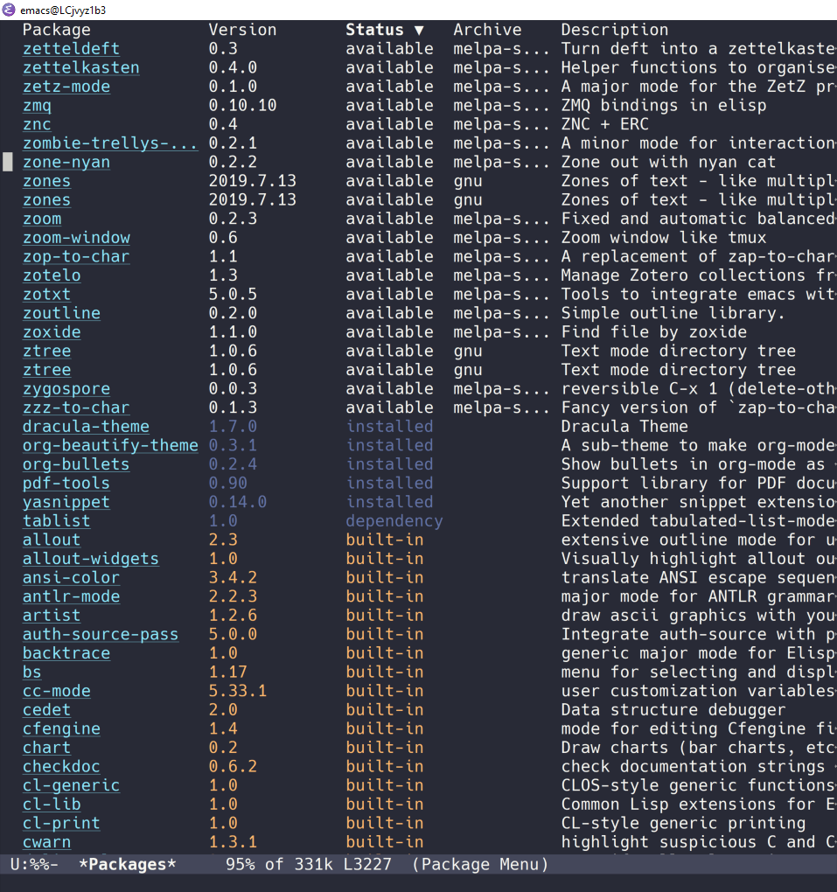
To install a package
- search and find it (forward search with C-s or backward search with C-r)
- enter i to mark the package for installation
- enter x to install it.

Presenting in Emacs
I often present in Emacs, especially when I use interactive notebooks. I use org-slide-tree-mode for that (see documentation). You need to install the package org-tree-slide and put the code below into your /.emacs file.
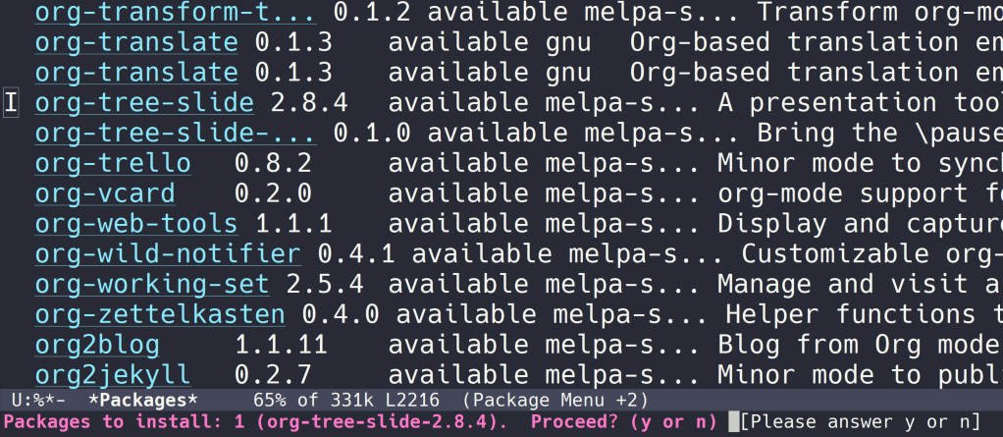

;; org-tree-slide: https://github.com/takaxp/org-tree-slide
;; to activate: M-x org-tree-slide-mode or <f9> - stop S-<f9>
(require 'org-tree-slide)
(with-eval-after-load "org-tree-slide"
(global-set-key (kbd "<f9>") 'org-tree-slide-mode)
(global-set-key (kbd "S-<f9>") 'org-tree-slide-skip-done-toggle)
(define-key org-tree-slide-mode-map (kbd "<f8>") 'org-tree-slide-move-previous-tree) ;; move forwards
(define-key org-tree-slide-mode-map (kbd "S-<f8>") 'org-tree-slide-move-next-tree) ;; move backwards
)
(setq org-image-actual-width nil)
(setq org-tree-slide-skip-outline-level 0)
(setq org-tree-slide-slide-effect t)
(org-tree-slide-simple-profile) ;; no headers

simple profile: ON
In the code, <f9> is used to switch the mode on or off (SHIFT + <f9>), and <f8> to move one slide forward or backward (SHIFT + <f8>). Slide headers have been removed. If you want slide headers, comment the last line by putting ;; in front of it like this:

;; (org-tree-slide-simple-profile) ;; no headers

Definitions and functions
You can use M-Q to fill a region (wrap the text and cut it off after 70 characters, a value set in fill-column). Sometimes it is useful to unfill a region (put it on one line, for example to copy it into an email). If you put the following definition into your ~/.emacs file, you can use M-x unfill-region to achieve that.

;; unfill region
(defun unfill-region (beg end)
"Unfill the region, joining text paragraphs into a single
logical line. This is useful, e.g., for use with
`visual-line-mode'."
(interactive "*r")
(let ((fill-column (point-max)))
(fill-region beg end)))

If you like to bind the function to a key sequence, you can use this code - now C-M-Q will invoke the function:

;; bind unfill-region to C-M-Q
(define-key global-map "\C-\M-Q" 'unfill-region)

Adding images and links to Org-mode files
My lecture scripts and notebooks often contain images and links. It is easy to add image and links (internal to Emacs or Internet URLs) to an Org-mode file.
Images can be named and given captions. Here is an example with figure 7.3.1 below. To show/hide images, use C-c C-x C-v (org-toggle-inline-images).

#+CAPTION: Google search trends for popular editors
#+NAME: fig:trend
#+ATTR_HTML: :width 400px
[[./img/trend.png]]

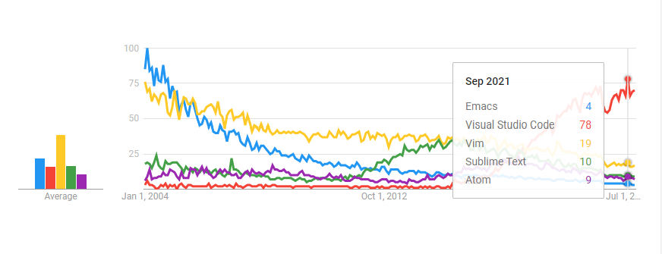 Figure 7.3.1: Google search trends for popular editors
And here is the link to the image - when viewing setup.org in Emacs, you can open links with C-c C-o (org-open-at-point).
https://github.com/birkenkrahe/cc100/raw/main/2_installation/img/trend.png

Tables
Org-mode has powerful table manipulation capabilities. I don't use Excel, I use active tables in Org-mode for my spreadsheet needs (e.g. computation of grades). There is too much to learn here - I suggest working through this short tutorial. For using tables as spreadsheets, see this short tutorial.

Summary
- To program in C, we need a computer, a compiler, and an editor.
- You can use an IDE like Code::Blocks, a Linux-like environment like Cygwin , or Linux directly, or an editor like Emacs
- You'll have to download the compiler for your operating system: MinGW (that's GNU gcc) for Windows, XCode (that's Clang) for MacOS. Linux comes with gcc already.

Jargon
CONCEPT | EXPLANATION
Source code | Human-readable program
Compiling | Translating source
Linking | Linking compiled program to libraries
Library | Bundle of reusable macros or functions
Object code | Code ready for execution by a machine
Execution | Running object code on a machine
Interpreter | Machine that interprets and executes source code
Script | Source code for an interpreter
Emacs | Extensible text editor (via Emacs Lisp)
Literate Program | Readable code - expands into doc + executable
GNU | "GNU's not UNIX"
GNU/Linux | Free, open source operating system
Richard Stallman | Creator of the GNU project and Emacs

What's next

References
Biggs/Donovan (November 9, 2020). Modern IDEs are magic. Why are so many coders still using Vim and Emacs? [Blog]. URL: stackoverflow.org.
DistroTube (October 4, 2019). Switching to GNU Emacs [video]. URL: youtu.be/Y8koAgkBEnM.
Galov (August 9, 2021). 111+ Linux Statistics and Facts - Linux Rocks! [blog]. URL: hostingtribunal.com.
Kenlon (March 10, 2020). Getting started with Emacs [blog]. URL: opensource.com.
Steinhart (2019). The Secret Life of Programs. NoStarch Press. URL: nostarch.com.
Wilson (November 28, 2021). M-x Forever: Why Emacs will outlast text editor trends. Emacs conference 2021 [video]. URL: youtu.be/9ahR5K_{wkNQ}.
System Crafters (March 8, 2021). The Absolute Beginner's Guide to Emacs [video]. URL: youtu.be/48JlgiBpw_{I}.

Code::Blocks, CodeLite, Netbeans, Microsoft Visual Studio (VS), are all free IDEs for C/C++, with VS being the most popular one right now.
The best way is to find the folder in the file explorer and copy the address as text: 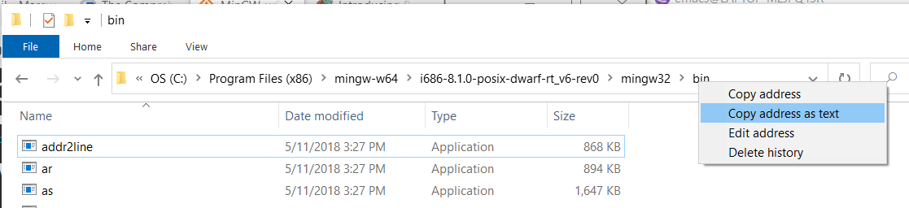
This link also shows you how to link notebooks. You can set a link anywhere (inside Emacs or Internet) with C-c C-l. If the target is another file, that file needs to be found (the path must be correct), and an anchor with the link name must be put into the file, in this case, the link is ~/.babel.org, and the anchor is <<babel.org>>

