
Self-submission Audit Wizard Specification
Invincibility Blueprint Toolkit
High-level design overview for the Self-submission Audit Wizard — covering wizard architecture, question types, conditional routing, data model, authentication, participant journey, admin dashboard, and Nano Fibre UK configuration.

Limitless Programme | March 2026 | Confidential | v1.0

Self-submission Audit Wizard Specification

Context
The Invincibility Blueprint toolkit has 3 self-submission audit instruments that need to become interactive web wizards in the Limitless Portal. The instruments are defined in the toolkit:
- 01 Company Audit (Director) — 11 sections (A–K), 60–90 min, no conditional logic
- 02 Manager Audit (Managers) — 13 sections, 30–45 min, Section 5 branches by department
- 03 Engineer Mini-Audit (Engineers) — 10 sections, 10–12 min, Section 5 branches by job type
First client: Nano Fibre UK — 27 participants, audit go-live March 10. Participant mapping in participant-instrument-mapping.md.

What the Spec Will Cover
The specification document will be placed at methodology/invincibility-blueprint/toolkit/wizard-specification.md (toolkit-level, not engagement-specific) and will define:

1. Wizard Step Architecture
Each instrument becomes a multi-step wizard with this structure:
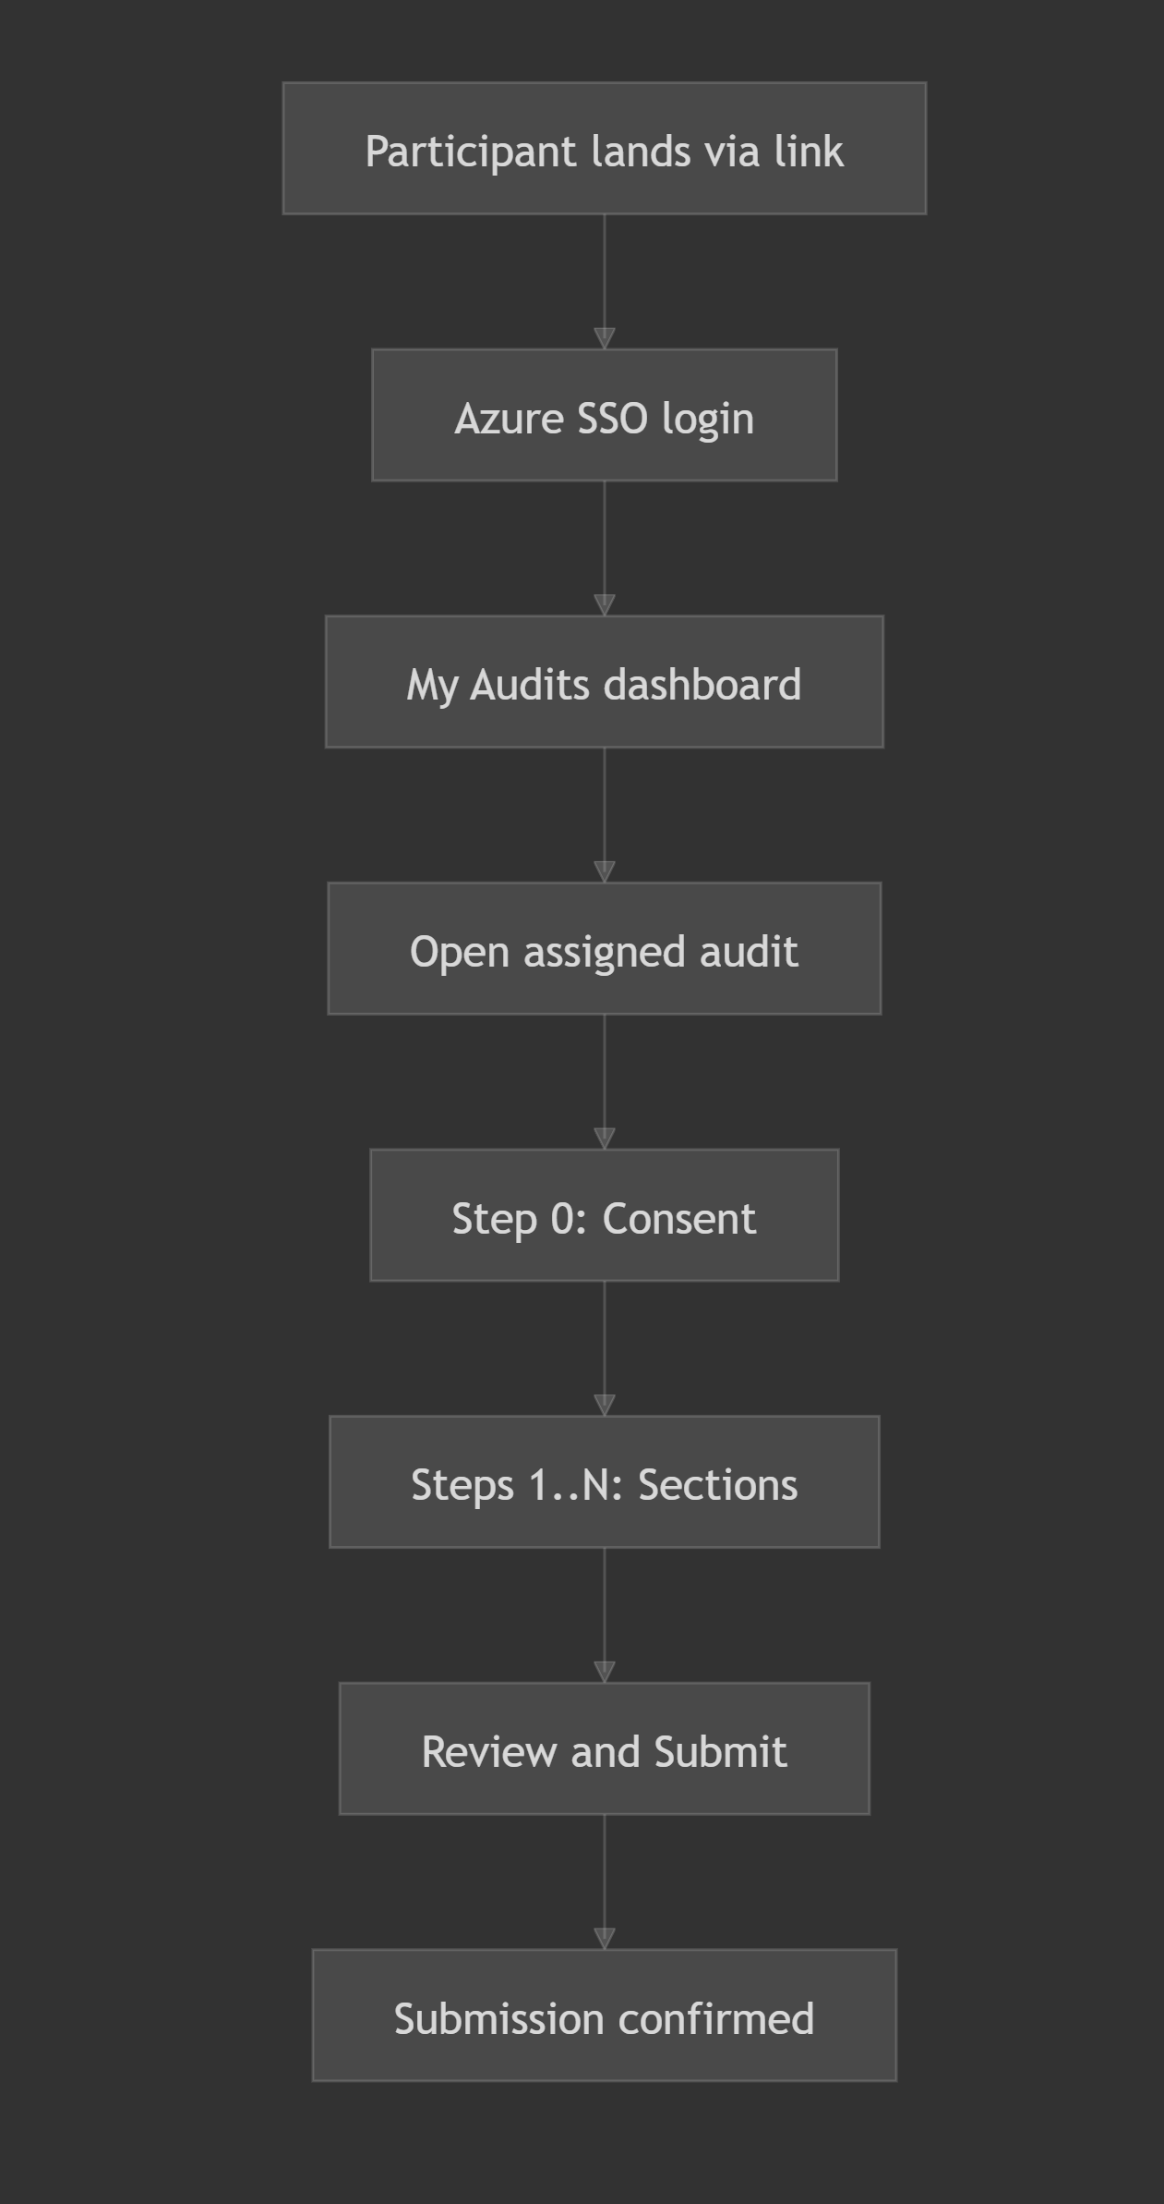
For each of the 3 instruments, the spec will define:
- Exact step sequence (step number, section name, estimated time)
- Which steps are mandatory vs optional
- Conditional routing rules (Section 5 branching)
- Per-step question inventory with question types

2. Question Type Taxonomy
Across all 3 instruments, every question maps to one of these input types:
Type | Widget | Example
FreeText | Single-line or multi-line text | Most "describe" questions
MultiSelect | Checkbox groups | "Tick all that apply"
SingleSelect | Radio/dropdown | OD Stage self-assessment, role type
FileUpload | Evidence uploads with metadata | Format, what it proves
TableGrid | Structured row input | Non-productive time estimates, Regular Duties cadence
RatingScale | Rating selector (8-point scale) | Reality Test ratings
ResponseMode | "For every request, choose one" pattern | Upload / Link / Not available / Will send later
ConsentCheckbox | Required consent before proceeding | GDPR consent gate

The spec will tag every question in every section with its type, required/optional status, and any validation rules.

3. Conditional Routing (Section 5)
Manager Audit Section 5 — branches based on department selected in Section 1:
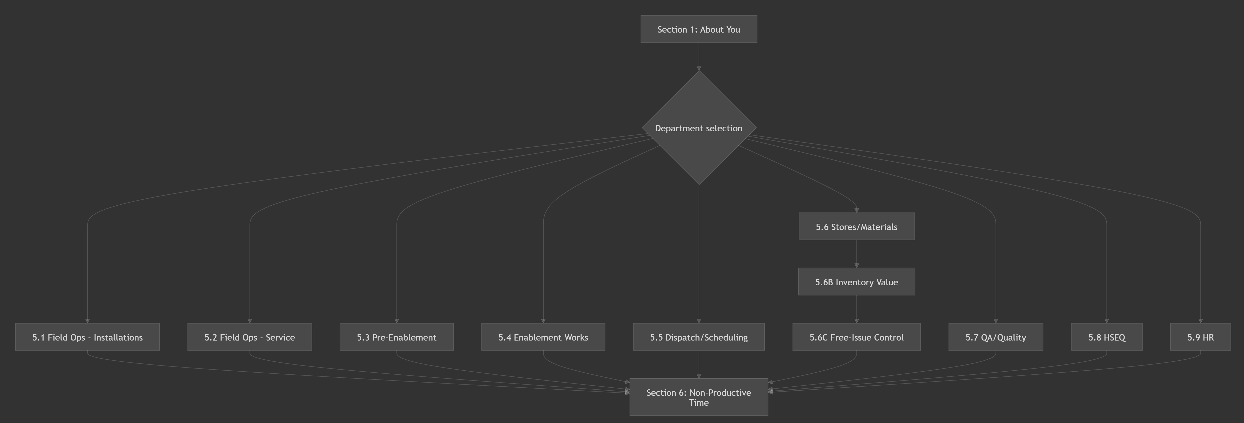
Engineer Mini-Audit Section 5 — branches based on role type selected in Section 1 (multi-skilled can answer 2 modules).
The spec will define the exact routing rules, including how Installation Managers (who are in "Field Ops — Installations" but doing Manager Audit) get the right Section 5.

4. Data Model
The spec will define the submission data structure:
Entity | Key Fields
Engagement | Client, dates, status, instruments assigned
Participant | Name, email, role, department, assigned instruments
Submission | Participant + instrument + status (not started / in progress / submitted)
Section | Per-section draft data (JSON blob), completion status, last saved timestamp
Upload | File reference, section, question, metadata (what it proves)

Key design decisions:
- Auto-save per section (save on navigate away)
- Draft vs submitted states
- Section-level completion tracking (progress bar)
- Submission locking after final submit (with option to unlock for amendments)

5. Authentication (Azure Entra ID SSO)
- Participants authenticate via Microsoft Entra ID (Azure AD)
- The spec will define: tenant configuration, redirect URIs, token handling, role mapping
- Nano Fibre UK participants use @nanois.co.uk and @nanofibre.co.uk domains
- Admin access (Greg, Fedor) via Tumai tenant

6. Participant Journey
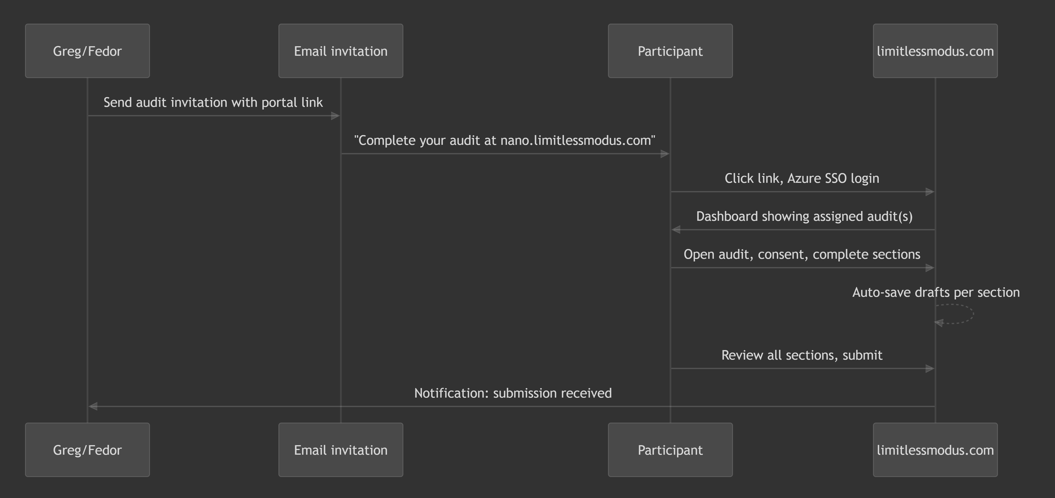

7. Admin Dashboard
The spec will define what Greg/Fedor see:
- Engagement overview (Nano Fibre UK)
- Participant submission tracker (27 rows, columns: name, instrument, status, % complete, last activity)
- Individual submission viewer (read submitted answers, download uploads)
- Export capability (all submissions to structured data for AI synthesis)

8. Nano Fibre UK Specifics
The spec will include an appendix mapping the 27 Nano Fibre participants to their wizard configuration:
- Directors (Wilhelm + Dirk) — joint Company Audit, shared submission
- 21 Managers — each gets Manager Audit, Section 5 pre-routed based on department
- 4 Engineers — each gets Engineer Mini-Audit, anonymous option

Output
One comprehensive markdown file: methodology/invincibility-blueprint/toolkit/wizard-specification.md
Sections:
- Overview and design principles
- Step flow per instrument (with question type annotations)
- Conditional routing rules
- Data model (entities, relationships, JSON schemas)
- Authentication and authorisation
- Participant journey (invitation to submission)
- Admin dashboard requirements
- File upload and evidence management
- Auto-save, progress tracking, and submission lifecycle
- Nano Fibre UK engagement configuration (appendix)
- API contract outline (endpoints for frontend-backend communication)

What This Does NOT Cover (deferred to implementation)
- Nuxt/Go scaffolding (next phase after spec approval)
- Visual design / Figma mockups
- Deployment and infrastructure (covered in limitless-portal CLAUDE.md)
- Interview instruments (04–06) — those are Greg-conducted, not self-submission

Status
All specification tasks completed. The full specification document has been produced at wizard-specification.md alongside this plan.

