TUM Open Infra Platform
Translation Documentation

Content
About this Document 1
Getting started 1
Translation files 1
Pro file 1
Adding translations 1
TS-files 1
Generating files 1
TS-files 1
QM-files 2

About this Document
This short guide shows you how to use the translation tools by Qt to generate *.ts and *.qm files.

Getting started

Translation files
Translation files are located in Data/translations. They end with *.ts and can be opened using the QtLinguist tool. The filename will be displayed in the dropdown menu (PreferenceDialog of OIP), so name it accordingly (preferably in that language).

Pro file
There is another important file in the root directory: the *.pro file. This is a simple text file holding information about files that contain literals that should be translated. This also holds the information where *.ts files should be generated.

Adding translations

TS-files
Adding translations is done using the QtLinguist tool (and the *.ts files).
Opening a *.ts file will show groups of literals on the left. Clicking on one will then show all grouped literals on the right. Below that list you can add translations.

Generating files

TS-files
TS-files will be generated using the *.pro file and the lupdate utility of Qt. Call „lupdate“ from a command line and pass the *.pro file as argument. When done, the *.ts files will be found in the directory that was specified in the .pro file (should be Data/translations/.ts).

QM-files
The running application will not use *.ts files, instead, it uses *.qm files. They hold the same information but in a binary format, and require less disk space.
Generating and copying them to their target location is both done by the already existing „CopyOpenInfraPlatformUIResources“ project.

CMake
Since CMake was already used to generate project files that, upon build, copy all UI resources into the specific folder in the build-tree, the following commands were added to CMake to also include translations into that process.
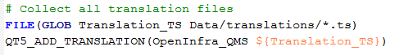
First we collect all (uncompiled) translations from the translations directory. Uncompiled translations are those ending on *.ts. We tell CMake to have Qt add those translations to be compiled.
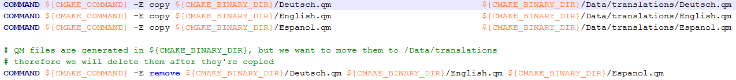
Next we copy the generated *.qm files to their target directory as CMake will generate them in the root dir. After having copied them they will be deleted from the root dir.

