Plate Forge
A single-sided car parking number plate you can re-letter in fifteen minutes
Design note · print settings · OpenSCAD source · October 2026

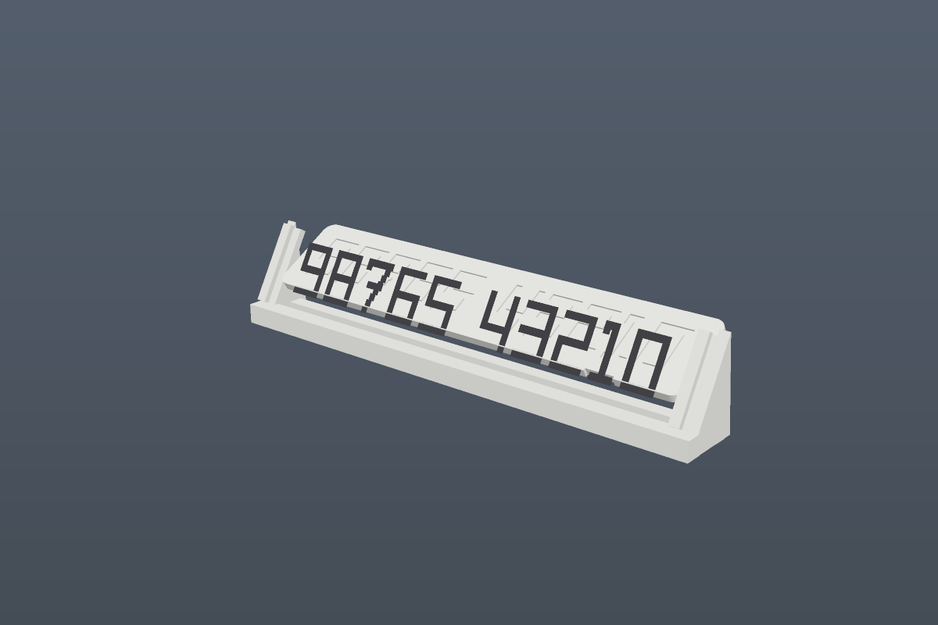
The panel seated in the easel at a 30° rake. The number is a 0.6 mm engraved groove.

1. What this is
A parking plate consists of two parts. The number panel is a flat 3 mm plate with the digits engraved 0.6 mm into the face; it prints face up, flat on the bed, with no supports. The easel is a separate wedge that holds the panel at a 30° rake and is printed once. Because the easel is reusable, changing the number costs one panel — about fifteen minutes and eleven grams — instead of a whole new plate.
Everything is sized for a Bambu Lab A1 mini. With the default eleven-character number the panel comes out 158 × 30 × 3 mm and the easel 167 × 28 × 32 mm, so both fit the 180 mm bed together.

2. The decision that shapes everything
Two reasonable requirements pull against each other, and the choice between them decides the rest of the design: PLA is the plastic that takes ink, and PETG is the plastic that survives a car. You cannot have both on this machine.
 | PLA | PETG
Marker / paint adhesion | good; forgiving of a missed primer | poor; ink beads on it, primer is not optional
Softens at | 57–60 °C | 80–85 °C
Dashboard in an Indian summer | 70–80 °C — sags over a few hot afternoons | marginal, but it survives
Use it when | the plate lives indoors or in shade | the plate lives in the car

ASA would settle the argument, but an A1 mini cannot print it — it is an open-frame machine with an 80 °C bed, and ASA wants 90–110 °C. So the default is PETG, and the glue-wash step in section 5 is what buys back the ink adhesion.

Engraved, not raised
A groove has two properties a raised ridge does not. Its rim acts as a paint dam, so you can flood the groove and wipe the face clean without the ink wandering. And its floor is a horizontal top surface, which means the slicer can iron it flat and seal the layer lines — the paths ink would otherwise creep along. Vertical groove walls also mean no layer stair-stepping, so the digit outline is exactly as sharp as the model.
Raised digits are still available in both the generator and the OpenSCAD file. They suit a chisel-tip pen laid almost flat and wiped across the tops, but the edge is less forgiving.

3. What you get
Part | Size (mm) | Volume | Print once? | Notes
Number panel | 158 × 30 × 3 | 13.6 cm³ | per number | engraved digits, prints face up
Easel | 167 × 28 × 32 | 17.4 cm³ | yes, reusable | prints standing, 20° overhang, no supports
Pen test coupon | 164 × 23 × 3.3 | 7.9 cm³ | once | six combinations in one short print

Volumes are the solid model volume. Actual filament use is lower — a 3 mm plate is nearly all walls and skins, so budget roughly 11 g of panel and 7 g of easel at 15 % infill.
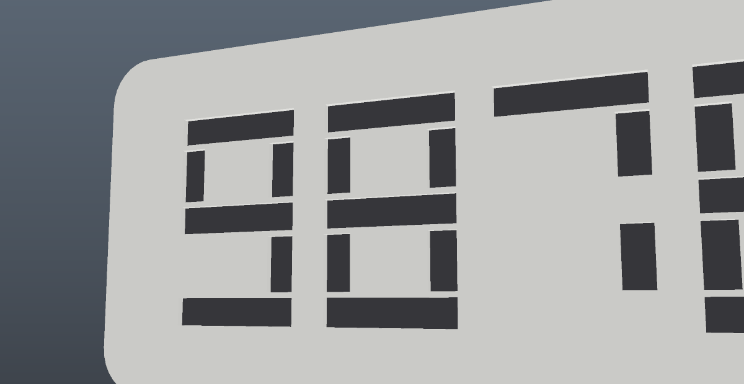
The groove at 0.6 mm deep, filled with a paint pen. The rim does the masking.

4. Printing
Bambu Studio names; OrcaSlicer uses the same ones.
Setting | Value | Why
Layer height | 0.20 mm | 0.6 mm groove = exactly three layers
Walls / top / bottom | 4 / 5 / 4 | the groove floor must be a solid skin
Infill | 15 % gyroid
Elephant-foot compensation | 0.15 mm | otherwise the panel edge fights the easel slot
Ironing type | All top surfaces | see the warning below
Ironing flow / spacing | 10 % / 0.10 mm | closes the inter-layer grooves
Ironing speed / inset | 30 mm/s / 0.2 mm
Plate | textured PEI + glue (PETG) | PETG bonds to smooth PEI hard enough to tear it

The one setting people get wrong: ironing must be set to “All top surfaces”, not “Only topmost”. The groove floors sit 0.6 mm below the plate rim, so “topmost” irons the rim, skips all ten digits, and wastes the print.
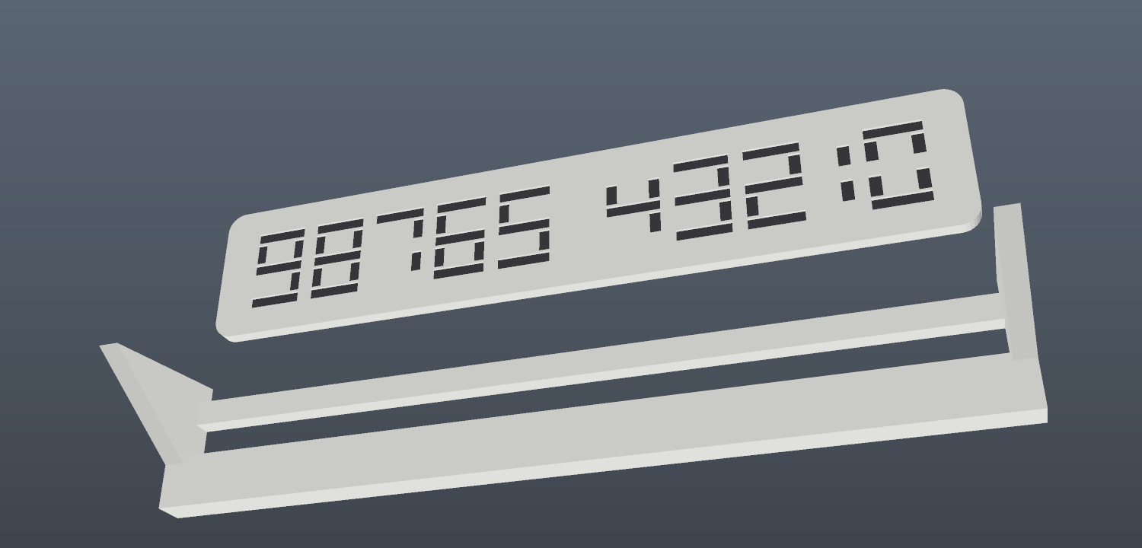
Both parts on the plate, as exported. The panel prints flat, the easel standing.

5. Painting the number
Ink wicking along layer lines is a real, documented effect and it is capillary, not sloppiness. The cheap fix that works is a diluted PVA wash in the groove before you flood it.
- Wipe the face with 70 % IPA. Skin oil is the usual reason ink “doesn't stick”.
- Brush a thin PVA or wood-glue wash into the grooves. Let it dry completely. This is the step that stops the creep.
- Flood with an oil-based paint pen. Sharpie Oil-Based or Posca PC-5M. Overfill slightly; do not try to stay inside the lines.
- Wipe the flat face while the ink is tacky. A barely damp cloth over a fingertip. The rim does the masking.
- Cure 24 hours, then two thin matte UV clear coats. Matte, because gloss makes ironing marks visible.


The pen test coupon: both relief styles at 0.4, 0.6 and 0.9 mm. Print this first.

6. The OpenSCAD file
openscad/plate_forge.scad is written for MakerWorld's Parametric Model Maker, not just for the desktop. It uses Customizer-style parameters with dropdowns at the top of the file, exposes the printable output through mw_plate_1() and an assembled preview through mw_assembly_view(), and pulls in no external libraries.
Parameter | Default | What it does
number | 98765 43210 | up to 14 characters; digits, space, + - .
mode | both | panel + easel, panel only, easel only, or coupon
lettering | engraved | engraved or raised
relief_depth | 0.6 mm | groove depth / ridge height
digit_height | 18 mm | cap height; shrinks automatically to fit the bed
stroke_ratio | 0.13 | stroke as a fraction of digit height
panel_thickness | 3.0 mm | 3 mm is the minimum for PETG on a dashboard
rake_deg | 30° | easel tilt from vertical

The layout is a 7-segment skeleton with real gaps between every bar, because two bars that touch, share an edge, or meet at a single corner make a self-intersecting sketch, and OpenSCAD's difference() will quietly drop geometry rather than complain. Every segment is separated by exactly segment_gap.

7. The web generator
The same geometry exists as a browser tool at tumesh007.github.io/plate-forge. It takes a number, renders the plate live, and exports STLs — panel, easel, both on one plate, or the coupon. There is no build step and no CDN dependency; it runs from a static folder.
The browser version builds the panel as a single closed manifold surface rather than two solids stacked, and its test suite asserts that every triangle edge is shared by exactly two triangles across twelve configurations. That check exists because an interior face sitting exactly on the groove floor can be read by a slicer as a filled cavity, which swallows the digits without any error message.

The easel as printed: two side fins, a plinth that doubles as the front lip, and a rear tie.

8. Files
Path | What it is
openscad/plate_forge.scad | the parametric model, MakerWorld ready
index.html, js/, css/ | the browser generator
OPTIONS.md | the research: what the alternatives are and why this one won
PRINT-SETTINGS.md | slicer settings and the ink workflow in full
MAKERWORLD.md | listing copy, tags and settings for the upload
test/check.mjs | headless geometry tests
docs/ | the images in this document

Print the coupon before the plate. It costs eight minutes and it turns every claim above into a measurement on your own filament.

