GAUTENG CITY COLLEGE
Knowledge · Integrity · Achievement

ADVANCED PROGRAMMING II
Project Title: Data Validation System - Java Swing

Student Name: Tumisang Ndhlovu

Student Number: 0605070402082

Lecturer: Mr Owami

Date: 22 September 2026

GitHub Link: https://github.com/tumieyndlovuu

TABLE OF CONTENTS

1. Cover Page .......................................................... 1
2. Table of Contents .................................................. 2
3. Introduction .......................................................... 3
4. System Design ...................................................... 3
5. Fields ................................................................... 5
6. Validation Checks ................................................ 5
7. Testing ................................................................ 7
8. Code ................................................................... 11
9. GitHub Repository ................................................ 14
10. Conclusion ........................................................ 14
11. References ........................................................ 15

INTRODUCTION

The Data Validation System is a desktop application built using Java Swing. Its purpose is to capture personal information from a user and validate every field before the data is accepted.

The system prevents invalid data from being saved by using presence checks, type checks, length checks, format checks, and range checks. If a user enters wrong data, the system gives immediate, clear feedback through dialog boxes and inline messages, without crashing.

This system can be used as a registration form for students or clients and ensures data integrity for any business, including my Clothing Business project.

SYSTEM DESIGN

Before coding, I planned the layout to be clean and user-friendly, not the default grey Swing look.
Layout: I used a `JFrame` with grouped `JPanels`. Personal details (Name, Surname, ID, Age/DOB) are at the top, contact details (Contact, Email) in the middle, and Gender radio buttons in a separate panel for clarity. Tab order is logical from top to bottom.

Colour and Font:
- Background: Navy Blue, Heading Yellow-Orange
- Fields: Dark Blue border, White text
- Buttons: Yellow-Orange for all of them
- Font: Segoe UI Black 36pt Bold for Title, 12pt for labels. This improves readability.
Usability: Clear labels, Save/Clear/Exit workflow, and non-technical error messages like "Please enter numbers only" instead of Java exceptions
System Interface Sketch/Screenshot
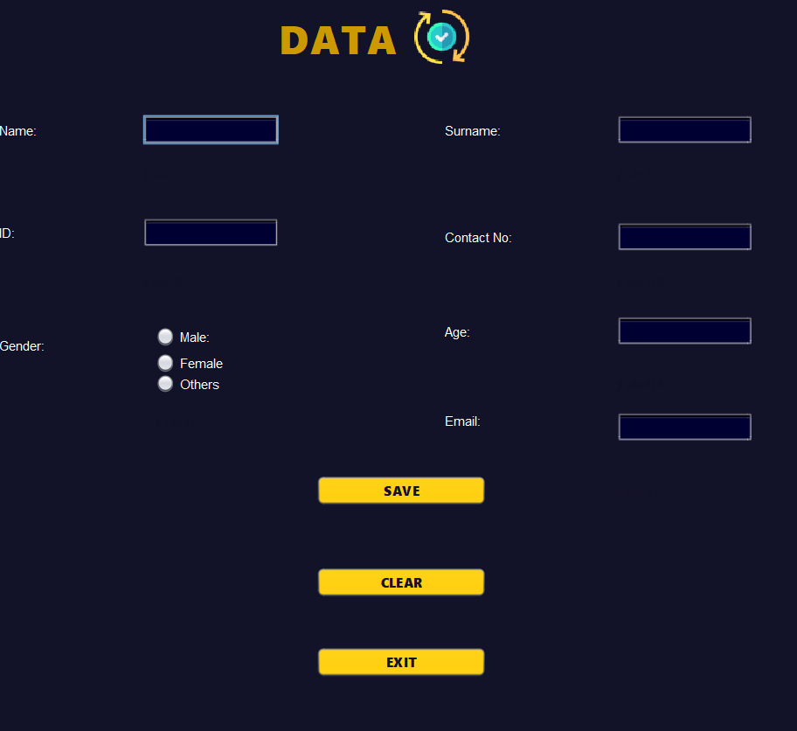

FIELDS

The system captures the following fields as required in 1.1:
Field Name | Component Used | Purpose
Name | JTextField | Captures user's first name
Surname | JTextField | Captures user's last name
ID / Student Number | JTextField | Unique 13-digit South African ID or 8-digit student number
Age / Date of Birth | JTextField / JSpinner | Captures age for range validation
Gender | JRadioButton | Captures gender - only one can be selected
Contact Number | JTextField | 10-digit SA phone number
Email Address | JTextField | User's email for communication

VALIDATION CHECKS

This is how I applied the 5 required checks:
1. Presence Check - Field is not empty
All fields use `if(field.getText().trim().isEmpty())`. If empty, show `JOptionPane.showMessageDialog(this, "Name cannot be empty!")`. This prevents blank submissions.

2. Type Check - Correct data type
- Name/Surname: Must be characters only. Implemented with `DocumentFilter` with regex `[a-zA-Z ]+`. In code: `if(!name.matches("[a-zA-Z ]+"))` -> error. Also used `Character.isLetter()`.
- ID/Age/Contact: Must be numbers only. Implemented with `DocumentFilter` with regex `[0-9]+` and `Character.isDigit()`. As discussed in development, this blocks letters before they appear.

3. Length Check - Min/Max characters
- ID Number: Must be exactly 13 characters. `if(id.length() != 13)` -> error.
- Contact Number: Must be 10 characters. `if(contact.length() != 10)` -> error.
- Student Number: 8 characters.

4. Format Check - Pattern matching
- Email: Uses regex format check: `if(!email.matches("^[A-Za-z0-9+_.-]+@(.+)$"))` -> "Invalid email format"
- Contact: Must start with 0. `if(!contact.startsWith("0"))`
- ID: Uses `matches("[0-9]+")` only.

5. Range Check - Sensible numeric range
- Age: Must be between 16 and 100. `if(age < 16 || age > 100)` -> error "Age must be between 16-100"
- ID: First 2 digits for year must be valid.

Each check gives immediate feedback via `JOptionPane` and clears the invalid field.

TESTING

- Before Testing - Invalid Data (Error Messages)
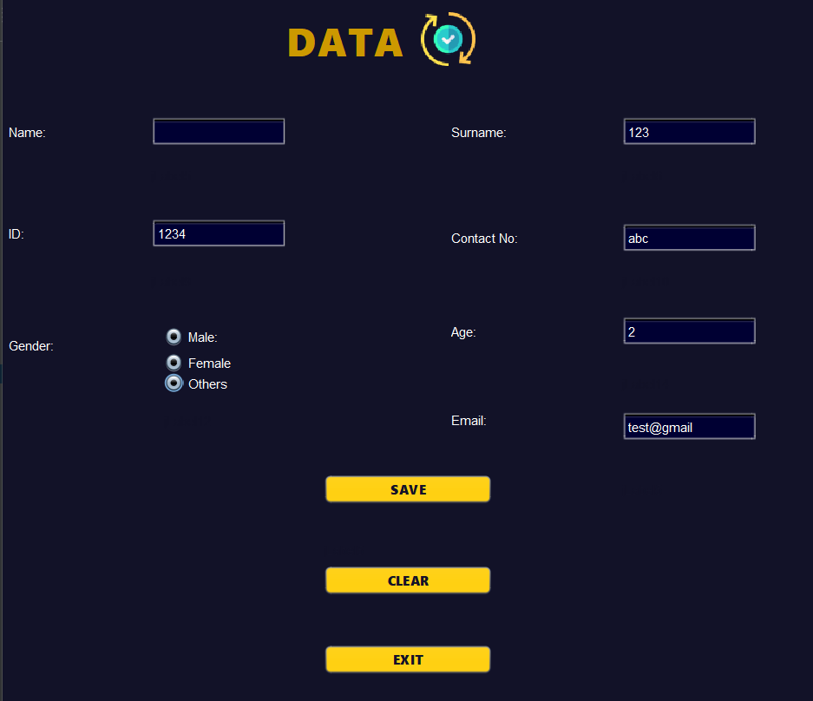
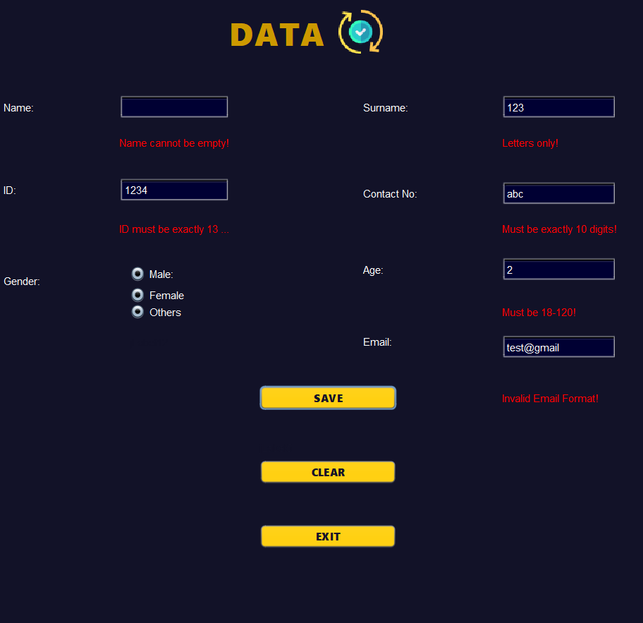
- After Testing - Valid Data Accepted
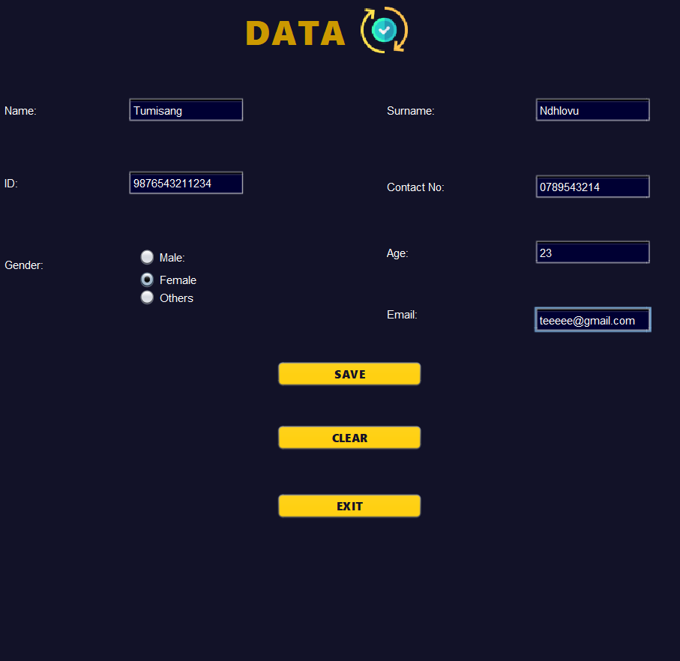
C. If All Input Is Valid
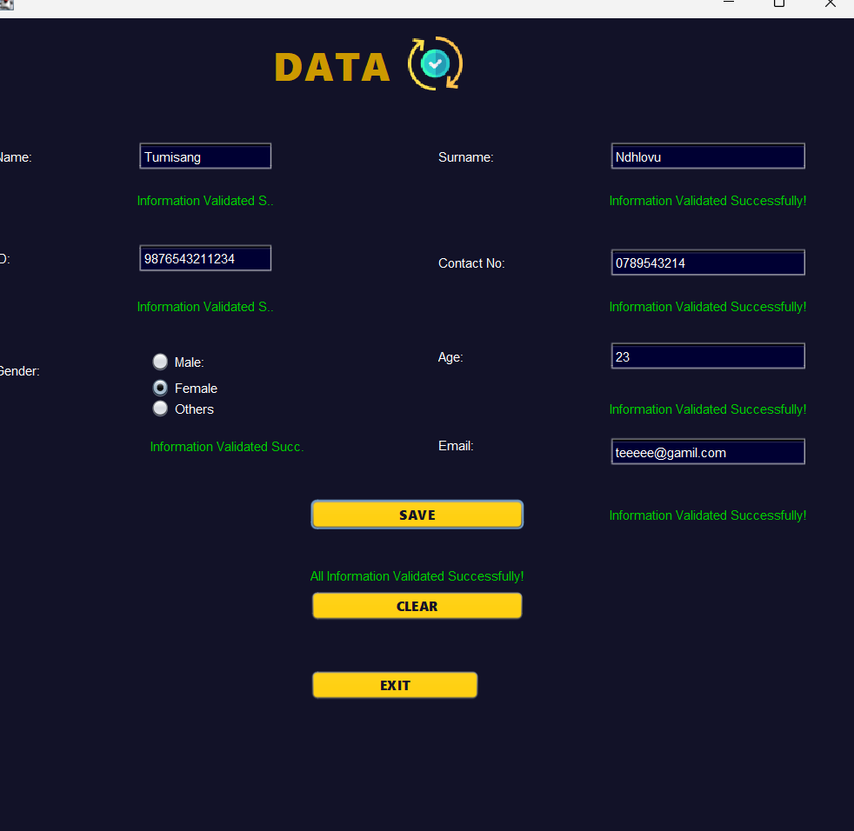

CODE

I organized code into methods for reusability and commented it.

Key Section 1: Number-Only Validation (DocumentFilter)
This was implemented to ensure ID, Age, Contact accept numbers only. It blocks wrong input in real-time, not after clicking Save. This is better than KeyListener because it also blocks paste.
public void onlyNumbers(JTextField field) {
((AbstractDocument) field.getDocument()).setDocumentFilter(new DocumentFilter() {
@Override
public void replace(FilterBypass fb, int off, int len, String str, AttributeSet a) throws BadLocationException {
// Presence + Type check: only 0-9 allowed
if (str.matches("[0-9]+") || str.isEmpty()) {
super.replace(fb, off, len, str, a);
}
}
});
}
// Usage in constructor after initComponents():
// onlyNumbers(txtID);
// onlyNumbers(txtContact);
Explanation: This filter checks every character the user types. If it matches numbers, it allows it, otherwise it ignores it.

Key Section 2: Letters-Only Validation
For Name and Surname, to ensure no numbers are entered.
public void onlyLetters(JTextField field) {
((AbstractDocument) field.getDocument()).setDocumentFilter(new DocumentFilter() {
@Override
public void replace(FilterBypass fb, int off, int len, String str, AttributeSet a) throws BadLocationException {
if (str.matches("[a-zA-Z ]+") || str.isEmpty()) {
super.replace(fb, off, len, str, a);
}
}
});
}
Key Section 3: Gender Group - RadioButtons
My code wouldn’t allow me to use ButtonGroup so I used RadioButtons
javax.swing.ButtonGroup genderGroup = new javax.swing.ButtonGroup();
genderGroup.add(male);
genderGroup.add(female);
genderGroup.add(others);

// To get selected value on Save:
private void btnSaveActionPerformed(ActionEvent evt) {
String gender = "";
if(!male.isSelected() && !female.isSelected() && !others.isSelected()){
lblGen.setForeground(Color.RED);
lblGen.setText("Please select Gender!");
isValid = false;
}

9. GITHUB REPOSITORY

Full Link: https://github.com/tumieyndlovuu

10. CONCLUSION

The biggest challenge was implementing real-time validation without crashing the program. At first I used `KeyListener` which failed when pasting text, then I learned `DocumentFilter` which is more professional. The gender group was also confusing until I understood it must be added AFTER `initComponents()` and assigned in Properties.

What I learned:
- How to combine 5 validation types in one system
- Importance of UI design - colour and spacing matters for marks
- How to use GitHub with meaningful commits
- How to give user-friendly error messages instead of technical Java errors

This project improved my Java Swing and validation logic skills and I can now build a professional registration form for any business.

11. REFERENCES

1. Oracle Java Documentation - Swing JTextField and DocumentFilter
2. From class - How to Use Radio Buttons
3. TutorialsPoint - Java Swing Tutorial
4. Stack Overflow - Email regex validation in Java
5. Class - NetBeans GUI Builder tutorial

