I



GCTMS – Jenkins Setup

Technical Design Document

Version 1.0

**Statement of Confidentiality**

This document is proprietary and confidential property of Western Union Financial Services**, Inc. and/or its affiliates (“Western Union”)**. It is intended solely for use by employees and agents of Western Union and shall not be reproduced or disclosed to **any other party** without the express written consent of Western Union. The use, disclosure, reproduction, modification, transfer, or transmittal of this work for any purpose in any form or by any means without the written permission of Western Union is strictly prohibited.

CONFIDENTIAL, UNPUBLISHED PROPERTY OF WESTERN UNION FINANCIAL SERVICES~~,~~ **.**USE AND DISTRIBUTION LIMITED SOLEY TO AUTHORIZED PERSONNEL.

© Western Union Financial Services, Inc. **2016.** All Rights Reserved

*The controlled master of this document is available on-line. Hard copies of this document are for information only and are not subject to document control.*

Document Revision History

|  |  |  |  |
| --- | --- | --- | --- |
| **Date** | **Version** | **Modification** | **Author** |
| 18-05-16 | 1.0 | Initial Draft | Ayesha Khan |
|  |  |  |  |
|  |  |  |  |
|  |  |  |  |
|  |  |  |  |
|  |  |  |  |
|  |  |  |  |
|  |  |  |  |
|  |  |  |  |
|  |  |  |  |
|  |  |  |  |
|  |  |  |  |
|  |  |  |  |
|  |  |  |  |

Table of Contents

1) Jenkins Binary 4

2) Jenkins URL 4

3) Jenkins logins 4

4) Granting access 4

5) Outbound Connectivity Requirements 5

# Jenkins Binary

Download Jenkins Binary from <https://jenkins.io/download/> from Internet.

Click Download Jenkins Button

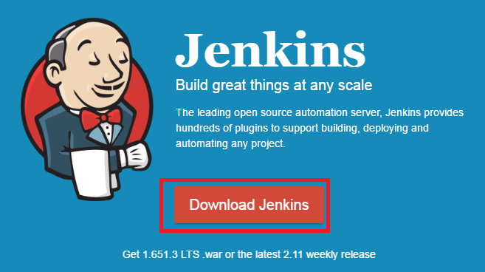

Download Long Term Support Release Binary LTS Release for Redhat Linux Operation System.

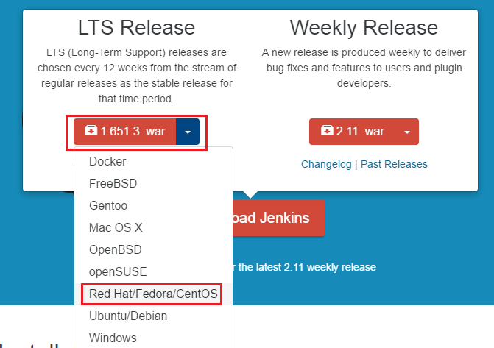

Download “**Jenkins-1.651.1.-1.1.noarch.rmp**” from Jenkins Website.

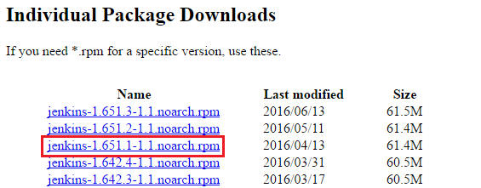

# Install Jenkins Binary in 10.45.16.247 Machine

Copy the Jenkins Binary “**Jenkins-1.651.1.-1.1.noarch.rmp**” from Local Desktop to 10.45.16.247 Machine.

Install the Jenkins Binary in **/apps** directory through root user.

**Note:-**

Jenkins Binary install through root user only

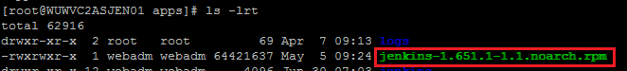

[root@WUWVC2ASJEN01 apps]# cd **/apps**

[root@WUWVC2ASJEN01 apps]# ls -lrt

total 62912

drwxr-xr-x 2 root root 69 Apr 7 09:13 logs

-rwxrwxr-x 1 webadm webadm 64421637 May 5 09:24 jenkins-1.651.1-1.1.noarch.rpm

[root@WUWVC2ASJEN01 apps]# **rpm -ivh jenkins-1.651.1-1.1.noarch.rpm**

warning: jenkins-1.651.1-1.1.noarch.rpm: Header V4 DSA/SHA1 Signature, key ID d50582e6: NOKEY

Preparing... ################################# [100%]

Updating / installing...

1:jenkins-1.651.1-1.1 ################################# [100%]

# Check Installed Jenkins Version in 10.45.16.247 Machine

By default Jenkins installed in **/var/lib** directory path

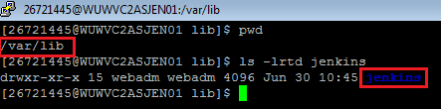

We can able to check the Installed Jenkins Version in /var/lib/jenkins/**config.xml** file

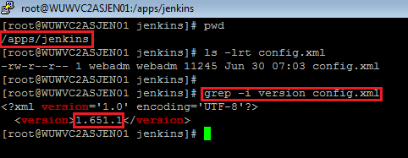

rpm -qa | grep -i jenkins

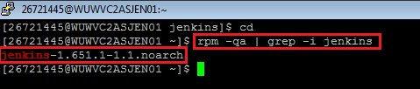

# Jenkins Service automatically added in init.d directory

The Jenkins Service automatically added in **/etc/init.d/Jenkins** file.

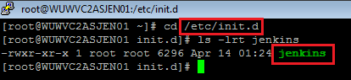

# Start & Stop Jenkins Service in Linux Machine

[root@WUWVC2ASJEN01 ~]#**service jenkins start** 🡪(only execute through root user)

[root@WUWVC2ASJEN01 ~]#**service jenkins stop** 🡪(only execute through root user)

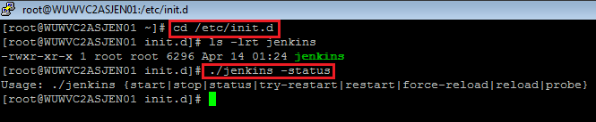

# Access Jenkins Admin Console in IE Browser

Check the 8080 port number is listening in 10.45.16.247 Machine.

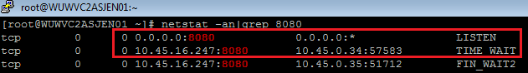

By default Jenkins listening 8080 port

[http://10.45.16.247:8080](http://10.45.16.247:8080/)

The 8080 Port number is blocked by WU-Internet Firewall.



Then we have to raise firewall request to Network Team to open 8080 port in WU

Internal. WU Network Team to open 8080 Port from WU Internal to 10.45.16.247. Then we can verify through telnet command in WU windows Jump Server 172.31.8.60.

C:\Users\TEMP.HQINTL1.035>telnet 10.45.16.247 8080

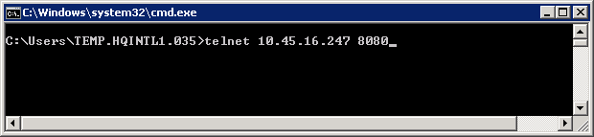

The page goes to blank page. It shows Jenkins server admin port number is opened in WU Internal.

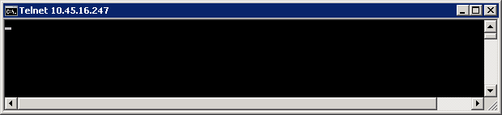

Jenkins Admin Console Home Page:-

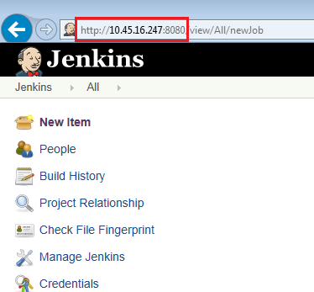

# Change the Jenkins Home Path to /apps directory

The Jenkins Server Home Path is configured in /etc/sysconfig**/jenkins** file

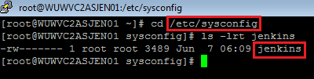

**Before:-**

JENKINS_HOME="/var/lib/jenkins"

**After:-**

JENKINS_HOME="/apps/jenkins"

Change the JENKINS_HOME path to /apps/Jenkins directory. Then restart the Jenkins Service by using

[root@WUWVC2ASJEN01 ~]# service jenkins stop

[root@WUWVC2ASJEN01 ~]# service jenkins start

# Change the Jenkins User to webadm userid

Jenkins Server by default installed **jenkins** userid. This Jenkins userid is configured in /etc/sysconfig/**jenkins** file



**Before:-**

JENKINS_USER=”**jenkins**"

**After:-**

JENKINS_USER="**webadm**"

Change the JENKINS_USER to “**webadm**” id in /etc/sysconfig/**jenkins** file . Then restart the Jenkins Service by using

[root@WUWVC2ASJEN01 ~]# service jenkins stop

[root@WUWVC2ASJEN01 ~]# service jenkins start

If you check the Jenkins process in Linux Machine by using

ps –ef|grep jenkins

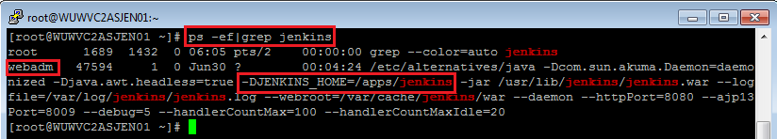

Jenkins Admin Console <URL:->

<http://10.45.16.247:8080/>

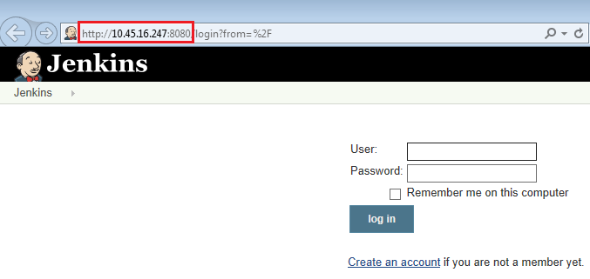

# Install JDK 1.8 version in Jenkins Server

Download Oracle JDK 1.8 64bit version from Oracle Website “**jdk-8u91-linux-x64.tar.gz**”

[http://www.oracle.com/technetwork/java/javase/downloads/java-archive-javase8-2177648.html#jre-8u91-oth-JPR](http://www.oracle.com/technetwork/java/javase/downloads/java-archive-javase8-2177648.html%23jre-8u91-oth-JPR)

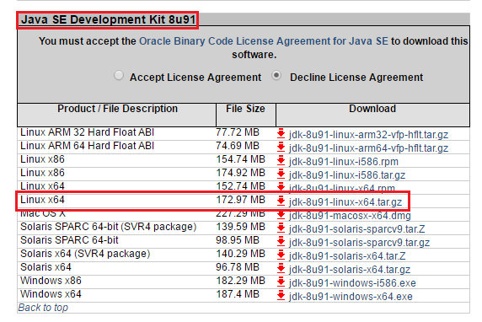



Copy the Oracle JDK 1.8 64bit binary to **/var/lib SUN_JDK_1.8/** path.

Then install Oracle JDK 1.8 version in **/var/lib SUN_JDK_1.8/** path

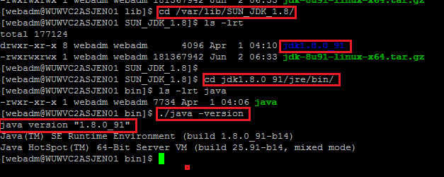

Copy the IBM JDK 1.8 64bit binary to **/var/lib IBM_JDK_1.8/** path.

Then install IBM JDK 1.8 version in **/var/lib IBM_JDK_1.8/** path

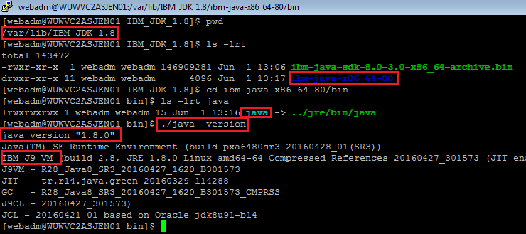

We have checked installed JDK version is **1.8.0.91 (64bit)**

**Jenkins 🡪 Manage Jenkins 🡪 Configure System 🡪 JDK**

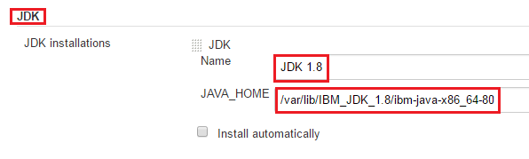

# Install Maven 3.3.9 Version in Jenkins Server

Download Maven 3.3.9 Version from Maven Apache Website “**apache-maven-3.3.9-bin.zip**”

<https://maven.apache.org/download.cgi>

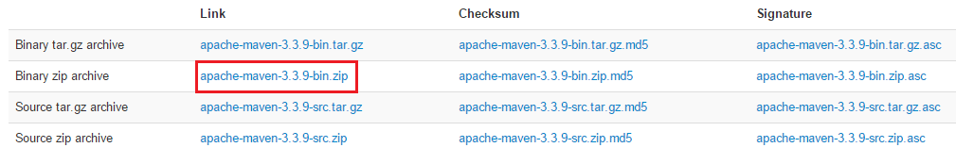

Copy [apache-maven-3.3.9-bin.zip](http://apache.spinellicreations.com/maven/maven-3/3.3.9/binaries/apache-maven-3.3.9-bin.zip) binary to Jenkins Server /var/lib/maven path

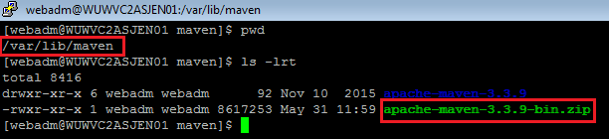

Install the Maven 3.3.9 in /var/lib/maven/ Path.

Check installed Maven version.

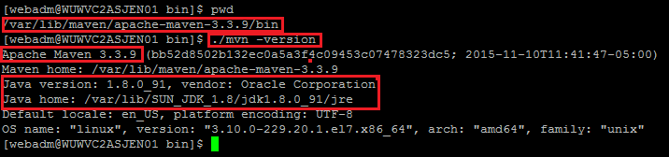

Create **maven.sh** script in /etc/profile.d path

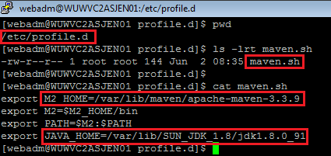

**Jenkins 🡪 Manage Jenkins 🡪 Configure System 🡪 Maven**

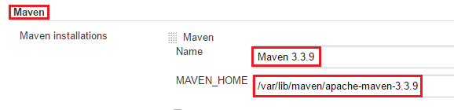

# Configure SMTP in Jenkins admin console Jenkins Server

Request Network team to open firewall port 25 for SMTP Servers to Jenkins Server

**SMTP Servers:-**

**RESTON Data Center:-**

smtpva.prod.wudip.com - 10.44.16.251 and 10.44.16.252

**CHICAGO Data Center:-**

smtpch.prod.wudip.com - 10.46.16.251 and 10.46.16.252

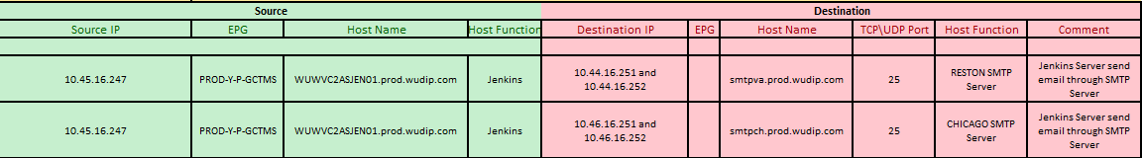

Then check SMTP server ipaddress with port number 25 in Jenkins Server for Reston & Chicago Data Centre SMTP Servers

[webadm@WUWVC2ASJEN01 ~]$ telnet 10.44.16.252 25

[webadm@WUWVC2ASJEN01 ~]$ telnet 10.46.16.251 25

[webadm@WUWVC2ASJEN01 ~]$ telnet 10.44.16.251 25

[webadm@WUWVC2ASJEN01 ~]$ telnet 10.46.16.252 25

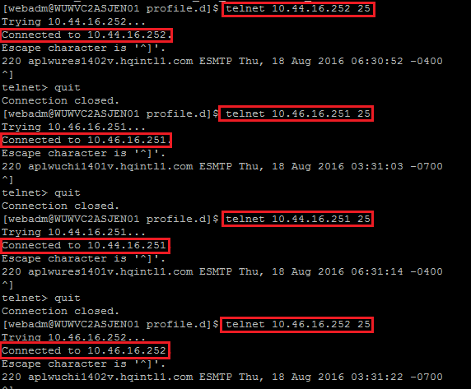

Requesting to **WU-Messing to White List Jenkins Server Ipaddress 10.45.16.247** for sending mail through Reston & Chicago SMTP Servers.

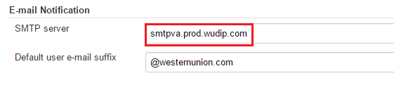

# Configure Proxy Setting in Jenkins Server for Internet Access

Configure Western Union Charlotte Forward Proxy (172.27.96.235:8080) in Jenkins Admin Console for Internet Access

Charlotte Forward Proxy: **10.44.20.93:80**

Request Network Team to open fireware port number from Jenkins Server to Charlotte Forward Proxy (**10.44.20.93**:8080)

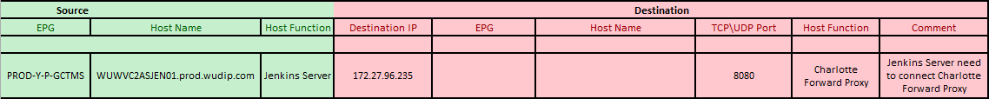

Verify Charlotte Forward Proxy Port number is opened from Jenkins Server

[webadm@WUWVC2ASJEN01 ~]$ **telnet 172.27.96.235 8080**

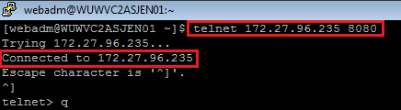

<http://10.45.16.247:8080/>

Jenkins 🡪 Manage Jenkins -> Advance (option)

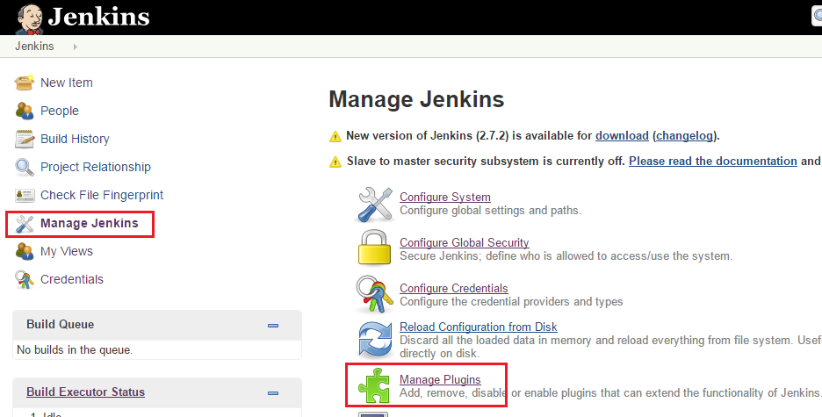

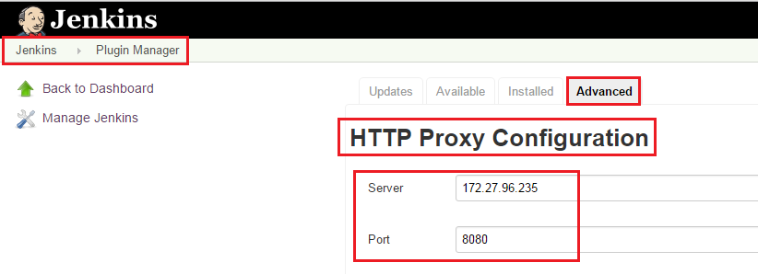

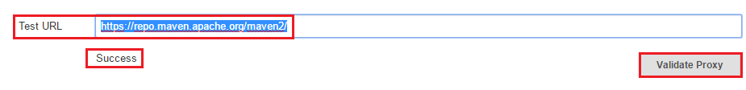

We can able to check Test URL in Jenkins Admin Console Proxy Configuration Page.

Test URL : <https://repo.maven.apache.org/maven2/>

Then Client the **Validate Proxy** Button. If the result shows Success then Jenkins Server able to connect Maven URL.

# Configure SSH-KEYGEN in Jenkins Server for without asking password login into remote machine.

### Step 1: Create public and private keys using ssh-key-gen on WUWVC2ASJEN01

[webadm@WUWVC2ASJEN01 ~]$ **ssh-keygen**

Generating public/private rsa key pair.

Enter file in which to save the key /home/webadm/.ssh/id_rsa):[Enter key]

Enter passphrase (empty for no passphrase): [Press enter key]

Enter same passphrase again: [Press enter key]

Your identification has been saved in /home/webadm/.ssh/id_rsa.

Your public key has been saved in /home/webadm/.ssh/id_rsa.pub.

The key fingerprint is:

33:b3:fe:af:95:95:18:11:31:d5:de:96:2f:f2:35:f9 webadm@WUWVC2ASJEN01

### Step 2: Copy the public key to remote-host using ssh-copy-id

[webadm@WUWVC2ASJEN01 ~]$ **ssh-copy-id -i ~/.ssh/id_rsa.pub remote-host**

webadm@remote-host's password:

Now try logging into the machine, with "ssh 'remote-host'", and check in:

.ssh/authorized_keys

to make sure we haven't added extra keys that you weren't expecting.

**Note:** ssh-copy-id **appends** the keys to the remote-host’s .ssh/authorized_key.

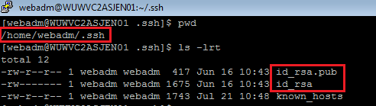

id_rsa 🡪RSA Private Key

id_rsa.pub 🡪 RSA Public Key

Copy the **id_rsa** private key in Jenkins Admin Console

Jenkins 🡪 Manage Jenkins 🡪 Configure Sytems 🡪 **Publish over SSH**

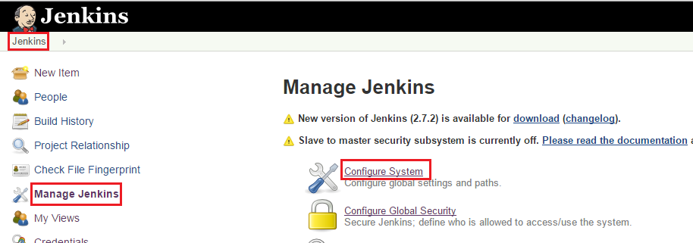

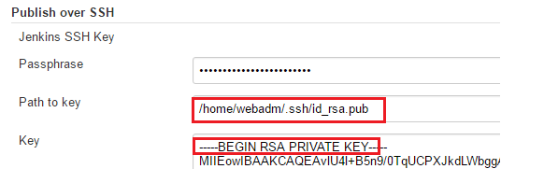

Configure **DEV Jboss Server for SSH Server** Configuration

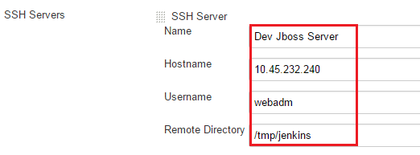

# Configure SVN URL in Jenkins Admin Console.

We have to raise firewall request to Network Team for SVN Source URL “[https://cvs1.wuintranet.net](https://cvs1.wuintranet.net/)” from Jenkins Server.

<https://cvs1.wuintranet.net/repos/GCTMS/trunk>

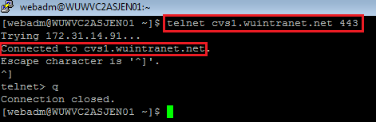

Jenkins 🡪 [GCTMS-CSCApp-Jars-Build](https://carejenkins.westernunion.net/job/GCTMS-CSCApp-Jars-Build/) 🡪 Configure 🡪 Source Code Management

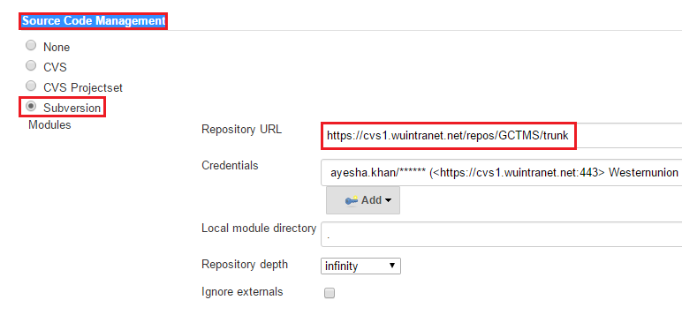

We have to raise firewall request to Network Team for SVN Source URL

“http:// git.wuintranet.net” from Jenkins Server.

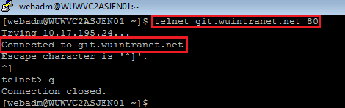

# Granting access

To grant access for a particular user, on the left side of the screen click Manage Jenkins 🡪 Configure Global Security. Under the Matrix-based security in Authorization, there is a field for “User/group to add”. Enter the name of the user you wish to authorize, and click Add. Then check the flags in the matrix that the user will need access to, e.g. “Administer”.

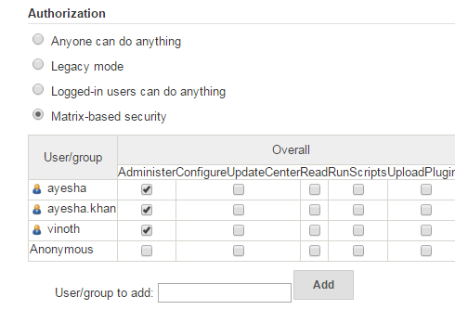

# Outbound Connectivity Requirements

Jenkins will require access to the following URLs:

1. SVN Repository - <https://cvs1.wuintranet.net/repos/GCTMS>
2. Maven Central Repository - <https://repo.maven.apache.org/maven2/>

# LDAP integration:

