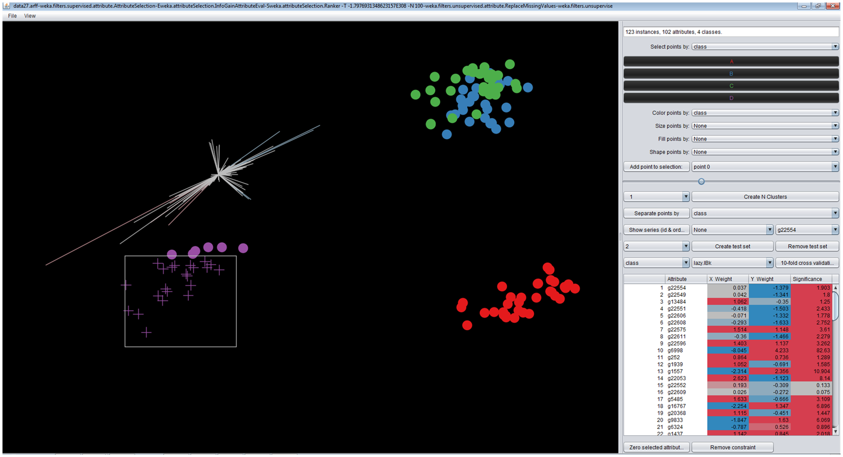

**The axes – one for each attribute. The length indicates the importance of the axis in separating the classes. The colour indicates the relative value of that attribute for the selected points. (Red indicates higher than mean; blue indicates lower than mean).**

**Points can be selected by area, then dragged to find a new view of the data**

**These classes of points could not be separated, indicating that there was little difference between them**

**Points can also be selected by class.**

**These controls allow you to change the attribute used to determine the colour, size, fill, and shape of each point. The slider changes the mean size.**

**The table shows the position and overall length of each attribute. The table can be ordered by any column (click on the heading)**