**Never Gonna Give U Up Documentation**

**Created by**

Tanakit Phentun 6330212121

**21102154 Programming Methodology**

**Semester 2 Year 2021**

**Chulalongkorn University**

**Car Racing**

**Introduction**

Car Racing is a game to play to relax, and you may have to concentrate when you are playing this game. To avoid a player's car crashing with others and collecting coins as much as possible.

**Rule**

Control white car by using 4 keys:W(forward) ,A(left) ,S (reverse) ,D(right)**.**Objective of this game is collecting coin as much as you can.

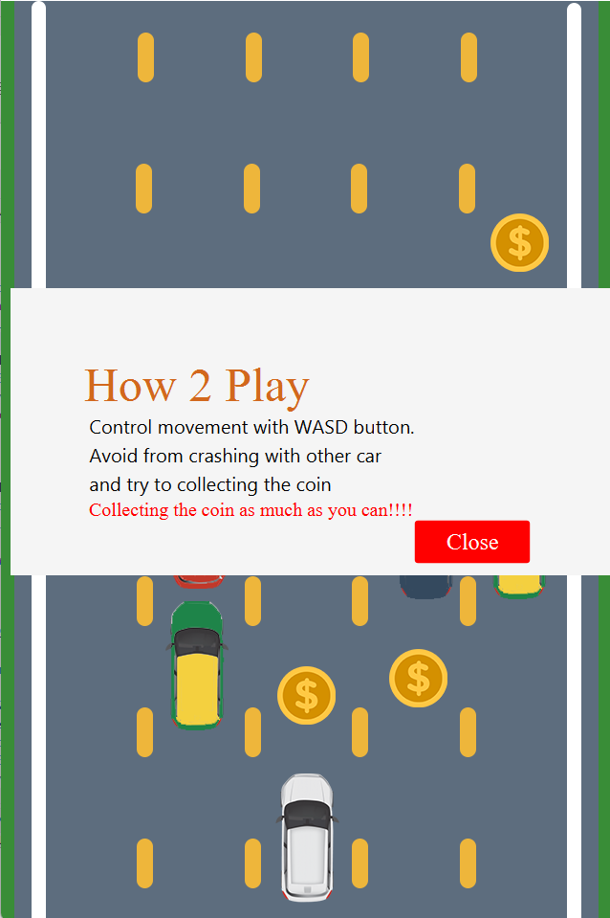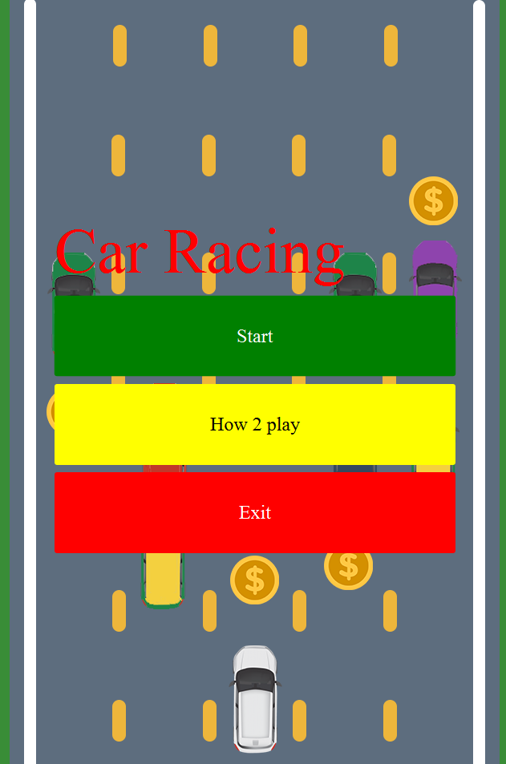 **Homepage How to play**

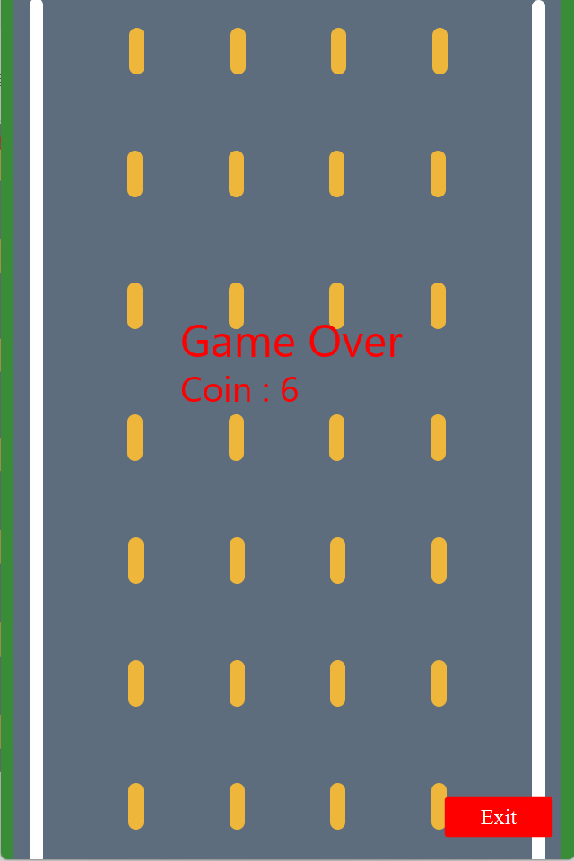รูปภาพประกอบด้วย ข้อความ

คำอธิบายที่สร้างโดยอัตโนมัติ **Gameplay GameOver**

**Class Diagram**

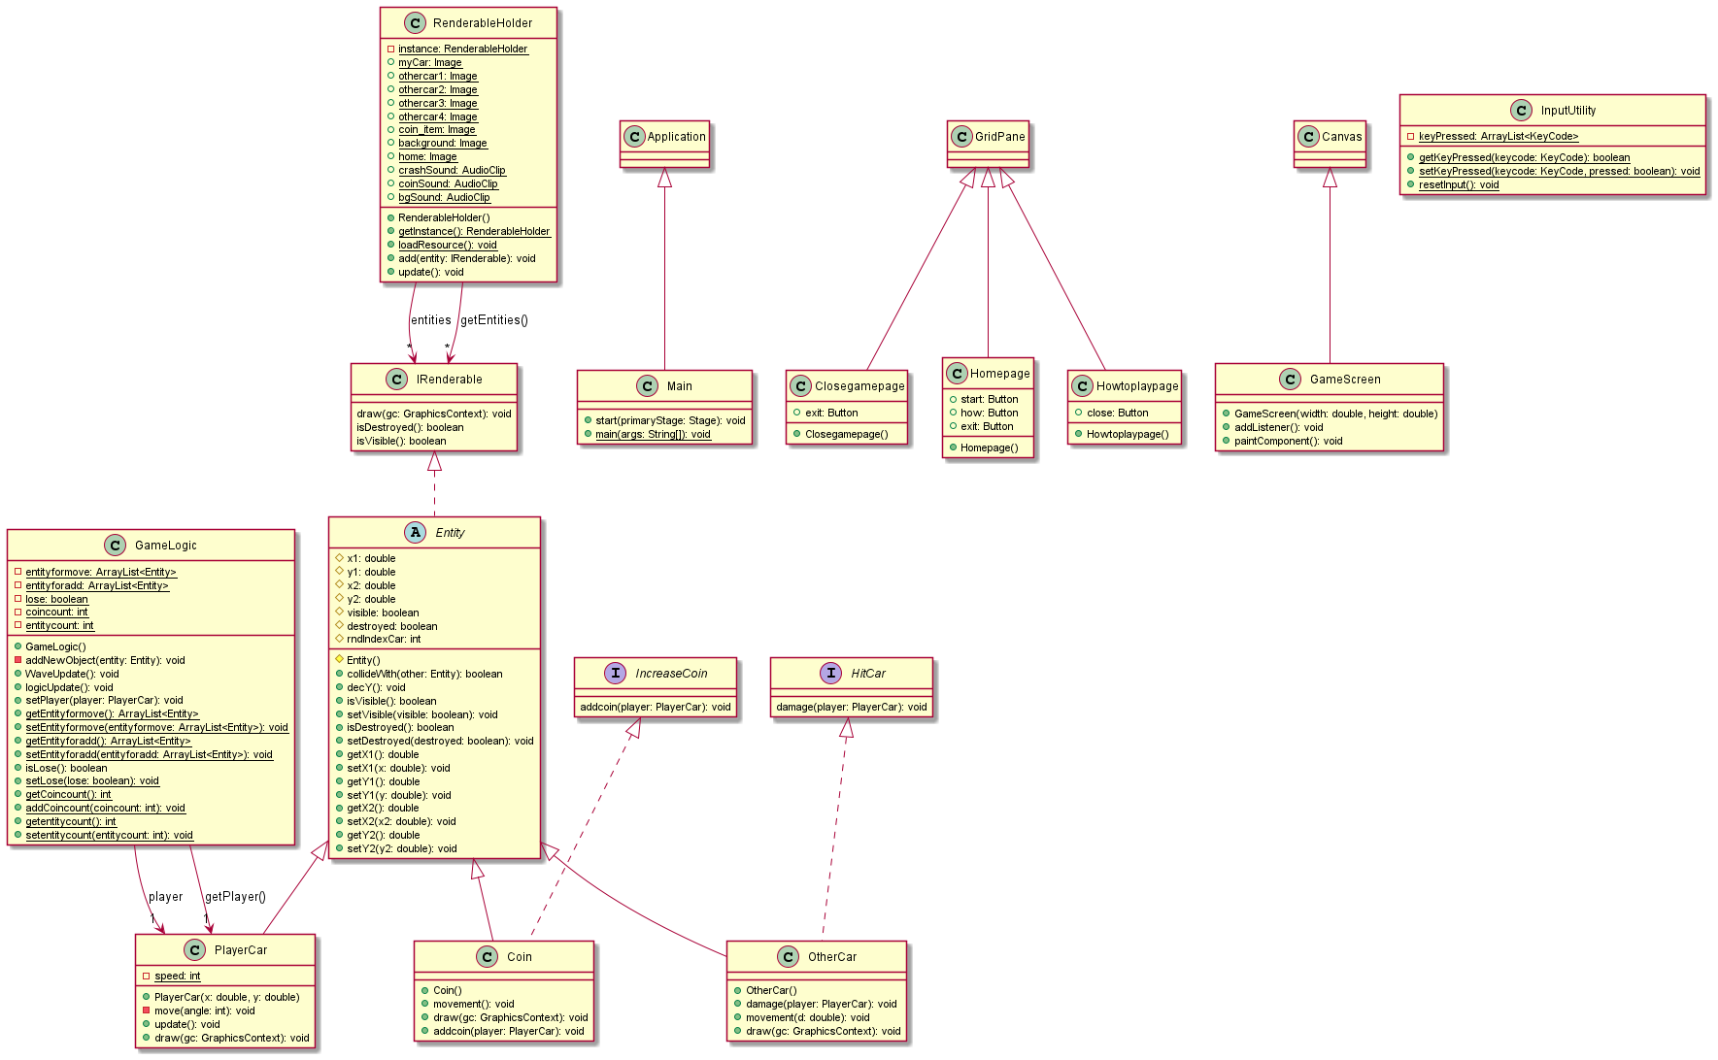

**1.Package shareObject**

1.1 interface IRenderable

1.1.1 Methods

|  |  |
| --- | --- |
| + void draw(GraphicsContext gc) | Draw each irenderable in canvas |
| + boolean isDestroyed() | Return destroyed |
| + boolean isVisible() | Return visible |

* 1. class RenderableHolder

1.2.1 Fields

|  |  |
| --- | --- |
| # RenderableHolder instance | Initialize new Renderableholder |
| # List<IRenderable> | Use to store all of entities for drawing |
| + Image myCar; | Image of Player’s car |
| + Image othercar1,othercar2,othercar3,othercar4; | Image of Other’s car. Have 4 variables for 4 difference cars. |
| + Image coin_item; | Image of Coin |
| + Image background; | Image of Background |
| + Image home; | Image of Homepage background. |
| + AudioClip crashSound; | Audio for Crashing sound |
| + AudioClip coinSound; | Audio for coin collecting |
| + AudioClip bgSound; | Audio for background sound |

1.2.2 Constructor

|  |  |
| --- | --- |
| + RenderableHolder() | Initialize entities |

1.2.3 Methods

|  |  |
| --- | --- |
| + static RenderableHolder getInstance() | Return instance |
| + static void loadResource() | Initialize all image and audio |
| + void add(IRenderable entity) | Add entity to entities |
| + void update() | Remove the destroyed entity from entities |
| + List getEntities() | Return entities |

**2.Package EntityBase**

2.1 interface HitCar

2.1.1 Fields

|  |  |
| --- | --- |
| +void damage(PlayerCar player); | Action when player’s car hit other’s car. |

2.2 interface IncreaseCoin

2.2.1 Fields

|  |  |
| --- | --- |
| +void addcoin(PlayerCar player); | Action when player’s car hit coin. |

2.3 abstract class Entity implements IRenderable

2.3.1 Fields

|  |  |
| --- | --- |
| # double x1,y1; | Coordinate position for top left of object |
| # double x2,y2; | Coordinate position for bottom right of object |
| # boolean visible; | Visibility of entity |
| # boolean destroyed; | State of entity |
| # int rndIndexCar; | Value of index of other’s car by random(Using by OtherCar class) |

2.3.2 Constructor

|  |  |
| --- | --- |
| # Entity() | initialize visible to true  initialize destroyed to false |

2.3.3 Methods

|  |  |
| --- | --- |
| + boolean collideWith(Entity other); | Return true if collide with other entity otherwise return false ( checking by intersection of two rectangle) |
| Getters and setter for all fields. |  |

**3.Package Entity**

3.1 class PlayerCar extends Entity

3.1.1 Fields

|  |  |
| --- | --- |
| - static int speed = 5; | Speed of Player’s Car. |

3.1.2 Constructor

|  |  |
| --- | --- |
| + PlayerCar(double x, double y) | Initialize position to(x1,y1) and (x2,y2) by Size of PlayerCar’s Image. |

3.1.3 Methods

|  |  |
| --- | --- |
| - void move(int angle) | Moving Car by angle  By equation  Math.cos(Math.toRadians(angle)) * speed |
| + void update() | Get Key Press then move player’s car position.  press W: forward  press A: move left  press S: reverse  press D: move right |
| + void draw(GraphicsContext gc) | Draw PlayerCar from RendableHolder |

3.2 class OtherCar extends Entity

3.2.1 Constructor

|  |  |
| --- | --- |
| + OtherCar() | Initialize position to  (x1:Random position in array items,  y1: 0)  and (x2,y2) by Size of OtherCar’s Image.  rndIndexCar is Index in array items ,selected by random. |

3.2.2 Methods

|  |  |
| --- | --- |
| - void damage(PlayerCar player) | Play crashing sound , set destroy to true |
| - void movement(double d) | OtherCar move down by d |
| + void draw(GraphicsContext gc) | Draw OtherCar from RendableHolder |

3.3 class Coin extends Entity implements IncreaseCoin

3.3.1 Constructor

|  |  |
| --- | --- |
| + Coin() | Initialize position to  (x1:Random position in array items,  y1: 0)  and (x2,y2) by Size of OtherCar’s Image. |

3.3.2 Methods

|  |  |
| --- | --- |
| - void addCoin(PlayerCar player) | Increament coin ,Play coin sound ,set destroy to true |
| - void movement() | Coin move down by 1.5 |
| + void draw(GraphicsContext gc) | Draw Coin from RendableHolder |

**4.Package logic**

4.1 class GameLogic

4.1.1 Fields

|  |  |
| --- | --- |
| - PlayerCar player; |  |
| - static ArrayList<Entity> entityformove; | Store entities that will call move |
| - static ArrayList<Entity> entityforadd; | Store entities and update their status except PlayerCar. |
| - static boolean lose; | the game status |
| - static int coincount; | Count collected coin. |
| - static int entitycount; | Count Other’s entity in game |

4.1.2 Constructor

|  |  |
| --- | --- |
| + GameLogic() | Initialize all field (set entitycount,coincount to 0 set lose to false) add player by method addNewObject |

4.1.3 Methods

|  |  |
| --- | --- |
| - addNewObject(Entity entity) | Add entity to RendeableHolde and entityforadd |
| + void WaveUpdate() | While game is not over  spawn OtherCar and Coin by  addNewObject by thread  (each entity has different spawn rate by)  Every entity in entityformove  Can be changing it’s speed  by method movement in thread  depend on count value |
| + void logicUpdate() | Update game logic by  -remove OtherCar and Coin which not existed in gamescreen.  -If player hit car->Gameover  -If player hit coin->increase coin |
| Getters and setter for all fields. |  |

5.Package input

5.1 class InputUtillity

5.1.1 Fields

|  |  |
| --- | --- |
| + static ArrayList keyPressed | Store the Pressed key. |

5.1.2 Methods

|  |  |
| --- | --- |
| + static boolean getKeyPressed(KeyCode keycode) | Return true if In keypressed contain keycode, otherwise return false |
| + static void setKeyPressed(KeyCode keycode, boolean pressed) | If pressed is true and keyPressed is not contain same keycode add keycode  OtherWise : remove keycode  and print keyPressed |
| + static void resetInput() | clear keyPressed |

6.Package drawing

6.1 class GameScreen extends Canvas

6.1.1 Constructor

|  |  |
| --- | --- |
| + GameScreen(double width, double height) | Initialize super constructor then call addListener(); |

6.1.2 Methods

|  |  |
| --- | --- |
| + void addListener() | setOnKeyPressed is InputUtility.setKeyPressed(event.ge tCode, true); setOnKeyReleased is InputUtility.setKeyPressed(event.ge tCode, false); |
| + void paintComponent() | Paint Player’s Coin,  Draw all entity from entities in RenderableHolder, if entity is visible and isn’t destroyed |

7.Package Application

7.1 class Homepage extends GridPane

7.1.1 Fields

|  |  |
| --- | --- |
| + Button start,how,exit | Button for startgame,go to how to play page,exit game respectively |

7.1.2 Constructor

|  |  |
| --- | --- |
| + Homepage() | Initialize super constructor.  Set game topic lable as “Car racing”  Initialize start button,how,exit  Add everything to GridPane. |

7.2 class Howtoplaypage extends GridPane

7.2.1 Fields

|  |  |
| --- | --- |
| + Button close | Return back to Homepage. |

7.2.2 Constructor

|  |  |
| --- | --- |
| + Howtoplaypage() | Initialize super constructor.  Set topic lable to “How 2 Play”  With description lable .  And initialize close button  Add everything to HBox. |

7.3 class Closegamepage extends GridPane

7.3.1 Fields

|  |  |
| --- | --- |
| + Button exit | To exit game. |

7.3.2 Constructor

|  |  |
| --- | --- |
| + Closegamepage() | Initialize super constructor  Initialize exit button.  Add everything to GridPane. |

7.4 class Main extends Application

7.4.1 Methods

|  |  |
| --- | --- |
| + void start(Stage primaryStage) | Set scene with stackpane size 640*960  Start with Homepage by use canvas to draw image home(as background) .  Add firstpage(Class Homepage) ,htoplay (Class Howtoplaypage),closepage (Class Closegamepage) , gameScreen (Class GameScreen) to root.   * Homepage  Click start button->Using AnimationTimer then Paint at gameScreen, Updatelogic If game is over. Indicating Coin and show “Game Over” Click exit button->exitgame Click how2play button->setFill rectangle with Whitesmoke,get children as htoplay and then If You click close button ,  Remove htoplay from root,Draw homescreen background and add firstpage to root   Using AnimationTimer for run a game  If game is over ,Indicate player’s coin and show text "Game Over",Stop playing music background.  Set title to “Car Racing”,set Scene,show. |
| + static void main(String[] args) | Start main application. |