Commercial Kitchen / Food Lab Heat Removal Ventilation (FDS)

1. Problem Statement
Objective: To evaluate heat and contaminant removal effectiveness of a commercial kitchen hood system.

2. Geometry & Assumptions
• Multiple stoves as burners
• Hood exhaust and make-up air diffusers

3. Heat Source Definition
• Burner heat release defined at stove surfaces

4. Ventilation System
• Hood exhaust flow rate defined
• Make-up air supply modeled

5. Mesh Details
• Fine mesh near burners and hood

6. Quantitative Results Plots and Figures
Table 1: Temperature above burners (°C)
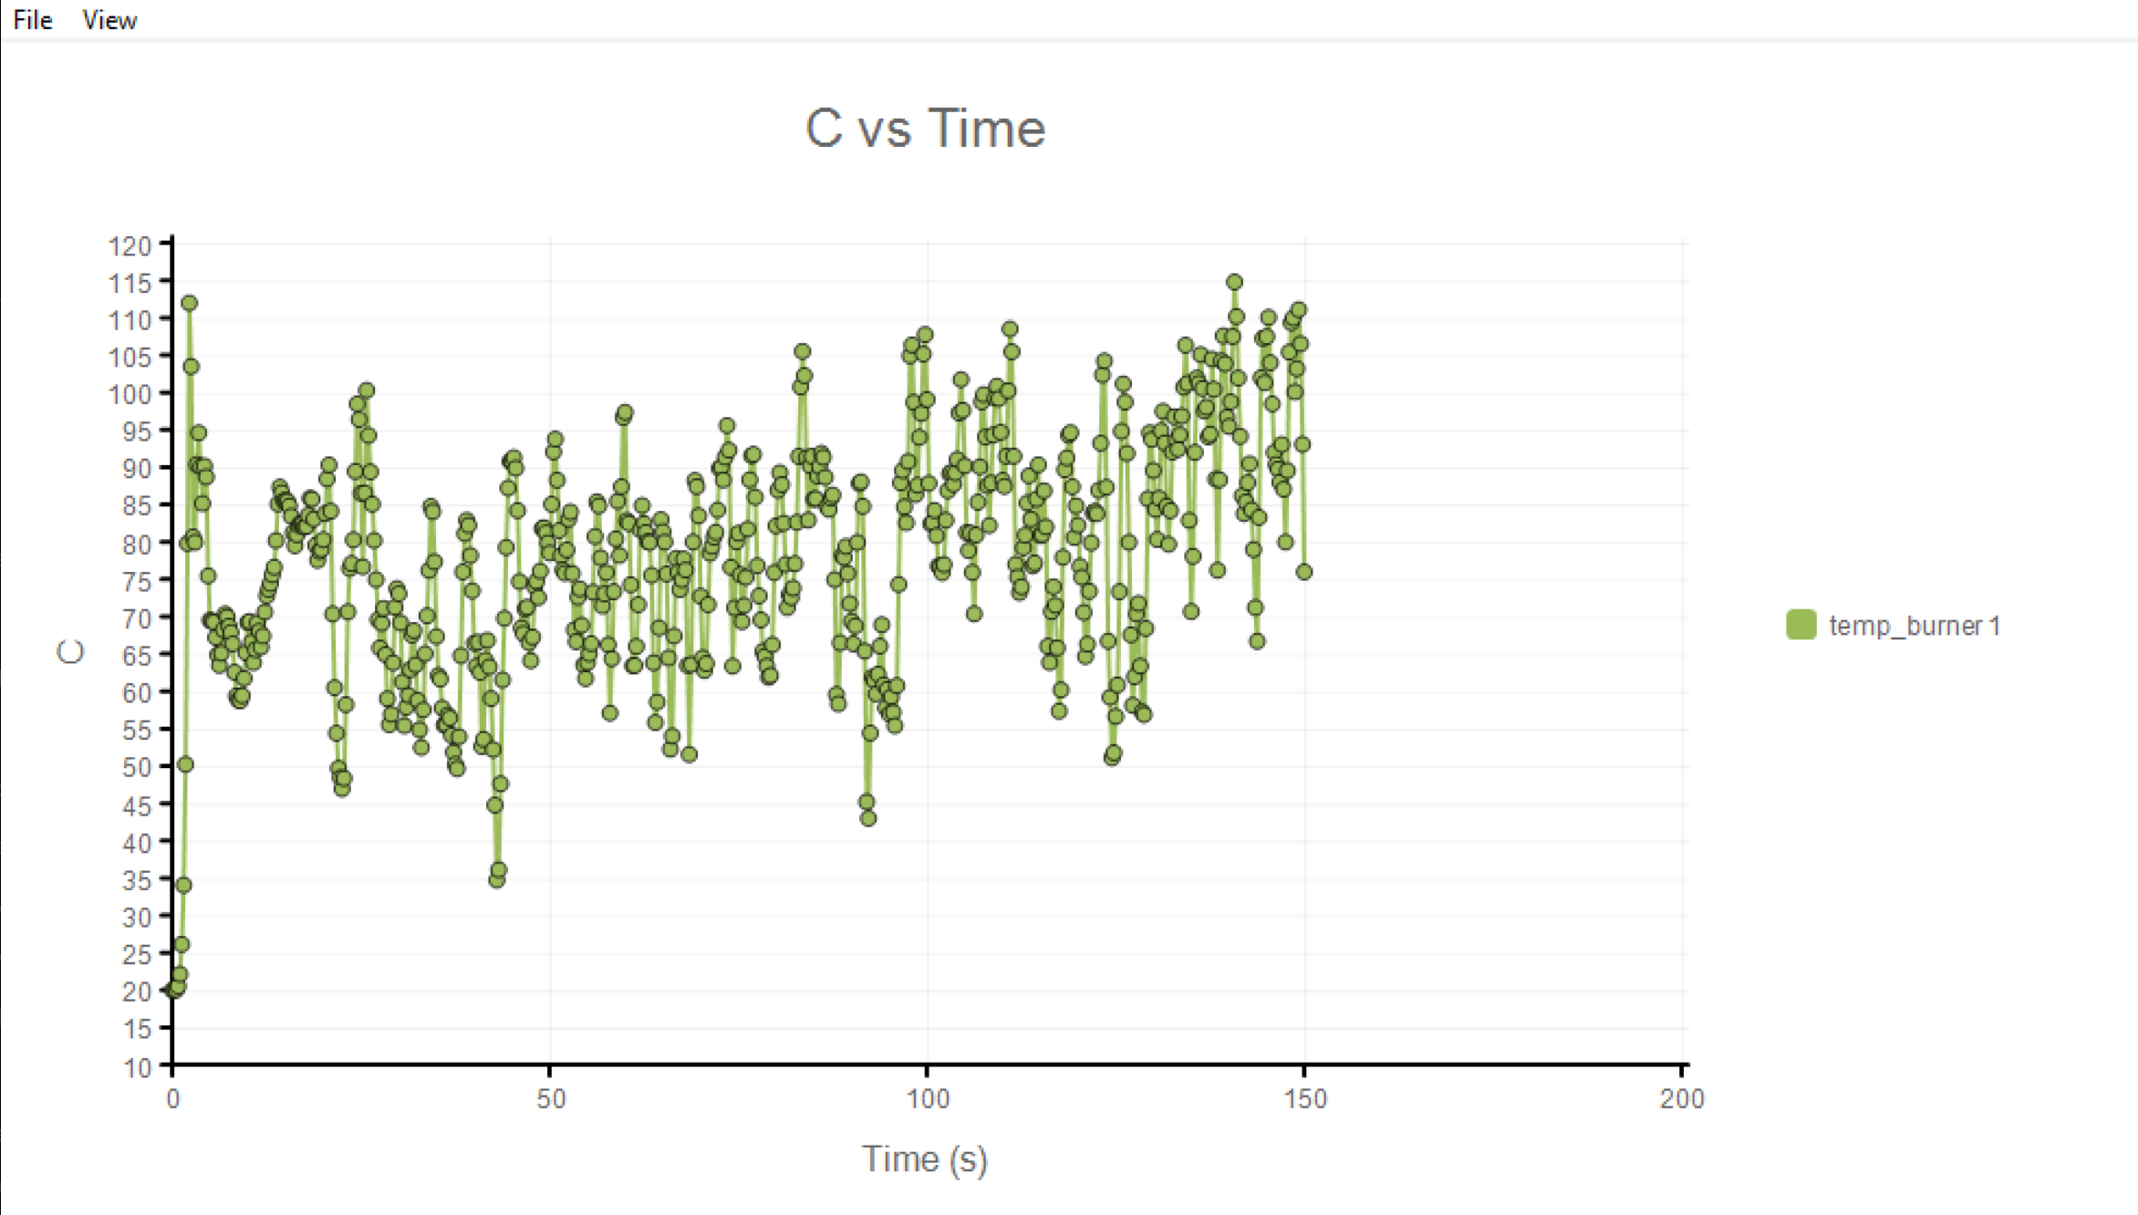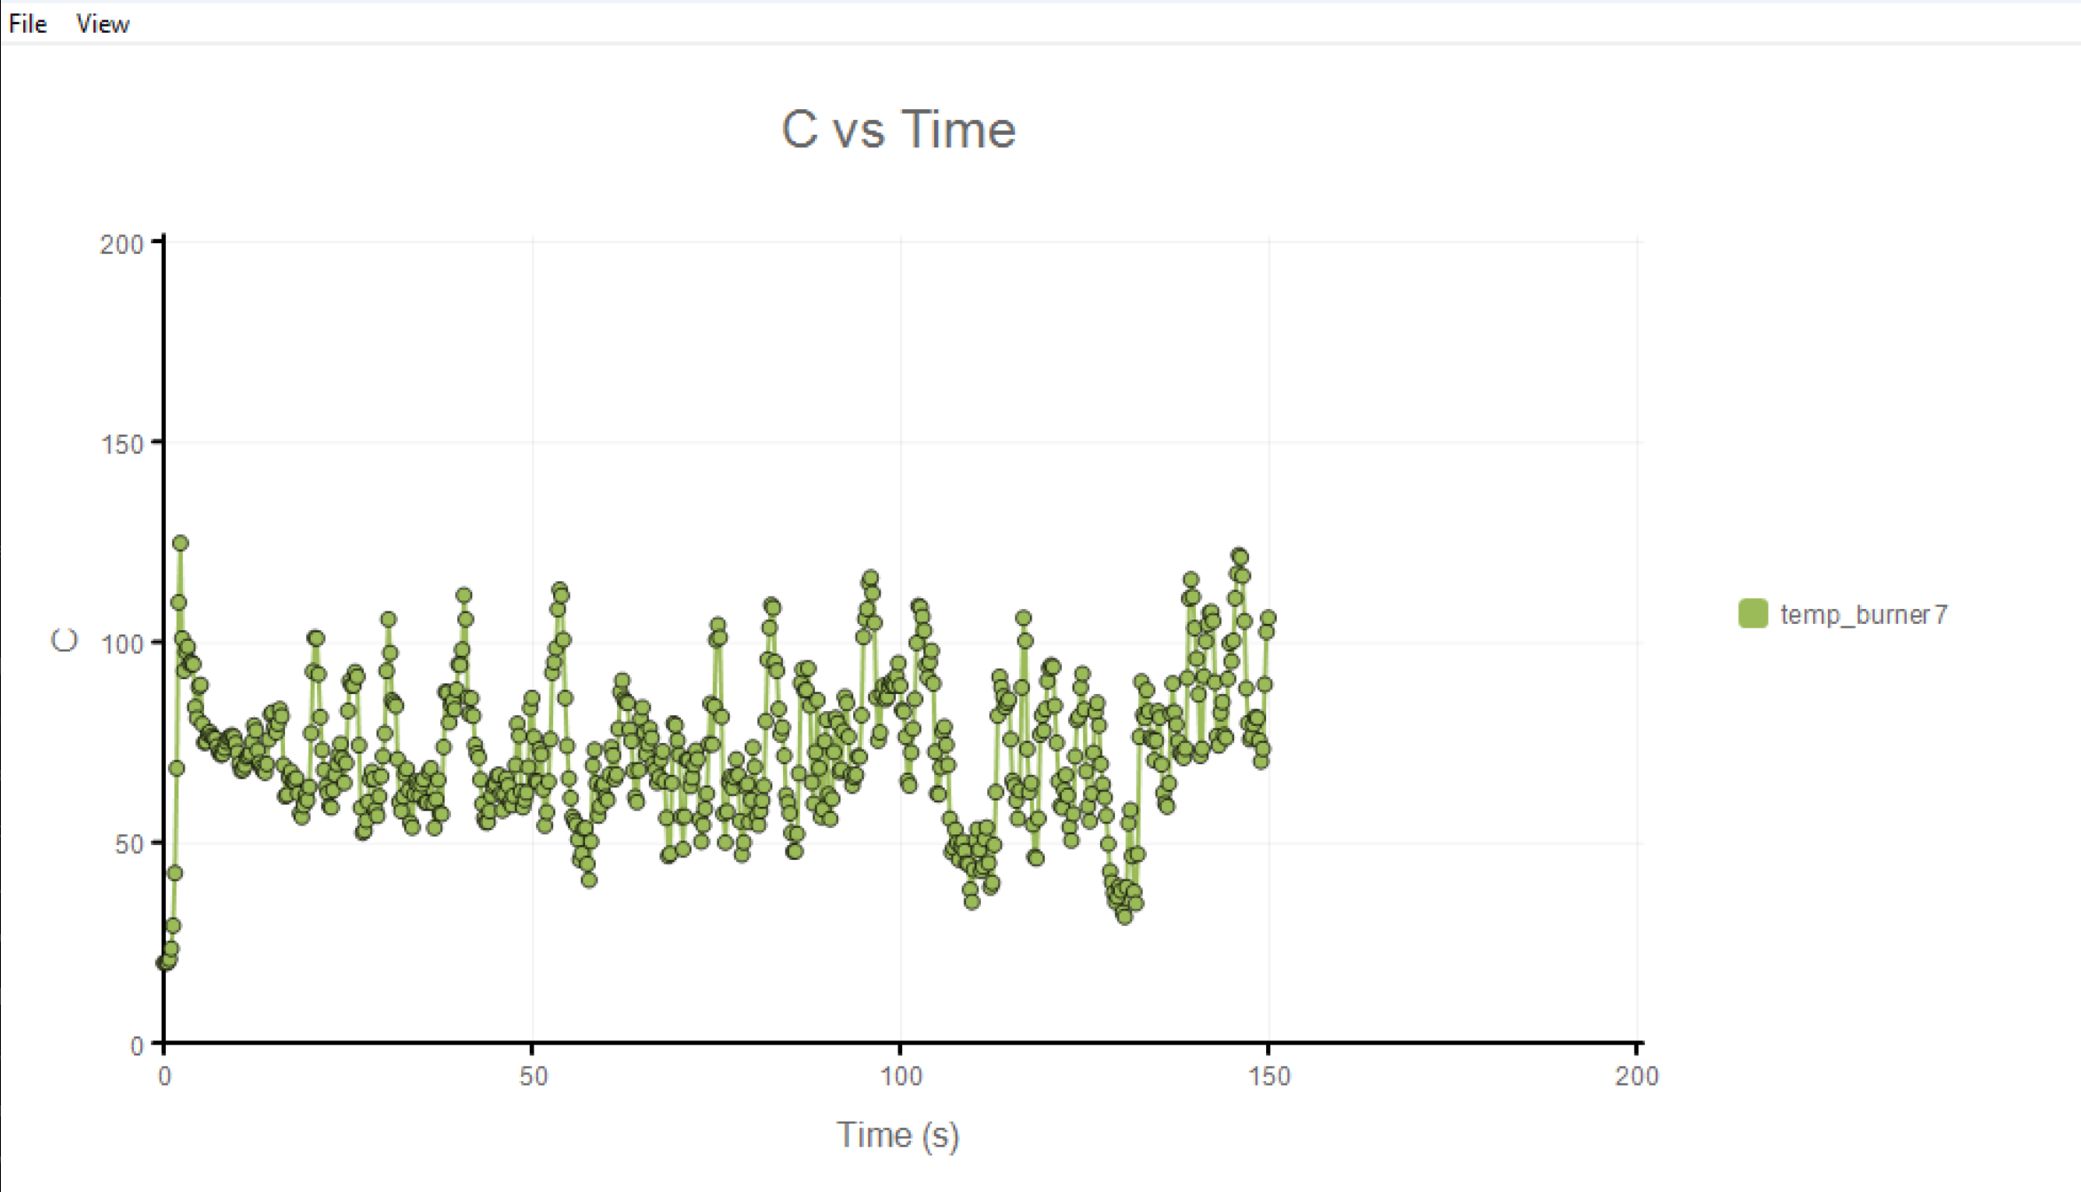
Table 2: Hood face velocity (m/s)
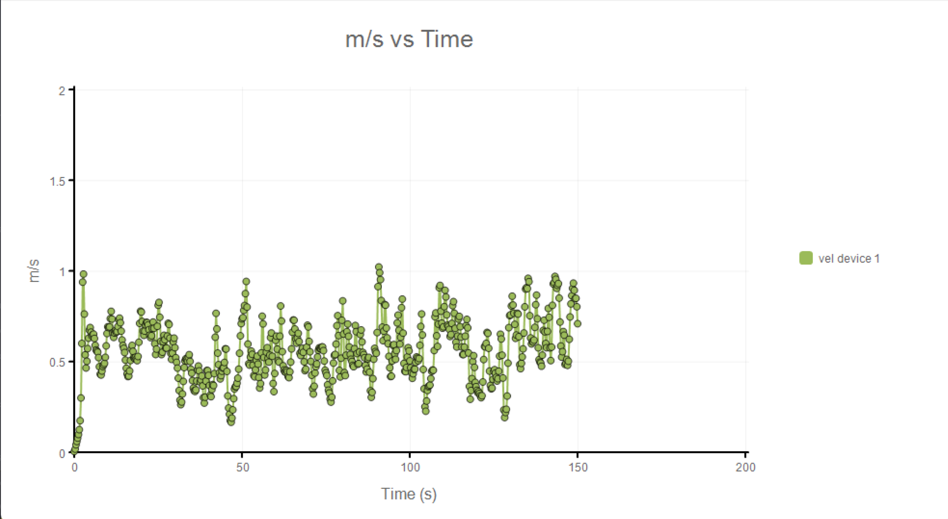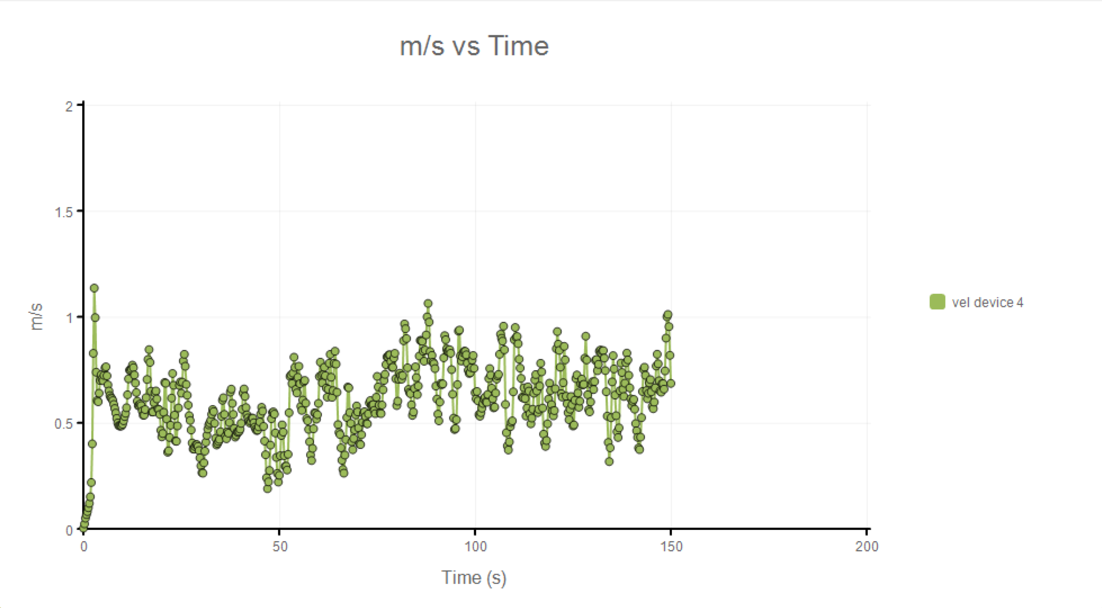
Table 3: Tracer / soot concentration
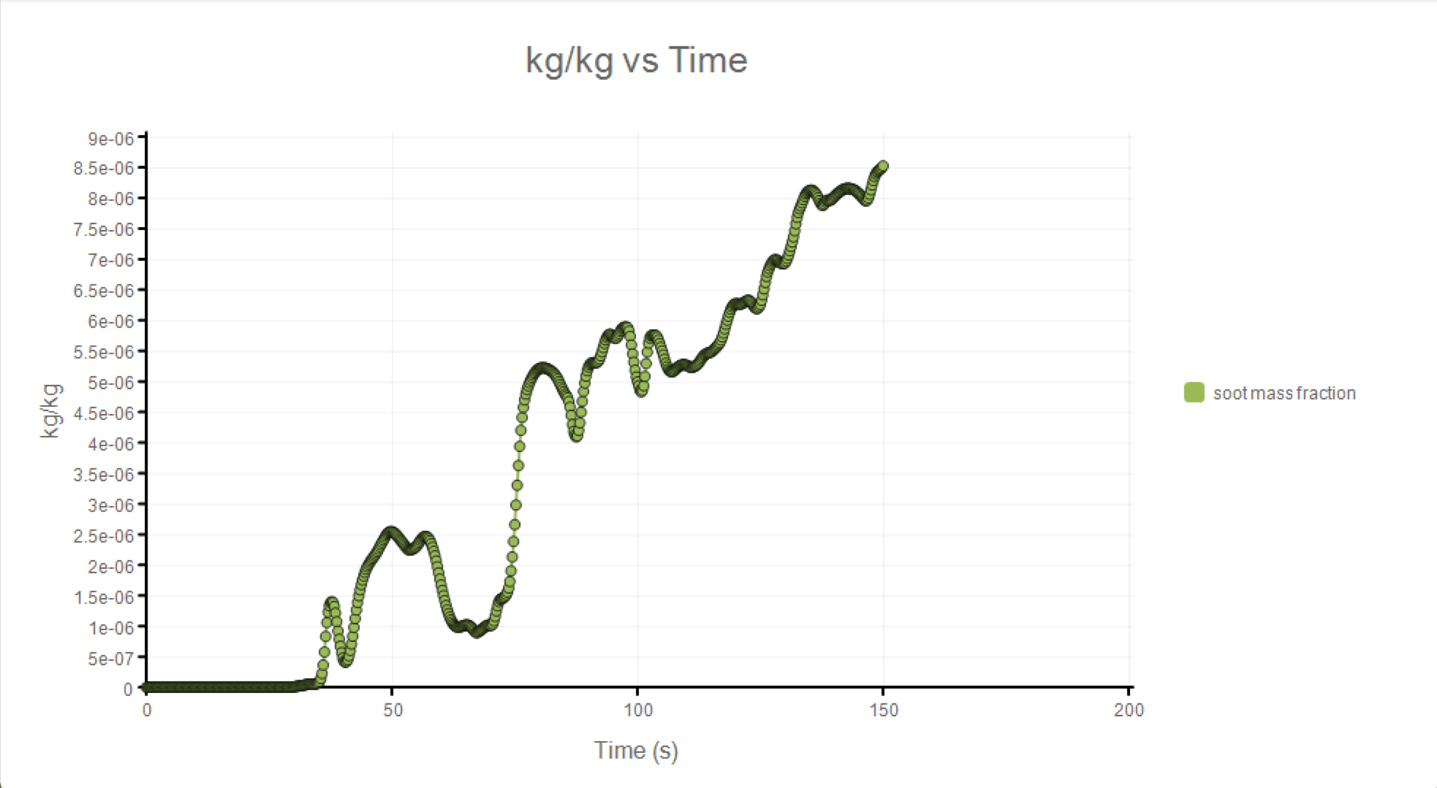

Figure 1: Temperature Field
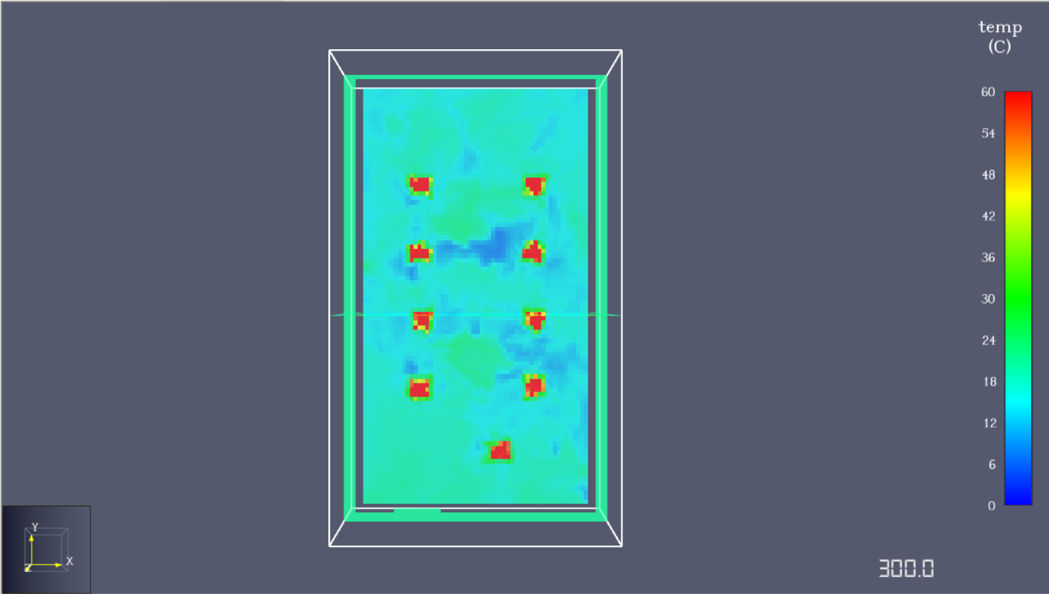
Figure 2: Velocity Vectors
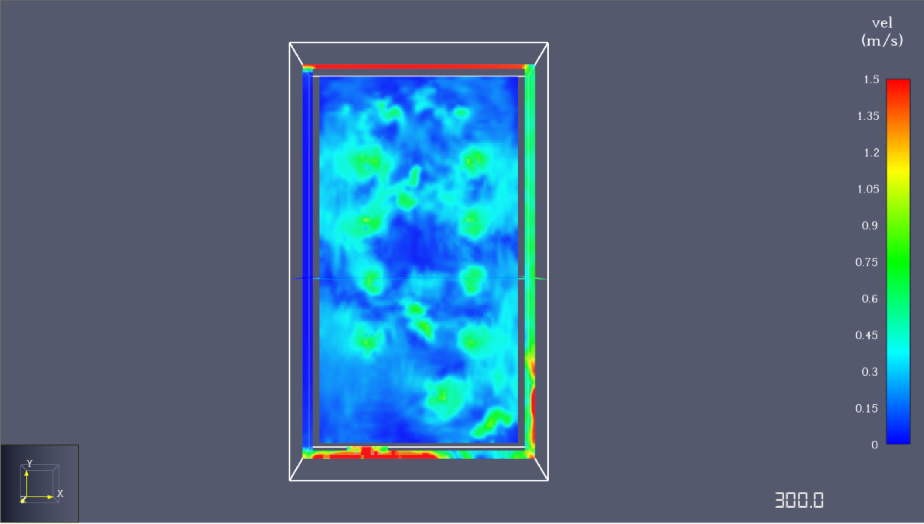

Figure 3: Tracer Distribution


7. Conclusions
The air temperature at the heater surface was evaluated using gas-phase temperature devices placed approximately 10 cm above the burner surfaces. The recorded temperature shows an initial transient followed by a quasi-steady behavior, with typical values ranging between 60–90 °C and short-duration peaks reaching approximately 110–120 °C due to turbulent plume fluctuations. This temperature range is consistent with buoyant thermal plumes generated by gas burners rather than solid surface temperatures. The adequacy of the exhaust airflow was assessed using velocity magnitude devices, 2D velocity slices, and particle tracking. The measured velocities near the hood and exhaust region generally lie between 0.4–1.0 m/s, which exceeds commonly recommended capture velocities for thermal plumes, indicating sufficient exhaust flow. Particle tracing from the heater surfaces further confirms the effectiveness of the hood, as the majority of emitted particles rise vertically and are entrained into the hood with no sustained lateral or downward spillage. Minor transient dispersion near the burners is observed due to turbulence but does not result in escape from the capture zone. Overall, the results indicate that the exhaust airflow is sufficient and that the hood dimensions and flow rate are appropriately sized to capture the thermal plume and heater-emitted particles under the simulated conditions.

