Title
ANSYS CFD Academic & Practice Simulations

Internal Flow Simulation – ANSYS Fluent

• Simulated incompressible internal flow in ducts/pipes
• Applied appropriate inlet velocity and outlet pressure boundary conditions
• Evaluated velocity profiles and pressure drop
• Used k–ε turbulence model
• Post-processed results using CFD-Post

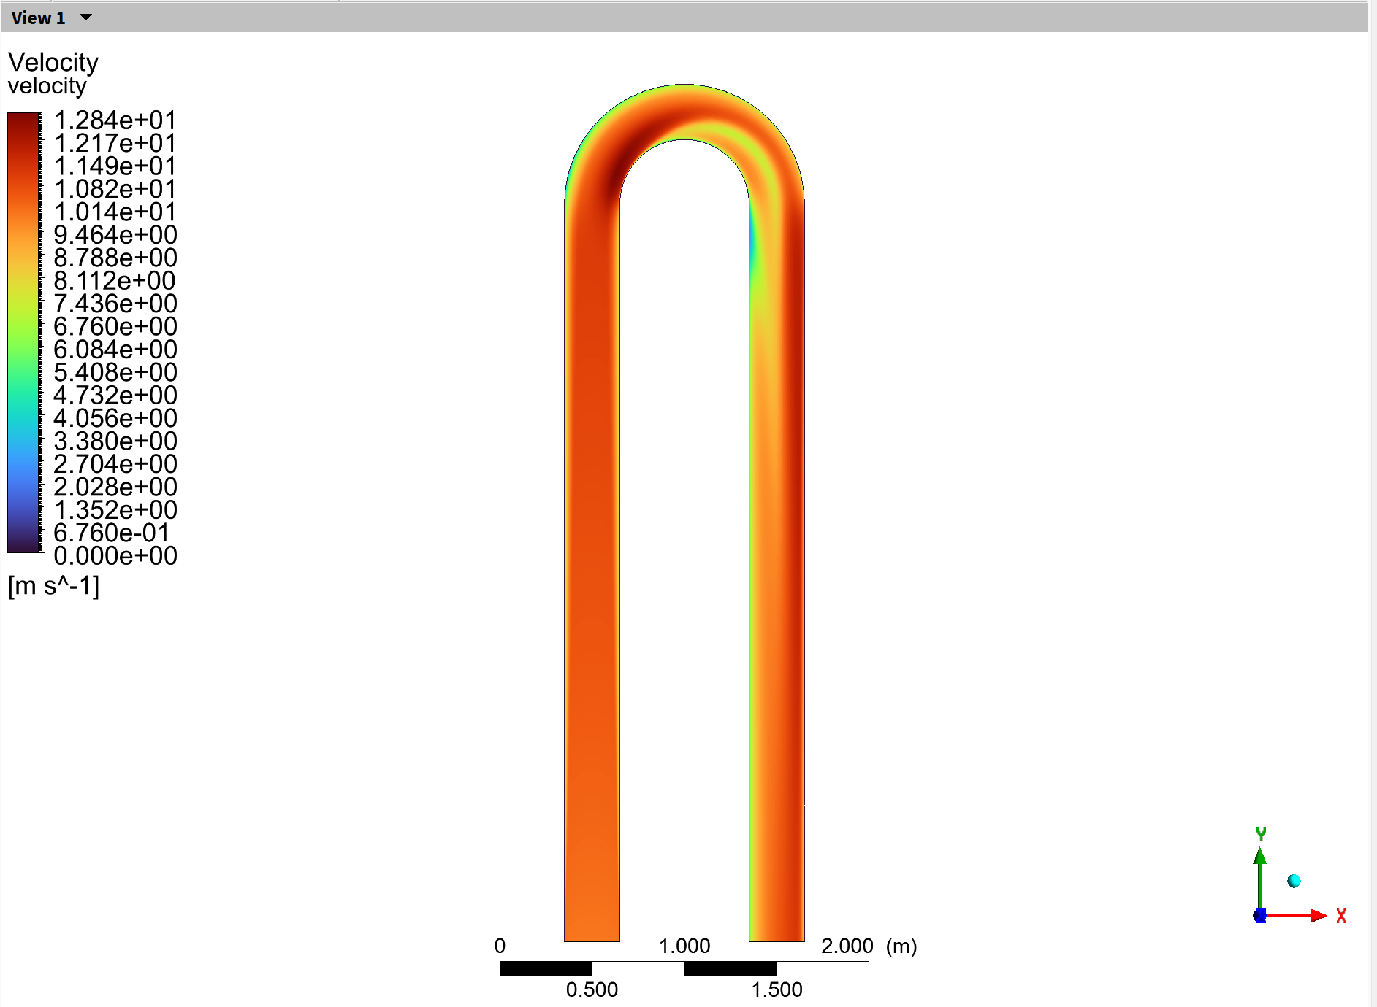
Figure 1: Velocity contour in a 3D pipe

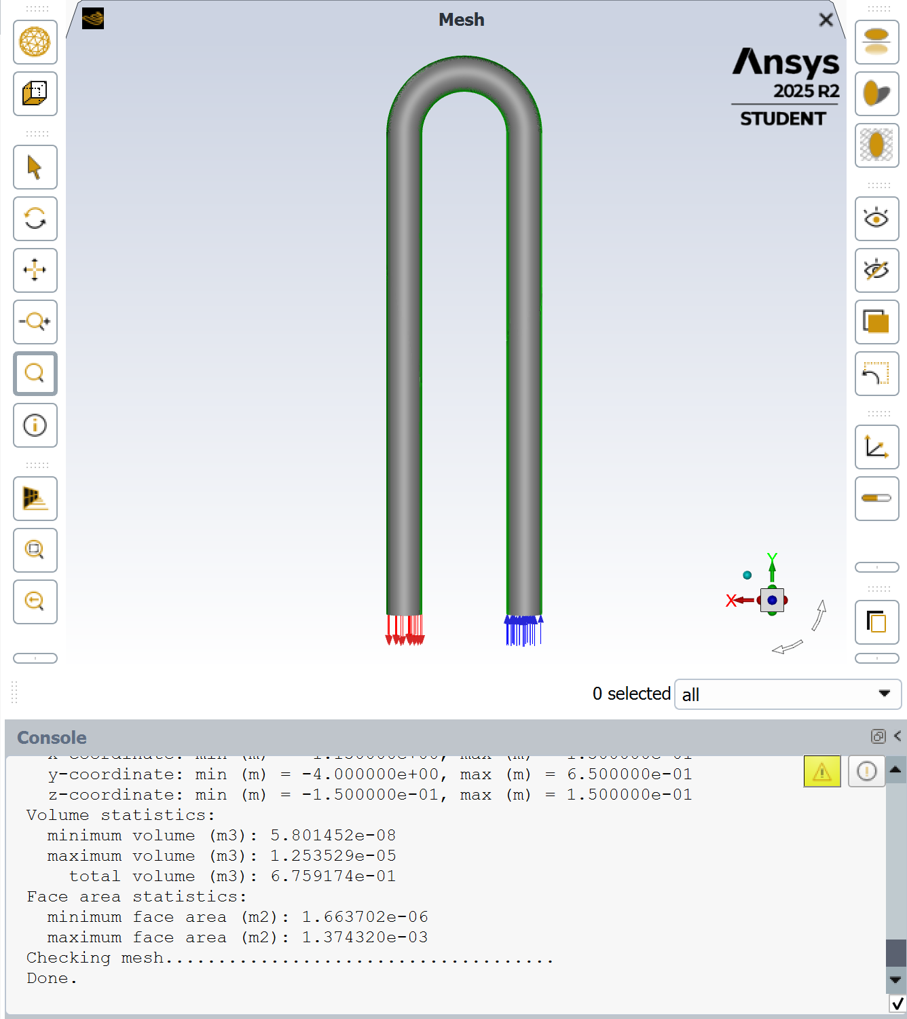
Figure 2: 3D pipe mesh

Heat Transfer Simulation – ANSYS Fluent

• Conductive and convective heat transfer analysis
• Steady-state thermal simulations
• Evaluated temperature distribution and heat flux
• Used second-order discretization schemes

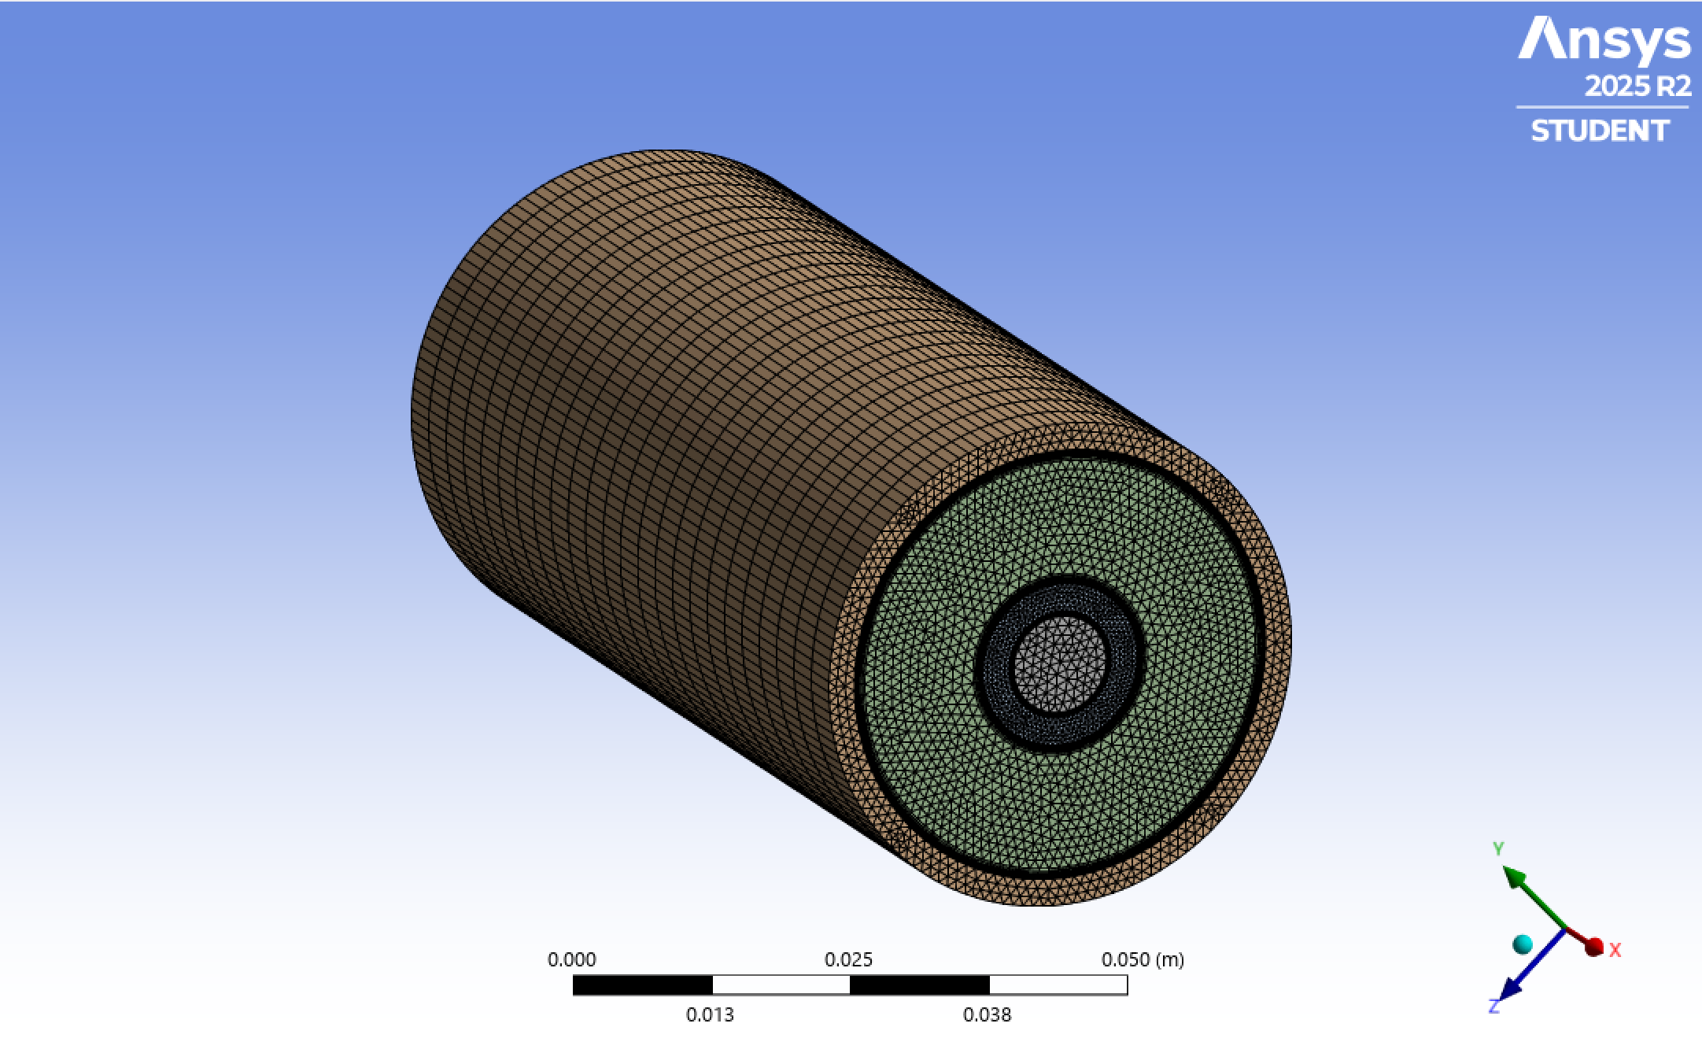
Figure 3: Mesh to study heat transfer flow in a pipe
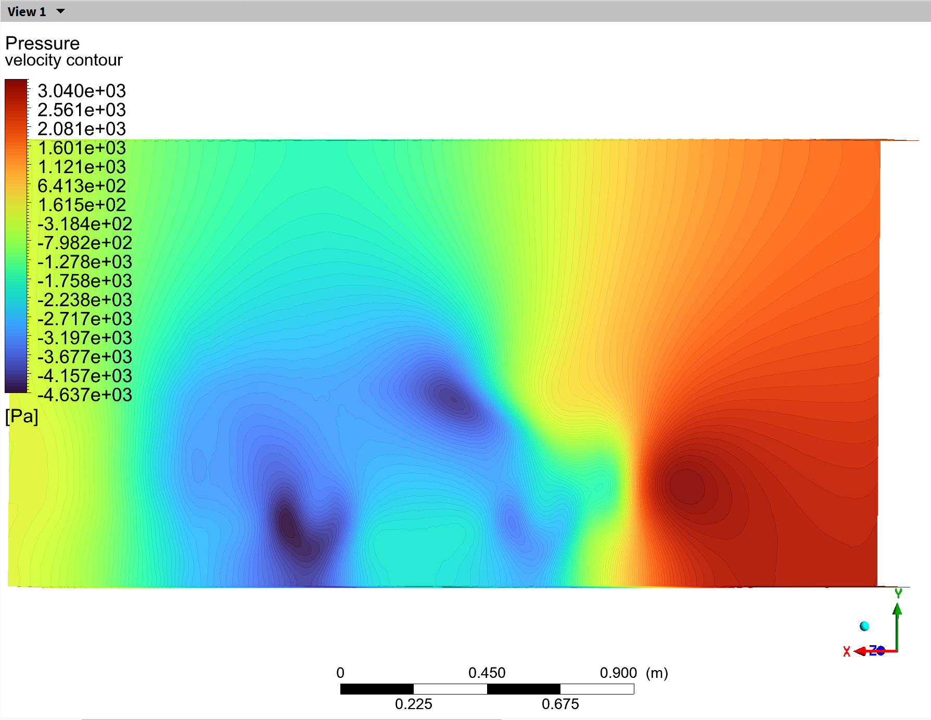
Figure 4: Pressure contour in a 3D car model

Combustion Fundamentals – ANSYS Fluent

• Introductory combustion modeling
• Species transport and reaction setup
• Temperature and species distribution analysis
• Focused on understanding combustion physics

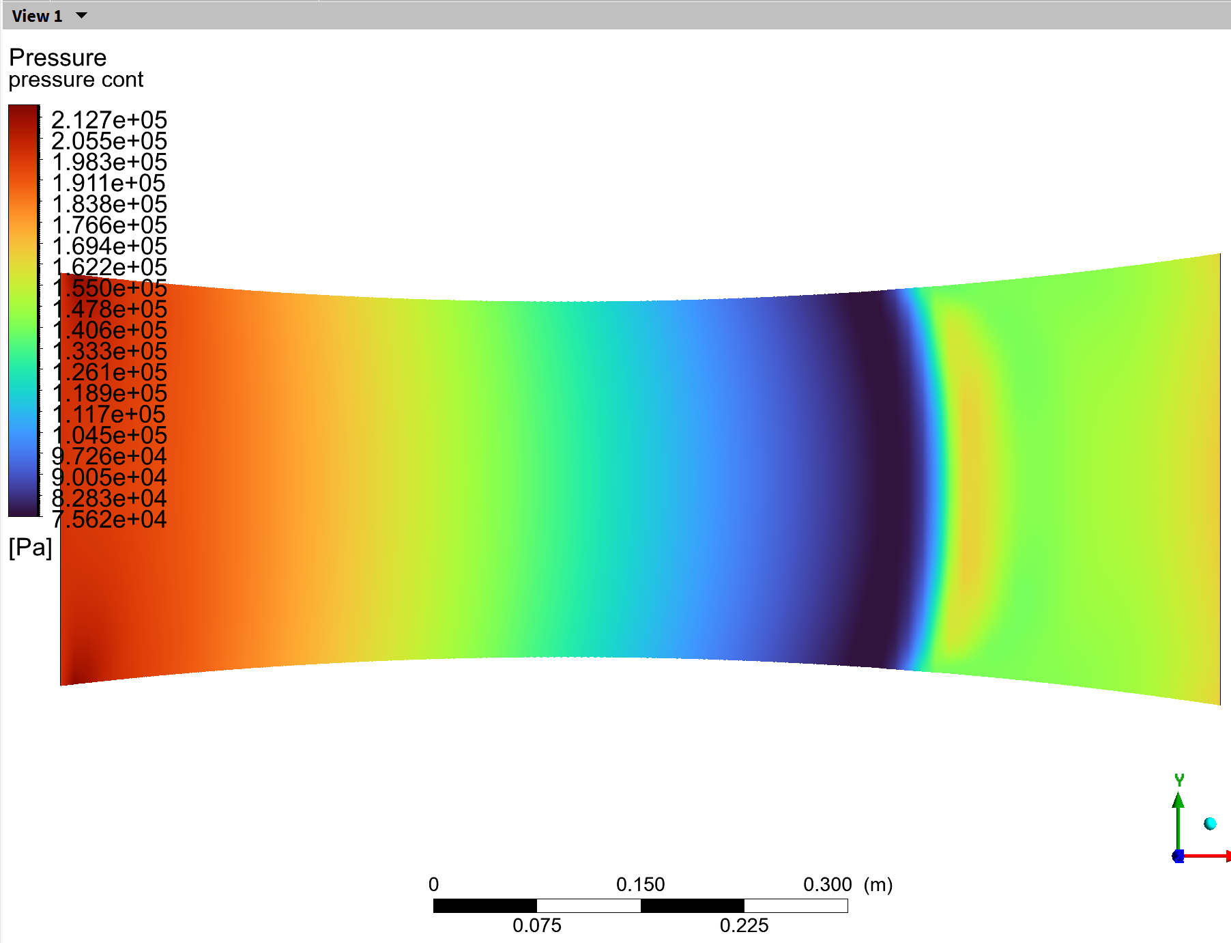
Figure 5: Pressure contour of a convergent-divergent nozzle

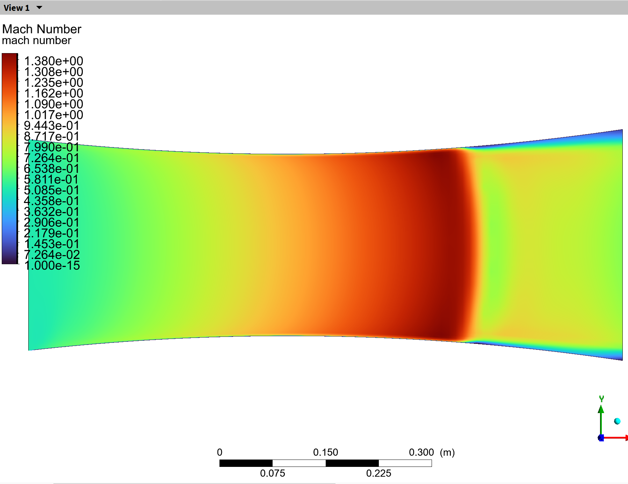
Figure 6: Mach number contour of a convergent-divergent nozzle

