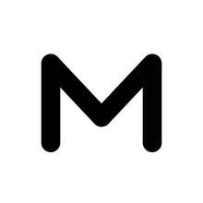
MUNE TOKENS
User Guide
Build a design system with Claude, review it, and bring it into Figma as real variables, styles and components.
Step by step, for first-time users · with a first-run test checklist
Version 1.0 · October 2026
Windows desktop app · local-first · Figma plugin included
Contents
1. What MUNE TOKENS does 3
The whole journey at a glance 3
2. Before you start 4
3. Install and open the app 5
3.1 First-time setup (once) 5
3.2 Opening the app 5
3.3 Closing the app 5
4. Check the AI connection 6
Defaults for new systems 6
5. Create your first design system 7
Other ways to start 7
6. Review and edit 8
6.1 Check contrast 8
6.2 Typography and motion 9
6.3 Brands (optional) 10
6.4 Let Claude improve one group 11
6.5 Save, history and undo 11
7. Build components (optional) 12
7.1 Plan the library 12
7.2 Review and finish each component 12
8. Export 14
8.1 Preview pages 14
8.2 Files 15
9. Bring it into Figma 16
9.1 Install the plugin (once) 16
9.2 Import a system 16
9.3 What you get in Figma 17
9.4 Updating Figma later 18
10. Bring Figma changes back 19
11. Keyboard shortcuts 20
12. Costs and Figma plans 21
13. First-run test checklist 22
14. Troubleshooting 24
Appendix: where things live 25
Sharing the app with someone 25

1. What MUNE TOKENS does
MUNE TOKENS is a desktop app for building a design system: the colours, type, spacing and other values (called tokens) that every screen of a product uses. You describe the product, Claude drafts the tokens, you review and adjust them, and the app hands everything to Figma and to developers in clean, named files.
Everything runs on your own computer. There is no account, no cloud database and no Figma AI involved.

The whole journey at a glance
- Describe the product in a short brief (and attach a logo or brand PDF if you have one).
- Generate the tokens with Claude, or start from a blank set.
- Review and edit: colours, contrast, type, spacing, motion and more. Nothing is saved until you click Save.
- Plan components (optional): Claude lists the components your product needs and writes a spec for each.
- Export: clean preview pages, a tokens file, CSS, Tailwind and a UI-CONFIG.md for AI coding tools.
- Import into Figma with the included plugin: variables with Light and Dark modes, text and shadow styles, components, and a showcase page.
Tip You can stop after any step. Many people only use steps 1–3 and 6.

2. Before you start
You need the following. Most people already have the first three.
What | Why | Where to get it
Windows 10 or 11 PC | The app is a Windows desktop app. | —
Google Chrome or Microsoft Edge | The app opens in its own browser window. | Usually installed already.
Node.js (LTS version) | Runs the app on your computer. | nodejs.org → Download → LTS. Install with the default options.
Claude access (one of these) | Claude writes the tokens and component specs. | Claude Code signed in to your Claude subscription (VS Code extension or CLI), or an Anthropic API key.
Figma desktop app | To run the MUNE Tokens Importer plugin. | figma.com/downloads. A Professional plan is recommended (see section 12).
The MUNE TOKENS app folder | The app itself. | From the owner: the GitHub repository or a zip of the folder.

Note AI is optional. Without Claude you can still start from a blank set or import an existing tokens file, edit everything by hand and export it.

3. Install and open the app

3.1 First-time setup (once)
- Put the app folder somewhere permanent, for example Desktop\Design System Generator\Design System generator app.
- Open the folder, right-click an empty space, choose Open in Terminal (or open PowerShell in that folder).
- Run: powershell -ExecutionPolicy Bypass -File .\create-shortcut.ps1
- A MUNE TOKENS shortcut with a black-and-white “M” icon appears on your desktop.

3.2 Opening the app
- Double-click MUNE TOKENS on the desktop.
- The first time, a console window appears while it installs and builds (one to two minutes). Later starts are quick and show no console.
- The app opens in its own window with the Dashboard.
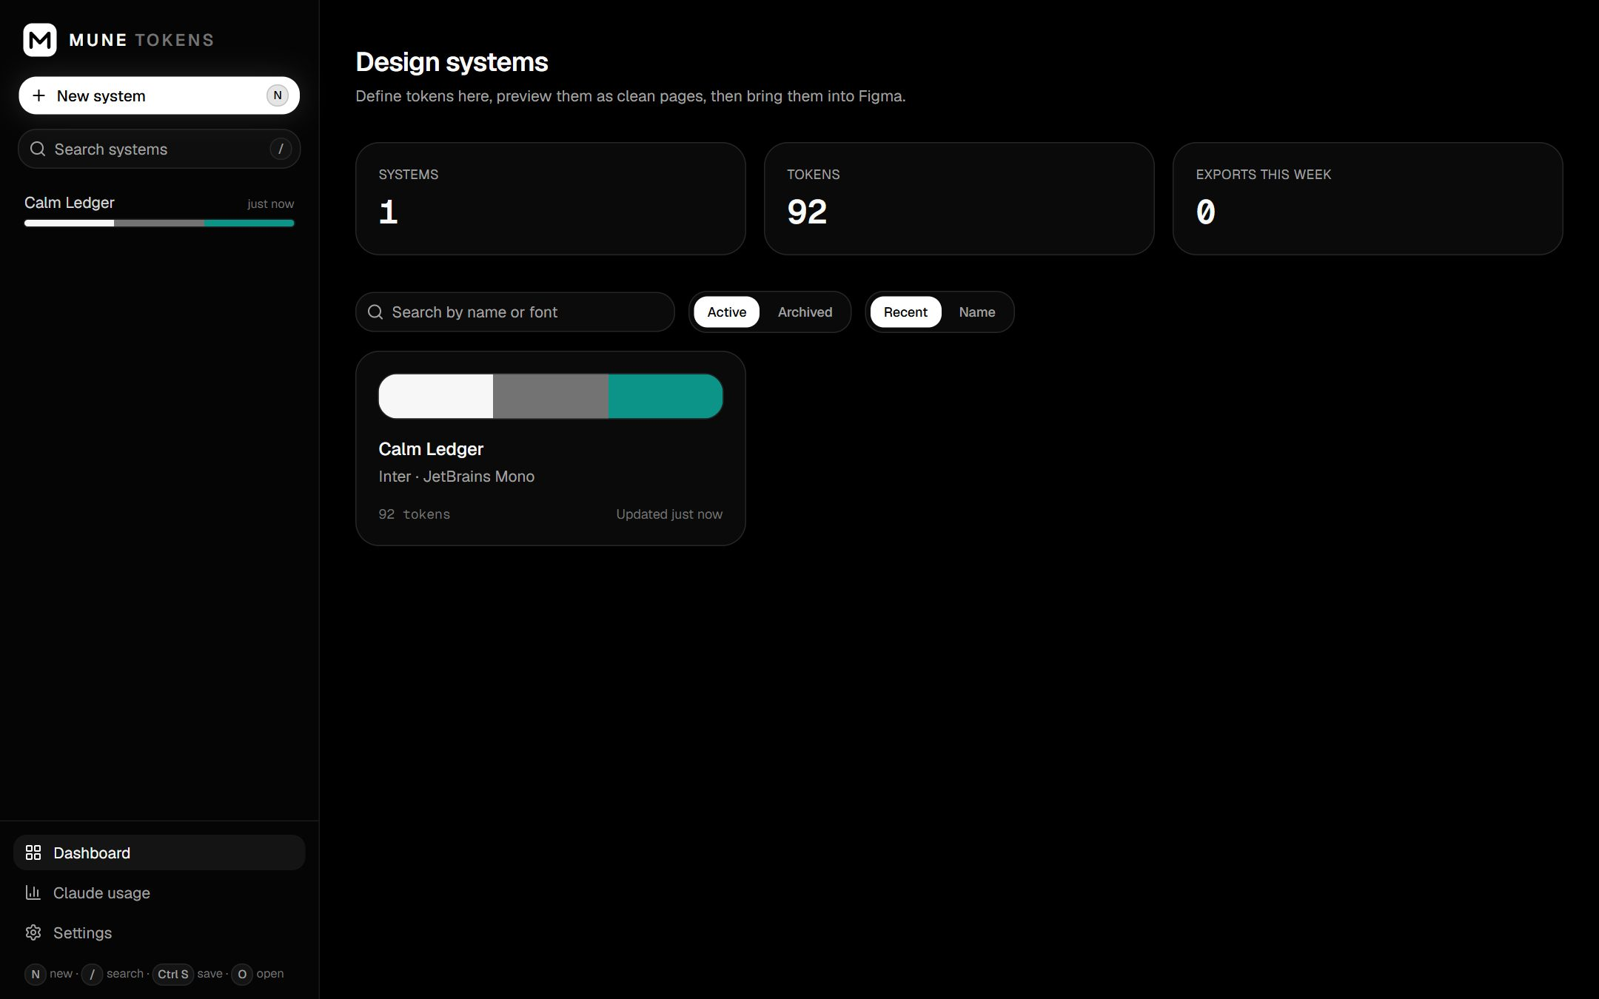
The Dashboard: your design systems, with a colour strip, fonts and token count for each.

3.3 Closing the app
Close the window. The app stops by itself when its last window closes. You can also use Quit MUNE TOKENS at the bottom of the sidebar. Your work is saved locally.

4. Check the AI connection
- Click Settings in the sidebar.
- Under AI provider, choose Auto (recommended) or Claude Code CLI.
- Check the status lines: Claude Code CLI should show a path with a tick. If you use an API key, ANTHROPIC_API_KEY should show a tick.
- Click Test connection. You should see a short reply such as “replied OK in 3.2s”.
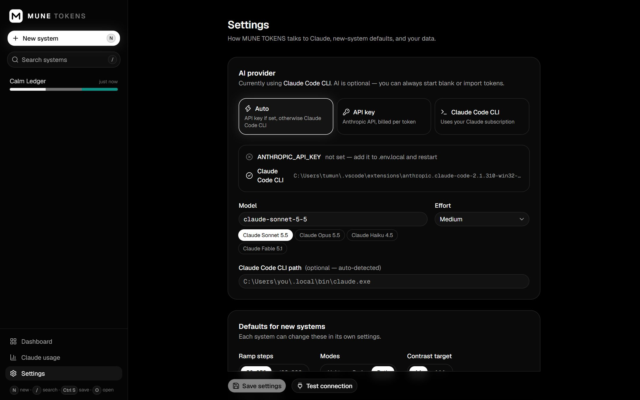
Settings: AI provider, model, and the status of the Claude Code CLI and API key.
Costs With Claude Code CLI (or Auto without an API key) every request runs on your Claude subscription: no per-request charge. The dollar amounts shown in the app are what the same request would cost at API prices, for comparison. If you add an API key, Auto switches to the API, which is billed per request; choose Claude Code CLI to rule that out.

Defaults for new systems
Further down Settings you can choose the default ramp steps (50–950 or 100–900), modes (Light, Dark or Both), the contrast target (AA or AAA) and where project folders are written. These are only defaults; each system can change them.

5. Create your first design system
- Click New system (or press N).
- Write a brief: the product, the audience, the mood, any brand colours and fonts, and your accessibility target. Two or three sentences are enough.
- Optional: click Add files to attach a logo, screenshots or a brand PDF (up to 6). Claude reads the brand colours and the type and mood from them. You can also attach existing CSS or notes.
- Under Generate, keep everything ticked, or untick groups you want to start from defaults.
- Choose Ramp steps, Modes (Both gives Light and Dark) and Contrast (AA is the usual target).
- Click Generate with Claude (or press Ctrl + Enter). Swatches and type samples appear on the right as Claude writes. It takes 20–40 seconds; press Esc to cancel.
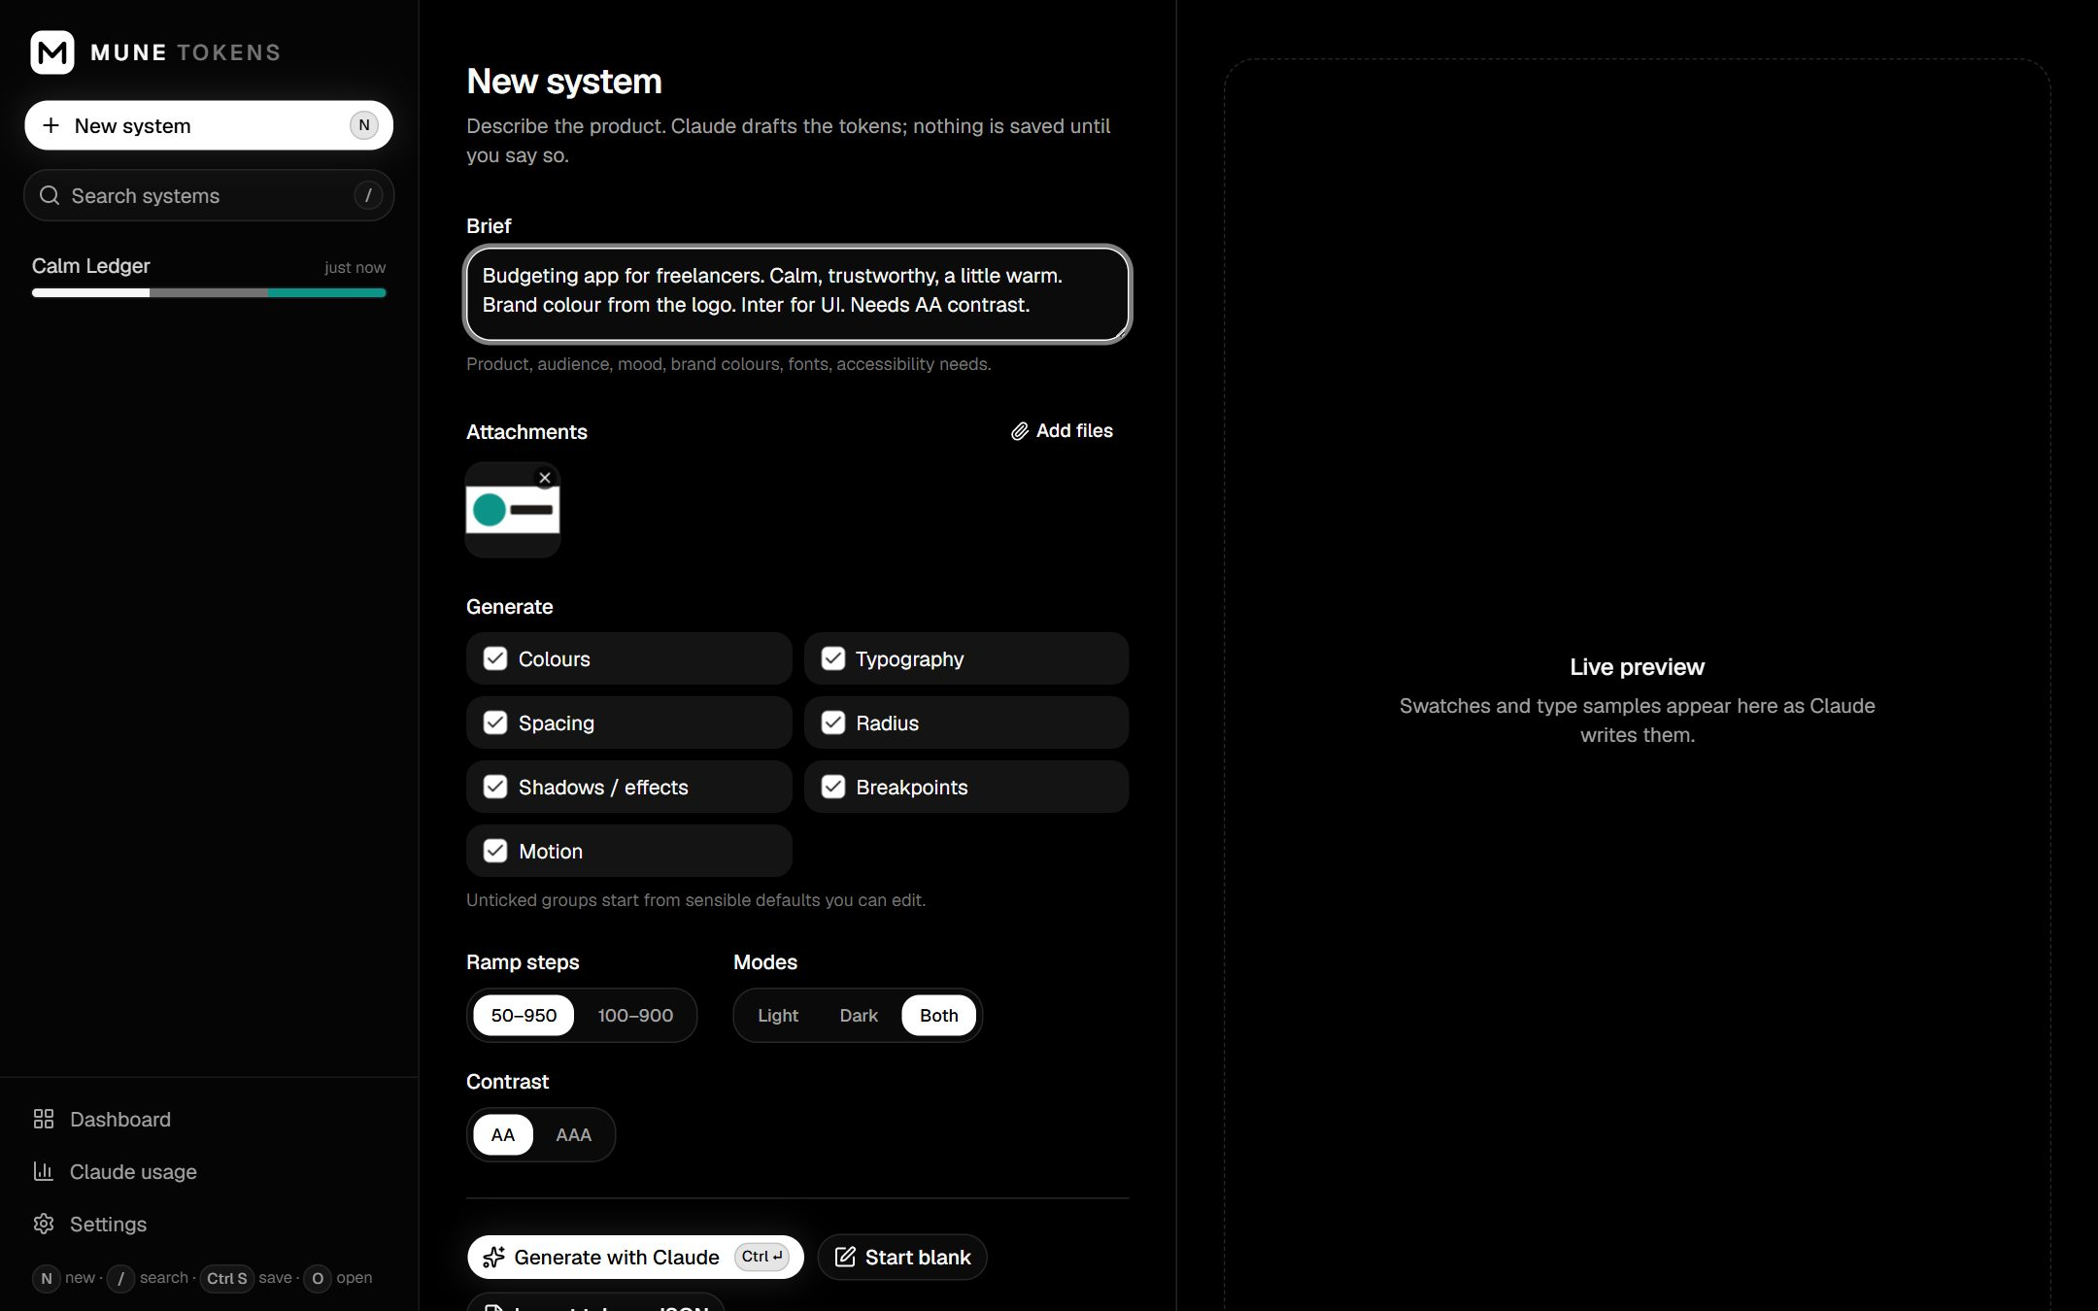
New system: brief, attached logo, what to generate, and the options.

Other ways to start
- Start blank: a small, sensible starter set (neutral and brand ramps, semantic colours, type scale, spacing, radius, shadows, motion) to edit by hand. No AI.
- Import tokens JSON: start from an existing W3C design tokens file, for example one exported from Figma (section 10).
Important Nothing is saved yet. Review the draft, then click Save system (or press Ctrl + S). The first save creates the system and its project folder.

6. Review and edit
A saved system opens in the editor. The tabs along the top hold each group of tokens. The header shows the version and whether you have unsaved changes.
Tab | What you do there
Colours | Colour ramps. Change a ramp's base colour and its steps rebuild evenly (in OKLCH). Click any step to fine-tune it. Add ramps. Below: Brands.
Semantic | The colours designs actually use (page background, text, borders, buttons) for Light and Dark, plus the contrast checker.
Typography | Fonts (with a Google Fonts check) and the type scale: size, line height, weight, letter spacing.
Spacing / Radius / Shadows / Breakpoints | Editable scales with visual previews.
Motion | Durations and easing curves (hover a track to play it).
Components | The component library (section 7).
Export | Preview pages, files and the Figma hand-off (sections 8 and 9).

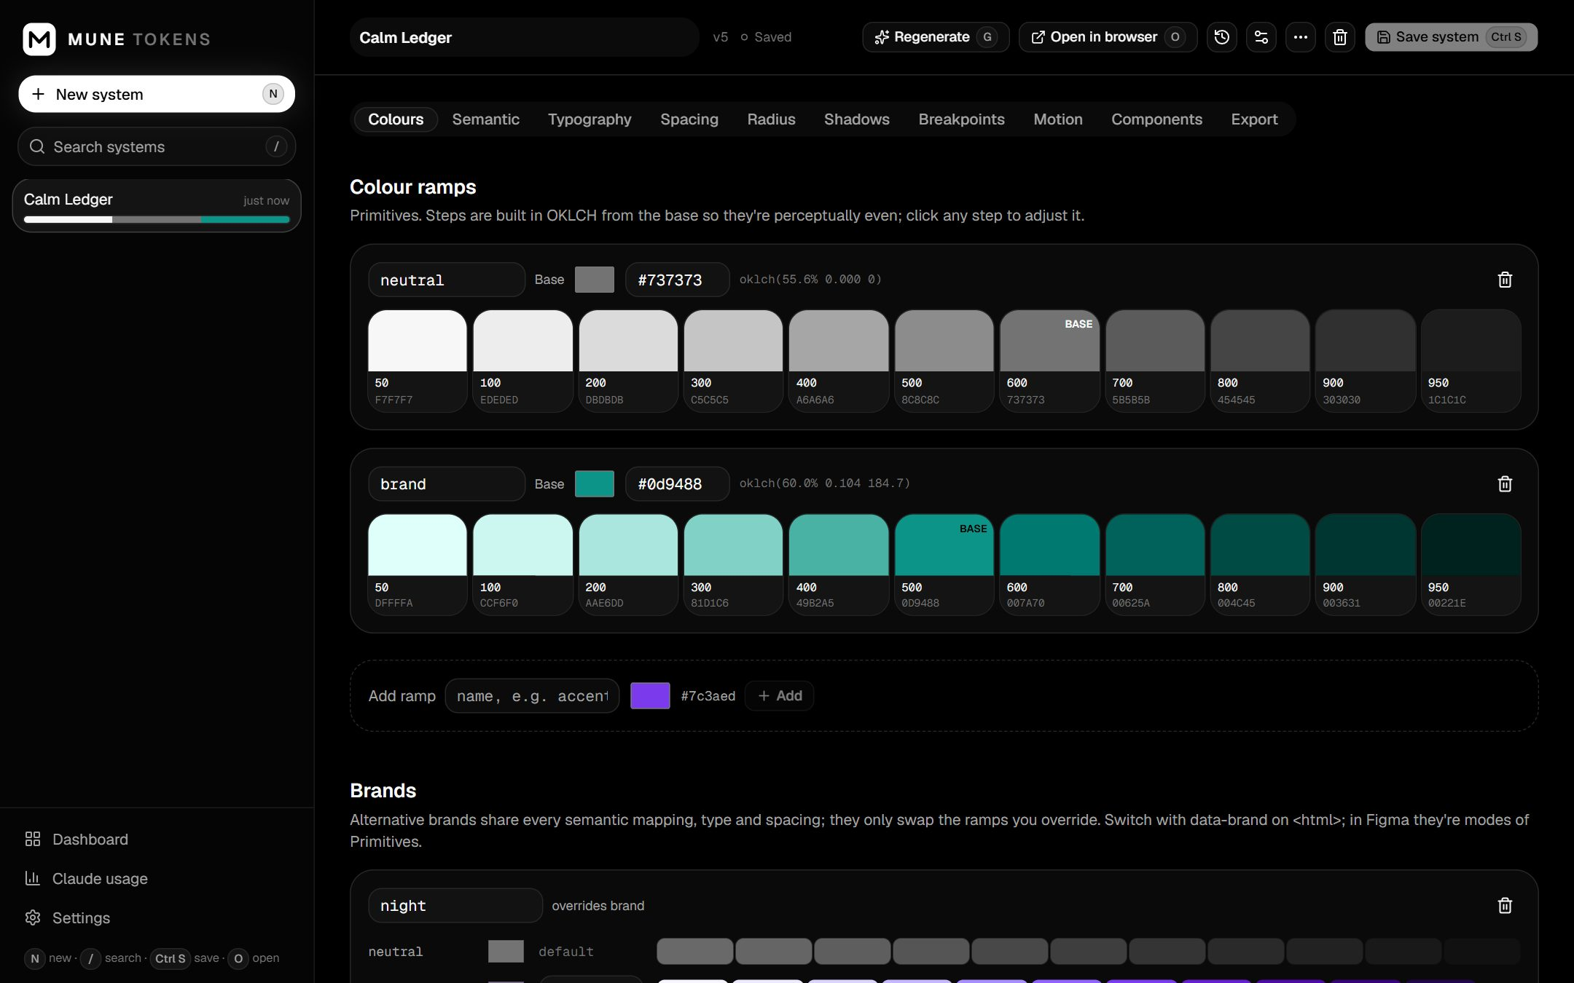
Colours: each ramp is built from its base colour; click a step to adjust it.

6.1 Check contrast
- Open the Semantic tab. The Contrast checker at the top lists each text colour on its background, for Light and Dark.
- Pairs below your target are listed first and marked with a warning icon and their ratio (for example 3.74 · AA Large).
- To fix one, change the colour in the table below: click its swatch and pick a darker or lighter step.
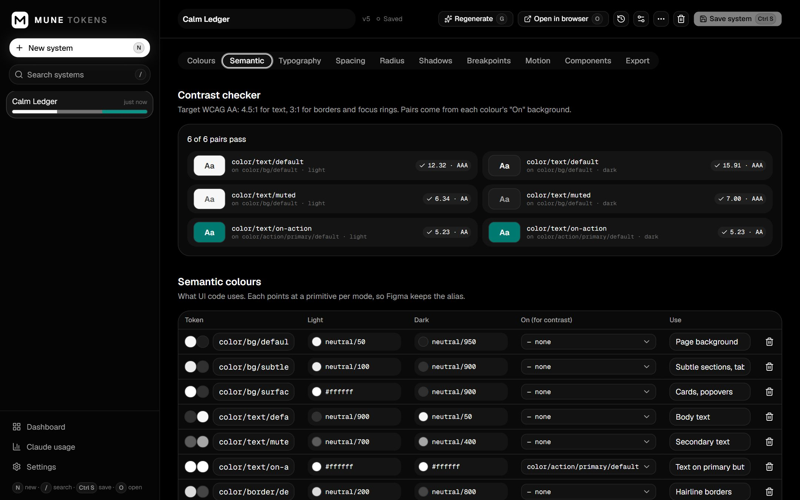
Semantic colours with the contrast checker: ratio, grade and an icon for each pair.

6.2 Typography and motion
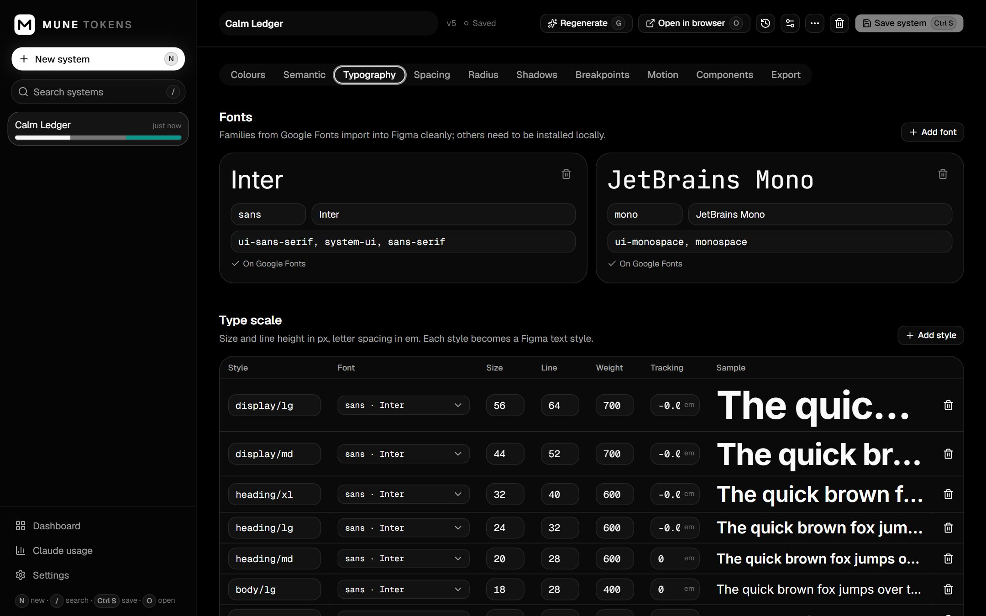
Typography: fonts and the type scale with live samples.
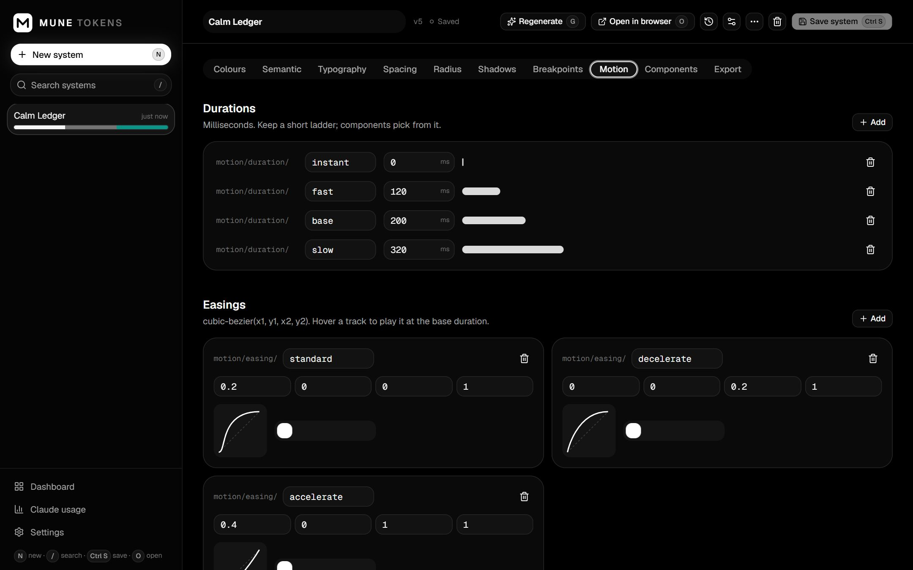
Motion: durations and easing curves. Older systems get an “Add a starter set” button.

6.3 Brands (optional)
A brand swaps some colour ramps and shares everything else, which is useful for a sub-brand or a white-label version.
- At the bottom of the Colours tab, type a name under Add brand and press Add.
- Pick a new base colour for the ramps that should differ (usually just brand). The others stay the same as the default brand.
- Save. In code the brand switches with data-brand="name"; in Figma each brand becomes a mode of the Primitives collection.
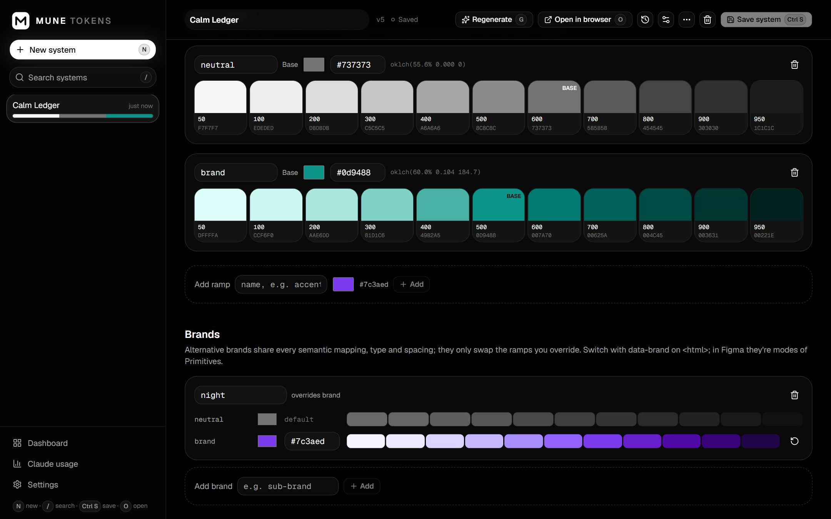
A “night” brand that overrides only the brand ramp.

6.4 Let Claude improve one group
Press Regenerate (or G) on any token tab and give a short instruction such as “warmer neutrals” or “tighter type scale”. You see the result and its cost before anything changes; click Apply to draft to accept.

6.5 Save, history and undo
- Save system (Ctrl + S) creates a new version and rewrites the project folder.
- Version history (the clock button in the header) lists every saved version. Pick one to see exactly what would change, then Restore into draft. Save to keep it.
- System settings (the sliders button) holds the brief, steps, modes, contrast target and Figma file link.
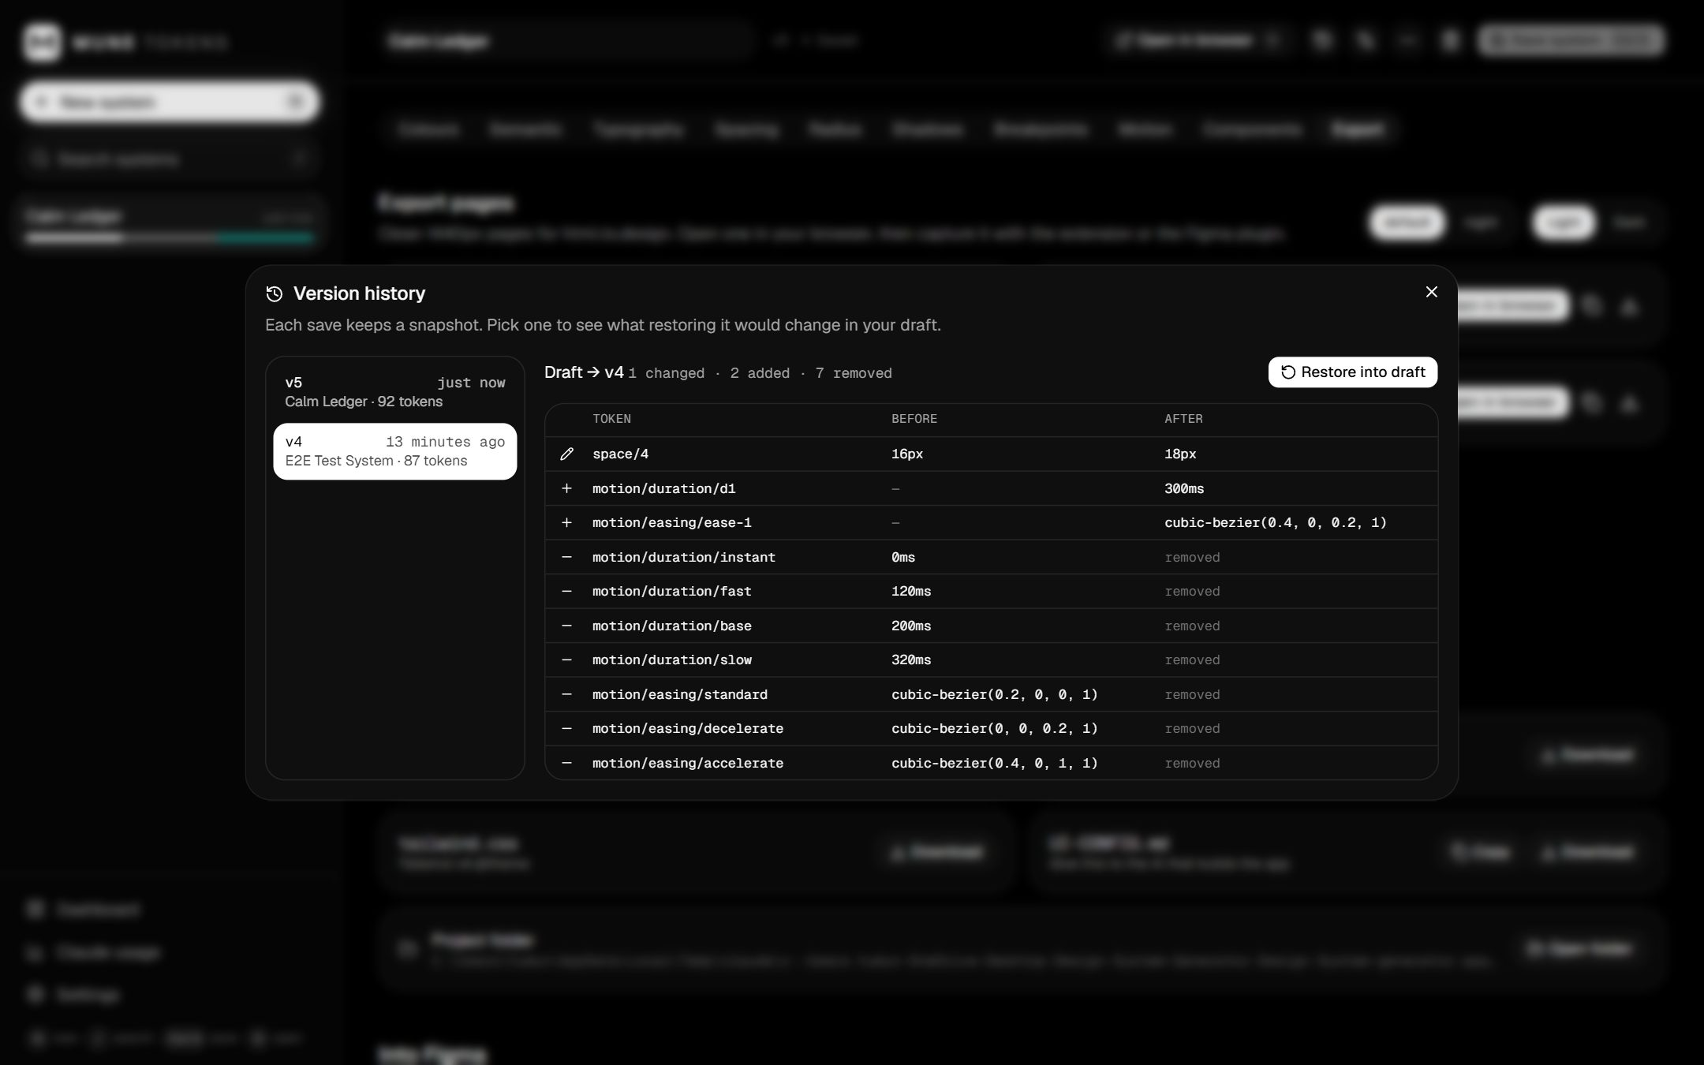
Version history: compare a saved version with your draft, then restore it.

7. Build components (optional)
Claude can work out which components your product needs and write a spec for each one. Every component uses only your tokens, so changing a token updates them all.

7.1 Plan the library
- Open the Components tab and click Plan from project idea.
- Describe the product you are building. You can attach a PRD, user flows or screenshots.
- Click Find components. Claude lists foundations, primitives, composites and product-specific components, each with why it is needed, its variants and states, and an estimated cost.
- Untick what you don't want, rename items, reorder them, or add your own.
- Click Add and write N specs. Specs are written one at a time; you can keep working.
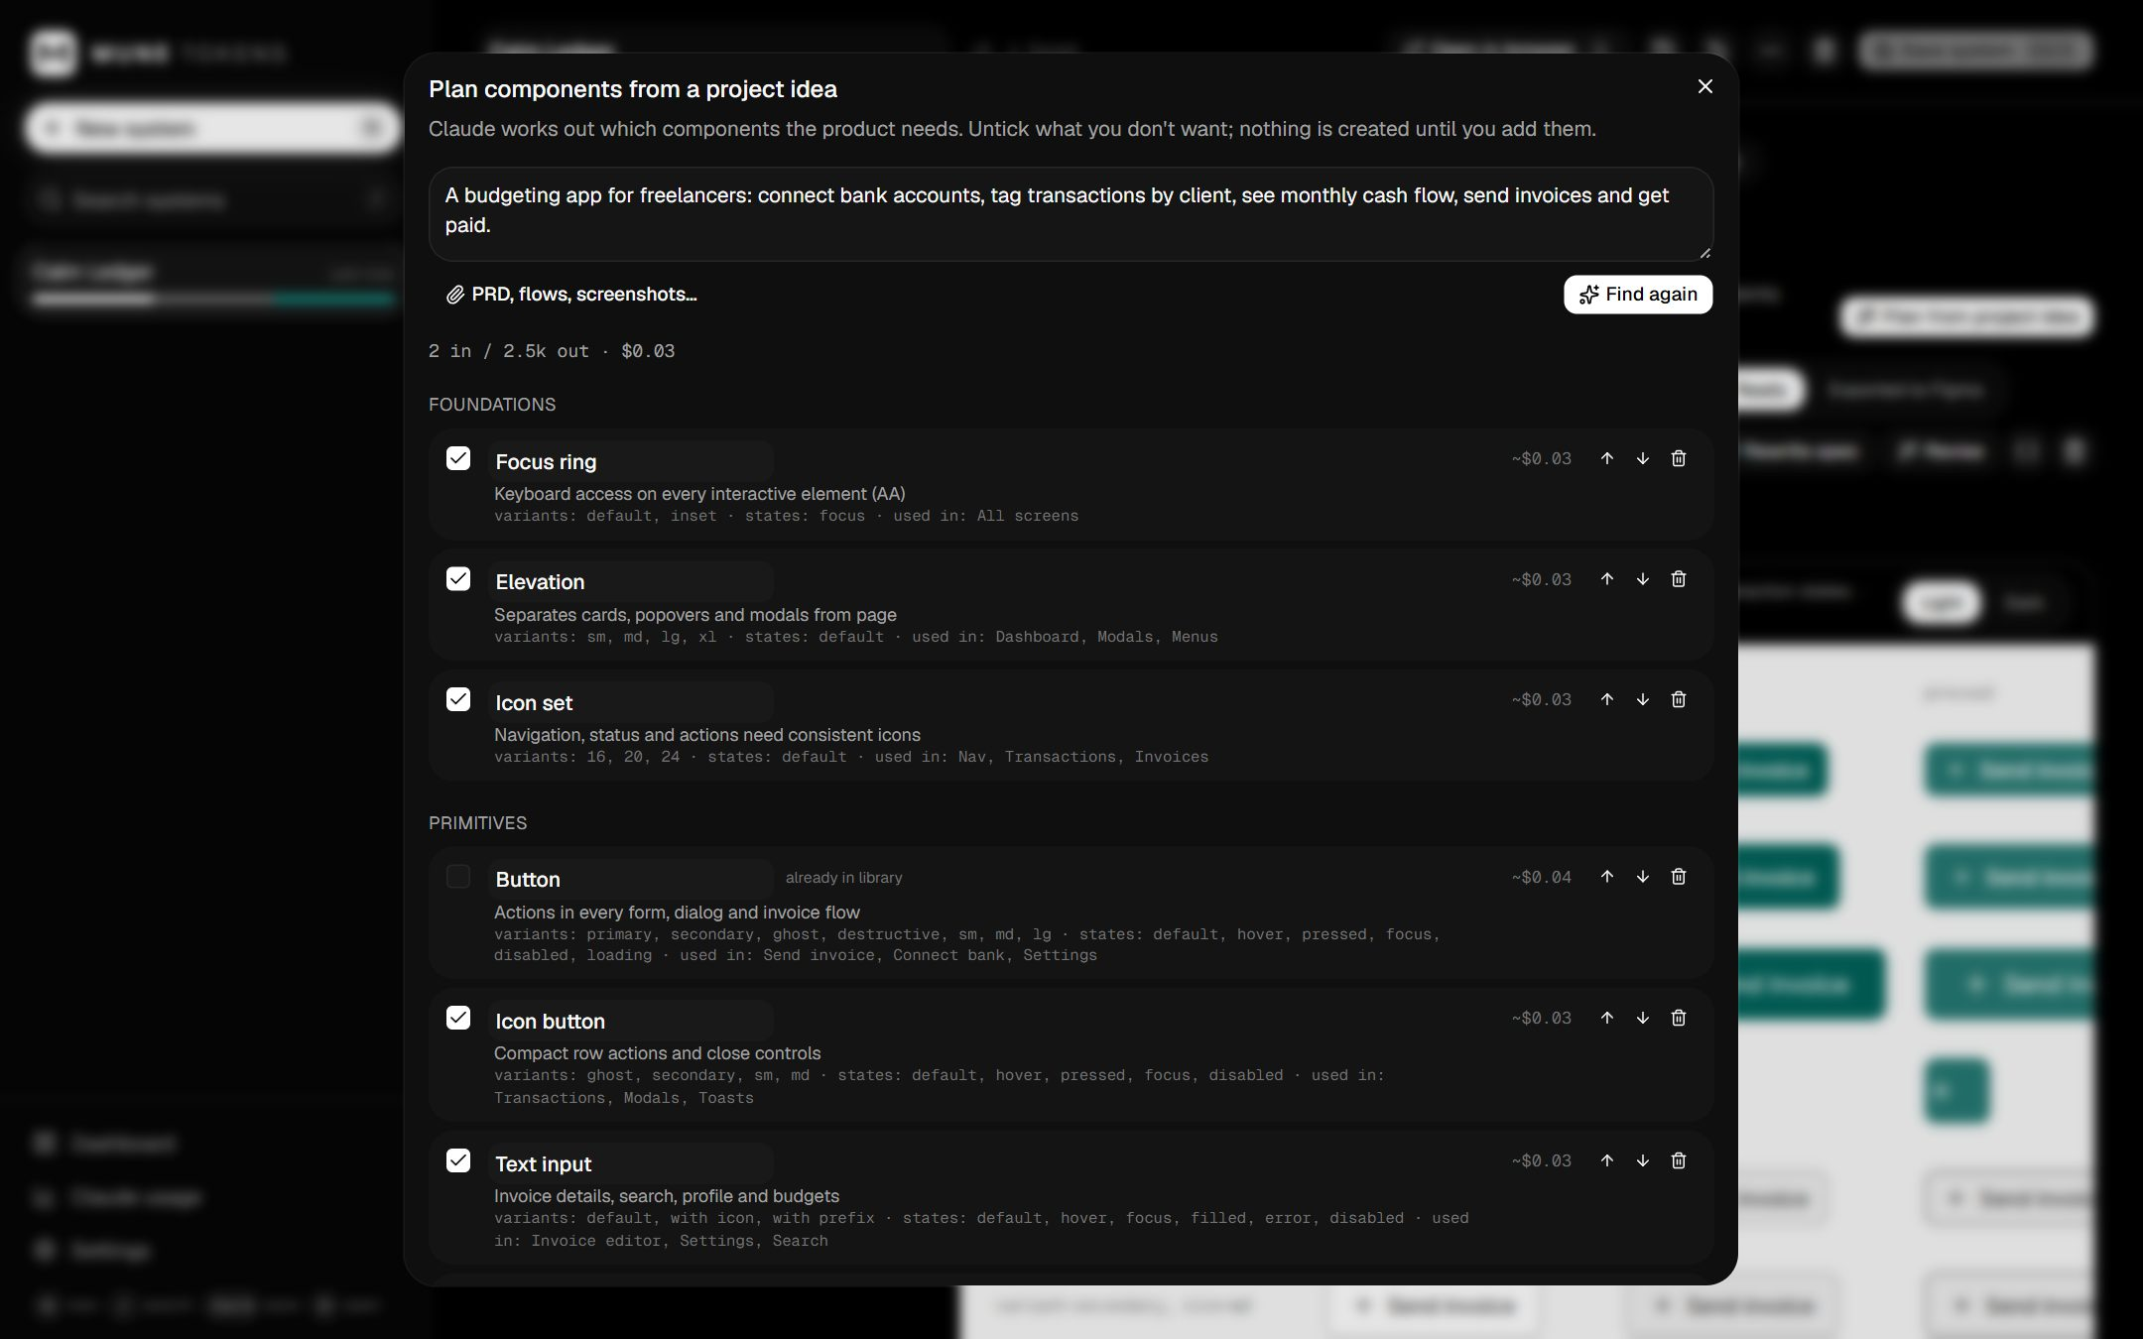
The component plan for a budgeting app, with reasons and estimated cost per spec.

7.2 Review and finish each component
- Click a component in the list. The preview shows every variant and state using your tokens, in Light or Dark.
- To change it, click Revise and describe the change (for example “add a destructive variant”). You see the new grid and its cost before applying. Advanced users can edit the spec as JSON (the { } button).
- When it looks right, set its status to Ready. Only Ready components go to UI-CONFIG.md, the Components export page and Figma.
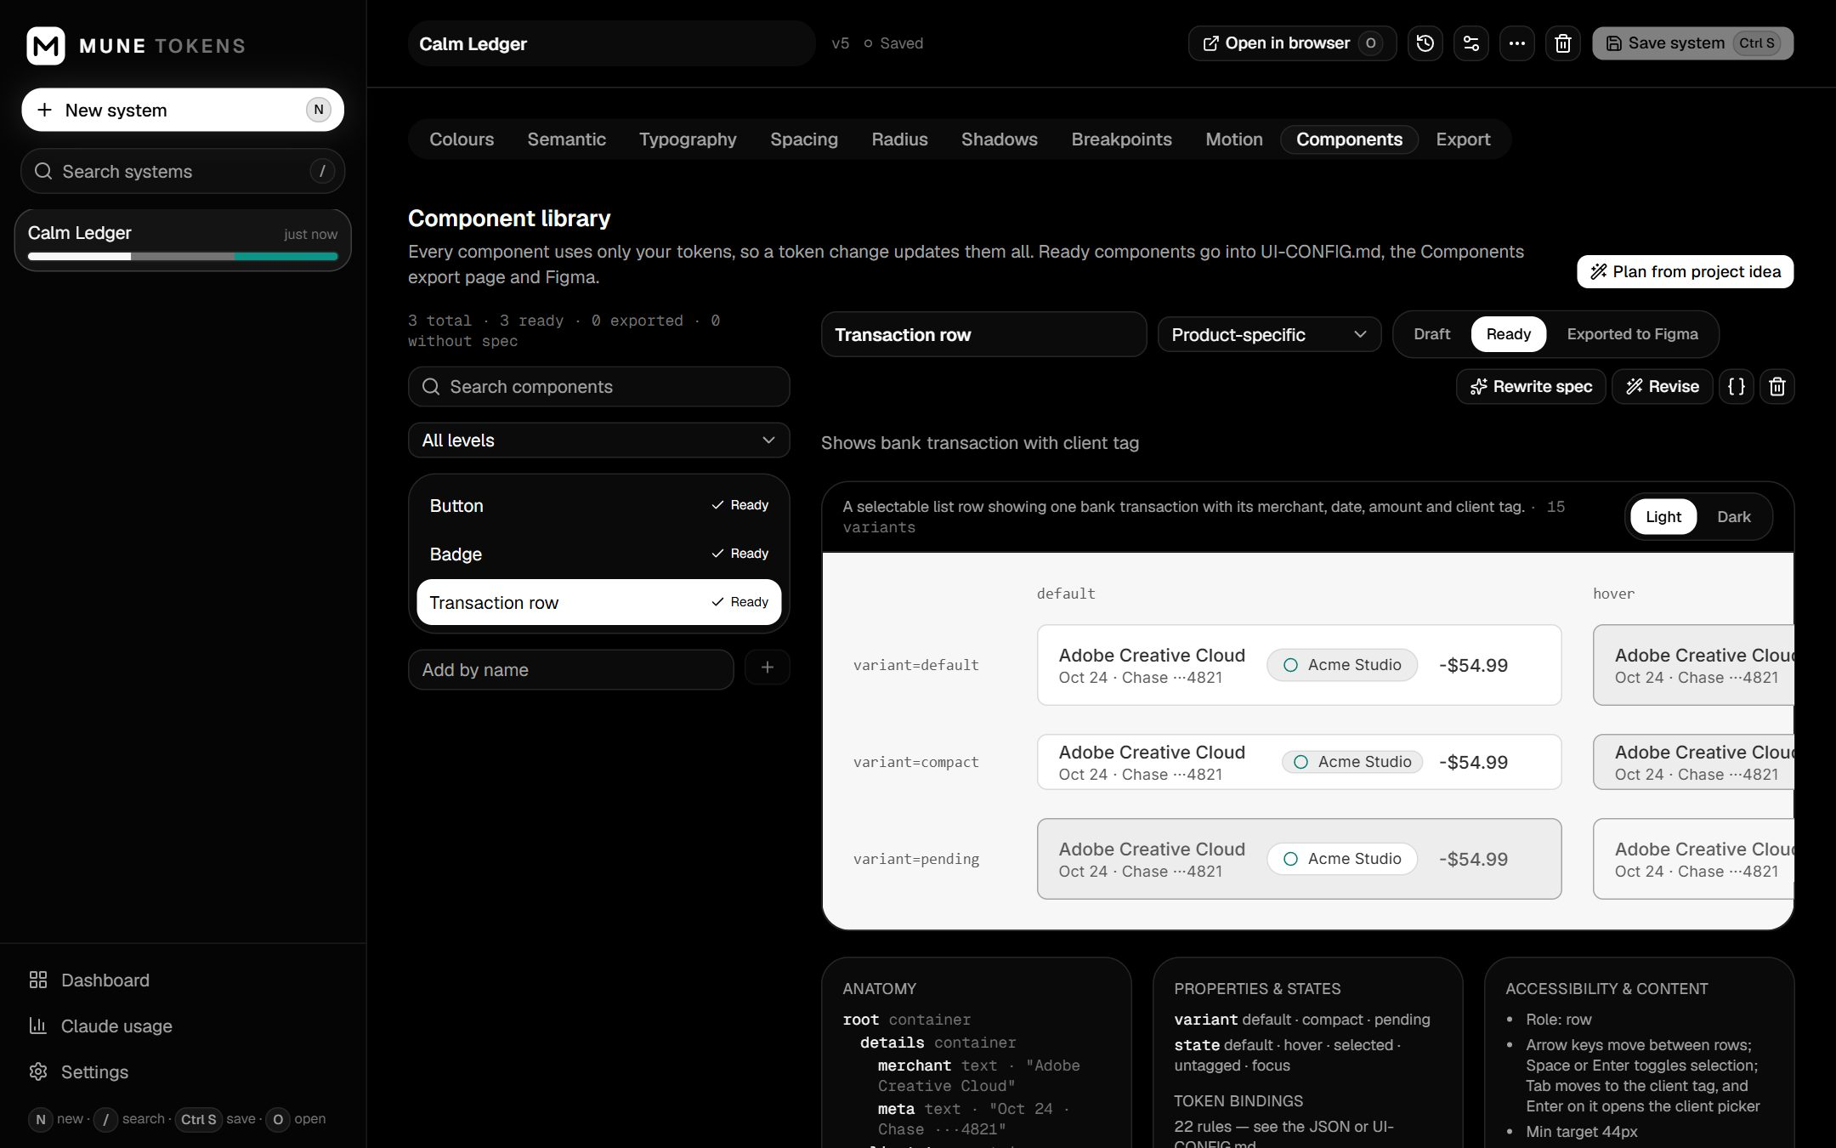
A Ready component with its variant × state grid, anatomy and accessibility notes.

8. Export
Open the Export tab. Everything here is built from the saved version, so save first.

8.1 Preview pages
Each page (Colours, Typography, Spacing & Radius, Effects, Components) is a clean 1440px page. Choose the mode (and brand, if you have brands), then:
- Open in browser opens it outside the app window (useful for the html.to.design extension).
- Copy URL and Download HTML are next to it. Download everything (.zip) gives all pages and files.
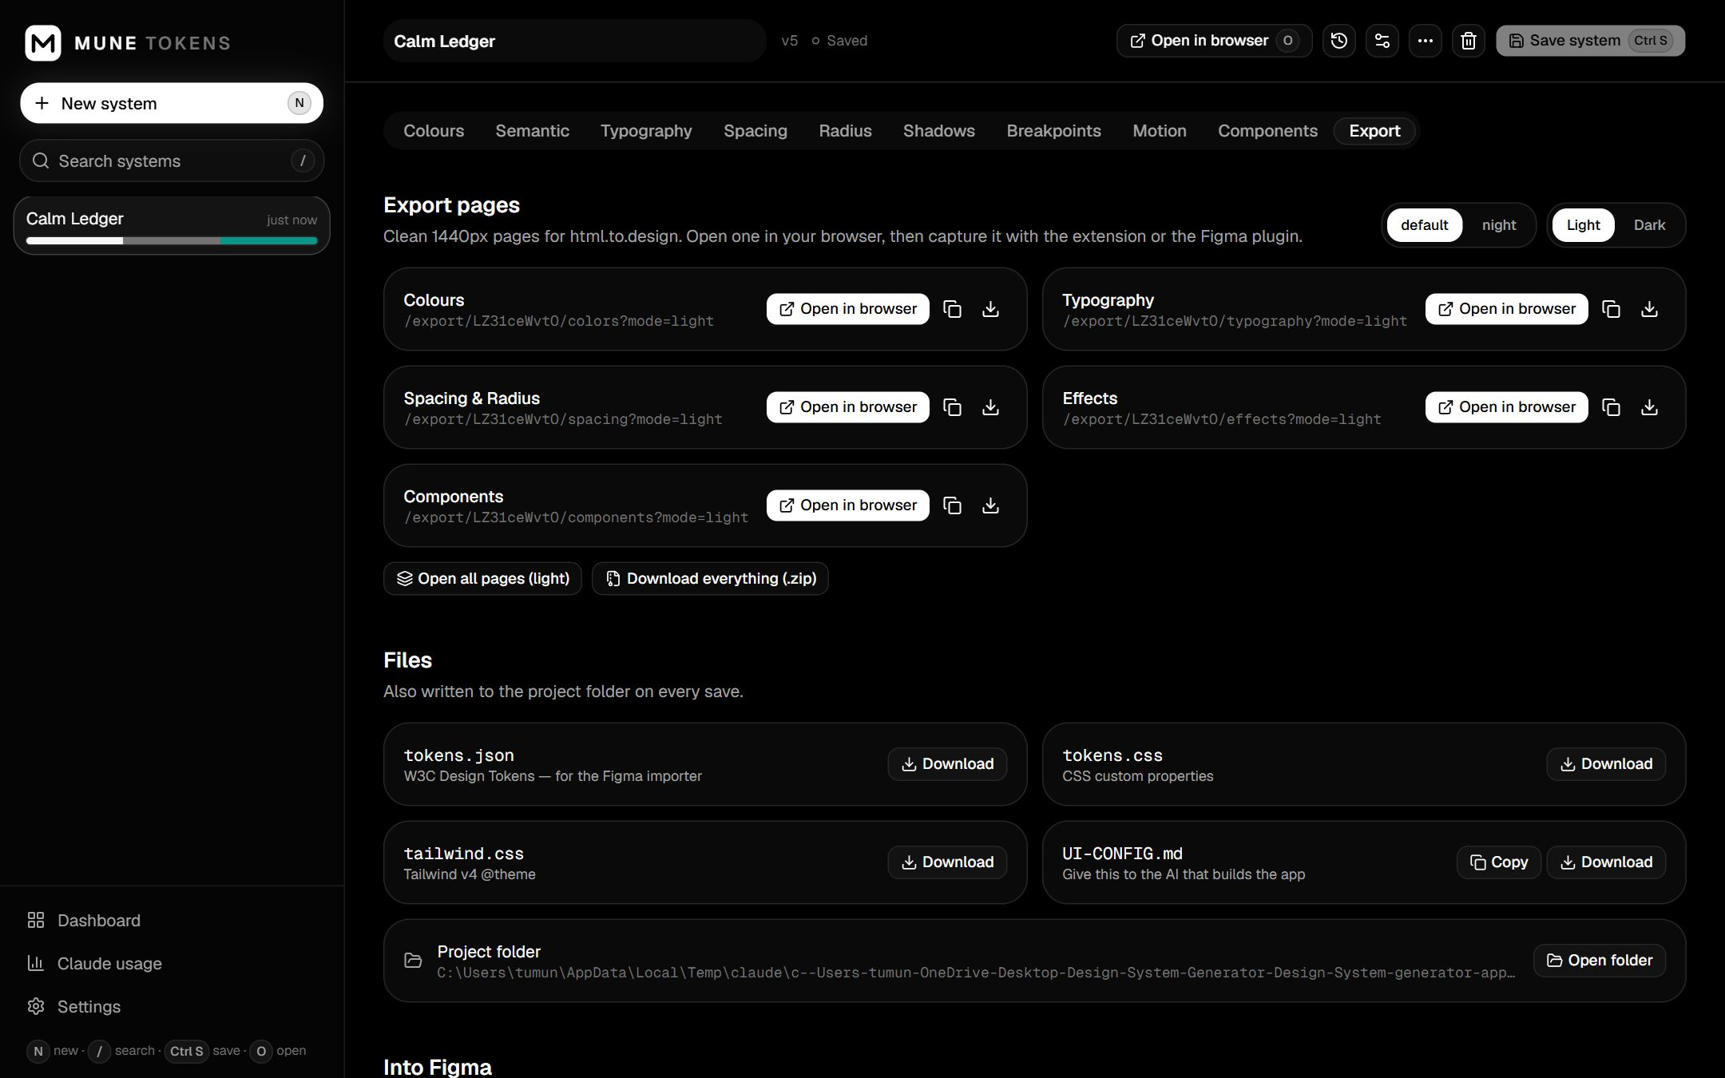
Export: preview pages per mode and brand, and the files.
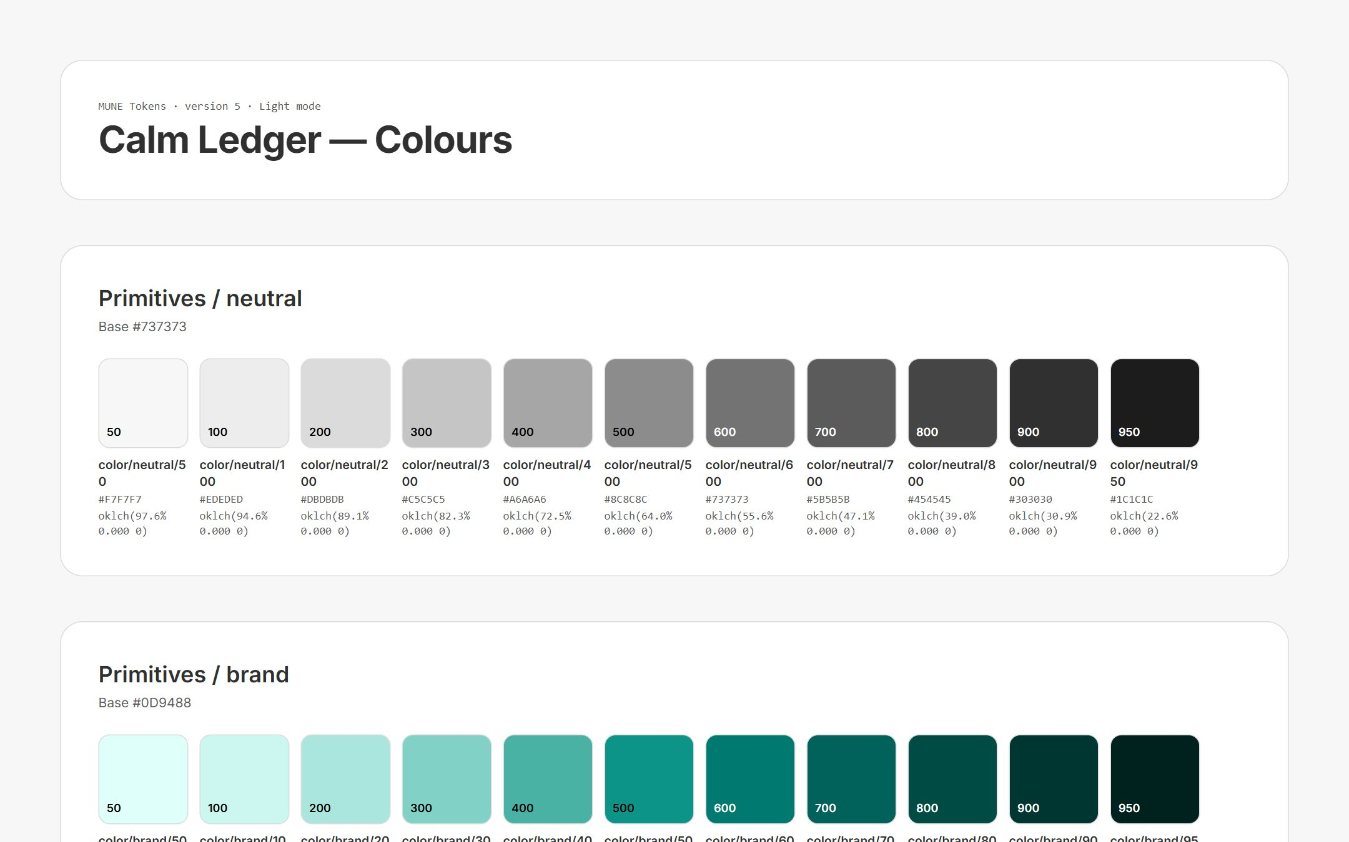
A preview page as it opens in the browser.

8.2 Files
File | What it is for
tokens.json | W3C design tokens: the source of truth for Figma and other tools.
tokens.css | CSS custom properties for developers (Light/Dark with data-theme, brands with data-brand).
tailwind.css | A Tailwind v4 theme.
UI-CONFIG.md | Rules and tokens written for an AI coding assistant. Give it to the AI that builds the app (Copy UI config puts it on the clipboard).

Every save also writes these files, plus the preview pages, to the system's project folder (by default Documents\MUNE Tokens\<system name>). Use ⋯ → Open folder to see it. If you edit UI-CONFIG.md by hand, the app notices and asks whether to keep your edits or overwrite the file.

9. Bring it into Figma
The included MUNE Tokens Importer plugin creates real Figma variables, styles and components. It is a private development plugin: free, not published, and it uses no Figma AI credits.

9.1 Install the plugin (once)
- Open the Figma desktop app (the plugin cannot be installed from the browser version).
- Open any design file, then go to the main menu: Plugins → Development → Import plugin from manifest…
- Pick the file figma-plugin\manifest.json inside the app folder. The full path is shown on the app's Export tab; click it to copy.

9.2 Import a system
- Keep MUNE TOKENS running. In the system's Export tab click Copy Figma link.
- In Figma, open the file you want (a new file is best for a first try), then Plugins → Development → MUNE Tokens Importer.
- Paste the link and click Load. You should see the system name and the number of Ready components.
- Keep the options ticked (Variables, Text styles, Effect styles, Components, Showcase page) and click Import.
- Wait for Done. in the log. Figma switches to the new MUNE Design System page.
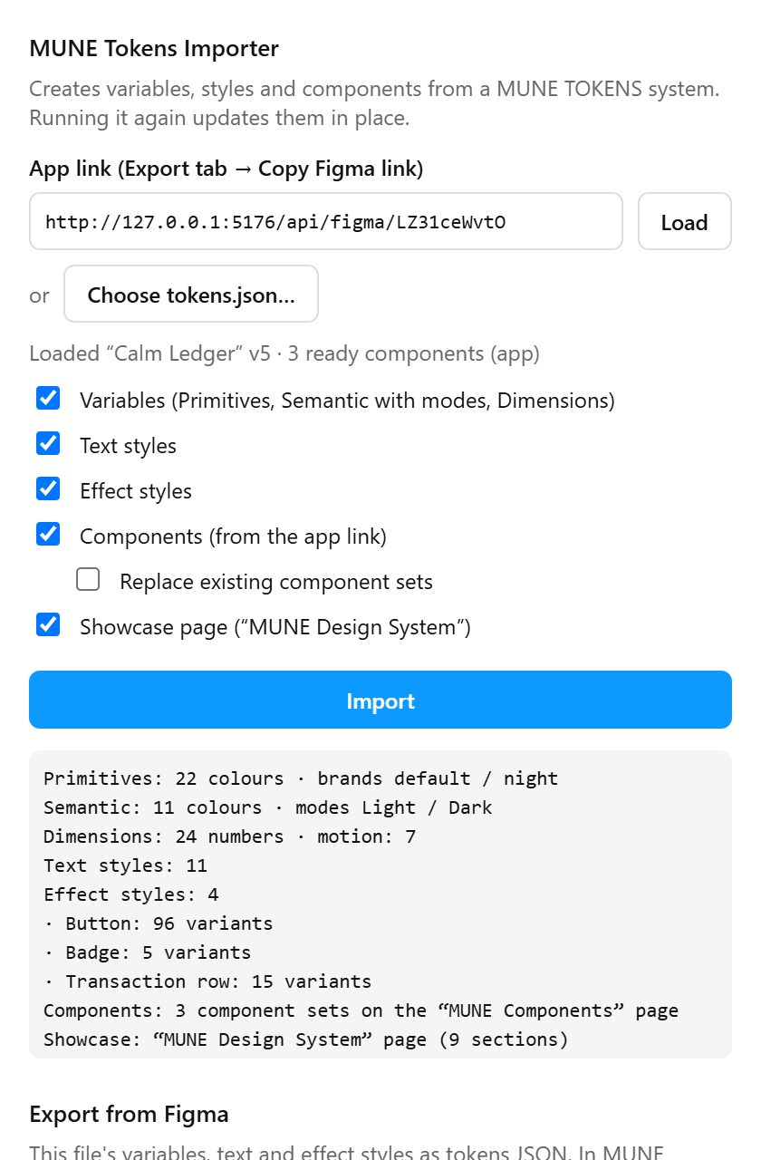
The plugin window after an import.
No connection? Click Choose tokens.json… in the plugin and pick the file from the system's project folder. That imports variables and styles (not components).

9.3 What you get in Figma
In Figma | Details
Variables: Primitives | Every ramp colour, hidden from pickers. With brands, one mode per brand.
Variables: Semantic | Light and Dark modes, each pointing at the primitives (aliases), with sensible scopes.
Variables: Dimensions | Spacing, radius, breakpoints and motion.
Text and effect styles | One per text style and per shadow.
MUNE Components page | One component set per Ready component, with variant properties. Fills, borders, padding, gaps, corner radius and sizes are bound to the variables.
MUNE Design System page | A showcase of the whole system: primitives per brand, semantic colours in Light and Dark, type, spacing, radius, motion, shadows and the components.

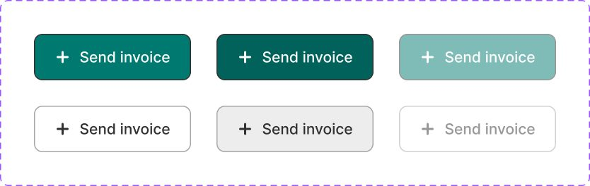
Button component set in Figma: variants and states, bound to variables.
The same components with the frame switched to Dark mode: colours follow the variables.
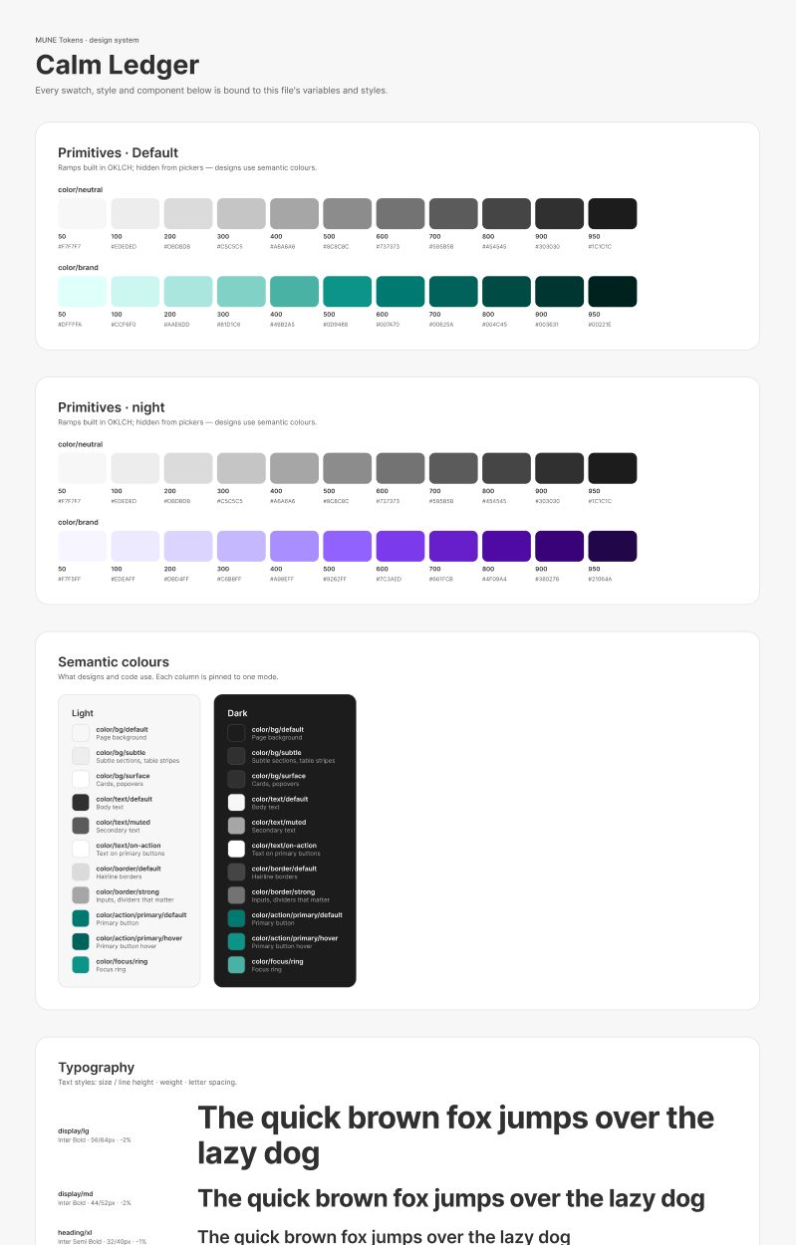
The top of the MUNE Design System showcase page (header, primitives, semantic colours).

9.4 Updating Figma later
Change and save the system in the app, then run the plugin again with the same link. Variables and styles update in place. Existing component sets are kept unless you tick Replace existing component sets. The showcase page is rebuilt each time.

10. Bring Figma changes back
If someone edits variables or styles in Figma, you can bring those changes into the app.
- In Figma, run the plugin and click Export tokens under Export from Figma. Then click Download .json (or Copy).
- In the app, open the system and choose ⋯ → Import from Figma / JSON… in the header.
- Choose the downloaded file. You see a list of every token that would change, be added or be removed.
- Click Apply to draft, review, then Save system.
Note Figma does not store which background a text colour is meant to sit on (the “On” column in the Semantic tab). After importing from Figma, check those pairings and the contrast checker.

11. Keyboard shortcuts
Keys | Action
N | New system
/ | Search
Ctrl + S | Save system
G | Regenerate the current group with Claude
O | Open the current group's preview page in the browser
J / K (or ↓ / ↑) | Move between tokens in the current tab
E | Edit the focused token
Ctrl + Enter | Generate (on the brief)
Esc | Cancel generation or close a dialog

12. Costs and Figma plans
Item | Cost
Claude (Claude Code CLI on a subscription) | No per-request charge; uses your plan's normal usage. Typical API-equivalent figures: a full system $0.04–0.06, a component plan $0.03, each component spec $0.03–0.07.
Claude (Anthropic API key) | Billed per request at those figures. Every request is listed on the Claude usage page.
Figma AI credits | None. The plugin uses no Figma AI.
Figma plan | Professional recommended: Light and Dark in one collection, brands as modes, unlimited files, team libraries. The free plan works with limits: one mode per collection (Dark goes to a separate collection, only the default brand is imported) and a limited number of files.
html.to.design (optional) | A separate third-party plugin with its own free monthly limit. Not needed: the MUNE plugin already creates variables, styles, components and the showcase page.

13. First-run test checklist
Work through these in order the first time. Each one takes a minute or two. Tick the last column when the result matches.
# | Test | Steps | Expected result | ✓
1 | App starts | Double-click the desktop shortcut. | The app window opens on the Dashboard. | ☐
2 | AI connection | Settings → Test connection. | A reply such as “replied OK” with a time. | ☐
3 | Start blank | New system → Start blank → type “Test 1” in the name box at the top left → Ctrl + S. | “Saved · version 1”; it appears in the sidebar. | ☐
4 | Edit and save | Colours → change the brand base colour → Ctrl + S. | The ramp rebuilds; the header shows v2 and “Saved”. | ☐
5 | Contrast | Semantic tab. | Every pair shows a ratio and a grade; failures are listed first. | ☐
6 | History | Clock button in the header → pick v1. | A list of changes (the brand colours) and Restore into draft. | ☐
7 | Generate with Claude | New system → write a brief → attach a logo → Generate. | Swatches stream in; the brand colour matches the logo; a cost line appears. | ☐
8 | Preview page | Export → Colours → Open in browser. | A clean page with every swatch and its name opens in your browser. | ☐
9 | Project folder | ⋯ → Open folder. | UI-CONFIG.md, tokens.json, tokens.css, tailwind.css and an export folder. | ☐
10 | Components | Components → Plan from project idea → Find components → add 2 → wait. | Both get specs and a variant grid; set one to Ready. | ☐
11 | Figma import | Copy Figma link → plugin → Load → Import (new Figma file). | Log ends with Done.; Variables panel shows Primitives, Semantic (Light/Dark), Dimensions. | ☐
12 | Showcase page | Look at the MUNE Design System page in Figma. | Swatches, type, spacing, shadows and your Ready component appear. | ☐
13 | Dark mode in Figma | Select a frame that contains a component. In the right panel's Layer section, click the variable mode icon and set Semantic to Dark. | Colours switch to the dark values. | ☐
14 | Round trip | Plugin → Export tokens → Download; app → ⋯ → Import from Figma / JSON. | A change list appears (usually only the “On” pairings). | ☐

14. Troubleshooting
Problem | What to do
The shortcut does nothing, or the app doesn't open within two minutes | Run start-mune-tokens.bat in the app folder to see the console messages. Check that Node.js is installed (node -v in a terminal). The log is in logs\server.log.
“No API key and no Claude Code CLI found” | Install Claude Code and sign in, or add ANTHROPIC_API_KEY= to a .env.local file in the app folder and restart. You can also set the CLI path in Settings.
Generation fails or stops | Try again; every response is checked and retried once automatically. Check the Claude usage page for the error message.
“Fix N problems before saving” | The yellow box lists them, usually a semantic colour pointing at a ramp step that no longer exists. Pick a new step in the Semantic tab.
Fonts look wrong in Figma | Text styles need the font installed in Figma. Use Google Fonts, or install the font on your computer, then run the plugin again.
The plugin says it can't load the link | Make sure MUNE TOKENS is running and the link starts with http://127.0.0.1:5176. Otherwise choose tokens.json in the plugin.
Only Light mode (or only the default brand) in Figma | Your Figma plan allows one mode per collection. Upgrade to Professional, or use the separate “Semantic (Dark)” collection the plugin created.
Files in the project folder didn't update | The Export tab shows the last write error, often a file locked by OneDrive. Save again after a moment.

Appendix: where things live
What | Where
The app | The app folder (for example Desktop\Design System Generator\Design System generator app).
Your systems (database) | data\mune-tokens.db inside the app folder. Back it up from Settings → Export all data.
Project folders | Documents\MUNE Tokens\<system name> (changeable in Settings).
Figma plugin | figma-plugin\manifest.json inside the app folder.
Server log | logs\server.log inside the app folder.

Sharing the app with someone
- Give them a copy of the app folder (or access to the GitHub repository). They don't need your data folder.
- They follow sections 2 to 4 of this guide on their own PC.
- To share a design system rather than the app, send its tokens.json; they can start from it with New system → Import tokens JSON.

