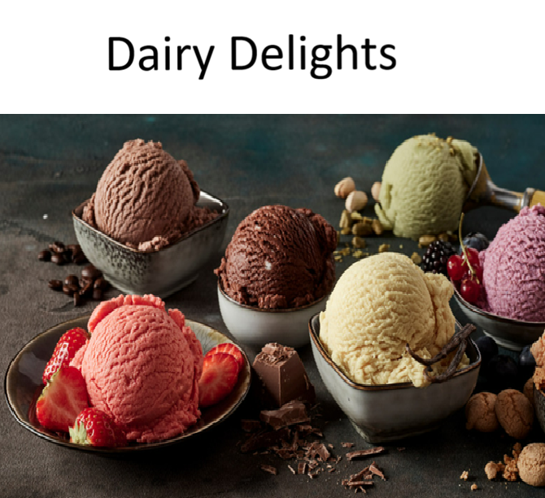
(Martin, 2022)
Contents
Introduction 3
Goals and objectives 3
The main goal 3
The business aims 3
KEY PERFORMANCE INDICATORS (KPIs) 3
To check if the business is doing well, we will look at: 3
WEBSITE FEATURES 3
DESIGN AND USER EXPERIENCE 3
TECHNICAL REQUIREMENTS 4
TIMELINE & MILESTONES 4
BUDGET 4
References 4

Introduction
People are always busy with work, school, or just trying to get trough the day. Because of this, there’s not always time to relax or enjoy small things. Sometimes all a person person needs after a long day is something sweet and refreshing to make them feel better.
Ice cream is one of those simple things that can instantly improve your mood. Its not just dessert, its something people enjoy when theyre happy, stressed, or just want a treat.
Dairy Delights focuses on making it easy for people to enjoy good ice cream without any stress. The idea is to give people something sweet that they can enjoy anytime, while also creating a fun and satisfying experience.

Goals and objectives
The main goal of Dairy Delights is to become a international success known for its diverse flavours and experience.
The business aims to sell a wide range of ice cream flavours that people enjoy and keep the prices affordable for students and families.
The slogan will be “A scoop of fun”, emphasizing our diversity.

KEY PERFORMANCE INDICATORS (KPIs)

To check if the business is doing well, we will look at:

- The number of orders made
- How much money customers spend
- Which flavours are selling the most
- How many people visit or share the website

WEBSITE FEATURES
The website will be simple and easy to use. It will include:
- Pictures of ice cream with prices
- An order form for customers
- Delivery details (location and time)
- A “Flavour of the Week” section

DESIGN AND USER EXPERIENCE

- The website should look fun and attractive so that people feel like ordering.

- Colours: Light and soft colours like pink, blue, and cream
- Fonts: Easy-to-read fonts like Open Sans
- Layout: Simple buttons and clear sections
- Speed: The website must load fast
Also:
- There should be options for people with dietary needs (like dairy-free)
- Ingredients should be clearly shown
The logo should be simple but eye-catching.

TECHNICAL REQUIREMENTS
- The website can be hosted on platforms like Vercel or Netlify
- Images should be optimized so the website runs smoothly
- It should work well on phones, tablets, and computers

TIMELINE & MILESTONES
- Week 1–2: Choose flavours and prices
- Week 3–4: Design the website
- Week 5: Test and launch
- Week 6–7: Final submission

BUDGET
- Development: R3000
- Maintenance: R400 – R1000 per month
- Hosting: R800 – R1200 per year
- Copywriting: R400

References
Martin, K. (2022, September 20). Tasting Table. Retrieved from Tasting Table: https://www.tastingtable.com/1017501/the-ingredient-swap-you-should-try-for-homemade-ice-cream/

