TECHNOLOGICAL INSTITUTE OF THE PHILIPPINES
COLLEGE OF COMPUTER STUDIES
ITE 012 - Computer Programming 2
MIDTERM

Name: Galang, Patrick James  Garcia, Dolf Philippe  Lamio, Adinoel Rodge  Payawal, Matthew James  Ramos, Erus | Date: March 6, 2026
Program/Section: ITE 012/CS12S4 | Instructor: Maam Elsa V. Isip-Barcelos
A Assessment Task: Application of Methods in Class Constructors
Output:
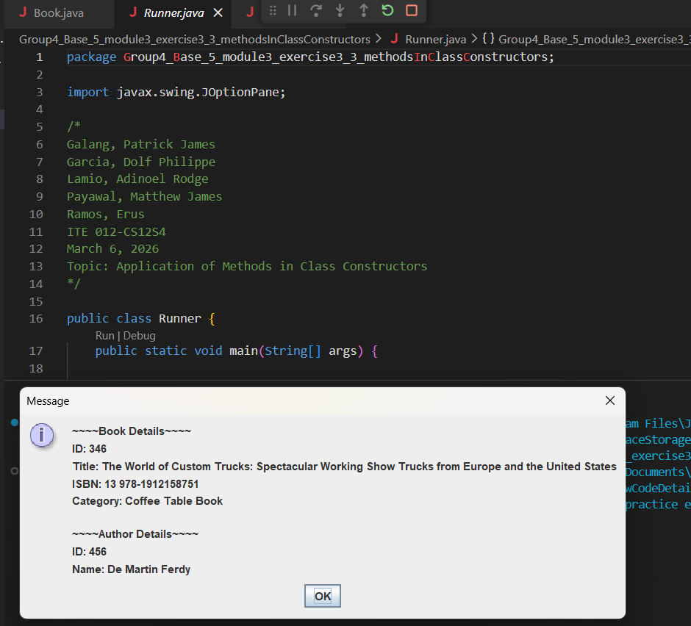

Author class
package Group4_Base_5_module3_exercise3_3_methodsInClassConstructors;

public class Author {
int authorId;
String lastName;
String firstName;

public Author(int authorId, String lastName, String firstName){
this.authorId = authorId;
this.lastName = lastName;
this.firstName = firstName;
}
public int getAuthorId() {return authorId;}
public String getfirstName() {return firstName;}
public String getlastName() {return lastName;}
}

Book Class
package Group4_Base_5_module3_exercise3_3_methodsInClassConstructors;

public class Book {
int bookId;
String title;
String ISBN;
String category;

public Book(int bookId, String title, String ISBN, String category){
this.bookId = bookId;
this.title = title;
this.ISBN = ISBN;
this.category = category;
}
public int getbookId() {return bookId;}
public String getTitle() {return title;}
public String getISBN() {return ISBN;}
public String getCategory() {return category;}
}

Runner Class
package Group4_Base_5_module3_exercise3_3_methodsInClassConstructors;

import javax.swing.JOptionPane;

/*
Galang, Patrick James
Garcia, Dolf Philippe
Lamio, Adinoel Rodge
Payawal, Matthew James
Ramos, Erus
ITE 012-CS12S4
March 6, 2026
Topic: Application of Methods in Class Constructors
*/

public class Runner {
public static void main(String[] args) {

int bookId = Integer.parseInt(JOptionPane.showInputDialog("Enter Book ID:"));
String title = JOptionPane.showInputDialog("Enter Book Title:");
String ISBN = JOptionPane.showInputDialog("Enter ISBN:");
String category = JOptionPane.showInputDialog("Enter Category:");

//Book Object
Book book1 = new Book(bookId, title, ISBN, category);

int authorId = Integer.parseInt(JOptionPane.showInputDialog("Enter Author ID:"));
String firstName = JOptionPane.showInputDialog("Enter First Name:");
String lastName = JOptionPane.showInputDialog("Enter Last Name:");

Author author1 = new Author(authorId, firstName, lastName);

JOptionPane.showMessageDialog(null,
"~~~~Book Details~~~~\n"+
"ID: "+book1.getbookId()+"\n"+
"Title: "+book1.getTitle()+"\n"+
"ISBN: "+book1.getISBN()+"\n"+
"Category: "+book1.getCategory()+"\n\n"+
"~~~~Author Details~~~~\n"+
"ID: "+author1.getAuthorId()+"\n"+
"Name: "+author1.getfirstName()+" "+author1.getlastName());
}
}

