TECHNOLOGICAL INSTITUTE OF THE PHILIPPINES
COLLEGE OF COMPUTER STUDIES
ITE 012 - Computer Programming 2
MIDTERM

Name: Galang, Patrick James  Garcia, Dolf Philippe  Lamio, Adinoel Rodge  Payawal, Matthew James  Ramos, Erus | Date: March 3, 2026
Program/Section: ITE 012/CS12S4 | Instructor: Maam Elsa V. Isip-Barcelos
A Assessment Task: Practice Exercise 3.2 Application of Methods with and without Parameters
Output:
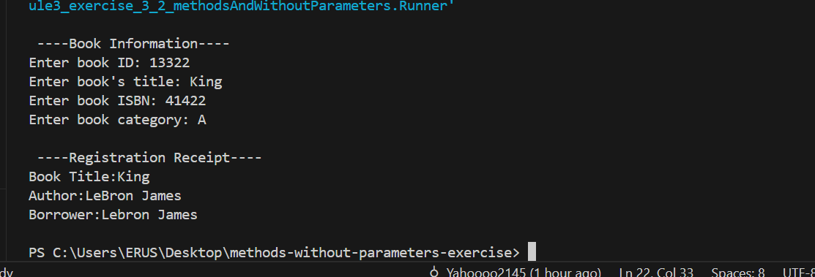
Source Code:
Runner.java
package Group_4_Base_5_module3_exercise_3_2_methodsAndWithoutParameters;
/* Galang, Patrick James
Garcia, Dolf Philippe
Lamio, Adinoel Rodge
Payawal, Matthew James
Ramos, Erus
ITE 012-CS12S4
March 2, 2026
Topic:Application of Methods with and without Parameters */

public class Runner {
public static void main(String [] args){
Book book1 = new Book();

Author author1 = new Author();

Borrower borrower1 = new Borrower();

System.out.println("\n ----Book Information----");
book1.setinfo();

author1.setinfo(101, "LeBron", "James");

borrower1.setborrower(209);
borrower1.setfirstName("Lebron");
borrower1.setlastname("James");

System.out.println("\n ----Registration Receipt----");
System.out.println("Book Title:" + book1.title);
System.out.println("Author:" + author1.lastName +" "+ author1.firstName );
System.out.println("Borrower:" + borrower1.getfirstname() + " " + borrower1.getlastName() + "\n");

}

}

Author.java
package Group_4_Base_5_module3_exercise_3_2_methodsAndWithoutParameters;

public class Author {
public int authorId;
public String lastName;
public String firstName;
void setinfo(int authorId, String lastName, String firstName) {
this.authorId = authorId;
this.lastName = lastName;
this.firstName = firstName;
}
}

Book.java
package Group_4_Base_5_module3_exercise_3_2_methodsAndWithoutParameters;

import java.util.Scanner;

public class Book {
public int bookId;
public String title;
public String ISBN;
public String category;
void setinfo() {

Scanner bookGet = new Scanner(System.in);

System.out.print("Enter book ID: ");
this.bookId = bookGet.nextInt();
bookGet.nextLine();

System.out.print("Enter book's title: ");
this.title = bookGet.nextLine();

System.out.print("Enter book ISBN: ");
this.ISBN = bookGet.nextLine();

System.out.print("Enter book category: ");
this.category = bookGet.nextLine();

}

}

Borrower.java
package Group_4_Base_5_module3_exercise_3_2_methodsAndWithoutParameters;
public class Borrower {
public int borrowerId;
public String lastName;
public String firstName;

public void setborrower(int id){
this.borrowerId = id;
}

public void setlastname(String ln){
this.lastName = ln;
}

public void setfirstName(String fn){
this.firstName = fn;
}

public int getborrowerId(){
return borrowerId;
}

public String getlastName(){
return lastName;
}

public String getfirstname(){
return firstName;
}

}

