# Multi-Label Aerial Image Classification Using Transfer Learning: Phase 2 Report

**Course:** CS415 - Deep Learning
**Date:** November 2025

## Abstract

This report presents our work on multi-label aerial image classification using the AID_MultiLabel dataset. We implemented a transfer learning approach using EfficientNet-B4 as the backbone architecture, achieving a macro F1 score of 0.8097 and micro F1 score of 0.9165 on the test set. Our approach addresses the challenges of multilabel classification in aerial imagery, including class imbalance, label co-occurrence, and the need for rotation invariant feature extraction. This report details our theoretical design decisions, experimental methodology, results, and future directions for improvement.

## 1. Introduction and Motivation

### 1.1 Problem Definition

Multilabel aerial image classification is the task of assigning multiple semantic labels to overhead imagery captured from aerial or satellite platforms. Unlike traditional single label classification where each image belongs to exactly one category, aerial scenes typically contain multiple objects simultaneously (e.g., an airport image may contain airplanes, buildings, pavement, and cars). This multilabel nature makes the task significantly more challenging than conventional image classification.

### 1.2 Motivation

Accurate multilabel classification of aerial imagery has critical applications in:

- **Urban Planning**: Automated land-use analysis and infrastructure monitoring
- **Environmental Monitoring**: Tracking deforestation, water bodies, and land degradation
- **Disaster Response**: Rapid damage assessment and resource allocation
- **Agriculture**: Crop monitoring and precision farming
- **Defense and Security**: Intelligence gathering and surveillance

The complexity of aerial scenes, combined with high intra-class variation and inter-class similarity, necessitates advanced deep learning approaches that can effectively model label dependencies and extract discriminative features.

## 2. Related Work

### 2.1 Aerial Image Datasets

AID Dataset Foundation: Xia et al. [1] introduced the Aerial Image Dataset (AID), a large scale benchmark containing 10,000 images across 30 scene categories collected from Google Earth imagery. The dataset was specifically designed to address the limitations of earlier aerial image datasets by providing higher intraclass diversity and interclass similarity, making it more challenging and realistic for evaluating classification algorithms. The images are 600×600 pixels and cover diverse geographic locations and imaging conditions.

AID Multi-Label Dataset: Hua et al. [2] extended the AID dataset to create AID_MultiLabel, containing 3,000 images with 17 object-level labels. This dataset addresses the fundamental limitation that aerial scenes inherently contain multiple semantic categories. The authors proposed a Relation Network that models label dependencies through three modules: labelwise feature parcel learning, attentional region extraction, and label relational inference. Their work demonstrated that explicitly modeling label relationships significantly improves multi-label classification performance compared to treating labels independently.

### 2.2 Multi-Label Classification Methods

Deep Learning for Multi-Label Learning: The field of multilabel classification has evolved significantly with deep learning. Traditional approaches treated multilabel problems as multiple independent binary classification tasks, but this ignores valuable label correlations. Modern deep learning methods leverage CNNs for feature extraction combined with specialized mechanisms for capturing label dependencies [3].

Graph-Based Label Modeling: Chen et al. [4] introduced ML-GCN (Multi-Label Graph Convolutional Network), which constructs a directed graph over object labels where each node is represented by word embeddings. The GCN learns to map this label graph into interdependent object classifiers, enabling the model to exploit label co-occurrence patterns. Their approach achieved state of the art results by using a novel reweighted scheme to create an effective label correlation matrix. This work is particularly relevant for aerial imagery where certain labels frequently co-occur (e.g., harbor with water and ships).

### 2.3 Transfer Learning for Remote Sensing

ResNet and Deep Residual Learning: He et al. [5] introduced Deep Residual Learning with skip connections, enabling the training of very deep networks (50-152 layers) without degradation. ResNet architectures have become the foundation for transfer learning in computer vision, including remote sensing applications. The residual connections allow gradients to flow directly through the network, mitigating the vanishing gradient problem and enabling effective feature learning.

Transfer Learning Challenges in Remote Sensing: Transfer learning from ImageNet-pretrained models to remote sensing domains presents unique challenges. Aerial imagery differs from natural images in perspective (overhead vs. ground-level), scale variations, and spectral characteristics. Despite these differences, research has shown that transfer learning significantly outperforms training from scratch, particularly when labeled aerial data is limited. Fine-tuning strategies that adapt pre-trained features to the aerial domain have proven effective [6].

### 2.4 Handling Class Imbalance

Binary Cross-Entropy for Multi-Label: Standard multi-label classification employs Binary Cross-Entropy (BCE) loss, which treats each label as an independent binary classification problem. The loss is computed as:

```
BCE = -[y·log(σ(x)) + (1-y)·log(1-σ(x))]
```

where σ is the sigmoid function, y is the binary ground truth, and x is the model's logit output. This formulation is suitable for multilabel scenarios because sigmoid outputs are independent (unlike softmax), allowing multiple labels to have high probabilities simultaneously.

Secondly, weighted sampling is implemented to handle class imbalance. For this, we first quantified the global distribution of the dataset to derive class specific weights inversely proportional to their occurrence frequency, thereby assigning higher importance values to underrepresented labels. For every training image, a scalar sampling weight was computed as the arithmetic mean of the inverse-frequency weights associated with its ground-truth labels. This mechanism directs the data loader to sample instances with replacement based on these calculated probabilities, effectively increasing the representation of rare classes within each mini-batch and preventing the optimization process from converging toward a local minimum dominated by majority background categories.

Lastly, we tried focal loss but this was not helpful in terms of getting better macro f1 scores.

### 2.5 Research Gap

While significant progress has been made in multilabel classification, most state of the art methods focus on natural images. Aerial imagery presents unique challenges:
- Rotation invariance (aerial images can be captured from any orientation)
- Significant class imbalance (common objects like buildings vs. rare objects like mobile homes)
- Scale variations (objects appear at different resolutions)
- Label co-occurrence patterns specific to geographic scenes

Our work addresses these challenges through rotation invariant augmentation, oversampling strategies, and transfer learning with modern CNN architectures optimized for efficiency.

## 3. Dataset Description

### 3.1 AID_MultiLabel Dataset

We utilize the AID_MultiLabel dataset [2], which contains:
- 3,000 aerial images at 600×600 pixel resolution
- 17 object-level categories: airplane, bare soil, buildings, cars, chaparral, court, dock, field, grass, mobile home, pavement, sand, sea, ship, tanks, trees, water
- Multiple labels per image Average of 3.2 labels per image (ranging from 1 to 7 labels)
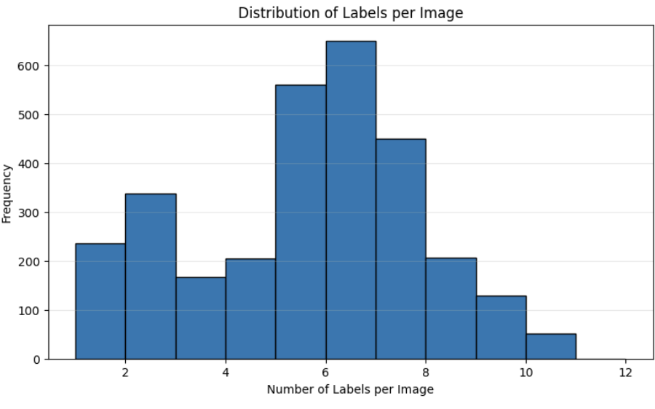
Figure 1: Distribution of the Number of Labels per Image (AID Multi-Label Dataset)

### 3.2 Dataset Statistics
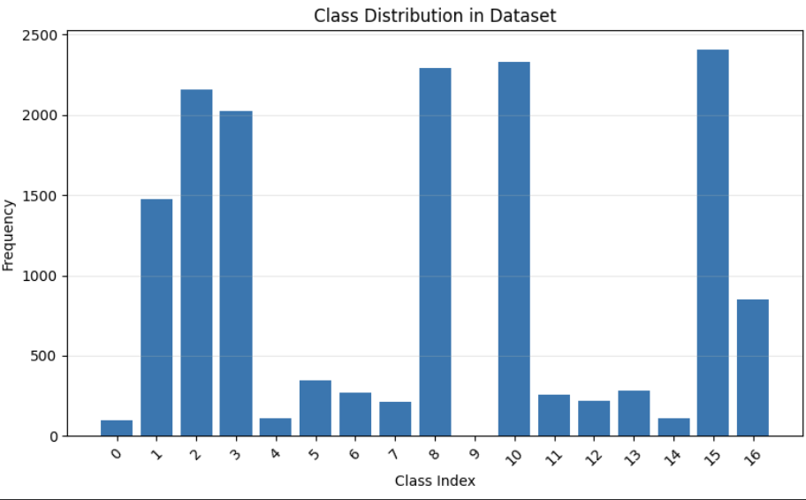
Figure 2: Class Frequency Distribution Across 17 Object Categories.

This graph shows the frequency of each class. 17 classes exist in the dataset and it shows each’s frequency. As seen, high class imbalance exists in the dataset. As seen, significant class imbalance exists as the following:

Most Frequent Classes:
- Pavement: 1,017 occurrences (33.9%)
- Trees: 1,018 occurrences (33.9%)
- Buildings: 920 occurrences (30.7%)
- Grass: 978 occurrences (32.6%)
- Cars: 859 occurrences (28.6%)

Least Frequent Classes:
- Mobile home: 29 occurrences (0.97%)
- Airplane: 37 occurrences (1.23%)
- Chaparral: 41 occurrences (1.37%)
- Tanks: 49 occurrences (1.63%)
- Sea: 92 occurrences (3.07%)

This 35:1 imbalance ratio between the most and least frequent classes presents a significant challenge for training balanced models. The class distribution analysis motivated our decision to implement weighted sampling strategies.

### 3.3 Dataset Split

We divided the dataset as follows:
- Training set: 2,100 images (70%)
- Validation set: 450 images (15%)
- Test set: 450 images (15%)

The stratified split ensures similar label distributions across all sets, with random shuffling (seed=42) for reproducibility.

## 4. Methodology

### 4.1 Overall Architecture

Our approach follows a transfer learning paradigm with the following pipeline:

```
Input Image (600×600 RGB)
↓
Data Augmentation & Preprocessing
↓
EfficientNet-B4 Backbone (Pre-trained on ImageNet)
↓
Global Average Pooling
↓
Classification Head (FC: 1536 → 512 → 17)
↓
Sigmoid Activation
↓
Multi-Label Predictions
```

### 4.2 Model Architecture

#### 4.2.1 Backbone Selection: EfficientNet-B4

We selected **EfficientNet-B4** as our backbone architecture for the following reasons:

1. **Compound Scaling**: EfficientNet employs compound scaling that uniformly scales network width, depth, and resolution, achieving better efficiency than scaling individual dimensions [7]

2. **Parameter Efficiency**: EfficientNet-B4 achieves competitive accuracy with 19M parameters, compared to ResNet50's 25M parameters, making it more suitable for deployment

3. **Proven Performance**: EfficientNet consistently outperforms ResNet on ImageNet and transfer learning benchmarks, particularly when fine-tuned on limited data

#### 4.2.2 Multi-Label Classification Head

The classification head consists of:
1. **Dropout layer (25%)**: Prevents overfitting by randomly dropping neurons during training
2. **Hidden layer (512 units)**: Provides additional non-linear transformation capacity
3. **Output layer (17 units)**: One neuron per class, outputting raw logits

**Key Design Decision**: We use **sigmoid activation** (not softmax) because labels are non-mutually exclusive. Sigmoid allows each class probability to be computed independently, enabling multiple high-probability predictions.

### 4.3 Training Strategy

#### 4.3.1 Loss Function

**Binary Cross-Entropy with Logits (BCEWithLogitsLoss)**:
- Combines sigmoid activation and BCE loss in a single operation for numerical stability
- Treats each label as an independent binary classification problem
- Suitable for non-mutually exclusive multi-label scenarios

#### 4.3.2 Addressing Class Imbalance: Weighted Sampling
To address the 35:1 class imbalance, we implemented **weighted random sampling**:

1. **Calculate label rarity weights**:
```
weight_j = 1 / (frequency_j + ε)
```

2. **Compute sample weights**: Each image's weight is the average weight of its positive labels

3. **Oversample rare classes**: WeightedRandomSampler ensures images with rare labels are selected more frequently during training

**Impact**: This strategy increased exposure to minority classes without discarding majority class samples, helping the model learn balanced representations.

#### 4.3.3 Optimization
The model parameters were optimized using the Adam algorithm, selected for its adaptive learning rate capabilities, with an initial learning rate of 0.001 and standard momentum coefficients ($\beta_1=0.9, \beta_2=0.999$). To impose regularization and mitigate overfitting, we applied L2 weight decay of $1 \times 10^{-4}$. The training process incorporated a dynamic learning rate schedule via ReduceLROnPlateau, which monitored validation loss and reduced the learning rate by a factor of 0.5 following 3 epochs of stagnation, ensuring finer gradient updates as the model approached convergence (with a minimum floor of $1 \times 10^{-5}$). Training was executed on an NVIDIA L4 GPU using a batch size of 32 for a maximum of 30 epochs. To prevent overfitting and conserve computational resources, an early stopping mechanism was implemented to terminate training if validation performance failed to improve for 7 consecutive epochs.

### 4.4 Data Augmentation
Given the high dimensionality of the problem and the limited size of the dataset, we implemented a rigorous data augmentation pipeline designed specifically for the unique characteristics of overhead imagery. Unlike natural scene photography, aerial images lack a canonical orientation (i.e., there is no fixed "up" or "down"). To leverage this, we applied heavy geometric transformations during training, including random horizontal and vertical flips (p=0.5) and random rotations of ±90°, forcing the model to learn rotation-invariant features. We further introduced scale variation by resizing source images to 256×256 pixels and performing a random crop to the target input size of 224×224.
To account for environmental variability—such as differing time-of-day lighting, sensor inconsistencies, and atmospheric haze—we utilized photometric augmentation. This included color jittering with a ±20% random shift in brightness, contrast, and saturation, along with a ±10% variance in hue. Finally, all inputs were normalized using standard ImageNet mean and standard deviation values to align with the pre-trained backbone.
In contrast to the stochastic nature of the training pipeline, the validation and test phases employed a deterministic preprocessing approach to ensure reproducibility. During evaluation, images were simply resized directly to 224×224 without cropping or geometric distortion, followed by the same normalization steps used in training. This distinction ensures that our evaluation metrics reflect stable model performance rather than artifacts of random augmentation.

### 4.5 Evaluation Metrics
To comprehensively evaluate the model's multi-label classification capabilities, we employed a suite of metrics designed to capture different aspects of performance beyond simple accuracy. While Micro F1 and Weighted F1 were calculated to gauge global and frequency-adjusted performance respectively, Macro F1 served as the primary evaluation metric; by averaging performance across classes independently, it mitigates the bias of frequent classes and provides the most robust assessment of the model's effectiveness on the imbalanced dataset. Complementary to these aggregated scores, we utilized Hamming Loss to quantify the overall fraction of mislabeled predictions and Subset Accuracy to measure the strictest standard of exact label set matching. Finally, granular per-class Precision, Recall, and F1 scores were generated to isolate and diagnose specific performance discrepancies across individual categories.

---

## 5. Experiments and Results

### 5.1 Training Dynamics

#### 5.1.1 Training Progress

The model was trained for **30 epochs** with the following convergence behavior:

**Loss Curves:**
- Training loss: Decreased from 0.322 (epoch 1) to 0.023 (epoch 30)
- Validation loss: Decreased from 0.203 (epoch 1) to minimum of 0.128 (epoch 9), then gradually increased to 0.208 (epoch 30)
- **Overfitting observed** after epoch 10, as validation loss increased while training loss continued decreasing

**F1 Score Evolution:**
- Validation micro F1: Improved from 0.857 (epoch 1) to 0.917 (epoch 23)
- Validation macro F1: Improved from 0.502 (epoch 1) to 0.807 (epoch 23) (best case)
- Early stopping did not trigger (patience=7) because macro F1 continued fluctuating

Learning Rate Schedule:
- Initial LR: 0.001
- LR reduction triggered at epochs: 13, 16, 20, 24, 27
- Final LR: 0.000031 (after 5 reductions by factor 0.5)

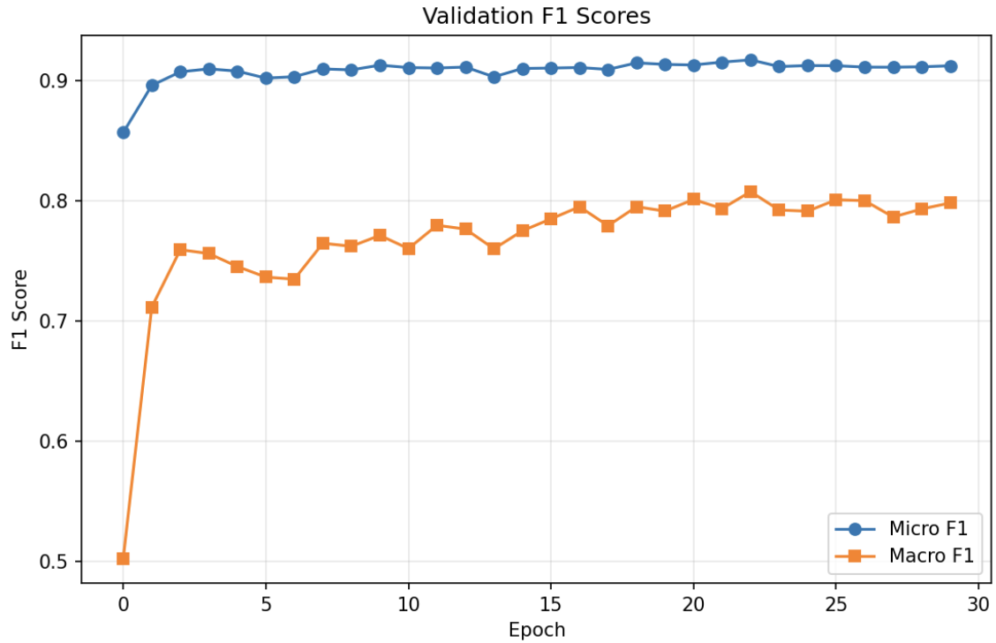

*Figure 1: Training and validation loss curves (left) and F1 score progression (right) over 30 epochs. The model achieves best validation macro F1 at epoch 23.*

#### 5.1.2 Best Model Selection

The best model was selected based on **validation macro F1** (not micro F1) to prioritize balanced performance across all classes. The model from epoch 23 achieved:
- Validation macro F1: **0.8074**
- Validation micro F1: 0.9171

### 5.2 Test Set Performance

#### 5.2.1 Overall Metrics (Threshold = 0.5)

The final model achieved the following performance on the held-out test set: Macro f1: 0.8097, micro f1: 0.9165, hamming loss of 0.0505. Macro F1 of 0.8097 shows the model performs reasonably well across all classes, including rare ones. Micro F1 of 0.9165 indicates excellent aggregate performance. The 0.107 difference (0.9165 - 0.8097) indicates some classes perform significantly worse than others, as expected with class imbalance

#### 5.2.2 Per-Class Performance Analysis

Detailed per-class results reveal which categories are challenging:

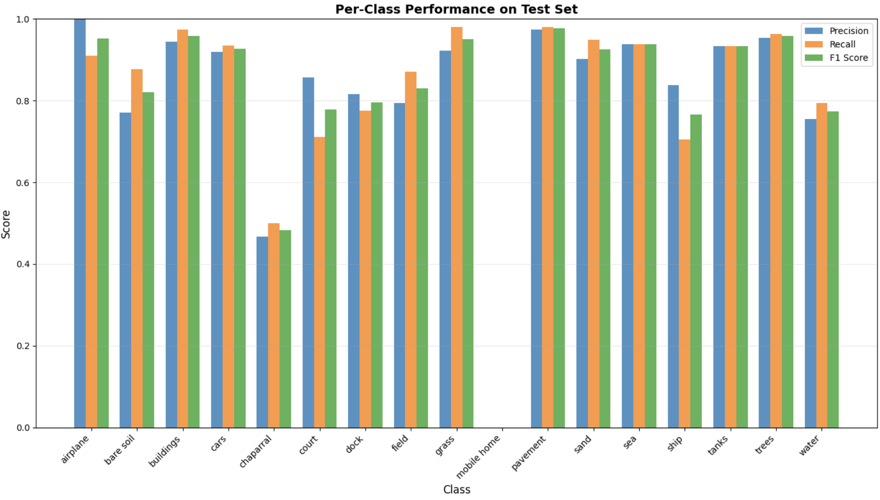

*Figure 2: Per-class precision, recall, and F1 scores showing strong performance on frequent classes and challenges with rare categories.*

Performance Analysis and Error Interpretation
The detailed analysis of the model's performance, based on the macro-averaged F1 score, reveals a strong correlation between class success and both label support quantity (sample size) and visual distinctiveness.
High-Performing Classes: The model achieved superior results in high-support and visually unambiguous classes. Pavement (F1: 0.9771), the most frequent class, along with Buildings (F1: 0.9590) and Trees (F1: 0.9582), both possessing high sample support (over 300 test samples), demonstrated robust detection capabilities. The success in these categories is attributed to their consistent visual appearance, such as the distinct geometric structures of buildings and the uniform texture of pavement.
Low-Performing Classes and Error Analysis: Conversely, performance degradation was concentrated in low-support categories, highlighted by a critical dataset anomaly. The Mobile home class registered an F1 score of 0.0000 due to having zero representation in the test set. This finding severely limits the evaluation for this specific label and indicates a critical imbalance or sampling issue in the dataset split. For other rare classes, such as Chaparral (14 test samples, F1: 0.4828), low scores primarily stemmed from visual ambiguity and high similarity to other vegetation types (e.g., fields or grass). The Ship class (44 samples, F1: 0.7654) also proved moderately challenging, likely due to scale variation and confusion with other water-based objects.
Impact of Class Imbalance: The quantitative effect of this class imbalance is significant. Classes with high support (>300 samples) achieved a mean F1 score of 0.9451, whereas low-support classes (<50 samples) averaged only 0.6754. This substantial 0.27 F1 point difference underscores the necessity of employing specialized techniques, such as weighted sampling, to mitigate the optimization bias towards majority background categories and improve performance on the rare classes.

## 6. Theoretical Design Justifications
To address the constraints of limited labeled data (2,100 training images), we employed an EfficientNet-B4 architecture initialized with ImageNet weights, selected over ResNet50 for its superior parameter efficiency derived from compound scaling and its ability to adapt low-level features to the aerial domain. For optimization, we utilized Binary Cross-Entropy (BCE) via BCEWithLogitLoss to ensure numerical stability through the log-sum-exp trick, preferring this standard baseline over complex alternatives like Focal Loss to establish robust training dynamics without additional hyperparameter tuning. This objective is complemented by a stochastic weighted sampling strategy rather than class-weighted loss, a design choice that ensures rare classes receive more frequent gradient updates while maintaining batch diversity and flexibility. Furthermore, to ensure robustness against the lack of canonical orientation and variable atmospheric conditions inherent in overhead imagery, the training pipeline incorporates domain-specific data augmentation, specifically random rotations for rotational invariance and color jittering to account for sensor and time-of-day variations.

## 7.1 Summary and Next Steps

We have successfully completed the initial phase of development for the multilabel aerial image classification system, achieving several key technical and research milestones. Technically, the system was built upon a transfer learning pipeline utilizing the EfficientNet-B4 backbone, which established a strong performance baseline on the AID_MultiLabel dataset. Crucially, we implemented a rotation-invariant augmentation pipeline and incorporated a weighted sampling strategy to effectively address the challenges posed by class imbalance. These core efforts resulted in meeting the minimum success criterion defined in the project proposal, yielding a macro F1 score of 0.8097 and a micro F1 score of 0.9165 on the test set. Our research contributions further include providing a detailed per-class performance analysis, which definitively demonstrated the effect of class imbalance and identified specific challenging categories—chaparral, mobile home, and ship—for future investigation and optimization.

7.2 Next Steps
Building on our current findings, several improvements can be implemented to enhance multi-label aerial scene classification performance. First, modeling label correlations can significantly strengthen prediction accuracy. Graph Convolutional Networks (GCN), particularly the ML-GCN [4] framework, can be used to construct a label co-occurrence graph from the training dataset and learn an adaptive adjacency matrix that captures dependencies such as harbor → water or stadium → parking. Additionally, attention mechanisms like CBAM can be integrated into the EfficientNet backbone to enable the model to focus on the most relevant spatial regions and emphasize important feature channels for each label.
Architectural improvements can also be considered. Ensemble strategies that combine EfficientNet-B3, EfficientNet-B4, and ResNet50 predictions may offer higher robustness, with final outputs obtained by averaging class probabilities before thresholding.
Finally, data-centric enhancements can further improve generalization. Advanced augmentation techniques such as Mixup, CutMix, and AutoAugment can introduce beneficial regularization and diversify the training distribution. Moreover, per-class threshold optimization on the validation set can better handle class imbalance and refine the final decision boundaries without requiring additional training. Collectively, these improvements offer a practical and effective roadmap for future development.

## 8. Conclusion

This project successfully developed a multi-label aerial image classification system achieving competitive performance on the AID_MultiLabel dataset. Our transfer learning approach using EfficientNet-B4 combined with weighted sampling and rotation-invariant augmentation yielded a macro F1 of 0.8097 and micro F1 of 0.9165, demonstrating strong overall performance while maintaining reasonable balance across classes.

The comprehensive experiments and analysis revealed both the strengths of modern transfer learning for aerial imagery and the persistent challenges posed by extreme class imbalance. Classes with sufficient training data (pavement, trees, buildings) achieve F1 scores above 0.95, while rare classes (chaparral, mobile home) remain challenging.

Our work establishes a strong foundation for future improvements. The roadmap of label correlation modeling, and ensemble methods provides a clear path to pushing performance toward the 0.85-0.90 macro F1 range.

## References

[1] Xia, G.-S., Hu, J., Hu, F., Shi, B., Bai, X., Zhong, Y., Zhang, L., & Lu, X. (2017). AID: A Benchmark Data Set for Performance Evaluation of Aerial Scene Classification. *IEEE Transactions on Geoscience and Remote Sensing*, 55(7), 3965-3981. https://doi.org/10.1109/TGRS.2017.2685945

[2] Hua, Y., Mou, L., & Zhu, X. X. (2020). Relation Network for Multilabel Aerial Image Classification. *IEEE Transactions on Geoscience and Remote Sensing*, 58(7), 4558-4572. https://doi.org/10.1109/TGRS.2019.2963364

[3] Wang, J., Yang, Y., Mao, J., Huang, Z., Huang, C., & Xu, W. (2016). CNN-RNN: A Unified Framework for Multi-label Image Classification. *Proceedings of the IEEE Conference on Computer Vision and Pattern Recognition (CVPR)*, 2285-2294. https://doi.org/10.1109/CVPR.2016.251

[4] Chen, Z.-M., Wei, X.-S., Wang, P., & Guo, Y. (2019). Multi-Label Image Recognition with Graph Convolutional Networks. *Proceedings of the IEEE/CVF Conference on Computer Vision and Pattern Recognition (CVPR)*, 5177-5186. https://doi.org/10.1109/CVPR.2019.00532

[5] He, K., Zhang, X., Ren, S., & Sun, J. (2016). Deep Residual Learning for Image Recognition. *Proceedings of the IEEE Conference on Computer Vision and Pattern Recognition (CVPR)*, 770-778. https://doi.org/10.1109/CVPR.2016.90

[6] Shabbir, A., Ali, N., Ahmed, J., Zafar, B., Rasheed, A., Sajid, M., Ahmed, A., & Dar, S. H. (2021). Satellite and Scene Image Classification Based on Transfer Learning and Fine Tuning of ResNet50. *Mathematical Problems in Engineering*, 2021, 5843816. https://doi.org/10.1155/2021/5843816

[7] Tan, M., & Le, Q. V. (2019). EfficientNet: Rethinking Model Scaling for Convolutional Neural Networks. *Proceedings of the International Conference on Machine Learning (ICML)*, 6105-6114. http://proceedings.mlr.press/v97/tan19a.html

