Universal Software-Driven Constraint Tracking Form

Purpose:
- This document captures constraints that originate from software itself, including architectural decisions, performance targets, concurrency limits, interface restrictions, and memory behavior.
- These constraints apply across various software domains (embedded, cloud, web, mobile, hybrid).

Constraint ID | Category | Constraint Description | Design Rationale | Owner | Impacted Requirements | Domain Application(s) | Impacted Components | Associated Standard(s) | Verification Method | Risk Impact | Status
SWC-01 | Performance | System shall generate route suggestions within ≤ 5 seconds after request. | Derived from PR-H01 to ensure responsiveness. | Erdem Baran | PR-H01 | Web | Routing Engine, DB | ISO/IEC 25010 | Latency Test | Medium | Planned
SWC-02 | Explainability / Transparency | The AI-based ranking module shall display key factors (weight, distance, category fit) used for route generation if the user wants. | Builds user trust and supports transparent decision logic for recommendations. | Tuna Kodal | FR-H02 | Web / Frontend | Recommendation Module, UI | ISO/IEC 23894, IEEE 7001 | UI Explainability Test | Medium | Planned
SWC-03 | User Rights / Ethical Control | Users shall be able to manually edit or override AI-generated routes . | Protects user autonomy and compliance with GDPR right to contest automated decisions. | Ebrar Sude Doğan | FR-H03 | Web | Route Replanning Module | GDPR Art. 22, KVKK Art. 11 | Functional Test | High | Planned
SWC-04 | Generalization / Model Robustness | The AI ranking model shall maintain ≤ 10% accuracy gap between training and validation datasets. | Prevents overfitting and ensures consistent recommendations across new inputs. | Kayrahan Toprak Tosun | FR-H02 | Web / Backend | Ranking Model | ISO/IEC TR 24029-1 | Model Validation Report / Cross-Validation | High | Planned
SWC-05
SWC-06
SWC-07
SWC-08
SWC-09
SWC-10
- Traceability to IEEE 29148 (SRS), ISO 26262 (safety), DO-178C (avionics), IEC 62304 (medical), and other domain-specific standards is enabled where required.

Approval & Control
Role | Name | Signature | Date
Project Manager | Ebrar Sude Doğan |  | 29.10.2025
Frontend Lead | Tuna Kodal |  | 31.10.2025
Backend & Integration Lead | Kayrahan Toprak Tosun |  | 31.10.2025
 | Erdem Baran | 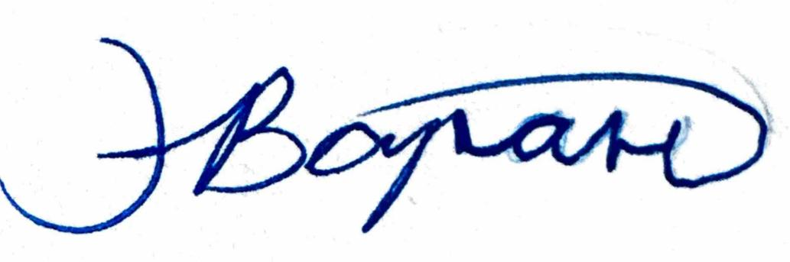 | 19.11.2025

