# TITLE PAGE

**STUDENT ONLINE MARKETING SYSTEM**

**FOR**

**USMAN DANFODIYO UNIVERSITY**

**BY:**

**YOUR NAME**

**YOUR REGISTRATION NUMBER**

**A PROJECT REPORT PRESENTED TO THE DEPARTMENT OF COMPUTER SCIENCE, FACULTY OF COMPUTER SCIENCE AND INFORMATION TECHNOLOGY, USMAN DANFODIYO UNIVERSITY, IN PARTIAL FULFILMENT OF THE REQUIREMENT FOR THE AWARD OF BACHELOR OF SCIENCE (B.Sc.) DEGREE IN COMPUTER SCIENCE.**

**NOVEMBER, 2017**

# DECLARATION

I, YOUR NAME with registration number YOUR REGISTRATION NUMBER hereby declare that this project titled Student Online Marketing System for Bayero University Kano is my original work and has not been presented elsewhere for the award of degree or certificate.

. . . . . . . . . . . . . . . . . . . . . . . . . . . . . . . . . . . . . . . . . . . . .

Signature of Student Date

# CERTIFICATION

This is to certify that this project entitled **“STUDENT ONLINE MARKETING SYSTEM FOR USMAN DANFODIYO UNIVERSITY”** by YOUR NAME has been approved, having met the partial fulfillment of requirements governing the award of Bachelor of Science (BS.C Computer Science) in the Department of Computer Science, Faculty of Computer Science and Information Technology, USMAN DANFODIYO UNIVERSITY, Nigeria.

……………………………….. …………………………….

**SUPERVISOR NAME Date**

**Supervisor**

……………………………….. ………………………………..

**HEAD OF DEPTNAME Date**

## Head of Department

. . . . . . . . . . . . . . . . . . . . . . . . . . . . . . . . . . . . . . . . . . . . . . . .

**PROJECT COORDINATOR NAME** **Date**

# Project Coordinator

# DEDICATION

I wish to dedicate this project to my beloved parents, FATHER NAME and MOTHER NAME and to my entire family who have supported me throughout the course of my study.

# ACKNOWLEDGEMENT

First, I wish to give thanks to Almighty Allah who gave me the ability to exist and thrive in this world.

I wish to express my profound gratitude to my entire family, my parent, brothers and sisters. Thank you all for your unwavering support.

Special thanks goes to my supervisor in person of SUPERVISOR NAME for his time effort, support and encouragement. I am truly grateful and appreciative of your efforts.

I will like to acknowledge the excellent, enormous support of the H.O.D computer science department and the entire staff. Thank you all, it has really been a wonderful experience.

Finally, I will like to acknowledge my friends, course mates and faculty staff. You have made this experience worthwhile.

**TABLE OF CONTENTS**

Title Page i

Declaration i

Certification ii

Dedication iii

Acknowledgement iv

List Of Table vii

List Of Figures viii

Abstract ix

**CHAPTER ONE**

1.1 Introduction 1

1.2 Problem Statement 2

1.3 Aim And Objectives 2

1.4 Significance Of The Study 3

1.5 Scope And Limitations 3

1.6 Methodology 4

1.7 Definition Of Terms 4

**CHAPTER TWO**

**LITERATURE REVIEW**

2.1 Introduction 5

2.2 An Overview Of Marketing 5

2.2.1. Concept Of Marketing 5

2.2.2. History Of Marketing 8

2.3 An Overview Of The Internet 12

2.4 Development Technologies And Platforms 12

2.4.1 Web Application Development Technologies 12

2.4.2 Evolution Of Web Application Development Technologies 13

2.5 Review Of Related Works 14

**CHAPTER THREE**

**SYSTEM ANALYSIS AND DESIGN**

3.1 Introduction 15

3.2 System Development Lifecycle 15

3.2.1 Iterative Lifecycle Model 16

3.3 System Analysis 17

3.3.1 System Analysis Requirement Definition 17

3.3.2 Description Of The Existing System 17

3.3.3 Shortcomings Of The Existing System 18

3.3.4 Description Of The Proposed System 19

3.3.5 Requirement Elicitation And Analysis 19

3.3.5.1 Functional Requirement 20

3.3.5.2 Non-Functional Requirement 20

3.3.6 Use Case Diagram 21

3.4 System Design 24

3.4.1 System Modelling 24

3.4.1.1 Sequence Diagram 24

3.4.1.2 Uml Class Diagram 27

3.5 Database Design 27

3.5.1 Database Structure 28

**CHAPTER FOUR**

**SYSTEM IMPLEMENTATION AND TESTING**

4.1 Introduction 29

4.2 System Implementation 29

4.2.1 Choice Of Programming Language And Ide 29

4.2.2 Features Of The System 30

4.3 Testing 34

4.3.1 Unit Testing 34

4.3.2 Integration Testing 36

4.3.3 System Testing 37

4.4 System Specification 37

**CHAPTER FIVE**

**SUMMARY, CONCLUSION AND RECOMMENDATION**

5.1 Introduction 39

5.2 Summary 39

5.3 Conclusion 40

5.4 Recommendations 40

References 41

# LIST OF TABLE

Table 3.1 Table Name: Admin Table 28

Table 3.2 Table Name: Students Table 28

Table 4.1: Web based 35

Table 4.3: Integration testing 36

Table 4.4: Hardware requirements 38

Table 4.5: Software Requirements 38

# LIST OF FIGURES

Figure 3.1: Iterative software process model 16

FIG 3.2: USECASE DIAGRAM. 21

Figure 3.3: Login Sequence diagram 24

Figure 3.4: View Items Sequence diagram 25

Figure 3.5: Sequence Diagram for Admin Interface 26

Figure 3.6: UML Class Diagram 27

Figure 4.1: Login form 30

Figure 4.2: Users Page 31

Figure 4.3: New Seller Form 31

Figure 4.4: New Category 32

Figure 4.5: Post Product Form 32

Figure 4.6: Upload Product Photo Page 33

Figure 4.7: Photo Upload Successful Page 33

Figure 4.8: Homepage 34

# ABSTRACT

## As generations evolve and technology develops, the advancement in the field of marketing and advertisements has been immense. Businesses are no longer bound by the limitations of traditional marketing techniques. One of the newest and most effective strategies has been online marketing, which is the topic for this project. Online marketing involves the use of internet to advertise and sell goods and services. This project deals with developing an online marketing website for students of USMAN DANFODIYO UNIVERSITY. The seller can use the web based system to g post products while the buyer can view the product details. Also, that admin can manage and update the system. The implementation of the automated marketing system was carried out using these technologies and languages: PHP, MySQL, JSON, XML, HTML, CSS and Sublime Text.

# 

# CHAPTER ONE

# 1.1 INTRODUCTION

Marketing is the process by which products are developed and brought to the market. The process starts by doing market research and finding buyer needs in the marketplace that are not being satisfied. These unsatisfied needs are also called market niches or segments. They represent spaces or holes in the market that are opportunities for companies or organizations to fill. Successful companies uniquely position themselves to penetrate these open windows of opportunity by developing products and other marketing strategies to satisfy the unfulfilled needs identified. (Kalb, 2002)

Mobile communication has transformed the way people live and work. Mobile devices allow mobile users to send email and text messages, access internet, play games, listen to music, access data and much more. The recent advances in mobile communication technology and striking adoption of mobile phones and other handheld devices give rise to the evolution of mobile business and mobile marketing activities. Mobile communication has a significant impact on business. As mobile device manufacturers and mobile network operators improve their services and products, mobile communication becomes the mainstream and changes the way of doing business. (Information Research Management Association, 2012)

Online marketing is a form of electronic commerce which allows for marketing of goods and services using digital technologies, mainly on the internet but also including mobile phones, display advertising and any other digital medium. In other words, online marketing allows consumers to directly buy goods or services from a seller over the internet using a web browser. An online shop evokes the physical feeling of buying products or services at a bricks and mortar retailer or shopping center, this process is called business-to-consumer (B2C) online shopping.

Ultimately, the goal of marketing online is to create a memorable experience for the visitors for the visitors to your site (Columbus, 2000). Marketing the right products using the internet makes all of our lives better. It frees us from repetitive and laborious tasks, gives us breakthrough to eradicate disabling diseases, improves our educational opportunities, and enables us to communicate better with each other around the globe.

Student online marketing system for USMAN DANFODIYO UNIVERSITY is a digital marketplace that is designed to serve as an effective and efficient way of automating business transactions in the university. This web application will reduce the hardships caused by the manual system by creating a digital platform for students who wish to sell their products.

# 1.2 PROBLEM STATEMENT

The process of business transactions in Bayero University is done manually. The manual system of business transaction does not enable students with small businesses to advertise their products to the entire student body. Students who want to sell their personal belongings or any marketable product find it difficult using the manual system. It also leads to time consumption, fatigue and other inconveniences. Having observed the difficulties involved, there is a need to automate the system by developing a new automated system where entrepreneurs and buyers can interact with each other.

# 1.3 AIM AND OBJECTIVES

The aim of this project is to develop an online marketing system for students and small businesses in Bayero University. The objectives of the new system are:

* To identify the shortcomings of the manual system.
* To design a web application that will automate business activities in USMAN DANFODIYO UNIVERSITY.
* To implement a new web application in USMAN DANFODIYO UNIVERSITY that will automate business operations among students.

# 1.4 SIGNIFICANCE OF THE STUDY

The students of USMAN DANFODIYO UNIVERSITY are currently practicing a manual system of business. The following are what will be achieved by the automated system:

1. The system will enable sellers to be open for business at all times without worrying about closing hours. Also, displaying products on the internet is also convenient for customers. They can browse the online store at anytime, anywhere and contact the buyer whenever it is convenient for them.
2. By marketing on the internet, barriers like distance, can be overcome. Students can sell goods from any part of the university without setting up local outlets, thereby widening their target market.
3. Marketing products on the internet costs less than marketing them through a physical retail store. Students do not have to deal with recurring costs of property rental and maintenance.
4. The internet provides an important platform for building relationships with customers and increasing customer retention levels. When a customer purchases a product from a seller’s online store, the seller can begin a relationship by sending a follow-up message to confirm the transaction and thank the customer. Also messaging the customer about special offers and new stock can help maintain the relationship. Customers can also submit reviews on products, helping to build a sense of community.

# 1.5 SCOPE AND LIMITATIONS

This project is designed to highlight the need and importance for commercial activities in Bayero University Kano. The University provides a lot of business opportunities for students and small businesses within the campus. This study is mainly centered on the marketing system of students in Bayero University Kano.

The web application requires network connectivity in order to access the contents of the application. The web application works on mobile phones, PCs and tablets using web browsers. The web application cannot ensure the delivery of goods, the customer has to directly contact the seller. There is no provision for online order of goods, when a customer wants to buy a certain product, he can do that by using whichever contact medium was listed by the seller.

# 1.6 METHODOLOGY

The web application will be implemented using Hypertext mark-up language (HTML) to design the graphical interface, PHP as programming language, JavaScript and JavaScript query for handling the logic and query language. MySQL for the database which is hosted on local WAMP server, Cascading style sheet (CSS) to format the layout of the mark-up and Sublime Text as text editor.

# 1.7 DEFINITION OF TERMS

1. RETAIL: Retail is the sale of goods to the public in small quantities for consumption and not for sale.
2. CUSTOMER: A customer is a person who buys goods or services from a shop or business.
3. CONSUMER: A person who buys goods and services for their own use.

# CHAPTER TWO

# LITERATURE REVIEW

# 2.1 INTRODUCTION

This chapter contains conceptual framework of marketing, overview of marketing and the internet, brief history of marketing, history of marketing in Bayero University, development technologies and platforms and reviews on related topics.

# 2.2 AN OVERVIEW OF MARKETING

Marketing is the social process by which individuals and organizations obtain what they need and want through creating and exchanging value with others. (Kotler and Armstrong 2010). Marketing is defined as a set of processes for creating, communicating and delivering value to customers and for managing customer relationships in ways that benefit the organization and its stakeholders’ (American Marketing Association, 2011).

There are many views and definitions of marketing by different authors but the most important role of marketing is to recognize and satisfy its customers. Therefore, it is more important than ever for organizations to build strong customer relationships based on real and enduring value (Phillip Kotler et al, 2015).

# 2.2.1. Concept of Marketing

There are many marketing definitions. The better definitions are focused upon market orientation and the satisfaction of customer needs. In broad terms, a market can be defined as those potential customers who share a similar want or need and who are able and willing to commit their resources to satisfy that want or need. Having decided to participate in a given market, it is then necessary to decide what portion, or segment of the market can feasibly be served with a given marketing strategy or mix. (Jenster, Hayes and Smith, 2005)

Marketing involves more than just activities performed by a group of people in a defined area or department. Marketing entails processes that focus on delivering value and benefits to customers. It uses communication, distribution and pricing strategies to provide customers and other stakeholders with the goods, services, ideas, values and benefits they desire when and where they want it. It involves building a long-term, mutually rewarding relationships when these benefits all parties concerned(Lamb, Hair & McDaniel, 2011)

Given that the fulfilment of customer satisfaction is the key to business success. McCarthy (1960) suggested the concept of the marketing mix (the 4Ps), which are: product, price, place and promotion. These variables form the key elements within the market function and can be adapted in order to generate and sustain customer satisfaction. Each ‘P’ contains various factors that can be emphasized to meet customer needs. All elements in the mix are interrelated. A change in product formulation may need to be reflected in the promotional element of the mix. The 4Ps are the vital decision areas for marketing managers as they offer controllable variables which can be innovatively applied in specific markets. (Blythe, 2009)

The following summarizes the key elements in the mix:

* Product: Products are solutions to customers’ needs. The provider needs to make various product decisions, including functionality, range offered, brand names, packaging, service and support. The product is normally the critical element in the mix, with all other decisions relating to this element.
* Price: This element determines what a provider is paid. Various price-setting models exist with decisions relating to factors like market penetration, credit terms, discount policy and cost of provision. It should be noted that the price is not always paid directly by the customer. For example, a charity may receive a government grant to provide services free of charge to worthy causes.
* Place: Place is mostly described as distribution. It is about making the product available. Some form of structured network is normally required; a distribution channel. However, true marketing power may lie with the control of the product.
* Promotion: The promotional element of the mix provides communication with the desired group. A range of mechanisms can be deployed for this purpose such as advertising, public relations, direct mail, internet marketing, selling and sales promotion. The blend of methods is often referred to as the communications mix. Generally, promotion aims to make a target market aware of a product offering, develop a long-term relationship with the customer and create and stimulate demand. (Blythe, 2009)

One desired outcome of marketing, is an exchange, people giving up something to receive something they would rather have. Normally, we think of money as the medium of exchange. We “give up money” to “get” the goods and services we want. However, exchange does not require money. Two persons may barter or trade such items such as baseball cards or oil paintings. An exchange can take place only if the following five conditions exist:

1. There must be atleast two parties.
2. Each party has something that might be of value to the other party.
3. Each party is capable of communication and delivery.
4. Each party is free to accept or reject the exchange offer.
5. Each party believes it is appropriate or desirable to deal with the other party.

Exchange will not necessarily take place even if all these conditions exist. They are, however, necessary for exchange to be possible. For example, you may place an advertisement in your local newspaper stating that your used car is for sale at a certain price. Several people may call you to ask about the car, some may test-drive it, and one or more may even make you an offer. All five conditions are necessary for an exchange to exist but unless you reach an agreement with a buyer and actually sell the car, an exchange will not take place. Notice that marketing can occur even if an exchange does not occur. In the example above, you would have engaged in marketing even if no one bought your used car. (Lamb et al, 2011)

# 2.2.2. History of marketing

During the late 18th and early 19th centuries, the Industrial Revolution made cheap mass production of consumer goods possible for the first time. The cost of producing (for example, clothing) fell to less than a tenth the cost of tailor-made clothing, and even if the clothing was rather standardised and boring. It still sold due to the price advantage. This is called production orientation, and works well in situations where demand exceeds supply. The strategic emphasis in business was to reduce costs as much as possible and compete on price, production issues were at the forefront of thinking.

With so many manufacturers competing and such huge quantities of goods being manufactured, markets became saturated. Firms began to look for better products and began to add more and more features. By the end of the 19th century, products became complex and even cumbersome. The search for the ideal product that does everything for everybody is called product orientation. The strategic emphasis shifted to the product and product development, rather than the process of production. (Blythe, 2000)

When products were still piled up in the warehouses some firms took the view that people needed to be persuaded to buy them, and that they would not buy enough products unless someone pressured them into buying. This is called selling orientation and was popular in the 1920s and 1930s. Selling orientation assumes that people do not mind being sold to, that having bought more than they intended, they will be happy to buy more next time the sales representative calls, and that they will not complain if the goods do not match their needs very well. The strategic thrust of business at this time was on the selling function; it was assumed that any defects in the product could be covered up by slick sales techniques. (Blythe, 2000)

In the 1950s and 1960s, organizations realized that they could produce products and services that were tailored to specific areas of the market. These areas (called segments) comprised groups of customers with similar needs. Products were made which met the needs of these groups as exactly as possible. This meant that resources were not wasted adding features that the segment did not want. Economics of scale could keep costs low, but customers’ needs would still be met. This is customer orientation.

Overtime this has involved the development of market research and analysis skills to identify market segments, and to identify the key needs of those segments. Strategic emphasis shifted to the customer, and the customer’s needs, rather than the company and the company’s needs. The assumption is that the company’s needs will best be met by creating satisfied customers. (Blythe, 2000)

Market orientation takes the concept to a further level, in that the firm’s strategic planners take the overall market (which includes competitors and other stakeholders) into account when formulating strategy. Marketing orientation is an internal concept which holds that all the firm’s activities have a direct bearing on its relationship with the market and therefore all members of any organisation have some responsibility for marketing. (Blythe, 2000)

It would be wrong to suppose that all organizations now subscribe to a customer orientation; many are still production, product or sales driven. The development of marketing did not end in the 1980s. During the 1970s and 1980s, the concept of societal marketing was developed. The orientation suggests that the organization should take account of the needs of society at large, including other stakeholders such as employees, government, the general public and the long-term future of the planet, and ultimately, the human race. This is a somewhat broad remit for most organizations, but it does have the advantage of taking account of environmentalist lobbies. Since environmental groups have proved fairly effective of marketing their own ideas, the concept of societal marketing has faded into the background. (Blythe, 2000)

During the 1990s, marketing thinking moved towards the relationship marketing concept. Traditional marketing has tended to concentrate on the single transaction with a short-term focus. Relationship marketing focuses on the ‘lifetime’ value of the customer. (Blythe, 2000)

Marketing in the 21st century presents many new challenges. Shrinking markets, environmental issues, runaway advances in communications technology and rapidly changing public attitude towards consumption and communication predicate major changes not only in marketing techniques but in corporate strategy many times. In an era of constant change, marketing cannot afford to stand still. (Blythe et al, 2005)

In some ways, the role of marketing is shifting from strategic function to a tactical one as consumers become more powerful. The strategic role of marketing has sometimes been seen as patriarchal; the powerful, all knowing marketers providing consumers with what the research says is best for them. For some time, in the face of unpredictable consumer responses, fragmentation of societies and increasing individualism, this model has been breaking down. This means that the market research findings no longer act as truly effective predictors in many cases, and marketers are therefore left to respond as effectively as they can to consumer demands through interactive media. (Blythe et al, 2005)

This set of circumstances will lead to a change in the way marketing operates. Of course, the traditional manufacturer domination will continue in some markets, and the retailer domination of major chain stores will also continue. But the increasing ability of consumers to make their purchases almost anywhere in the world and to access information from almost anywhere will increase the pressure on marketers to upgrade their activities to maximise effectiveness and efficiency. (Blythe et al, 2005)

# 2.2.3. History of Bayero University Kano (USMAN DANFODIYO UNIVERSITY)

The seed of Bayero University Kano was the Ahmadu Bello College set up in 1960, located within the School for Arabic Studies (SAS), in the old city of Kano. With the establishment of Ahmadu Bello University, Zaria, in 1962, it was renamed Abdullahi Bayero College. In 1964, it moved to a temporary site at the old Kano Airport Hotel, admitting its first set of ten undergraduate students for a B.A. degree programme of Ahmadu Bello University.

This first set graduated in 1966 but it continued as a faculty of ABU until 1980. Before then the temporary site had attracted hostile fire during the civil war and had to move to its permanent site (present old campus) in the vicinity of Kabuga and Dukawuya gates on the Kano-Gwarzo road. The next phase of development occurred in 1975, when Abdullahi Bayero College was raised to the status of a University College with the right to award degrees on behalf of Ahmadu Bello University and was renamed Abdullahi Bayero University College, with its own Governing Council.

All University colleges in Nigeria were raised to the status of full-fledged universities in 1977 by the Federal Government and Abdullahi Bayero University College became Bayero University Kano (USMAN DANFODIYO UNIVERSITY) (backed by the promulgation of USMAN DANFODIYO UNIVERSITY Decree no 79 of 1979). Dr. Mahmud Tukur, the Principal of the University College became its pioneer Vice Chancellor (1977-1978) leading the team that laid the foundation and initiated the process that gave rise to the present permanent site and the shape of the university as we know it today. (www.USMAN DANFODIYO UNIVERSITY.edu.ng)

# 2.3 AN OVERVIEW OF THE INTERNET

The internet started as a technological revolution, designed to protect national interests by ensuring redundancy and resiliency in governmental networks, particularly in time of war. It has spawned a worldwide cultural revolution, fostering universal communication exchange with limitless geographic, time and subject matter boundaries. The extent and ease of the internet’s adoption has had profound implications in all aspects of life; personal, business, and governmental. There is no place on earth that cannot be reached by internet. (Morreale and Terplan, 2009)

The growth of the internet is perhaps the single greatest contributing factor to the communication explosions. The internet is now commercial, and almost any individual, school, or company can subscribe to a service that connects to the internet, as well as register a unique domain name (i.e, [www.mysite.com](http://www.mysite.com)) receive automatic information updates, and transmit and receive video and audio. (Barron, 2002)

# 2.4 DEVELOPMENT TECHNOLOGIES AND PLATFORMS

# 2.4.1 Web Application Development Technologies

The process and practice of developing web applications is known as web application development. Free-servers defined a website as a collection of web pages (documents that are accessed through the internet). Any content-centric information provided and accessed over the web with the use of a web browser is known as a website (Webapp, 2012). Web Technologies include: CSS, ASP, CGI, Html, Java, JavaScript, PHP, Ruby, Python etc.

# 2.4.2 Evolution of Web Application Development Technologies

Web was introduced by Tim Burners-Lee in late 1989 (Maged, Boulous & Wheeler, 2007). Tim Burners Lee views on the capabilities of the Web were expressed by three innovations, typically associated with three phases: namely, the Web of documents (Web 1.0), the Web of people (Web 2.0) and the Web of data (the still-to-be-realised Web 3.0) (Anderson, 2007). The WWW takes a journey from 1.0 to 4.0, with each transformation imbibed in its advancement in technologies and technological features. Web 1.0 was characterized as the cognition web, web 2.0 as communication web, web 3.0 as cooperation web and web 4.0 as integration web (Aghaei, Ali & Khosravi, 2012).

Web 1.0 was the first implementation of the web (1989 – 2005), it was mainly a read-only and was static and somewhat mono-directional (Aghaei et al., 2012). Web 2.0 was defined by Dale Dougherty in 2004 as a read write web (Berners, 1998). Web 2.0 preside over features like participatory, distributed practices which enable formal and in-formal spheres of daily activities on going on the web, flexible web design, creative reuse, updates e.t.c (Aghaei et al., 2012). One of prominent features of web 2.0 is to support collaboration and to help gather collective intelligence rather web 1.0 (Murugesan, 2007).John Markoff of the New York Times suggested web 3.0 as the third generation of the web in 2006 (Spivack, 2011). Web 3.0 can also be stated as “executable Web” (Choudhury, 2004). The basic idea of web 3.0 is to define structured data and link them in order to enable more effective discovery, automation, integration, and reuse across various applications (Nykänen, 2003)**.** Web3.0 supports world wide database and web oriented architecture which was described as a web of document.Web 4.0 is also known as symbiotic web.Although there is no exact idea about web 4.0 and its technologies, but it is obvious that the web is moving toward using artificial intelligence to become as an intelligent web.

# 2.5 REVIEW OF RELATED WORKS

In the literature, there has been several research papers that have discussed the experience of a number of universities around the world to implement an online market application. Delafrooz, Narges et al (2010) analyzed that there were four main factors which influenced consumers’ attitude towards online shopping. These factors were utilitarian orientation, convenience, price and wider selection. He discussed that there were three more things which affected the sales of e-tailers. These were personalities of consumers, online shopping perceived benefits and material of shopping sites. If an e-marketer wanted a utilitarian as their consumers then they should be task oriented and if they wanted hedonics as their consumers, they should focus on the attractiveness and user friendly attributes of their shopping sites.

Adam et al (2004) discussed the underlying factors related to personal online shopping in the workplace. They also gave the reasons for online shopping at work and those were boredom, connection speed, convenience, work life balance, efficiency, etc. In their study, they found that Americans were fonder of shopping online at workplace than Canadians. The main reason is that there was faster connections.

Syed et al (2008) analyzed that there were four key factors which influenced the young consumer’s perception towards online shopping. They found that those factors were website design, website reliability, customer service and privacy. They also discussed that there was no difference among the perceptions of various races towards online shopping in Malaysia. The most consistent factor that influenced buyer’s behavior towards online shopping was found to be Trust E-tailers need to add trust and reliability, which is everything for the buyers.

# CHAPTER THREE

# SYSTEM ANALYSIS AND DESIGN

# 3.1 INTRODUCTION

This chapter contains discussion on how data was sourced from the existing (manual) system, analysis of the data with the aim of finding a better procedure to computerize the existing system and the design of the new (computerized) system.

System analysis is referred to as the systematic examination or detailed study of a system in order to identify problems of the system, and using the information gathered in the analysis stage to recommend improvements or solution to the system. System design is an abstract representation of a system component and their relationship and which describe the aggregated functionality and performance of the system.

# 3.2 SYSTEM DEVELOPMENT LIFECYCLE

Software development life is the standard that defines all the tasks required for developing and maintaining software (Roebuck, 2011). The goal of a software development process is to produce a software that works on time, within budget and can be maintained and reused. Software development life cycle (SDLC) is the methodology used by system developers to produce a reliable and well developed software. The outcome of this study is a web based system. The software model adopted for this system is the iterative enhancement model also known as the iterative model.

# 3.2.1 Iterative Lifecycle Model

An iterative lifecycle model does not attempt to start with a full specifications of requirements. Instead, development begins by specifying and implementing only a part of the software, which is then repeated, producing a new version of the software at the end of each iteration of the model. In iterative model, the product is built step by step, therefore all shortcomings can be tracked and rectified from the early stages of the product. This is suitable for developing websites. The diagram below is a representation of iterative lifecycle model:

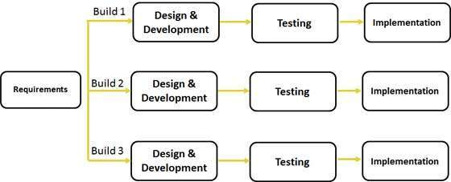

### Figure 3.1: Iterative software process model

**Source**: [www.tutorialspoint.com](http://www.tutorialspoint.com)

3.3 SYSTEM ANALYSIS

System Analysis is a methodology that involves the application of systematic approaches to collects facts about an existing system with the aim of improving it or replacing it with more efficient system within the context of the available resources. The system analysis part of this project is aimed at achieving two major objectives. Firstly, to examine the existing process in use, which would give several results that will help in analyzing the existing system and the second objective is to gather all the logical requirements required to successfully implement the proposed system best upon the findings of the system analysis phase.

# 3.3.1 System Analysis Requirement Definition

The software requirements are description of features and functionalities of the target system. Requirements convey the expectations of users from the software product. Requirement analysis is an important aspect of project management. It involves determining user’s expectations for a new or modified product. Requirements constitute a specification for the new system. They serve as a contract between customers and developers (Mylopoulos, 2004). The requirement of the system will be from the students in USMAN DANFODIYO UNIVERSITY who will be the users. The admin officer is responsible for administering while the students remain the users of the system.

# 3.3.2 Description of the Existing System

The process of business transactions in Bayero University is done manually. The manual system of business transaction does not enable students with small businesses to advertise their products to the entire student body. Students who want to sell their personal belongings or any marketable product find it difficult using the manual system. It also leads to time consumption, fatigue and other inconveniences.

# 3.3.3 Shortcomings of the Existing System

The following are the problems of the existing system:

* Cost of rent for opening shops.
* Time consuming.
* Inconvenience and stress to the buyers because they have to go to wherever the seller is in order to buy what they want.
* Sellers have to post physical adverts on notice boards which might not reach the notice of a lot of students,

# 3.3.4 Description of the Proposed System

The proposed system helps tackle the manual system shortcomings. The seller can sign up by entering a full name, an email and a password which will enable in opening an account. Upon successful validation, he/she can post items that they have for sale along with their contact information using the web based systems. Buyers can log on to the website by using a web address that can be accessed with a web browser on his/her phone and view items that are on sale.

# 3.3.5 Requirement Elicitation and Analysis

The term requirement means Condition or Capability that must be met by a system, Requirement elicitation also known as requirement gathering is the practice of obtaining the requirements of a system from users, customers and other stake holders (Rowel et al., 1997). However, the information required for the project are categorized into two:

1. Information based on the current manual system of marketing.
2. Information based on a suitable option for marketing by students which is the automation,

These two information comes from the following sources:

1. Interview with the students.
2. Observation.
3. Internet, articles and journals.
4. Brainstorming

# 3.3.5.1 Functional Requirement

Functional requirement describes the interactions between the system and its environment independent of implementation. The functional requirements of the marketing system consists of the web based technology functional requirement.

1. Admin shall be able to log on to the system.
2. Admin shall be able to add and manage sellers.
3. Admin shall be able to update items.
4. A seller shall be able log onto the system.
5. A seller shall be able to view his items and update item details.
6. A buyer shall be able to log onto the system.
7. A buyer shall be able to view items and contact sellers.
8. Admin shall be able to logout of the system.
9. A seller shall be able to logout of the system.

# 3.3.5.2 Non-functional Requirement

The non-functional requirements of the system are:

1. User friendly: The system should be easy to use and understandable.
2. Maintainability: The system should be easy to maintain and accommodate changes.
3. Security: The system should provide the password security access control to avoid unauthorized user to login to the system.
4. Responsiveness: The system should respond to a user’s command immediately.
5. Reliability: The system should be reliable and dependable.

# 3.3.6 Use Case Diagram

BUYER

SELLER

ADMINISTRATOR

### FIG 3.2: USECASE DIAGRAM.

1. **Login:**

The user shall be able to log onto the website using his/her username and password and will be denied if either the username or password are not valid.

Actor: Buyer, Administrator

Precondition: None

Post condition: If the use case is successful, the login page will be displayed else nothing will be displayed.

1. **View Category:**

The user shall be able to see items that will be posted in each category by the seller. The admin shall be able to view postings after generating it.

Actor: Buyer, Admin

Precondition: Items

Post condition: If the use case is successful, the view category page will be displayed otherwise nothing will be displayed.

1. **Choose Category:**

The buyer shall be able to choose between several categories of item that will be displayed on the homepage.

Actor: Buyer

Precondition: Select category

Post condition: If the use case is successful, the page of the category selected will be displayed else it will not.

1. **View Item:**

The admin is responsible for managing all item updates. Seller shall be able to post new items and remove sold items. The buyer shall be able to view all items on sale from all categories.

Actor: Administrator, Seller, Buyer

Precondition: None

Post condition: If the use case is successful, the items page will be displayed and updated else nothing will happen.

1. **Sign Up:**

The admin is responsible for managing all the account sign up requests by validating the information of potential sellers. Adding new sellers or updating an old sellers.

Actor: Administrator

Precondition: None

Post condition: If the use case is successful, the website will be displayed and updated, else nothing will happen.

1. **Upload Item:**

The system shall enable a seller to upload new items. The system shall be able to uplad the website to display the updated items.

Actor: Seller, Administrator

Precondition: None

Post condition: If the use case is successful, the items page will be displayed else nothing will be displayed.

1. **Logout**

The system shall enable a seller to exit from his/her account regardless of whether an action is carried out or not.

Actor: Seller, Administrator

Precondition: Login

Post condition: If the use case is successful, the logout page will be displayed else nothing will be displayed.

# 3.4 SYSTEM DESIGN

System design is said to be the descriptive in nature of what the system is and what it does and shows how the expected program is to be operated (John, Robert & Stephen, 2010). The system is designed to be web based with a user site and admin site.

# 3.4.1 System Modelling

# 3.4.1.1 Sequence Diagram

The sequence diagrams below show how various objects interacts with others in a particular scenario of a use case:

Enter email and password

Submit details

Getlogin details

: Login

: Login Detail

: Login Checker

Check login

Success or error message

### Figure 3.3: Login Sequence diagram

Execute details

Show Items

: User

View ITEMS

: Interface

: Database

: File

SEARCH ITEM

Show posting

### Figure 3.4: View Items Sequence diagram

: Admin

Manage Seller staffs

ñ

: Account

: Seller

: Items

: System

Acknowledgement

Manage Site

Manage Items

Acknowledgement

Acknowledgement

Acknowledgement

Manage Account

### Figure 3.5: Sequence Diagram for Admin Interface

# 3.4.1.2 UML class diagram

The class diagram below shows the architecture of the designed marketing system with classes and interfaces:

login

+Email: VarChar

+ password: Varchar

+Login ()

Item Posting

+Desc: VarChar

+Price: Int

+Seller ID: VarChar

+Contact: Varchar

+Item Status: VarChar

+Generate Items ()

ONLINE MARKETING SYSTEM

User

+ID: Int

+Name: Varchar

+Password: Varchar

+Gender: Varchar

+Address: Varchar

+Phone no: Varchar

+Dept: Varchar

+add ()

+modify ()

+delete ()

My Items ()

My messages ()

Login ()

Logout ()

### Figure 3.6: UML Class Diagram

# 3.5 DATABASE DESIGN

Database design is the process of producing a detailed data model of a database. This logical data model contains all the needed logical and physical design choices and storage parameters needed to generate a design definition in a Data Definition Language, which can then be used to create a database (Donald & Tony, 2004). The database used in this work is MySQL which is a relational database. It is accessed using a GUI i.e. graphical user interface provided by the phpMyadmin tool that allows the database to be administered through the web browser using a virtual server (XAMPP server). It allows developers to manage website and all components.

# 3.5.1 Database structure

The DBMS used was MySQl because of its simplicity and easy to use and this section includes details of the database design. The two most prominent and important tables are described below:

**The table below shows the structure of the admin table in the database.**

|  |  |  |  |
| --- | --- | --- | --- |
| S/N | Field Name | Field Type | Field Width |
| 1. | admin_id | Int | 11 |
| 2. | username | Varchar | 100 |
| 3. | Password | Varchar | 100 |
| 4. | FirstName | Varchar | 100 |
| 5. | LastName | Varchar | 100 |

## Table 3.1 Table Name: Admin Table

**The table below is the structure of the seller table in the database.**

|  |  |  |  |
| --- | --- | --- | --- |
| S/N | Field Name | Field Type | Field Width |
| 1. | seller_id | Int | 11 |
| 2. | Username | Varchar | 100 |
| 3. | FirstName | Varchar | 100 |
| 4. | LastName | Varchar | 100 |
| 5. | Password | Varchar | 100 |

## Table 3.2 Table Name: Students Table

# CHAPTER FOUR

# SYSTEM IMPLEMENTATION AND TESTING

# 4.1 INTRODUCTION

This chapter consist of how the system is developed, implemented into being and tested using appropriate technologies, languages and tools.

# 4.2 SYSTEM IMPLEMENTATION

System implementation is said to be the conversion of the system requirement into an executable system (Aggarwal &Yogesh, 2007).

# 4.2.1 Choice of programming language and IDE

Student online marketing system was developed as a web based application. The web based application is implemented using HTML, CSS, JavaScript, PHP and MySQL is used for the database. The IDE used for the web application was Sublime Text.

**HTML:** Hypertext mark-up language was the standard mark-up language used for creating the web application.

**CSS:** The cascading style sheets was used so as to describe how the Html elements are displayed on the screen. It controls the layouts of the web pages.

**PHP:** It is a server side scripting language and a powerful tool for making dynamic and interactive web application. It is the primary language used for scripting the entire web application. It was also used to query the database.

**JavaScript:** It is a scripting language for web pages. Its library which use jQuery so as to handle navigation on the web application.

**MySQL:** It is an open source relational database management system (RDBMS). It was the primary query language used for data storage and processing.

**Sublime Text3:** It is a free open source code editor which supports several programming languages running under Microsoft windows. It is the IDE used for developing the entire web application.

# 4.2.2 Features of the system

The web based system is composed of many forms each performing different tasks. The Admin first start the server (XAMPP server) and get to the system through a web browser by using the application URL.

**Login form:** The first form that appears is the login form. It requires admin to fill in his ID and password before login. Valid ID and password is required for successful login while invalid ID and password leads to unsuccessful login.

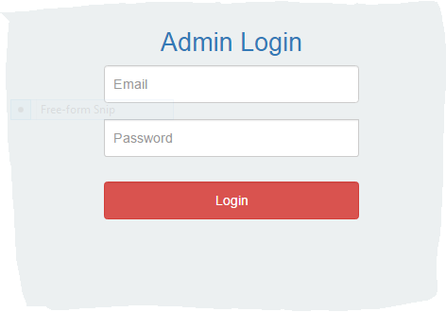

### Figure 4.1: Login form

**Users Page:** This page shows all the registered sellers in a tabular form containing their names, ID and email address.

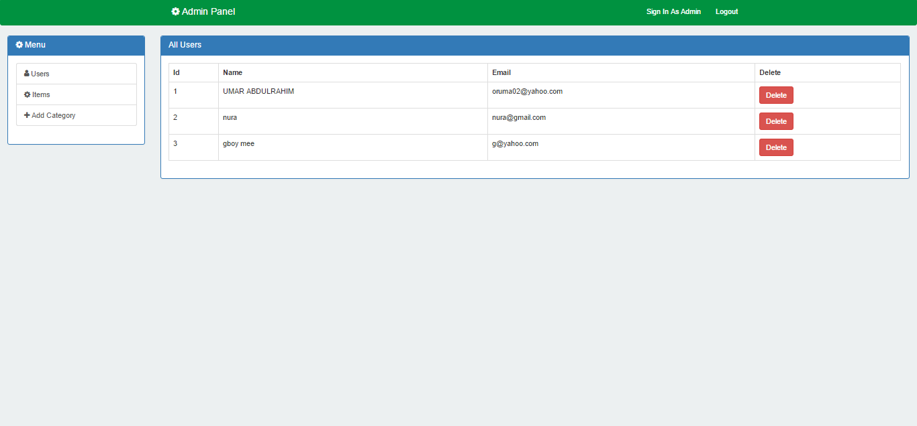

### Figure 4.2: Users Page

**New Seller Form:** This form allows admin to register new sellers to the database, update existing sellers and delete seller if required.

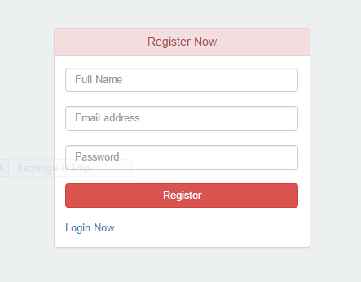

### Figure 4.3: New Seller Form

**New Category form:** Admin can create new categories using this form by filling in the name and description of the new category.

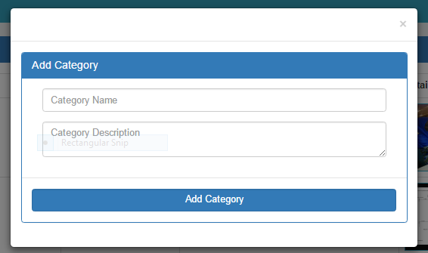

### Figure 4.4: New Category

**Post Item Form:** This form accepts the name description, category and price of products then posts it to the homepage.

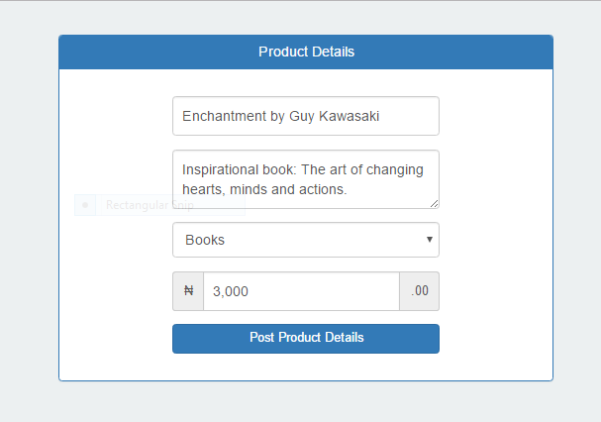

### Figure 4.5: Post Product Form

**Upload Product Photo Page:** This page enables sellers to upload pictures of the product they are putting on sale.

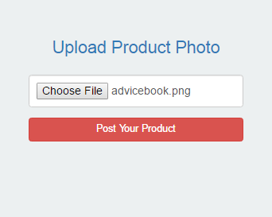

### Figure 4.6: Upload Product Photo Page

**Photo Upload Successful Page:** This page appears after the photo of a product is uploaded successfully.

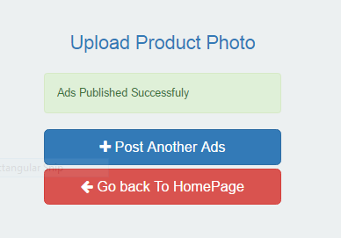

### Figure 4.7: Photo Upload Successful Page

**Homepage:** This is the welcome page which will take both the administrator and the user to login page. It also displays all items posted by sellers.

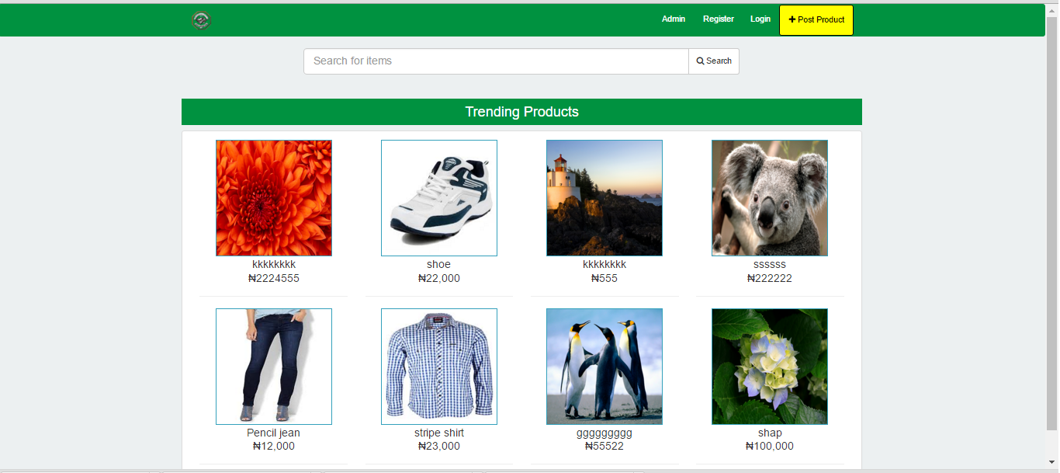

### Figure 4.8: Homepage

# 4.3 TESTING

System testing is among the most important stage of software life cycle. After a system is implemented, it needs to be tested to ensure all functionality, to show the presence of errors and to meet the stated objectives of the project.

# 4.3.1 Unit testing

Various components and functionalities of the system were tested to ensure efficiency of functions.

## Table 4.1: Web based

|  |  |  |
| --- | --- | --- |
| **Test cases** | **Explanation** | **Result** |
| IsLogin() | To check whether only admin is capable to login after filling the correct values in the available fields. Check if it was successful | Pass |
| All seller() | To check whether admin is able to view all the registered sellers with their details. Check if it was successful | Pass |
| New seller() | To check whether admin can add new seller, update and delete existing seller. check if it was successful | Pass |
| All items() | To check whether the admin is capable of viewing all the registered items with their Id and price. Check if it was successful | Pass |
| New Item() | To check whether admin can add new product, update and delete existing items. Check if it was successful | Pass |
| Posting() | To check whether seller is able to generate postings by selecting the item and clicking on the post button. | Pass |
| Logout() | Check whether admin can exist from the software by clicking on the logout button. Check if it was successful | Pass |

# 4.3.2 Integration testing

The integration testing was carried out after the unit testing. Interface links and integrations between components or one activity and another were tested and everything went well.

## Table 4.3: Integration testing

|  |  |  |  |  |  |
| --- | --- | --- | --- | --- | --- |
| **Test Case ID** | **Test Case objective** | **Test Case Description** | **Input** | **Expected Output** | **Results** |
| 1 | Check the interface link between post product and homepage. | Click on home page. | Button clicked.  Button not clicked. | To be directed to post product activity.  Nothing happens. | Pass  Pass |
| 2 | Check the interface link between homepage activity and product details activity. | Click on any list on the posting lists | Button clicked.  Button not clicked. | To be directed to product details activity  Nothing happens. | Pass.  Pass. |
| 3 | Check the interface link between home activity and logout activity. | Click on the logout button. | Button clicked.  Button not clicked. | To be directed back to login activity.  Nothing happens. | Pass.  Pass. |
| 4 | Check the interface link between login activity and home activity. | Click on the login button. | Button clicked.  Button not clicked. | To be directed to home activity.  Nothing happens. | Pass.  Pass. |

# 4.3.3 System Testing

Various parts of the whole system were tested. Also, all interfaces between the integrated units were checked for any inconsistencies that might arise and everything went successful.

# 4.4 SYSTEM SPECIFICATION

The system specifications show the hardware and software requirements needed to run the web application.

## Table 4.4: Hardware requirements

|  |  |  |
| --- | --- | --- |
| **S/N** | **Hardware** | **Minimum System Requirement** |
| 1 | Processor | 1 GHZ processor speed |
| 2 | Memory | 128 MB |
| 3 | Disk space | 400MB |
| 4 | Display | 1280 * 800 minimum screen resolution |

## Table 4.5: Software Requirements

|  |  |  |
| --- | --- | --- |
| **S/N** | **Software** | **Minimum System Requirement** |
| 1 | Operating System | Microsoft windows 8/7/vista (32-or64-bit). |
| 2 | Random access memory(RAM) | 2GB RAM minimum, 4GB RAM recommended |
| 2 | Database Management System | MySQL |
| 3 | Run-time Environment | WAMP server |

# CHAPTER FIVE

# SUMMARY, CONCLUSION AND RECOMMENDATION

# 5.1 INTRODUCTION

This chapter will discuss the summary, conclusion and recommendation of this project.

# 5.2 SUMMARY

This project titled student online marketing system was designed and developed to cater for the manual activity of buying and selling in Bayero University Kano. With this new system, the difficulties encountered with the students’ business activities in the university are overcome. The automated system reduces the work of the students, saves time and increases efficiency.

The analysis and design was done using appropriate modelling tools, implementation was done on the new system. The admin uses the web based system to manage activities such as items postings, adding or deleting sellers and products, as well as keeping track of the number of sellers. On the other hand, the sellers can also use the system to see their posted items, post or remove items, and also view other sellers’ items.

Chapter one of the study introduces the background of the study, problem statement, aim and objectives, significance of the study, scope and limitations, research methodology, and definitions of terms. Chapter two contains explanation on overview of marketing and the internet, Web development technologies, History of Bayero University Kano and reviews on related works. Chapter three includes description of the software development life cycle, the iterative model, the requirement elicitation tools used, functional and non-functional requirements. The analysis was done using UseCase and the design using sequence and UML class diagram. Chapter four titled system implementation and testing contains explanation on how the requirements of chapter three was converted into an executable coding, screenshots of the system and how it works. The testing done was unit testing. Finally, this chapter (five) contains highlighted summary, conclusion and recommendation on the work done in this project.

# 5.3 CONCLUSION

To conclude this research work, it can be observed that the development of the security deployment system was successful. Since sellers are able to post items with less time and the minimized human stress in posting them is achieved. Also the software has succeeded in designing a database for UDU providing easy input, storage and retrieval of information.

Finally, the development of this software encountered some difficulties which includes time constraint, financial challenges. Even though the above problems were encountered, the exercise was a worthy one.

# 5.4 RECOMMENDATIONS

Having followed through the various stages of this Software development, I wish to recommend the following:

1. Web technology is still developing into new and better versions, so there is a need for constant upgrade of the application to improve efficiency.
2. Implementing it as a fully working web application that can be accessed online by hosting it on a server.
3. Advance marketing measures need to be added to the web based application, this is to ensure integrity of the marketing system.
4. Adding a feature that can enable online ordering and payment will be a great idea of improving the study.
5. Improving the study by adding modules that allow buyers and sellers to get in touch with the admin for assistance, complaint and suggestion.

# REFERENCES

Aakjeer A. (2015): *Open Innovation:* Popularity, Performance and Usability of Mobile Application Development Technologies. Cambridge, MA, Harvard Business School Press.

Aggarwal, K.K. & Yogesh, s. (2007): *Software Engineering* (3rd ed.). New Age International Publishers.

Aghaei, S., Ali, M.N., Khosravi, H.F. (2012): *Evolution of the World Wide Web*: From Web 1.0 to Web 4.0. *International Journal of Web & Semantic Technology (IJWesT).* Vol.3, No.1.

American Marketing Association (2011): *Sampling in Marketing Research.*

Barron, E (2002): *Technologies for Education*: A Practical Guide.

Berners-Lee, T. (1998): *The World Wide Web*: A very short personal history. Available from: <<http://www.w3.org/People/Berners-Lee/ShortHistory.html>.>

Blythe, J. (2005); *Marketing 1.* Pp12 – 15.

Blythe, J. (2009): *Key Concepts in Marketing.*

C.W. Lamb, ‎J. F. Hair, ‎C. McDaniel (2011): *Essentials of Marketing.* Available from <<http://www.cengage.com/highered>>

Information Resources Management Association (2012): *E-marketing: Concepts, Methodologies, Tools and Applications.*

Ira S. Kalb (2000*): E-marketing: What Went Wrong and How To Do It Right.*

Maged, N., Boulos, K., & Wheeler, S. (2007): *The emerging Web 2.0 social software: an enabling suite of sociable technologies in health and health care education, Health Information and Libraries Journal.* pp2 -23.

Morreale, A & Terplan, K (2009): *CRC Handbook of Modern Telecommunications,* Second Edition.

Murugesan, S. (2007): *Understanding Web 2.0: Journal IT Professional.*

Mylopoulos, J. (2004): *Information systems analysis and design.* CSC340.

Nykänen, O. (2003). *Semantic Web:* Definition. <http://www.w3c.tut.fi/talks/2003/0331umediaon/slide6-0.html>.

Per V. Jenster, ‎H. Michael Hayes, ‎David E. Smith (2005*): Managing Business Marketing and Sales:* An International Perspective. Copenhagen Business School Press.

Philip K, Burton and Deans, (2015): *Introduction to Marketing.*

Spivack, N. (2011): *Web 3.0: The Third Generation Web is Coming*. Available from: <<http://lifeboat.com/ex/web.3.0> >

Webapp. (2012): [Online] [Retrieved 2016 Aug. 27, 5:00am]. Available from: < <http://web.appstorm.net/general/opinion/what-is-a-web-app-heres-our-definition/> >