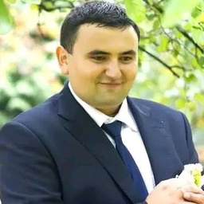

**K I S H M Y K O L A**  
 **M A N U A L Q A E N G I N E E R**

I am manual QA engineer am a responsible,   
punctual, self-motivated specialist who knows   
how to and likes to work in a team to achieve   
the final result. I like to radically change   
everything in life, that's why I switched to IT. I   
am waiting for your suggestions. I would be   
glad to give up my time to work making a   
valuable contribution to your company.

|  |  |  |  |
| --- | --- | --- | --- |
|  | +380667078837 |  | **P R O F E S S I O N A L S K I L L S** |
| +4915752920758 | Basic knowledge in of processes, standards, and |

|  |  |
| --- | --- |
|  | mykolakish1@gmail.com  Bamber Deutschland  www.linkedin.com/in/mykola-kish-  6b0537264 |

**S K I L L S**   
HTML, CSS, JavaScript, Unix, JSON, XML, SQL, GIT, REST, Postman, Charles, Jira

**E D U C A T I O N**   
Online courses for QA in Techmission from October 2022 to February 2023

**Mukachevo State Institute:** Economics and Management

**Supervisor (**head of the sales team) **E X P E R I E N C E**

1. Planning, organization, motivation   
and control of a sales team of 5 people  
 Good communication skills Attentive to details Flexibility and adaptability.

Fast learner. Motivated

Ukrprominvest Mukachevo testing methodologies.

Understanding of Agile/ Scrum, Kanban.

Basic knowledge in SDLC (Software Development Lifecycle) and Bug Life Cycle.

Developing test documentation: bug reports, test cases, and checklists.

Basic knowledge in testing theory.

I know how to work in a team and achieve results

 2. Fulfillment of planned indicators by

|  |  |  |
| --- | --- | --- |
| 2006-2011 years |  | 105% or more |
| 3. Quantitative and qualitative |

distribution on the territory.

|  |  |  |
| --- | --- | --- |
| **L A N G U A G E** |  | 4. Development of marketing programs |
| Ukrainian-Native | to promote the product and displace |
| English-B1 | competitors. |

Deutsch -B1