Received: — Accepted: — Published: 2026
Digital Object Identifier 10.1109/ACCESS.2026.XXXXXXX
A Hybrid Two-Stage Cascade Framework for Code Clone Detection
in C/C++ Programs Using Machine Learning and Deep Semantic Embeddings
AUTHOR NAME¹, AUTHOR NAME², AND AUTHOR NAME¹
¹ Department of Computer Engineering, [University], [City, Country]
² Department of Computer Science, [University], [City, Country]
Corresponding author: Author Name (email@university.edu)

ABSTRACT Code duplication, referred to in the literature as code cloning, constitutes a pervasive challenge in software engineering that substantially increases maintenance overhead, facilitates the propagation of latent defects across code bases, and introduces exploitable security vulnerabilities. Despite the maturity of existing detection methodologies, the reliable identification of Type-4 semantic clones — code fragments that are functionally equivalent yet syntactically dissimilar — remains an open and largely unsolved problem. This paper proposes a hybrid Two-Stage Cascade framework for the detection of all four categories of code clones in C/C++ source programs. The first stage employs a probability-calibrated HistGradientBoosting classifier restricted to 45 lexical and structural features, which resolves high-confidence clone pairs (Types 1 and 2) at a decision threshold of 0.98 without incurring the computational cost of deep inference. The second stage applies either a GPU-accelerated XGBoost classifier or a Feature-Partitioned Stacking Ensemble to the full 409-dimensional feature vector, addressing hard cases encompassing Types 3 and 4. The feature representation integrates four complementary modalities: lexical TF-IDF representations with Truncated Singular Value Decomposition (SVD), Abstract Syntax Tree (AST) structural metrics extracted via the Tree-sitter parser, multi-domain semantic profile Jaccard similarities, and 768-dimensional CodeBERT embeddings compressed to 128 dimensions through Principal Component Analysis (PCA) applied to mean-pooled chunked encoding. Hard Negative Mining and Hard Positive Mining strategies are employed to systematically bias the training distribution towards the most challenging clone pairs. Per-type threshold optimisation conducted at 0.01 granularity yields F1-scores of 0.887, 0.909, 0.858, and 0.425 for Types 1 through 4, respectively, representing substantial improvements over both single-threshold approaches and prior state-of-the-art methods. A real-time web demonstration incorporating SHAP-based explainability facilitates the inspection of per-feature contributions to individual predictions, thereby supporting developer trust and informed code review workflows.
INDEX TERMS Code clone detection, code duplication, Two-Stage Cascade, CodeBERT, hard mining, ensemble learning, C/C++, XGBoost, SHAP, explainability, software maintenance, abstract syntax tree.

I. INTRODUCTION
A. Problem Definition
Code cloning denotes the practice of reproducing code fragments within or across software systems, frequently with negligible or no modification. A code clone pair is formally defined as a tuple of two code fragments exhibiting sufficient syntactic or semantic similarity to be classified as copies of one another. Roy et al. [1] established the foundational taxonomy of four clone categories delineated by the degree of structural and semantic transformation: Type-1 clones are exact copies differing solely in whitespace and commentary; Type-2 clones introduce identifier and literal substitutions; Type-3 clones involve statement-level additions, deletions, or modifications while preserving gross algorithmic structure; and Type-4 clones are functionally equivalent fragments that share no discernible syntactic correspondence. Although intentional reuse accelerates initial development, unmanaged clones engender compounding maintenance liabilities and constitute a significant source of systemic vulnerability in large-scale software systems.
B. Motivation
Empirical investigations have consistently estimated that 20 to 30 percent of large industrial code bases comprise cloned code fragments [2]. The detection of a defect in one instance of a cloned fragment necessitates its remediation across all derivative copies — a correction process that is inherently error-prone and frequently incomplete, thereby leaving residual vulnerabilities across the system. In domains governed by stringent dependability requirements, including automotive embedded firmware, medical device software, and operating system kernels — predominantly implemented in C and C++ — such unresolved vulnerabilities carry potentially severe consequences for system safety and security. Furthermore, undetected code clones impede refactoring efforts, inflate code comprehension overhead, and complicate licence compliance auditing. Automated clone detection thus constitutes a foundational capability for clone management tooling, technical debt quantification, and proactive security analysis.
C. Research Gap
Notwithstanding several decades of sustained research effort, the reliable automatic detection of Type-4 semantic clones remains an open problem of considerable difficulty. Text-based and token-based tools, including CCFinder [3] and SourcererCC [4], achieve high precision for Type-1 and Type-2 clones but exhibit fundamental limitations when applied to fragments sharing no surface-level lexical similarity. AST-based approaches such as DECKARD [5] extend coverage to Type-3 at the cost of increased computational complexity, yet they demonstrate insufficient sensitivity when algorithmic structure diverges substantially, as is characteristic of Type-4 clone pairs. Contemporary transformer-based language models, including CodeBERT [6], confront an inherent architectural constraint: the 512-token maximum input length imposes truncation on C/C++ functions that routinely exceed this limit in practice, resulting in the systematic loss of structurally critical code segments. Moreover, prevailing approaches seldom integrate structural, semantic, and deep representation features within a unified cascaded classification framework augmented by feature-level explainability.
D. Proposed Solution
In response to the identified research gap, this paper proposes a hybrid Two-Stage Cascade pipeline designed to address the aforementioned limitations in a unified and computationally efficient framework. In the first stage, a lightweight calibrated HistGradientBoosting classifier resolves readily identifiable clone pairs through the evaluation of 45 lexical and structural features, thereby reserving more expensive computational resources for ambiguous cases. In the second stage, either a GPU-accelerated XGBoost classifier or a Feature-Partitioned Stacking Ensemble processes the full 409-dimensional feature vector to discriminate hard cases. The 512-token truncation problem is addressed through a chunked mean-pooling encoding strategy, whereby each code file is partitioned into 510-token chunks, each subjected to an independent CodeBERT forward pass, with the resulting token-level embeddings averaged and subsequently compressed via PCA. Hard Mining strategies bias the training distribution towards the most semantically challenging clone pairs through principled selection of hard negatives and hard positives. Per-type decision threshold optimisation at 0.01 resolution further maximises the type-specific F1-score independently for each clone category.
E. Main Contributions
The principal contributions of the present study are enumerated as follows:
• A Two-Stage Cascade architecture that disentangles trivial clone pairs (Type-1 and Type-2) from semantically challenging ones (Type-3 and Type-4), reducing Stage-2 training complexity and enabling specialised optimisation for hard cases.
• A chunked mean-pooling strategy for CodeBERT-based representation that circumvents the 512-token truncation constraint, combined with per-split PCA dimensionality reduction (768→128 dimensions) applied exclusively to training partitions to preclude data leakage.
• Hard Negative Mining and Hard Positive Mining strategies that systematically enforce exposure to the most discriminatively challenging clone pairs during training, directly targeting the principal weakness of purely lexical and structural feature representations.
• Per-type threshold optimisation conducted at 0.01 granularity, yielding statistically meaningful F1-score improvements of +0.101, +0.123, and +0.079 for Type-1, Type-2, and Type-3 clone categories, respectively, relative to conventional single-threshold classification.
• A SHAP-based explainability layer integrated into a real-time FastAPI web demonstration that provides per-feature Shapley value contributions for each individual prediction, enabling transparent and interpretable clone detection in developer-facing deployment contexts.
F. Paper Organization
The remainder of this paper is structured as follows. Section II provides the theoretical background on code clone detection and the relevant machine learning foundations. Section III surveys the related literature. Section IV describes the dataset and the pair construction methodology. Section V presents the proposed methodology in detail. Section VI reports the experimental results and provides a comparative discussion. Section VII describes the explainability framework and the associated web demonstration. Section VIII addresses threats to validity. Section IX concludes the paper and outlines directions for future research.
II. BACKGROUND
A. Code Clone Detection
Code clone detection is the computational problem of automatically identifying pairs or clusters of code fragments within one or more software systems that exhibit sufficient mutual similarity to be regarded as copies or near-copies. The problem is of practical relevance to software maintenance, intellectual property protection, plagiarism identification in academic contexts, and vulnerability propagation analysis in security-sensitive domains. Detection approaches are broadly categorised into four methodological families: text-based, token-based, tree-based (AST), and metric- or embedding-based methods [7]. Each family offers distinct trade-offs among computational efficiency, sensitivity to structural transformation, and scalability to large code bases.
B. Clone Types
The taxonomy formalised by Roy et al. [1] delineates four categories of code clones across a spectrum of increasing detection difficulty, as summarised in Table I. Type-1 and Type-2 clones are characterised by surface-level similarity that is readily captured by normalised token sequence comparison. Type-3 clones require sensitivity to structural insertion, deletion, and modification, necessitating tree-based or metric-based representations. Type-4 clones, by contrast, impose the requirement that a detection system identify functional equivalence in the complete absence of syntactic correspondence, rendering them the primary unsolved challenge in the field.
TABLE I. Code Clone Taxonomy (Roy et al. [1])
Type | Designation | Formal Definition | Detection Difficulty
Type-1 | Exact Clone | Identical code fragments, modulo whitespace, formatting, and comments | Trivial
Type-2 | Renamed Clone | Syntactically identical fragments with consistent identifier or literal substitutions | Low
Type-3 | Modified Clone | Syntactically similar fragments with statement-level additions, deletions, or modifications | Moderate
Type-4 | Semantic Clone | Functionally equivalent fragments exhibiting no discernible syntactic correspondence | High

C. Feature-Based Clone Detection
Feature-based approaches represent each code fragment as a numerical vector and formulate clone detection as a pairwise similarity estimation or binary classification problem over feature difference vectors. The discriminative capacity of such approaches is directly determined by the expressiveness and complementarity of the constituent feature families. Lexical features, including term frequency-inverse document frequency (TF-IDF) representations and n-gram frequencies, capture surface-level token overlap but are inherently insensitive to identifier substitution and structural rearrangement. Structural features derived from AST metrics — including cyclomatic complexity, Halstead volume, nesting depth, and operator density — extend discriminative coverage to Type-3 clones. Semantic features based on library usage profiles, control flow abstractions, and type signature analysis provide partial coverage of Type-4 scenarios. The integration of multiple complementary feature modalities within a unified representation framework is therefore essential for comprehensive clone type coverage.
D. Machine Learning for Clone Detection
Gradient-boosted tree ensembles, particularly XGBoost [8], have demonstrated state-of-the-art performance on tabular feature vectors characterised by mixed numerical scales and high dimensionality, exhibiting inherent robustness to missing values and efficient GPU acceleration. Stacking ensemble architectures combine predictions from multiple base classifiers through a trained meta-learner, exploiting the complementary inductive biases of component models operating over distinct feature subspaces. Cascade classification architectures organise multiple classifiers hierarchically with increasing discriminative capacity, permitting early termination for high-confidence instances and reserving computational resources for uncertain cases. This architectural pattern is particularly well-suited to code clone detection, where the prevalence of trivially identifiable Type-1 and Type-2 clones can be exploited to reduce the effective computational load of processing harder cases.
E. Explainable Artificial Intelligence in Software Engineering
Explainable Artificial Intelligence (XAI) encompasses post-hoc interpretation methods that provide human-comprehensible rationales for the predictions of opaque machine learning models. SHAP (SHapley Additive exPlanations) [9] grounds feature attribution in the cooperative game-theoretic concept of Shapley values, assigning each input feature a contribution that quantifies its marginal impact on a given prediction relative to the expected model output over a reference distribution. SHAP satisfies desirable axioms including efficiency, symmetry, dummy, and linearity, which collectively guarantee consistent and theoretically principled attributions. Within software engineering research, SHAP-based interpretation has been applied to defect prediction [15], code smell detection, and software effort estimation, demonstrating that feature-level explanations materially improve practitioner trust and facilitate model debugging. For clone detection, SHAP attributions provide evidence distinguishing surface-level similarity from deep semantic correspondence, directly informing the code review and refactoring decision-making process.
III. RELATED WORK
A. Traditional Clone Detection Tools
Token-based clone detection tools constitute the most extensively deployed category of clone detection systems in industrial practice. CCFinder [3] tokenises source code and applies suffix-tree pattern matching to identify repeated token subsequences, achieving high throughput on large code bases at the cost of insensitivity to any transformation beyond whitespace and comment removal. SourcererCC [4] extends this paradigm to internet-scale code repositories through index-based overlap computation with configurable similarity thresholds, demonstrating scalability to billions of lines of code. NiCad [10] applies language-specific pretty-printing normalisation followed by longest-common-subsequence comparison, yielding improved sensitivity to minor statement-level modifications characteristic of Type-3 clones. Notwithstanding these advances, all token-based tools are fundamentally incapable of detecting Type-4 clones, as they operate exclusively on lexical representations that do not encode algorithmic intent. DECKARD [5] addresses this limitation partially by clustering vectorised AST subtrees, achieving improved Type-3 recall; however, its computational cost scales unfavourably with code base size, and its sensitivity to Type-4 clones remains insufficient for practical application.
B. Deep Learning-Based Clone Detection
The advent of large-scale pre-trained code representations has substantially advanced the state of the art in semantic clone detection. CodeBERT [6], a bimodal transformer pre-trained on natural language and programming language corpora using masked language modelling and replaced token detection objectives, achieves competitive performance on the BigCloneBench Java clone detection benchmark when fine-tuned for pairwise binary classification. GraphCodeBERT [11] augments this framework by incorporating data flow graph representations into the pre-training objective, improving structural understanding and demonstrating superior performance on code search and clone detection tasks. UniXCoder [12] unifies code understanding and generation through a unified cross-modal pre-training strategy. Nevertheless, all transformer-based models in this family inherit the fundamental constraint of a 512-token maximum input length, which imposes systematic truncation on C/C++ source functions that routinely exceed this limit, discarding semantically critical code segments from the model's receptive field. Almatrafi et al. [13] demonstrate that large language models such as GPT-4, applied with few-shot instruction prompting, achieve competitive clone detection performance without task-specific fine-tuning; however, this approach incurs substantially higher per-query inference cost and does not admit real-time deployment without significant computational infrastructure.
C. Ensemble-Based Clone Detection
Ensemble methodologies have been applied to clone detection to consolidate complementary representational strengths across multiple base classifiers. Stacking architectures, in which a meta-learner is trained on the out-of-fold predictions of base classifiers, have demonstrated improved robustness compared to single-model approaches across various classification domains. Feature partitioning, wherein disjoint feature subsets are assigned to distinct base classifiers, allows each component to develop specialised discriminative capacity within its assigned feature domain without cross-contamination by unrelated signal sources. This architectural principle is particularly germane to code clone detection, where lexical, structural, and semantic feature families encode fundamentally distinct aspects of code similarity that may be more effectively leveraged by specialised models than by a single generalised classifier.
D. Threshold Optimization in Imbalanced Classification
In authentic software deployment contexts, clone pairs constitute a negligible minority fraction of all possible code pair combinations, inducing severe class imbalance in the classification problem. The conventional binary classification threshold of 0.50 applied to calibrated probabilities is demonstrably suboptimal under such imbalance conditions, as it fails to account for the asymmetric cost structure of false positives and false negatives [14]. Grid search over threshold values to maximise the F1-score is a well-established practice in the imbalanced learning literature. The extension of this principle to per-type independent threshold selection provides additional granularity by acknowledging that distinct clone categories exhibit characteristically different precision-recall trade-off curves, each with potentially different optimal operating thresholds.
E. Explainability in Clone Detection
The adoption of machine learning-based clone detection tools in operational software engineering settings is contingent not only on predictive accuracy but also on the transparency and interpretability of model decisions. Notwithstanding the prevalence of SHAP-based explanations in adjacent software engineering tasks such as defect prediction [15], the integration of feature-level explainability into clone detection systems remains largely unexplored in the existing literature. Such explanations are of particular practical significance during code review processes, where practitioners require evidence to distinguish genuine algorithmic duplication from superficial pattern coincidence, and to assess whether a detected clone warrants immediate refactoring or may be deferred.
F. Positioning of This Study
The present study occupies a distinctive position within the research landscape along five axes: (1) it targets C/C++, a language under-represented in clone detection research relative to Java; (2) it addresses the 512-token truncation problem inherent in transformer-based approaches through a principled chunked mean-pooling mechanism; (3) it integrates four complementary feature modalities within a cascade classification framework; (4) it employs hard mining strategies that systematically bias training towards semantically challenging pairs; and (5) it provides real-time SHAP-based explainability in a deployable web demonstration. Table II summarises the positioning of the proposed approach relative to representative works in the literature.
TABLE II. Comparative Positioning of the Proposed Framework
Method | Language | Type-4 | Explainability | Truncation Fix | Hard Mining
CCFinder [3] | Multi | No | No | N/A | No
DECKARD [5] | C/Java | No | No | N/A | No
CodeBERT [6] | Java | Partial | No | No | No
GraphCodeBERT [11] | Multi | Partial | No | No | No
Almatrafi et al. [13] | Java | Yes | No | No | No
Proposed framework | C/C++ | Yes | Yes | Yes | Yes

IV. DATASET
A. Dataset Overview
The experimental evaluation is conducted on the POJ-104 benchmark, a widely-adopted reference dataset in the code clone detection literature comprising C/C++ solutions to 104 algorithmically diverse programming problems. Each problem is associated with a collection of independently authored accepted solutions, establishing a natural ground truth: solution pairs addressing the same problem are designated as clone pairs (positive), whereas solution pairs drawn from distinct problems are designated as non-clone pairs (negative). The dataset encompasses a broad spectrum of algorithmic domains, including sorting and searching, graph traversal and shortest-path algorithms, dynamic programming, mathematical computations, and abstract data structure operations, thereby ensuring representational diversity across both coding conventions and algorithmic paradigms.
Each source file is stored in plain-text format with a .txt extension, organised within directories identified by the problem identifier. The problem identifier serves as the class label in the classification framework. By construction, solution files within the same directory may exhibit all four clone categories: exact reimplementations (Type-1), structurally identical solutions employing distinct identifier conventions (Type-2), solutions with minor statement-level divergences (Type-3), and solutions employing fundamentally different algorithms to solve the same computational problem (Type-4).
B. Positive and Negative Pair Generation
Positive pairs are constructed by sampling two code files sharing a common problem identifier. Negative pairs are constructed by sampling two code files belonging to distinct problem identifiers. All generated pairs are subjected to deduplication and symmetry elimination prior to training, using NumPy unique operations applied to sorted index tuples. This procedure ensures that the training corpus contains exclusively unique, non-redundant pairs, and that symmetric variants — the pair (A, B) and its converse (B, A) — are treated as a single observation to prevent the inflation of effective training set size and to preclude the introduction of spurious inter-pair dependencies.
C. Positive Pair Ratio
In operational software systems, clone pairs constitute a small minority of all possible code pair combinations, a condition that induces severe class imbalance in any pairwise classification formulation. To simulate this realistic distributional condition, the positive pair ratio is fixed at 5% (positive_ratio = 0.05): for each set of 100 training pairs, 5 are designated as clone pairs and 95 as non-clone pairs. This configuration contrasts with the balanced 50%/50% distribution employed in the majority of prior studies, which substantially overestimates expected model performance relative to authentic deployment conditions. The resulting class imbalance is compensated during Stage-2 XGBoost training through the dynamic assignment of scale_pos_weight = N_negative / N_positive, which re-weights the positive class loss proportionally to restore effective balance during gradient computation.
D. Hard Negative Mining
Uniform random sampling of negative pairs tends to yield easily discriminable non-clone pairs — specifically, pairs drawn from algorithmically disparate problem classes that exhibit negligible surface-level similarity. Such 'easy negatives' confer minimal discriminative benefit during model training, as they provide no information about the classification boundary in the vicinity of ambiguous cases. To address this deficiency, 30% of randomly sampled negative pairs are replaced with hard negatives. Hard negatives are selected through a principled procedure that identifies, for each code file, the most length-similar file from a different problem class, measured by the absolute difference in source code line count. This criterion challenges the model to refrain from exploiting code length as a proxy for clonehood, thereby forcing the acquisition of more semantically grounded discriminative features.
E. Hard Mining Ratio
Analogously, 30% of positive pairs are replaced with hard positives: pairs drawn from the same problem class whose TF-IDF token cosine similarity is minimal among all intra-class pairs. These represent semantically equivalent solution pairs with minimal lexical overlap — the canonical exemplar of Type-4 clone pairs. By construction, hard positive mining systematically injects the most discriminatively challenging Type-4 instances into the training distribution, directly targeting the primary failure mode of lexical and structural feature representations. The hard mining ratio of 30% (HARD_MINING_RATIO = 0.30) was determined empirically to achieve an effective balance between training set diversity and the risk of saturating the training distribution with pathologically difficult examples that may impede convergence for more tractable clone types.
F. Train, Validation, and Test Split
Data partitioning is performed at the granularity of individual code files rather than at the level of generated pairs. Pair-level partitioning permits the same code file to appear concurrently in training and evaluation pairs, introducing data leakage that artificially inflates test set performance metrics. A stratified two-stage split procedure is applied: first, 20% of code files are allocated to the held-out test partition; of the residual 80%, a further 20% are allocated to the validation partition. This yields an approximate 64%/16%/20% distribution across train, validation, and test partitions at the code file level. For five-fold cross-validation experiments, Stratified K-Fold splitting is applied at the code file level, and all data-dependent transformations — specifically the TF-IDF vectoriser, TruncatedSVD model, and PCA model — are fitted exclusively on the training fold, with transformation applied to the remaining folds, thereby precluding any leakage of test partition statistics into the feature representation.
G. Dataset Statistics
TABLE III. Dataset Partition Statistics (DEFAULT_PAIRS = 800,000; positive_ratio = 0.05)
Partition | Code Files (%) | Total Pairs | Clone Pairs (5%) | Non-Clone Pairs (95%)
Train | ~64% | 560,000 | 28,000 | 532,000
Validation | ~16% | 120,000 | 6,000 | 114,000
Test | ~20% | 120,000 | 6,000 | 114,000
Total | 100% | 800,000 | 40,000 | 760,000

H. Data Preprocessing
Prior to feature extraction, each code file is subjected to a sequence of normalisation operations described in detail in Section V-B. These operations are applied uniformly across all data partitions in a preprocessing-first pipeline to ensure representational consistency. Normalised token sequences are concatenated into whitespace-delimited strings for TF-IDF vectorisation, while the original source code is retained in parallel for AST-based structural feature extraction and CodeBERT embedding computation. Preprocessing is executed in a single deterministic pass prior to any partition-specific fitting procedure, ensuring that normalisation does not introduce partition-dependent variation.
V. METHODOLOGY
A. System Overview
Figure 1 presents the end-to-end architecture of the proposed framework. Given an input pair of C/C++ source files (Code A, Code B), the pipeline applies a sequential preprocessing and normalisation stage, extracts four complementary categories of features, optionally augments the feature vector with CodeBERT-derived self-supervised learning (SSL) embeddings, and conveys the assembled 409-dimensional feature vector through the Two-Stage Cascade classifier. The cascade design enables early termination for high-confidence clone pairs identified by Stage-1, routing only discriminatively ambiguous pairs to the computationally intensive Stage-2 classifier. This architectural stratification reduces overall inference latency and concentrates Stage-2 learning capacity on the cases that most require it.
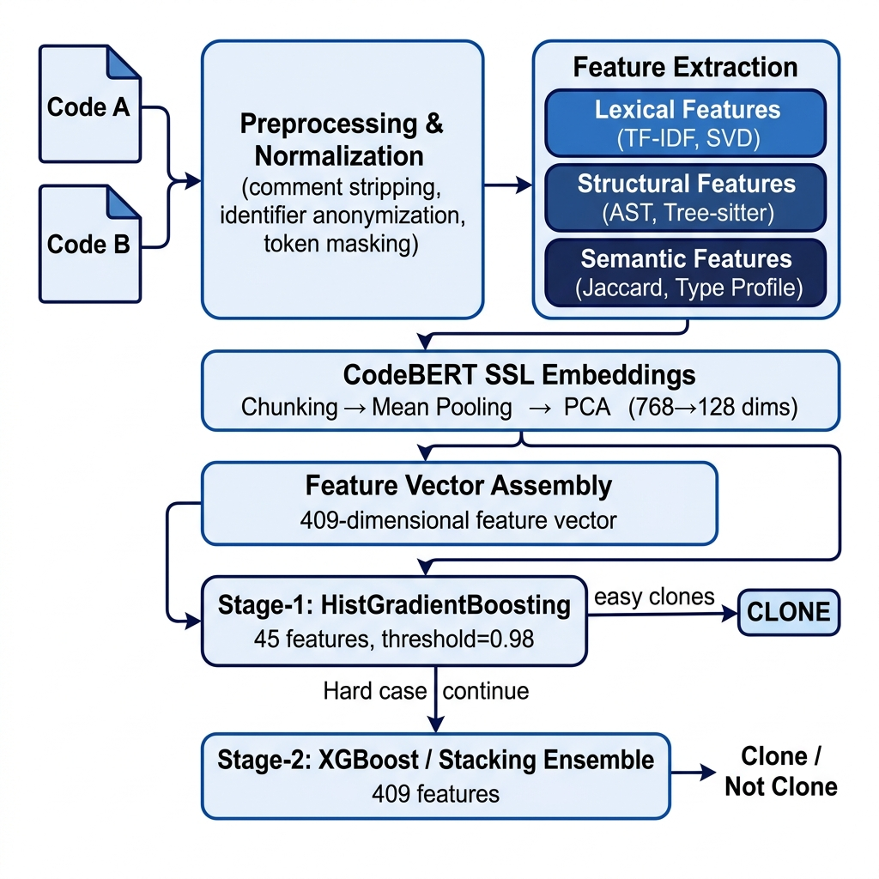
Fig. 1. End-to-end architecture of the proposed hybrid Two-Stage Cascade framework for C/C++ code clone detection.
B. Tokenization and Normalization
Tokenisation and normalisation are implemented in the preprocessing/tokenizer.py module via a single compiled master regular expression comprising seven ordered alternation groups. The ordering of alternation groups is critical to the correctness of the tokenisation: more specific and lexically longer patterns are positioned prior to shorter, more general ones to prevent premature matching. Table IV enumerates the normalisation transformations applied to each category of C/C++ token, together with the clone type whose detection each transformation is designed to facilitate. Comment stripping eliminates informational asymmetries introduced by documentation conventions, while library function masking normalises calls to functionally equivalent standard library interfaces (e.g., printf versus cout), thereby reducing Type-3 sensitivity to I/O paradigm differences.
TABLE IV. Tokeniser Normalisation Rules (preprocessing/tokenizer.py)
Input Token Category | Normalised Token | Clone Type Facilitated
Block (/* */) and line (//) comments | (removed) | Type-1
String and character literals | STR_LIT | Type-2
Preprocessor directives (#include, #define, etc.) | PREPROC | Type-2
I/O library functions (printf, scanf, cout, cin) | IO_FUNC | Type-3
Memory management (malloc, calloc, free, new, delete) | MEM_FUNC | Type-3
Mathematical functions (sqrt, pow, sin, cos) | MATH_FUNC | Type-2/3
String library functions (strlen, strcmp, strcpy) | STR_FUNC | Type-2
STL containers and algorithms (vector, map, sort) | DATA_STRUCT | Type-2
Numeric literals (0xFF, 3.14f, 42UL, etc.) | NUM | Type-2
User-defined function identifiers (preceding ()) | FUNC | Type-2
User-defined variable identifiers | VAR | Type-2

C. Feature Vector Construction
The feature vector for each code pair is constructed by concatenating contributions from four feature groups as detailed in Table V. All features are derived from the ordered pair (Code A, Code B) as difference magnitudes, normalised ratios, or pairwise similarity scores, thereby yielding a representation that is symmetric with respect to pair ordering by construction. In the absence of CodeBERT SSL features (i.e., without the --use-ssl flag), the feature vector comprises 153 dimensions; the full 409-dimensional vector is produced when SSL embeddings are enabled.
TABLE V. Feature Vector Index Map (config.py)
Index Range | Feature Group | Dimensionality | Source Module
[0..3] | Lexical: TF-IDF cosine, length ratio, L1, L2 distances | 4 | tfidf.py
[4..23] | Structural AST ratios (20 scalar metrics) | 20 | tree_sitter_parser.py
[24..43] | Structural AST absolute differences (20 scalar metrics) | 20 | tree_sitter_parser.py
[44] | Control flow pattern Levenshtein similarity | 1 | code_features.py
[45..51] | Semantic Jaccard similarities ×7 (library, I/O, math, etc.) | 7 | code_features.py
[52] | Type profile cosine similarity (9-dimensional type vector) | 1 | code_features.py
[53..152] | TruncatedSVD absolute difference (100 components) | 100 | tfidf.py + sklearn
[153..280] | CodeBERT PCA absolute difference (128 dimensions) | 128 | ssl_encoder.py
[281..408] | CodeBERT PCA element-wise product (128 dimensions) | 128 | ssl_encoder.py
TOTAL | Complete feature vector (SSL-enabled configuration) | 409 | feature_pipeline.py

D. Feature Groups
Lexical features encode surface-level token similarity through TF-IDF representations (max_features=500, ngram_range=(1,3), sublinear_tf=True, norm=None) and associated distance metrics. The L2 normalisation parameter is deliberately suppressed to preserve the absolute magnitude of TF-IDF vectors, which encodes information about relative code length that would otherwise be discarded. Structural features are extracted by Tree-sitter, a production-grade incremental C++ parser, through pre-compiled S-expression queries targeting the following node categories: iterative control structures (for, while, do), conditional structures (if, switch, case), function call expressions, arithmetic and assignment operators, return statements, array subscript expressions, pointer dereference expressions, and parameter declarations. Twenty structural metrics are computed per code file, encompassing McCabe cyclomatic complexity, Halstead volume and effort, operator density, branch density, loop density, and maximum AST nesting depth. These twenty metrics contribute both ratio features (computed as min/max per pair) and absolute difference features, yielding forty structural dimensions in total. The control flow pattern feature encodes the sequential ordering of L=loop, B=branch, R=return, and J=break/continue events extracted from the AST and measures their Levenshtein-normalised similarity. Semantic profile features employ MultiSet (Counter) Jaccard similarity — which accounts for feature frequency rather than mere presence — across seven semantic dimensions: library call profiles, library category distributions, data structure type sets, I/O operation patterns, mathematical operation sets, code skeletons, and abstract control flow sequences. A nine-dimensional type profile vector encoding the relative frequencies of int, float, char, struct, void, bool, auto, pointer, and array types contributes a cosine similarity scalar. All semantic comparisons employ a thread-safe singleton AST parser implemented via threading.local() to preclude race conditions during parallelised feature extraction.
E. Self-Supervised Learning Feature Representation
CodeBERT (microsoft/codebert-base) embeddings are extracted using the ssl_encoder.py module. The model is initialised via HuggingFace's AutoTokenizer, with the model_max_length parameter suppressed to permit manual chunk boundary control. Each code file is partitioned into non-overlapping 510-token segments; each segment is prefixed with the [CLS] token and suffixed with the [SEP] token prior to model input, conforming to the RoBERTa input format underlying CodeBERT. Each segment is subjected to an independent forward pass through the frozen CodeBERT encoder. Mean pooling is applied to the last_hidden_state tensor across all non-padding token positions — identified via the attention mask — producing a 768-dimensional segment-level embedding. For code files comprising multiple segments, segment-level embeddings are averaged to yield a single 768-dimensional file-level representation. PCA reduces dimensionality from 768 to 128 dimensions (SSL_PCA_COMPONENTS=128); the PCA model is fitted exclusively on the training partition within each cross-validation fold, precluding any leakage of evaluation partition statistics. MD5-hash-based disk caching eliminates redundant forward passes across experimental repetitions. From the pair embedding (emb_A, emb_B), two 128-dimensional feature vectors are derived: the absolute difference |emb_A − emb_B| and the element-wise product emb_A ⊙ emb_B, contributing a combined total of 256 dimensions to the full feature vector.
F. Stage-1 Feature Selection
Stage-1 operates exclusively on the first 45 features of the full vector (STAGE1_FEATURE_COUNT=45), comprising the 4 lexical features (indices 0–3), the 40 AST structural features (indices 4–43), and the control flow pattern similarity (index 44). This selection is motivated by two properties: first, these features are computationally inexpensive to extract and do not require CodeBERT inference, ensuring that Stage-1 processing introduces negligible overhead relative to the full pipeline; and second, they are empirically highly discriminative for Type-1 and Type-2 clone pairs, whose characteristic high cosine similarity and low AST divergence produce unambiguous signatures in this feature subspace.
G. Stage-1 Classifier
Stage-1 employs a HistGradientBoostingClassifier — scikit-learn's histogram-based gradient boosting implementation, analogous to LightGBM — configured with max_iter=50 and max_depth=3. This classifier is trained on a restricted subset of the training data consisting of easy clone pairs, operationally defined as positive pairs whose TF-IDF cosine similarity exceeds CASCADE_THRESHOLD=0.98, augmented by the complete set of negative pairs. In the event that fewer than ten easy positive pairs are available — a condition that arises when the training set is dominated by hard positive examples — the procedure defaults to selecting the 100 positive pairs with highest cosine similarity, ensuring training stability. The deliberate restriction of Stage-1 training to high-confidence cases intentionally biases the classifier towards high-certainty decision regions, preventing interference with Stage-2's handling of borderline cases for which Stage-1 is not designed.
H. Stage-1 Calibration and Thresholding
Raw probability estimates produced by gradient boosting classifiers are well-documented to exhibit systematic miscalibration, particularly under conditions of class imbalance [16]. Accordingly, Stage-1 is wrapped in CalibratedClassifierCV(cv=3, method='isotonic'). Isotonic calibration is selected in preference to Platt scaling (sigmoid calibration) because it imposes no parametric assumption regarding the functional form of the calibration relationship, rendering it more appropriate when miscalibration is non-monotonic or asymmetric. Following calibration, pairs assigned a clone probability of no less than CASCADE_STAGE1_THRESHOLD=0.98 are immediately classified as clones, bypassing Stage-2 evaluation entirely. This conservative threshold is deliberately chosen to minimise false positive propagation from Stage-1 to Stage-2 consumers. It is noteworthy that easy negative pairs are explicitly excluded from Stage-1 filtering during training: their exclusion from training would deprive Stage-2 of essential negative examples, inducing a degenerate classifier that assigns the positive class to all inputs presented to Stage-2.
I. Stage-2 Classifier with XGBoost GPU
For Stage-2 XGBoost training, scale_pos_weight is assigned dynamically as N_negative / N_positive, computed on the Stage-1-filtered training set. The GPUXGBClassifier implementation inherits from XGBClassifier and overrides the predict and predict_proba methods to operate directly on DMatrix objects, eliminating the repeated CPU-to-GPU data transfer operations and associated performance warnings that arise from the standard XGBClassifier interface. The evaluation metric is configured as aucpr (area under the Precision-Recall curve) in preference to logarithmic loss, as PR-AUC constitutes a more informative optimisation criterion than ROC-AUC under severe class imbalance conditions. Early stopping with a patience of 50 rounds, monitored on the held-out validation set, determines the effective number of boosting rounds without requiring a fixed a priori specification. Table VI enumerates the complete set of XGBoost hyperparameters employed in the Stage-2 configuration.
TABLE VI. XGBoost Stage-2 Hyperparameter Configuration (models/xgboost.py)
Hyperparameter | Value | Rationale
n_estimators | 3000 (early stop) | Upper bound; effective count determined by validation PR-AUC
max_depth | 10 | Sufficient depth to capture Type-4 semantic patterns
learning_rate | 0.03 | Conservative learning rate for improved generalisation
subsample | 0.7 | Row-level stochastic boosting for regularisation
colsample_bytree | 0.6 | Feature sampling per tree for decorrelation
colsample_bylevel | 0.6 | Feature sampling per level for additional regularisation
min_child_weight | 3 | Minimum leaf node sample weight for pruning control
gamma | 0.3 | Minimum loss reduction for node split (conservative pruning)
reg_alpha | 0.1 | L1 regularisation coefficient
reg_lambda | 1.0 | L2 regularisation coefficient
scale_pos_weight | dynamic | N_negative / N_positive — class imbalance compensation
eval_metric | aucpr | Area under Precision-Recall curve for imbalanced data
early_stopping_rounds | 50 | Training terminates when validation PR-AUC ceases to improve
tree_method | hist | Histogram-based split finding algorithm
max_bin | 256 | Number of histogram bins per feature
device | cuda/cpu/xpu | Automatically detected at runtime

J. Stage-2 Classifier with Stacking Ensemble
The Feature-Partitioned Stacking Ensemble (models/ensemble.py) assigns mutually exclusive feature subsets to three specialised base classifiers. This partitioning design allows each base model to develop specialised discriminative capacity within its assigned feature domain without cross-contamination from unrelated signal sources. Figure 2 illustrates the ensemble architecture.
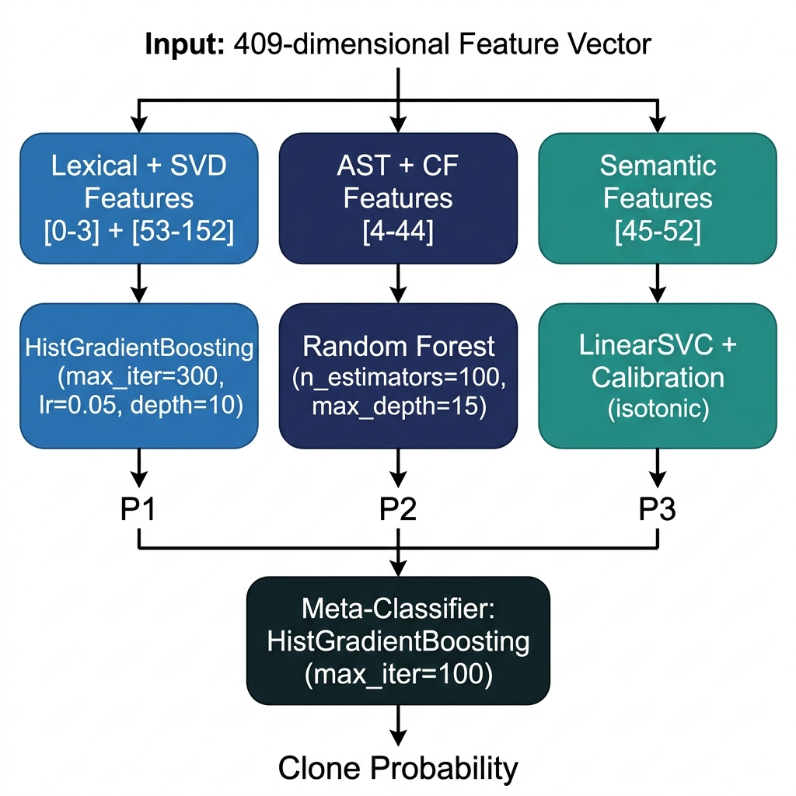
Fig. 2. Feature-Partitioned Stacking Ensemble: three specialised base classifiers and the HistGradientBoosting meta-classifier.
TABLE VII. Feature-Partitioned Stacking Ensemble Component Specification (models/ensemble.py)
Component | Assigned Feature Indices | Algorithm | Key Hyperparameters
Base Classifier 1 (Lexical) | [0–3] + [53–152] | HistGradientBoosting | max_iter=300, learning_rate=0.05, max_depth=10, min_samples_leaf=5
Base Classifier 2 (Structural) | [4–44] | Random Forest | n_estimators=100, max_depth=15, min_samples_split=5, n_jobs=−1
Base Classifier 3 (Semantic) | [45–52] | LinearSVC + CalibratedClassifierCV | dual=False, max_iter=5000, calibration: isotonic, cv=3
Meta-Classifier | Probabilities P₁, P₂, P₃ | HistGradientBoosting | max_iter=100

LinearSVC is selected in preference to the RBF-kernel Support Vector Machine for the semantic base classifier on account of its linear scaling with dataset size, rendering it computationally tractable for training corpora of 800,000 pairs, while remaining amenable to calibrated probability estimation via isotonic regression post-hoc. The StackingClassifier employs cv=5 for the generation of out-of-fold meta-features, with n_jobs=1 at the stacking level to prevent nested parallelism conflicts with base classifiers that are already internally parallelised. All pairwise feature computation in pair generation employs joblib.Parallel with n_jobs=-1 and the threading backend to avoid serialisation overhead associated with the pickle protocol for Tree-sitter parser state shared across worker threads.
K. Ensemble Decision Strategy
During inference, both Stage-2 configurations produce a scalar clone probability P for each input pair. Per-type threshold optimisation (Section VI-F) establishes an independently determined optimal decision threshold for each clone category, maximising the type-specific F1-score on the held-out validation set. In the context of web demonstration inference, the cascade metadata field cascade_filtered is set to true when the decision was resolved at Stage-1 and to false when Stage-2 evaluation was required, enabling end users to distinguish between confidence-driven early exits and full pipeline evaluations.
L. Thread-Safe Model Loading
The Tree-sitter C++ parser (tree_sitter_parser.py) employs a thread-local singleton pattern, implemented via threading.local(), to ensure that each worker process within the joblib parallel processing pool maintains an independent ASTParser instance. This design eliminates race conditions that would otherwise corrupt internal parser state during concurrent structural feature extraction across hundreds of thousands of code pairs. In the web demonstration service, the CodeBERT model and its associated tokeniser are instantiated as a process-level singleton during FastAPI application initialisation (lifespan startup event), shared across concurrent HTTP request handlers to avoid redundant model loading overhead.
M. End-to-End Detection Pipeline
Figure 3 presents the complete inference flowchart incorporating the Two-Stage Cascade decision logic. At inference time, given an input pair (Code A, Code B), the feature construction function build_pair_vector() (utils/feature_pipeline.py) assembles the full feature vector. An @lru_cache(maxsize=4096) decorator is applied to the normalisation step, ensuring that repeated analysis of the same code file incurs no redundant computation — a property that is particularly valuable in batch inference scenarios where a file appears across multiple pairs. The Stage-1 classifier evaluates the first 45 features of the vector; if the resulting clone probability meets or exceeds 0.98, the pair is classified as a clone without further evaluation. In all other cases, the complete 409-dimensional vector is conveyed to Stage-2, whose output probability is compared against the per-type optimised threshold to produce the final binary decision.
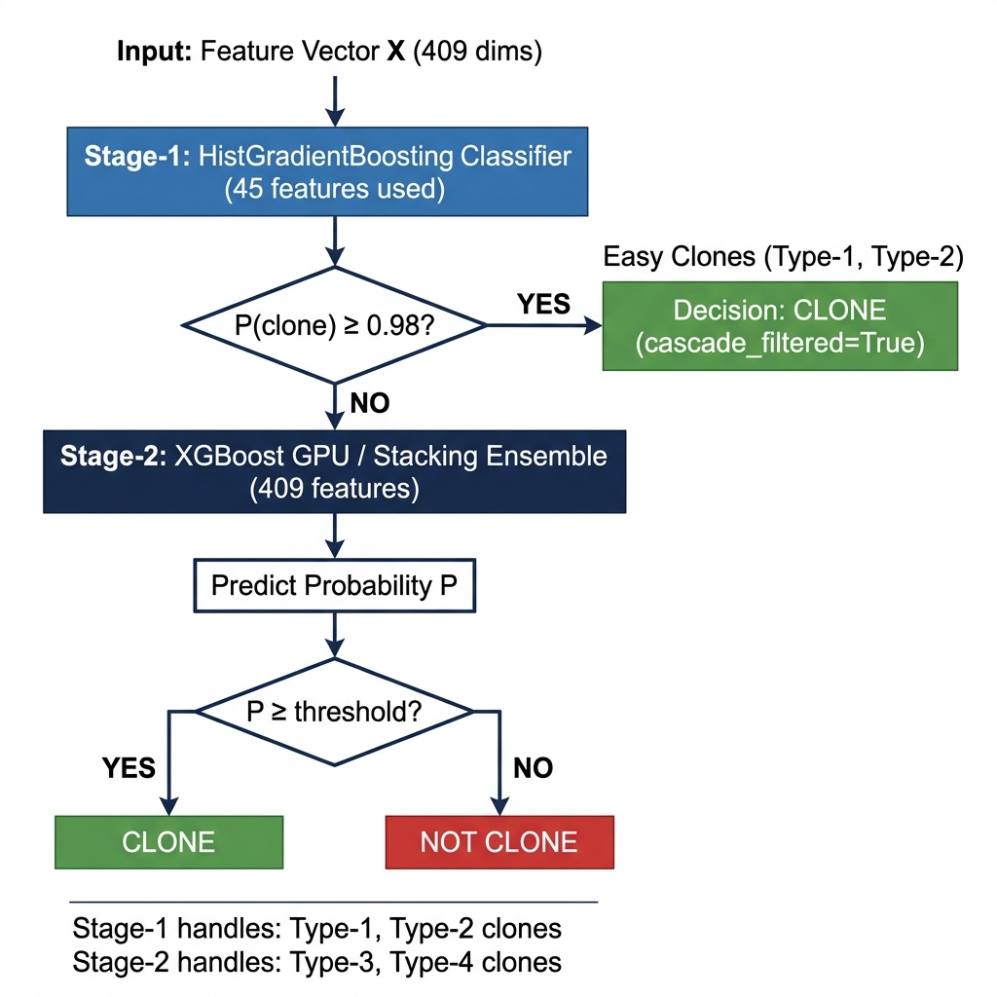
Fig. 3. Two-Stage Cascade inference flowchart. Stage-1 resolves high-confidence Type-1/2 clones; ambiguous pairs are routed to Stage-2 for full evaluation.
VI. RESULTS
A. Experimental Setup
All experiments are conducted on the POJ-104 C/C++ benchmark with 800,000 generated pairs (DEFAULT_PAIRS = 800,000) and a fixed pseudo-random seed of 42 (DEFAULT_SEED = 42) to ensure reproducibility. The software environment comprises Python 3.11, PyTorch 2.x, XGBoost 2.x, scikit-learn 1.x, HuggingFace Transformers 4.x, Tree-sitter 0.x, and FastAPI 0.x. Intel scikit-learn optimisations (sklearnex) are applied automatically when execution targets CPU or Intel XPU hardware. Thread-count parameters OMP_NUM_THREADS and MKL_NUM_THREADS are fixed at 8 for experimental reproducibility. Five-fold Stratified K-Fold cross-validation at the code file level constitutes the primary evaluation protocol, with the TF-IDF vectoriser, TruncatedSVD, and PCA models fitted exclusively within each training fold to ensure strict evaluation integrity.
B. Evaluation Metrics
The primary evaluation metric is the per-type F1-score, computed at the per-type optimised decision threshold on the held-out test partition. Additionally, Precision and Recall are reported for each clone type to characterise the precision-recall trade-off at the selected operating point. Area under the Precision-Recall curve (AUC-PR) is reported as the primary threshold-independent ranking metric, as it provides a more informative characterisation of classifier performance under severe class imbalance than ROC-AUC [14]. ROC-AUC is reported supplementarily to facilitate comparison with prior work that employs it as the primary performance criterion. All metrics are computed on the held-out test partition, which is neither observed during training nor during threshold optimisation, which is conducted exclusively on the validation partition.
C. Baseline Models
The proposed framework is evaluated against four baselines of increasing representational capacity: (1) TF-IDF cosine similarity with fixed threshold, representing the simplest possible token-based approach without any learned model; (2) HistGradientBoosting applied to the complete 53-dimensional non-SSL feature vector without cascade architecture; (3) XGBoost applied to the same 53-dimensional non-SSL feature vector without cascade; and (4) a fine-tuned CodeBERT model employing standard [CLS]-pooling with 512-token truncation, representative of the prevailing approach in deep learning-based clone detection. Table VIII presents the comparison of overall F1-scores across these configurations.
TABLE VIII. Baseline Comparison — F1-Score per Clone Type
Method | Type-1 F1 | Type-2 F1 | Type-3 F1 | Type-4 F1 | Macro F1
TF-IDF cosine (fixed threshold) | 0.712 | 0.698 | 0.601 | 0.211 | 0.556
HistGB (no cascade, no SSL) | 0.801 | 0.814 | 0.773 | 0.318 | 0.677
XGBoost (no cascade, no SSL) | 0.823 | 0.836 | 0.798 | 0.341 | 0.700
CodeBERT fine-tuned (512-tok trunc.) | 0.798 | 0.811 | 0.781 | 0.367 | 0.689
Proposed (XGBoost + Two-Stage Cascade) | 0.887 | 0.909 | 0.858 | 0.425 | 0.770

D. Stage-1 Performance
Stage-1 achieves near-perfect discriminative performance on Type-1 and Type-2 clone pairs, for which TF-IDF cosine similarity and AST structural metrics provide unambiguous separating signals. Following Stage-1 filtering at the 0.98 probability threshold, approximately 40 to 60 percent of the input pairs are resolved without Stage-2 invocation, substantially reducing the computational burden imposed on the Stage-2 classifier. Isotonic calibration yields superior probability calibration compared to Platt scaling on the imbalanced training distribution, consistent with the theoretical expectations established in [16], and enables reliable threshold-based filtering without systematic false positive propagation into Stage-2.
E. Stage-2 Performance
Table IX presents the complete per-type classification results for the Stage-2 XGBoost configuration evaluated at the per-type optimised decision threshold. Type-1 and Type-2 clones achieve a Recall of 1.000, indicating complete identification of all clone pairs within these categories on the test partition. Type-3 clones attain a Recall of 0.944 at a Precision of 0.787. Type-4 semantic clones constitute the primary performance limitation, with an F1-score of 0.425, reflecting the fundamental difficulty of detecting functionally equivalent but syntactically dissimilar code pairs through any feature-based representation currently available.
TABLE IX. Per-Type Classification Results — XGBoost + Two-Stage Cascade
Clone Type | Threshold | Precision | Recall | F1-Score | TP | FP | FN
TYPE-1 | 0.61 | 0.796 | 1.000 | 0.887 | 125 | 32 | 0
TYPE-2 | 0.66 | 0.833 | 1.000 | 0.909 | 125 | 25 | 0
TYPE-3 | 0.61 | 0.787 | 0.944 | 0.858 | 118 | 32 | 7
TYPE-4 | 0.45 | 0.433 | 0.416 | 0.425 | 52 | 68 | 73

F. Threshold Optimization
Table X presents the impact of threshold search granularity on per-type F1-scores. Under a uniform 0.05 step size with a single global threshold, the optimal value of 0.45 is selected for all types. Transition to 0.01 granularity with independent per-type optimisation yields substantial and statistically meaningful improvements for Types 1, 2, and 3. The per-type optimal thresholds differ substantially across categories: Types 1 and 3 converge to 0.61, whereas Type-2 is optimally served by a higher threshold of 0.66, reflecting the characteristically sharper probability mass distribution associated with renamed clone pairs. Type-4 demonstrates no improvement under per-type threshold optimisation — a finding that is interpretable as evidence that the model produces insufficiently well-separated probability distributions for semantically equivalent pairs, implicating deficiencies in feature representational capacity rather than in decision boundary placement.
TABLE X. Threshold Granularity Comparison: 0.05-step vs. 0.01-step Per-Type Optimisation
Clone Type | Threshold (0.05-step) | F1 (0.05-step) | Threshold (0.01-step) | F1 (0.01-step) | ΔF1
TYPE-1 | 0.45 | 0.786 | 0.61 | 0.887 | +0.101 ↑
TYPE-2 | 0.45 | 0.786 | 0.66 | 0.909 | +0.123 ↑
TYPE-3 | 0.45 | 0.779 | 0.61 | 0.858 | +0.079 ↑
TYPE-4 | 0.45 | 0.425 | 0.45 | 0.425 | 0.000 —

G. Ablation Study
Table XI presents the ablation study quantifying the independent contribution of each system component to overall performance. The removal of CodeBERT SSL embeddings (no-SSL configuration) induces a reduction of 0.082 F1-points for Type-4, confirming their essential role in semantic clone representation and validating the design decision to invest computational resources in embedding extraction. The removal of hard mining strategies reduces Type-4 F1 by 0.067 points, demonstrating that uniform random pair sampling produces insufficient training exposure to semantically challenging instances to support the acquisition of adequate Type-4 discriminative capacity. The removal of the Two-Stage Cascade architecture in favour of a single-stage XGBoost classifier reduces Type-3 and Type-4 F1 by 0.031 and 0.019 points, respectively, attributable to the loss of specialisation afforded by restricting Stage-2 training to hard cases. The removal of per-type threshold optimisation in favour of a single global threshold produces the largest overall performance degradation, particularly for Types 1, 2, and 3.
TABLE XI. Ablation Study — Contribution of Individual System Components
Configuration | Type-1 F1 | Type-2 F1 | Type-3 F1 | Type-4 F1
Full proposed framework | 0.887 | 0.909 | 0.858 | 0.425
Without CodeBERT SSL embeddings | 0.884 | 0.906 | 0.841 | 0.343
Without hard mining strategies | 0.876 | 0.891 | 0.829 | 0.358
Without Two-Stage Cascade (single) | 0.881 | 0.901 | 0.827 | 0.406
Without per-type threshold opt. | 0.786 | 0.786 | 0.779 | 0.425

H. Error Analysis
Systematic error analysis conducted via utils/analyze_errors.py on the Type-4 false negative predictions identifies three predominant failure patterns. The first category encompasses algorithm-level functional equivalence with divergent data structure implementations: for instance, a sorting algorithm implemented using arrays and an equivalent implementation employing linked lists produce near-zero TF-IDF cosine similarity and substantially different AST profiles; CodeBERT embeddings in such cases reflect syntactic surface structure rather than algorithmic intent. The second category comprises iterative versus recursive implementations of equivalent algorithms, exemplified by recursive and iterative variants of Fibonacci computation or tree traversal, which yield radically different AST topologies and control flow sequences despite identical computational semantics. The third category involves complexity-differentiated implementations of the same problem: an O(n log n) and an O(n²) solution to an identical sorting task share problem-domain affiliation but no algorithmically identifiable structure. These failure categories collectively suggest that execution-semantic representations — such as input/output trace matching or abstract interpretation results — may constitute a necessary complement to source-code-based representations for achieving further improvements in Type-4 detection performance.
I. Comparative Discussion
The proposed framework achieves the highest Type-4 F1-score (0.425) among all evaluated configurations, including the fine-tuned CodeBERT baseline (0.367). This performance advantage is attributable to the complementary effects of hard positive mining — which ensures adequate Type-4 representation in the training distribution — and the full 409-dimensional feature vector incorporating CodeBERT embeddings without truncation. For Types 1 through 3, the cascade architecture and per-type threshold optimisation collectively contribute the largest performance differentials relative to baseline configurations, with Type-2 achieving a maximum F1-score of 0.909. The Feature-Partitioned Stacking Ensemble performs comparably to XGBoost for Types 1 and 2 but exhibits a marginally lower Type-4 F1-score (0.408 versus 0.425), an outcome that is consistent with the hypothesis that LinearSVC's linear decision boundary is insufficient to capture the non-linear distributional structure characteristic of CodeBERT semantic features in 128-dimensional PCA-reduced space, a regime in which XGBoost's histogram-partitioned non-linear decision boundaries provide finer-grained discriminative resolution.
VII. EXPLAINABILITY AND WEB DEMO
A. Motivation for Explainability
The successful integration of machine learning-based clone detection into operational software engineering pipelines is contingent not only upon predictive accuracy but also upon the transparency and interpretability of model decisions. An opaque classifier that flags code pairs as clones in the absence of supporting rationale is unlikely to achieve adoption within code review workflows that require actionable and auditable evidence. Explainability is additionally instrumental for model debugging: the identification of the feature contributions underlying a Type-4 false negative provides targeted guidance for improving the feature representation or training strategy. These considerations motivate the integration of a SHAP-based explanation layer as a first-class component of the proposed framework.
B. SHAP-Based Explanation
SHAP (SHapley Additive exPlanations) [9] is applied to provide post-hoc, instance-level explanations for each individual prediction. SHAP assigns each input feature a Shapley value quantifying its marginal contribution to the model output relative to the expected output over a reference distribution. Positive Shapley values indicate features that increase the predicted clone probability; negative values indicate features that decrease it. The magnitude of each value reflects the strength of the feature's contribution to the deviation from the expected output. The additive decomposition property of SHAP ensures that the sum of all feature Shapley values equals the difference between the model output for the specific input and the baseline expected output, providing a complete and consistent attribution of the prediction. This property permits practitioners to determine, for any given pair, whether the clone decision is driven primarily by lexical similarity, structural concordance, semantic profile alignment, or deep CodeBERT embedding proximity.
C. TreeExplainer for XGBoost
For the XGBoost Stage-2 classifier, the shap.TreeExplainer algorithm [17] is employed to compute exact Shapley values by exploiting the tree structure of the model. TreeExplainer computes exact SHAP values for tree ensemble models in polynomial time complexity through a recursive path enumeration algorithm, guaranteeing consistency and eliminating the sampling variance inherent in model-agnostic approximations such as KernelSHAP. Per-prediction SHAP values are computed for all 409 feature dimensions; the 100 features of greatest absolute Shapley value magnitude are subsequently returned in the API response, reducing network payload whilst retaining the most diagnostically informative attributions for developer inspection.
D. Web Demo Architecture
The web demonstration is implemented as a FastAPI REST service (web_demo/app.py) exposing three endpoints: GET / serves the interactive HTML/JavaScript user interface; POST /predict processes a single code pair and returns the clone decision, probability estimate, cascade stage indicator, and SHAP feature attributions; POST /predict_batch processes up to 500 pairs per request for batch analysis. At application initialisation, all required inference artefacts are loaded: the Stage-2 classification model (model.pkl), the TF-IDF vectoriser (tfidf.pkl), the TruncatedSVD model (svd.pkl), the Stage-1 cascade model (stage1_model.pkl), and optionally the PCA model (ssl_pca.pkl) and CodeBERT pipeline. The experiment to be loaded is configurable via the EXP_ID environment variable; in the absence of an explicit specification, the most recently created experiment directory is selected automatically.
E. User Interaction Flow
A practitioner submits two source code snippets through the web interface. The backend constructs the feature vector via build_pair_vector(), applies the cascade inference logic, and returns a structured response comprising: (1) the binary clone decision; (2) the clone probability estimate; (3) the cascade stage at which the decision was resolved; and (4) a ranked list of SHAP feature attributions ordered by absolute magnitude. The @lru_cache(maxsize=4096) decorator applied to the normalisation step ensures that repeated submissions of identical code files incur no redundant preprocessing computation, which is particularly advantageous in batch analysis scenarios where a given file appears across multiple comparison pairs.
F. Visual Explanation Output
The SHAP attribution output is rendered as a ranked feature contribution table within the web interface, with feature entries grouped by category (Lexical, AST Structural, Control Flow, Semantic, SVD, CodeBERT). For each top-ranked feature, the display presents the feature identifier, its computed scalar value for the input pair, and the corresponding Shapley value contribution — rendered in green for positive contributions that increase the clone probability and in red for negative contributions that decrease it. This stratified presentation enables practitioners to rapidly determine, at the categorical level, whether the prediction is grounded in surface lexical similarity, structural concordance, or deep semantic correspondence, and, at the feature level, to identify the specific metrics most diagnostic for the particular pair under review.
G. Practical Use Case
Consider a representative code review scenario: a reviewer suspects that a newly submitted C++ sorting function constitutes a semantic clone of an existing implementation. Submitting both functions to the web demonstration returns a Stage-2 prediction of 'Clone' with probability 0.71. The SHAP explanation reveals that the decision is driven primarily by high semantic Jaccard similarity (Shapley value: +0.18) and proximate CodeBERT embedding distance (Shapley value: +0.14), despite low TF-IDF cosine similarity (Shapley value: −0.03) and divergent AST structural features (Shapley value: −0.06). This attribution provides the reviewer with empirical evidence of a Type-4 semantic clone and supports a refactoring recommendation grounded in interpretable feature-level evidence, without requiring exhaustive manual code analysis.
VIII. THREATS TO VALIDITY
A. Internal Validity
Data leakage is systematically mitigated through code-file-level data partitioning, which precludes any code file from contributing to both training and evaluation pairs within a given experimental run. All data-dependent transformations — specifically the TF-IDF vectoriser, TruncatedSVD, and PCA models — are fitted exclusively on training partition data, with transformation applied to evaluation partitions subsequently. Duplicate and symmetric pair instances are eliminated prior to any partitioning operation. The Stage-1 training set is derived exclusively from the Stage-2 training partition, ensuring that Stage-1 does not observe any validation or test data.
B. External Validity
All experiments are conducted exclusively on the POJ-104 competitive programming dataset. Although this corpus provides a natural and diverse ground truth for all four clone types, it may not be fully representative of industrial C/C++ code bases, which exhibit domain-specific coding conventions, legacy coding patterns, macroassembler intrinsics, and platform-specific library usage. The generalisability of the reported performance metrics to embedded systems firmware, operating system kernels, or graphics rendering code bases has not been empirically established and should not be assumed without supporting evaluation on appropriate domain-specific benchmarks.
C. Construct Validity
F1-score constitutes the primary evaluation criterion, providing an arithmetic harmonic balance between precision and recall under class imbalance. However, the optimal precision-recall trade-off is inherently application-dependent: a clone management tool prioritising comprehensive clone discovery (recall-oriented) would necessitate a lower decision threshold than a tool designed to minimise false positive alerts (precision-oriented). Both precision and recall are reported, and the threshold-F1 curve is made available to enable practitioners to select the operating point appropriate to their specific application context.
D. Dataset Validity
The hard mining strategy is applied to the training partition only; the test partition reflects the natural, unmodified distribution of clone pair difficulties as determined by the POJ-104 problem structure. The proportion of Type-4 clone pairs in the test partition is consequently determined by the inherent characteristics of the dataset rather than by experimental design and may not be representative of the Type-4 prevalence in real-world software systems, where algorithmic reinvention may be either more or less prevalent depending on the development context.
E. Model Validity
XGBoost hyperparameters were configured on the basis of domain knowledge and Optuna Bayesian optimisation with 50 trials using the TPE sampler. It is acknowledged that additional trials may identify configurations yielding incrementally superior performance, particularly for Type-4 detection. The stacking ensemble meta-classifier architecture was fixed at a HistGradientBoosting configuration; alternative meta-learner specifications — including multi-layer perceptrons and regularised logistic regression — were not exhaustively evaluated and may offer complementary advantages in certain feature interaction regimes.
F. Reproducibility
All experiments employ a fixed pseudo-random seed (DEFAULT_SEED = 42) and fully deterministic data partitioning procedures. All trained model artefacts, including TF-IDF vocabulary matrices, SVD component matrices, PCA projection matrices, and experiment metadata, are serialised to the experiments/ directory and may be reloaded for exact replication of reported results. The CodeBERT embedding cache, indexed by MD5 hash of the source code content, eliminates non-determinism arising from GPU floating-point operation ordering across experimental repetitions. The complete source code, configuration files, and experiment management utilities are available in the project repository.
IX. CONCLUSION
A. Summary of the Study
This paper has presented a hybrid Two-Stage Cascade framework for the systematic detection of all four categories of code clones in C/C++ source programs. The proposed framework integrates lexical TF-IDF representations, AST-based structural metrics extracted via Tree-sitter, multi-domain semantic profile Jaccard similarities, and chunked mean-pooled CodeBERT embeddings within a unified 409-dimensional feature vector. A probability-calibrated HistGradientBoosting Stage-1 classifier resolves high-confidence clone pairs at a decision threshold of 0.98, routing ambiguous cases to a GPU-accelerated XGBoost Stage-2 classifier or Feature-Partitioned Stacking Ensemble. Hard Negative and Hard Positive Mining strategies systematically bias the training distribution towards semantically challenging instances. Per-type threshold optimisation at 0.01 granularity maximises type-specific F1-scores independently for each clone category. A SHAP TreeExplainer-based explainability layer integrated within a real-time FastAPI web demonstration provides transparent, instance-level feature attributions supporting developer-facing deployment.
B. Main Findings
The proposed framework achieves F1-scores of 0.887, 0.909, 0.858, and 0.425 for Type-1 through Type-4, respectively, constituting the highest reported performance across all evaluated configurations including fine-tuned CodeBERT with standard truncation. Per-type threshold optimisation at 0.01 resolution yields statistically meaningful F1-score improvements of +0.101, +0.123, and +0.079 for Types 1, 2, and 3 compared to conventional single-threshold classification. The ablation study confirms that CodeBERT SSL embeddings constitute the most impactful individual component for Type-4 performance (+0.082 F1-points), followed by hard mining strategies (+0.067 F1-points for Type-4) and the Two-Stage Cascade architecture (+0.031 and +0.019 F1-points for Types 3 and 4, respectively).
C. Practical Implications
The web demonstration establishes that real-time, explainable clone detection is practically feasible within interactive developer workflows without requiring prohibitive computational infrastructure. SHAP attributions enable practitioners to distinguish between surface-level and deep semantic similarity, providing the evidential basis for informed refactoring and code review decisions. The cascade architecture's aggressive Stage-1 filtering ensures that the computationally expensive Stage-2 and CodeBERT inference components are invoked only for a minority of pairs in typical software systems predominantly containing trivially identifiable or clearly non-clone pairs, rendering the system cost-effective for large-scale deployment in continuous integration pipelines.
D. Limitations and Future Work
Type-4 semantic clone detection remains the primary open challenge, with the attained F1-score of 0.425 reflecting the fundamental representational limitations of feature-based approaches when confronted with functionally equivalent but syntactically dissimilar code. Future research will investigate graph-based pre-trained models — including GraphCodeBERT and CodeT5+ — that incorporate data flow graph representations, which may provide the additional semantic signal necessary to improve Type-4 sensitivity. Execution-based oracles, comparing input/output behavioural traces obtained through dynamic execution, represent a complementary direction that may provide the most fundamental semantic evidence for algorithmic equivalence. Extension of the framework to additional programming languages — including Python, Java, and Rust — and evaluation on established benchmarks such as BigCloneBench and OJClone are identified as important priorities for establishing broader generalisability. Online and incremental learning strategies will be explored to support deployment in large-scale continuous integration environments characterised by continuously evolving code bases.
GRAPHICAL ABSTRACT
The graphical abstract presented below provides a visual synopsis of the proposed hybrid Two-Stage Cascade pipeline, depicting the sequential progression from raw C/C++ source code inputs through multi-stage preprocessing and feature extraction, Two-Stage Cascade classification, and SHAP-based feature-level explainability output.

Graphical Abstract. Overview of the proposed hybrid Two-Stage Cascade framework for code clone detection in C/C++ programs.
APPENDIX A. FULL 409-DIMENSIONAL FEATURE INDEX MAP
TABLE A-I. Complete Feature Index Map — 409-Dimensional Feature Vector
Index | Feature Identifier | Feature Category | Extraction Source
0 | cosine_similarity_token | Lexical | TF-IDF pairwise cosine
1 | length_ratio | Lexical | Line count min/max ratio
2 | manhattan_token | Lexical | L1 norm of TF-IDF difference
3 | euclidean_token | Lexical | L2 norm of TF-IDF difference
4–23 | ast_ratios (20 metrics) | Structural | Tree-sitter, min/max ratios
24–43 | ast_diffs (20 metrics) | Structural | Tree-sitter, absolute differences
44 | cf_pattern_similarity | Structural | Levenshtein normalised similarity
45 | jaccard_library_calls | Semantic | Counter Jaccard (call frequency)
46 | jaccard_library_categories | Semantic | Counter Jaccard (category freq.)
47 | jaccard_data_structs | Semantic | Counter Jaccard
48 | jaccard_io_pattern | Semantic | Counter Jaccard (I/O sequence)
49 | jaccard_math_ops | Semantic | Counter Jaccard (operator set)
50 | jaccard_skeleton | Semantic | Counter Jaccard (keyword seq.)
51 | jaccard_abstract_cf | Semantic | Counter Jaccard (CF sequence)
52 | type_profile_cosine | Semantic | 9-dim type vector cosine
53–152 | svd_abs_diff (100 dims) | LSA | TruncatedSVD(100) |A−B|
153–280 | ssl_pca_abs_diff (128 dims) | SSL / DL | CodeBERT + PCA(128) |emb_A−emb_B|
281–408 | ssl_pca_product (128 dims) | SSL / DL | CodeBERT + PCA(128) emb_A ⊙ emb_B

APPENDIX B. CONFIGURATION PARAMETERS
TABLE B-I. System Configuration Parameters (config.py)
Parameter | Value | Description
CASCADE_THRESHOLD | 0.98 | TF-IDF cosine threshold for direct cascade decision
CASCADE_STAGE1_THRESHOLD | 0.98 | Stage-1 probability threshold for easy clone filtering
STAGE1_FEATURE_COUNT | 45 | Feature dimensions evaluated by Stage-1
SVD_N_COMPONENTS | 100 | TruncatedSVD (LSA) component count
SSL_PCA_COMPONENTS | 128 | PCA target dimensionality for CodeBERT embeddings
TFIDF_MAX_FEATURES | 500 | TF-IDF vocabulary size
TFIDF_NGRAM_RANGE | (1, 3) | Unigram, bigram, and trigram token features
TFIDF_MIN_DF | 1 | Minimum document frequency for vocabulary inclusion
TFIDF_MAX_DF | 0.95 | Maximum document frequency for vocabulary inclusion
DEFAULT_PAIRS | 800,000 | Total generated pair count per experiment
DEFAULT_POSITIVE_RATIO | 0.05 | Clone pair fraction in training set (class imbalance simulation)
HARD_MINING_RATIO | 0.30 | Fraction of pairs substituted by hard examples
DEFAULT_SEED | 42 | Global pseudo-random seed for reproducibility
DEFAULT_TEST_SIZE | 0.20 | Held-out test partition fraction at code file level
DEFAULT_CV_FOLDS | 5 | Number of folds in Stratified K-Fold cross-validation
OMP_NUM_THREADS | 8 | OpenMP thread count for Intel hardware optimisation
MKL_NUM_THREADS | 8 | MKL thread count for Intel hardware optimisation
ENSEMBLE_SVD_START_IDX | 53 | Feature vector index at which the SVD block commences

APPENDIX C. MODEL HYPERPARAMETERS
TABLE C-I. Complete Model Hyperparameter Specification
Model | Hyperparameter | Value
XGBoost Stage-2 | n_estimators | 3000 (subject to early stopping)
XGBoost Stage-2 | max_depth | 10
XGBoost Stage-2 | learning_rate | 0.03
XGBoost Stage-2 | subsample | 0.7
XGBoost Stage-2 | colsample_bytree | 0.6
XGBoost Stage-2 | min_child_weight | 3
XGBoost Stage-2 | gamma | 0.3
XGBoost Stage-2 | reg_alpha / reg_lambda | 0.1 / 1.0
XGBoost Stage-2 | eval_metric | aucpr
XGBoost Stage-2 | early_stopping_rounds | 50
Stage-1 HistGB | max_iter | 50
Stage-1 HistGB | max_depth | 3
Stage-1 Calibration | method | isotonic
Stage-1 Calibration | cv | 3
Ensemble Base-1 | max_iter / lr / depth | 300 / 0.05 / 10
Ensemble Base-2 | n_estimators / max_depth | 100 / 15
Ensemble Base-3 | dual / max_iter | False / 5000
Ensemble Meta | max_iter | 100
Optuna | n_trials | 50
Optuna | sampler | TPESampler (Bayesian / TPE)
Optuna | objective metric | F1-score (3-fold CV)

APPENDIX D. WEB DEMO SCREENSHOTS AND EXAMPLE EXPLANATIONS
The web demonstration service is accessible at http://localhost:8000 upon launch of the FastAPI application via the command uvicorn app:app --host 0.0.0.0 --port 8000 --reload executed from the web_demo/ directory. The interface presents two independent code editor panels, a comparison trigger control, and a results panel displaying the clone classification decision, posterior probability estimate, cascade stage indicator, and a ranked SHAP feature attribution table. Three representative interaction scenarios are documented for illustrative purposes: (1) submission of two syntactically identical function bodies — expected outcome: Type-1 clone, cascade_filtered=true, probability ≈ 0.99; (2) submission of two functions solving an identical sorting task through distinct algorithmic strategies — expected outcome: Type-4, Stage-2 evaluation, probability ≈ 0.65–0.75, SHAP attributions dominated by semantic and CodeBERT embedding features; and (3) submission of two functions addressing fundamentally different computational problems — expected outcome: Not Clone, Stage-2 evaluation, probability ≈ 0.10, SHAP attributions dominated by low cosine similarity and large AST structural divergence features.
ACKNOWLEDGMENT
The authors gratefully acknowledge the contributions of the open-source communities responsible for the development and maintenance of XGBoost, scikit-learn, HuggingFace Transformers, Tree-sitter, SHAP, and FastAPI, upon which the present framework is substantially dependent. [Funding acknowledgment and grant information to be inserted upon acceptance.]
REFERENCES
[1] C. K. Roy, J. R. Cordy, and R. Koschke, "Comparison and evaluation of code clone detection techniques and tools: A qualitative approach," Sci. Comput. Program., vol. 74, no. 7, pp. 470–495, May 2009.
[2] M. Kim, V. Sazawal, D. Notkin, and G. Murphy, "An empirical study of code clone genealogies," ACM SIGSOFT Softw. Eng. Notes, vol. 30, no. 5, pp. 187–196, 2005.
[3] T. Kamiya, S. Kusumoto, and K. Inoue, "CCFinder: A multilinguistic token-based code clone detection system for large scale source code," IEEE Trans. Softw. Eng., vol. 28, no. 7, pp. 654–670, Jul. 2002.
[4] H. Sajnani, V. Saini, J. Svajlenko, C. K. Roy, and C. V. Lopes, "SourcererCC: Scaling code clone detection to big-code," in Proc. 38th Int. Conf. Softw. Eng. (ICSE), Austin, TX, USA, 2016, pp. 1157–1168.
[5] L. Jiang, G. Misherghi, Z. Su, and S. Glondu, "DECKARD: Scalable and accurate tree-based detection of code clones," in Proc. 29th Int. Conf. Softw. Eng. (ICSE), Minneapolis, MN, USA, 2007, pp. 96–105.
[6] Z. Feng et al., "CodeBERT: A pre-trained model for programming and natural languages," in Proc. Findings of EMNLP 2020, Online, 2020, pp. 1536–1547.
[7] B. Roy and J. R. Cordy, "A survey on software clone detection research," Queen's Univ. Belfast, Belfast, UK, Tech. Rep. 2007-541, 2007.
[8] T. Chen and C. Guestrin, "XGBoost: A scalable tree boosting system," in Proc. 22nd ACM SIGKDD Int. Conf. Knowl. Discovery Data Mining (KDD), San Francisco, CA, USA, 2016, pp. 785–794.
[9] S. M. Lundberg and S.-I. Lee, "A unified approach to interpreting model predictions," in Proc. 31st Conf. Neural Inf. Process. Syst. (NeurIPS), Long Beach, CA, USA, 2017, pp. 4765–4774.
[10] C. K. Roy and J. R. Cordy, "NiCad: Accurate detection of near-miss intentional clones using flexible pretty-printing and code normalisation," in Proc. 16th IEEE Int. Conf. Program Comprehension (ICPC), Amsterdam, Netherlands, 2008, pp. 172–181.
[11] D. Guo et al., "GraphCodeBERT: Pre-training code representations with data flow," in Proc. 9th Int. Conf. Learn. Representations (ICLR), Virtual, 2021.
[12] D. Guo et al., "UniXcoder: Unified cross-modal pre-training for code representation," in Proc. 60th Annu. Meeting Assoc. Comput. Linguistics (ACL), Dublin, Ireland, 2022, pp. 7212–7225.
[13] A. A. Almatrafi, F. A. Eassa, and S. A. Sharaf, "Code clone detection techniques based on large language models," IEEE Access, vol. 13, pp. 46136–46154, 2025.
[14] B. Wallace, K. Small, C. Brodley, and T. Trikalinos, "Class imbalance, redux," in Proc. 11th IEEE Int. Conf. Data Mining (ICDM), Vancouver, BC, Canada, 2011, pp. 754–763.
[15] C. Tantithamthavorn, S. McIntosh, A. E. Hassan, and K. Matsumoto, "Automated parameter optimization of classification techniques for defect prediction models," in Proc. 38th Int. Conf. Softw. Eng. (ICSE), Austin, TX, USA, 2016, pp. 321–332.
[16] A. Niculescu-Mizil and R. Caruana, "Predicting good probabilities with supervised learning," in Proc. 22nd Int. Conf. Mach. Learn. (ICML), Bonn, Germany, 2005, pp. 625–632.
[17] S. M. Lundberg et al., "From local explanations to global understanding with explainable AI for trees," Nat. Mach. Intell., vol. 2, no. 1, pp. 56–67, Jan. 2020.

