程式設計(二)

姓名:林文盛(乙班)

學號：F74037049

Project2：2048

I use 2D array to write the 4x4 number and use Qpixmap to display them. Then, I use event to set what the array’s number change when I press up, down, right and left.

Below are the game’s screen shot I done:   
when start::::::

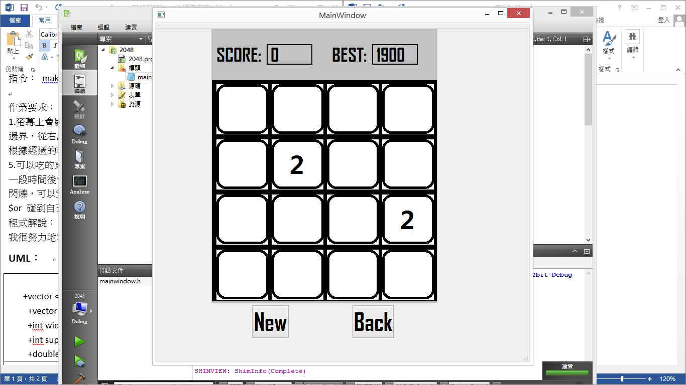

When finish::::

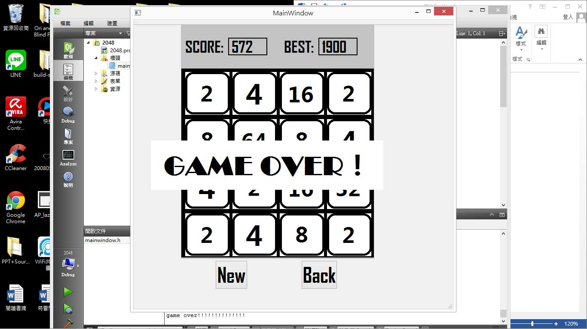

UML

|  |
| --- |
| mainwindow |
| -arr[4][4], mark, mark, sarr[4][4], bestmark : interger  -on_pushButton_clicked()  -on_pushButton_2_clicked() |
| +*keyPressEvent*(QKeyEvent * event)  +pic()  +add()  +finish()  +best() |

Bonus：

1. I add a back button to undo the step but just one time to let player have chance to modify their mistake.
2. I also add the best score label to record the best score of the player and it wont disappear when restart or closed the 2048 game.