程式設計(二)

姓名:林文盛(乙班)

學號：F74037049

Project 3: I use 10x 10 array pushbutton and Qicon to display the candy.

My game Target is 20 step and if you reach 15000point you success this game and get 1star. 18000point you get 2 star. 20000 point you get 3 star .

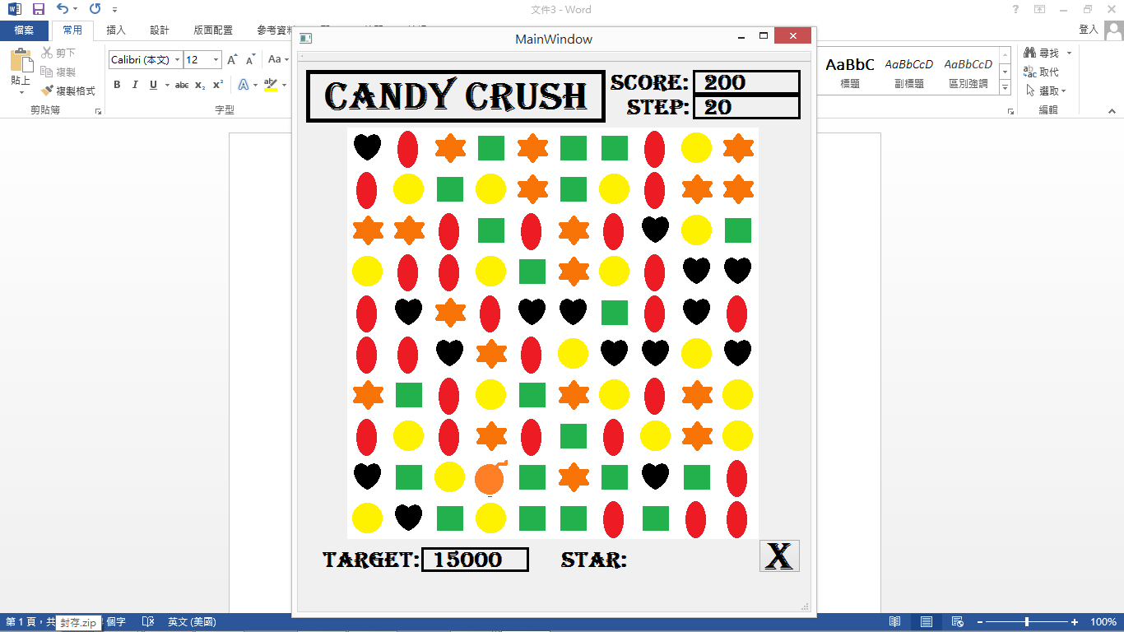 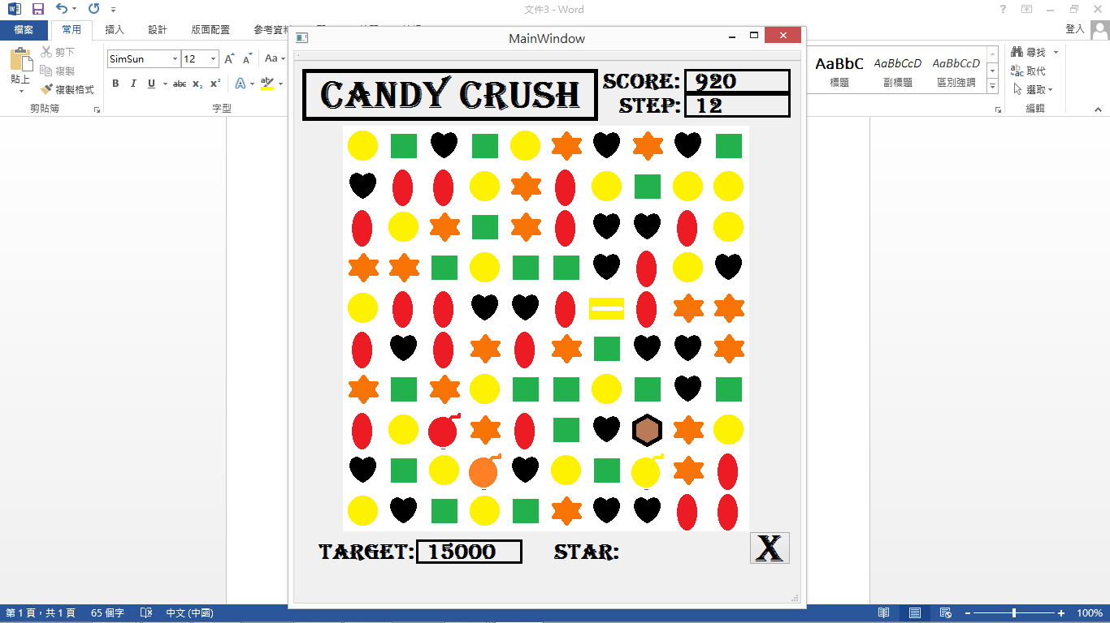 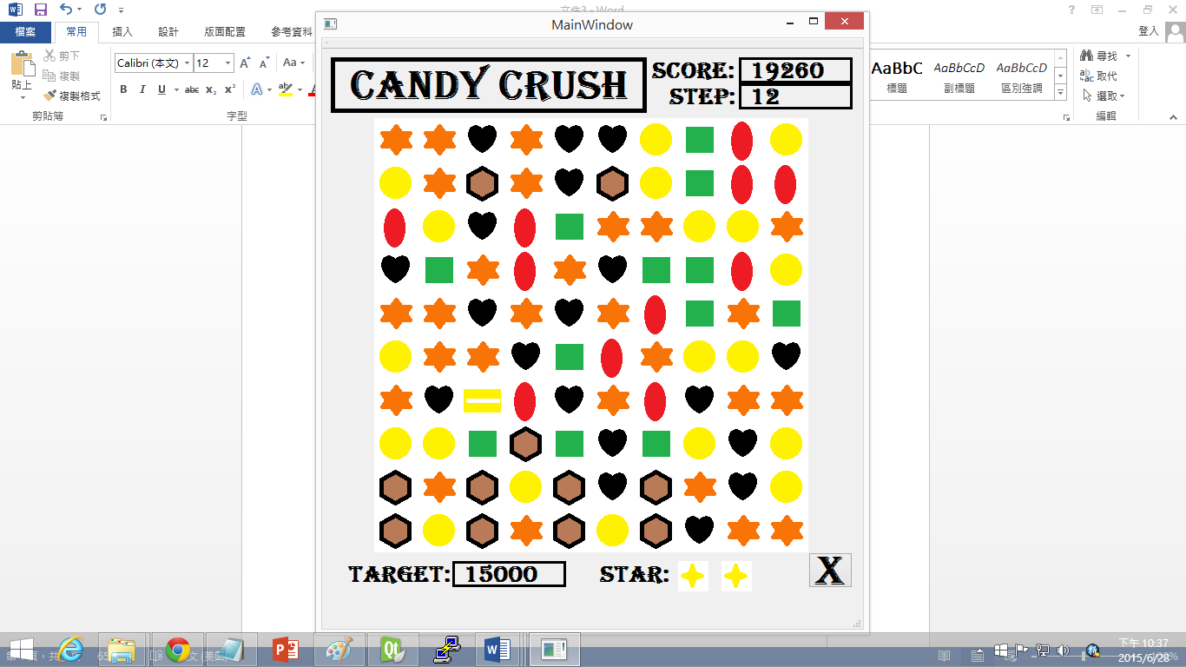 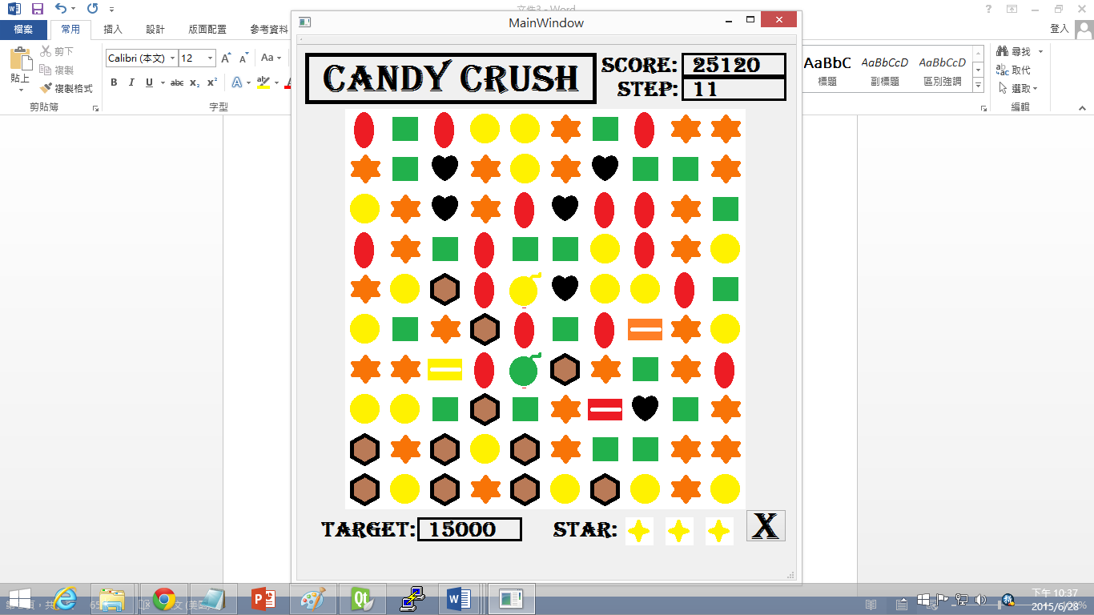

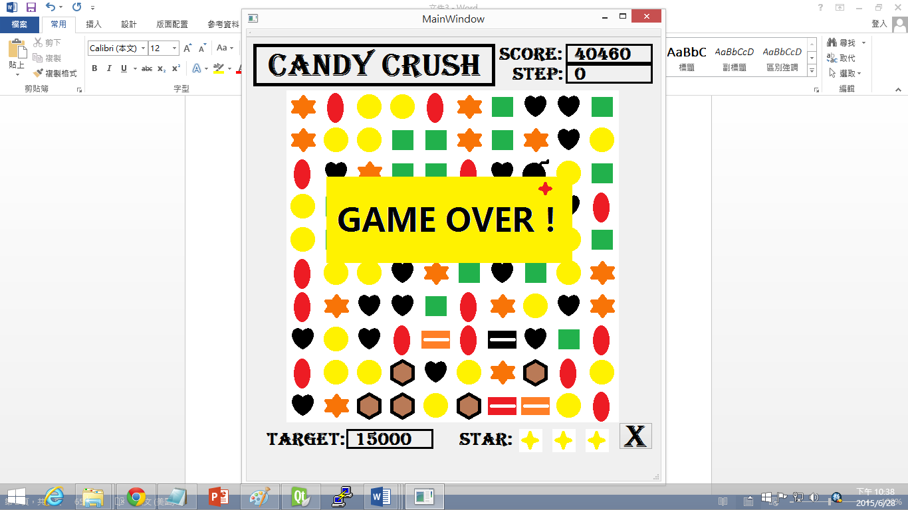

When you play after 20 step, game over.

will destroy the column when you make it 3 in 1 line and have same color.



will destroy the whole row of the candy when you make it in 1 line of 3 same candy.



will destroy 3x3 area of candy



will destroy all the same color of candy when you change it if another candy.



The x button is the signal Button.

**UML**

|  |
| --- |
| **mainwindow** |
| -arr[10][10],checkarr[10][10],savearr[10][10],first,second,score,f,step,star:int  - on_pushButton_clicked()  - on_pushButton_2_clicked()  - on_pushButton_3_clicked()  - on_pushButton_4_clicked()  - on_pushButton_5_clicked()  - on_pushButton_6_clicked()  - on_pushButton_7_clicked()  - on_pushButton_8_clicked()  - on_pushButton_9_clicked()  - on_pushButton_10_clicked()  - on_pushButton_11_clicked()  - on_pushButton_12_clicked()  - on_pushButton_13_clicked()  - on_pushButton_14_clicked()  - on_pushButton_15_clicked()  - on_pushButton_16_clicked()  - on_pushButton_17_clicked()  - on_pushButton_18_clicked()  - on_pushButton_19_clicked()  - on_pushButton_20_clicked()  - on_pushButton_21_clicked()  - on_pushButton_22_clicked()  - on_pushButton_23_clicked()  - on_pushButton_24_clicked()  - on_pushButton_25_clicked()  - on_pushButton_26_clicked()  - on_pushButton_27_clicked()  - on_pushButton_28_clicked()  - on_pushButton_29_clicked()  - on_pushButton_30_clicked()  - on_pushButton_31_clicked()  - on_pushButton_32_clicked()  - on_pushButton_33_clicked()  - on_pushButton_34_clicked()  - on_pushButton_35_clicked()  - on_pushButton_36_clicked()  - on_pushButton_37_clicked()  - on_pushButton_38_clicked()  - on_pushButton_39_clicked()  - on_pushButton_40_clicked()  - on_pushButton_41_clicked()  - on_pushButton_42_clicked()  - on_pushButton_43_clicked()  - on_pushButton_44_clicked()  - on_pushButton_45_clicked()  - on_pushButton_46_clicked()  - on_pushButton_47_clicked()  - on_pushButton_48_clicked()  - on_pushButton_49_clicked()  - on_pushButton_50_clicked()  - on_pushButton_51_clicked()  - on_pushButton_52_clicked()  - on_pushButton_53_clicked()  - on_pushButton_54_clicked()  - on_pushButton_55_clicked()  - on_pushButton_56_clicked()  - on_pushButton_57_clicked()  - on_pushButton_58_clicked()  - on_pushButton_59_clicked()  - on_pushButton_60_clicked()  - on_pushButton_61_clicked()  - on_pushButton_62_clicked()  - on_pushButton_63_clicked()  - on_pushButton_64_clicked()  - on_pushButton_65_clicked()  - on_pushButton_66_clicked()  - on_pushButton_67_clicked()  - on_pushButton_68_clicked()  - on_pushButton_69_clicked()  - on_pushButton_70_clicked()  - on_pushButton_71_clicked()  - on_pushButton_72_clicked()  - on_pushButton_73_clicked()  - on_pushButton_74_clicked()  - on_pushButton_75_clicked()  - on_pushButton_76_clicked()  - on_pushButton_77_clicked()  - on_pushButton_78_clicked()  - on_pushButton_79_clicked()  - on_pushButton_80_clicked()  - on_pushButton_81_clicked()  - on_pushButton_82_clicked()  - on_pushButton_83_clicked()  - on_pushButton_84_clicked()  - on_pushButton_85_clicked()  - on_pushButton_86_clicked()  - on_pushButton_87_clicked()  - on_pushButton_88_clicked()  - on_pushButton_89_clicked()  - on_pushButton_90_clicked()  - on_pushButton_91_clicked()  - on_pushButton_92_clicked()  - on_pushButton_93_clicked()  - on_pushButton_94_clicked()  - on_pushButton_95_clicked()  - on_pushButton_96_clicked()  - on_pushButton_97_clicked()  - on_pushButton_98_clicked()  - on_pushButton_99_clicked()  - on_pushButton_100_clicked()  - on_pushButton_101_clicked() |
| +add()  +pic()  +movedown()  +eat()  +swap()  +GetArray_From_Number() |

**Bonus:**

**My bomb have different color and corresponding to each same color of candy to let the candy crush game more interested.**