**OBITUARY**

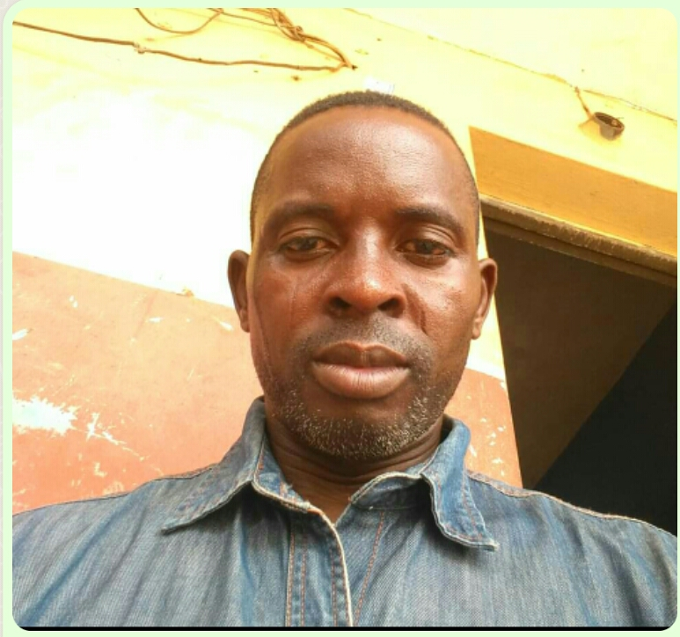

We are sad to announce the death of our brother and friend, Mr. Akeem Olayiwola Tijani who met his sad end on Sunday, 29th May 2022 at the University College Hospital (UCH) Ibadan

He will be buried on Monday, 30th May 2022 at his residence Lane 5, Unity Estate, behind Nobel High School, Bode Igbo, Panada, along Omi-Adio Raod, Ibadan.

Time is 4:00 PM

He is survived by an aged mother, wife and three children.

Announcer: Friends and family