2021 Inflation Analysis

Project 2 Report  
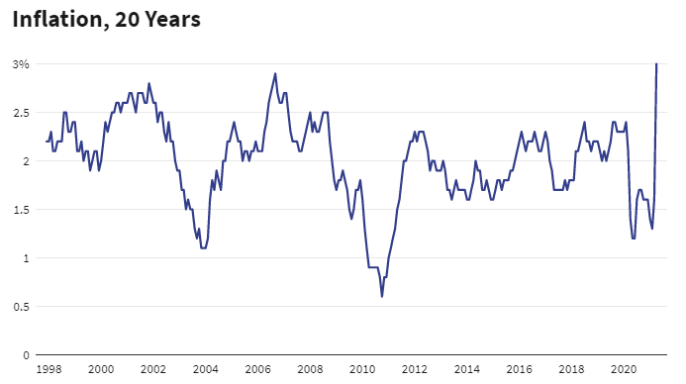  
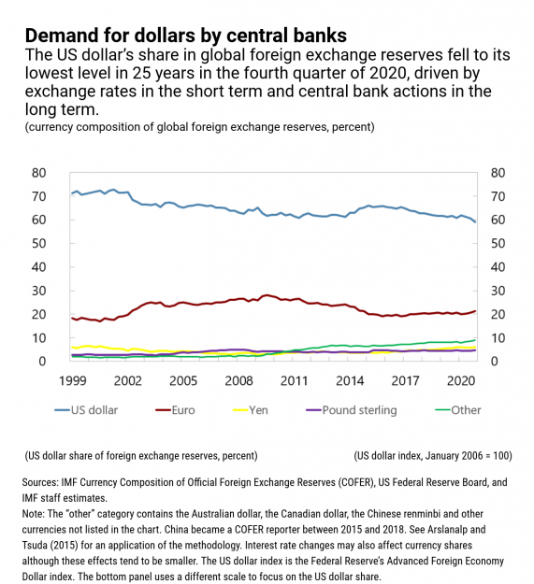

**Matt Maroofi & Don Irwin**

08/03/2021

MIDS W200 - Summer 2021

# Introduction

The objective of our research project is to present analysis that communicates the current state of inflation using multiple financial market indicators.   
  
 Our hypothesis is the currently reported inflation rate of 5% from the government is below the real-world measure of inflation.

A generally accepted definition of inflation is an increase in prices and fall in the purchasing value of money. The resulting inflationary effect is a decline in the consumer's purchasing power.   
  
 There exists asset-price inflation, as well as consumer price inflation and producer price inflation. Asset price inflation impacts asset owners only. Asset holders who own stocks, bonds, and real estate, constitute a very small minority of the population.

Consumer price inflation impacts the entire population as it impacts attempting purchase, food, shelter, education, medical care, energy, and transportation.

Producer price inflation feeds into consumer price inflation as it impacts the cost of producing consumer goods. There is a close relationship to effective real-world inflation and the consumers perception of inflation and their resulting behavioral changes due to concerns of inflation.

We will use data and data visualizations to communicate the definition of inflation, and answer questions listed below.

# The Federal Reserve System (the FED)

In order to understand inflation we must know what the FED is and what its functions are.  
  
 The Federal Reserve System (A.K.A. the Fed or Federal Reserve) is the central banking system of the United States. It is in fact a private bank, formed by the Federal Reserve Act of congress in 1913. Despite being a private company, the FED ostensibly operates under the supervision of congress. It’s presidents are political appointees (appointed by sitting presidents), and confirmed by congress. However, it has broad latitude and independence on its policy decisions.

The Fed is responsible for the monetary and economic policies of the US Government and operates as an independent organization. The Fed is composed of 12 regional banks working in unison towards a common economic and monetary policy. The Fed's primary charter includes maximizing employment, stabilizing prices and moderating long-term interest rates.

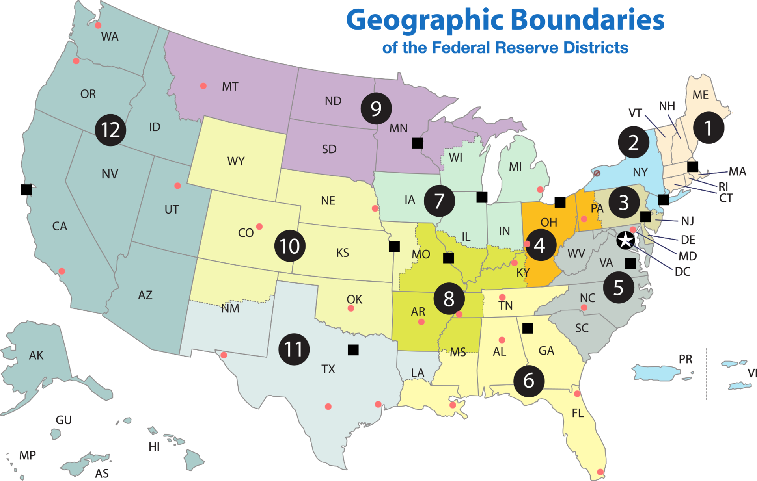

Figure - Federal Reserve Regions

The Fed has several tools to implement its policies, they include open market operations, discount rate and reserve requirements.

* The open market operation includes the purchases and sales of US Treasuries. The federal funds rate is the interest rate banks charge each other for overnight loans of federal funds.
* The discount rate is the interest rate changed to commercial banks and other depository institutions on loans they receive from their regional Federal Reserve Banks, also known as the discount window.
* The reserve requirement is the deposit threshold the Fed levies on financial institutions for deposits liabilities.

Understanding the common tools the Fed uses is important because it also highlights possible indicators for inflation as the Fed attempts to find the right balance between inflation and deflation. For example, the federal funds rate and the corresponding federal funds target rate are tools used by the Fed in controlling the amount of money in the financial system by throttling the interest rate and money supply. The money supply is modified through the loaning of currency to lending institutions with varying interest rates.

# Approach and Questions

Our approach was based on providing multiple views into primary and secondary indicators of inflation. We aggregated data from the Fed. With the datasets available to us we attempted to answer the following questions with the relevant data sets:

* Are the measures of inflation reported by the Fed accurate measures of real inflation in the economy?
* What is the historic relationship between interest rates and inflation?
* What is the relationship between the money supply M2 and inflation?
* Is inflation likely to be transitory or permanent?
* What is the impact of inflation on the working class and barely middle class in the United States?

# Our Data

Our primary data source was the FED, they aggregate data and make them available for download, through their API services.  
  
Fed data “Series” are economic measurements, some complex, some simple, over time.  
  
We’ve identified series which are primary and secondary indicators of inflation. Some are precursors that can lead to inflation while others are indicators measuring the effects of inflation.

The following are the FED Series we have utilized:

|  |  |  |  |  |  |  |
| --- | --- | --- | --- | --- | --- | --- |
| FED Series ID | Title | Freq | Obs Start | Obs End | Unit | Seasonal Adjustment |
| MEHOINUSA672N | Real Median Household Income in the United States | A | 1/1/1984 | 1/1/2019 | 2019 CPI-U-RS Adjusted Dollars | Not Seasonally Adjusted |
| CPIAUCSL | Consumer Price Index for All Urban Consumers: All Items in U.S. City Average | M | 1/1/1947 | 6/1/2021 | Index 1982-1984=100 | Seasonally Adj |
| MEHOINUSA672N | Real Median Household Income in the United States | A | 1/1/1984 | 1/1/2019 | 2019 CPI-U-RS Adjusted Dollars | Not Seasonally Adj |
| PCE | Personal Consumption Expenditures | M | 1/1/1959 | 6/1/2021 | Billions of Dollars | Seasonally Adj Annual Rate |
| WPS0811 | Producer Price Index by Commodity: Lumber and Wood Products: Softwood Lumber | M | 1/1/1975 | 6/1/2021 | Index 1982=100 | Seasonally Adj |
| PCOPPUSDM | Global price of Copper | M | 1/1/1990 | 6/1/2021 | U.S. Dollars per Metric Ton | Not Seasonally Adj |
| PSAVERT | Personal Saving Rate | M | 1/1/1959 | 6/1/2021 | Percent | Seasonally Adj Annual Rate |
| PCEC96 | Real Personal Consumption Expenditures | M | 1/1/2002 | 6/1/2021 | Billions of Chained 2012 Dollars | Seasonally Adj Annual Rate |
| TCU | Capacity Utilization: Total Index | M | 1/1/1967 | 6/1/2021 | Percent of Capacity | Seasonally Adj |
| CPILFESL | Consumer Price Index for All Urban Consumers: All Items Less Food and Energy in U.S. City Average | M | 1/1/1957 | 6/1/2021 | Index 1982-1984=100 | Seasonally Adj |
| CSUSHPINSA | S&P/Case-Shiller U.S. National Home Price Index | M | 1/1/1987 | 5/1/2021 | Index Jan 2000=100 | Not Seasonally Adj |
| MABMM301USM189S | M3 for the United States | M | 1/1/1960 | 5/1/2021 | National Currency | Seasonally Adj |
| UNRATE | Unemployment Rate | M | 1/1/1948 | 6/1/2021 | Percent | Seasonally Adj |
| FPCPITOTLZGUSA | Inflation consumer prices for the United States | A | 1/1/1960 | 1/1/2020 | Percent | Not Seasonally Adj |
| GOLDAMGBD228NLBM | Gold Price in US Dollars | D | 1/1/1958 | 7/29/2021 | Dollars | Not Adjusted |
|  |  |  |  |  |  |  |

The Location of the FED API is below:

<https://fred.stlouisfed.org/docs/api/fred/>

Examples of Fred Series Data:

|  |  |
| --- | --- |
| “CPIAUCSL” -- Consumer Price Index All Urban Consumers | “MABMM301USM189S” -- FED M3 Money Supply |
| |  |  | | --- | --- | | **date** | **Value** | | 1947-01-01 | 21.48 | | 1947-02-01 | 21.62 | | 1947-03-01 | 22.0 | | 1947-04-01 | 22.0 | | 1947-05-01 | 21.95 | | 1947-06-01 | 22.08 | | 1947-07-01 | 22.23 | | 1947-08-01 | 22.4 | | 1947-09-01 | 22.84 | | 1947-10-01 | 22.91 | | 1947-11-01 | 23.06 | | 1947-12-01 | 23.41 | | … | … | | 2020-12-01 | 261.560 | | 2021-01-01 | 262.231 | | 2021-02-01 | 263.161 | | 2021-03-01 | 264.793 | | 2021-04-01 | 266.832 | | 2021-05-01 | 268.551 | | 2021-06-01 | 270.981 | | |  |  | | --- | --- | | **date** | **value** | | . … | . … | | 2019-08-01 | $ 14,938,800,000,000.00 | | 2019-09-01 | $ 15,030,100,000,000.00 | | 2019-10-01 | $ 15,156,700,000,000.00 | | 2019-11-01 | $ 15,254,400,000,000.00 | | 2019-12-01 | $ 15,329,100,000,000.00 | | 2020-01-01 | $ 15,410,000,000,000.00 | | 2020-02-01 | $ 15,473,400,000,000.00 | | 2020-03-01 | $ 16,014,300,000,000.00 | | 2020-04-01 | $ 17,042,900,000,000.00 | | 2020-05-01 | $ 17,893,000,000,000.00 | | 2020-06-01 | $ 18,179,600,000,000.00 | | 2020-07-01 | $ 18,320,000,000,000.00 | | 2020-08-01 | $ 18,381,800,000,000.00 | | 2020-09-01 | $ 18,605,000,000,000.00 | | 2020-10-01 | $ 18,751,100,000,000.00 | | 2020-11-01 | $ 18,960,200,000,000.00 | | 2020-12-01 | $ 19,131,400,000,000.00 | | 2021-01-01 | $ 19,395,400,000,000.00 | | 2021-02-01 | $ 19,666,700,000,000.00 | | 2021-03-01 | $ 19,912,800,000,000.00 | | 2021-04-01 | $ 20,118,800,000,000.00 | | 2021-05-01 | $ 20,370,100,000,000.00 | |

### Our Data Pipeline, Cleansing and Normalization

Our selection of data sources from official government websites and commercial entities provided us with fairly clear data with a minimal need for cleaning.   
  
Our analysis required identifying the appropriate time ranges as many of the datasets are available for over 50 years. The official nature of the data also addressed any concerns for sanity checks. Some of the data series had gaps in their recordings, however the trend lines for the years that are relevant were available. The lumber cost series below in Figure 4 is an example of missing data, but the trend line for the years with inflationary concerns are apparent.  
  
Cleanliness of the native data aside, we still needed to build a data aggregation pipeline, in order to acquire the FED data, combine series, and then generate visualizations.

|  |  |  |  |  |  |  |  |
| --- | --- | --- | --- | --- | --- | --- | --- |
| |  | | --- | | Data Pipeline Steps (High Level) | | 1. Extract Series from FED API 2. Scale and combine two or more series, clean missing data to prevent it from being graphed as no values 3. Render visualizations with multiple y scales, of differing dimensions. 4. Persist Series data as Excel and CSV 5. Persist visualization as PNG | | |  |  |  |  | | --- | --- | --- | --- | | |  | | --- | | Before Cleaning and Normalization. | | After Cleaning and Normalization. | |  | |

**Exhibit 1 – Data pipeline**

# Using Data to Answer Explain and Answer Questions

## Question: Are the measures of inflation reported by the Fed accurate measures of real inflation in the economy?

Two common indicators of inflation used by the Fed are the Consumer Price Index (CPI) and the Personal Consumption Expenditure (PCE). The Consumer Price Index which is a measure of average price of goods and services, such as transportation, food and medical care. The basket of goods and services included in the CPI is called the market basket. The market basket is updated on a periodic basis to be reflective of consumables and services commonly used by most of the population. Updating the market basket allows for more timely and accurate measurements of broad price changes. CPI statistics are not inclusive of all population categories, as they include professional, self-employed, unemployed, and retired folks. The CPI does not include non-metro and rural populations, farm families and armed forces. The CPI is calculated by the Bureau of Labor Statistics (BLS) and reported on a monthly basis. The CPI rating is pegged to the index average for the period of 1982 to 1984. Thus a CPI value of 100 means that inflation is equal to the inflation level of 1984. The CPI value is not the same thing as an inflation %, which is a comparison to a previous period of time, such as month-month or year-year.

The market basket includes, but is not limited to:

* Food and Beverages
* Housing
* Clothes
* Transportation
* Medical Care
* Recreation
* Education and Communication
* Other Goods and Services (tobacco and smoking products, haircuts and other personal services, funeral expenses)

CPI measurements, while diverse and comprehensive in it’s inclusion of many goods and service prices, does not include the following key elements; savings, investments and utilities. CPI-U is specific to urban wage earners, while CPI-W includes only expenditures of hourly wage earning or clerical jobs.

The Personal Consumption Expenditures (PCE) looks at the other half of the financial transaction by measuring what businesses are selling. The PCE is prepared and released by the Bureau of Economic Analysis (BEA). One of the common issues with CPI is the measure of substitutions, such as a reduction in purchasing of bananas due to an increase in price. The PCE attempts to provide insight into possible substitutions consumers may make, by measuring what else a consumer may have purchased instead of the banana.

There’s also a difference between CPI and Core Inflation. Core Inflation is a measure of CPI without the more volatile elements such as food and energy utility costs.

A consumer's purchasing power is a measure of their income, ability to buy goods and services and the price of those goods and services. Any true measure of purchasing power would require the comparison of both elements. Figure 2 below shows the increase in CPI and fluctuations in income. Figure 3 below shows the rise in personal consumption expenditures and rise in income.  
  
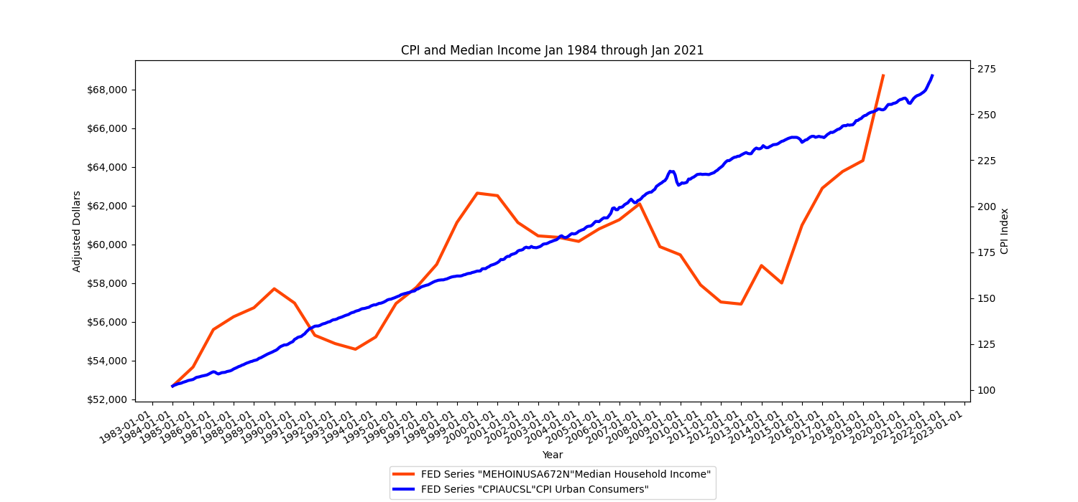

**Figure 2 - Consumer Price Index & Median Income**

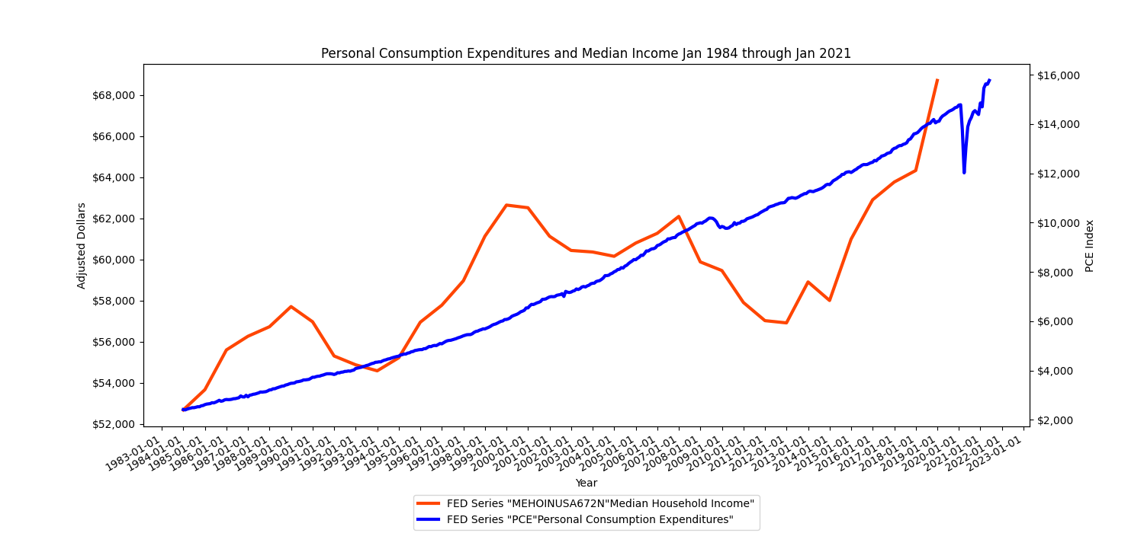

**Figure 3 - Personal Consumption Expenditures & Median Income**

Several other discrete price fluctuations can also be monitored as leading indicators of possible inflation. They include commodity prices such as raw materials that are economically sensitive materials, like copper and lumber. Figure 4 below shows the sharp rise in lumber prices versus the gradual rise in inflation, indicating a very sharp variation in a leading indicator whose impact on the larger inflation indicator is muted due to the Fed methodology. Figure 5 below is also another example of a very sharp rise in copper product costs and the same muted response on the Fed inflation indicator.

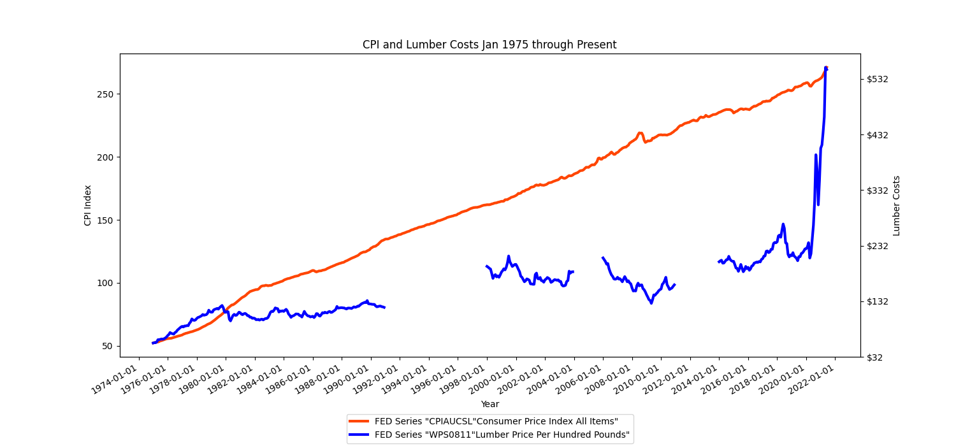

**Figure 4 - Consumer Price Index & Lumber Costs**

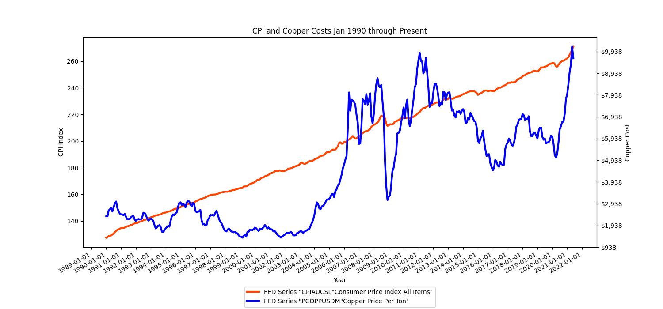

**Figure 5 - Consumer Price Index & Copper Costs**

Another example of economic health is the factory capacity utilization. A higher utilization rate indicates high demand for goods and a limited capacity to increase production. A rate of >84% capacity is deemed concerning for inflation. Figure 6 below shows the factory utilization rate and it’s sharp decline and rise.

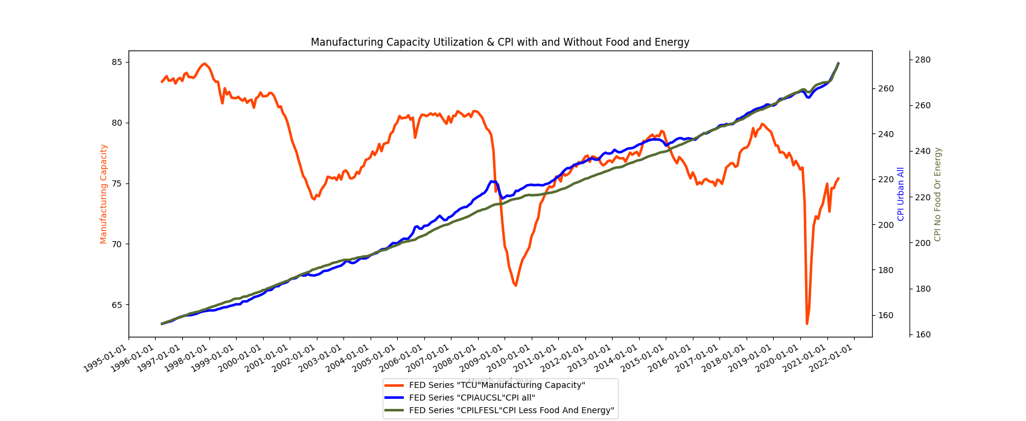

**Figure 6 - Manufacturing Capacity Utilization & CPI**

Another possible leading indicator of inflation is the unemployment rate. The relationship with unemployment is based on the theory that a reduction in unemployment rate will result in an increase in worker income, thus raising consumption and market demand. A raise in demand would thus lead to inflation pressure with limited supply. Figure 7 below shows the correlation between inflation and the unemployment rate, the lower the unemployment rate the higher the inflation rate. The correlation is clear in 2008 and in 2020 below.

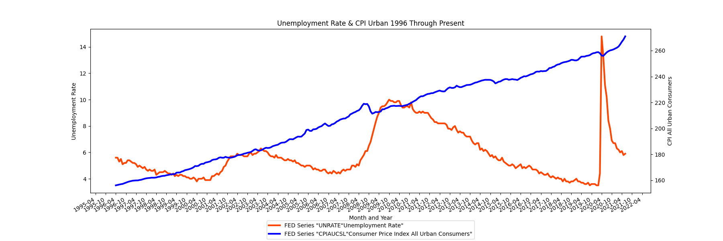

**Figure 7 - Unemployment Rate & CPI Urban**

## 

## Question: What is the historic relationship between interest rates and inflation?

Interest is the reward a saver receives for forgoing consumption in favor of saving their money and lending it out. Data from the Fed indicates that when inflation is high, that is to say that few goods, services, and assets can be purchased for a certain amount of money, savers require a higher rate of interest as compensation and protection against decreased buying power. Figure 8 below shows the correlation between the inflation rate and the Federal Fund rate.

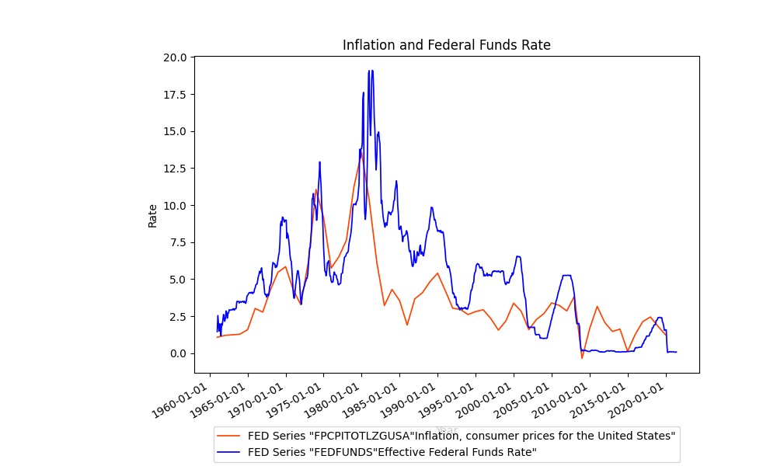

**Figure 8 - Inflation & Fed Fund Rate**

Looking at the figure above, we see that historically, the rate of interest, as measured by the Effective Federal Funds Rate, is generally higher than the rate of inflation, prior to the 2008 financial crisis. Figure 9 below shows the CPI rise and the fall in the Federal funds rate.

There is no historical precedent for a fall in the Federal Funds Rate accompanied by a sharp rise in CPI.

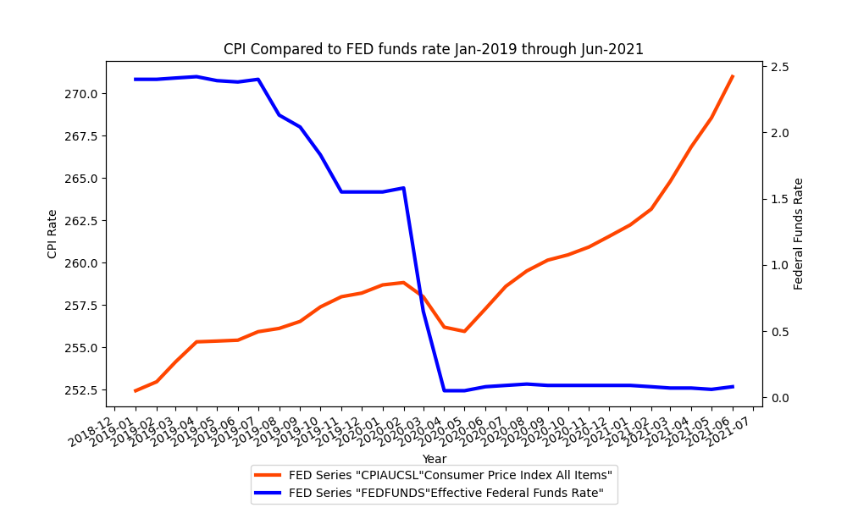

**Figure 9 - CPI & Federal Fund Rate**

When we compare the Consumer Price Index, to the Fed Funds rate over the past 3 years, we see a situation where interest rates are unnaturally low, while the CPI is beginning to skyrocket. This is unprecedented; typically interest rates are higher than the rate of inflation, For the past year, and two months, the opposite has been true, inflation has been higher than the rate of interest. Typically the FED has responded to high inflation by raising interest rates. Currently the FED cannot raise interest rates for reasons we outline below.

## Question: What is the relationship between the money supply M2 and inflation?

Much of the rise in the stock market is being fueled by stock buyback and retail investment frenzy. There exists a risk that the current inflation, fueled in part by mass increase in the money supply and ongoing quantitative easing by the FED, could give way to deflationary pressures which lay bare the fundamental weakness of the economy ravaged by the pandemic and an erosion in real wages for workers. Figure 10 below shows the supply of money and the Case-Schuller Index, which is the leading measure of US residential real estate prices.

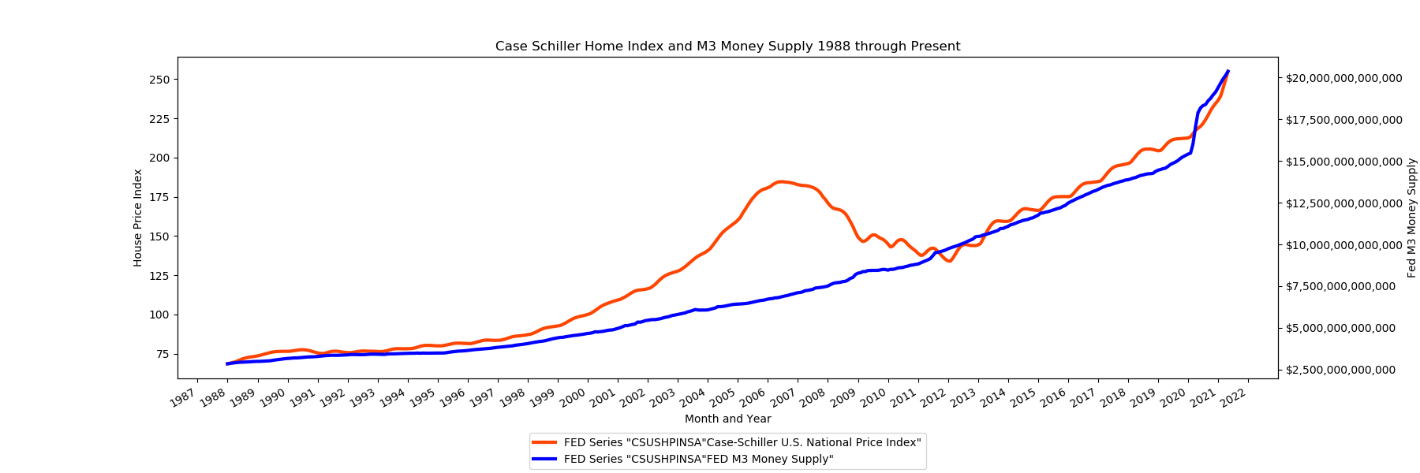

**Figure 10 - Case-Schiller Index & M3 Money Supply**

## Question: Is inflation likely to be transitory or permanent?

Asset inflation is at an all-time high. The graphs above show that stocks are at an all time high, home prices are at an all time high, money printing (quantitative easing) is at an all time high, and corporate credit as measured by the prices in the bond market is at an all time high.

What is fueling this asset bubble is a FED which will not let stock prices, or home prices fall, because it is buying up bonds backing those assets. If the FED were to stop buying those bonds, at artificially low rates, the open market, interest rate would be close to 10% which would crash both the bond market, and the equity markets.

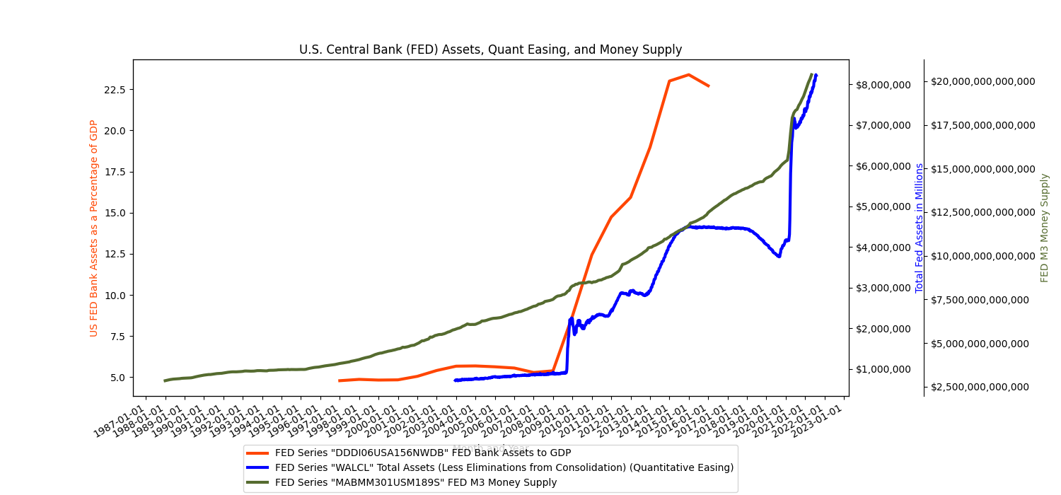  
**Figure 11 – FED Assets as a Percentage of GDP, Quant Easing, and Money Supply**

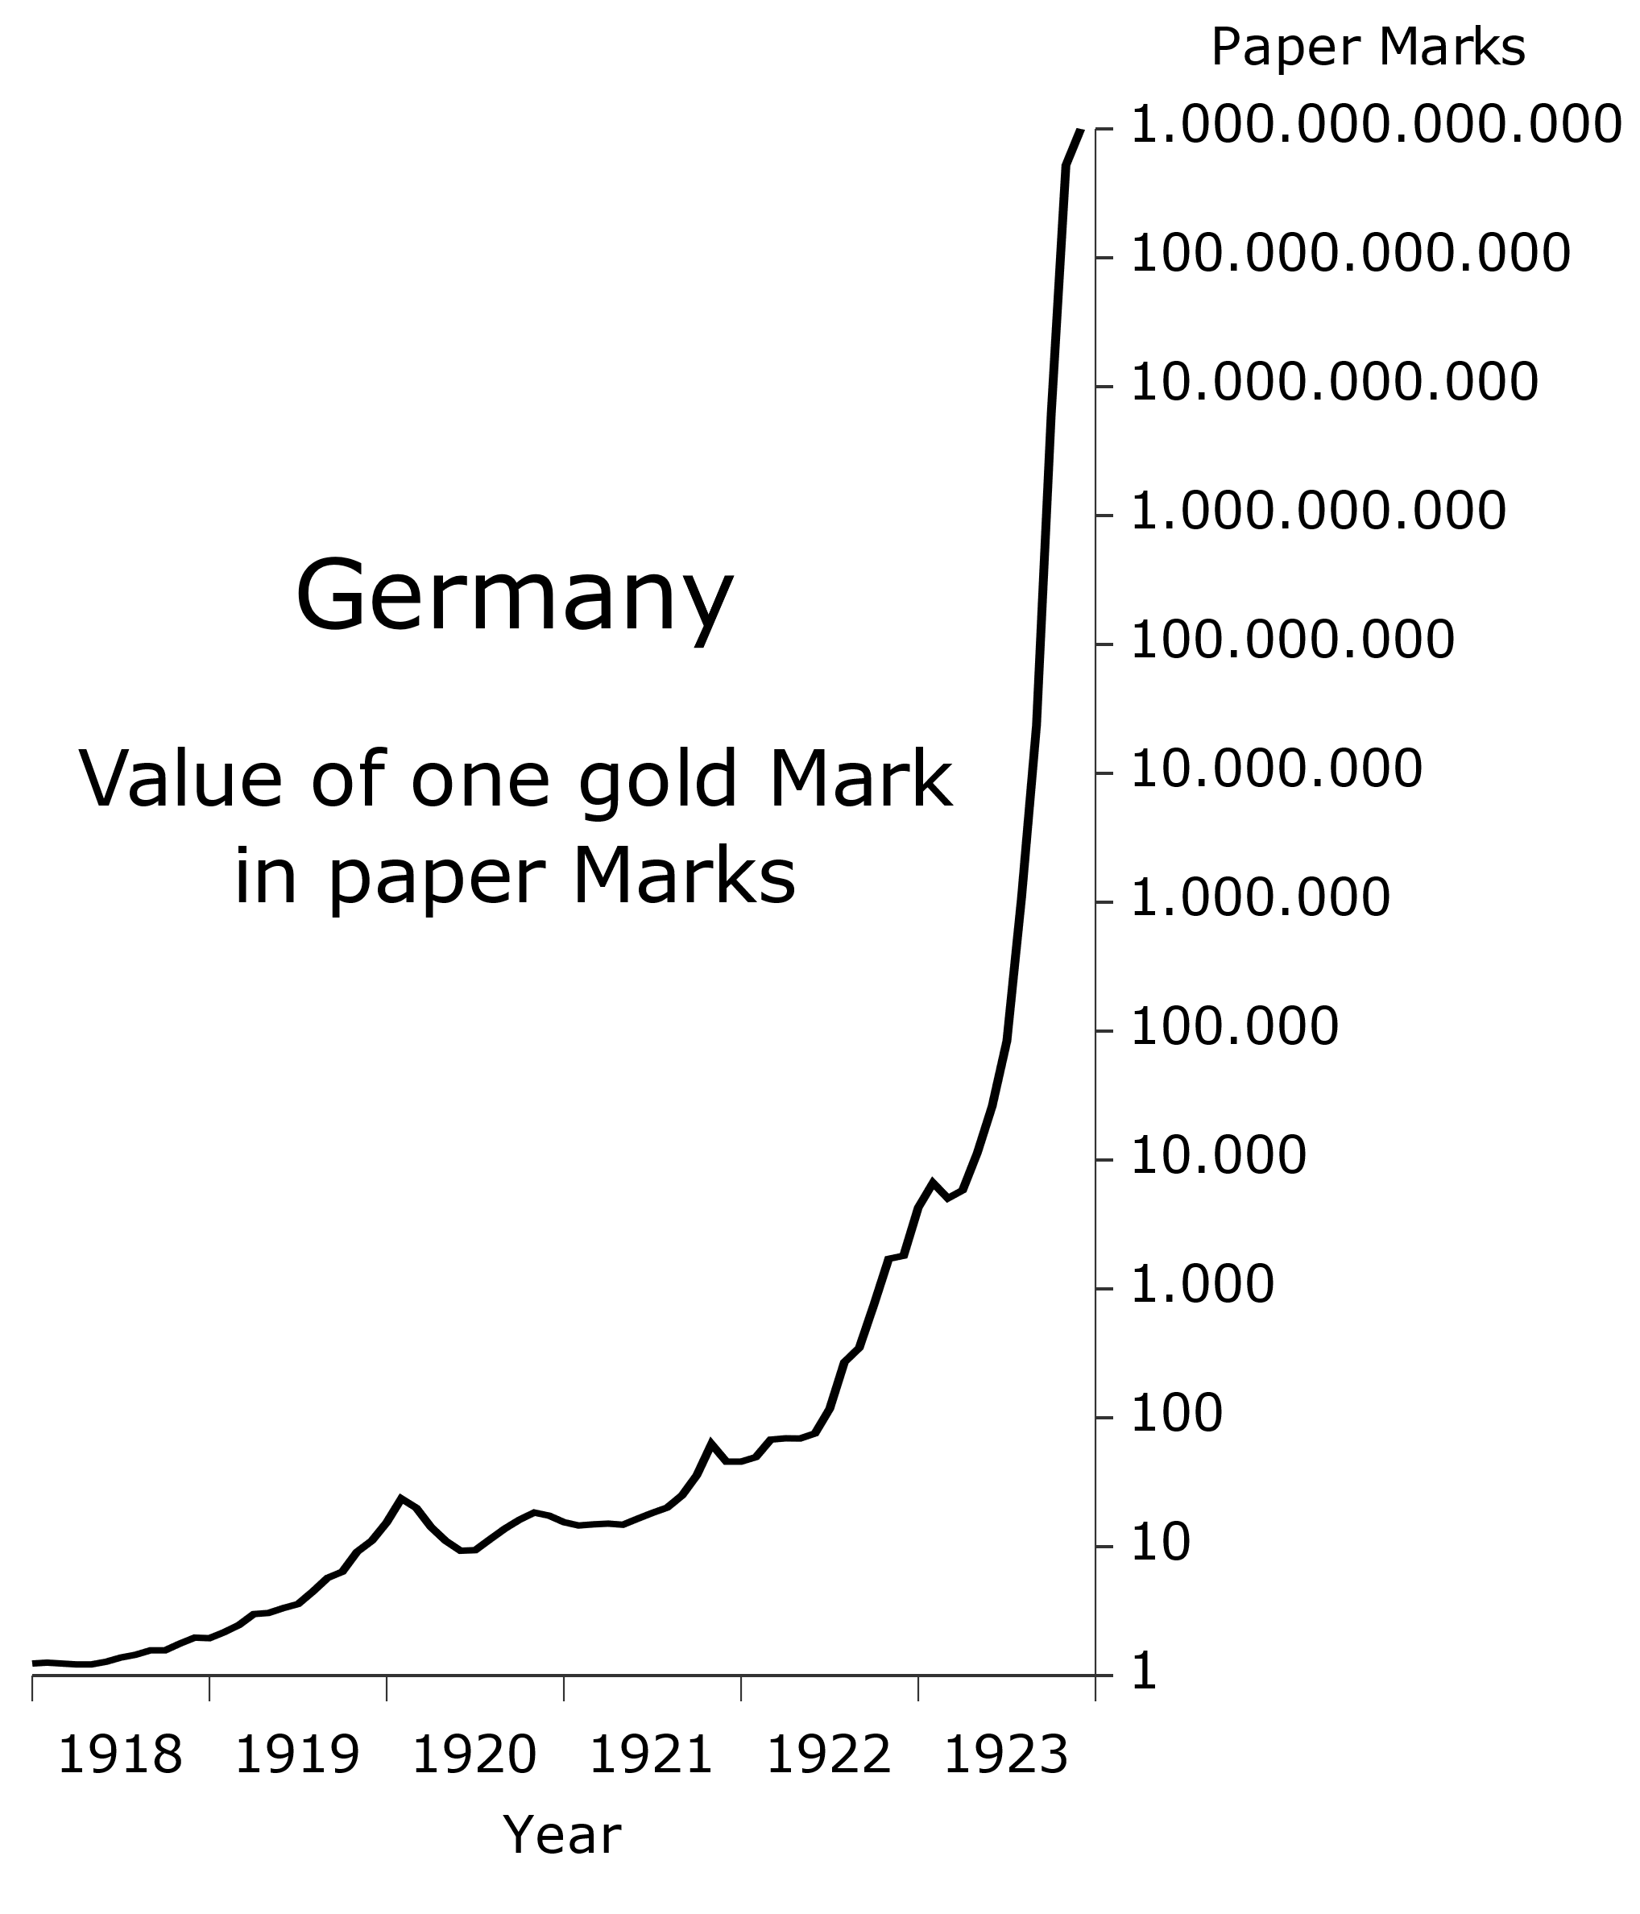  
Other that Weimar Germany’s runaway inflation, there does not exist historical precedent for being able to understand what is happening in the U.S. financial system. The events of the past 5 years, challenge every published model, index, theory and observation about monetary policy, inflation, money supply and asset inflation. Unlike the Weimar Republic, the U.S. has the printing press for the world’s reserve currency until it no longer enjoys that place of privilege.  
  
At this point the FED is in a debt trap, two actions are available to it:

1. The FED raises rates, which will control inflation, but crash the asset markets, home market, and bond markets leading to recession.
2. The FED does not raise rates, which will lead to increase in asset price inflation, which will feed into consumer price inflation, fueling further speculation until recession occurs.

Figure 13 Price of gold in German Marks during German Hyperinflation. Source: wikipedia.

The wildcard in the equation is the question of for how long the U.S. dollar will remain the world’s reserve currency. If that changes the cost of imports will rise very significantly and consumer price inflation, and producer price inflation will increase, while asset prices may decrease.

## What is the impact of inflation on the working class and barely middle class in the United States?

Inflation is effectively a tax, that has an uneven impact on the low, middle and high income earners. Rich individuals can, and typically do, invest in assets that tend to accumulate in value faster than inflation. Their investments include stocks, properties, and other financial assets. The lower income have little to nothing with which to invest, little savings. In a hyperinflationary environment their wages do not keep up with the increase in goods and services costs, resulting in a major loss of purchasing power. The middle class, while shrinking, has some savings, investments, and ownership of properties.

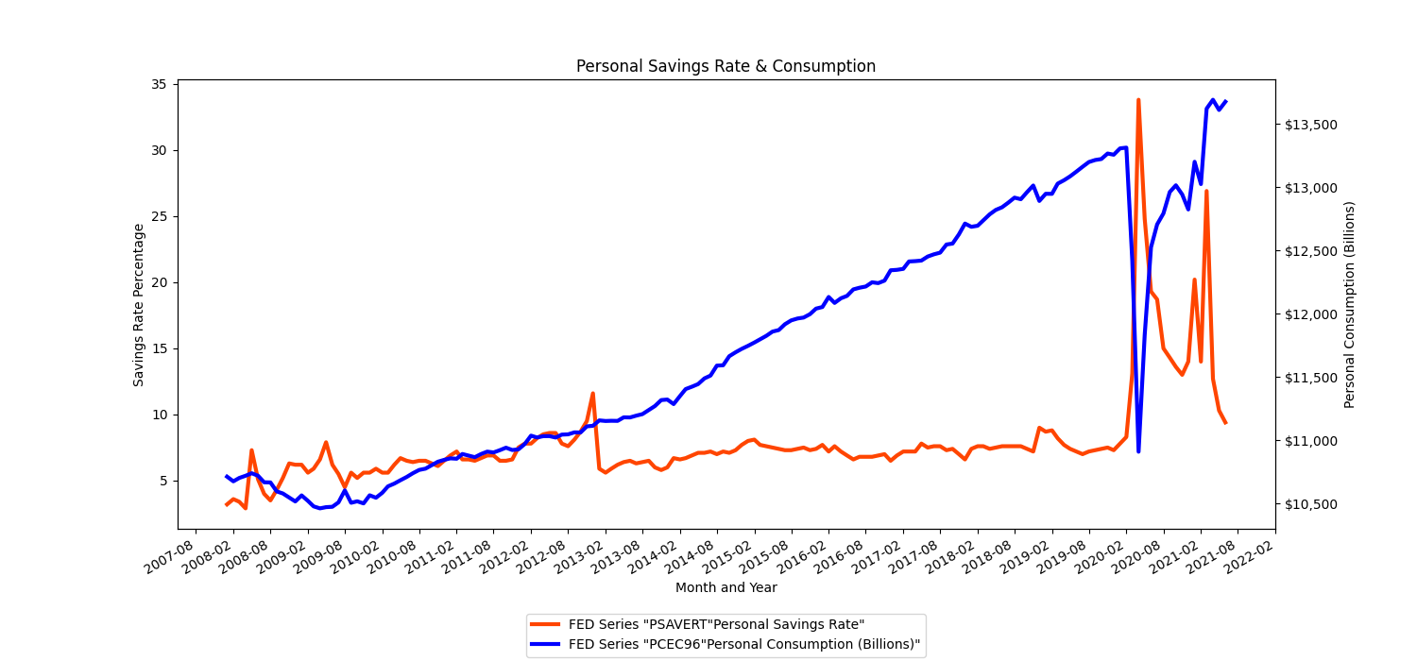

**Figure 12 - Personal Savings Rate & Consumption**

The Federal Reserve injects money into the financial system by buying bonds either directly from corporations, or from banks which hold those bonds. Many companies are using bond sales to finance stock buybacks, pushing up equity prices based on debt, which is being purchased by the FED. The graph below shows that over the past five years, workers’ portion of GDP has struggled to increase by one or two percentage points, while Fed quantitative easing (bond purchases) and stock indices have more than doubled during the same period.

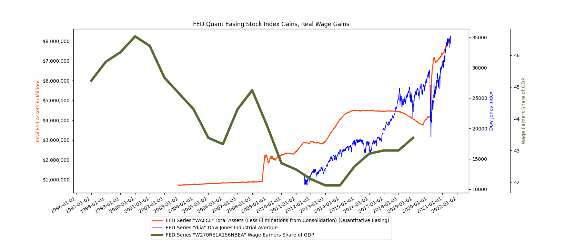  
**Figure 13 – FED quantitative easing, stock indexes, only 1.5% gain in wage earners share of GDP**

## Conclusion

Every piece of historical data available suggests that we are in an unprecedented financial and monetary state. We are seeing runaway asset inflation fueled by credit extended at negative real interest rates to the ultra rich and those institutions, banks, brokerages and hedge funds, connected to the FED money printing pipeline.

At present that asset inflation is feeding into price inflation as measured by the CPI, and PCE. That is to say, asset inflation is feeding into daily cost of living, such as the cost of housing, raw materials, and energy.

The FED is in a debt trap, where if it raises rates to control inflation there will be a crash in the cheap credit fueled asset bubbles, stocks, bonds, and real-estate. If it does not raise rates we are likely to continue to see increased inflation.

The Fed has developed key multiple indicators of inflation which are widely accepted as semi-timely measures of current market conditions. These measures include CPI and PCE, which are very large indexes that include thousands of individual variables. Neither measure is perfect and each has its own sets of weaknesses, such as timeliness or comprehensive inclusion of all market variables. Our research approach was based on identifying and analysing secondary indicators of inflation that would support or show a variance from the accepted CPI, PCE and inflation indicators. Our methodical approach and resulting research questions addressed the current state of inflation using multiple financial market indicators. Our hypothesis was that the current reported inflation rate of 5% from the government is below the real-world measure of inflation. Based on our analysis the secondary measure of inflation looking at discrete market variables, such as lumber, copper, unemployment, factory capacity utilization, money supply and other measures, clearly shows a very large upswing in costs. The measure CPI and PCE indexes do not show similar upticks in cost due to the dampening effects of thousands of variables. Nonetheless, further analysis is required to continue investigating these secondary discrete indicators as well as reducing the datasets to regional geographic zones as not all regions experience the same fluctuations.